Assignment - Web Scraping and Visualization with Prometheus and Grafana

1. Connecting Grafana to Prometheus as a data source.

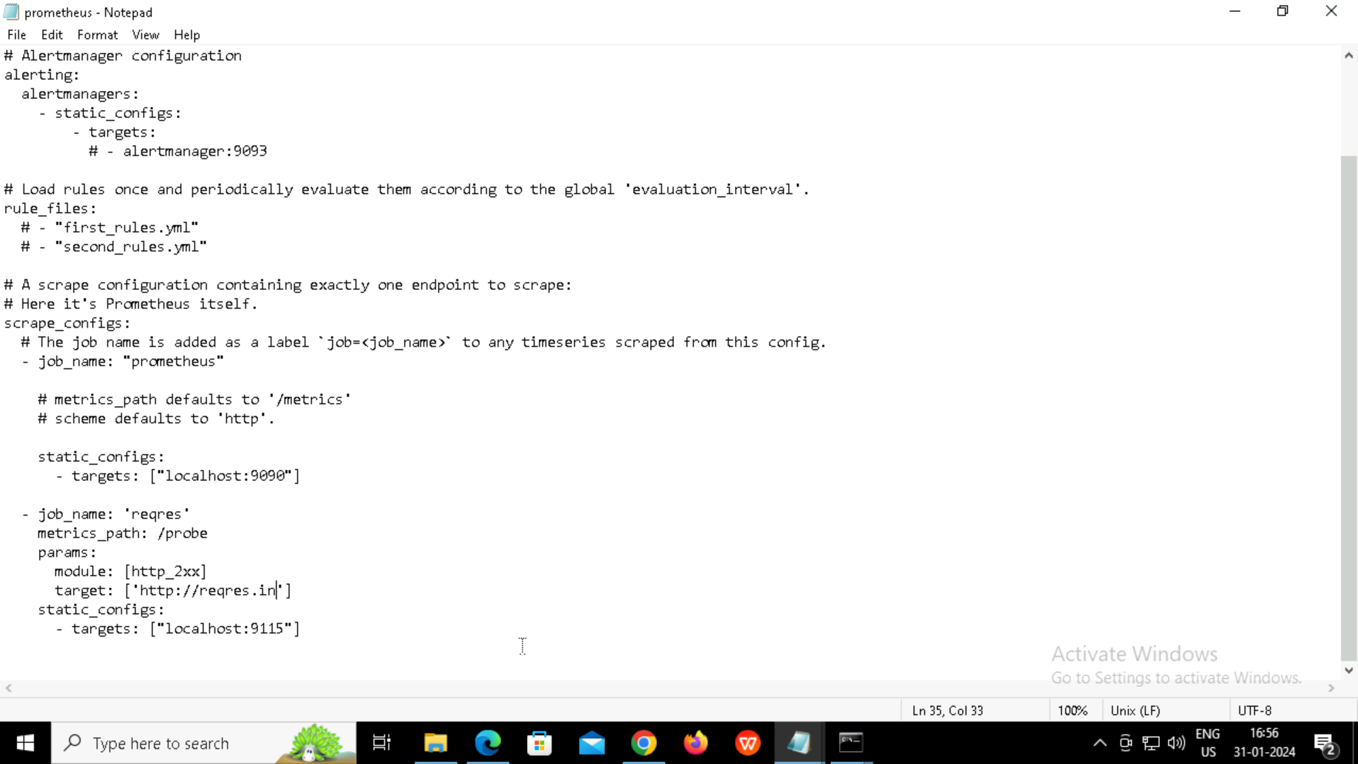

2.

4.

