**CaseStudy_CaseKaro**

Request DefaultsTest script recorder – Test plan creation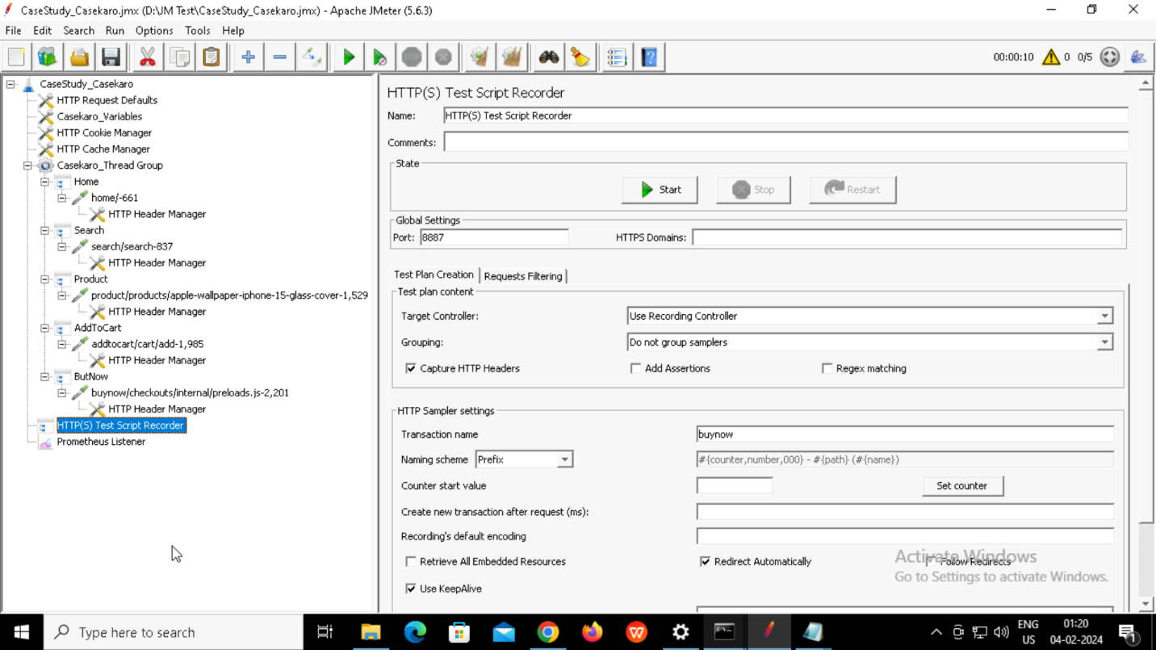

Prometheus Listener

Filtering requestsCreating rules in YAML file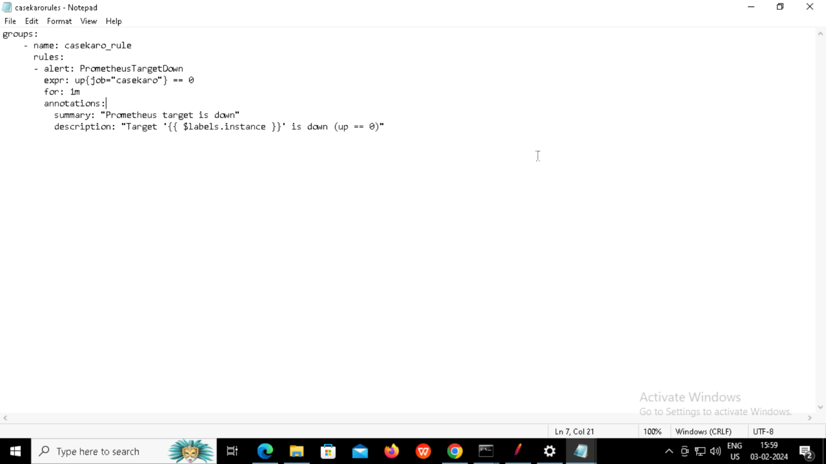

Configuring prometheus YAML file with new rule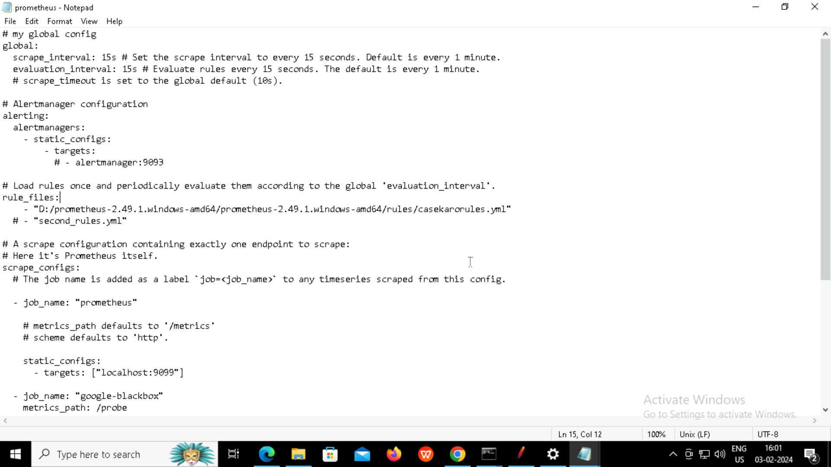Setting target as localhost:9270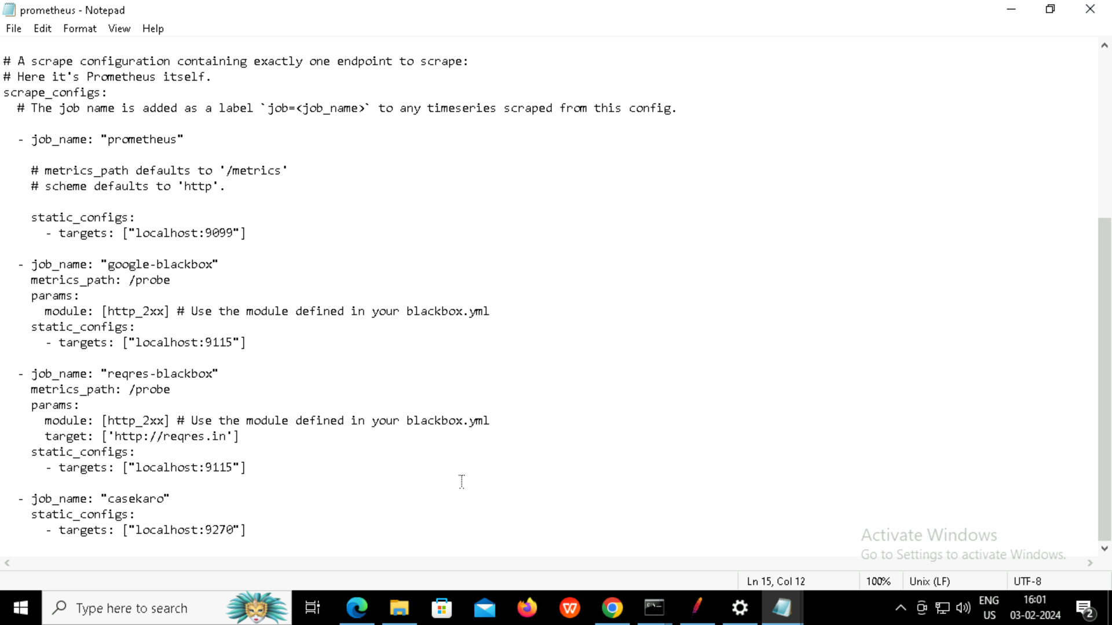

Metrics in the target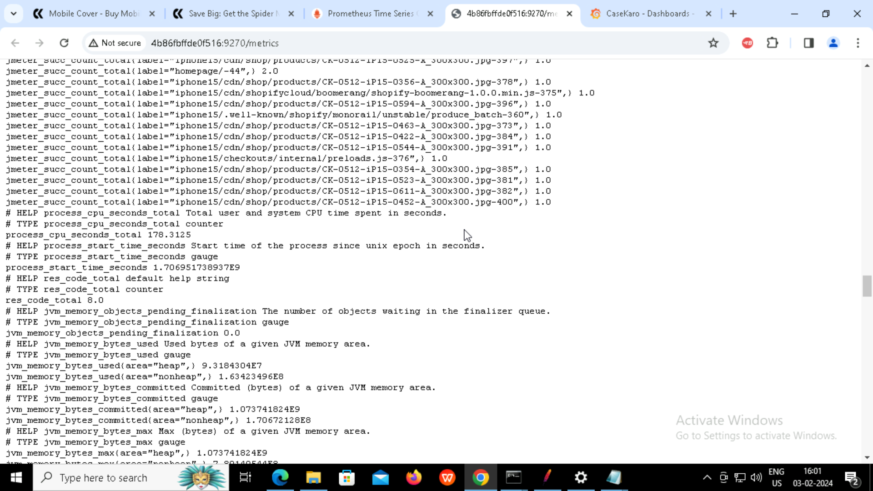Alert fired in prometheus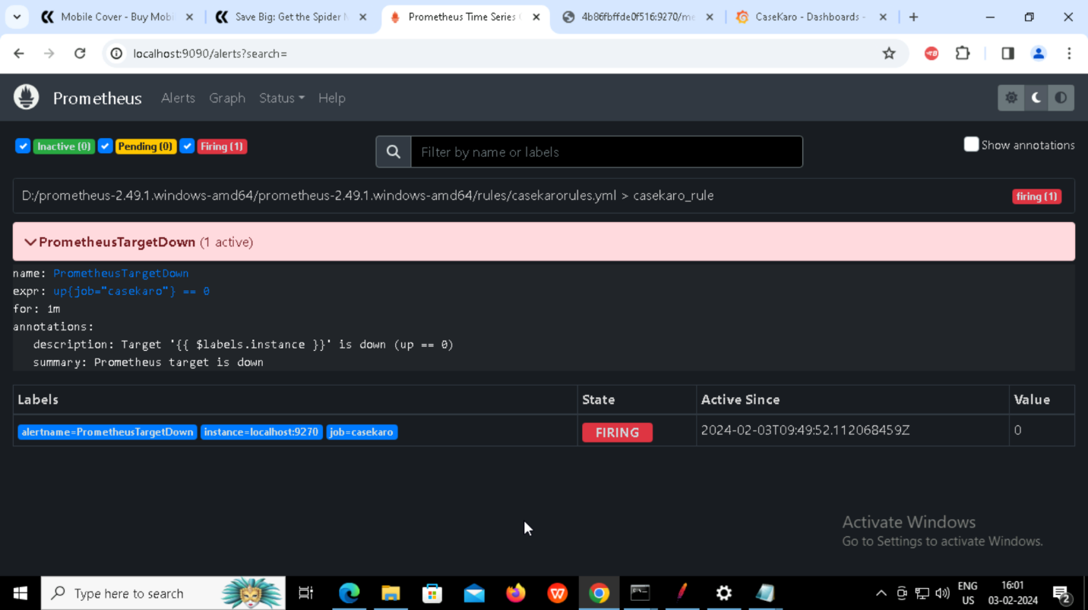

Final dashboard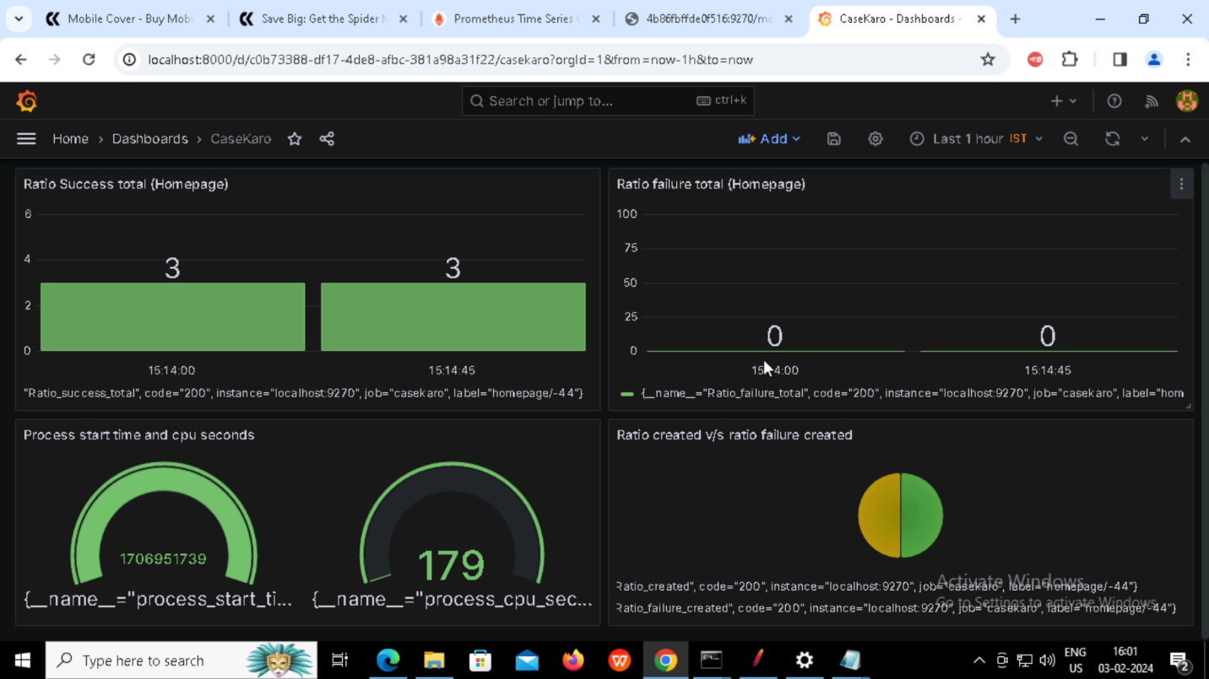Running jmeter tests in non GUI mode and generating logs and reports in specified destinations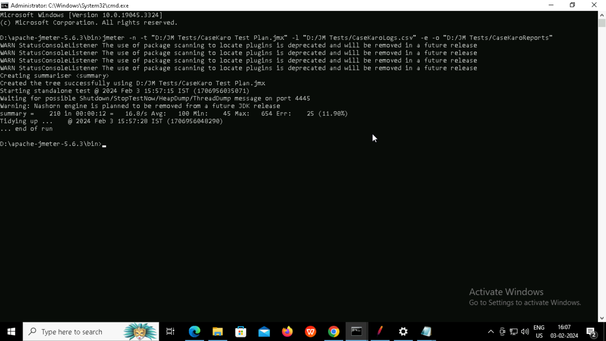

Report Index file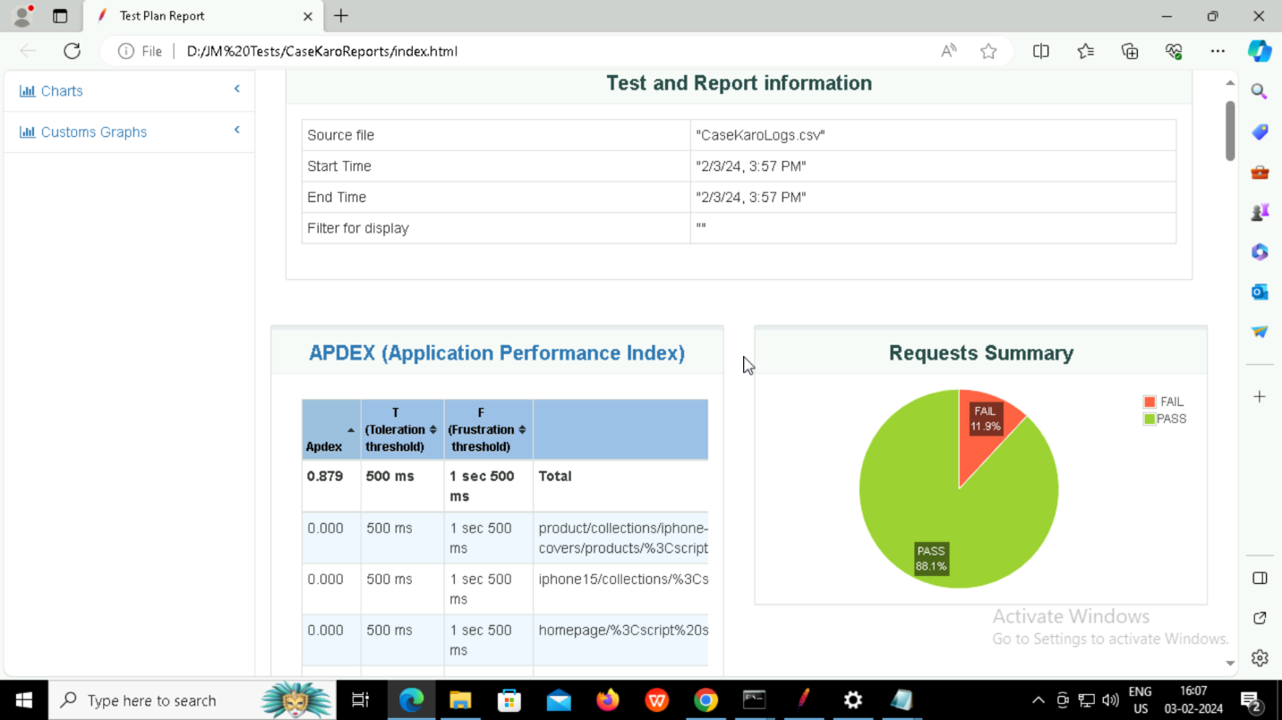

Log file as csv