TCS conducts 4 rounds to select freshers as Assistant System Engineer in their organisation.

* Written Round
* Technical Round
* Managerial Round
* HR Round

**Written Round :**

The Written round consists of four sections and the total time allotted is 90 minutes. The four sections include:

1. **Quantitative Aptitude Test:**

The first is the Quantitative Aptitude test where the numerical and the reasoning ability sections are tested. There are 20 questions that need to be attempted in 40 minutes. There are 2-star questions which have more weight than normal questions and are a bit tricky. There is negative marking of 1/3rd for the questions other than the star.

Important topics include Number system, Equations, Ratio and Proportion, Percentages, Profit and Loss, Time and Work, Time speed Distance, Areas and Mensuration, Averages, Permutations and Combinations, Probability, Plane geometry, Seating Arrangements, Sets, Progressions, Functions, Series, Coding, Truth and Lie based puzzles.

1. **Programming Language Test:**

This round consists of general questions from computer science and programming languages. It consists of 10 to 12 questions and the time allotted is 20 minutes. It is an MCQ round and basically consists of basic programming questions.

1. **Coding Round:**

This is a technical coding round. It consists of 1 to 2 questions and the time allotted is 20 minutes.

1. **E-mail writing :** There will be given certain clues/words using which you have to write an e-mail addressing the scenario. You have to type the e-mail in the space given. The most important thing is you have to use all the phrases given without missing even a single one. The time allotted is 10 minutes.

**Technical Round :**

The students who clear the written round are called for Technical Interview. There is no hard & fast rule for which questions will be asked in this round, you can expect questions on any topic depending on the panel. To clear this round you should be clear with your basics. You should be prepared with Data structures and Algorithms, DBMS, Operating System, Networking, OOPs concepts and a programming language of your choice. Students from branches other than CS should prepare for the other two subjects related to their branch. CS students will be expected to write codes in the interview. You may be asked puzzles in this round.

**Managerial Round :**

This round includes everything which was in Technical round plus it will be under pressure and a lot of cross-checking. Doubts will be raised on your answers to check if you can handle stress or not. Students may or may not be sent to this round depending on the feedback of the previous round. If the feedback of the previous round was good you may expect to directly been sent to HR round. Key for this round is to be calm, confident, clear on your thoughts and to not give up on pressure. If you don’t know the answer you must try to attempt it with whatever you know.

**HR Round :**

This is the final round of the recruitment process. The interview panel can question you anything related to your personality, family, education, hobbies, internships, general knowledge, basic HR questions like Why should I hire you?, If any problem in relocation etc. The key here is to be confident about everything you speak.



### Test -1

Ques1. Write a code to check whether no is prime or not. Condition use function check() to find whether entered no is positive or negative ,if negative then enter the no, And if yes pas no as a parameter to prime() and check whether no is prime or not?

* 1. **Whether the number is positive or not, if it is negative then print the message “please enter the positive number”**
  2. **It is positive then call the function prime and check whether the take positive number is prime or not.**

***Ques2*** *Number Series with a Twist – 1*

Find the 15th term of the series? 0,0,7,6,14,12,21,18, 28

**Ques3** Consider the following series: 1, 1, 2, 3, 4, 9, 8, 27, 16, 81, 32, 243, 64, 729, 128,

2187 …

This series is a mixture of 2 series – all the odd terms in this series form a geometric series and all the even terms form yet another geometric series. Write a program to find the Nth term in the series.

The value N in a positive integer that should be read from STDIN. The Nth term that is calculated by the program should be written to STDOUT. Other than value of n th term,no other character / string or message should be written to STDOUT. For example , if N=16, the 16th term in the series is 2187, so only value 2187 should be printed to STDOUT.

You can assume that N will not exceed 30.

### Ques 4

consider the below series :

0, 0, 2, 1, 4, 2, 6, 3, 8, 4, 10, 5, 12, 6, 14, 7, 16, 8

This series is a mixture of 2 series all the odd terms in this series form even numbers in ascending order and every even terms is derived from the previous term using the formula (x/2)

Write a program to find the nth term in this series.

The value n in a positive integer that should be read from STDIN the nth term that is calculated by the program should be written to STDOUT. Other than the value of the nth term no other characters /strings or message should be written to STDOUT.

For example if n=10,the 10 th term in the series is to be derived from the 9th term in the series. The 9th term is 8 so the 10th term is (8/2)=4. Only the value 4 should be printed to STDOUT.

You can assume that the n will not exceed 20,000.

### Ques5

1. The program will recieve 3 English words inputs from STDIN
   1. These three words will be read one at a time, in three separate line
   2. The first word should be changed like all vowels should be replaced by %
   3. The second word should be changed like all consonants should be replaced by #
   4. The third word should be changed like all char should be converted to upper case
   5. Then concatenate the three words and print them

Other than these concatenated word, no other characters/string should or message should be written to STDOUT

For example if you print how are you then output should be h%wa#eYOU. You can assume that input of each word will not exceed more than 5 chars **Ques 6**

*Addition of two numbers a Twist*

1. Using a method, pass two variables and find the sum of two numbers. Test case:

Number 1 – 20

Number 2 – 20.38

Sum = 40.38

There were a total of 4 test cases. Once you compile 3 of them will be shown to you and 1 will be a hidden one. You have to display error message if numbers are not numeric.

### Ques7

*Consider the below series :*

***0, 0, 2, 1, 4, 2, 6, 3, 8, 4, 10, 5, 12, 6, 14, 7, 16, 8***

This series is a mixture of 2 series all the odd terms in this series form even numbers in ascending order and every even terms is derived from the previous term using the formula (x/2)

Write a program to find the nth term in this series.

The value n in a positive integer that should be read from STDIN the nth term that is calculated by the program should be written to STDOUT. Other than the value of the nth term no other characters /strings or message should be written to STDOUT.

For example if n=10,the 10 th term in the series is to be derived from the 9th term in the series. The 9th term is 8 so the 10th term is (8/2)=4. Only the value 4 should be printed to STDOUT.

You can assume that the n will not exceed 20,000.

**Question 8**

Find the nth term of the series. 1,1,2,3,4,9,8,27,16,81,32,243,….

**Question 9**

Consider a long alley with a N number of doors on one side. All the doors are closed initially. You move to and fro in the alley changing the states of the doors as follows: you open a door that is already closed and you close a door that is already opened. You start at one end go on altering the state of the doors till you reach the other end and then you come back and start altering the states of the doors again.

In the first go, you alter the states of doors numbered 1, 2, 3, … , n. In the second go, you alter the states of doors numbered 2, 4, 6… In the third go, you alter the states of doors numbered 3, 6, 9 … You continue this till the Nth go in which you alter the state of the door numbered N. You have to find the number of open doors at the end of the procedure.

## Input:

The first line of input contains a single integer T denoting the number of test cases. Then T test cases follow. Each test case consists of one line. The line consists of a positive integer N.

## Output:

Corresponding to each test case, in a new line, print the number of doors that will be open at the end of the procedure mentioned above.

## Constraints:

1 ≤ T ≤ 100

1 ≤ N ≤ 1012

## Example: Input:

5

372

2

100

825625

63542

## Output:

19

1

10

908

252

**Practice on this link https://practice.geeksforgeeks.org/problems/number-of-open- doors/0

## Question 10

Given n doors and n persons. The doors are numbered from 1 to n and persons are given id’s numbered from 1 to n. Each door can have only two statuses ie open (1) or closed (0) . Initially all the doors have status closed. Find the final status of all the doors, when all the persons have changed the status of the doors of which they are authorized. i.e. if status open then change the status to closed and vice versa. A person with id ‘i’ is authorized to change the status of door numbered ‘j’ if ‘j’ is a multiple of ‘i’.

**Note:** A person has to change the current status of all the doors for which he is authorized exactly once.

## Example:

**Input :** 3

**Output :** 1 0 0

**Explanation :** Initially status of rooms 0 0 0 person with id 2

changes room 2 to open ie (0 1 0) person with id 1 changes room 1,

2, 3 status (1 0 1) person with id 3 changes room 3 status ie (1 0 0)

## Input:

The first line of input contains an integer T denoting the no of test cases. Then T test cases follow. Each test case contains an integer n.

## Output:

For each test case in a new line print the n space separated integers either (1 or 0) depending on the status of the ith door where 1 denotes the door is open and a 0 denotes door is closed.

## Constraints:

1 <= T <= 100

1 <= N <= 1000

## Example: Input:

2

3

5

## Output:

1 0 0

1 0 0 1 0

** practice on link https://practice.geeksforgeeks.org/problems/check-if-the-door-is-open- or-closed/0

### Question 11

Given a number **N,** print the first N fibonacci numbers.

##### Input:

The first line of input contains an integer **T** denoting the number of test cases. Then T test cases follow. The first line of each test case contains the integer N.

##### Output:

Print the first n fibonacci numbers with a space between each number. Print the answer for each test case in a new line.

##### Constraints:

1<= T <=100

1<= N <=84

##### Example:

**Input:**

2

7

5

##### Output:

1 1 2 3 5 8 13

1 1 2 3 5

**\*\*\*Practice on** https://practice.geeksforgeeks.org/problems/print-first-n-fibonacci-numbers/0

### Question 12

Rahul and Ankit are the only two waiters in Royal Restaurant. Today, the restaurant received N orders. The amount of tips may differ when handled by different waiters, if Rahul takes the ith order, he would be tipped

Ai rupees and if Ankit takes this order, the tip would be Bi rupees.

In order to maximize the total tip value they decided to distribute the order among themselves. One order will be handled by one person only. Also, due to time constraints Rahul cannot take more than X orders and Ankit cannot take more than Y orders. It is guaranteed that X + Y is greater than or equal to N, which means that all the orders can be handled by either Rahul or Ankit. Find out the maximum possible amount of total tip money after processing all the orders.

##### Input:

* The first line contains one integer, number of test cases.
* The second line contains three integers N, X, Y.
* The third line contains N integers. The ith integer represents Ai.
* The fourth line contains N integers. The ith integer represents Bi.

##### Output:

Print a single integer representing the maximum tip money they would receive.

##### Constraints:

1 ≤ N ≤ 105

1 ≤ X, Y ≤ N; X + Y ≥ N

1 ≤ Ai, Bi ≤ 104

##### Example: Input:

2

5 3 3

1 2 3 4 5

5 4 3 2 1

8 4 4

1 4 3 2 7 5 9 6

1 2 3 6 5 4 9 8

##### Output:

21

43

**\*\*Practice on link** https://practice.geeksforgeeks.org/problems/maximum-tip-calculator/0

### Question 13

John was given a task to make a rectangular box during his innovation competition. He was given with

the A cm of wire and B cm2 of special paper. He had to use all the wire (for the 12 edges) and paper (for the 6 sides) to make the box. So what will be the maximum volume of that box?

##### Input:

The first line contains T, the number of test cases. Each test case contains two integers A and B in a line.

##### Output:

Single lined output for the maximum floored volume of the made box.

##### Constraints:

1<=T<=100

1<=A,B<=106

##### Example:

**Input:**

2

20 14

20 16

##### Output:

3

4

### ** Practice link

https://practice.geeksforgeeks.org/problems/maximum-volume-of-a-rectangular-box/0

**Question 14**

Bastin once had trouble finding the numbers in a string. The numbers are distributed in a string across various test cases. There are various numbers in each test case you need to find the number in each test case. Each test case has various numbers in sequence. You need to find only those numbers which do not contain 9. For eg, if the string contains "hello this is alpha 5051 and 9475".You will extract 5051 and not 9475. You need only those numbers which are consecutive and you need to help him find the numbers.

Note: Use long long for storing the numbers from the string.

## Input:

The first line consists of **T** test cases and next **T** lines contain a string.

## Output:

For each string output the number stored in that string if various numbers are there print the largest one. If a string has no numbers print -1.

## Constraints:

1<=**T**<=100

1<=**|S|**<=10000

## Example:

**Input:**

1

This is alpha 5057 and 97

## Output:

5057

Practice link:- https://practice.geeksforgeeks.org/problems/extract-the-number-from-the- string/0

### Question 15 :-Binary search

Given a sorted array **A[]**(0 based index) and a key **"k"** you need to complete the function **bin_search** to determine the position of the key if the key is present in the array. If the key is not present then you have to return **-1**. The arguments left and right denotes the left most index and right most index of the array **A[]**. There are multiple test cases. For each test case, this function will be called individually.

##### Input:

The first line contains an integer **'T'** denoting the number of test cases. Then **'T'** test cases follow. Each test case consists of 3 lines. First line of each test case contains an integer **N** denoting the size of the array. Second line of each test case consists of **'N'** space separated integers denoting the elements of the array **A[]**. The third line contains a key **'k'** .

##### Output:

Prints the position of the key if its present in the array else print **-1** if the key is not present in the array.

##### Constraints:

1 <= T <= 100

1 <= N <= 200

##### Example: Input:

2

5

1 2 3 4 5

4

5

11 22 33 44 55

445

##### Output:

3

-1

### Refer link

https://practice.geeksforgeeks.org/problems/binary-search/1

### Question 16 :- Linked List Insertion

Given a **key** (or data) to be inserted into the linked list of size **N**. The task is to insert the element at head or tail of the linked list depending on the input just before it p. If p is 0, then insert the element at beginning else insert at end.

**Hint :** When inserting at the end, make sure that you handle NULL explicitly.

##### Input Format:

First line of input contains number of testcases T. For each testcase, first line of input contains length of linked list N and next line

contains **2*N** integers, each element to be inserted into the list is preceded by a **0 or 1 w**hich decide the **place** to be inserted.

##### Output Format:

For each testcase, there will be a single line of output which contains the linked list elements.

##### Your Task:

This is a **function** problem. You only need to complete the **functions insertAtBeginning** and **insertAtEnd** that **returns head** after successful insertion. The **printing** is done **automatically** by the **driver code**.

##### Constraints:

1 <= T <= 100

1 <= N <= 103

##### Example: Input:

3

5

9 0 5 1 6 1 2 0 5 0

3

5 1 6 1 9 1

4

15 0 36 0 95 0 14 0

##### Output:

5 2 9 5 6

5 6 9

14 95 36 15

##### Explanation:

**Testcase 1:** After inserting the elements at required position, we have linked list as 5, 2, 9, 5, 6.

### Question 17

Given a struct array of type Height, having two elements **feet** and **inches**. Find the maximum height, where height is calculated sum of feet and inches after converting feet into inches.

##### Input:

First line of input contains number of testcases. For each testcase, first line of input contains N, number of given heights. Next line contains 2*N number of elements (feet and inches for each N).

##### Output:

Output maximum height from array.

**Your Task:** Your task is to only complete the function of find maximum height from given array.

##### Constraints:

1<=T<=100

1<=N<=105

0<=Feet, Inches<=105

##### Example:

**Input:**

2

2

1 2 2 1

4

3 5 7 9 5 6 5 5

##### Output:

25

93

Explanation:

**Testcase 1:** (1, 2) and (2, 1) are respective given heights. After converting both heigths in to inches, we get 14 and 25 as respective heights. So, 25 is the maximum height.

https://practice.geeksforgeeks.org/problems/maximum-in-struct-array/1

### Question 18

Given a dictionary of words and a pattern. Every character in the pattern is uniquely mapped to a character in the dictionary. The task is to complete a function **findMatchedWords(dict,pattern)** that returns a vector of strings matching with given pattern. The function takes two argument the first argument is an array of strings **dict** which denote the dictionary and the second argument is the **pattern** to match.

##### Input:

The first line of input contains an integer **T** denoting the number of test cases. Each testcase contains 3 lines. The first line contains an integer **N** denoting the number of strings in the dictionary,second line

N space separated strings denoting the strings of the dictionary. The third line contains pattern.

##### Output:

The output for each test case will be the space separated strings that matches the given pattern in lexicographical order.

##### User Task:

Since this is a functional problem you don't have to worry about input, you just have to complete the function **findMatchedWords()**

##### Constraints:

1 <= T <= 100

1 <= N <= 10

##### Input

1

4

abb abc xyz xyy foo

##### Output

abb xyy

##### Explanation

**Testcase 1**: In the above test case xyy and abb have same character at index 1 and 2 like the pattern.

**\*\*** https://practice.geeksforgeeks.org/problems/match-specific-pattern/1

### Question 19

Given an integer **x**. The task is to find the square root of x. If **x** is not a perfect square, then return floor(√x).

##### Input Format:

First line of input contains number of testcases T. For each testcase, the only line contains the number x.

##### Output Format:

For each testcase, print square root of given integer.

##### User Task:

The task is to complete the function **floorSqrt**() which should return the square root of given number x.

##### Constraints:

1 ≤ T ≤ 1000

1 ≤ x ≤ 107

##### Example:

**Input**:

2

5

4

##### Output:

2

2

##### Explanation:

**Testcase 1:** Since, 5 is not perfect square, so floor of square_root of 5 is 2.

**Testcase 2:** Since, 4 is a perfect square, so its square root is 2.

**\*\*** https://practice.geeksforgeeks.org/problems/square-root/1

### Question 20

Your task is to implement the function **strstr**. The function takes two strings as arguments **(s,x)** and locates the occurrence of the string **x** in the

string **s**. The function returns and integer denoting the **first occurrence** of the string x in s.

##### Input Format:

The first line of input contains an integer **T** denoting the no of test cases . Then T test cases follow. The first line of each test case contains two strings **s and x**.

##### Output Format:

For each test case, in a new line, output will be an integer denoting the first occurrence of the x in the string s. Return **-1** if no match found.

##### Your Task:

Since this is a function problem, you don't have to take any input. Just complete the **strstr()** function. The function returns -1 if no match if found else it returns an integer denoting the first occurrence of the x in the string s.

##### Constraints:

1 <= T <= 200

1<= |s|,|x| <= 1000

##### Example:

**Input**

2

GeeksForGeeks Fr GeeksForGeeks For **Output**

-1

5

##### Explanation:

**Testcase 1:** Fr is not present in the string GeeksForGeeks as substring.

**Testcase 2:** For is present as substring in GeeksForGeeks from index 5.

**\*\*** https://practice.geeksforgeeks.org/problems/implement-strstr/1

### Question 21 Reorder list

Given a singly linked list*: A*0→*A*1→…→*An*-1→*A*n, reorder it to: *A*0→*An*→*A*1→*An*-1→*A*2→*An*-2→…

For example: Given 1->2->3->4->5 its reorder is 1->5->2->4->3.

##### Note: It is recommended do this in-place without altering the nodes' values.

**Input:**

First line of input contains number of testcases T. For each testcase, there will be two lines of input, first of which contains length of linked list and next line contains elements of the nodes of linked list.

##### Output:

Reorder it as explained above.

##### User Task:

The task is to complete the function **reorderList**() which should reorder the list as required.

##### Constraints:

1 <= T <= 200

1 <= N <= 200

##### Example:

**Input:**

2

3

1 2 3

4

1 7 3 4

##### Output:

1 3 2

1 4 7 3

##### Explanation:

**Testcase 2**: After rearranging the given list as required, we have list as 1 -

> 4 -> 7 -> 3.

**\*\*** https://practice.geeksforgeeks.org/problems/reorder-list/1

**Question 22 Implement two stacks in an array**

Your task is to implement 2 stacks in one array efficiently .

##### Input Format:

The first line of the input contains an integer '**T**' denoting the number of test cases. Then T test cases follow.

First line of each test case contains an integer **Q** denoting the number of queries .

A Query **Q** is of 4 Types

1. 1 1 x (a query of this type means pushing **'x'** into the stack 1)
2. 1 2 (a query of this type means to pop element from stack1 and print the poped element)
3. 2 1 x (a query of this type means pushing 'x' into the stack 2)
4. 2 2 (a query of this type means to pop element from stack2 and print the poped element)

The second line of each test case contains **Q** queries seperated by space.

##### Output Format:

The output for each test case will be space separated integers having **-1** if the stack is empty else the element poped out from the stack.

You are required to complete the 4 methods **push1, push2** which takes one argument an integer **'x'** to be pushed into the stack one and

two and **pop1, pop2** which returns a integer poped out from stack one and two .

##### Your Task:

Since this is a function problem, you don't need to take any input. Just complete the provided functions.

##### Constraints:

1 <= **T** <= 100

1 <= **Q** <= 100

1 <= **x** <= 100

##### Example:

**Input**

2

6

1 1 2 1 1 3 2 1 4 1 2 2 2 2 2

4

1 1 2 2 2 1 2 2 2

##### Output

3 4 -1

-1 2 -1

##### Explanation:

**Testcase1:**

1 1 2 the stack1 will be {2}

1. 1 3 the stack1 will be {2,3}
2. 1 4 the stack2 will be {4}
3. 2 the poped element will be 3 from stack1 and stack1 will be {2}
4. 2 the poped element will be 4 from stack2 and now stack2 is empty 2 2 the stack2 is now empty hence -1 .

** https://practice.geeksforgeeks.org/problems/implement-two-stacks-in-an-array/1

**Question 23 Maximum path sum**

Given a binary tree in which each node element contains a number. Find the **maximum** possible **sum** from one leaf node to another.

##### Input Format:

The input contains **T**, denoting number of testcases. For each testcase there will be two lines. The first line contains number of edges. The second line contains two nodes and a character separated by space. The first node denotes data value, second node denotes where it will be assigned to the previous node which will depend on character '**L**' or '**R**' i.e. the 2nd node will be assigned as left child to the 1st node if character is 'L' and so on.

The first node of second line is **root node**. The struct or class **Node** has a data part which stores the data, pointer to left child and pointer to right child. There are multiple test cases. For each test case, the function will be called individually.

##### Output Format:

For each testcase, in a new line, print he maximum possible sum.

##### Your Task:

This is a function problem. You only need to complete the **function maxPathSum** that returns the maximum sum from one lead to other.

##### Constraints:

1 <=T <= 100

1 <= N <= 30

##### Example:

**Input:**

1

12

-15 5 L -15 6 R 5 -8 L 5 1 R -8 2 L -8 -3 R 6 3 L 6 9 R 9 0 R 0 4 L 0 -1 R -1

10 L

##### Output:

27

##### Explanation:

**Testcase 1:** The maximum possible sum from one leaf node to another is (3 + 6 + 9 + 0 + -1 + 10 = 27)

**\*\*** https://practice.geeksforgeeks.org/problems/maximum-path-sum/1

**Question 24 Given a linked list of 0s, 1s and 2s, sort it.**

Given a linked list of **N** nodes where nodes can contain

values **0s**, **1s** and **2s** only. The task is to segregate **0s**, **1s** and **2s** linked list such that all zeros segregate to headside, 2s at the end of the linked list and 1s in the mid of 0s and 2s.

##### Input Format:

First line of input contains number of testcases T. For each testcase, first line of input contains length of linked list and next line contains N elements as the data in the linked list.

##### Output Format:

For each testcase, segregate the 0s, 1s and 2s and display the linked list.

##### Your Task:

The task is to complete the function **segregate**() which segregate the nodes in the linked list as asked in the problem statement. The **printing** is done **automatically** by the **driver code**.

##### Constraints:

1 <= T <= 100

1 <= N <= 103

##### User Task:

The task is to complete the function **sortList**() which takes head reference as the argument and returns void.

##### Example:

**Input:**

2

8

1 2 2 1 2 0 2 2

4

2 2 0 1

##### Output:

0 1 1 2 2 2 2 2

0 1 2 2

##### Explanation:

**Testcase 1:** All the 0s are segregated to left end of the linked list, 2s to the right end of the list and 1s in between.

https://practice.geeksforgeeks.org/problems/given-a-linked-list-of-0s-1s-and-2s-sort-it/1

**Question 25 Reverse a linked list**

Given a linked list of **N** nodes. The task is to reverse this list.

Input: Head of following linked list 1->2->3->4->NULL

Output: Linked list should be changed to, 4->3->2->1->NULL

Input: Head of following linked list 1->2->3->4->5->NULL

Output: Linked list should be changed to, 5->4->3->2->1->NULL

Input: NULL Output: NULL

Input: 1->NULL Output: 1->NULL

##### Input:

First line of input contains number of testcases T. For each testcase, first line contains length of linked list and next line contains the elements of linked list.

##### Output:

Reverse the linked list and return head of the modified list.

##### User Task:

The task is to complete the function **reverseList**() which head reference as the only argument and should return new head after reversing the list.

##### Constraints:

1 <= T <= 100

1 <= N <= 103

##### Example:

**Input:**

2

6

1 2 3 4 5 6

5

2 7 8 9 10

##### Output:

6 5 4 3 2 1

10 9 8 7 2

##### Explanation:

**Testcase 1:** After reversing the list, elements are as 6->5->4->3->2->1.

**\*\*** https://practice.geeksforgeeks.org/problems/reverse-a-linked-list/1

**Question 26 Reverse words in a given string**

Given a String of length **S**, reverse the whole string without reversing the individual words in it. Words are separated by **dots**.

##### Input:

The first line contains **T** denoting the number of testcases. T testcases follow. Each case contains a string S containing characters.

##### Output:

For each test case, in a new line, output a single line containing the reversed String.

##### User Task:

The task is to complete the function **reverseWords**() which reverse words from the given string and prints the answer. The **newline** is automatically appended by the **driver code**.

##### Constraints:

1 <= T <= 100

1 <= |S| <= 2000

##### Example:

**Input:**

2

i.like.this.program.very.much pqr.mno

##### Output:

much.very.program.this.like.i mno.pqr

##### Explanation:

**Testcase 1:** After reversing the whole string(not individual words), the input string becomes much.very.program.this.like.i.

**\*\*** https://practice.geeksforgeeks.org/problems/reverse-words-in-a-given-string5459/1

**Question 27 Unit Area of largest region of 1's**

Consider a matrix with **N** rows and **M** columns, where each cell contains either a **‘0’** or a **‘1’** and any cell containing a 1 is called a filled cell. Two cells are said to be connected if they are adjacent to each other horizontally, vertically, or diagonally. If one or more filled cells are connected, they form

a region. The task is to find the unit area of the largest region.

##### Input:

The first line of input will be the number of testcases **T**, then T testcases follow. The first line of each testcase contains 2 space separated integers n and m. Then in the next line are the nxm inputs of the matrix A separated by space.

##### Output:

The output in the expected output will be the length of the largest region formed.

##### User Task:

The task is to complete the function **findArea**() which finds the area of largest region with 1s.

##### Constraints:

1 <= T <= 100

1 <= N, M <= 50

0 <= A[][] <= 1

##### Example:

**Input:**

2

3 3

1 1 0 0 0 1 1 0 1

1 3

1 1 1

##### Output:

4

3

##### Explanation:

**Testcase 1:** Matrix can be shown as follows: 1 1 0

0 0 1

1 0 1

Largest region of 1s in the above matrix is with total 6 1s (colored in Red).

**\*\*** https://practice.geeksforgeeks.org/problems/length-of-largest-region-of-1s/1

**Question 28 Finding middle element in a linked list**

Given a singly linked list of **N** nodes. The task is to find middle of the linked list. For example, if given linked list is 1->2->3->4->5 then output should be 3.

If there are even nodes, then there would be two middle nodes, we need to print second middle element. For example, if given linked list is 1->2->3->4-

>5->6 then output should be 4.

##### Input:

First line of input contains number of testcases T. For each testcase, first line of input contains length of linked list and next line contains data of nodes of linked list.

##### Output:

For each testcase, there will be a single line of output containing data of middle element of linked list.

##### User Task:

The task is to complete the function **getMiddle**() which takes head reference as the only argument and should return the data at the middle node of linked list.

##### Constraints:

1 <= T <= 100

1 <= N <= 100

##### Example:

**Input:**

2

5

1 2 3 4 5

6

2 4 6 7 5 1

##### Output:

3

7

##### Explanation:

**Testcase 1:** Since, there are 5 elements, therefore 3 is the middle element at index 2 (0-based indexing).

**\*\*** https://practice.geeksforgeeks.org/problems/finding-middle-element-in-a-linked-list/1

**Question 29 Reverse Level Order Traversal**

Given below is a tree. The task is to print the **Reverse Level Order Traversal** of the given tree. You will be given a function **reversePrint()**, which accepts root of the tree as argument.

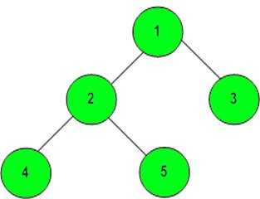

##### Input:

The first line of input contains **T**, denoting the number of testcases. Each testcase contains number of edges. The second line contains number of edges+1 data of nodes of tree separated by space.

##### Output:

For each testcase in new line, print the reverse level order traversal of tree separated by space.

##### User task:

Since this is a functional problem you don't have to worry about input, you just have to complete the function **reversePrint().**

##### Constraints:

1 <= T <= 30

1 <= Number of edges <= 3*103 1 <= Data of a node <= 3*103

##### Example: Input:

2

2

1 2 R 1 3 L

4

10 20 L 10 30 R 20 40 L 20 60 R

##### Output:

3 2 1

40 60 20 30 10

##### Explanation:

**Testcase 1:** There are total 3 nodes of tree.

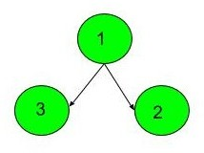

Reverse level order traversal of tree is: 3 2 1.

** https://practice.geeksforgeeks.org/problems/reverse-level-order-traversal/1

**Question 30 Queue using two Stacks**

Implement a Queue using 2 stacks **s1** and **s2** .

##### Input Format:

The first line of the input contains an integer '**T**' denoting the number of test cases. Then T test cases follow.

First line of each test case contains an integer **Q** denoting the number of queries .

A Query **Q** is of 2 Types

1. 1 x (a query of this type means pushing **'x'** into the queue)
2. 2 (a query of this type means to pop element from queue and print the poped element)

The second line of each test case contains **Q** queries seperated by space.

##### Output Format:

The output for each test case will be space separated integers having **-1** if the queue is empty else the element poped out from the queue .

You are required to complete the two methods **push** which take one argument an integer **'x'** to be pushed into the quee and **pop** which returns a integer poped out from other queue.

##### Your Task:

Since this is a function problem, you don't need to take inputs. Just complete the provided functions. The **printing** is done **automatically** by the **driver code**.

##### Constraints:

1 <= **T** <= 100

1 <= **Q** <= 100

1 <= **x** <= 100

##### Example: Input

2

5

1 2 1 3 2 1 4 2

4

1 2 2 2 1 4

##### Output

2 3

2 -1

##### Explanation: Testcase1:

1 2 the quee will be {2}

1. 3 the queue will be {2 3}
2. poped element will be 2 the queue will be {3} 1 4 the queue will be {3 4}

2 poped element will be 3

Note:The **Input/Ouput** format and **Example** given are used for system's internal purpose, and should be used by a user for **Expected Output** only. As it is a function problem, hence a user should not read any input from stdin/console. The task is to complete the function specified, and not to write the full code

** https://practice.geeksforgeeks.org/problems/queue-using-two-stacks/1

**Question 31 Reverse a Linked List in groups of given size.**

Given a linked list of size **N**. The task is to reverse every **k** nodes (where k is an input to the function) in the linked list.

##### Input:

First line of input contains number of testcases T. For each testcase, first line contains length of linked list and next line contains the linked list elements.

##### Output:

For each testcase, there will be a single line of output which contains the linked list with every k group elements reversed.

##### User Task:

The task is to complete the function **reverse**() which should reverse the linked list in group of size **k**.

##### Example:

**Input:**

1

8

1 2 2 4 5 6 7 8

4

##### Output:

4 2 2 1 8 7 6 5

##### Explanation:

**Testcase 2:** Since, **k = 4**. So, we have to reverse everty group of two elements. Modified linked list is as 4, 2, 2, 1, 8, 7, 6, 5.

** https://practice.geeksforgeeks.org/problems/reverse-a-linked-list-in-groups-of-given-size/1

**Question 32 Delete nodes greater than k**

Given a **BST** and a **value x**, the task is to delete the nodes having values **greater than or equal to x**.

##### Input Format:

The first line of input contains an integer **T** denoting the no of test cases. Then **T** test cases follow. The first line of each test case consists of an integer **N**. Then in the next line are **N** space separated **values** of the BST nodes. In the next line is an **integer x** representing the value of the node in the BST.

##### Output Format:

For each test case, in a new line, print the inorder traversal after deletions.

##### Constraints:

1 <= T <= 100

1 <= N <= 103

1 <= A[] <= 103

1 <= x <= N

##### Example:

**Input:**

2

7

20 8 22 4 12 10 14

8

7

20 8 22 4 12 10 14

10

##### Output:

4

4 8

** https://practice.geeksforgeeks.org/problems/delete-nodes-greater-than-k/1

**Question 33 ongest substring containing '1'**

Given a function that takes a binary string. The task is to return the longest size of contiguous substring containing only ‘1’.

## Input:

The first line of input contains an integer T denoting the no of test cases.Then T test cases follow. Each test case contains a string S.

## Output:

For each test case return the maximum length of required sub string.

## Constraints:

1<=T<=100

1<=|string length|<=104

## Example:

**Input:**

2

110

11101110

## Output:

2

3

** https://practice.geeksforgeeks.org/problems/longest-substring-containing-1/1

**Question 34 Convert to Roman No**

Given an integer n your task is to complete the

function **convertToRoman** which prints the corresponding roman number of n .

## Input:

The first line of each test case contains the no of test cases T. Then T test cases follow. Each test case contains a single integer n.

## Output:

Complete **convertToRoman** function and return the roman number representation of n.

## Constraints:

1<=T<=100

1<=n<5000

## Example:

**Input**

2

5

3

## Output

V III

** https://practice.geeksforgeeks.org/problems/convert-to-roman-no/1

**Question 35 Rotate by 90 degree**

Given a square **matrix[][]** of size **N x N**. The task is to rotate it by **90 degrees in an anti-clockwise** direction without using any extra space.

##### Input:

The first line of input contains a single integer **T** denoting the number of test cases. Then T test cases follow. Each test case consists of two lines. The first line of each test case consists of an integer **N**, where **N** is the size of the square matrix. The second line of each test case contains **N x N** space- separated values of the matrix.

##### Output:

Corresponding to each test case, in a new line, print the rotated array.

##### Your Task:

You only need to implement the given function **rotate()**. Do not read input, instead use the arguments given in the function.

##### Constraints:

1 ≤ T ≤ 50

1 ≤ N ≤ 50

1 <= matrix[][] <= 100

##### Example:

**Input**:

1

3

1 2 3 4 5 6 7 8 9

##### Output:

3 6 9

2 5 8

1 4 7

**\*\*** https://practice.geeksforgeeks.org/problems/rotate-by-90-degree0356/1

**Question 36 Max rectangle**

Given a binary matrix, Your task is to complete the

function **maxArea** which the maximum size rectangle area in

a binary-sub-matrix with all 1’s. The function takes 3 arguments the first argument is the Matrix M[ ] [ ] and the next two are

two integers n and m which denotes the size of the matrix M. Your function should return an integer denoting the area of the maximum rectangle .

## Input:

The first line of input is an integer T denoting the no of test cases . Then T test cases follow. The first line of each test case are 2 integers n and m denoting the size of the matrix M . Then in the next line are n*m space separated values of the matrix M.

## Output:

For each test case output will be the area of the maximum rectangle .

## Constraints:

1<=T<=50

1<=n,m<=50

0<=M[][]<=1

## Example:

**Input**

1

4 4

0 1 1 0 1 1 1 1 1 1 1 1 1 1 0 0

## Output

8

## Explanation

For the above test case the matrix will look like 0 1 1 0

1 1 1 1

1 1 1 1

1 1 0 0

the max size rectangle is 1 1 1 1

1 1 1 1

and area is 4 *2 = 8

**Note:**The **Input/Ouput** format and **Example** given are used for system's internal purpose, and should be used by a user for **Expected Output** only. As it is a function problem, hence a user should not read any input from stdin/console. The task is to complete the function specified, and not to write the full code.

** https://practice.geeksforgeeks.org/problems/max-rectangle/1

**Question 37 Alien Dictionary**

Given a sorted dictionary of an alien language having N words and k starting alphabets of standard dictionary the task is to complete the function which returns a string denoting the order of characters in the language.

**Note:** Many orders may be possible for a particular test case, thus you may return any valid order.

##### Examples:

Input: Dict[] = { "baa", "abcd", "abca", "cab", "cad" }, k = 4 Output: Function returns "bdac"

Here order of characters is 'b', 'd', 'a', 'c'

Note that words are sorted and in the given language "baa" comes before "abcd", therefore 'b' is before 'a' in output.

Similarly we can find other orders.

Input: Dict[] = { "caa", "aaa", "aab" }, k = 3 Output: Function returns "cab"

##### Input:

The first line of input contains an integer T denoting the no of test cases.

Then T test cases follow. Each test case contains an integer N and

k denoting the size of the dictionary. Then in the next line are sorted space separated values of the alien dictionary.

##### Output:

For each test case in a new line output will be 1 if the order of string returned by the function is correct else 0 denoting incorrect string returned.

##### Constraints:

1 <= T <= 200

1 <= N <= 100

1 <= k <= 26

1 <= Length of words <= 1000

##### Example:

**Input:**

2

5 4

baa abcd abca cab cad 3 3

caa aaa aab

##### Output:

1

1

**\*\*** https://practice.geeksforgeeks.org/problems/alien-dictionary/1

**Question 38 The Celebrity Problem**

You are in a party of **N** people, where only one person is known to everyone. Such a person **may be present** in the party, if yes, (s)he doesn’t know anyone in the party. Your task is to find the stranger (celebrity) in party.

You will be given a square matrix **M**[][] where if an element of row i and column j is set to 1 it means ith person knows jth person. You need to complete the function **getId()** which finds the id of the celebrity if present else return **-1**. The function **getId**() takes two arguments, the

square matrix **M** and its size **N**.

**Note:** Expected time complexity is O(N) with constant extra space.

##### Input:

The first line of input contains an element T denoting the number of test cases. Then T test cases follow. Each test case consist of 2 lines. The first line of each test case contains a number denoting the size of the matrix M. Then in the next line are space separated values of the matrix **M**.

##### Output:

For each test case output will be the id of the celebrity if present (0 based index). Else **-1** will be printed.

##### User Task:

The task is to complete the function **getId()** which returns the Id of celebrity if present, else **-1**.

##### Constraints:

1 <= T <= 50

2 <= N <= 501

0 <= M[][] <= 1

##### Example:

**Input (To be used only for expected output)** : 2

3

0 1 0 0 0 0 0 1 0

2

0 1 1 0

**Output** : 1

-1

##### Explanation :

For the above test case the matrix will look like

*0 1 0*

*0 0 0*

*0 1 0*

Here, the celebrity is the person with index 1 ie id 1

**\*\*** https://practice.geeksforgeeks.org/problems/the-celebrity-problem/1

**Question 39 Check if Linked List is Palindrome**

Given a singly linked list of size **N** of integers. The task is to check if the given linked list is palindrome or not.

##### Input:

First line of input contains number of testcases T. For each testcase, first line of input contains length of linked list N and next line contains N integers as data of linked list.

##### Output:

For each test case output will be 1 if the linked list is a palindrome else 0.

##### User Task:

The task is to complete the function **isPalindrome**() which takes head as reference as the only parameter and returns true or false if linked list is palindrome or not respectively.

##### Constraints:

1 <= T <= 103

1 <= N <= 50

##### Example(To be used only for expected output):

**Input:**

2

3

1 2 1

4

1 2 3 4

##### Output:

1

0

##### Explanation:

**Testcase 1:** 1 2 1, linked list is palindrome.

**\*\*** https://practice.geeksforgeeks.org/problems/check-if-linked-list-is-pallindrome/1

**Question 40 Find the number of islands**

A group of connected 1's forms an island. The task is to complete the method **findIslands()** which returns the **number of islands** present. The function takes three arguments the first is the boolean matrix **A** and then

the next two arguments are **N** and **M** denoting the size(N*M) of the matrix A .

##### Input:

The first line of input will be the number of testcases **T**, then T test cases follow. The first line of each testcase contains two space separated integers N and M. Then in the next line are the NxM inputs of the matrix A separated by space .

##### Output:

For each testcase in a new line, print the number of islands present.

##### User Task:

Since this is a functional problem you don't have to worry about input, you just have to complete the function **findIslands().**

##### Constraints:

1 <= T <= 100

1 <= N, M <= 50

0 <= A[i][j] <= 1

##### Example(To be used only for expected output) : Input

2

3 3

1 1 0 0 0 1 1 0 1

4 4

1 1 0 0 0 0 1 0 0 0 0 1 0 1 0 0

##### Output

2

2

##### Explanation:

**Testcase 1:** The graph will look like 1 1 0

0 0 1

1 0 1

Here, two islands will be formed

First island will be formed by elements {A[0][0] , A[0][1], A[1][2], A[2][2]} Second island will be formed by {A[2][0]}**.**

**\*\*** https://practice.geeksforgeeks.org/problems/find-the-number-of-islands/1

**Question 41 Longest Palindrome Substring**

Given a string S, find the longest palindromic substring in S. **Substring of string S:** S[ i j ] where 0 ≤ i ≤ j < len(S)**. Palindrome string:** A string

which reads the same backwards. More formally, S is palindrome if reverse(S) = S. **Incase of conflict**, return the substring which occurs first ( with the least starting index ).

**NOTE:** Required Time Complexity **O(n2). Input:**

The first line of input consists of the number of test cases. The

following **T** lines consist of a string each.

##### Output:

For every test case, print the longest palindromic substring in a new line.

##### User Task:

You don't need to read input or print anything, printing is done by the driver code, user just needs to complete **longestPalindrome()** function and return the **longest palindromic substring**.

##### Constraints:

1 ≤ T ≤ 100

1 ≤ Str Length ≤ 500

##### Example:

**Input:**

1

aaaabbaa

##### Output:

aabbaa

##### Explanation:

**Testcase 1:** The longest palindrome string present in the given string is "aabbaa".

** https://practice.geeksforgeeks.org/problems/longest-palindrome-in-a-string2235/1

**Question 42 Solve the Sudoku**

Given an incomplete Sudoku configuration in terms of a 9 x 9 2-D square matrix (mat[][]). The task to print a solved Sudoku. For simplicity you may assume that there will be only one unique solution.

##### Sample Sudoku for you to get the logic for its solution:

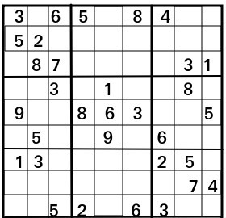

**Input:**

The first line of input contains an integer T denoting the no of test cases. Then T test cases follow. Each test case contains 9*9 space separated values of the matrix mat[][] representing an incomplete Sudoku state where a 0 represents empty block.

##### Output:

For each test case, in a new line, print the **space separated values** of the solution of the the sudoku.

##### Constraints:

1 <= T <= 10

0 <= mat[] <= 9

##### Example: Input:

1

3 0 6 5 0 8 4 0 0

5 2 0 0 0 0 0 0 0

0 8 7 0 0 0 0 3 1

0 0 3 0 1 0 0 8 0

9 0 0 8 6 3 0 0 5

0 5 0 0 9 0 6 0 0

1 3 0 0 0 0 2 5 0

0 0 0 0 0 0 0 7 4

0 0 5 2 0 6 3 0 0

##### Output:

3 1 6 5 7 8 4 9 2

5 2 9 1 3 4 7 6 8

4 8 7 6 2 9 5 3 1

2 6 3 4 1 5 9 8 7

9 7 4 8 6 3 1 2 5

8 5 1 7 9 2 6 4 3

1 3 8 9 4 7 2 5 6

6 9 2 3 5 1 8 7 4

7 4 5 2 8 6 3 1 9

##### Explanation:

**Testcase 1:** Not needed, I guess. Solved sudoku is already given in output.

**\*\*** https://practice.geeksforgeeks.org/problems/solve-the-sudoku/1

**Question 43 Interleaved Strings**

Given three strings A, B and C your task is to complete

the function **isInterleave** which returns true if C is an interleaving of A and B else returns false. C is said to be interleaving A and B, if it contains all characters of A and B and order of all characters in individual strings is preserved.

## Input:

The first line of input contains an input T denoting the no of test cases. Then T test cases follow. Each test case contains three space separated strings A, B, C.

## Output:

For each test case output will be 1 if C is interleaving of string A and B else 0.

## Constraints:

1<=T<=100

1<=length of A, B, C <=100

## Example(To be used only for expected output): Input:

2

YX X XXY XY X XXY

## Output

0

1

## Explanation:

1. For first test case XXY is not interleaving of YX and X
2. For the sec test case XXY is interleaving of XY and X.

**Note:**The **Input/Ouput** format and **Example** given are used for system's internal purpose, and should be used by a user for **Expected Output** only. As it is a function problem, hence a user

should not read any input from stdin/console. The task is to complete the function specified, and not to write the full code.

** https://practice.geeksforgeeks.org/problems/interleaved-strings/1

**Question 44 Implement Atoi**

Your task is to implement the function **atoi**. The function takes a string(str) as argument and converts it to an integer and returns it.

## Input:

The first line of input contains an integer T denoting the no of test cases . Then T test cases follow. Each test case contains a string str .

## Output:

For each test case in a new line output will be an integer denoting the converted integer, if the input string is not a numerical string then output will be -1.

## Constraints:

1<=T<=100

1<=length of (s,x)<=10

## Example(To be used only for expected output) : Input:

2

123

21a

## Output:

123

-1

**Note:**The **Input/Ouput** format and **Example** given are used for system's internal purpose, and should be used by a user for **Expected Output** only. As it is a function problem, hence a user should not read any input from stdin/console. The task is to complete the function specified, and not to write the full code.

** https://practice.geeksforgeeks.org/problems/implement-atoi/1

**Question 45 Validate an IP Address**

Write a program to Validate an IPv4 Address. According to Wikipedia, IPv4 addresses are canonically represented in dot- decimal notation, which consists of four decimal numbers, each ranging from 0 to 255, separated by dots, e.g., 172.16.254.1 . The generalized form of an IPv4 address is **(0-255).(0-255).(0-255).(0- 255).** Here we are considering numbers only from 0 to 255 and any additional leading zeroes will be considered invalid.

Your task is to complete the function **isValid** which returns 1 if the ip address is valid else returns 0. The function takes a string ip as its only argument .

## Input:

The first line of each test case contains an integer T denoting the number of test case . Then T test cases follow . Each test case takes a string ip.

## Output:

For each test case output will be 1 if the string is a valid ip address else 0.

## Constraints:

1<=T<=100

1<=length of string <=50

## Example(To be used only for expected output) : Input

4

222.111.111.111

5555..555

0000.0000.0000.0000

1.2.3.04

## Output

1

0

0

0

**Note:**The **Input/Ouput** format and **Example** given are used for system's internal purpose, and should be used by a user for **Expected Output** only. As it is a function problem, hence a user should not read any input from stdin/console. The task is to complete the function specified, and not to write the full code.

** https://practice.geeksforgeeks.org/problems/validate-an-ip-address/1

**Question 46 Multiply two strings**

Given two numbers as stings s1 and s2 your task is to multiply them. You are required to complete the function **multiplyStrings** which takes two strings s1 and s2 as its only argument and returns their product as strings.

##### Input:

The first line of input contains an integer T denoting the no of test cases. Then T test cases follow . Each test case contains two strings s1 and s2 .

##### Output:

For each test case in a new line the output will be a string denoting the product of the two strings s1 and s2.

##### Constraints:

1 <= T <= 100

1 <= length of s1 and s2 <= 103

##### Example(To be used only for expected output) :

**Input:**

2

33 2

11 23

##### Output:

66

253

**Note:**The **Input/Ouput** format and **Example** given are used for system's internal purpose, and should be used by a user for **Expected Output** only. As it is a function problem, hence a user should not read any input from stdin/console. The task is to complete the function specified, and not to write the full code.

** https://practice.geeksforgeeks.org/problems/multiply-two-strings/1

**Question 47 Word Boggle**

Given a dictionary of distinct words and a M x N board where every cell has one character. Find all possible words from the dictionary that can be formed by a sequence of adjacent characters on the board. We can move to any of 8 adjacent characters, but a word should not have multiple instances of same cell.

##### Input:

The first line of input contains an integer T denoting the number of test cases. Then T test cases follow. Each test case contains an integer x denoting the number of words in the dictionary. The next line contains x space separated strings denoting the contents of the dictinory. The next line contains two integers M and N denoting the size of the boggle. M lines follow each containing N space separated characters.

##### Output:

For each test case in a new line print the space separated sorted distinct words of the dictionary which could be formed from the boggle. If no word can be formed print -1.

##### Your Task:

Complete the function **boggle** that takes MxN board and dictionary as input and returns a list of words that exist in the board.

##### Constraints:

1 <= T <= 100

1 <= X <= 10

1 <= M,N <= 10

##### Example:

**Input:**

1

4

GEEKS FOR QUIZ GO 3 3

G I Z U E K Q S E

##### Output:

GEEKS QUIZ

**\*\*** https://practice.geeksforgeeks.org/problems/word-boggle4143/1

**Question 48 Longest Palindromic Substring in Linear Time**

Given a string, find the longest substring which is palindrome in Linear time O(N).

##### Input:

The first line of input contains an integer T denoting the no of test cases . Then T test cases follow. The only line of each test case contains a string.

##### Output:

For each test case print the Longest Palindromic Substring.

##### Constraints:

1 <= T <= 100

1 <= N <= 50

##### Example:

**Input:**

2

babcbabcbaccba forgeeksskeegfor

##### Output:

abcbabcba geeksskeeg

**Note:**The **Input/Ouput** format and **Example** given are used for system's internal purpose, and should be used by a user for **Expected Output** only. As it is a function problem, hence a user should not read any input from stdin/console. The task is to complete the function specified, and not to write the full code

** https://practice.geeksforgeeks.org/problems/longest-palindromic-substring-in-linear-time/1

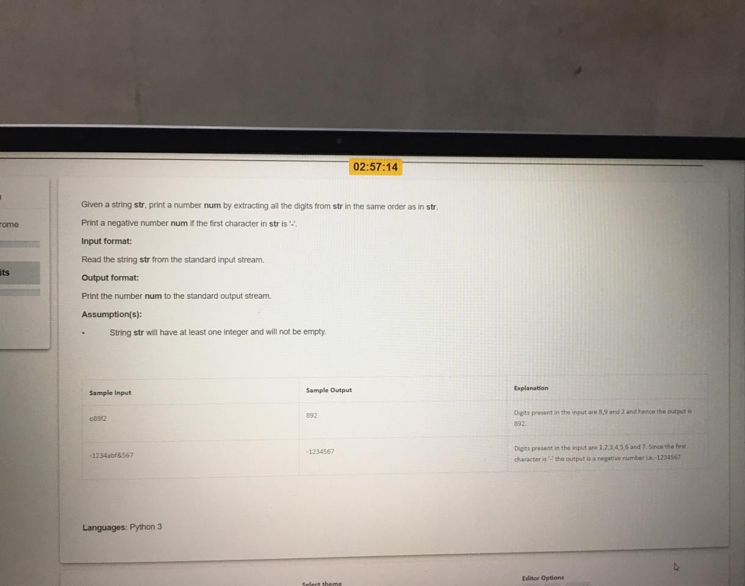

**Question 49**

**Question 50**

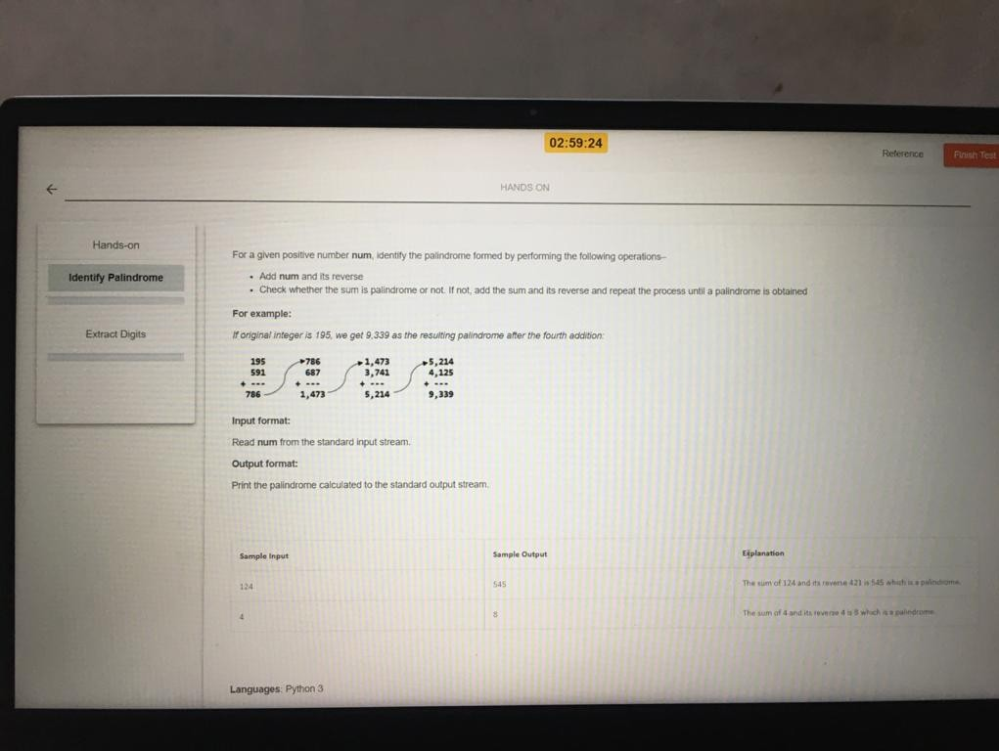

Question 51

# Reverse words in a given string

Given a String of length **S**, reverse the whole string without reversing the individual words in it. Words are separated by **dots**.

##### Input:

The first line contains **T** denoting the number of testcases. T testcases follow. Each case contains a string S containing characters.

##### Output:

For each test case, in a new line, output a single line containing the reversed String.

##### User Task:

The task is to complete the function **reverseWords**() which reverse words from the given string and prints the answer. The **newline** is automatically appended by the **driver code**.

##### Constraints:

1 <= T <= 100

1 <= |S| <= 2000

##### Example:

**Input:**

2

i.like.this.program.very.much pqr.mno

##### Output:

much.very.program.this.like.i mno.pqr

##### Explanation:

**Testcase 1:** After reversing the whole string(not individual words), the input string becomes much.very.program.this.like.i.

** https://practice.geeksforgeeks.org/problems/reverse-words-in-a-given-string5459/1

Question 52 :- **Merge Sort for Linked List**

Given Pointer/Reference to the head of the linked list, the task is to **Sort the given linked list using Merge Sort**.

**Note:** If the length of linked list is odd, then the extra node should go in the first list while splitting.

##### Input:

First line of input contains number of testcases T. For each testcase, first line of input contains number of nodes in the linked list and next line contains N elements of the linked list.

##### Output:

For each test, in a new line, print the sorted linked list.

##### Your Task:

**For C++ and Python:** The task is to complete the function **mergeSort**() which sort the linked list using merge sort function.

**For Java:** The task is to complete the function **mergeSort**() and return the node which can be used to print the sorted linked list.

##### Constraints:

1 <= T <= 100

1 <= N <= 105

##### Example:

**Input:**

2

5

3 5 2 4 1

3

9 15 0

##### Ouput:

1 2 3 4 5

0 9 15

##### Explanation:

**Testcase 1:** After sorting the given linked list, the resultant matrix will be 1-

>2->3->4->5.

** https://practice.geeksforgeeks.org/problems/sort-a-linked-list/1

Question 53 **Square root**

Given an integer **x**. The task is to find the square root of x. If **x** is not a perfect square, then return floor(√x).

##### Input Format:

First line of input contains number of testcases T. For each testcase, the only line contains the number x.

##### Output Format:

For each testcase, print square root of given integer.

##### User Task:

The task is to complete the function **floorSqrt**() which should return the square root of given number x.

##### Constraints:

1 ≤ T ≤ 1000

1 ≤ x ≤ 107

##### Example:

**Input**:

2

5

4

##### Output:

2

2

##### Explanation:

**Testcase 1:** Since, 5 is not perfect square, so floor of square_root of 5 is 2.

**Testcase 2:** Since, 4 is a perfect square, so its square root is 2.

** https://practice.geeksforgeeks.org/problems/square-root/1

Question 54

# Replace all 0's with 5

You are given an integer n. You need to convert all zeroes of n to 5.

##### Input Format:

The first line of input contains an integer **T** denoting the number of test cases . Then **T** test cases follow . Each test case contains a single integer **n** denoting the number.

##### Output Format:

The output of the function will be an integer where all zero's are converted to 5 .

##### Your Task:

Your task is to complete the function **convertFive** which takes an integer n as argument and replaces all zeros in the number **n with 5** .Your function should return the converted number .

##### Constraints:

1 <= T < 100

1 <= n <= 10000

##### Example:

**Input**

2

1004

121

##### Ouput

1554

121

**Note:**The **Input/Ouput** format and **Example** given are used for system's internal purpose, and should be used by a user for **Expected Output** only. As it is a function problem, hence a user should not read any input from stdin/console. The task is to complete the function specified, and not to write the full code.

** https://practice.geeksforgeeks.org/problems/replace-all-0s-with-5/1

Question 55

# Binary String

Given a binary string **S**. The task is to count the number of substrings that start and end with 1. For example, if the input string is “00100101”, then there are three substrings “1001”, “100101” and “101”.

##### Input:

The first line of input contains an integer T denoting the number of test cases. Each test case consist of an integer 'N' denoting the string length and next line is followed by a binary string.

##### Output:

For each testcase, in a new line, print the number of substring starting and ending with 1 in a separate line.

##### User Task:

The task is to complete the function **binarySubstring**() which counts the number of substrings starting and ending with 1 and returns count.

##### Constraints:

1 ≤ T ≤ 100

1 ≤ |S| ≤ 104

##### Example:

**Input:**

2

4

1111

5

01101

##### Output:

6

3

##### Example:

**Testcase 1:** There are 6 substrings from the given string. They are 11, 11, 11, 111, 111, 1111.

**Testcase 2:** There 3 substrings from the given string. They are 11, 101,

1101.

** https://practice.geeksforgeeks.org/problems/binary-string/1

Question 56

# Match specific pattern

Given a dictionary of words and a pattern. Every character in the pattern is uniquely mapped to a character in the dictionary. The task is to complete a function **findMatchedWords(dict,pattern)** that returns a vector of strings matching with given pattern. The function takes two argument the first argument is an array of strings **dict** which denote the dictionary and the second argument is the **pattern** to match.

##### Input:

The first line of input contains an integer **T** denoting the number of test cases. Each testcase contains 3 lines. The first line contains an integer **N** denoting the number of strings in the dictionary,second line

N space separated strings denoting the strings of the dictionary. The third line contains pattern.

##### Output:

The output for each test case will be the space separated strings that matches the given pattern in lexicographical order.

##### User Task:

Since this is a functional problem you don't have to worry about input, you just have to complete the function **findMatchedWords()**

##### Constraints:

1 <= T <= 100

1 <= N <= 10

##### Input

1

4

abb abc xyz xyy foo

##### Output

abb xyy

##### Explanation

**Testcase 1**: In the above test case xyy and abb have same character at index 1 and 2 like the pattern.

** https://practice.geeksforgeeks.org/problems/match-specific-pattern/1



**Test-II**

**Question #1**

Neelam wants to share her code with a colleague, who may modify it. Thus she wants to include

the date of the program creation, the author and other she wants to include the date of the program creation, the author and other information with the program. What component should she use?

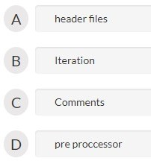

Ans D

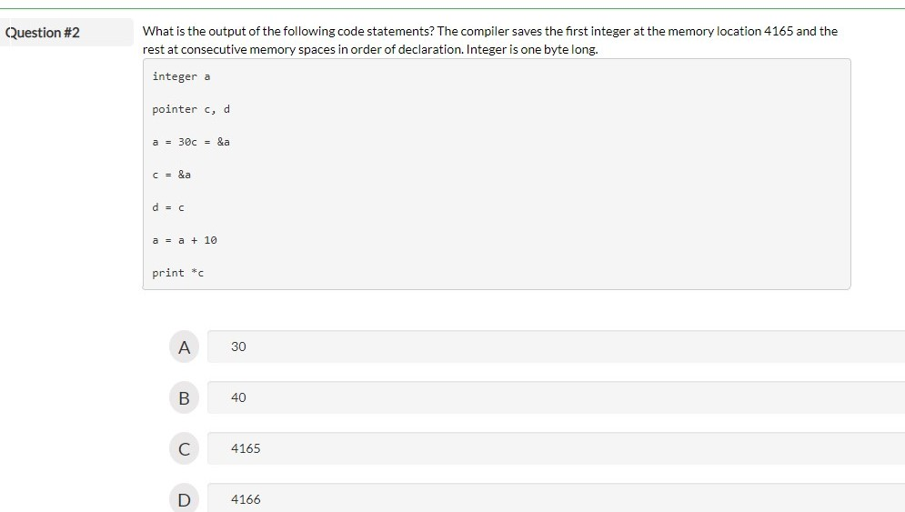

#### Ans B

**Question #3**

A data type is stored as a 6 bit signed integer. Which of the following cannot be represented by

this data type?

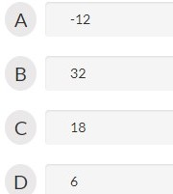

#### Ans B

**Question #4**

A language has 28 different letters in total. Each word in the language iscomposed of maximum 7

letters. You want to create a data-type to store a word ofthis language. You decide to store the word as an array of letters. How many bits will you assign to the data-type to be able to store all kinds of words of the language.

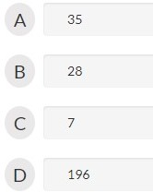

#### Ans A

**Question #5**

A 10-bit unsigned integer has the following range:

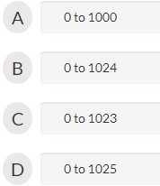

#### Ans C

**Question #6**

Parul takes as input two numbers: a and b. a and b can take integer valuesbetween 0 and 255.

She stores a, b and c as 1-byte data type. She writes the following code statement to process a and b and put the result in c.

c = a + 2*b

To her surprise her program gives the right output with some input values of a and b, while gives an erroneous answer for others. For which of the following inputs will it give a wrong answer?

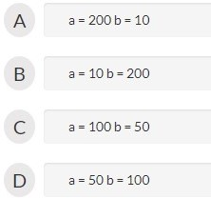

#### Ans B

**Question #7**

Which is used to convert source code to target language

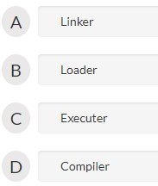

#### Ans D

**Question #8**

Tricha wants to store a list of binary data.Which of following data types should she use?

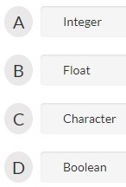

#### Ans D

**Question #9**

Which of the following options is an exception to being a part of composite data types?

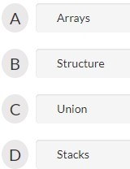

#### Ans D

**Question #10**

Which data type is most suitable for storing a number 65000 in a 32-bit system?

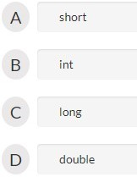

#### Ans A



Test III

**Question #1**

What is the difference between a function and a method?

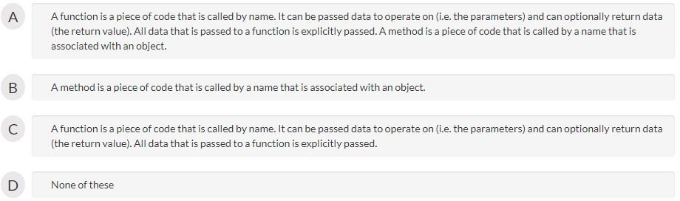

#### Ans A

**Question #2**

Consider the following code:

function modify(a,b)

{

integer c, d = 2 c = a*d + b return c

}

function calculate( )

{

integer a = 5, b = 20, c integer d = 10

c = modify(a, b); c = c + d

print c

}

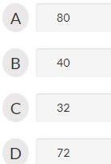

#### Ans B

**Question #3**

What is the term given to the variable whose scope is beyond all the scopes i.e., it can be

accessed by all the scopes?

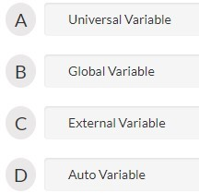

#### Ans B

**Question #4**

Anu wants to make a function that is not bound to any identifier. Which of the following

functions should she incorporate in her program?

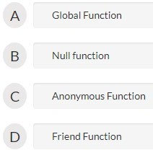

#### Ans C

**Question #5**

Which of the following accessibility modes can be the speciﬁer of a top level class’?Top-level classes can only have public, abstract, and final modifiers, and it is also possible to not define any class modifiers at all. This is called default/package accessibility. Besides that, private, protected, and static modifiers cannot be used when declaring top-level classes.

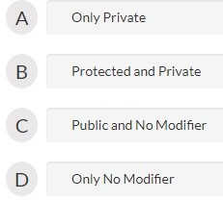

#### Ans C

**Question #6**

Choose the correct answer. A pseudo-code which is similar to that of C++ and self-explanatory

An accessible member function or data member for an object are accessed by the statement objectname.functionname or objectname. data member name respectively.

class brush

{

Private:

integer size, colorcode

function getdata( ) {--}//Statement 1 public:

integer name // Statement 2 function putdata(){...}

}

function main

{

brush b1, b2

print bl.name //Statement 3 b2.getdata() //Statement 4

}

Deleting which line will correct the error in the code?

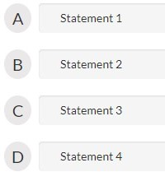

#### Ans D

**Question #7**

function MyDisplay(string MyStr) //statement 1

{

print "Hello !" print MyStr

return 1 // statement 2

}

function main() //statement 3

{

string str= "Mickey" MyDisplay(str) // statement 4

}

Which statement will generate an error.

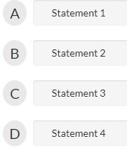

#### Ans B

**Question #8**

Choose the correct answer

Tanuj writes the code for a function that takes as input n and calculates the sum of first n natural numbers.

Function sum( n )

{

if(??)

return 1 else

return (n + sum(n-1)) end

}

Fill in ?? in the code.

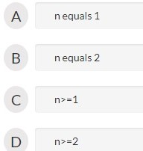

#### Ans A

**Question #9**

Choose the correct answer

Shrishti writes the code for a function that computes the factorial of the inputted number n.

function factorial(n)

{

if(n equals 1)

return 1 else

— MISSING STATEMENT —

end

}

Fill in the missing statement.

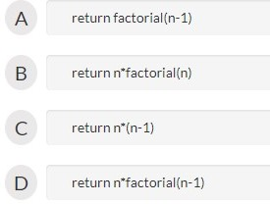

#### Ans D

**Question #10**

What is the output of this C code?

#include <stdio.h> int main() {

int y = 10000; int y = 34;

printf(“Hello World! %d\n”,y); return 0;

}

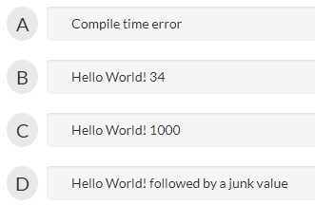

#### Ans A



Test IV

**Question #1**

function main() { integer a=5,b=7 switch(a) { case 5 :print "I am 5" break case b:print "I am not 5"

break default:print "I am different" } }

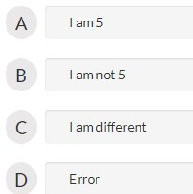

#### Ans D

**Question #2**

Ashima wants to print a pattern which includes checking and changing a variables value

iteratively She decides to use a loop/condition Which of the following options should she use such that the body of the loop/condition is executed atleast once whether the variable satisfies the entering condition or not?

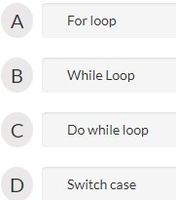

#### Ans C

**Question #3**

The construct “if (condition) then A else B” is for which of the following purposes?

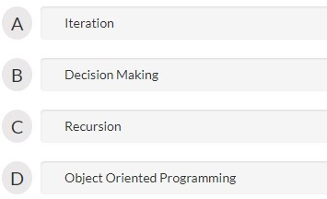

#### Ans B

**Question #4**

Ravi and Rupali are asked to write a program to sum the rows of 2X2 matrices stored in the array

A.

Ravi writes the following code (Code A):

for n = 0 to 1

sumRow1[n] = A[n][1] + A[n][2] end

Rupali writes the following code (Code B):

sumRow1[0] = A[0][1] + A[0][2]

sumRow1[1] = A[1][1] + A[1][2]

Comment upon these codes (Assume no loop unrolling done by compiler):

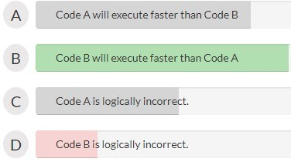

#### Ans B

**Question #5**

Integer a =40, b =35, c=20, d =10

Comment about the output of the following two statements •

Print a*b/c-d

Print a*b/(c-d)

Comment about the output of the following two statements

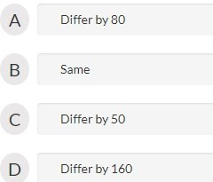

#### Ans A

**Question #6**

What is the output of the following pseudo code?

Int a =456,b,c,d=10; b=a/d;

c=a-b; print c;

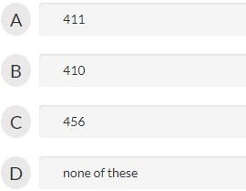

#### Ans A

**Question #7**

Function main()

{

Integer i=0.7 Static float m=0.7 If(m equals i)

Print(“We are equal”) Else If(m>i)

Print(“I am greater”) Else

Print(“I am lesser”)

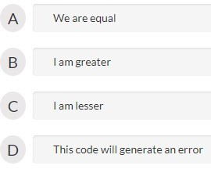

#### Ans D

**Question #8**

Recursion is a method in which the solution of a problem depends on _

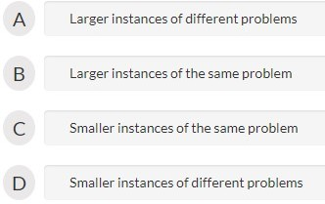

#### Ans C

**Question #9**

Which of the following problems can be solved using recursion?

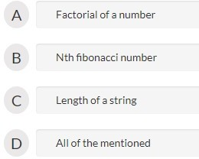

#### Ans D

**Question #10**

Recursion is similar to which of the following?

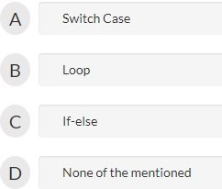

#### Ans B



Test V

**Question #1**

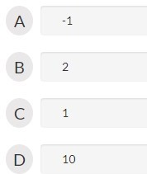

**The value of EOF is**

#### Ans A

**Question #2**

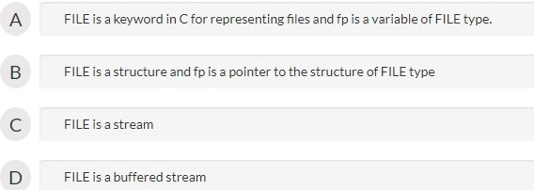

**Which of the following true about FILE *fp**

#### Ans B

**Question #3**

**The first and second arguments of fopen are**

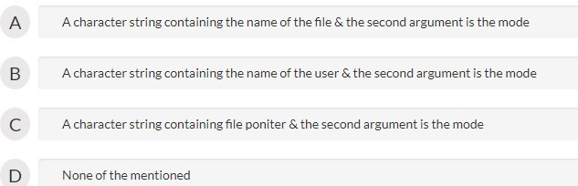

#### Ans A

**Question #4**

**If there is any error while opening a file, fopen will return**

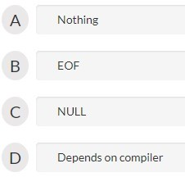

#### Ans C

**Question #5**

**fseek() should be preferred over rewind() mainly because**

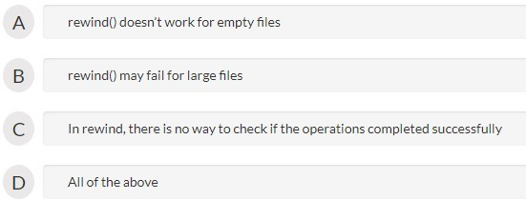

#### Ans C

**Question #6**

**FILE is of type**

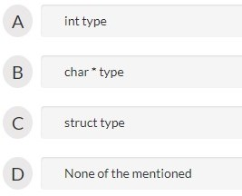

#### Ans C

**Question #7**

**FILE reserved word is**

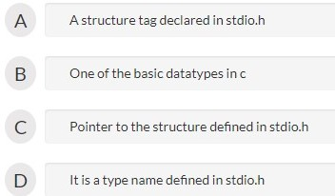

**Question #8**

**getc() returns EOF when**

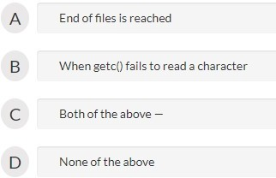

#### Ans C

**Question #9**

**Which of the following functions from “stdio.h” can be used in place of printf()?**

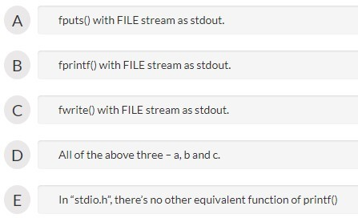

#### Ans B

**Question #10**

**fputs adds newline character**

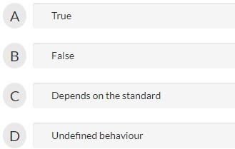

#### Ans B



Test VI

**Question #1**

An array is also known as _

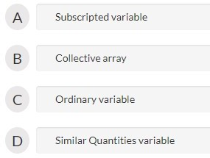

#### Ans A

**Question #2**

**Till the array elements are not given any specific value, they are supposed to contain all**

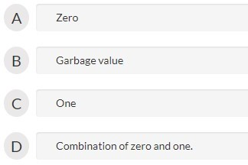

#### Ans B

**Question #3**

If array is initialized where it is declared, then mentioning of array is optional.

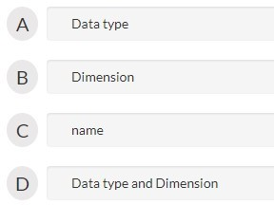

#### Ans B

**Question #4**

What happen if we assign a value to an array element whose subscript exceeds the size of array.

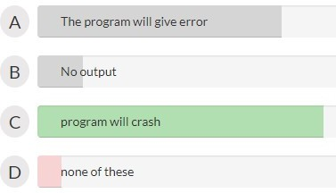

#### Ans C

**Question #5**

What will be output of the following program int main() { int b[4]={5,1,3,2,4}; int

k,l,m; k=++b[1]; l=b[1]++; m=b[k++]; printf(“%d, %d, %d”,k,l,m); return 0; }

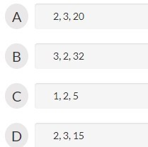

#### Ans B

**Question #6**

What will be output of the following program where c=65474 and int=2 bytes. int main() { int

c[3][4]={2,3,1,6,4,1,6,2,2,7,1,10}; printf(“%u, %u\n”, c+1, &c+1); return 0; }

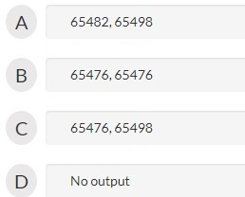

#### Ans A

**Question #7**

What will be output of the following program int main() { int

a[5],i=0; while(i<5) a[i]=++i; for(i=0;i<5;i++) printf(“%d,”,a[i]); }

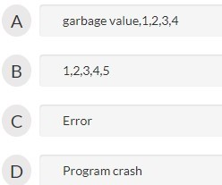

#### Ans A

**Question #8**

What will be output of the following program int main() { float a[]={12.4, 2.3, 4.5,

* 1. }; printf(“%d, %d”, sizeof(a), sizeof(a[0])); return 0; }

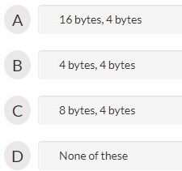

#### Ans A

**Question #9**

Which one of this is equivalent to

int fun(int arr[])

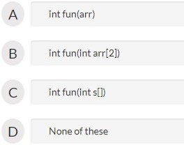

#### Ans C

**Question #10**

In 2 Dimensional Array, it is necessary to mention dimension.

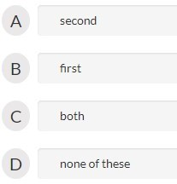

#### Ans A



Test VII

**Question #1**

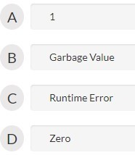

**What is the output of this C code?**

#include <stdio.h> void main()

{

static int i; printf(“i is %d”, i);

}

#### Ans D

**Question #2**

**What is the output of this C code?**

#include <stdio.h> int *i;

int main()

{

if (i == NULL)

printf(“true\n”); return 0;

}

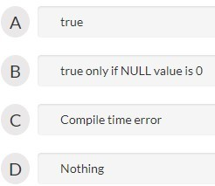

#### Ans A

**Question #3**

**What is the output of this C code?**

#include <stdio.h> static int i; void main()

{

int i;

printf(“i is %d”, i);

}

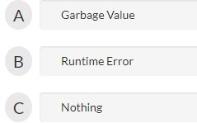

#### Ans A

**Question #4**

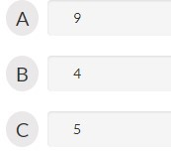

**What is the output of this C code?**

#include <stdio.h> static int x = 5; void main()

{

x = 9;

{

int x = 4;

}

printf(“%d”, x);

}

#### Ans A

**Question #5**

**The scope of an automatic variable is:**

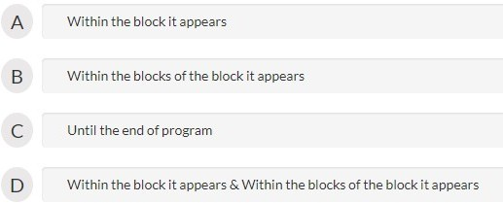

#### Ans D

**Question #6**

**Automatic variables are allocated space in the form of a:**

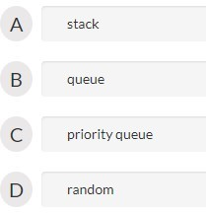

#### Ans A

**Question #7**

**Which of the following is a storage specifier?**

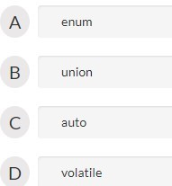

#### Ans C

**Question #8**

**Automatic variables are stored in**

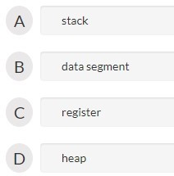

#### Ans A

**Question #9**

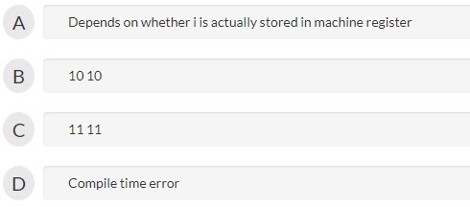

**What is the output of this C code?**

#include <stdio.h> int main()

{

register int i = 10; int *q = &i;

*q = 11;

printf(“%d %d\n”, i, *q);

}

#### Ans D

**Register storage class can be specified to global variables**

**Question #10**

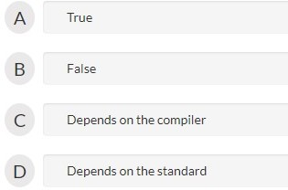



#### Test VIII

**Question #1**

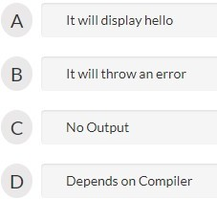

**The output of the code below is**

#include <stdio.h> void main()

{

int a = 5; if (true);

printf(“hello”);

}

#### Ans B

**Question #2**

**The output of the code below is**

#include <stdio.h>

void main()

{

int a = 0; if (a == 0)

printf(“hi”); else

printf(“how are u”); printf(“hello”);

}

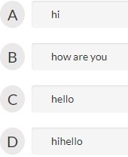

#### Ans D

**Question #3**

**The following code ‘for(;;)’ represents an infinite loop. It can be terminated by.**

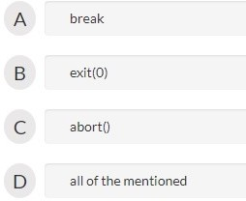

#### Ans A

**The correct syntax for running two variable for loop simultaneously is.**

**Question #4**

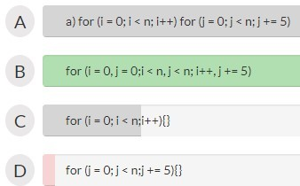

Ans B

**Question #5**

**Which for loop has range of similar indexes of ‘i’ used in for (i = 0;i < n; i++)?**

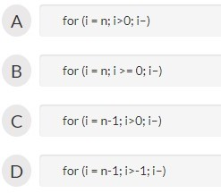

Ans D

**Question #6**

**The output of this C code is?**

#include <stdio.h> void main()

{

int x = 0;

for (x < 3; x++)

printf(“Hello”);

}

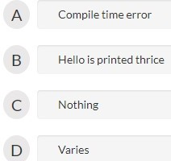

Ans A

**Question #7**

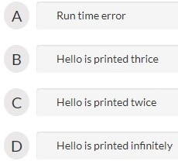

**The output of this C code is?**

#include <stdio.h> void main()

{

double x = 0;

for (x = 0.0; x < 3.0; x++) printf(“Hello”);

}

Ans B

**Question #8**

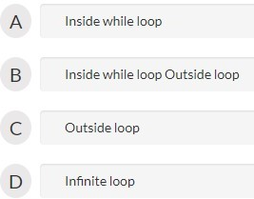

**The output of this C code is?**

#include <stdio.h> int main()

{

do

printf(“Inside while loop “); while (0);

printf(“Outside loop\n”);

}

Ans B

**Question #9**

**The output of this C code is?**

#include <stdio.h> int main()

{

int i = 0; do {

i++;

printf(“Inside while loop\n”);

} while (i < 3);

}

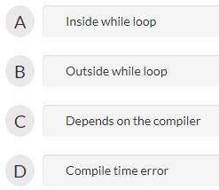

Ans A

**Question #10**

Which of the following can not be used as LHS of the expression for (exp1 ;exp2 ; exp3)?

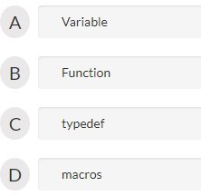

Ans D



#### Test IX

**Question #1**

**Which of the following syntax is correct for command-line arguments?**

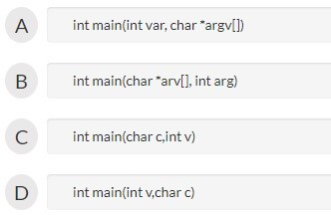

#### Ans A

**Question #2**

**What does argv and argc indicate in int main(int argc, char *argv[]) ?**

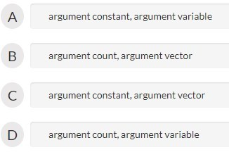

#### Ans B

**Question #3**

**What type of array is generally generated in Command-line argument?**

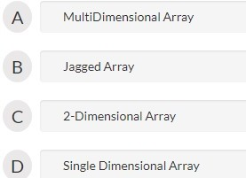

#### Ans B

**Question #4**

**The maximum length of the command-line arguments including the spaces is**

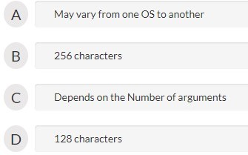

#### Ans A

**Question #5**

**The index of the last argument in command line arguments is**

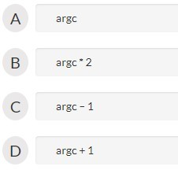

#### Ans C

**Question #6**

**What is the first argument of command line ?**

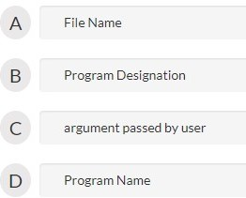

#### Ans A

**Question #7**

**What argv means in command line argument?**

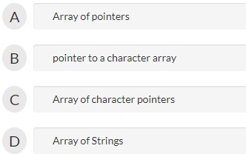

#### Ans C

**Question #8**

**What will be the output of the following program if argument passed to command lin es are : prog 1 4 2**

**#include<stdio.h>**

**int main(int argc, char *argv[])**

**{**

**int j;**

**j = argv[1] + argv[2] – argv[3];**

**printf(“%d”, j);**

**return 0;**

**}**

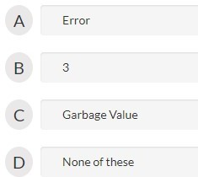

#### Ans A

**Question #9**

**What argv[0] and argv[1] denote in Command line Arguments ?**

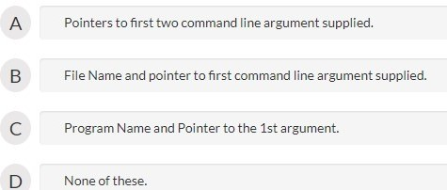

#### Ans B

**Question #10**

**Which one of these is equivalent to argc ?**

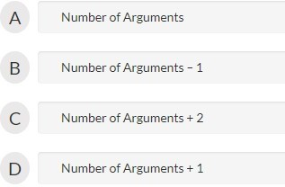

#### Ans D



Test X

**Question #1**

Which one of the following connects the high-speed high-bandwidth device to memory

subsystem and CPU.

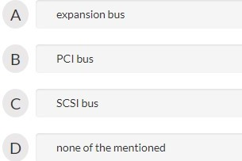

Ans A

**Question #2**

The present a uniform device-access interface to the I/O subsystem, much as system

calls provide a standard interface between the application and the operating system.

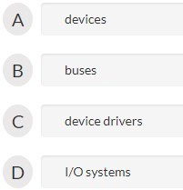

Ans C

**Question #3**

When device A has a cable that plugs into device B, and device B has a cable that plugs into device C and device C plugs into a port on the computer, this arrangement is called a .

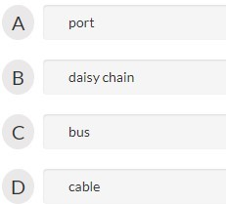

Ans B

**Question #4**

The determines the cause of the interrupt, performs the necessary processing and

executes a return from the interrupt instruction to return the CPU to the execution state prior to the interrupt.

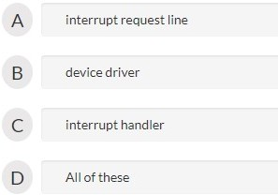

Ans C

**Question #5**

The register is read by the host to get input.

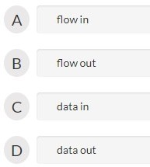

Ans C

**Question #6**

The register is written by the host to send output.

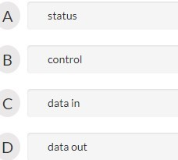

Ans D

**Question #7**

The CPU hardware has a wire called that the CPU senses after executing every

instruction.

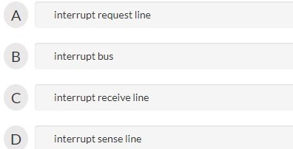

Ans A

**Question #8**

The are reserved for events such as unrecoverable memory errors.

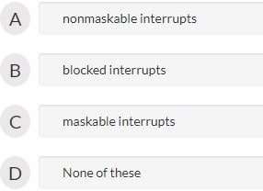

Ans A

**Question #9**

The hardware mechanism that allows a device to notify the CPU is called .

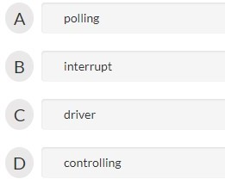

Ans B

**Question #10**

Spooling :

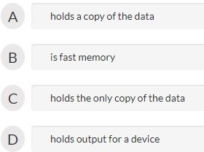

Ans C



#### Test XI

**Question #1**

**Ques. 1 Which is the character array used to accept command line arguments?**

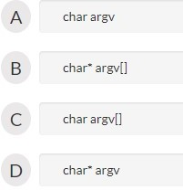

**Ans B**

**Question #2**

**What is a dangling pointer?**

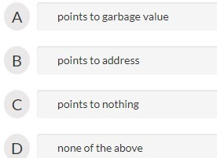

**Ans A**

**Question #3**

**Which is not a string function?**

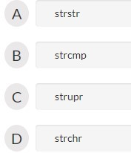

**Ans C**

**Question #4**

**Which of the following does not require to include math.h header file?**

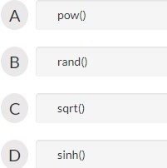

**Ans B**

**Question #5**

**What is the task of pre-processor?**

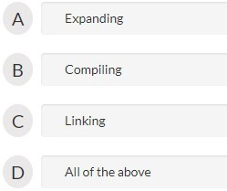

**Ans A**

**Question #6**

**Which of the following is true?**

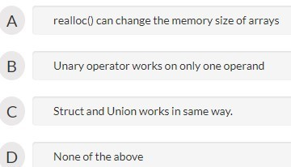

**Ans B**

**Question #7**

**Which of this is used to skip one iteration:**

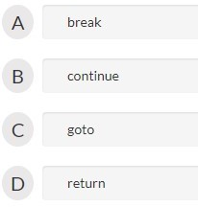

**Ans B**

**Question #8**

**Which address does a pointer to an array store:**

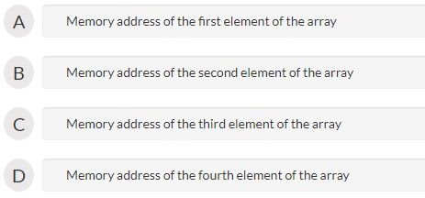

**Ans A**

**Question #9**

**Predict the output:**

*float a = 0.1; if(a==0.1) printf(“Yes”); else*

*printf(“No”)*

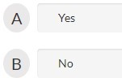

**Ans B**

**Question #10**

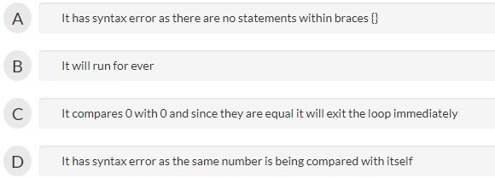

**Another output based question which basically displayed the input string in revers e pattern.**

For example, ABRACADABRA was displayed as **ARBADACARBA.**

Comment on the below while statement

while(0 == 0) { }

**Ans B**



#### Test XII

**Question #1**

**The function obtains block of memory dynamically.**

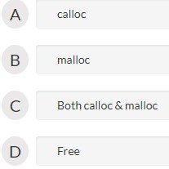

**Ans C**

**Question #2**

**For a typical program, the input is taken using**

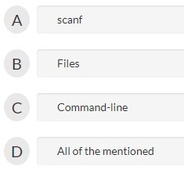

**Ans D**

**Question #3**

What is the default return-type of getchar()?

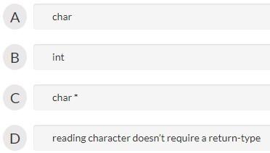

**Ans B**

**Question #4**

**Memory allocation using malloc() is done in?**

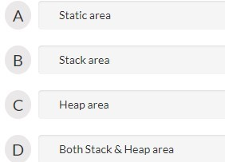

**Ans C**

**Question #5**

**What is the sizeof(char) in a 32-bit C compiler?**

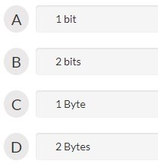

**Ans C**

**Question #6**

**What type of value does sizeof return?**

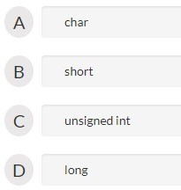

**Probably ans A**

**Question #7**

**Which one is used during memory deallocation in C?**

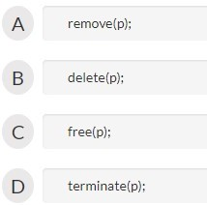

**Ans C**

**Question #8**

**What is the output of this C code?**

#include <stdio.h> void main()

{

int x = 97;

int y = sizeof(x++); printf(“x is %d”, x);

}

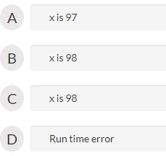

**Ans A**

**Question #9**

What is the output of:

#include int main()

{

int x=40;

{

int x=20; printf("%d",x);

}

printf("%d",x); return 0;

}

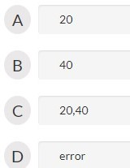

**Ans C**

**Question #10**

Predict the output of following code:

main()

{

int a=2000;

printf(“%2d”,a); //format specification

}

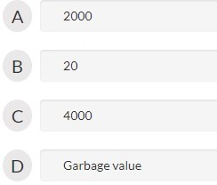

**Ans A**



#### Test 13

**Question 1**

The word democracy is ……. from a conjunction of two Greek words “demos” meaning people and “kasha” which means rule. Thus democracy is when people choose to rule themselves or in the words of Abraham Lincoln, “government by the people, of the people, for the people”. Obviously everyone in the country cannot possible take part in the government so the people elect those by whom they want to be governed. What is criticism? Any opinion against the scheme is criticism. Criticism can be of two

types – constructive and destructive. The purpose of criticism is to improve the

present for the good of all. This is a positive approach. Destructive criticism is usually criticism for the sake of criticism. It is a negative approach which is disconcerting at the individual level and destructive in general. Constructive criticism is a must for all democracies. It encourages …… participation in the government, which is the hallmark of any democracy. Moreover, it the politicians to accept responsibility for their

actions and gauge the public response. It is a system of feedback by which the public pulse can be felt. When these forms are alive and active we may say democracy …….. .

A.

1. taken
2. derived
3. found

**Correct Option: 2**

B.

1. existent
2. living
3. existents

**Correct Option: 1**

C.

1. effective
2. constructive
3. Both 1 and 2

**Correct Option: 3**

D.

1. peoples
2. local
3. public

**Correct Option: 3**

E.

1. compels
2. dissuade
3. oblige

**Correct Option: 1**

F.

1. cease
2. wither
3. thrives

**Correct Option: 3**

**Question 2**

The phrase ‘Time is money’ is very commonly used now a days and is very true when seen in the present scenarios and the current state of the society and the market as a general example. The economic shifts in terms of up’s and down’s are seen very ……..

every day. The economic shift and the stock market value increase and decrease are now seen to be seen basically dependent on the functionalities and the various working …….

of the people associated with the company. Where every employee contributes a huge sum towards the development of the company and this helps in the understanding of the fact that every single moment the employee works in the company contributes if not a large sum but at least a little sum for the development of the company and thus contributing a sum and thus can be said that every moment contributes a sum and thus the term -time is money. Apart from this example various other more commonly ……..

examples too can be given where it can be said that every single moment of hard work if not presently but definitely pays in the long run and thus every moment is and thus

the term money is a measure of time or a penny saved is a penny earned is very …… with the father of all these terms that is ‘time is money’.

A.

1. mildly
2. trivially
3. drastically

**Correct Option: 3**

B.

1. lack
2. prowess
3. cowardice

**Correct Option: 2**

C.

1. affiliated
2. detached
3. avoided

**Correct Option: 1**

D.

1. impaired
2. adored
3. precious

**Correct Option: 3**

E.

1. inapt
2. apropos
3. stupid

**Correct Option: 2**

**Question 3**

Perhaps, the most fundamental question which divides sociologists is the ….. sociology as a science. The founding fathers of sociology took it for granted that sociology a science. Comte, the father of sociology, called sociology as the “queen of sciences”. Since then many sociologists has come to view sociology in terms of natural sciences. But however there have been differences of opinion regarding the scientific nature of sociology. There is lot of …… about the nature of sociology as a science. There are two schools thought or group regarding the nature of sociology as a science; some ……..

claim that sociology is a science in its own rights. It is as much a science like other social sciences such History, Economics, Political science etc. Others deny its scientific status. Before forming an opinion on this subject, let us enquiry into what constitutes “Science”. A science is “a branch of knowledge or study dealing with a body of facts truths systematically arranged and showing the operation of general laws. It facts and links

them together in their causal sequence with a view to draw valid inferences. Scientific knowledge is based on reason and According to William Estlinger, what

distinguishes a science is that “it is exclusive and methodically based on reason”. Experimentation and prediction are not its requirement it only signifies the instance of systematic methods of enquiry. According to Huxley a science is a systematic body of knowledge based on reason and evidences.

A.

1. lowliness
2. status
3. tag

**Correct Option: 2**

B.

1. concurrence
2. controversy
3. forbearance

**Correct Option: 2**

C.

1. amateur
2. complementary
3. reviewer

**Correct Option: 3**

D

1. brings
2. distributes
3. collects

**Correct Option: 3**

E.

1. concealment
2. evidences
3. disproof

**Correct Option: 2**

F.

1. enquiry
2. inquiry
3. None

**Correct Option: 1**

**Question 4**

In order to prevent the spread of microbial diseases, we must take steps to check the growth of disease-causing micro-organisms and to prevent the microbial carriers like houseflies, mosquitoes and cockroaches from For this, we must follow some

guidelines. Eating a balanced diet: A balanced diet increases the of our body against

diseases. Proper storage of food and water: We must store food and water in closed containers to protect them from micro-organisms and insects. Maintaining

personal We must keep ourselves clean to prevent micro-organisms from

entering our body. Vaccination: Diseases like T.B. (tuberculosis), measles, polio, chicken pox, typhoid, whooping cough and tetanus can be prevented by vaccinating children against them. Maintaining clean environment: Keeping our home and neighbourhood clean prevents the growth of both micro-organisms and their carriers. Proper disposal of wastes: Proper disposal of human and domestic waste prevents the contamination

of water which would otherwise cause many diseases like cholera, jaundice,

diarrhoea, etc. A.

1. breeding
2. flying
3. raising

**Correct Option: 1**

B.

1. compliance
2. resistance
3. assistance

**Correct Option: 2**

C.

1. foulness
2. hygiene
3. solitariness

**Correct Option: 2**

D.

1. waste
2. excreta
3. excretion

**Correct Option: 2**

E.

1. water-borne
2. water-born
3. water-bourn

**Correct Option: 1**

**Question 5**

In less than a century, the British occupied a large part of India. The reason for the success of the British can be explained by a number of factors. The Indian states lacked unity. Powerful states such as Punjab, Mysore and the Marathas ……… to act unitedly against a common foreign All of them fell prey to the British policy of ‘Divide and

Rule’. The British, on the other hand, were a united lot and under a unified command. The Indian rulers failed to create a stable social, political and economic order. Most of them were short-sighted in the of their goals. They failed to win the loyalty of their

subjects. The badly-trained and poorly-paid Indian armies were no match for the ……..

and well-trained British forces. The Indians were technologically backward whereas, the British had developed new techniques of The British were strong at sea. None of

the Indian states had a strong navy. By the middle of the nineteenth century AD, the British had firmly established their position in India. A large part of the country was under direct British rule. The areas that remained independent were indirectly under British influence. India was subjugated politically as well as economically. The economic exploitation of India was a result of its political subjugation.

A.

1. ascended
2. failed
3. lost

**Correct Option: 2**

B.

1. army
2. enemy
3. associate

**Correct Option: 2**

C.

1. trail
2. retreat
3. pursuit

**Correct Option: 3**

D.

1. disciplined
2. imprecise
3. unmethodical

**Correct Option: 1**

E.

1. ceasefire
2. truce
3. warfare

**Correct Option: 3**

F.

1. thrall
2. subjugation
3. retreat

**Correct Option: 2**

Most asked Questions

*TCS Cloze Test Most asked questions*

**Question 1**

As opposed to the idea of ‘counter’ salesmanship, ……. salesmanship is outdoor salesmanship. It is the kind of salesmanship under which the salesman moves from his head branch office to the customers of a particular area which is generally called as sales which is assigned to him. Traveling salesmanship is basically a creative

salesmanship than competitive as he is to hunt the customers meet them, sell his ideas and clinch an order. His work is …… type as he cuts new ice and he educates the customers and converts prospects into customers. He the seeds to harvest the rich

profits in due course of time. The life of a traveling salesman is not easy and cosy; instead it is really hard as he has to be always away from his family and his associates. He is always on the move staying at different places in the entire sales territory where he faces the basic problems of food and drinking water that has impact on his health both physical and mental. Because of this arduous work, his remuneration is so much higher for the sacrifices he makes for the company he works. This job is challenging, thrilling and rewarding. This type of salesmanship is more suitable to those who are interested in meeting new people, new places, learning new languages, and generating the committed class of customers by of hard work and taint of impressive presentation

and palatable persuasion. A.

1. moving
2. walking
3. travelling

**Correct Option: 3**

B.

1. office
2. territory
3. branch

**Correct Option: 2**

C.

1. terminating
2. ceasing
3. pioneering

**Correct Option: 3**

D.

1. antagonists
2. rivals
3. associates

**Correct Option: 3**

E.

1. dig
2. sows
3. raze

**Correct Option: 2**

F.

1. dint
2. idleness
3. lethargy

**Correct Option: 1**

**Question 2**

Food preservation adds variety to the food. For example, in the ……. of fresh peas during the hot summer months, canned or dehydrated peas may be made use of. Food preservation **increases the shelf life** of food. Pineapples, cherries and other fruits and vegetables may be preserved by different …… for long periods of time. Food preservation **increases the food supply.** Food preservation **decreases the …….** of food. Excess foods which would have otherwise been wasted, when processed and preserved add to the existing supplies, thus also decreasing the wastage of food. Food preservation **decreases dietary** Variety in diet is brought about with the help of

preserved foods. For example, some Middle-East countries do not grow any vegetables due to arid soil conditions, this shortcoming is overcome through the import of fresh

and preserved fruits and vegetables. However, the Middle East countries are the chief exporters of dates and dry fruits. Likewise, certain regions of a country which may be lacking in a particular food item, can make good the deficiency by ……… them from various regions where it is plentiful. In the snow-bound areas of the Himalayas most often, food is brought in from other parts of the country.

A.

1. absence
2. abundance
3. existence

**Correct Option: 1**

B.

1. Both 2 and 3
2. methods
3. ways

**Correct Option: 1**

C.

1. **wastage**
2. usage
3. None

**Correct Option: 1**

D.

1. excess
2. abundance
3. **inadequacies**

**Correct Option: 3**

E.

1. disengage
2. procuring
3. blocking

**Correct Option: 2**

**Question 3**

When a cell is kept in water or in a solution less ……… than the cell sap, water enters the cell. This increases the volume of the cell and the protoplasm …… pressure against the cell wall. As a result of this the cell wall becomes ……… This state of the cell is termed turgid condition. Turgidity is the fully expanded condition of a cell with its wall stretched due to excessive accumulation of water. The ……… pressure exerted by the cell fluid on the cell wall is called turgor pressure. The inward pressure exerted on the cell contents by the stretched cell wall is called wall pressure. Normally these two pressures counterbalance each other and a state of is maintained between them. Three factors influence the

turgidity of a living cell. These are: (a) formation of osmotically active substances inside the cell, (b) an adequate supply of water, and (c) a semi-permeable membrane. It helps in the movement of nutrient solutions from cell to cell. This is because of the difference in the concentration of the cell …… between one cell and the other. It is necessary for the growth of different organs.

A.

1. condensed
2. saturated
3. fragile

**Correct Option: 2**

B.

1. lazes
2. conceals
3. exerts

**Correct Option: 3**

C.

1. stretched
2. compressed
3. bloated

**Correct Option: 1**

D.

1. None
2. outward
3. inward

**Correct Option: 2**

E.

1. equilibrium
2. agitation
3. excitement

**Correct Option: 1**

F.

1. sapling
2. sap
3. sampling

**Correct Option: 2**

**Question 4**

This realm consists of all water bodies, including the vast oceans, lakes, seas, rivers and ponds. They cover 71 per cent of the earth’s surface. The oceans are large salt water bodies separated by continents. The largest and deepest ocean is the Pacific. Its ……..

point is the Mariana Trench. This ocean fills the gap between Asia and Australia on the west and America on the east. The Atlantic Oceans is an ‘S’ shaped water body between the America on the west, and Europe and Africa on its east. Its waters enter through the narrow …… of Gibraltar into the Mediterranean Sea which separates Africa from Europe. It is a narrow neck of water between two landmasses that join two water bodies. The Indian Ocean is located at the head of the Indian subcontinent. It from the

edge of Africa to Australia in the east are small water bodies surrounded by land

while others of larger size are called seas, e.g. Caspian Sea, Aral Sea and Dead Sea. Locate them in your atlas. Apart from seas there are gulfs and bays. A gulf is a body of water jutting deep into the land e.g. Persian gulf and Gulf of Guinea while a bay is an inlet of the sea wider than a gulf, e.g. Bay of Bengal and Bay of Biscay.

A.

1. highest
2. steepest
3. deepest

**Correct Option: 3**

B.

1. closure
2. strait
3. ease

**Correct Option: 2**

C.

1. moves
2. stretches
3. starts

**Correct Option: 2**

D.

1. rivers
2. ponds
3. lakes

**Correct Option: 3**

E.

1. inlet
2. slew
3. loch

**Correct Option: 1**

**Question 5**

Curzon came to India in December 1898. He ……… unpopular measures which intensified the opposition to British rule. The partition of Bengal’s object was given out as administrative ……… But the real object of division was to create hatred among the Hindus and Muslims to make the nationalist movement weak. The group which led to the extremists in the Congress consisted of Bal Gangadhar Tilak, Bipin Chandra Pal and Lala Lajpat Rai. They were popularly known as ‘Lal Bal Pal’. They ……… the past of India in order to inculcate self confidence and national pride in the Indians. In 1897 Tilak was prosecuted and sentenced to 18 months ……….. imprisonment for his ………writings and speeches. He had started Kesari and Maratha newspapers. He also revived the Ganpati and Shivaji festivals and made use of them for arousing national feelings. In Bengal, the cult of the goddess Kali was adopted. The extremists condemned the old leadership of the Congress for their praise of Western culture and their faith in the British government. There were a lot of differences in ……… between the extremists and the moderates. The

‘extremist’ leaders drew masses into the struggle, particularly in urban areas. The mobilization of youth, for the struggle was a main contribution of the ‘extremists.’

A.

1. overlook
2. imposed
3. prevent

**Correct Option: 2**

B.

1. hindrance
2. in utility
3. convenience

**Correct Option: 3**

C.

1. extolled
2. castigate
3. condemn

**Correct Option: 1**

D.

1. lenient
2. imprecise
3. rigorous

**Correct Option: 3**

E.

1. alienated
2. seditious
3. estranged

**Correct Option: 2**

F.

1. dovishness
2. hawkishness
3. outlook

**Correct Option: 3**



### Test 14

**Question #1**

Which of the following is not a valid type of polymorphism?

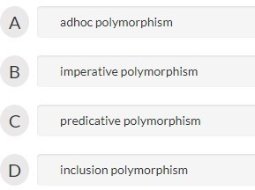

Ans B

**Question #2**

What is the function used to describe the situation, when a function in base class is redefined in

inherited class?

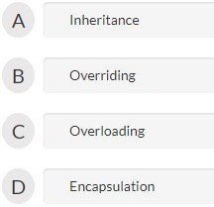

Ans B

**Question #3**

How can a call to an overloaded function be ambiguous?

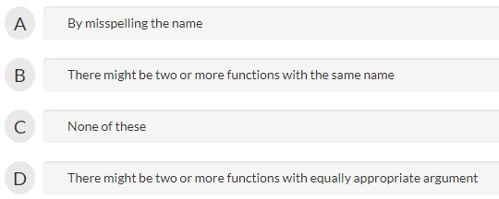

Ans D

**Question #4**

A complete binary tree with the property that the value at each node is at least as large as the

values at its children is known as

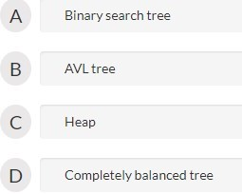

Ans C

**Question #5**

Which of the following correctly describes overloading of functions?

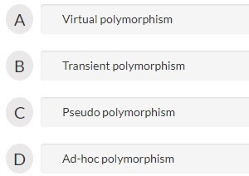

Ans D

**uestion #6**

Which of the following operator is overloaded for object cout?

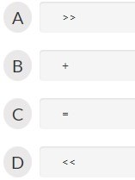

Ans D

**Question #7**

Which of the following operators cannot be overloaded?

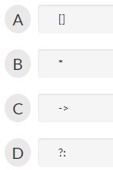

Ans B

**Question #8**

Which of the following is a mechanism of static polymorphism?

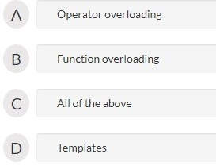

Ans C

**Question #9**

Which of the following keyword is used to overload an operator?

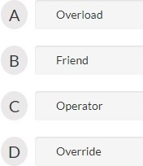

Ans C

**Question #10**

The operator << when overloaded in a class

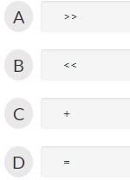

Ans B



#### Test 15

**Question #1**

Which Keyword from the following is used to inherit properties from one class into another?

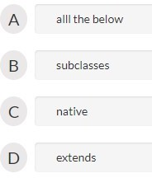

#### Ans D

**Question #2**

Which of the following supports the concept of hierarchical classification?

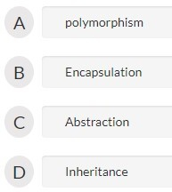

#### Ans D

**Question #3**

The process of building new classes from existing one is called .

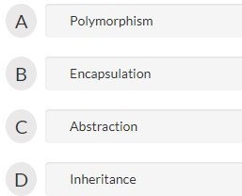

#### Ans D

**Question #4**

Which of the following is not a type of inheritance?

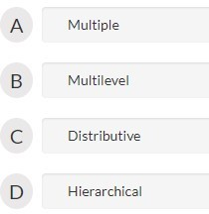

#### Ans C

**Question #5**

Which of the following are available only in the class hierarchy chain?

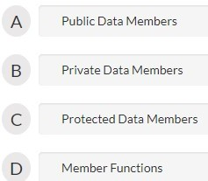

#### Ans C

**Question #6**

Which of the following cannot be inherited?

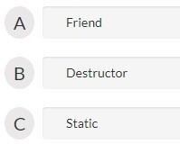

#### Ans C

**Question #7**

Which type of inheritance needs a virtual function:

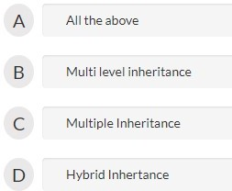

#### Ans A

**Question #8**

Which of the following concepts of OOPS means exposing only necessary information to client?

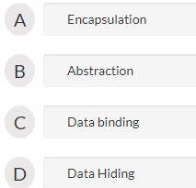

**Question #9**

Which type of class allows only one object of it to be created?

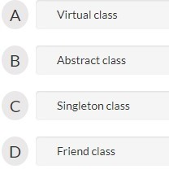

#### Ans C

**Question #10**

What makes a class abstract?

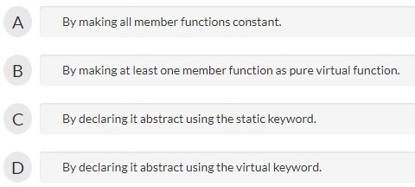

#### Ans B



Test

#### 1. Click on link for mock-aptitude

https://[www.geeksforgeeks.org/tcs-placement-paper-mcq-1/](http://www.geeksforgeeks.org/tcs-placement-paper-mcq-1/)



#### Test-II

TCS Email writing questions

TCS Placement Paper | E-mail Writing

During the on-campus recruitment process, TCS conducts an E-Mail writing test of 10 minutes duration and is included in the other writing tests. This round plays a vital role in the recruiting process and is mandatory for every student. TCS has its own way of testing job applicants, based on there circumstance analysis, situational understanding and English proficiency through e-mail writing. Basically, a situation is introduced at the start of the question followed by a number of phrases ranging from 10 to 15. With a proper understanding of the situation, students need to frame a formal e-mail, including all those phrases mentioned in the question. One needs to understand the context of the e-mail through the first part of the question and mould the given phrases into the context of the situation.

These points must be kept in mind while proceeding with the e-mail writing:

* Do not make grammatical, spelling mistakes or any typing errors while writing the e-mail.
* Stick to the formal tone while writing the e-mail.
* Keep the mail short and crisp, covering all the points. (Recommended a minimum of 50 words).
* Do not beat around the bush and write according to the points.
* Do not skip any phrase mentioned in the question.
* Do not change the tense or order of the mentioned phrases.
* Divide the mail into paragraphs (Recommended 2 paragraphs).
* Keep proper note of to whom the mail is addressed and from whom is it sent.
* Make proper salutations and formal references to subjects mentioned in the question.
  + 1. Use all the phrases given.
    2. Minimum words should be 50 otherwise your email cannot be validated.
    3. Addressing and signing should be done as in the question given.
    4. Common grammatical rules, punctuation should be according to standard English.
    5. You can use your own phrases along with the phrases given.

**Question:**

As a member of your residential society, write an email to the inspector of the local

Police station, Mr.Agarwal, informing him about miscreants who ride their bikes rashly every evening outside your society. Sign the email as Shyam.

**Phrases:**

residential area - ride - rashly - children - play - elderly - walk - grocery shop -

across the road - dangerous - accidents - nuisance - action - immediately.

#### Ans

*Dear Mr Agarwal,*

*I am a resident of Lajpat Nagar and on behalf of the society, would like to bring to your kind attention regarding the rash driving during the evening hours in the residential area of the society. The evening is the time when all the children come out to play and the elderly commences there evening walk. Being a residential area, there is a grocery shop across the street and now and then people walk across the road to buy groceries. For many days, the rash driving of miscreants is causing dangerous problems for the people, leading to accidents.*

*This is causing a constant nuisance to the people and action must be taken to curb this problem immediately.*

*Yourssincerely, Shyam.*

**Question:2**

As a former student, write an email to your professor, Mrs Suzanne, thanking her for teaching and guidance that contributed to your overall development. Sign the email as Sameer.

**Phrases:**

Successful - Placed - grateful - help - advice - grooming - values - shaping my future - sincere - professional

**Solution – Sample E-mail:**

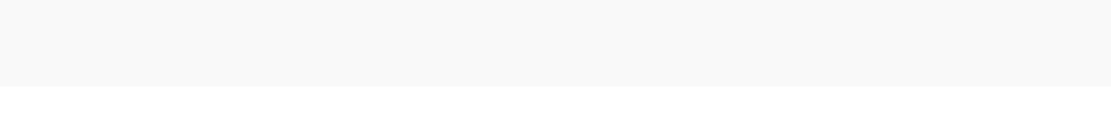

*Dear Mrs Suzanne,*

*With a joyful heart, I would like to inform you regarding my successful placement in the recent campus drive of my college. I am successfully placed at TCS and am grateful to you for your constant help and advice. The grooming sessions totally developed my personality and inculcated the skills and professional values required to shape my future.*

*I would like to extend my sincere thanks for your immense support, professional help and guidance.*

*With warm regards, Sameer.*

**Question:3**

As an intern at XYZ consulting Pvt.Ltd, write an email to your internship Project

Manager, Mr.Karunesh, informing about the progress that you are making and some

difficulties that you are encountering. Sign the email as Max.

**Phrases:**

Thank - challenging - progress - tight schedule - support - report - analytics -

guidance - access - doubt - requirements - design.

**Solution – Sample E-mail:**

*Dear Mr Karunesh,*

*Firstly, I would like to thank you for providing me with an opportunity to work with a challenging project during my internship period. I am making a consistent progress and have been learning new things. Since the project is due next month, we are on a tight schedule. I am facing a difficulty and need your support in context with the report of the analytics of testing. Your previous guidance has helped in accessing the database smoothly and solving the problem but I am facing some additional doubts with the requirement of the designing.*

*It would be great if you could assist me with this problem and help me to come with a successful project.*

*Yours sincerely, Max*

### Question:4

As a resident, write an email to the Municipal Commissioner of your city, Mr.Kumar, reporting nuisance of a building under construction beside your place. Sign the email as Arvind.

**Phrases:**

building - construction - long time - three years - water usage - mosquitoes -

unhygienic - construction workers - bad behaviour - attention -request

- action - immediately

**Solution – Sample E-mail:**

*Dear Mr Kumar,*

*I am a resident of Ashok Vihar and would like to bring to your notice about the P/T constructions company who are building a construction for a very long time. The work has been going for three years and hardly made any progress. There has been reckless water usage since the years. The water spill all over the locality along with the constructing debris, forming a breeding ground for mosquitoes. The place is starting to turn unhygienic by the pigs, mosquitoes and construction waste. We tried to get in touch with the construction workers but there bad behaviour with the locals is raising another issue.*

*It would be great if you could pay your attention to this problem and request you to take action to resolve this problem immediately.*

*Thanks and regards,*

Abc

### Question:5

**Question:**

As a student representative of your department, write an email to your batch mates, suggesting a party for Head of Department Prof.Mandy who is retiring next month. Sign the email as Shruti.

**Phrases:**

inform - retire - plan - surprise - party - host - family - exceptional teacher -

guide - mentor - groom - students - helpful - together - memorable

**Solution – Sample E-mail:**

*Hello All,*

*This is to inform all that the Head of Department Prof. Mandy is going to retire next month and hence we would like to plan for a surprise party for her and her family and host it on the eve of her retirement. We already know that Prof. Mandy is an exceptional teacher and has been a guide and mentor to the seniors and other students of this institution. She has been a very helpful teacher and a person. Its a*

*request to all the students to come together and make the event successful and one of the most memorable eve of her life.*

*Thanks and regards, Shruti.*

### Question:6

**Question:**

As a student representative of your college, write an email to the Principal of Professional Engineering College, Prof.Sanjib Chatterjee, inviting his institute to participate in the Technical symposium being organized in your college. Sign the email as Arun.

**Phrases:**

Invite - technical Symposium - previous - success - expecting - huge participation -

latest technology - stalls - demos - interaction - topics - complete - exchange ideas -

exciting prizes.

**Solution – Sample E-mail:**

*Dear Prof Chatterjee,*

*As a student representative of our college, I would like to invite your institute into the technical Symposium that is about to be held in our college next Sunday. Many eminent personalities would be visiting the Symposium just like the previous years. We are planning for a huge success this year too and are expecting a huge participation from your esteemed institution. The symposium would introduce to the mass about the latest technologies, followed by stalls set up to show demos on Science projects. It would be a great platform for interaction on some interesting topics with some of the eminent personalities. Participants can complete their registrations before the upcoming Sunday.*

*It is a great opportunity to exchange ideas and win exciting prizes. Looking forward*

*to a great participation.*

*Thanks and regards, Arun.*

### Question:7

As a supplier, write an email to the manager of RD Wheel company, Mr.Malhotra, intimating of their payment that is due for the products delivered to them three months ago. Sign the email as Sameer

**Phrases:**

On time - delivery of goods - three months - credit period - overdue - payment -

of the earliest - longstanding - relationship

**Solution – Sample E-mail:**

*Hi Mr Malhotra,*

*You are a valued customer of our company for a very long time and we appreciate doing business with you. You have always made on time payment of the delivery of goods but recently, we have observed an extreme delay in payment. Moreover, the three months credit period is also over and still, the payment is overdue. I would request you to make payment for the above goods delivered of the earliest. We are looking forward to the payment at earliest and a longstanding relationship in doing business with your company.*

*Thanks and regards, Sameer.*

### Question:8

**Question:**

Using the following phrases, write an email with a minimum of 70 words to the customer Mr Roy explaining the delay to the project.

**Phrases:**

Payment processing system – Schedule – 10th May (Friday) – Unexpected power outage –

3 days – Overall delay – 7 days – includes recovery of lost work – will not recur

**Solution – Sample E-mail:**

*Dear Mr Roy,*

*The project “Payment Processing System” which was scheduled to be completed by 10th May (Friday) will face a delay. Due to an unexpected power outage at the site*

*for the past 3 days and failing to get the backups online, an overall delay is imminent.*

*Therefore a maximum of 7 days would be required to come up with an overhaul which includes recovery of lost work and resuming the task.*

*We would like to apologize for the delay caused and would ensure that the failure will not recur in the future again.*

*Thanks and regards, Chinmoy.*

### Question:9

You are a part of the corporate communication team in your company. The working time period is revised as 8:30 am to 5:00 pm. Using the following phrases, write an email with a minimum of 70 words and a maximum of 100 words to the employees in your company informing the same.

**Phrases:**

by 30 minutes to avoid traffic - effect from next week - lunch duration-

revised working time - reduced by 15 minutes-free breakfast-office will start earlier -

till the end of rainy season - will be in effect.

**Solution – Sample E-mail:**

*Dear All,*

*We henceforth announce a revision in the work timings as 8:30 AM to 5:00 PM, i.e., an increase in office hours by 30 minutes to avoid traffic that is to take effect from next week.*

*With the commencement of the office 30 minutes earlier, the lunch session will be reduced by 15 minutes, with a reduction in the timings of breakfast. The office will start earlier till the end of the rainy season and all other timings will stay in effect till the traffic issues are dealt with.*

*Thanks and regards,*

*Lead – Corporate Communication.*

### Question:10

As your company is doing good business and expanding, your company is relocating its office to a new address. Using the following phrases, write an email with a minimum of 70 words and a maximum of 100 words to your customer informing the change in address.

**Phrases:**

near outer ring road - shifting to - bigger office space - November 10

-

change in telephone number - new address is provided below - fourth floor -

Cessna Business Park.

**Solution – Sample E-mail:**

*Dear All,*

*It gives a pleasure in announcing the expansion of this company, a sign of growing business and increasing clientele. For a better productivity result, we are relocating the company and shifting to a bigger office space from November 10th onwards.*

*New facilities and amenities shall be installed along with modern state of art amenities. There has been a change in telephone number along with the new address is provided below:*

*Fourth Floor, Cessna Business Park(Near Outer Ring Road), Noida. Phone: 1234567890*

*Please make a note of this to serve our clients better. Thanks and Regards*

### Sameer



#### List of Programs

1. Print the pattern (You only need to write function here)
2. Print table (This is a full code problem. Please see sample codes here before attempting the problem)
3. Series AP
4. Series GP
5. Closest Number
6. Armstrong Numbers
7. Sum of digits of a number
8. Reverse digits
9. Print the Kth Digit
10. Binary number to decimal number
11. Jumping Numbers
12. GCD of two numbers
13. LCM of two numbers
14. Add two fractions
15. GCD of array
16. Factorial of a number
17. Compute nPr
18. Compute nCr
19. Largest prime factor 1.

Perfect Numbers

1. Pair cube count
2. Find Nth root of M
3. Prime Number
4. Sieve of Eratosthenes
5. Sum of all prime numbers between 1 and N.
6. Pairs of prime numbers

**Puzzles**

1. Count Squares
2. 3 Divisors
3. Check if four points form a square
4. Check for power
5. Overlapping rectangles
6. Trailing zeroes in factorial
7. Angle between hour and minute hand
8. Number Of Open Doors
9. Triangular Numbers 10.

Nth Even Fibonacci Number

* 1. Last two digit Fibonacci
  2. Squares in a Matrix
  3. Day of the week
  4. Array operations (Search, insert, delete)
  5. Array alternate printing
  6. Maximum and minimum in an array
  7. Second largest in array
  8. Sum of array elements
  9. Reverse an Array
  10. Rotate Array
  11. Count of smaller elements
  12. Remove duplicate elements from sorted Array
  13. Count possible triangles
  14. Leaders in an array
  15. Minimum distance between two numbers
  16. Sorted subsequence of size 3
  17. Maximum Sub Array
  18. Majority Element
  19. Wave Array
  20. Maximum Index
  21. Max sum path in two arrays
  22. Product array puzzle
  23. Find duplicates in a small ranged array
  24. Find Missing And Repeating
  25. Stock buy and sell
  26. Trapping Rain Water
  27. Pair with given sum in a sorted array
  28. Chocolate Distribution Problem
  29. Longest Consecutive subsequence
  30. Three way partitioning

**String :**

1. Check for palindrome
2. Check for anagram
3. Anagram Palindrome
4. Title case conversion
5. Sort the string
6. Merge two strings
7. Save Ironman
8. Good or Bad string
9. URLify a given string
10. Extract Maximum
11. Reverse words in a given string
12. Implement strstr
13. Check for subsequence
14. Check for rotation
15. Check if two strings are k-anagrams
16. Uncommon characters
17. Anagram Search
18. First repeating character
19. First non-repeating character
20. Longest Distinct characters in string
21. Longest Palindromic Substring
22. Find k-th character in string
23. Smallest window in a string containing all characters of another string
24. Add Binary Strings
25. Multiply two Strings
26. Nearest multiple of 10

**Searching :**

1. Linear Search
2. Facing the sun
3. Magnet Array Problem
4. Binary Search
5. Floor in a Sorted Array
6. Count occurrences in a sorted array
7. Search in a sorted and rotated
8. Find the missing number
9. Missing element of AP
10. Square root of a number
11. Find Transition Point in a Sorted Binary Array
12. Last index of One
13. Peak element
14. Allocate minimum number of pages
15. Common elements in three sorted
16. Smallest Positive missing number

**Sorting :**

1. Check if array is sorted
2. Sort a binary array
3. Sort an array of 0s, 1s and 2s
4. Bubble Sort
5. Insertion Sort
6. Selection Sort
7. Quick Sort
8. Merge Sort
9. Sort an array when two halves are sorted
10. Relative Sorting
11. Triplet Sum in Array
12. Minimum Swaps to Sort
13. Sorting elements by frequency
14. Triplet Family
15. Count the triplets

**Matrix :**

1. Transpose of Matrix
2. Print Matrix in snake Pattern
3. Print a given matrix in spiral form
4. Is Sudoku Valid
5. Count zeros in a sorted matrix
6. Squares in a Matrix
7. A Boolean Matrix Question
8. Search in row-wise and column-wise sorted
9. Find the row with maximum number of 1s
10. Count pairs Sum in matrices
11. Median In a Row-Wise sorted Matrix

**Hashing :**

1. Count distinct elements
2. Array Subset of another array
3. Nuts and Bolts Problem
4. Count frequencies of elements
5. Check if two arrays are equal or not
6. First element to occur k times
7. In First But Second
8. Non-Repeating Element
9. Group Anagrams Together
10. Winner of an election
11. Check for a pair with given sum
12. Count distinct pairs with difference k
13. Count pairs with given sum
14. Find all four sum numbers

15. A Simple Fraction

16. Largest Fibonacci Subsequence

**Recursion :**

1. Print Pattern
2. Handshakes
3. Tower of Hanoi
4. Josephus problem
5. Recursively remove all adjacent duplicates
6. Possible words from Phone digits
7. Flood fill Algorithm
8. Permutations of a string

**Divide & Conquer :**

1. Write your own power function
2. Program for n-th Fibonacci Number
3. K-th element of two sorted Arrays
4. Median of two sorted arrays
5. Karatsuba Algorithm
6. The Painter’s Partition Problem
7. Convex Hull
8. Counting inversions

**Linked List :**

1. Print a Linked List
2. Length of a linked list
3. Node at a given index in linked list
4. Middle of a linked list
5. n-th node from end of a linked list
6. Delete a node
7. Remove every k’th node
8. Delete N nodes after M nodes of a linked list
9. Delete without head pointer
10. Rearrange a linked list
11. Segregate even and odd (Using only one traversal)
12. Reorder List
13. Polynomial Addition
14. Insert in a Sorted List
15. Swap nodes in pairs
16. Reverse a linked list
17. Reverse a Linked List in groups of given size.
18. Check for palindrome
19. Flattening a linked list
20. Get intersection point
21. Remove duplicates from sorted list
22. Remove duplicates from unsorted lists
23. Sort a linked list of 0s, 1s and 2s.
24. Circular Linked List
25. Detect loop in a linked list
26. Find length of Loop
27. Remove loop in a linked list
28. Add two numbers represented by linked lists
29. Clone a linked list with random pointers
30. Add 1 to a number represented as linked list
31. Add two numbers represented as linked list
32. Multiply two linked lists
33. Merge two sorted linked lists
34. Merge Sort on Linked List
35. Intersection of Two Linked Lists
36. Union of Two Linked Lists

**Doubly and Circular Linked Lists**

1. Insert a node in Doubly linked list
2. Delete node in Doubly Linked List
3. Circular Linked List Traversal
4. Split a Circular Linked List into two halves
5. Insert in Sorted way in a Sorted DLL
6. QuickSort on Doubly Linked List
7. Merge Sort on Doubly Linked List
8. Rotate doubly Linked List by P nodes
9. XOR Linked List

**Stack**

1. Implement Stack using Array
2. Implement Stack using Linked List
3. Check for balanced parenthesis
4. Reverse a stack
5. Implement two stacks in an array
6. Design a stack with getMin
7. The celebrity problem
8. Stock Span Problem
9. Next Greater Element
10. Next Smaller Element
11. Longest valid Parentheses

**Queue and Dequeue**

1. Implement Queue using Linked List
2. Implement Queue using Array
3. Implement Stack using Queue
4. Implement Queue using Stack
5. Reversing a Queue
6. Circular tour

**Prefix Sum and Sliding Window**

1. Equilibrium Point
2. Check if there is a subarray with 0 sun
3. Longest Sub-Array with Sum K
4. Longest subarray with sum divisible by K
5. Largest subarray with equal 1s and 0s
6. Longest common span with same number of 1s and 0s among two arrays
7. Find mximum sum in any subarray of size k
8. Count distinct elements in every window of size k
9. Check for subarray with given sum

**Bit Magic**

1. Check if a number is even or odd.
2. Number of bit flips
3. Game of XOR
4. Find bit at a position
5. Swap odd and even bits
6. Power of 2
7. Odd occurring element
8. Missing number in array
9. Index Of an Extra Element
10. Reverse Bits
11. Count set bits
12. Power Set

**Tree**

1. Inorder Traversal
2. Preorder Traversal
3. Postorder Traversal
4. Level order traversal
5. Find height of Binary Tree
6. Count Leaves in Binary Tree
7. Check for Children Sum Property
8. Mirror Tree
9. Check for Balanced Tree
10. Lowest Common Ancestor in a Binary Tree
11. Diameter of Binary Tree
12. Left View of Binary Tree
13. Right View of Binary Tree
14. Maximum path sum
15. Level order traversal line by line
16. Tree from Postorder and Inorder
17. Tree from Preorder and Inorder
18. Connect Nodes at Same Level
19. Zig-Zag level order traversal
20. Serialize and Deserialize a Binary Tree
21. Leaves to DLL
22. Binary Tree to Doubly Linked List

Binary Tree to Circular Doubly Linked List

**Binary Search Tree**

1. BST Search
2. BST Insert
3. BST Delete
4. Minimum in BST
5. Inorder Traversal and BST
6. Count BST nodes that lie in a given range
7. Add all greater values
8. Predecessor and Successor in BST
9. Closest Neighbor in BST
10. Lowest Common Ancestor in a BST
11. Convert Level Order Traversal to BST
12. Normal BST to Balanced BST
13. Pair with given sum in BST
14. Check for BST
15. Correct BST with two nodes swapped
16. Median of BST

17. k-th smallest element in BST

1. Unique BST’s
2. Array to BST 20.

Preorder Traversal and BST

* 1. Preorder to Postorder
  2. Leaf nodes from preorder traversal
  3. Triplet with 0 sum in BST
  4. Merge two BST ‘s
  5. Largest BST Subtree

1. Binary Heap Operations
2. Height of Heap
3. Heap Sort
4. Sort a Nearly Sorted Array
5. K Largest Elements
6. K-th largest element in a stream
7. Median of stream
8. Merge k sorted arrays

**Heap**

1. Print adjacency list
2. Breadth First Search
3. Depth First Search
4. Find whether path exist
5. Knight Walk
6. Snake and Ladder Problem
7. Bipartite Graph

**Graph**

1. Detect Cycle in an undirected graph
2. Detect Cycle in a directed graph
3. Find first n numbers with given set of digits
4. Rotten oranges
5. Topological sort
6. Shortest Source to Destination Path
7. Transitive closure of a Graph
8. Strongly Connected Components

**Greedy Algorithms**

1. Fractional Knapsack
2. Largest number with given sum
3. Activity Selection
4. N meetings in one room
5. Minimum Platforms
6. Minimum number of Coins
7. Job Sequencing Problem
8. Minimize the heights
9. Huffman Coding
10. Huffman Decoding
11. Minimum Spanning Tree
12. Dijkstra for Adjacency Matrix

**Dynamic Programming**

1. Print first n Fibonacci Numbers.
2. Count ways to reach the n’th stair
3. Cutted Segments
4. Kadane’s Algorithm
5. Stickler Thief
6. Minimum number of jumps
7. Total Decoding Messages
8. Min Cost Path
9. Coin Change
10. Longest Common Subsequence
11. Consecutive 1’s not allowed
12. Edit Distance
13. Rod Cutting
14. Water Overflow
15. Maximum Tip Calculator
16. Longest Increasing Subsequence
17. Maximum sum increasing subsequence
18. Max length chain

19. 0 – 1 Knapsack Problem

* 1. Maximum Tip Calculator
  2. Interleaved string
  3. Longest Palindromic Subsequence
  4. Wildcard Pattern Matching
  5. Box Stacking
  6. Longest Bitonic subsequence
  7. Minimum sum partition
  8. Largest square formed in a matrix
  9. Word Break
  10. Matrix Chain Multiplication
  11. Special Keyboard
  12. Egg Dropping Puzzle
  13. Optimal Strategy for a Game

**Backtracking**

1. Rat Maze With Multiple Jumps
2. Coins and Game
3. Hamiltonian Path
4. Solve the Sudoku
5. Combination Sum – Part 2
6. Combination Sum
7. Subsets
8. Largest number in K swaps
9. M-Coloring Problem
10. Black and White

**Misc Questions to test your overall learning**

1. Longest common prefix
2. Implement Atoi
3. Two numbers with sum closest to zero
4. Smallest greater elements in whole array
5. Max rectangle
6. Find triplets with zero sum
7. Counting elements in two arrays
8. Merge K sorted linked lists
9. Maximum Difference
10. Circle of strings
11. All possible Word Breaks
12. Alien Dictionary
13. Design a tiny URL or URL shortener
14. Implement LRU Cache 15.



#### For above coding questions refer link

https://[www.geeksforgeeks.org/practice-for-cracking-any-coding-interview/#math](http://www.geeksforgeeks.org/practice-for-cracking-any-coding-interview/#math)



#### Company wise coding questions Google:-

1. Subarray with given sum
2. Maximum Index
3. Finding the numbers
4. Longest valid Parentheses
5. Jumping Numbers
6. Connect Nodes at Same Level
7. Count BST nodes that lie in a given range
8. Implement LRU Cache
9. Interleaved Strings
10. Find triplets with zero sum
11. Egg Dropping Puzzle
12. Word Break Problem
13. Check if a Binary Tree contains duplicate subtrees of size 2 or more
14. Find largest word in dictionary by deleting some characters of given string
15. Modular Exponentiation (Power in Modular Arithmetic)

**Facebook :**

1. Subarray with given sum
2. Find all pairs with a given sum
3. Total Decoding Messages
4. Word Boggle
5. Activity Selection
6. Minimum Depth of a Binary Tree
7. Implement strstr
8. Multiply two strings
9. K-Palindrome
10. Find triplets with zero sum
11. Largest subset whose all elements are Fibonacci numbers
12. Look-and-Say Sequence
13. Converting Decimal Number lying between 1 to 3999 to Roman Numerals
14. Convert Ternary Expression to Binary Tree
15. Maximum Rectangular Area in a Histogram

**Amazon :**

1. K largest elements from a big file or array
2. Reverse a Linked List in groups of given size
3. Implement a stack with push(), pop() and min() in O(1) time
4. Add two numbers represented by linked lists
5. Convert a Binary tree to DLL
6. Stock span problem
7. Next larger element
8. Edit distance
9. Maximum of all subarrays of size k
10. Pythagorean Triplet
11. Print a Binary Tree in Vertical Order
12. Level order traversal
13. Smallest window in a string containing all the characters of another string
14. Find the number of islands
15. Detect and Remove Loop in a Linked List
16. Check if a binary tree is BST or not
17. Boolean Parenthesization
18. Arrange given numbers to form the biggest number
19. Implement LRU Cache
20. Maximum difference between node and its ancestor in Binary Tree

**Microsoft :**

1. Key Pair
2. Is Binary Number Multiple of 3
3. Kadane’s Algorithm
4. Missing number in array
5. Majority Element
6. Search in a Rotated Array
7. Check for BST
8. Finding middle element in a linked list
9. Root to leaf path sum
10. Reverse a linked list
11. Remove every k’th node
12. Merge 2 sorted linked list in reverse order
13. Longest Even Length Substring such that Sum of First and Second Half is same
14. k largest(or smallest) elements in an array | added Min Heap method
15. Write an Efficient Function to Convert a Binary Tree into its Mirror Tree
16. Determine if Two Trees are Identical

**Adobe :**

1. Search in a Rotated Array
2. Subset Sum Problem
3. Reverse words in a given string
4. Sort an array of 0s, 1s and 2s
5. Minimum number of jumps
6. Check for BST
7. Root to leaf path sum
8. Sum Tree
9. Finding middle element in a linked list
10. Reverse a linked list
11. Level order traversal in spiral form
12. Right View of Binary Tree
13. Remove duplicate element from sorted Linked List
14. Merge Sort for Linked List
15. Count set bits in an integer

**Oracle :**

1. 0 – 1 Knapsack Problem
2. Search in a matrix
3. Power of 2
4. Palindrome
5. Root to leaf path sum
6. Kadane’s Algorithm
7. Binary Search
8. Implement Queue using Linked List
9. Connect Nodes at Same Level
10. Remove loop in Linked List
11. Implement Stack using Queues
12. Implement Queue using Stacks
13. Remove duplicate element from sorted Linked List
14. Search in a row wise and column wise sorted matrix
15. Find the first repeating element in an array of integers

**MAQ Software :**

1. Sort an array of 0s, 1s and 2s
2. Permutations of a given string
3. Rotate Array by n elements
4. Non Repeating Character
5. Nth Fibonacci Number
6. Finding middle element in a linked list
7. n’th node from end of linked list
8. Detect Loop in linked list
9. Implement Queue using Stacks
10. Find Missing And Repeating
11. Find the Closest Element in BST
12. Check if a linked list is Circular Linked List
13. Reverse a String
14. Reverse words in a given string
15. Egg Dropping Puzzle

**Yahoo :**

1. First non-repeating character in a stream
2. Find median in a stream
3. Largest prime factor
4. Form coils in a matrix
5. Word Boggle
6. Largest Product Palindrome
7. Surpasser Count
8. Return two prime numbers
9. Sort a stack
10. Three way partitioning
11. LRU Cache
12. Serialize and Deserialize a Binary Tree
13. Split a Circular Linked List into two halves
14. Interleaved Strings
15. Max Sum without Adjacents

**ccolite :**

1. Count Squares
2. Longest Prefix Suffix
3. N-Queen Problem
4. Coin Change
5. Permutations of a given string
6. Stock buy and sell
7. Longest Palindrome in a String
8. Sum of two numbers represented as arrays
9. Max sum submatrix
10. Maximum sum Rectangle
11. Root to leaf path sum
12. Lowest Common Ancestor in a Binary Tree
13. Level order traversal in spiral form
14. Implement Stack using Queues
15. n’th node from end of linked list

**Walmart Labs :**

1. Longest consecutive subsequence
2. Largest number in K swaps
3. k largest elements
4. Word Break
5. Find the highest occurring digit in prime numbers in a range
6. Count all possible paths from top left to bottom right
7. Minimum Platforms
8. Parenthesis Checker
9. Implement LRU Cache
10. Josephus Problem
11. Top View of Binary Tree
12. Intersection of Two Linked Lists
13. Alien Dictionary
14. Remove Loop in Linked List
15. Wildcard Pattern Matching

**Samsung :**

1. Longest Increasing Subsequence
2. Next larger element
3. Permutations of a given string
4. Next greater number set digits
5. Finding middle element in a linked list
6. Root to leaf path sum
7. Detect Loop in linked list
8. Left View of Binary Tree
9. Implement Queue using Linked List
10. Egg Dropping Puzzle
11. Total number of possible Binary Search Trees with n keys
12. Count number of bits to be flipped to convert A to B
13. Implement two stacks in an array
14. Given only a pointer/reference to a node to be deleted in a singly linked list, how do you delete it?

**Paytm :**

1. Sort an array of 0s, 1s and 2s
2. Reverse words in a given string
3. Reverse a linked list
4. Reverse a Linked List in groups of given size
5. Max Sum without Adjacents
6. Mirror Tree
7. Flattening a Linked List
8. Check for Balanced Tree
9. Find the number of islands
10. Coin Change
11. Count frequencies of all elements in array in O(1) extra space and O(n) time
12. Convert array into Zig-Zag fashion
13. Find the row with maximum number of 1s
14. Maximum Rectangular Area in a Histogram

**Ola Cabs :**

1. Kadane’s Algorithm
2. Missing number in array
3. Sort an array of 0s, 1s and 2s
4. Search in a matrix
5. Left View of Binary Tree
6. Mirror Tree
7. Connect Nodes at Same Level
8. K distance from root
9. Level order traversal in spiral form
10. Non Repeating Character
11. Find the number of islands
12. Find the character in first string that is present at minimum index in second string
13. Maximum difference between two elements such that larger element appears after the smaller number
14. Find the element that appears once in sorted array
15. Boolean Matrix Problem

**Flipkart :**

1. Kadane’s Algorithm
2. 0 – 1 Knapsack Problem
3. Inversion of array
4. Consecutive 1’s not allowed
5. Finding middle element in a linked list
6. Get minimum element from stack
7. Left View of Binary Tree
8. Add two numbers represented by linked lists
9. Connect Nodes at Same Level
10. Sum of dependencies in a graph
11. Maximum of all subarrays of size k
12. Possible words from Phone digits
13. Reverse Level Order Traversal
14. Implement Queue using Stack
15. Maximum Width of Tree

**SAP Labs :**

1. Sort an array of 0s, 1s and 2s
2. Check if a number is Bleak
3. Reverse words in a given string
4. Remove Spaces from string
5. Second Largest
6. Check if a number is power of another number
7. Reverse a linked list
8. Get minimum element from stack
9. BFS traversal of graph
10. Find median in a stream of integers
11. Quick Sort
12. GCD of Array
13. LCM And GCD
14. Heap Sort
15. Bubble Sort

**VMware :**

1. Longest Common Subsequence
2. Maximum Index
3. Array to BST
4. Egg Dropping Puzzle
5. K’th smallest element
6. Check for BST
7. Finding middle element in a linked list
8. Reverse a linked list
9. Detect Loop in linked list
10. Run Length Encoding
11. Height of Binary Tree
12. Infix to Postfix
13. Diameter of Binary Tree
14. Mirror Tree
15. Boolean Matrix Problem

**Cisco :**

1. Missing number in array
2. Reverse words in a given string
3. Permutations of a given string
4. Array to BST
5. Counbt set bits
6. Reverse a linked list
7. Level order traversal
8. Minimum Spanning Tree
9. Does array represent Heap
10. Kth largest element in a stream
11. Escape the jail
12. K’th smallest element
13. Insertion Sort
14. Bubble Sort

**Goldman Sachs :**

1. Reverse words in a given string
2. Overlapping rectangles
3. Column name from a given column number
4. Non Repeating Character
5. Total Decoding Messages
6. Sum Tree
7. Get minimum element from stack
8. Flattening a Linked List
9. Sort a stack using Recursion
10. Intersection Point in Y Shapped Linked Lists
11. Stock buy and sell
12. Egg Dropping Puzzle
13. Check for Balanced Tree
14. Check if two arrays are equal or not
15. Implement Queue using Stacks

**MakeMyTrip :**

1. Distinct palindromic substrings
2. Two water Jug problem
3. Minimum Cost Path
4. Transpose of Matrix
5. Smallest window in a string containing all the characters of another string
6. Check Mirror in N-ary tree
7. Longest Prefix Suffix
8. Maximum Difference
9. Nuts and Bolts Problem

10. N meetings in one room

1. String formation from substring
2. Longest Common Subsequence
3. Next Permutation
4. Trailing zeroes in factorial

1. Egg Dropping Puzzle

**Snapdeal :**

1. Fighting the darkness
2. Money Division
3. Group Anagrams Together
4. Pangram Strings
5. 0 – 1 Knapsack Problem
6. Longest Arithmetic Progression
7. Next greater number set digits
8. Number of Coins
9. Check If two Line segments Intersect
10. Two numbers with sum closest to zero
11. Parenthesis Checker
12. Maximum Rectangular Area in a Histogram
13. Smallest Positive missing number
14. Find the number of islands
15. Reverse a Linked List in groups of given size

**Qualcomm :**

1. Find length of Loop
2. Implement strstr
3. Min distance between two given nodes of a Binary Tree
4. Delete a node from BST
5. Left View of Binary Tree
6. Intersection Point in Y Shapped Linked Lists
7. Check for BST
8. Reverse a linked list
9. Detect Loop in linked list
10. Reverse Bits
11. Next Permutation
12. Array Subset of another array
13. Set Bits
14. Find Prime numbers in a range
15. Subsequence matching

**Payu :**

1. Reverse each word in a given string
2. First non-repeating character in a stream
3. Next larger element
4. 0 – 1 Knapsack Problem
5. Leaders in an array
6. Trapping Rain Water
7. Pattern Searching
8. Implement Atoi
9. Lowest Common Ancestor in a Binary Tree
10. Level order traversal in spiral form
11. Flattening a Linked List
12. Finding middle element in a linked list
13. Missing number in array
14. Kadane’s Algorithm
15. Count possible ways to construct buildings

**Intuit :**

1. Element with left side smaller and right side greater
2. Find median in a stream
3. Product array puzzle
4. Count Occurences of Anagrams
5. Maximum Sub Array
6. Binary Array Sorting
7. Sort a Stack
8. Find the number of islands
9. Remove duplicates from an
10. Remove duplicates from an unsorted linked list
11. Implement LRU Cache
12. Max Rectangle
13. Reverse a linked list
14. Pairwise swap elements of a linked list by swapping data
15. Find the missing no in string
16. Depth First Traversal for a Graph

#### For above questions follow link

https://[www.geeksforgeeks.org/must-coding-questions-company-wise/#google](http://www.geeksforgeeks.org/must-coding-questions-company-wise/#google)