AI Powered Learning Tutorial Search Engine : A Comprehensive Review

## Abstract

The rapid expansion of online educational content has created a paradox of choice for learners, Making It difficult to identify relevant and high-quality technical tutorials. To address this information Overload, we present tutorial Finder, an intelligent web application that leverages artificial intelligence To personalize the course discovery process. Tutorial Finder employs automated web scraping using Python's BeautifulSoup and Playwright frameworks to aggregate course data from trusted online Sources. This data is processed and vectorized to facilitate efficient retrieval. The system's core Intelligence is provided by a Large Language Model (LLM) integration through LangChain and OpenAI's GPT, which understands complex user queries and learning objectives. To overcome context window limitations, a text chunking strategy is implemented. The final product is a deployed, user-friendly web Interface that acts as a personalized learning concierge. Preliminary evaluation indicates that Tutorial Finder successfully retrieves contextually relevant course recommendations, demonstrating The viability of integrating LLMs with real-time data retrieval to create personalized educational experiences. This approach reduces search time and helps students embark on optimal learning paths Tailored to their specific needs.

**Keywords:** Recommendation Systems, Personalized Education, Web Scraping, Large Language Models, LangChain, Vector Retrieval, Web Development.

# Introduction

In the past few years, several changes, including the COVID-19 pandemic, brought more popularity to online platforms compared to traditional face-to-face education.This trend also happened in the educational field. Online tutoring helped to improved students' learning experiences. . While educational institutions and individuals around the world adopt online teaching, the need for user-friendly platforms for both teachers and students to have quality education becomes demanding. This study aims to address this need by designing and developing a website addressing the requirements of both students and teachers.

This study highlights two issues in current tutorial recommendation technologies: the Recommendation Gap and the Practicality Gap.

Figure1 shows how AI personalises learning trips, combining technology and education. As this research indicates, AI driven customised learning can improve education and prepare students for job challenges, transforming education.

AI-powered tailored learning evaluates students' learning styles, preferences, and academic ability using advanced algorithms. These algorithms enhance comprehension, engagement, and retention beyond training. AI analytics makes learning flexible and interesting. Worldview changes boost academic achievement and engagement. Modern AI systems offer multiple learning resources, activities, and evaluations due to complex learning patterns and preferences. This method includes information dissemination, interactive simulations for visual learners, gamified modules for kinesthetic learners, and customised practice tools for failing students. This new method detects learning styles and customises teaching for each student.

Traditional teaching is less flexible and inclusive than AI- enabled tailored learning. AI helps schools effortlessly integrate students' talents and interests with individualised instruction, making learning interesting and successful. AI helps students learn vital ideas and overcome problems faster by identifying knowledge gaps and customising teaching.

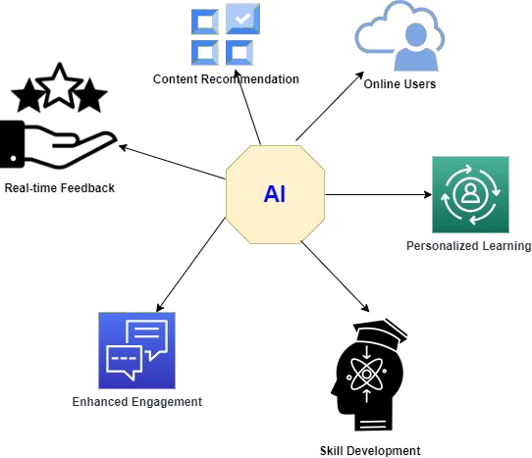

AI-powered solutions give students real-time feedback and coaching to track progress and alter lessons. Students control their education with data. AI affects non- school education. AI-driven translation overcomes language barriers, ensuring diverse students receive outstanding education. 24/7 AI chatbot training aids. AI technologies let parents track their child's progress and offer interactive learning. AI makes education more accessible and increases learning outside of school. Education is greatly impacted by AI. Customised learning boosts student success. Equity and effectiveness in education require AI-enabled tailored learning. AI could improve education by personalising it for each student. Intelligent material recommendations based on needs and interests make education dynamic, flexible, and personalised.

**To achieve this goal, the requirements for the website were gathered. This process involved collecting data through literature review analysis, and conducting surveys and interviews with potential users. The survey results provided potential useful features of the website. Also, interviews allow to become more familiar with challenges in online tutoring. These findings inform the development of customized features and functionalities.**

*preprint arXiv:2106.09685*, 2021.