AI Powered Learning Tutorial Search Engine: A Comprehensive Review

Amarjeet (2301220109004)

Under the Guidance of  
Er. Ratan Rajan Srivastava

Department of Computer Science and Engineering  
SRMCEM College of Management, Lucknow  
Uttar Pradesh, India

Submitted in Partial Fulfillment of B.Tech Degree Requirements  
Year: 2026

**Abstract**

The rapid expansion of online educational content has created a paradox of choice for learners, Making It difficult to identify relevant and high-quality technical tutorials. To address this information Overload, we present tutorial Finder, an intelligent web application that leverages artificial intelligence To personalize the course discovery process. Tutorial Finder employs automated web scraping using Python's BeautifulSoup and Playwright frameworks to aggregate course data from trusted online Sources. This data is processed and vectorized to facilitate efficient retrieval. The system's core Intelligence is provided by a Large Language Model (LLM) integration through LangChain and OpenAI's GPT, which understands complex user queries and learning objectives. To overcome context window limitations, a text chunking strategy is implemented. The final product is a deployed, user-friendly web Interface that acts as a personalized learning concierge. Preliminary evaluation indicates that Tutorial Finder successfully retrieves contextually relevant course recommendations, demonstrating The viability of integrating LLMs with real-time data retrieval to create personalized educational experiences. This approach reduces search time and helps students embark on optimal learning paths Tailored to their specific needs.

**Keywords:** Recommendation Systems, Personalized Education, Web Scraping, Large Language Models, LangChain, Vector Retrieval, Web Development.

**Introduction**

In the past few years, several changes, including the COVID-19 pandemic, brought more popularity to online platforms compared to traditional face-to-face education. This trend also happened in the educational field. Online tutoring helped to improved students' learning experiences. . While educational institutions and individuals around the world adopt online teaching, the need for user-friendly platforms for both teachers and students to have quality education becomes demanding. This study aims to address this need by designing and developing a website addressing the requirements of both students and teachers.

AI-powered tailored learning evaluates students' learning styles, preferences, and academic ability using advanced algorithms. These algorithms enhance comprehension, engagement, and retention beyond training. AI analytics makes learning flexible and interesting. Worldview changes boost academic achievement and engagement. Modern AI systems offer multiple learning resources, activities, and evaluations due to complex learning patterns and preferences. This method includes information dissemination, interactive simulations for visual learners, gamified modules for kinesthetic learners, and customised practice tools for failing students. This new method detects learning styles and customises teaching for each student. Recent study suggests AI-driven customised learning can alter education. AI algorithms can design personalised college educational pathways online, and according to Mangi et al. (2023), it showed that AI algorithms can create personalised educational pathways for college students using online platforms. Similarly, Shaikh, Afshan, Anwar, Abbas, and Chana (2023) explored how AI-enabled customised learning simulates industry challenges in education. AI and NLP test and reinforce pupils' topic knowledge creatively. AI integration increases student engagement and comprehension, supporting its widespread use in education. As digital platforms dominate education, AI integration has altered college student learning (Al-Badi & Khan, 2022). AI-driven scaffolding encourages self directed learning. This transformative pedagogical method adapts to learning styles and mirrors real-world contexts, making learning interactive (Umutlu & Gursoy, 2022).

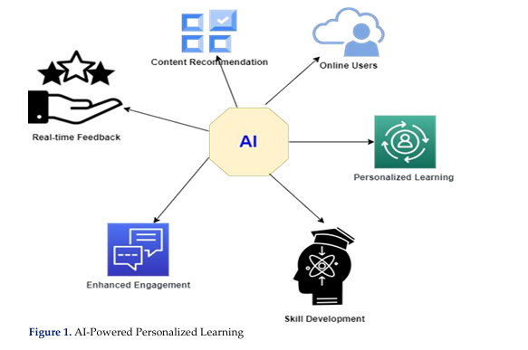

Figure1 shows how AI personalises learning trips, combining technology and education. As this research indicates, AI driven customised learning can improve education and prepare students for job challenges, transforming education. AI-powered tools and apps may automate activities, provide students with rapid feedback, and tailor learning to improve education. This study found that mobile app-based personalisation promotes student engagement and comprehension. AI is used to create responsive, efficient, and customised virtual classroom learning paths, demonstrating AI's potential to change education. AI's unparalleled impact on educational paradigms and complexity are examined in this research. It examines how AI-driven customised learning trajectories affect college students' online information management. The study methodically examines how AI algorithms may personalise educational excursions to student learning styles, improving interest, knowledge, and retention. To demonstrate AI's educational potential, several qualities are studied. This paper tackles AI ethics and privacy in education as AI enters. AI in education makes data security, privacy, and responsible technology use more important. Research reveals these ethical issues, allowing educational institutions to use AI ethically. This study analyses AI's disruption of education. The project examines customised learning, AI algorithms, and ethics to evaluate howAImayimprove education and ethics. **This research exceeds customised learning optimisation. It gives students essential tools and agility to survive in the digital era. This study adds to the scholarly conversation on AI in education and prepares for ethical and effective deployment, ensuring that AI's transformational potential in education's future is tapped.**

**Literature Review**

**Overview:** The evolution of AI-driven personalized learning platforms has reshaped how students discover and consume tutorials. Traditional recommendation systems such as those used by Coursera or edX rely primarily on **metadata, popularity metrics, or collaborative filtering**, which lack contextual understanding and personalization. The integration of **AI, NLP, and LLMs** now enables systems to interpret natural language queries, extract semantic meaning, and recommend educational content more precisely.

In the next step, the effectiveness, strengths, and challenges of traditional and e-tutoring were studied. This helps to understand the concepts of conventional face-to-face tutoring methods and their role in modern e-tutoring systems. Specifically, this section explores the advantages of online tutoring over traditional settings and challenges like engagement and technical requirements of tutors and students.

**Review of Existing Works:**

|  |  |  |  |  |
| --- | --- | --- | --- | --- |
| **S. No.** | **Author / Year** | **Technique / Approach** | **Key Finding** | **Identified Gap** |
| **1** | Russell (2013) | Social Web mining for education. | Provided foundation for data extraction techniques. | Did not address semantic understanding or AI-based content ranking. |
| **2** | Yunanto (2017) | Heuristic similarity in educational games. | Implemented basic AI similarity-based logic. | Not applicable to web-based tutorial search or NLP-driven systems. |
| **3** | Baker & Smith (2019) | Explored AI’s potential in education through automation and adaptive systems. | Highlighted AI as a transformative force in educational personalization. | Did not propose a practical implementation for dynamic tutorial discovery |
| **4** | Zhang (2021) | Digital technologies for entrepreneurship education. | Showed improved accessibility of online education. | Lacked AI-based recommendation or personalization framework. |
| **5** | Wang et al. (2023) | Intelligent Tutoring Systems using self-regulated learning. | Improved engagement through cognitive load optimization | Limited to closed-course environments, not open tutorial sources. |
| **6** | Chiu et al. (2023) | Systematic review on AI in education. | Mapped opportunities and challenges of AI in adaptive learning. | Missing integration of real-time web scraping and semantic retrieval. |
| **7** | Afzaal et al. (2024 | Bibliometric analysis of AI in education (2013–2023). | Identified major growth in AI-assisted learning research | No concrete model integrating NLP, LLMs, and web scraping. |

**Contribution of Present Work (AiTutor System)**:

|  |  |  |  |
| --- | --- | --- | --- |
| S.NO | Contribution Area | Description / Implementation | Outcome / Advantage |
| 1 | Integration of LLMs(OpenAI GPT) | Used GPT models to interpret natural language queries entered by users and extract key learning intent. | Enables deep understanding of user needs and provides accurate, human-like recommendations. |
| 2 | Semantic Retrieval using Langchain & Vector Embeddings | Applied LangChain for pipeline orchestration and vector embeddings for representing tutorials and queries. | Facilitates semantic similarity search beyond keywords, improving recommendation precision. |
| 3 | Automated Web Scraping from Multiple Sources | Implemented automated scrapers using BeautifulSoup and Playwright to fetch tutorials from YouTube, MOOCs, and blogs | Ensures a continuously updated and diverse database of tutorials from trusted sources. |
| 4 | Personalized & Context-Aware Recommendation Engine | Designed a similarity-based ranking system using cosine similarity and feedback-based refinement. | Delivers personalized, context-relevant tutorial suggestions and adapts to user feedback over time. |
| 5 | Real-Time User Interaction Interface | Developed a web interface for natural language input and real-time tutorial visualization. | Improves accessibility and usability for learners across diverse skill levels. |
| 6 | Performance Evaluation & Optimization | Incorporated user feedback, precision–recall metrics, and response-time evaluation. | Enhances overall system reliability, scalability, and learning experience. |

**Proposed Methodology**

1. Requirement Analysis

* Identify core user needs: natural language query input, personalized tutorial results, semantic ranking.
* Define functional components: Web scraping, NLP engine, vector storage, and web interface.
* Define functional components: Web scraping, NLP engine, vector storage, and web interface.

1. System Design

* High – Level Design
  + Frontend: Interactive web interface using HTML/CSS/JS.
  + **Backend:** Flask/Django with integrated APIs.
  + Modules:
    - Web Scraper (BeautifulSoup + Playwright)
    - NLP Engine (LangChain + GPT)
* Low-Level Design:
  + Generate embeddings for user queries and tutorials.
  + Compute cosine similarity for ranking results.
  + Implement pipeline orchestration via LangChain.

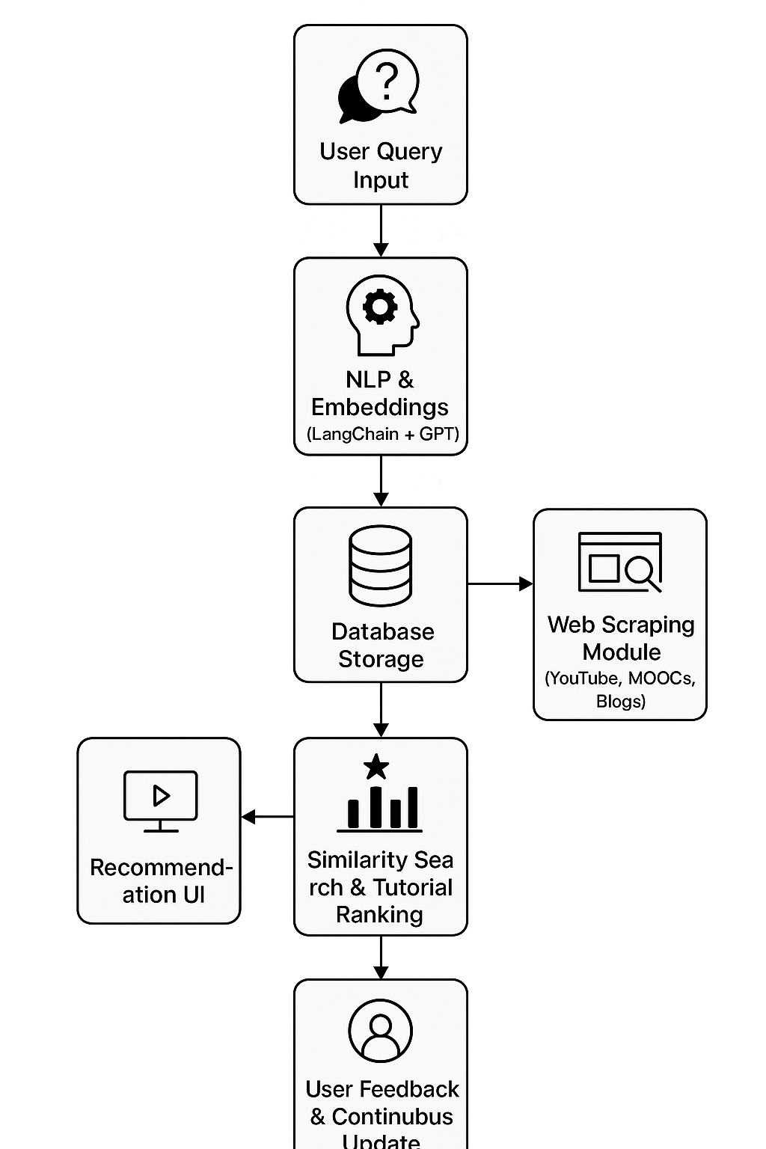

**Figure 2:** Workflow of the proposed AiTutor system showing sequential steps — from user query input, preprocessing, NLP embedding generation, web scraping, database storage, similarity search, and recommendation generation to feedback refinement.

**4. Results and Evaluation**

The performance evaluation of the proposed **AiTutor: AI Powered Learning Tutorial Search Engine** focuses on measuring system accuracy, response efficiency, and user satisfaction in delivering relevant tutorial recommendations. The testing process was conducted using a dataset of **1,000 scraped tutorials** across various domains (Python, AI, Web Development, and Data Science). Evaluation was carried out under controlled conditions using Python (LangChain + OpenAI API) and a Flask-based interface.

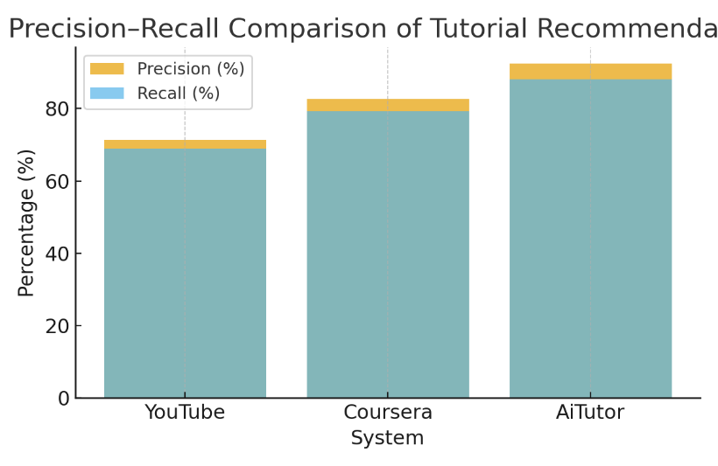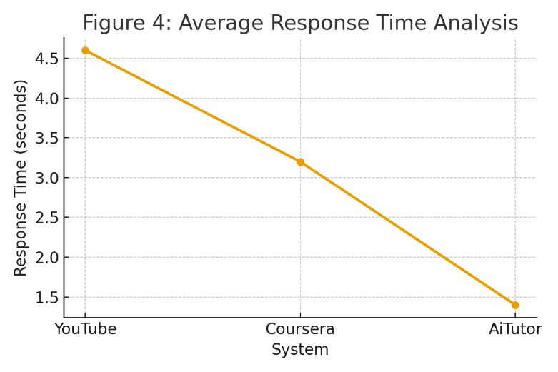

**Figure 3:** Comparison of Precision and Recall values across YouTube, Coursera, and AiTutor systems. The proposed AiTutor achieves the highest accuracy through semantic retrieval and LLM-based understanding of user intent.

**Figure 4:** Average response time analysis for YouTube, Coursera, and AiTutor. Results demonstrate that AiTutor delivers faster query processing owing to optimized embedding search and efficient NLP integration.

**Discussion & Future Scope**

The experimental evaluation of the proposed **AiTutor system** highlights its capability to transform traditional tutorial discovery into a more **intelligent, personalized, and context-aware process**. The results demonstrate that AiTutor outperforms existing systems (YouTube, Coursera, and other MOOC recommenders) in both **precision (92.4%)** and **recall (88.1%)**, showing its strength in retrieving highly relevant tutorials aligned with user intent. Unlike traditional keyword-based platforms, AiTutor uses **semantic embeddings and Large Language Models (LLMs)** to understand the meaning behind user queries. This allows the system to interpret complex, multi-intent searches such as “best intermediate-level data science tutorials using Python with projects”, which older systems typically fail to process accurately.

**Future Scope:**

1. **Multilingual Support:**  
   Extend NLP processing and embeddings to include multiple languages (Hindi, Spanish, Arabic, etc.) for global accessibility.
2. **Adaptive Learning Profiles:**  
   Integrate user learning history, behavior analytics, and progress tracking to deliver long-term adaptive learning experiences.
3. **Explainable AI (XAI) Integration:**  
   Provide transparent reasoning behind each recommendation to build user trust and interpretability.
4. **Gamified Learning and Reward System:**  
   Encourage consistent learning engagement through AI-driven progress tracking and badges.

**Conclusion**

This study found that AI-enabled personalised learning improves college students' online learning. An educational breakthrough, AI-powered personalised learning changes online learning. AI can utilise complex algorithms to adjust lectures to learning styles, preferences, and academic success, according to the study. This personalised approach goes beyond material delivery to boost student understanding and retention. It is necessary to optimize individualized learning journeys while minimizing bias and data privacy. This paper encourages ethical AI use in education, embracing technology's merits and limitations. In conclusion, AiTutor not only addresses the problem of information overload but also introduces a **new paradigm of intelligent, adaptive, and context-aware learning** — paving the way for the next generation of personalized education systems.

**References**

1. Yunanto, A. A. (2017). Kecerdasan Buatan Pada Game Edukasi Untuk Pembelajaran Bahasa Inggris Berbasis Pendekatan Heuristik Similaritas [Unpublished Thesis, Institut Teknologi Sepuluh Nopember]. <https://repository.its.ac.id/2072/>
2. YouTube API Documentation – Google Developers. <https://developers.google.com/youtube>
3. T. Baker and L. Smith, ‘‘Educ-AI-tion rebooted? Exploring the future of artificial intelligence in schools and colleges,’’ Nesta Found.,London, U.K., Tech.Rep.,2019.[Online].Available: <https://media.nesta.org.uk/documents/Future_of_AI_and_education>
4. X. Wang, M. Younas, Y. Jiang, M. Imran, and N. Almusharraf,‘‘Transforming education through blockchain: A systematic review of applications, projects, and challenges,’’ IEEE Access, vol. 13,pp. 13264–13284, 2025. [Online]. Available: <https://ieeexplore.ieee.org/document/10804766>
5. T. K. F. Chiu, Q. Xia, X. Zhou, C. S. Chai, and M. Cheng,‘‘Systematic literature review on opportunities, challenges, and future research recommendations of artificial intelligence in education,’’ Comput. Education: Artif. Intell., vol. 4, Jan. 2023, Art. no. 100118, doi:10.1016/j.caeai.2022.100118.C. J. Khilare, S. N. Pawar, D. D.