VISVESVARAYA TECHNOLOGICAL UNIVERSITY,
BELAGAVI , KARNATKA-590014


A Seminar Report on

Blockchain-based Electronic
Voting System for Modern Democracy
SUBMITTED BY:

Amarjeet Kumar

In partial fulfillment of requirements for the degree of

Bachelor of Engineering In
Computer Science & Engineering



Department of Computer Science and Engineering
Shri Madhwa Vadiraja Institute of Technology & Management
Vishwothama Nagar, Bantakal-574 115 [2023-2024]

Shri Madhwa Vadiraja Institute of Technology & Management
Vishwothama Nagar, Bantakal-574 115


DEPARTMENT OF COMPUTER SCIENCE & ENGINEERING

CERTIFICATE

Certified that the Seminar on topic Blockchain-based Electronic Voting System for Modern Democracy has been successfully presented at Shri Madhwa Vadiraja Institute of Technology by Amarjeet Kumar, bearing USN 4MW20CS008, in partial fulfillment of the requirements for the VIII Semester degree of Bachelor of Engineering in Computer Science and Engineering of Visvesvaraya Technological University, Belagavi during academic year 2023-2024.

Ms. Bharthi | Dr. Sowmya J Bhat Ms. Bharthi
Seminar Guide | Head of Department (HOD) Seminar Coordinator

ACKNOWLEDGEMENT
I am using this opportunity to express my deepest gratitude and special thanks to my seminar guide, Ms. Bharthi, Department of Computer Science and Engineering for her valuable support, guidance and encouragement which has been absolutely helpful in successful completion of the seminar.

My heartfelt gratitude to my seminar coordinator, Ms. Bharathi, Assistant Professor, Department of Computer science and engineering who in spite of being extraordinarily busy with her duties, took time out to hear, guide and keep me on the correct path and allowing me to carry out my seminar and for her valuable suggestions and guidance in the preparation of the seminar report. I will be failing in duty if I do not acknowledge with grateful thanks to the authors of the references and other literatures referred to in this seminar.
I perceive as this opportunity as a big milestone in my career development. I will strive to use gained skills and knowledge in the best possible way, and I will continue to work on their improvement, in order to attain desired career objectives.

AMARJEET KUMAR 4MW20CS008

Contents Page No
Acknowledgement i
Table of Contents ii
Figures and Tables iii
Abstract iv
Chapter 1 Introduction 1-2
  - Background 1
  - Blockchain for Electronic Voting System 3
Chapter 2 Literature Survey 5-6
Chapter 3 Blockchain-Based Voting System Implementation 7-9
  - Steps in performing Blockchain-Based Voting System
    - Requirements Analysis and Design
    - Development of Smart Contracts
    - Deployment of Blockchain Network
    - Voter Registration
    - Voting Process
    - Vote Tallying and Results Verification
    - Post-Election Procedures and Audits
    - Regulatory Compliance and Legal Framework
  - Advantages and Disadvantages of Blockchain-Based Voting System 10
Conclusion 12
Bibliography 13

Figure | Figure Name | Page No
Figure 1.1.1 | Blockchain Structure | 1
Figure 1.1.2 | Comparison b/w traditional and blockchain voting system | 2
Figure 1.2.1 | Characteristics of Blockchain Architecture | 3
Figure 1.2.2 | Blockchain-voting-systems-architectural-overview | 4
Figure 3.1 | Blockchain Based Voting System | 7
Figure 3.1.5 | Electronic Voting | 8
Figure 3.1.8 | Security requirements for electronic voting system | 9

ABSTRACT

Amidst the era of digital transformation, the landscape of democracy undergoes a profound evolution, accompanied by a shift in the mechanisms through which citizens engage in the electoral process. Traditional paper-based voting systems, long plagued by inefficiencies, security breaches, and doubts surrounding election integrity, face a pressing need for innovation. In response to these challenges, the integration of blockchain technology into electronic voting systems emerges as a promising solution, offering unparalleled levels of transparency, security, and accessibility. This abstract introduces an innovative blockchain-based electronic voting system poised to revolutionize modern democracy.

The envisioned system harnesses the immutability and decentralized architecture of blockchain to ensure the integrity and credibility of the electoral process. Employing cryptographic techniques, each vote is securely recorded on the blockchain, forming an indelible and tamper-proof ledger of all transactions. This not only eradicates the threat of fraudulent activities like double voting or ballot manipulation but also enables instantaneous verification of election outcomes, instilling greater trust among voters and stakeholders. Moreover, the decentralized nature of blockchain prevents any single entity from wielding control over the voting process, thereby safeguarding against central points of failure and reducing the susceptibility to external interference or manipulation.

Additionally, the adoption of a blockchain-based electronic voting system fosters inclusivity and accessibility by allowing citizens to cast their votes conveniently from any location with internet connectivity. By eliminating geographical barriers and offering alternative avenues for participation, such as mobile voting applications, the system empowers marginalized communities and enhances voter turnout. Furthermore, the transparency and auditability inherent in blockchain technology facilitate independent scrutiny and oversight, reinforcing democratic principles of accountability and equity. Overall, the integration of blockchain into electronic voting systems represents a monumental stride towards unlocking the full potential of modern democracy, nurturing increased trust, participation, and legitimacy in electoral processes.

Chapter 1

INTRODUCTION

Background

In the era of digital advancement, conventional voting methodologies are undergoing a profound rethinking to tackle persistent hurdles such as security vulnerabilities, operational inefficiencies, and accessibility constraints. With the pervasive integration of technology into societal frameworks, there emerges an escalating demand for inventive solutions capable of augmenting the credibility and inclusivity of democratic procedures. Among these solutions, the adoption of blockchain technology within electronic voting systems is gaining considerable momentum.

Blockchain, the decentralized and immutable ledger that underpins cryptocurrencies such as Bitcoin, presents an innovative avenue for remedying the limitations inherent in traditional voting mechanisms. By harnessing cryptographic principles and distributed consensus mechanisms, blockchain-powered electronic voting systems aspire to redefine the conduct of elections, ushering in unprecedented levels of transparency, integrity, and accessibility.

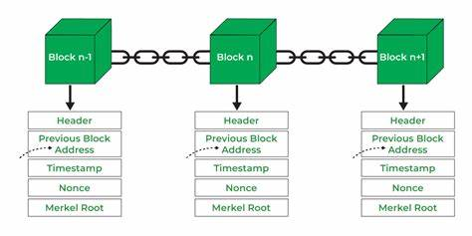

    - Blockchain Structure

Through the utilization of blockchain technology, each ballot cast is securely recorded and time-stamped, establishing an immutable trail of transactions. This not only mitigates the risks associated with tampering and fraudulent activities but also facilitates instantaneous verification of election outcomes, instilling heightened confidence among voters and stakeholders alike. Furthermore, the decentralized nature of blockchain architecture ensures that no single entity holds dominion over the voting process, thereby mitigating the potential for undue influence or manipulation.

Moreover, blockchain-based electronic voting systems have the potential to enhance accessibility by enabling citizens to participate conveniently from any location with internet connectivity. By eliminating geographical barriers and offering alternative avenues for engagement, such as mobile voting applications, these systems empower individuals from diverse demographics to partake in the democratic process.

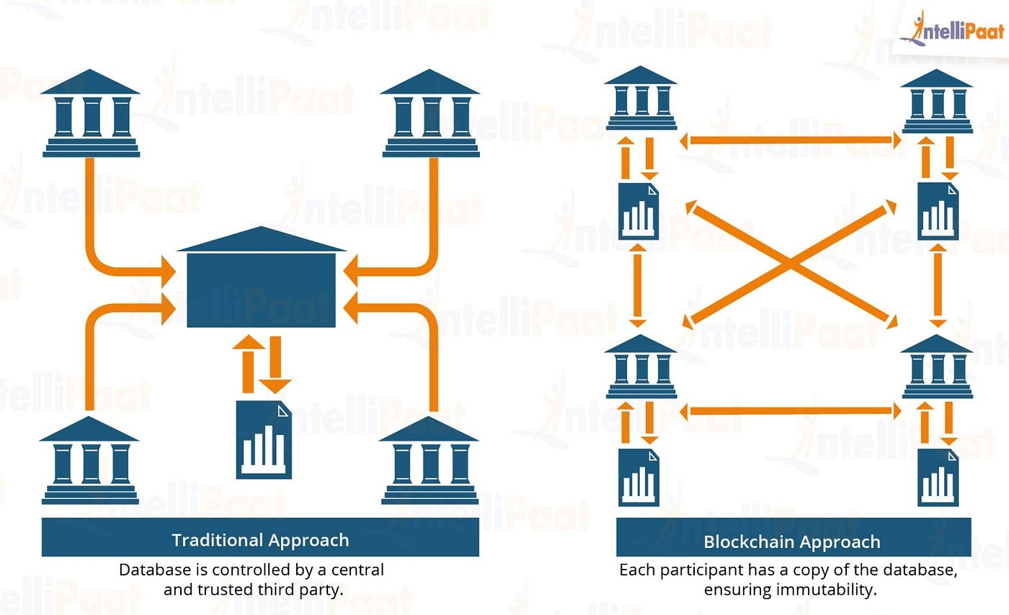

    - Comparison b/w traditional and blockchain voting system

Blockchain for Electronic Voting System

Blockchain technology emerges as a revolutionary remedy for revitalizing the electoral process in democratic societies via the implementation of electronic voting systems. Through harnessing the decentralized and immutable attributes of blockchain, these systems provide unmatched levels of security, transparency, and accessibility. In stark contrast to traditional voting methodologies, where reliance is vested in centralized authorities, blockchain-based electronic voting systems distribute trust across a network of nodes, rendering it exceedingly challenging for any singular entity to manipulate or compromise the integrity of the voting proceedings. Each ballot cast is securely encrypted and logged on an incorruptible ledger, guaranteeing that the outcomes remain transparent and open to scrutiny by all vested parties.
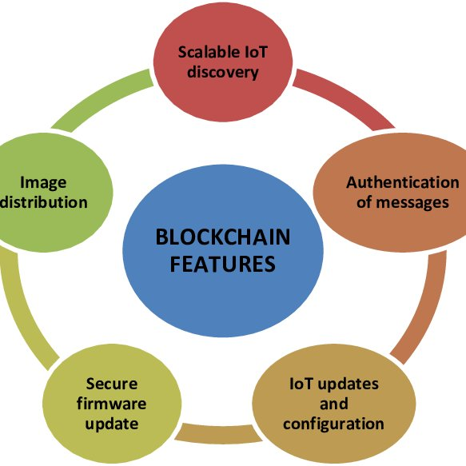
    - Characteristics of Blockchain Architecture

Moreover, blockchain-driven electronic voting systems tackle persistent issues of inclusivity and accessibility in democratic elections. By leveraging digital platforms and mobile applications, voters can engage in the electoral process from any corner of the globe, eliminating hurdles like geographical limitations and mobility constraints. This facilitates heightened voter turnout and involvement, particularly among marginalized demographics encountering obstacles in accessing traditional polling venues. Additionally, the traceability and openness inherent in blockchain technology enable impartial verification of election outcomes, bolstering trust in the democratic process and reinforcing fundamental democratic values of answerability and validity. Consequently, the incorporation of blockchain into electronic voting systems marks a notable advancement in propelling contemporary democracy forward, laying the groundwork for more fortified, inclusive, and transparent-electoral
practices.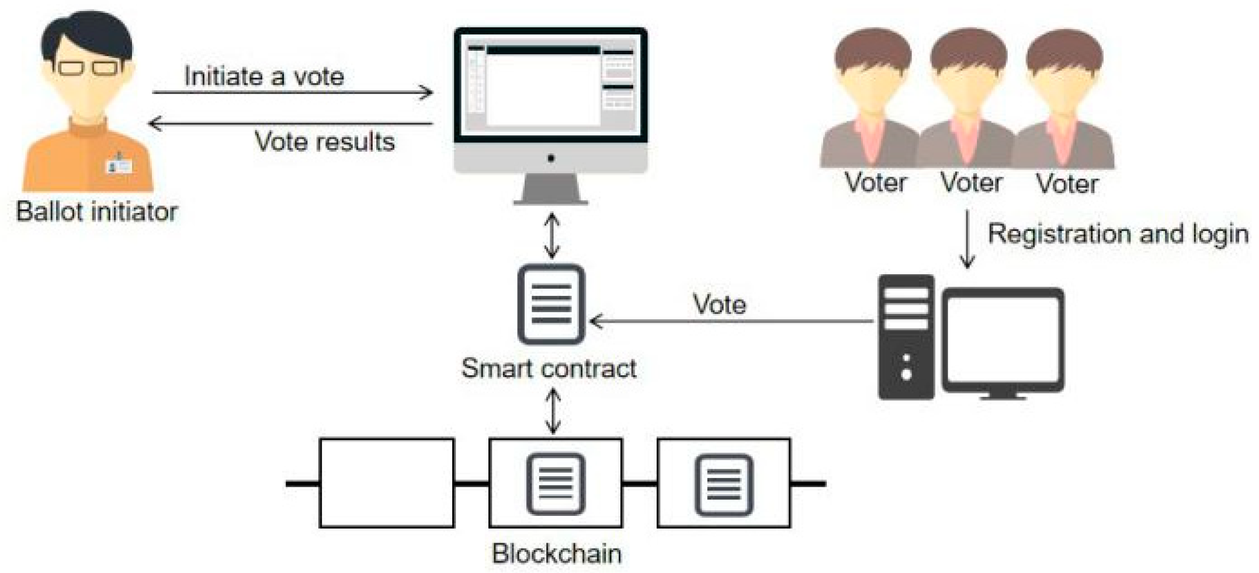

    - Blockchain-voting-systems-architectural-overview

Chapter 2

LITERATURE SURVEY

D. Weiss, J. Wolmer and A. Vatsa, "Blockchain-based Electronic Voting System for Modern Democracy: A Review," 2022:
This paper underscores the critical role of electoral integrity in bolstering public trust and accountability within democracies. By leveraging blockchain technology, electronic voting systems can ensure security, integrity, and trust, vital pillars of modern democracy. Blockchain principles such as universal ownership and immutable transaction records fortify e-voting systems, offering a cheaper, faster, and more transparent alternative. Smart Contracts eliminate intermediaries, providing digital proof of transactions and ensuring certification of votes.

J. Wolmer, A. Vatsa and D. Weiss, "Retrieval of Data from the Database of a BCT–Voting System," 2022:
This paper introduces BCT-Voting, a secure and decentralized blockchain-based electronic voting system designed to enhance transparency and public trust in modern democracy. Deployed on the Ethereum framework, BCT-Voting incorporates five modules to manage the nomination process, voter identity, vote integrity, donation tracking, and final vote tallying. To address data retrieval challenges, the paper proposes Ethereum Query Language (EQL) for querying smart contract
data, enabling efficient audits while safeguarding voter privacy.
- A. Mendon, B. Manoj Votavat and A. Lodh, "Blockchain based e-voting system," 2022. This paper delves into the potential of Blockchain Technology as a solution to address the shortcomings of electoral systems worldwide, including in powerful democracies like India, the United States, and Japan. It explores the fundamental workings and characteristics of Blockchain from scratch, emphasizing its application in public voting systems.

S. Prakash, V. Sahu and L. Kumar, "Blockchain Based E-Voting System," 2022:
This research presents the implementation of an e-voting system utilizing blockchain technology within a Django web application framework. Addressing the shortcomings of traditional paper-based voting systems, the study aims to provide a more reliable, secure, and modern approach to democratic processes. By leveraging blockchain's inherent security features, the proposed system offers a robust solution to digital voting security concerns, ensuring integrity and trust in electoral outcomes.

V. Vijeya Kaveri, V. Meenakshi, A. S, A. P and K. B, "Blockchain based Reliable Electronic Voting Technology," 2022:
This research introduces a blockchain-based electronic voting system aimed at addressing the challenges of security and democratic responsibility in the digital age. By leveraging blockchain technology, the system offers decentralization, transparency, and the ability for voters to update their votes within specified timeframes, enhancing the integrity and verifiability of democratic processes.

Chapter 3

Blockchain-Based Voting System Implementation
Implementing a blockchain-based voting system involves several key steps to ensure its effectiveness, security, and usability.

  - 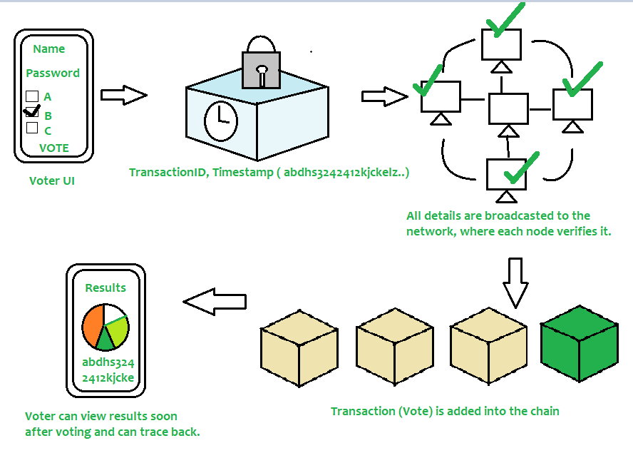Blockchain Based Voting System

3.1 Phases in Implementing Blockchain-Based Voting System

- Needs Assessment and Design: Initiate by outlining the prerequisites of the voting system, considering elements such as the electorate size, voting modalities (e.g., online, mobile), security protocols, and regulatory adherence. Based on these criteria, devise the framework of the blockchain-based voting system, encompassing the selection of suitable blockchain platforms (e.g., Ethereum, Hyperledger), consensus mechanisms, smart contracts, and user interfaces.
- Creation of Smart Contracts: Smart contracts are self-executing agreements with contract terms encoded directly into the code. Develop smart contracts to oversee the voting process, incorporating functionalities for voter enrollment, ballot formulation, vote submission, and tabulation. These intelligent contracts should be coded to uphold transparency, security, and impartiality throughout the voting process while safeguarding voter confidentiality.
- Establishment of Blockchain Network: Establish the blockchain network as the foundational infrastructure for the voting system. Depending on requirements and preferences, opt for public, private, or consortium blockchains. Deploy the smart contracts onto the blockchain network and configure requisite nodes to support decentralized consensus mechanisms.
- Voter Enrollment: Implement a robust voter enrollment mechanism to authenticate the identities of eligible voters and prevent fraudulent registrations. This may entail integrating identity verification measures such as biometrics, digital signatures, or government-issued identification documents. Ensure that voter registration data is encrypted and securely stored on the blockchain to preserve voter privacy.
- Voting Procedures: Develop intuitive interfaces (e.g., web portals, mobile applications) to streamline the voting process for participants. Enable voters to securely cast their ballots using cryptographic keys and digital signatures. Introduce mechanisms to thwart duplicate voting and ensure that each voter can only cast a single ballot per election. All cast votes should be logged as transactions on the blockchain in a transparent and immutable manner.

- 3.1.5 Digital Voting
Tabulation of Votes and Results Authentication: Upon conclusion of the voting period, tabulate the ballots recorded on the blockchain utilizing the smart contracts. Validate the integrity of the voting outcomes by permitting stakeholders, including voters and election monitors, to scrutinize the blockchain and independently authenticate the tabulation. Confirm that the voting results are transparent, verifiable, and resistant to tampering, fostering trust in the integrity of the electoral process.

- 7. Post-Election Procedures and Audits: Execute post-election procedures such as audits and recounts to address any disparities or issues arising during the voting process. Maintain a comprehensive audit trail of all activities and transactions on the blockchain for purposes of accountability and transparency. Continuously monitor the blockchain network for any suspicious activities or security breaches and take appropriate corrective actions.


3.1.5 Electronic Voting

- Post-Election Procedures and Audits: Conduct post-election procedures, such as audits and recounts, to address any discrepancies or concerns raised during the voting process. Maintain an audit trail of all activities and transactions on the blockchain for accountability and transparency purposes. Continuously monitor the blockchain network for any suspicious activities or security breaches and take appropriate measures to address them.
- Regulatory Compliance and Legal Framework: Ensure compliance with relevant regulations and legal requirements governing elections and data protection. Collaborate with election authorities, legal experts, and regulatory bodies to establish a legal framework for the blockchain-based voting system, addressing issues such as voter eligibility, data privacy, and dispute resolution.

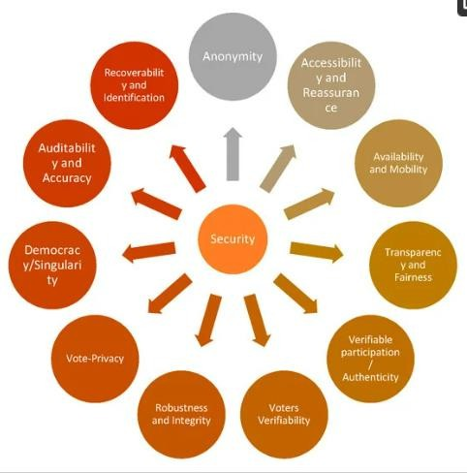
3.1.8 Security requirements for electronic voting system

Advantages and Disadvantages of Block-chain-Based Voting System

ADVANTAGES
3.1 Pros and Cons of Blockchain-Based Voting Systems
- Enhanced Security: Blockchain technology offers robust security measures by virtue of its decentralized and tamper-resistant architecture. Each vote is cryptographically secured and recorded on a distributed ledger, rendering it exceedingly challenging for malicious entities to tamper with or alter the voting data.
- Transparency and Verifiability: The transparent and immutable nature of blockchain ensures that all transactions, including votes cast, are documented and accessible to all network participants. This transparency fosters trust and confidence in the integrity of the electoral process, as stakeholders can independently authenticate the validity of the voting records.
- Immutable Records: Once recorded on the blockchain, voting data becomes immutable and impervious to modification or tampering. This eliminates the possibility of fraudulent activities such as duplicate voting, ballot manipulation, or tampering with election outcomes, thereby upholding the accuracy and integrity of the voting mechanism.
- Enhanced Accessibility: Blockchain-based voting systems can improve accessibility by enabling voters to participate remotely through digital platforms and mobile applications. This diminishes barriers to engagement, such as geographical constraints and mobility limitations, thereby encouraging broader voter participation, especially among underrepresented demographics.
- Decentralization: By dispersing authority and control across a network of nodes, blockchain-based voting systems reduce dependence on centralized authorities and intermediaries. This diminishes the vulnerability to single points of failure and fortifies the resilience and durability of the electoral process against external interference or manipulation.

DISADVANTAGES

- Technical Complexity: The implementation of a blockchain-based voting system demands specialized knowledge in blockchain technology, cryptography, and software development. Tasks such as crafting and deploying smart contracts, configuring blockchain networks, and ensuring compatibility with established voting infrastructures pose considerable technical hurdles and resource demands.
- Scalability Issues: Current blockchain solutions, particularly public ones like Ethereum, grapple with scalability challenges, especially when tasked with managing the high transaction volumes associated with large-scale elections. Scaling blockchain-based voting systems to accommodate millions of voters while maintaining efficiency and responsiveness remains a formidable obstacle.
- Privacy Considerations: While blockchain guarantees the security and immutability of voting data, it also raises concerns regarding voter privacy. Despite votes being recorded anonymously on the blockchain, the transparent nature of the ledger means that individual voting patterns could potentially be discerned, compromising the anonymity of voters.
- Voter Education and Acceptance: The introduction of blockchain-based voting systems necessitates comprehensive voter education efforts to familiarize the electorate with the technology and assuage concerns about its reliability and security. Garnering widespread adoption and trust in the new voting paradigm may require extensive public awareness campaigns and educational initiatives targeting voters.
- Regulatory and Legal Hurdles: Blockchain-powered voting systems may encounter regulatory obstacles and legal ambiguities, particularly concerning compliance with existing electoral statutes and regulations. Establishing a robust legal framework addressing issues such as voter eligibility, data confidentiality, dispute resolution, and auditability is imperative for the successful implementation and adoption of blockchain-based voting solutions.

CONCLUSION

In summary, the integration of a blockchain-driven electronic voting framework offers immense potential for advancing the fundamental tenets of contemporary democracy. By leveraging the capabilities of blockchain technology, such a framework provides unprecedented levels of security, transparency, and inclusivity within the electoral sphere. The inherent immutability and decentralization of blockchain ensure the integrity of each vote, effectively safeguarding against any attempts at tampering or manipulation, while concurrently delivering verifiable and instantaneous results.

Moreover, by eradicating geographical barriers and providing alternative avenues for engagement, such as mobile voting platforms, blockchain-powered voting systems foster inclusivity and empower citizens to exercise their democratic privileges with greater ease and convenience.

Furthermore, the adoption of blockchain in electronic voting processes bolsters the overall trust and credibility of democratic mechanisms. Through its transparent and incorruptible ledger, blockchain instills confidence among voters and stakeholders alike, alleviating concerns and skepticism regarding the impartiality and precision of election outcomes. Additionally, the decentralized architecture of blockchain mitigates the risks associated with centralized control or external interference, ensuring the resilience and integrity of electoral procedures.

As we navigate the complexities inherent in contemporary governance, embracing blockchain-enabled electronic voting mechanisms signifies a pivotal stride towards cultivating enhanced trust, participation, and transparency within democratic frameworks.

BIBLIOGRAPHY
- D. Weiss, J. Wolmer and A. Vatsa, "Blockchain-based Electronic Voting System for Modern Democracy: A Review," 2022.

- Weiss, Dylan & Wolmer, Jacob & Vatsa, Avimanyou. (2022). Blockchain-based Electronic Voting System for Modern Democracy.

- T. Kim, J. Ochoa, T. Faika, H. A. Mantooth, J. Di, Q. Li, et al., "An overview of Cyber-Physical security of battery management systems and adoption of blockchain technology", IEEE Journal of Emerging and Selected Topics in Power Electronics, vol. 10, no. 1, pp. 1270-1281, 2022

- Syada Tasmia Alvi, Mohammed Nasir Uddin, Linta Islam and Sajib Ahamed, "DVTChain: A blockchain-based decentralized mechanism to ensure the security of the digital voting system",Journal of King Saud University - Computer and Information Sciences, vol. 34, pp. 6855- 6871, 2022.

- S. Mookherji, O. Vanga and R. Prasath, "Blockchain-based e-voting protocols", Blockchain Technology for Emerging Applications, pp. 239-266, 2022.

- Lundkvist, M. I., & Åström, J. (2020). Security and transparency aspects of blockchain for electronic voting systems. IEEE Access, 8, 144007-144022.

