**Spark Local Installation**

**Installing java 8**

<https://www.oracle.com/in/java/technologies/javase/javase8-archive-downloads.html>

To verify the installation: java –version

**Installing Scala**

<https://www.scala-lang.org/download/2.13.11.html>

To verify the installation: scala –version

**Installing Apache Spark**

<https://spark.apache.org/downloads.html>

To verify the downloaded file use the command

**certutil –hashfile C:\users\xs334-amakum\Downloads\spark-3.4.0-bin-hadoop3-scala2.13.tgz SHA512**

Match the output given by the above code with the value given under checksum in the downloads page

After downloading use the following commands in PowerShell:

Step 1: cd \

Step 2: mkdir spark

Step 3: Now extract the downloaded spark (.tgz file) in the spark directory

Step 4: Move to the directory containing the extracted file

Step 5: Download winutils.exe from : <https://github.com/cdarlint/winutils>

Step 6: Set the environment variables like **HADOOP_HOME**, **JAVA_HOME**, **SPARK_HOME**, etc.

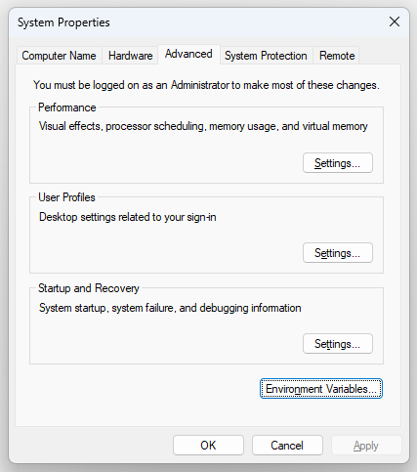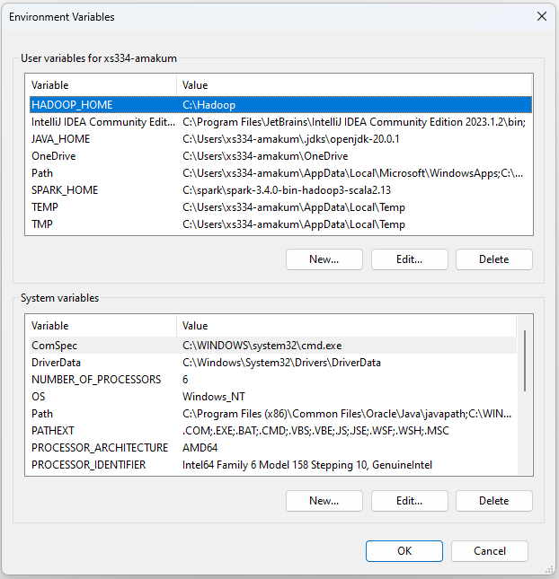

Step 7: Set the path variables

Step 8: Finally, to run spark, go to the directory containing the extracted spark file and then enter **spark-shell**

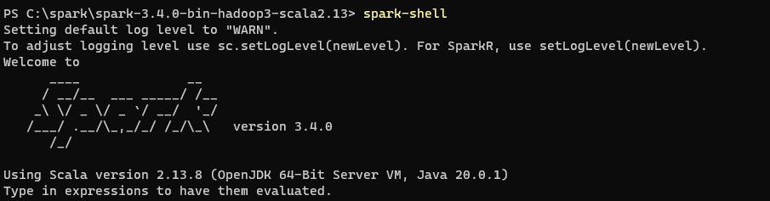

To stop the spark-shell enter **:quit**