**Reminder**

(Tech Spec Document)

Class Diagram

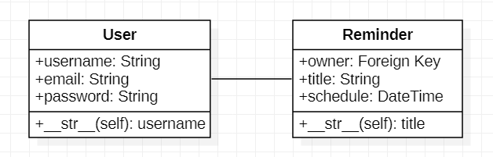

Sequence Diagram

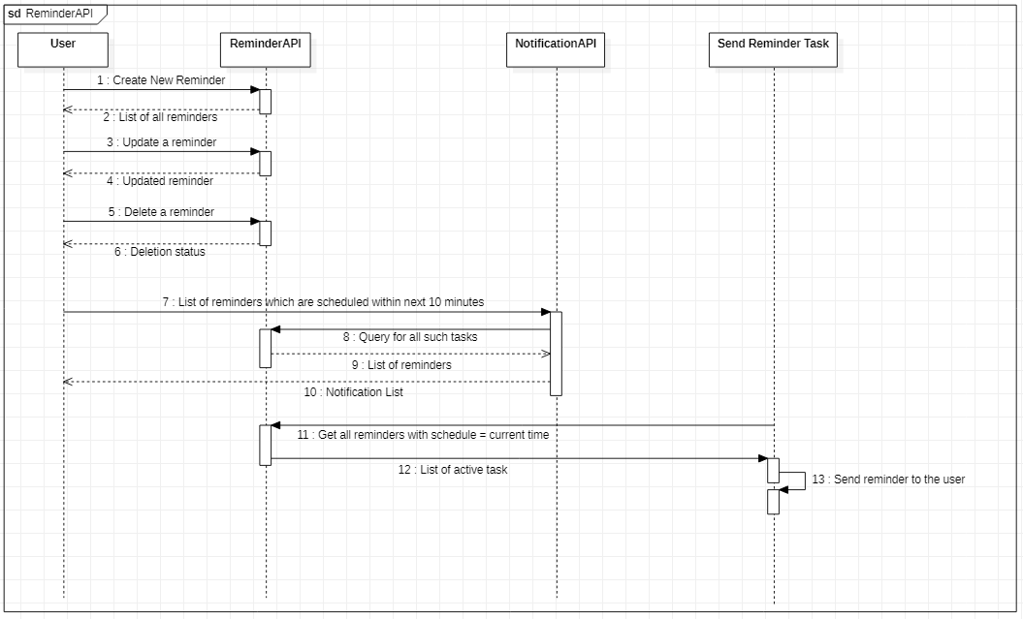

Dependency

Celery (For performing async task)

APIs

1. User Registration API

|  |  |
| --- | --- |
| REQUEST | RESPONSE |
| POST http://localhost:8000/api/user HTTP/1.1  Content-Type: application/json  {  “username”: “xyz”,  “email”: [xyz@gmail.com](mailto:xyz@gmail.com),  “password”: “123”  } | HTTP 201 CREATED |

1. Reminder API

|  |  |
| --- | --- |
| REQUEST | RESPONSE |
| GET http://localhost:8000/api/reminders HTTP/1.1  Accept: application/json | **{**  **"success": true,**  **"data": {**  **"reminder": {**  **"pk": 1,**  **"title": "Team Meeting",**  **"schedule": "2021-02-24T13:02:11"**  **}**  **}**  **}** |
| POST http://localhost:8000/api/reminders HTTP/1.1  Content-Type: application/json  {  “title”: “Meeting 1”,  "schedule": "2021-02-24T17:00:00"  } | HTTP 201 CREATED |
| PUT http://localhost:8000/api/reminders/1 HTTP/1.1  Content-Type: application/json  {  “title”: “Team Meeting”,  "schedule": "2021-02-24T17:00:00"  } | **{**  **"success": true,**  **"data": {**  **"reminder": {**  **"pk": 1,**  **"title": "Team Meeting",**  **"schedule": "2021-02-24T13:02:11"**  **}**  **}**  **}** |
| PATCH http://localhost:8000/api/reminders HTTP/1.1  Content-Type: application/json  {  “title”: “Team meet”  } | **{**  **"success": true,**  **"data": {**  **"reminder": {**  **"pk": 1,**  **"title": "Team meet",**  **"schedule": "2021-02-24T13:02:11"**  **}**  **}**  **}** |
| DELETE http://localhost:8000/api/reminders/1 HTTP/1.1 | HTTP 204 NO CONTENT |

1. Notification API

|  |  |
| --- | --- |
| REQUEST | RESPONSE |
| GET http://localhost:8000/api/notifications HTTP/1.1  Accept: application/json | **{**  **"success": true,**  **"data": {**  **"notification": {**  **"pk": 3,**  **"title": "Sprint meeting",**  **"schedule": "2021-02-24T13:02:11"**  **}**  **}**  **}** |