Proxy at the top

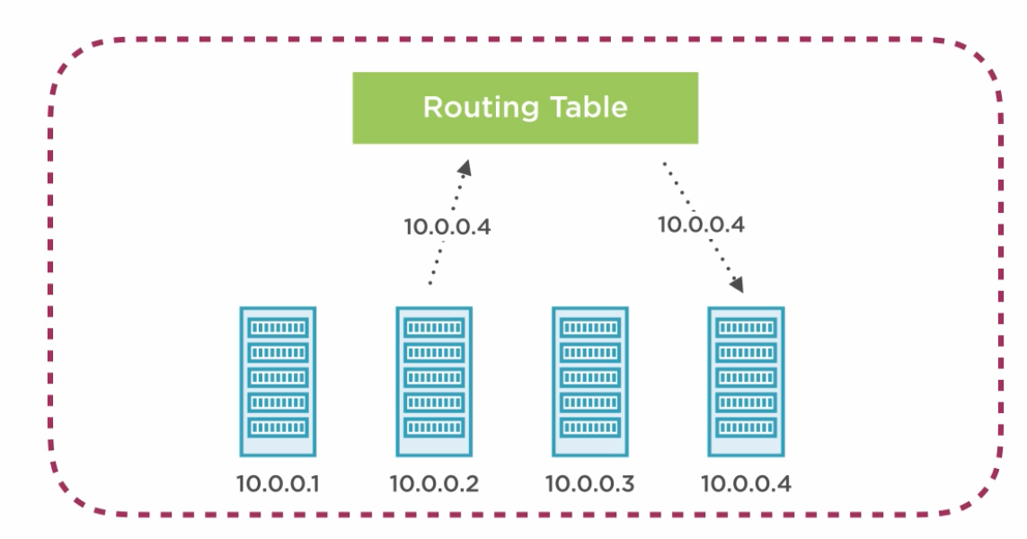

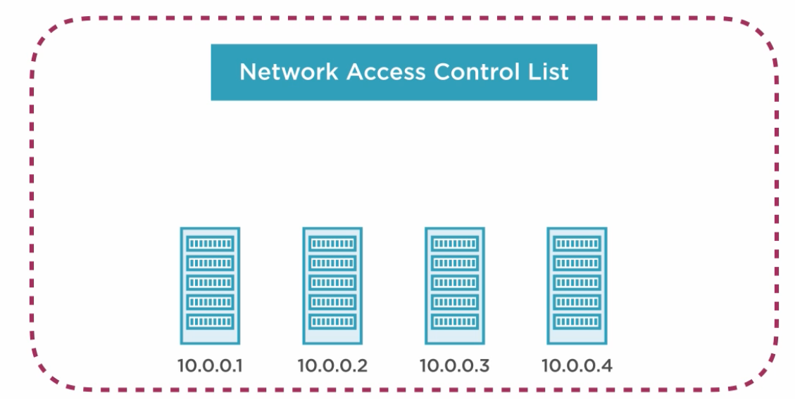

Create a VPC in one AZ?, Tenancy default or dedicated (Dedicated Servers)

Create Subnets (select VPC) only one subnet is in one AZ

Amazon resverse 3 ips

Create one internet gateway (need to attach to VPC)

Create a route table

Edit route table

Create a route to the internet gataway

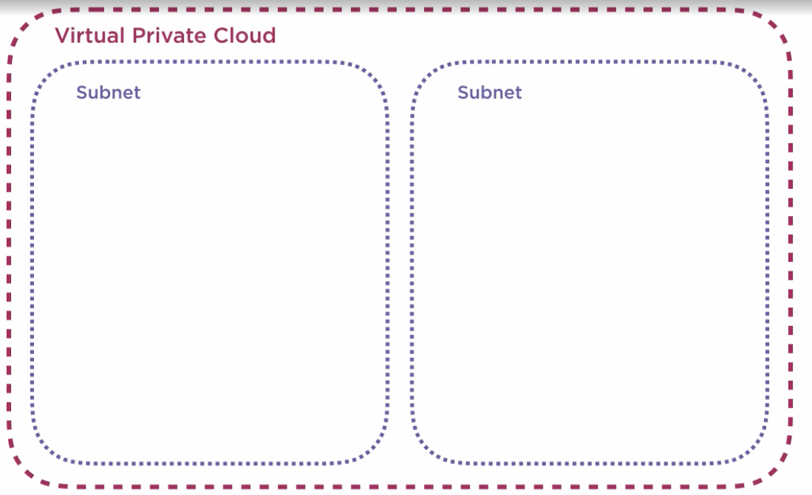

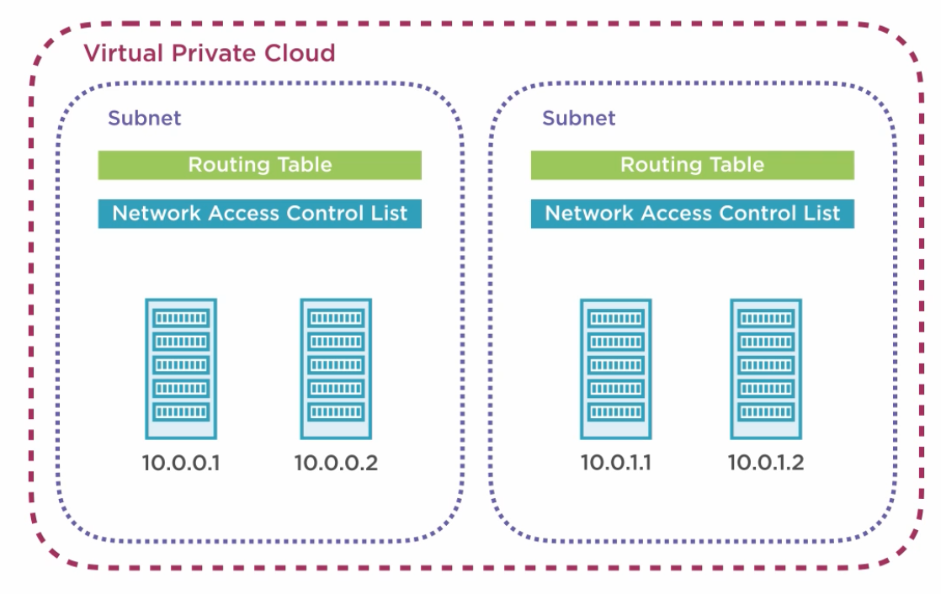

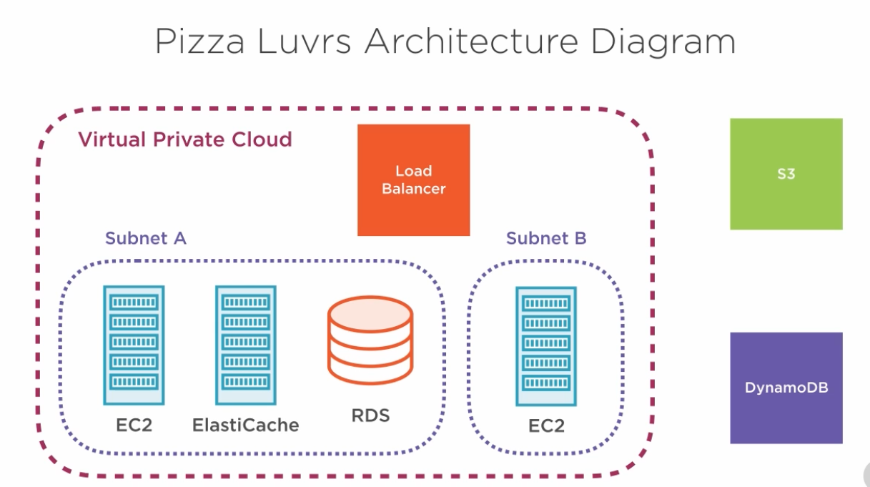

**VPC**

Create VPC

**Routing**

Update Routing table

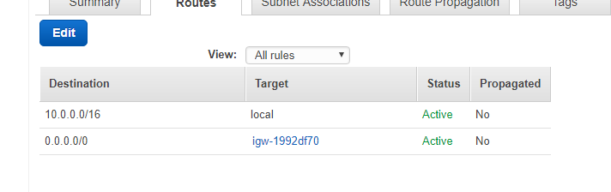

Add

Des * to Target (default SG)

**Subnet**

Create additional subnet (Subnet B) in VPC