LiRA Membership Inference Attack
Methodology, Implementation, and Findings · Standard vs. Differentially Private Classifiers
Companion report to “An Empirical Study of the Privacy-Utility Trade-off in Differentially Private Classifiers” (CIIT 2026)

1. What is the LiRA attack?
LiRA stands for the Likelihood Ratio Attack. It is a way to test whether a particular person's record was used to train a machine-learning model. This kind of test is called a membership inference attack (MIA).
Why does this matter for medical data? Imagine a model trained only on gallstone patients. If an attacker can confirm that your record was in that model's training set, they have effectively learned that you are a gallstone patient — a real privacy breach. Differential Privacy (DP) is the defence we test against this exact threat.
LiRA (Carlini et al., IEEE S&P 2022) is currently the strongest practical version of this attack, so it gives us the most honest, worst-case picture of how much our models leak.

Why LiRA, and not just the earlier attacks?
The study already used two older attacks (Yeom and Shokri). Those are “average-case” — they apply one rule to everybody and usually report a score near 0.5, meaning “on average you can barely guess.” LiRA is different: it looks at each record one at a time. This lets it catch the few specific patients who are badly exposed, even when the average looks safe.
The key number to watch: TPR @ 1% FPR — how many real training members the attacker correctly catches while almost never falsely accusing an outsider. Pure guessing scores 0.01. Anything much higher than 0.01 is real leakage.

2. How LiRA works (in plain steps)
For each record we want to test, LiRA does the following:
- Train many “shadow” models of the same type, on random halves of the real data. For each one, the record is either IN or OUT of its training data.
- For every shadow model, record how confident it is about that record, and put that confidence on a stable scale (the logit transform).
- Build two bell curves: one for the confidences when the record WAS used in training, and one for when it was NOT.
- Ask the real target model how confident it is about the record, and see which bell curve that confidence fits better.
- If it fits the “was trained on” curve, the record is flagged as a member. Sweep this across all records to measure the attack's success.
In short: a model that memorised a patient will look unusually confident about that patient, and LiRA detects exactly that giveaway.

3. How we ran it in this study
Setting | What we used
Models attacked | The exact trained models the paper reports on (LR, RF, GNB, SVM, DNN), both Standard and DP versions
Shadow models | 32 per target, trained on real random halves of the data
Privacy budgets (ε) | 0.1, 0.4, 0.8, 1.0, 2.0, 10.0
Members vs non-members | Members = the model's training set; non-members = the held-out test set
Attack mode | Online LiRA (the strongest setup)

One honest caveat: the DNN shadow models are not private even when attacking a DP-DNN target, and the strictest 0.1% FPR number is limited by how many non-members exist. So we treat the 1% FPR figure as the reliable worst-case number.

Datasets attacked
Dataset | Train / Test | Classes
GALLSTONE | 255 / 64 | 2
KIDNEY_STONE | 3,200 / 800 | 2
KIDNEY_FUNCTION | 4,000 / 1,000 | 2
LUNG_CANCER | 40,000 / 10,000 | 3

Note the huge size range — the largest dataset has about 157 times more training records than the smallest. This size difference turns out to be the most important factor in the results.

4. Results
All numbers below are TPR @ 1% FPR (random guessing = 0.01), with the attack AUC in brackets (0.5 = random). Higher means more leakage.

4.1 Standard (non-private) models — who leaks?
Model | GALLSTONE (n=255) | KIDNEY_STONE (3,200) | KIDNEY_FUNCTION (4,000) | LUNG_CANCER (40,000)
RF | 0.953 (0.998) | 0.026 (0.610) | 0.017 (0.523) | 0.011 (0.500)
LR | 0.008 (0.645) | 0.017 (0.497) | 0.006 (0.508) | 0.008 (0.497)
GNB | 0.008 (0.484) | 0.011 (0.499) | 0.011 (0.500) | 0.012 (0.498)
SVM | 0.000 (0.482) | 0.016 (0.494) | 0.010 (0.494) | 0.011 (0.500)
DNN | — | 0.017 (0.508) | — | 0.010 (0.501)

Reading this: almost every cell is near 0.01 (safe). The one glaring exception is Random Forest on GALLSTONE at 0.953 — about 95 times the safe baseline.

4.2 Effect of DP on GALLSTONE (the only dataset that really leaked)
Model | Standard TPR@1% | DP best TPR@1% | DP test acc | Standard test acc
RF | 0.953 | 0.004 (ε=0.4) | 0.69 | 0.80
LR | 0.008 | 0.004 (ε=0.1) | 0.61–0.77 | 0.81
GNB | 0.008 | 0.000 (ε=0.8/1.0) | 0.47–0.56 | 0.55
SVM | 0.000 | 0.012 (ε=0.8) | 0.53 | 0.50

Across every GALLSTONE DP model and every ε, the worst leftover leakage is just 0.043. DP turns the dangerous 0.953 RF leak into essentially noise.

5. The graphs, explained simply
Colours are kept the same in every graph so they are easy to compare: Random Forest is red, Logistic Regression is blue, Gaussian Naive Bayes is green, SVM is purple, and the Deep Neural Network is orange.

Graph 1 — Which standard models leak?
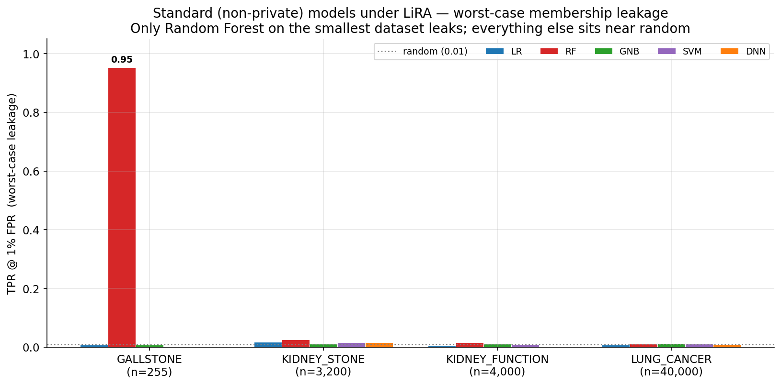
Figure 1. Worst-case leakage (TPR @ 1% FPR) of every non-private model, grouped by dataset.
What it shows: one tall red bar on the far left — Random Forest on GALLSTONE — reaching 0.95. Every other bar is flat against the floor.
Finding: Only one configuration is dangerous: a Random Forest trained on the small (255-record) gallstone data. It has basically memorised its patients. All the simpler models, and all models on bigger data, sit at the safe random level.

Graph 2 — Why dataset size matters
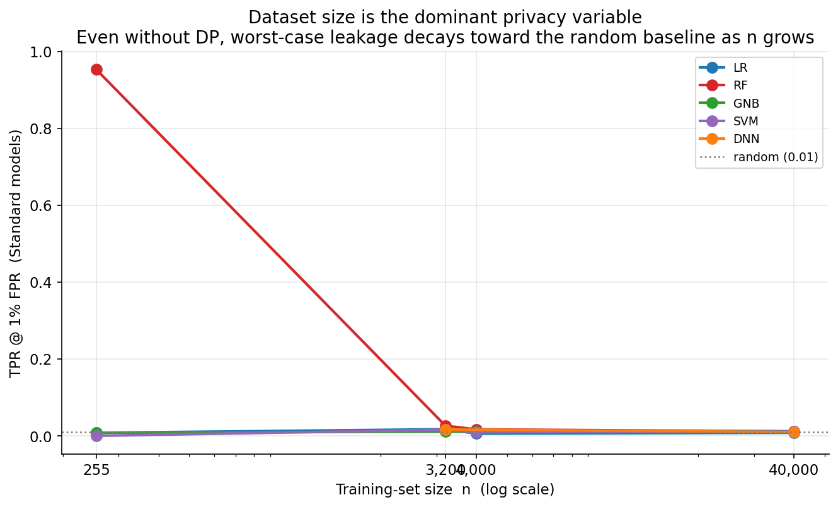
Figure 2. Standard-model leakage versus training-set size (size shown on a log scale).
What it shows: the red Random Forest line starts very high at 255 records and crashes down to the safe baseline as the datasets get bigger. The other lines are already low and stay low.
Finding: More data means more privacy, even with no protection added. When a model sees tens of thousands of records, no single patient stands out enough to be identified.

Graph 3 — What DP does on the risky dataset
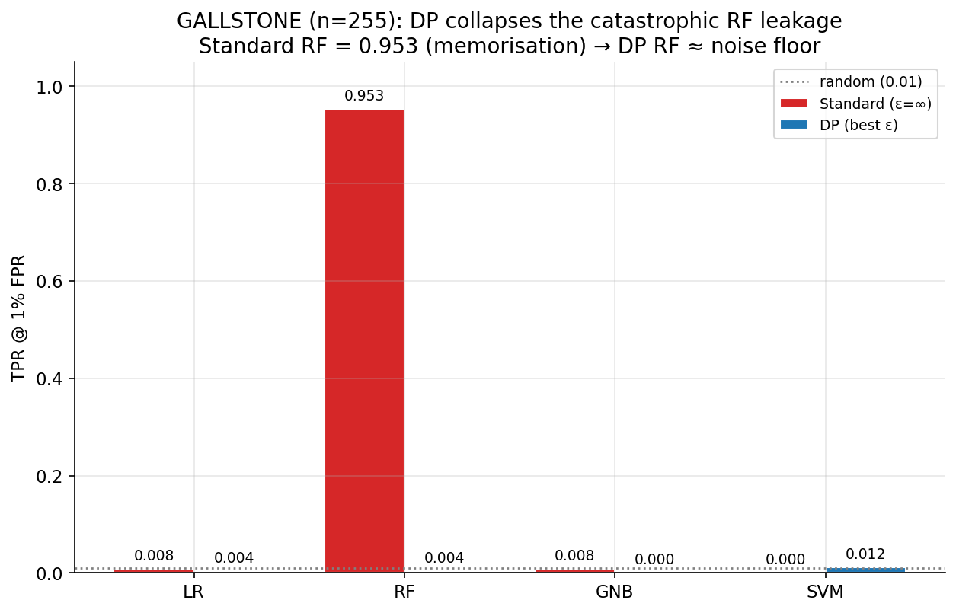
Figure 3. GALLSTONE: leakage of each Standard model (red) versus its best differentially private version (blue).
What it shows: the red Standard Random Forest bar towers at 0.95; its blue DP version is squashed down to almost nothing. The other models were already low and stay low.
Finding: Differential Privacy completely removes the Random Forest memorisation problem, pulling the leak down to the random baseline.

Graph 4 — DP-Random Forest across all datasets
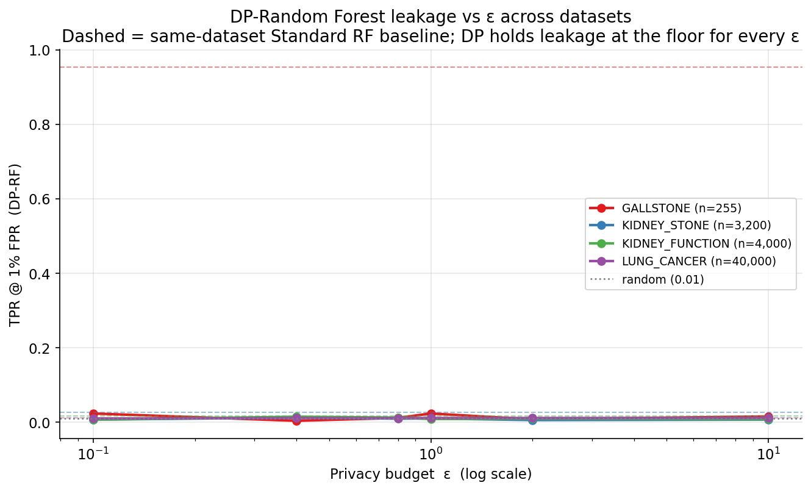
Figure 4. Leakage of the differentially private Random Forest as the privacy budget ε changes, for each dataset. Dashed lines mark each dataset's non-private baseline.
What it shows: every DP-RF line stays flat along the bottom no matter the value of ε. The dashed GALLSTONE baseline sits far above, off the top.
Finding: Once DP is applied, the Random Forest stops leaking at every privacy setting we tried — the protection is robust across the whole ε range.

Graph 5 — The full attack-strength heatmap
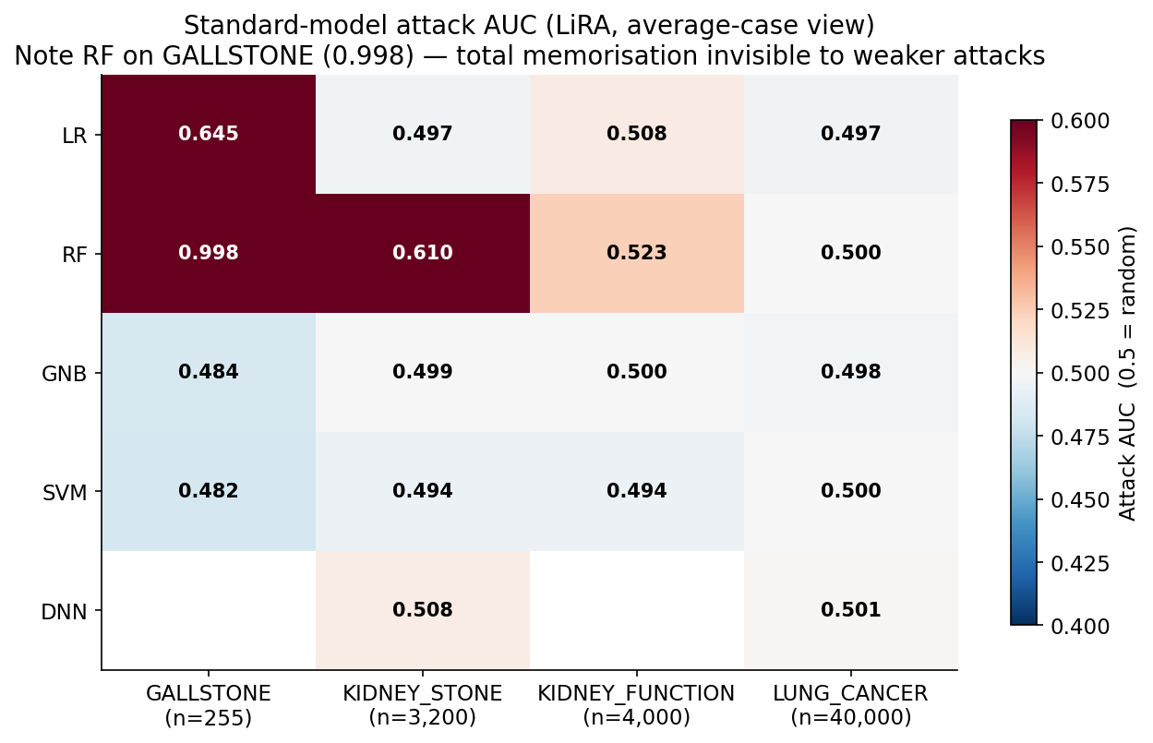
Figure 5. Attack AUC for every Standard model and dataset. Blue = safe (near 0.5), red = the attack works.
What it shows: a grid that is mostly pale (safe), with two strong red squares for Random Forest — darkest on GALLSTONE (0.998), still visible on KIDNEY_STONE (0.610).
Finding: The 0.998 score means the attack is almost perfect against the small-data Random Forest. Crucially, the older average-case attacks missed this — only LiRA's per-record view reveals it.

Graph 6 — The privacy-versus-usefulness trade-off
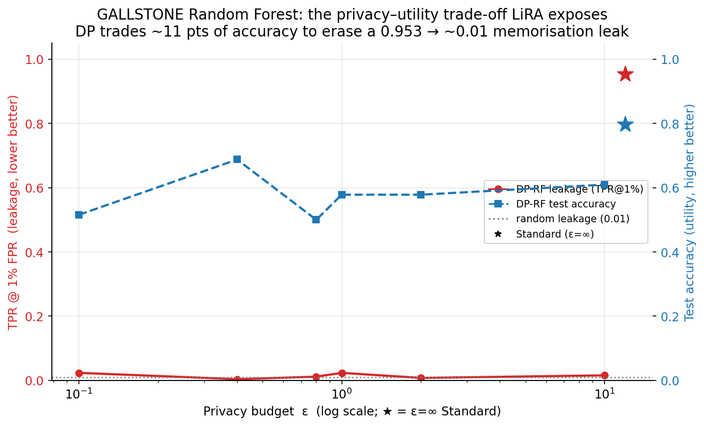
Figure 6. GALLSTONE Random Forest: leakage (red) and accuracy (blue) as ε changes. Stars show the non-private model.
What it shows: the red leakage line drops from the star (0.95) all the way to the floor once DP is on. The blue accuracy line dips from about 0.80 down to roughly 0.69 — the cost we pay.
Finding: DP trades about 11 percentage points of accuracy to erase a near-total privacy leak. On sensitive small datasets, that is a trade worth making.

6. Comparing the models against LiRA
Ranked from most privacy-safe to most at-risk:
- Standard SVM / GNB / LR — naturally safe on every dataset because they are too simple to memorise individuals. But on small data this safety comes with weak accuracy.
- All DP models — pushed down to the safe floor by the formal guarantee, whatever the model type.
- Standard Random Forest on large data — safe, but only because the dataset is big, not by design.
- Standard Random Forest on small data (GALLSTONE) — the single high-risk case. Must not be deployed without DP.
Bottom line: On small medical datasets, use DP-Random Forest, not a plain Random Forest. It keeps the most usefulness among the private models while closing the only serious leak LiRA found. On large datasets the risk is already tiny, so the privacy budget can be relaxed toward better accuracy.

7. Key takeaways at a glance
- A standard Random Forest on tiny data memorised its patients — LiRA identified 95% of them. This was invisible to weaker attacks.
- Bigger datasets are safer on their own: leakage fell from 0.95 to the safe baseline as data grew from 255 to 40,000 records.
- Simple models (LR, SVM, GNB) barely leaked even without any protection.
- Differential Privacy removed every real leak, but only earned its cost where there was a genuine risk to begin with.
- Recommended choice for sensitive small data: DP-Random Forest.

Reference: N. Carlini, S. Chien, M. Nasr, S. Song, A. Terzis, F. Tramèr. “Membership Inference Attacks From First Principles.” IEEE S&P 2022. arXiv:2112.03404.

