Project Plan

Problem Statement
Can federated learning achieve performance comparable to centralized training while preserving the privacy of each solar station's data?

Dataset and Clients
Item | Description
Dataset | hourly_pv_weather_station.csv
Clients | Seven solar stations (one client per station)
Time Span | 27 June 2024 – 1 June 2025
Prediction Task | To be finalized after EDA (Regression or Time-Series Forecasting)
Regression Objective | Predict current-hour power generation from weather variables.
Forecasting Objective | Predict future power generation h hours ahead using historical observations.

Experimental Design
This design is a working outline. It will be refined as the project progresses, but the current plan if as follows:
- Partition hourly_pv_weather_station.csv into 7 client datasets, one per station, and freeze a chronological train/validation/test split for each client.
- Perform feature engineering to derive the most informative predictors, fitting all transformations independently per client on training data only.
- Train a centralized model on the pooled data to establish an upper bound on achievable performance.
- Train a local-only model for each station independently, with no communication between clients, to establish a lower bound.
- Train federated models using FedAvg and FedProx, with the 7 stations as clients.
- Compare all four regimes on a per-station scorecard, reporting results for each station individually rather than as a single pooled average.
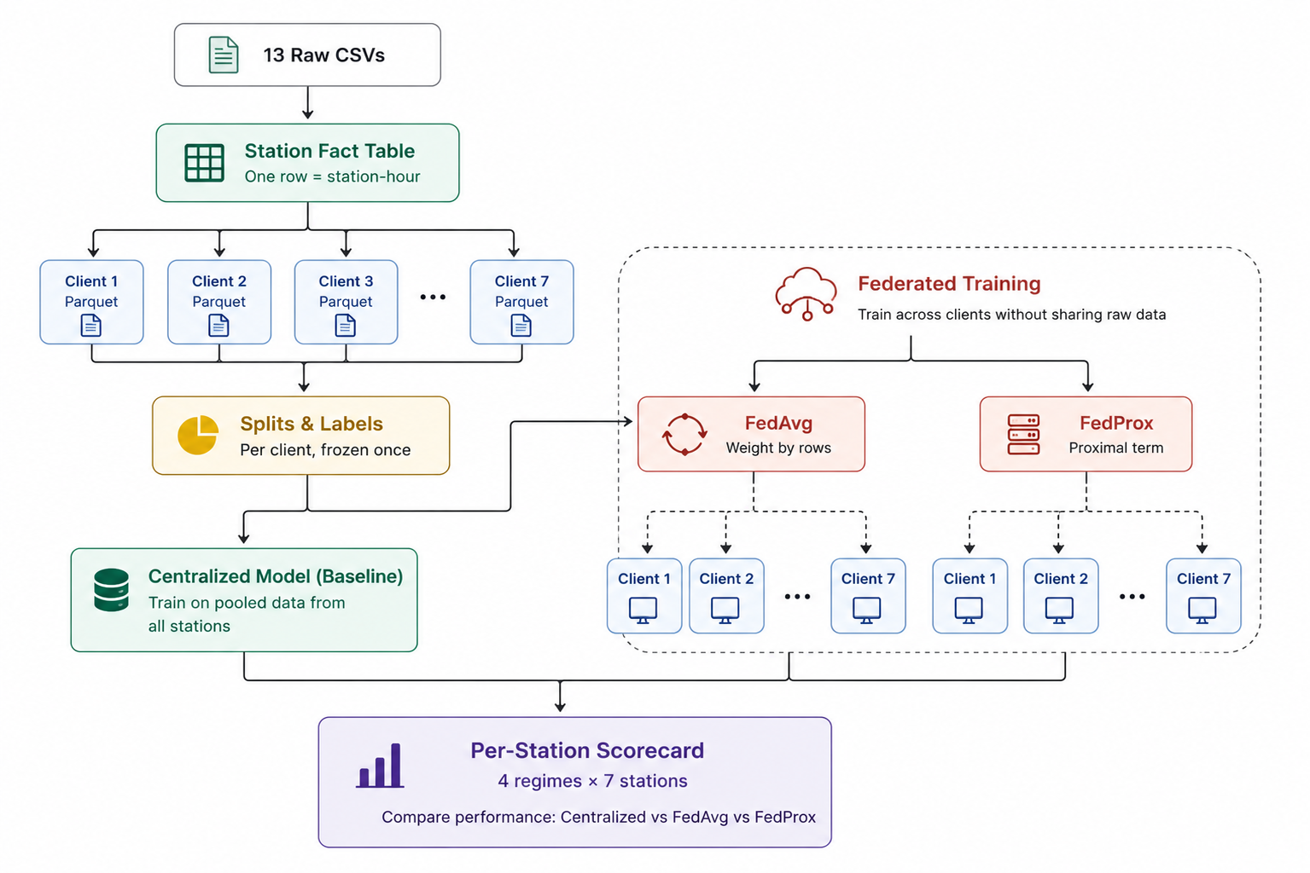
Primary technology stack: Python and the Flower federated learning framework.

Project Timeline
Week | Focus | Deliverables
W1 | Data Understanding & Preparation | Conduct EDA, profile all seven stations, determine the prediction task, prepare client-specific datasets, create chronological train/validation/test splits, and implement the evaluation pipeline with a baseline model.
W2 | Baseline Models | Train centralized and local models to establish performance bounds for federated learning.
W3 | Federated Learning (FedAvg) | Implement FedAvg in Flower, simulate seven clients, and compare results with the baseline models.
W4 | Federated Learning (FedProx) | Implement FedProx, evaluate its performance on heterogeneous data, and validate robustness through repeated experiments.
W5 | Evaluation & Documentation | Compare all approaches, analyze results, document limitations, and finalize the report and project documentation.

Detailed Weekly Plan
Week 1: Conduct exploratory data analysis to understand the dataset, validate the data dictionary, profile all seven stations, and examine the relationship between weather variables and power generation. Based on these findings, finalize whether the task is regression or forecasting. Prepare one client dataset per station, create fixed chronological data splits, and implement a reproducible evaluation pipeline.
Week 2: Train a centralized model using pooled data and independent local models for each station. These models will establish the upper and lower performance bounds for evaluating federated learning.
Week 3: Implement FedAvg using the Flower framework in simulation mode. Treat each station as an independent client and evaluate whether collaborative learning improves performance over local training while approaching centralized performance.
Week 4: Implement FedProx to better address data heterogeneity across clients. Compare its performance with FedAvg and repeat experiments using multiple random seeds to assess stability and reproducibility.
Week 5: Summarize the experimental results by comparing centralized, local, FedAvg, and FedProx models. Complete the documentation, present the key findings, and discuss the study's limitations.

