Problem

Our problem statement: Can federated learning achieve performance close to centralized training while keeping each station’s data private?

Data & Client

I will be using “hourly_pv_weather_station.csv” dataset and this will be divided into multiple stations.
Source Dataset | “hourly_pv_weather_station.csv”
Clients | 7 stations
Real Feature | Not decided yet
Span | 2024-06-27 → 2025-06-01

Task – Undecided
I might go with Regression or Time-Series Forecasting or maybe both. I haven’t decided it yet but will be decided by the end of July 2026.

For Regression:
Predict the current hour production based on the weather parameters (Rough Idea)

For Forecasting:
Predict production h hours ahead from the past history.

Experimental Design
The experimental design I have thinking right now is just a rough idea and it will get better with time and iteration. But for starting I think this is likely what it will look like.
- First we will process the “hourly_pv_weather_station.csv” data into 7 clients .
- Then do the feature engineering to extract most relevant features.
- Train the centralized model using pooled data to establish the baseline performance
- In parallel, also traing the local model using FL techniques like FedAvg or FedProx.
- Evaluate and compare the certralized and FL model performance.

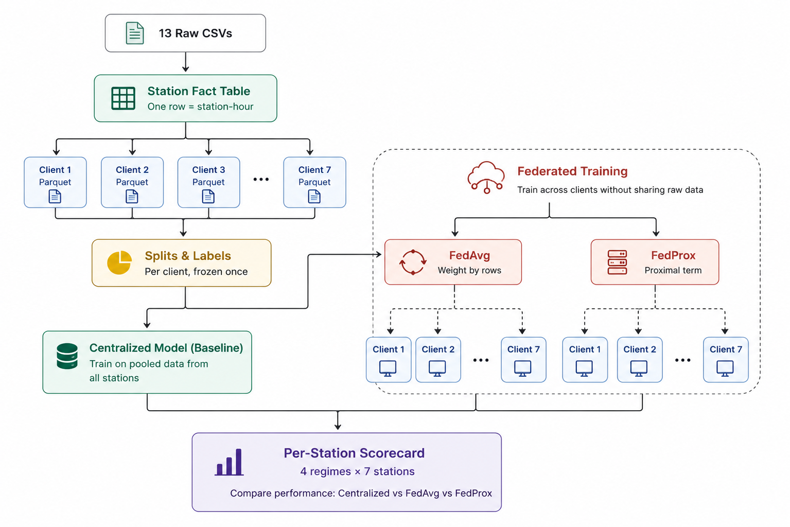

For tech stack mostly python and flower (for federated learning will be used).

Timeline
Weeks | Focus | Output
W1 | Data Understanding & Preparation | Perform EDA, profile all seven stations, determine whether the task is regression or forecasting, create client-wise datasets, establish chronological train/validation/test splits, and build the evaluation pipeline with a baseline predictor
W2 | Baseline Model Development | Train centralized and local-only models to establish upper and lower performance bounds for subsequent federated learning experiments.
W3 | Federated Learning (FedAvg) | Implement FedAvg using Flower, simulate seven clients, and compare federated performance against centralized and local baselines
W4 | Federated Learning (FedProx) | Implement FedProx, evaluate its effectiveness on non-IID data, and assess robustness through multiple experimental runs.
W5 | Evaluation & Documentation | Compare all learning paradigms, analyze results, document limitations, and prepare the final report and project documentation.

