MLOps Assignment 1 - Heart Disease Risk Prediction
Name: Amarnath K
BITS ID: 2025ae05664
Course: Machine Learning Operations (AIMLCZG523)
Code repository: https://github.com/Amarnath2016/heart-mlops
Video Link: https://drive.google.com/file/d/1LZKLkNhmfJih0lWMIoTivp8zB6t41_KP/view?usp=drive_link

1. Setup and installation
Python 3.11 is used. From a clean checkout:
- python -m venv .venv && source .venv/bin/activate
- pip install -r requirements.txt
- python scripts/download_data.py # downloads UCI data, writes data/processed/heart_clean.csv
- python -m src.eda # figures in reports/figures
- python -m src.train # MLflow runs in ./mlruns, model in models/
- mlflow ui --backend-store-uri ./mlruns # browse experiments
- pytest -v
- docker build -t heart-api . && docker run -p 8000:8000 heart-api
- kubectl apply -f k8s/

2. Data and exploratory analysis
The Cleveland subset of the UCI Heart Disease dataset has 303 rows and 13 predictors plus a 0-4 diagnosis column. The diagnosis was binarised (0 = no disease, 1-4 = disease). After removing duplicates, 303 rows remain: 164 without and 139 with disease (45.9% positive), so the classes are reasonably balanced and accuracy is meaningful alongside recall and ROC-AUC.
Missing values ('?' in the raw file): ca (4), thal (2). They are imputed inside the modelling pipeline (median for numeric, most-frequent for categorical) so that statistics are learned on training folds only.
Features most correlated with the target (Pearson, |r|): thal (+0.53), ca (+0.46), exang (+0.43), oldpeak (+0.42), thalach (-0.42).
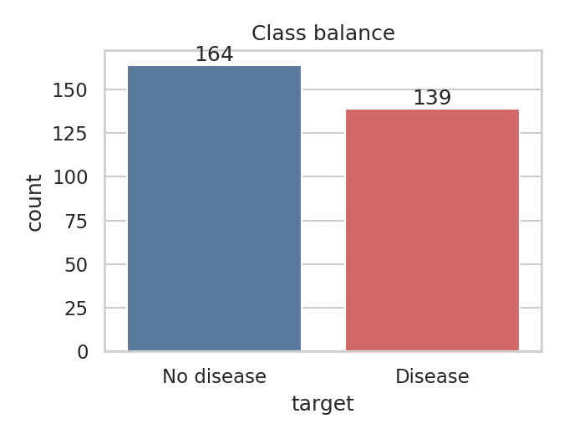
Figure 1 - Class balance
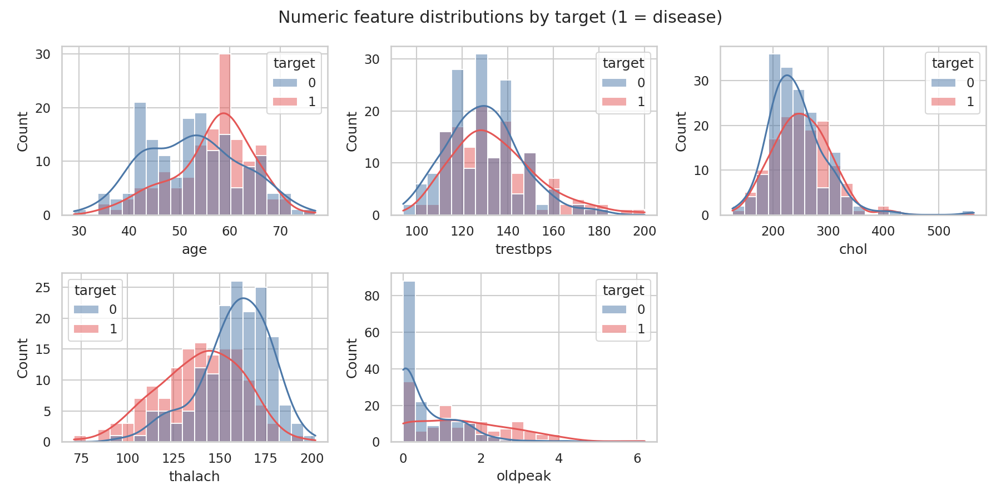
Figure 2 - Numeric feature distributions by target
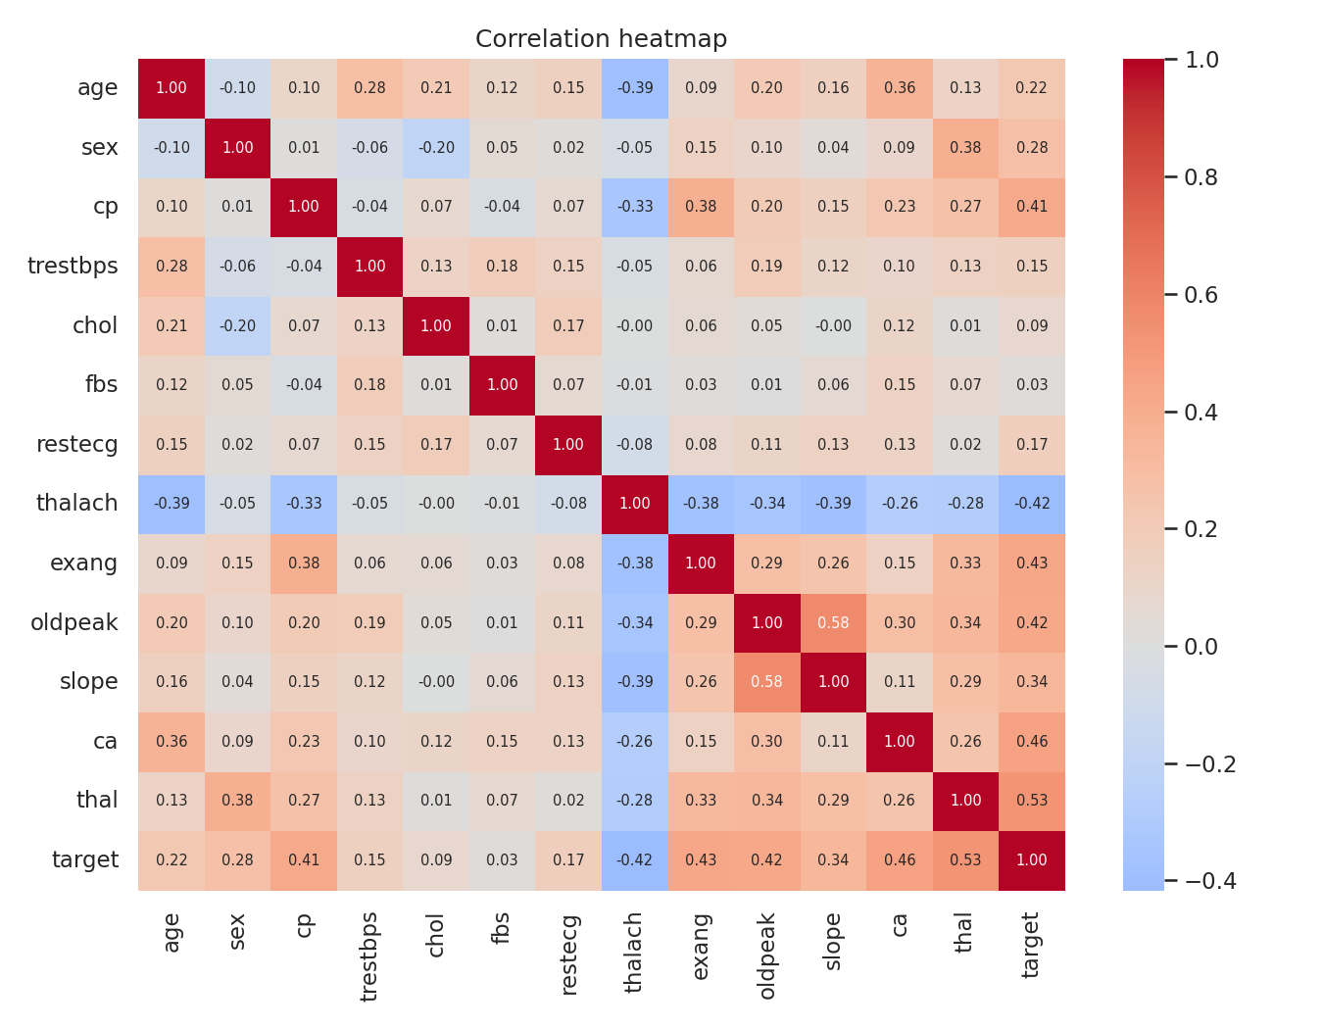
Figure 3 - Correlation heatmap
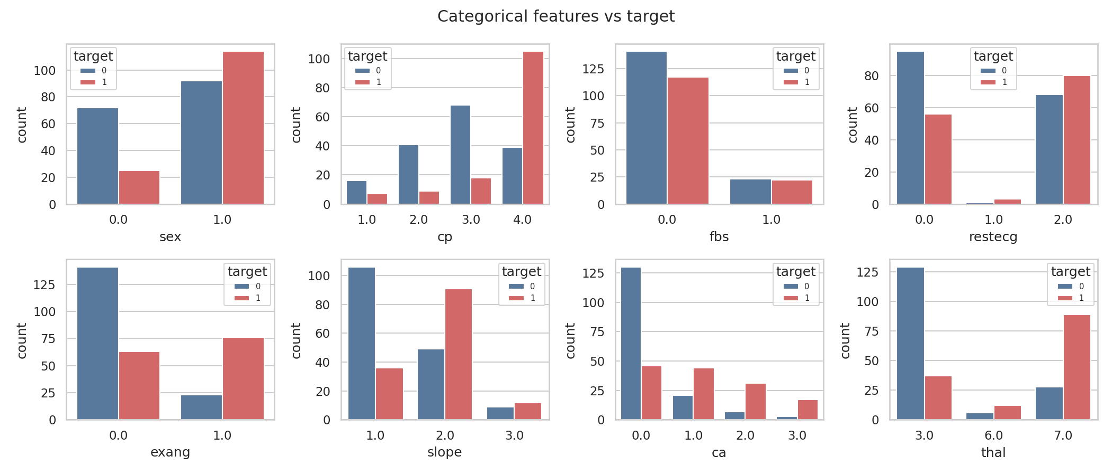
Figure 4 - Categorical features vs target

3. Feature engineering and model development
A single scikit-learn ColumnTransformer is used for both training and serving: numeric features (age, trestbps, chol, thalach, oldpeak) are median-imputed and standardised; categorical codes (sex, cp, fbs, restecg, exang, slope, ca, thal) are mode-imputed and one-hot encoded with handle_unknown='ignore'. Because the transformer is part of the model pipeline, the API only needs the raw 13 fields.
Data was split 80/20 (stratified, seed 42). Logistic Regression and Random Forest were tuned with GridSearchCV (5-fold stratified CV, ROC-AUC as the objective) on the training split only. The final model is chosen by mean cross-validated ROC-AUC; the hold-out test set is used only for the final report.
Model | CV ROC-AUC | Test acc. | Test precision | Test recall | Test ROC-AUC
logistic_regression | 0.902 | 0.885 | 0.839 | 0.929 | 0.966
random_forest | 0.902 | 0.852 | 0.806 | 0.893 | 0.948
Selected model: logistic_regression with parameters {'clf__C': '1.0'}.
Cross-validated metrics of the selected model (mean +/- std): accuracy 0.847 +/- 0.010; precision 0.877 +/- 0.054; recall 0.783 +/- 0.046; f1 0.825 +/- 0.007; roc_auc 0.902 +/- 0.014.
Note: with ~240 training rows, test-set metrics have wide uncertainty; differences of a few points between models are not conclusive.

4. Experiment tracking
Each model family is one MLflow run in experiment 'heart-disease-risk'. Logged: best hyper-parameters, grid size, split sizes, CV mean/std and hold-out metrics, ROC curve and confusion-matrix plots, and the fitted pipeline as an MLflow model. Selected run id: 8d3f024d90894143aff79a1f838e448b.

5. Packaging and reproducibility
The full pipeline (preprocessing + classifier) is saved with joblib to models/model.joblib with models/model_metadata.json (features, params, metrics, run id). Dependencies are pinned in requirements.txt; the serving image uses requirements-serve.txt with identical versions. Random seeds are fixed.

6. CI/CD and automated testing
Unit tests (tests/) cover data parsing and cleaning, preprocessing output, stratified splitting, unseen categories, metric ranges, input validation and the API (health, predict, bad input, metrics). The GitHub Actions workflow runs flake8, pytest, data download + EDA + training, uploads model/MLflow/reports as artifacts, then builds the Docker image and smoke-tests /health and /predict. Any failing step fails the run with its logs.

7. Containerisation
The Flask API runs under gunicorn in a python:3.11-slim image as a non-root user. POST /predict accepts the 13 fields as JSON and returns prediction, label, confidence and probability of heart disease. Other endpoints: /health, /model-info, /metrics.
{"age":63,"sex":1,"cp":4,"trestbps":145,"chol":233,"fbs":1,"restecg":2,"thalach":150,"exang":0,"oldpeak":2.3,"slope":3,"ca":0,"thal":6}

8. Production deployment
k8s/deployment.yaml (2 replicas, readiness/liveness probes, resource limits) and k8s/service.yaml (type LoadBalancer) are applied to a local Kubernetes cluster; an optional Ingress is provided. Access instructions are in the README.

9. Monitoring and logging
Every request is logged as one JSON line (timestamp, request id, method, path, status, latency, prediction). /metrics exposes request counts by endpoint/status, predictions per class and a latency histogram; Prometheus scrapes it and a provisioned Grafana dashboard shows request rate, p95 latency, prediction mix and error rate (monitoring/docker-compose.yml).

10. Architecture
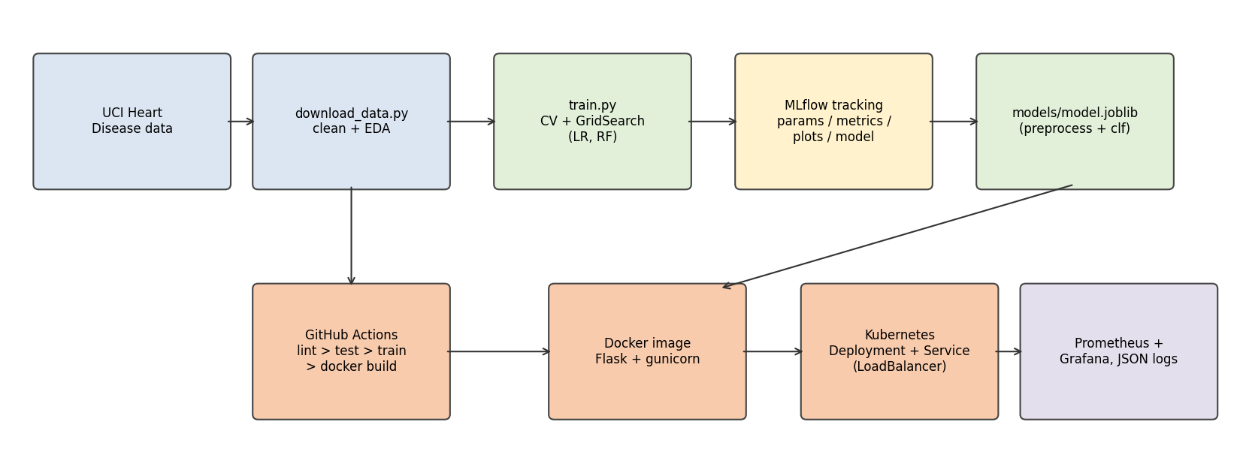
Figure - End-to-end architecture

11. Screenshots
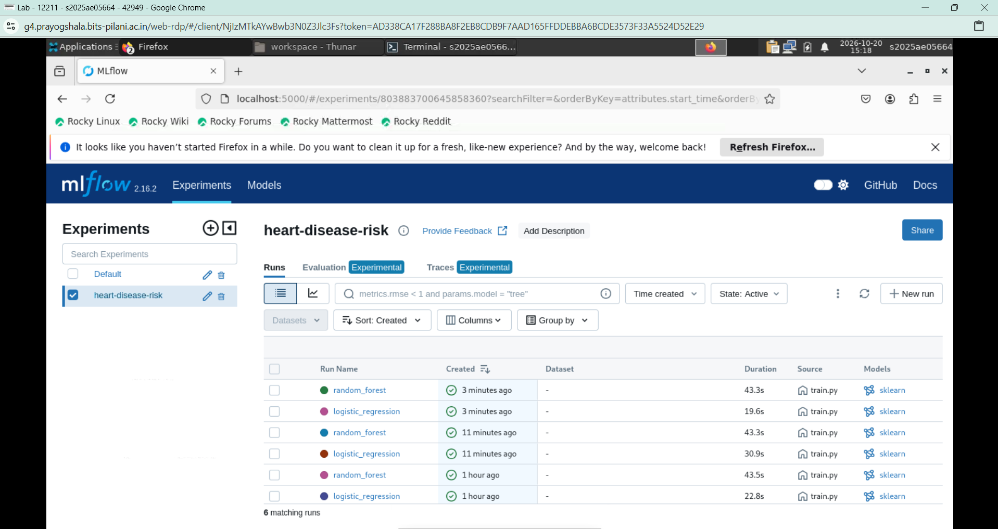
MLflow UI - experiment runs
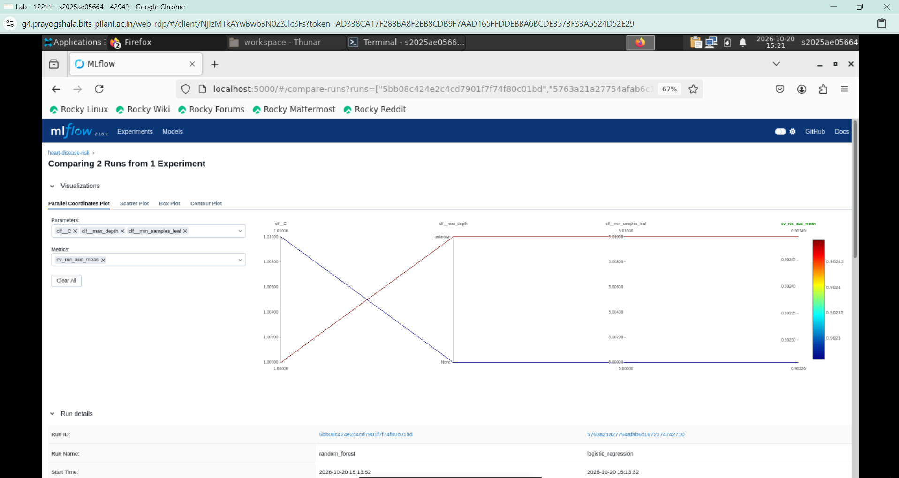
MLflow - run comparison
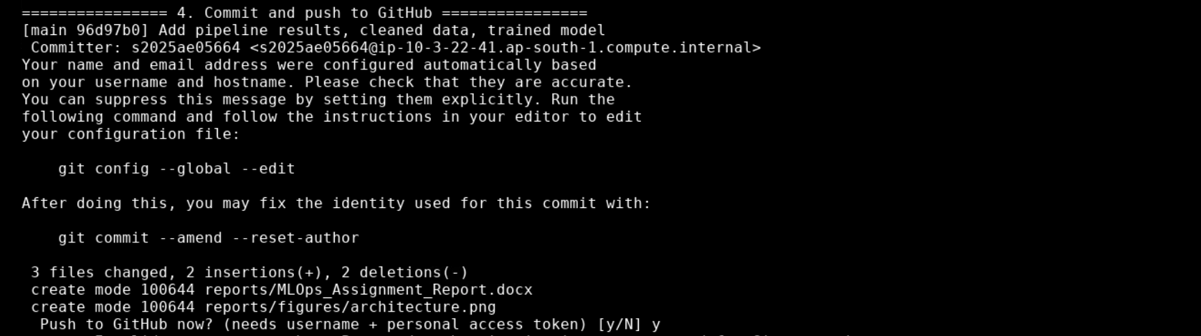
GitHub Actions - successful workflow run

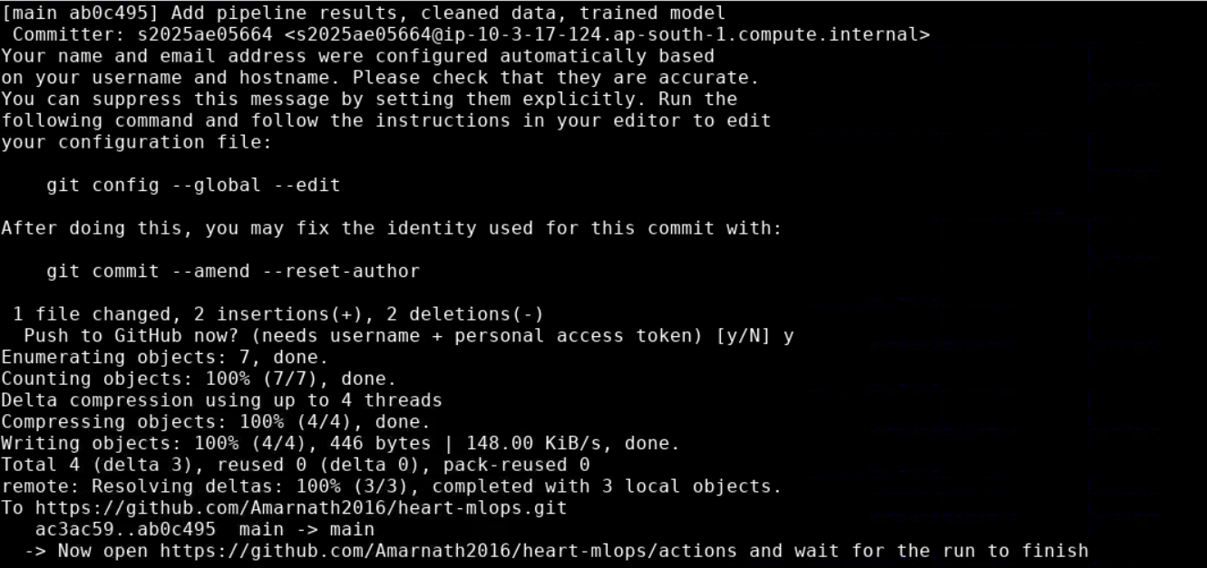
Gi uploaded artifacts

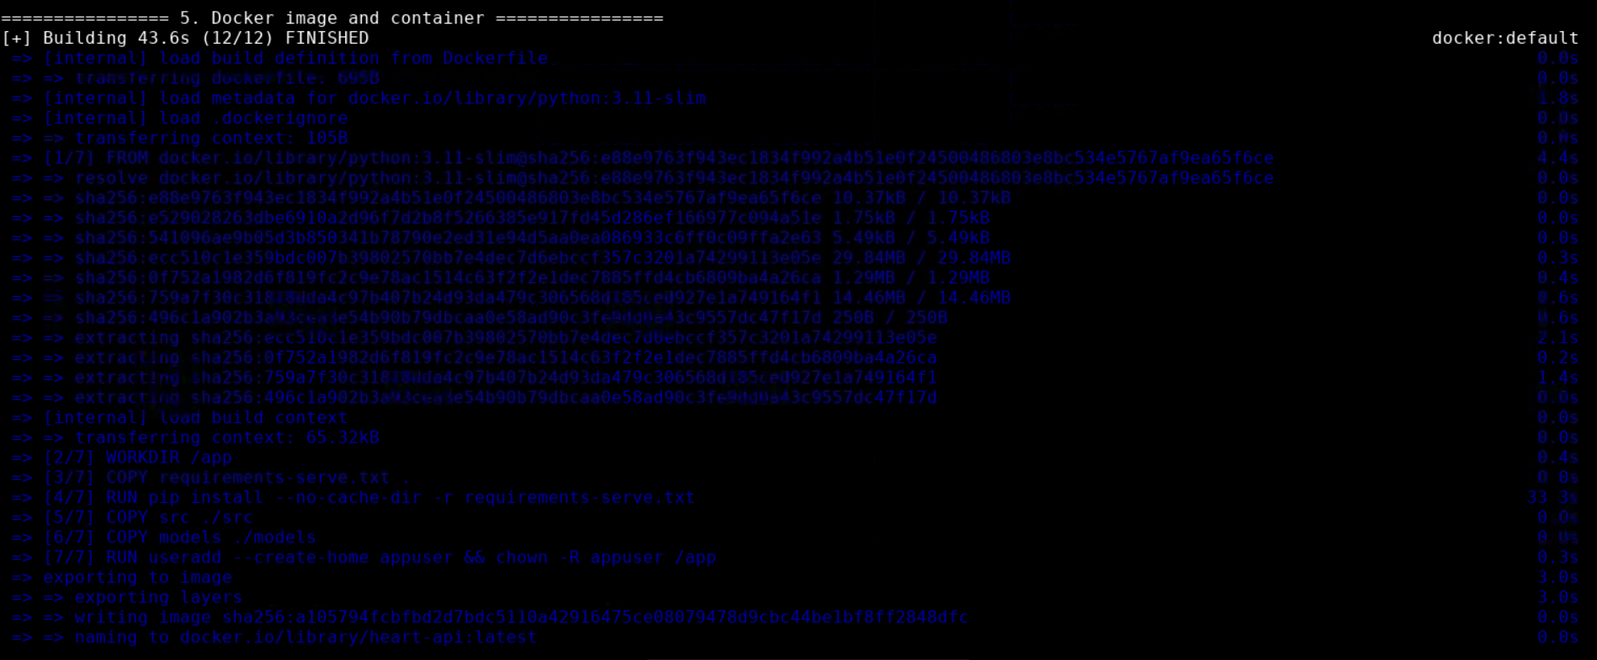
[MISSING: docker_build.png - Docker image build]
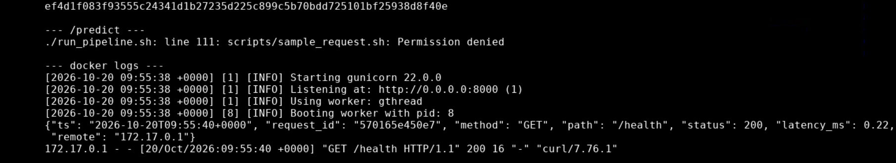
Container running and answering /predict
[MISSING: kubectl_get_all.png - kubectl get pods,svc - deployment status]
[MISSING: k8s_predict.png - /predict via the Kubernetes LoadBalancer]
Structured request logs
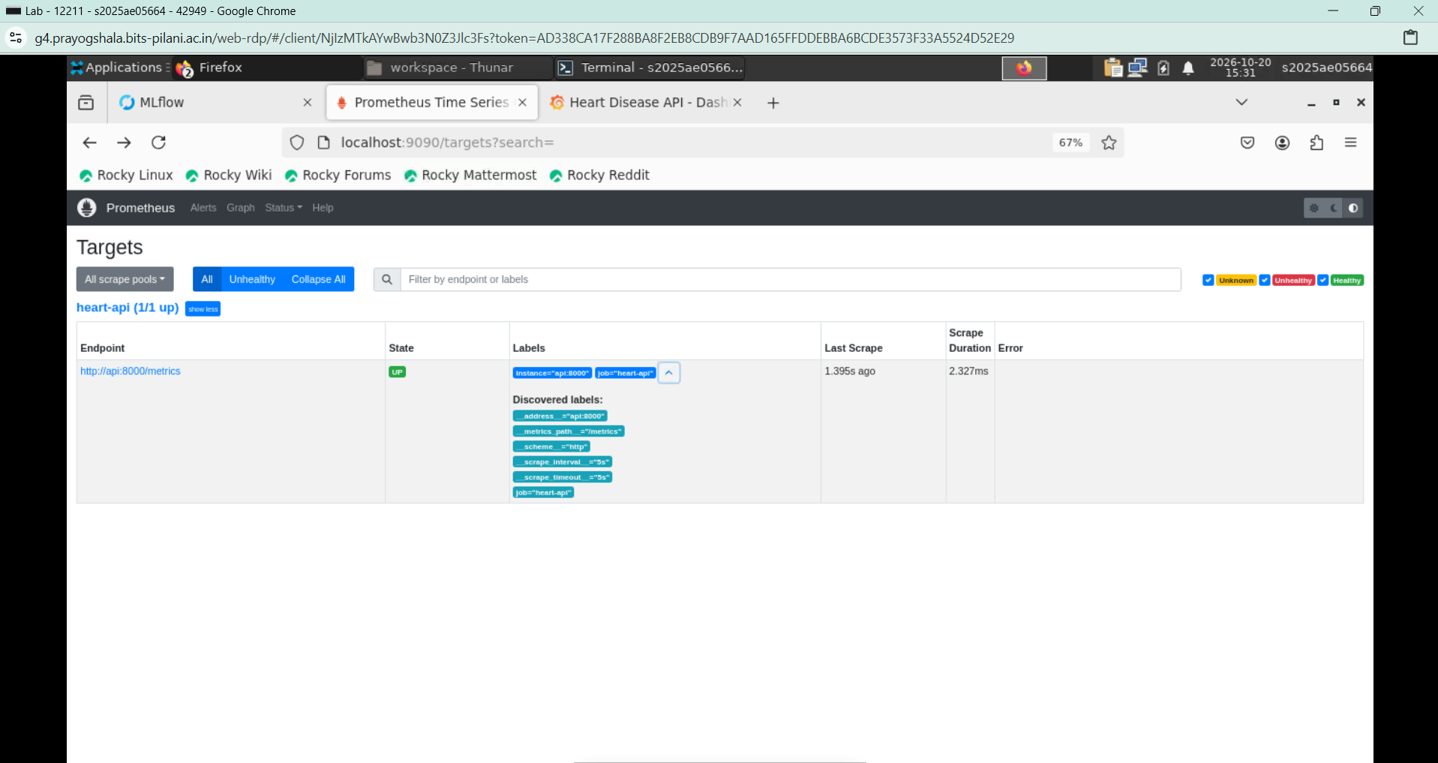
Prometheus target UP
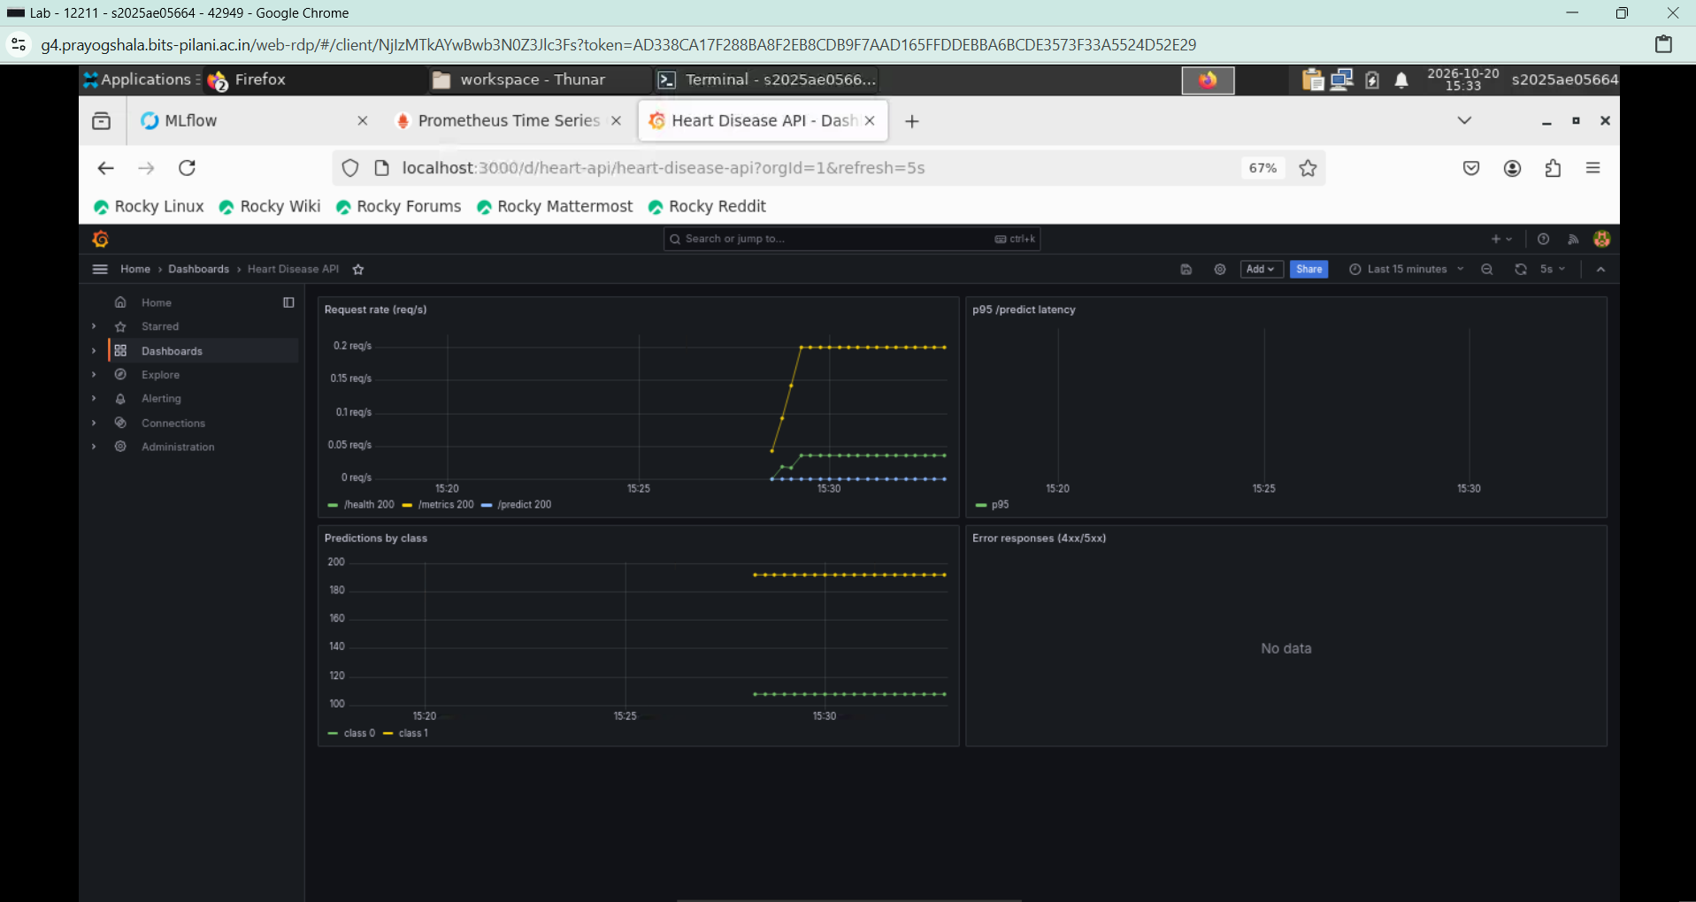
Grafana dashboard

12. Repository
https://github.com/Amarnath2016/heart-mlops

13. Video Link
https://drive.google.com/file/d/1LZKLkNhmfJih0lWMIoTivp8zB6t41_KP/view?usp=drive_link

