Spring – Maven – How to link css/js files Date: 27June2014

Consider project as “TilesWebApplication”.

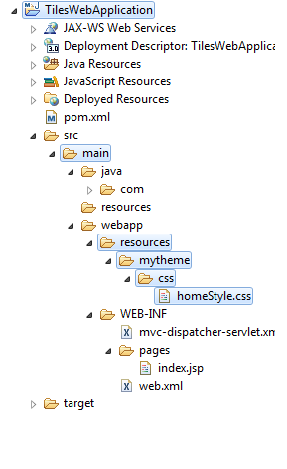

Step – 1:
Create a resource folder under webapp and then create a folder mytheme which will hold both the css and js directories (here I am doing only for CSS)
I have created a homeStyle.css which will have some css properties.

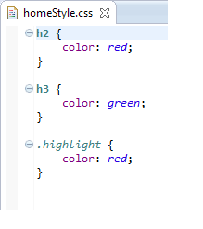

Step – 2:
But we are using spring so we need to say to spring framework where to look for the resources?
So we need to mention the resource fodler detail,

“<mvc:resources mapping="/resources/**" location="/resources/mytheme/" /> “
Which means when ever we call “/resource/” it will be replaced with “/resource/mytheme/”.
Also here for mvc:resources tag we need to include the following beans, (see below image)

xmlns:mvc="http://www.springframework.org/schema/mvc"
and
In schema location bean,
http://www.springframework.org/schema/mvc
http://www.springframework.org/schema/mvc/spring-mvc-3.0.xsd

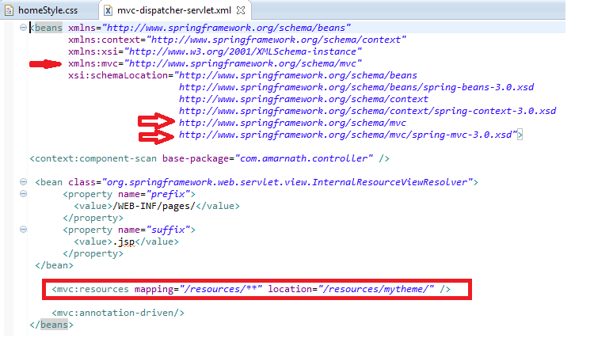
Requested URL = example.com/resources/css/default.css
Spring Converted to this = example.com/resources/mytheme/css/default.css

Step – 3:
Finally include the css in the jsp page for which you will need jstl to be included in your dependencies.

Include the below dependency in pom.xml dependencies.
<dependency>
<groupId>javax.servlet</groupId>
<artifactId>jstl</artifactId>
<version>1.2</version>
</dependency>

And also use jstl tags to map the css and js files using c:url tag.
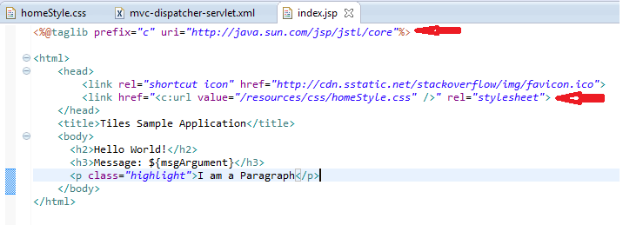
Jstl tag: <%@taglib prefix="c" uri="http://java.sun.com/jsp/jstl/core"%>
Jstl tag: <link href="<c:url value="/resources/css/homeStyle.css" />" rel="stylesheet">

Finally Output:
