Spring-Maven step by step tutorial Date: 25June2014

Reference: Create Spring-Maven Project

Requirements:
- JDK7
- Spring 3.2
- Maven 3.2
- Eclipse Kepler
- Apache Tomcat 6
- Create a work directory in D-Drive and name it as work
- Install maven in eclipse (m2e)

Step -1:
Download jdk7 and install. After installing goto the C drive and copy the installed Java folder to work folder. Set the JDK7 path to system variable by giving name as JAVA_HOME, download maven 3.2 and Tomcat 6 and place them inside work folder. Also give the path of these in the system variables.
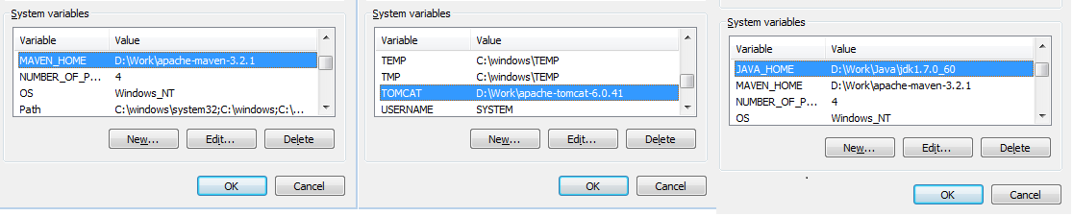
Step – 2:
Inorder to make the above Environmental variables available we need to mention them in the path system variable.
So open the system variable path and append it with,
%MAVEN_HOME%\bin;%JAVA_HOME%\bin;%TOMCAT%\bin;
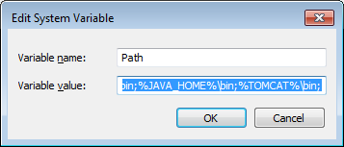
You can check by running, mvn or javac or java on command prompt.

Step – 3:
Installing Maven in eclipse.
Eclipse → Help → Install new software → and give the URL as
m2e releases repository - http://download.eclipse.org/technology/m2e/releases and in search type maven. You will be seeing the Maven Integration for Eclipse select it and install.

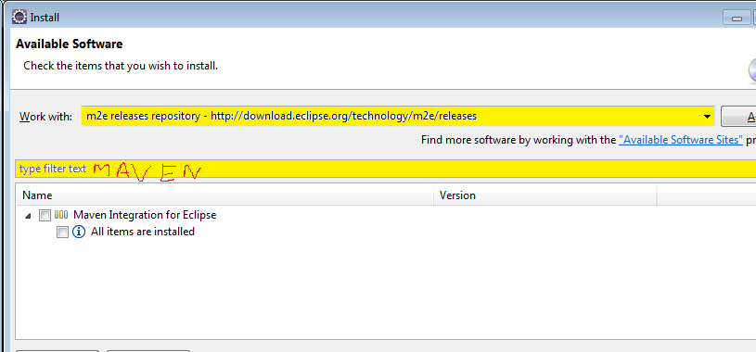
Step - 4:
So we are all set with all the installations and classpaths.
Now create a workspace for eclipse. Say Code.
Goto Code workspace and run the following command,
> mvn archetype:generate -DgroupId=com.javacodegeeks -DartifactId=SampleWebApplication -DarchetypeArtifactId=maven-archetype-webapp -DinteractiveMode=false
This will create a directory and you can see the project structure as below.
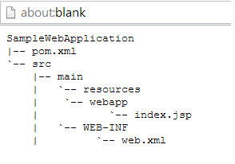
You will have pom.xml, web.xml, index.jsp files generated.

Step – 5:
Enrich the pom.xml file. The files generated are rather outdated so add Spring dependencies, compiler plugin for knowing that jdk7 has to be used, Junit later version.
Similarly add update the web.xml file.
You can check both the above file code in the SampleWebApplication project.
Note: Servlet dependency is missing in the reference site for pom.xml which we have added in the SampleWebApplication's pom.xml

Step-6:
Add M2_REPO to the eclipse IDE inorder to locate the dependencies inside the maven project.
Eclipse → Windows → Preferacne → on left click Java → Build path → Classpath Variable → on right click New → Give name as M2_REPO and click on Folder and select repository inside .m2. You will find .m2 at C Drive → users → .m2

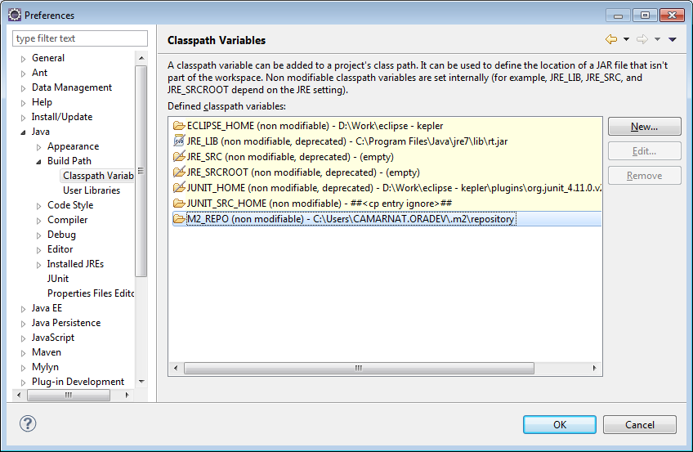

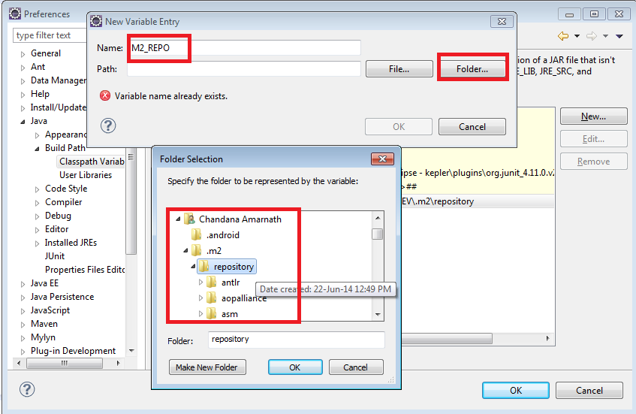

Step – 7:
Import this project into Eclipse.
Eclipse → Import → Maven → Existing maven Project → Browse and select the project.

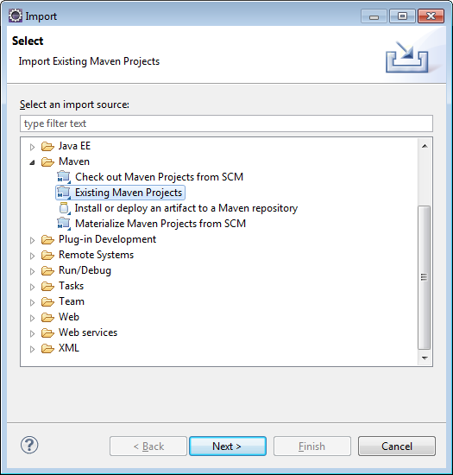
During this import sometimes I got few errors by maven. When you get these just delete the .m2 repository and then do the import again.

Step – 8:
Now after import Right Click on Project → Properties → Project Facts → Check Dynamic Web Project and Java → OK.
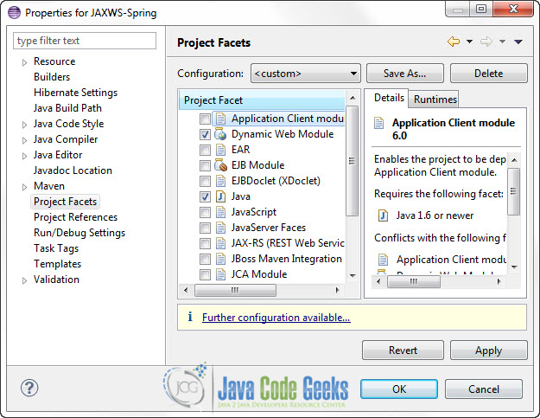

Step – 9:
Create a controller class inside the “/src/main/java/com/javacodegeeks/controller”.
In order to do this, first we need to create fodler java in the src/main. Then create a package with name as com.javacodegeeks.controller.
Copy the java code which is attached in the project to this class.
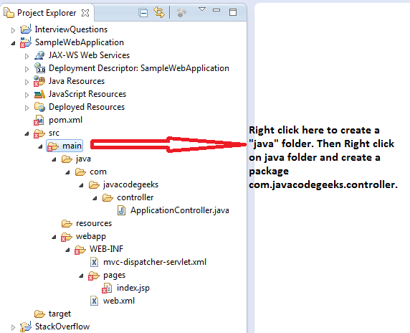

Step – 10:
Update web.xml using the code attached in the SampleWebApplication project. In this code we have a tag called <servlet-name> which is having mvc-dispatcher. Spring will append servlet to this name and search for the file mvc-dispatcher-servlet.xml.
This is given wrong in the reference site.

Step – 10:
Create a servlet with name mvc-dispatcher-servlet.xml inside “/src/main/webapp/WEB-INF/”
Note: Very important part of the Spring framework. Spring frame work will search for this class by using the name given in web.xml.

Step – 11:
Create a folder pages inside WEB-INF, and move index.jsp to this folder.
For the content of index.jsp check the SampleWebApplication project.

Step – 12:
Below is the final folder structure of the samplewebapplication project.
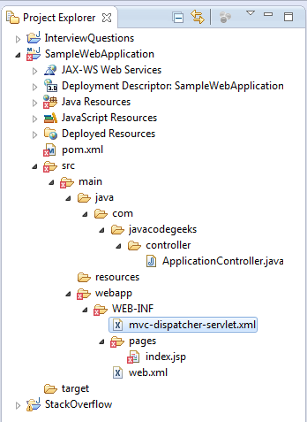

Step – 13:
Finally goto inside the project root folder and type mvn package.
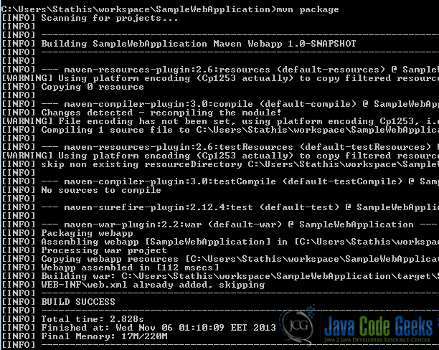
Step – 14:
When we do mvn package a war file is generated inside target folder which is inside the project root folder. Workspace → SampleWebApplication → target → .war

Step – 15:
Finally copy this to Tomcat → Webapps.
And start the tomcat using start.bat which is inside the bin folder. When you start please check in the tomcat logs whether there is any error or not.

Step – 16:
You can run using the following URL: localhost:8080/SampleWebApplication/Test

Final Output:
