Spring – Tiles – Setup Guide Date: 27June2014

Reference: http://krams915.blogspot.in/2010/12/spring-mvc-3-tiles-2-integration.html

What is Tiles:
Consider the following scenario,
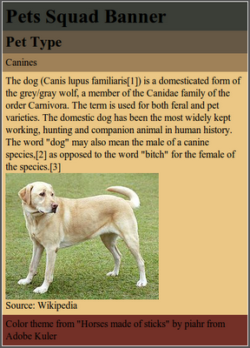
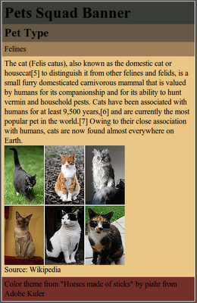
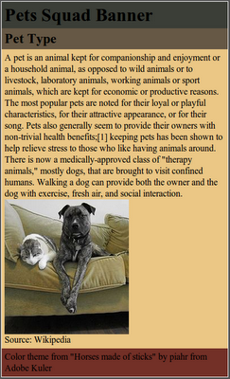
In the above three pages of type pets (1st one), dogs(2nd one) and cats(3rd one).
This is the common scenario where we see in all the web sites where the most part of the web page structure remains the same and only the major content changes.

So in order to stop writing the same parts of the page again we use Tiles framework.

So the main structure will remain the same. Just like the way we do by using the abstract class in Java
where only the abstract methods needs to be implemented and the concrete methods will be the same.

Requirements:
- Spring
- Maven
- Eclipse

To setup Spring-Maven using eclipse please see the previous tutorial. (look SampleWebApplication)

Step – 1:

Add tiles dependencies in the pom file.

<!-- Tiles - dependencies - START -->
<dependency>
<groupId>org.apache.tiles</groupId>
<artifactId>tiles-core</artifactId>
<version>2.2.2</version>
<type>jar</type>
<scope>compile</scope>
</dependency>

<dependency>
<groupId>org.apache.tiles</groupId>
<artifactId>tiles-template</artifactId>
<version>2.2.2</version>
<type>jar</type>
<scope>compile</scope>
</dependency>

<dependency>
<groupId>org.apache.tiles</groupId>
<artifactId>tiles-jsp</artifactId>
<version>2.2.2</version>
<type>jar</type>
<scope>compile</scope>
</dependency>

<dependency>
<groupId>org.apache.tiles</groupId>
<artifactId>tiles-servlet</artifactId>
<version>2.2.2</version>
<type>jar</type>
<scope>compile</scope>
</dependency>
<!-- Tiles - dependencies - END -->

We will also need slf4j dependencies. So add them too in the pom.

<!-- slf4j - dependency - START -->
<dependency>
<groupId>org.slf4j</groupId>
<artifactId>slf4j-api</artifactId>
<version>1.5.6</version>
</dependency>

<dependency>
<groupId>org.slf4j</groupId>
<artifactId>slf4j-log4j12</artifactId>
<version>1.5.6</version>
</dependency>
<!-- slf4j - dependency - END -->

Step – 2:
Declare a template definition to manage the pages. So create tiles-definition.xml under WEB-INF
Please refer tiles-definition.xml in TilesWebApplication project.

Explanation:
As per the above images we have three screens.
First page is divided into 4 parts and Second and Thrid page are divided into 5 parts each.
So we need two definitions for the two types of pages.
See the tiles-definition.xml file we have template-main definition which we will use for First page and template-detail for second and third page definitions.

Template-main: (Below page is divided into 4 parts.)
<definition name="template-main" template="/WEB-INF/pages/main.jsp">
<put-attribute name="banner-content" value="" />
<put-attribute name="title-content" value="Pet Type" /> (This part is constant.)
<put-attribute name="primary-content" value="" />
<put-attribute name="footer-content" value="" />
</definition>

Template-detail: (Below the page is divided into 5 parts. Below banner.jsp and footer.jsp does not exist)
<definition name="template-detail" template="/WEB-INF/jsp/layouts/detail.jsp">
<put-attribute name="banner-content" value="/WEB-INF/pages/banner.jsp" />
<put-attribute name="title-content" value="Pet Type" /> (This part of the page is constant.)
<put-attribute name="subtitle-content" value="" />
<put-attribute name="primary-content" value="" />
<put-attribute name="footer-content" value="/WEB-INF/pages/footer.jsp" />
</definition>

Now its like a inheritance in Java. What all are specific to the sub-class will be implemented by the sub-class itself and if any thing same then the sub-class will be using the super-class information.

Consider for Dogs (which is having 5 parts layout structure.)
<definition name="dog-tiles" extends="template-detail">
<put-attribute name="banner-content" value="Dog-Example" />
<put-attribute name="subtitle-content" value="Canines" />
<put-attribute name="primary-content" value="/WEB-INF/pages/dogs.jsp" />
</definition>

Here we are implementing on the one that is specific to Dogs. The rest of the page will be same as the detail.jsp page specification. Look at detail.jsp page for more details.

In Dogs.jsp page previously we implemented everything now we will only implement the required ones. Please refer the Dogs.jsp page and in this the commented section is the one which is common and hence need no to implement again.

The same we will be doing for Cats.jsp

Similarly for Pets (which is having a 4 parts layout structure) we will be using template-main definition which is following main.jsp

Step – 3:
In the dispatcher mvc-dispatcher-servlet.xml include the tiles resource.
<import resource="tiles-context.xml"/>
So we are importing a resource called tiles-context.xml

Step – 4:
Create a file called tiles-context.xml under WEB-INF which will point to the tiles-definition.xml.
Please refer tiles-context.xml file for more details.

Step – 5:
Finally go the controller class and then you can see the method return was “index” but now we are returning pets-tiles or dogs-tiles or cats-tiles.

So when pets-tiles or dogs-tiles or cats-tiles is returned Spring first checks in the tiles-definition.xml and if present then return the corresponding tiles-definition.

Note: All the XML files are inder the WEB-INF folder.
Also see the page linking path .. I mean the relative path of the jsp pages .. it is WEB-INF/pages/*.jsp
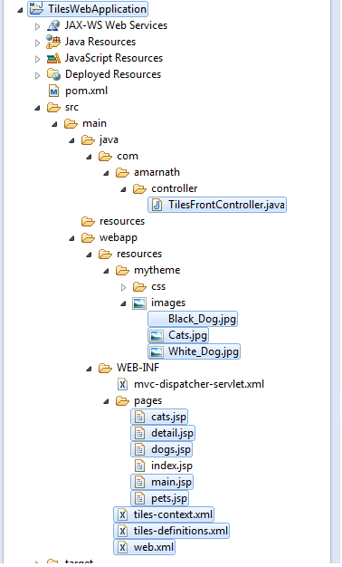
Finally Folder Structure looks like below,

Note – 1: (Error Details)
While I am running the TilesWebApplication I got an error in TOMCAT 6 logger. I think its worth it is worth mentioning here about the error,

SEVERE: Error listenerStart tomcat

The error is due to the logging collision between deafult java.util.logger and the log4j.
You need to follow the following TOMCAT 6 documentation inorder to resolve this issue.
Link: TOMCAT6_LOG4J_ISSUE_RESOLVER
Please do every step here and also please not,
$CATALINA_HOME and $CATALINA_BASE are nothing but the pointing to the root folder of TOMCAT.

So in our folder structure,
$CATALINA_HOME = $CATALINA_BASE = “D:\Work\apache-tomcat-6.0.41”

But in LINUX both of these are pointing to different directories.
$CATALINA_HOME = “/usr/share/tomcat6”
$CATALINA_BASE = “/var/lib/tomcat6”

Note – 2: (Error Details)
Also I got an error on Tomcat stating slf4j error. Just include that dependencies in pom nad you can eliminate them.

