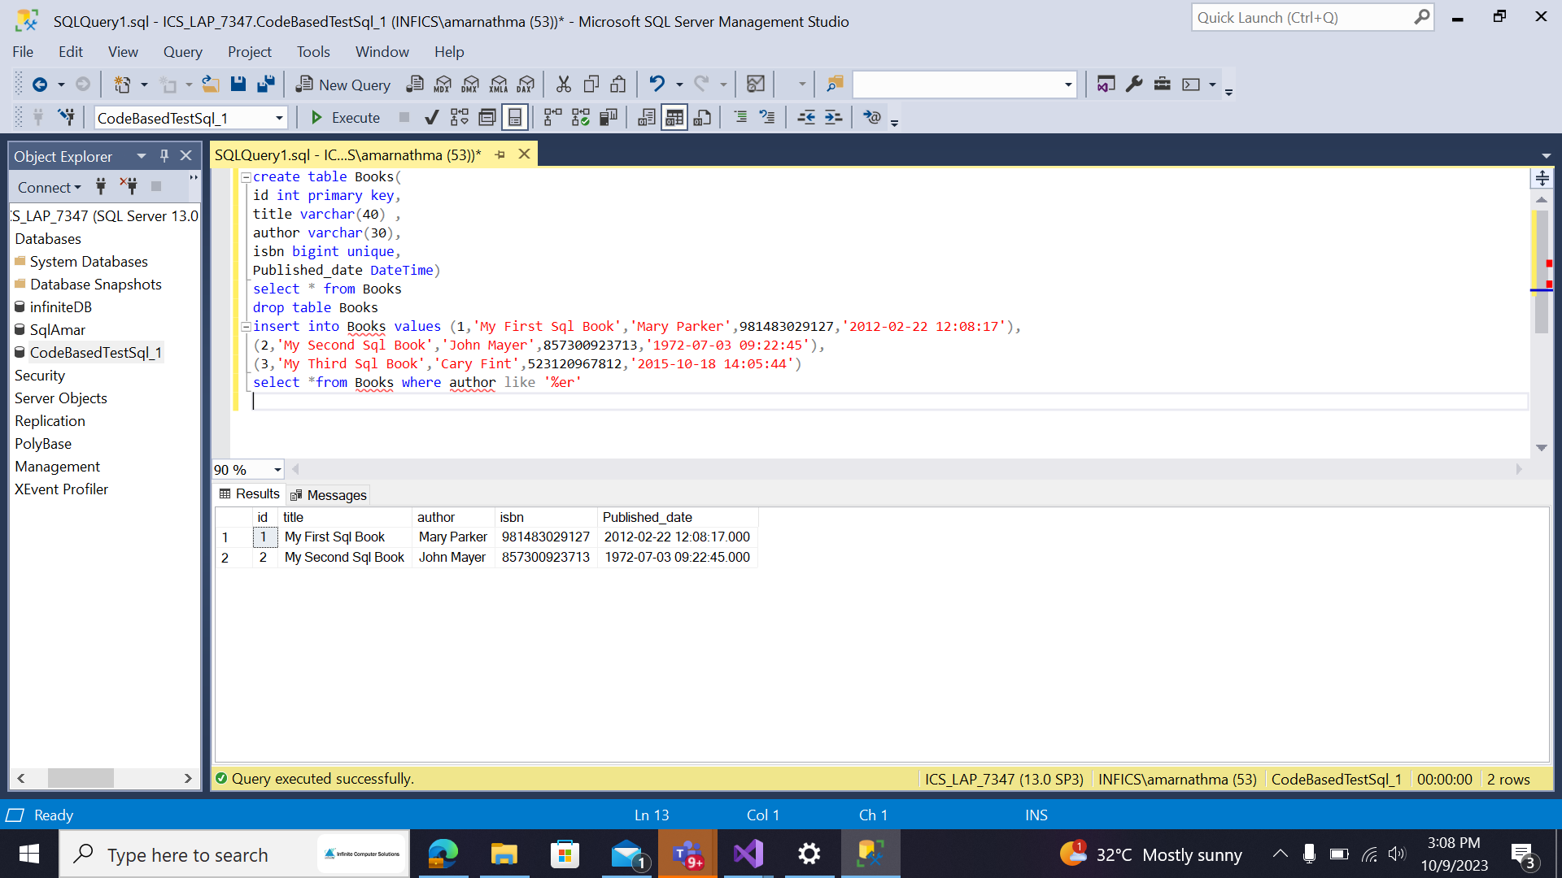
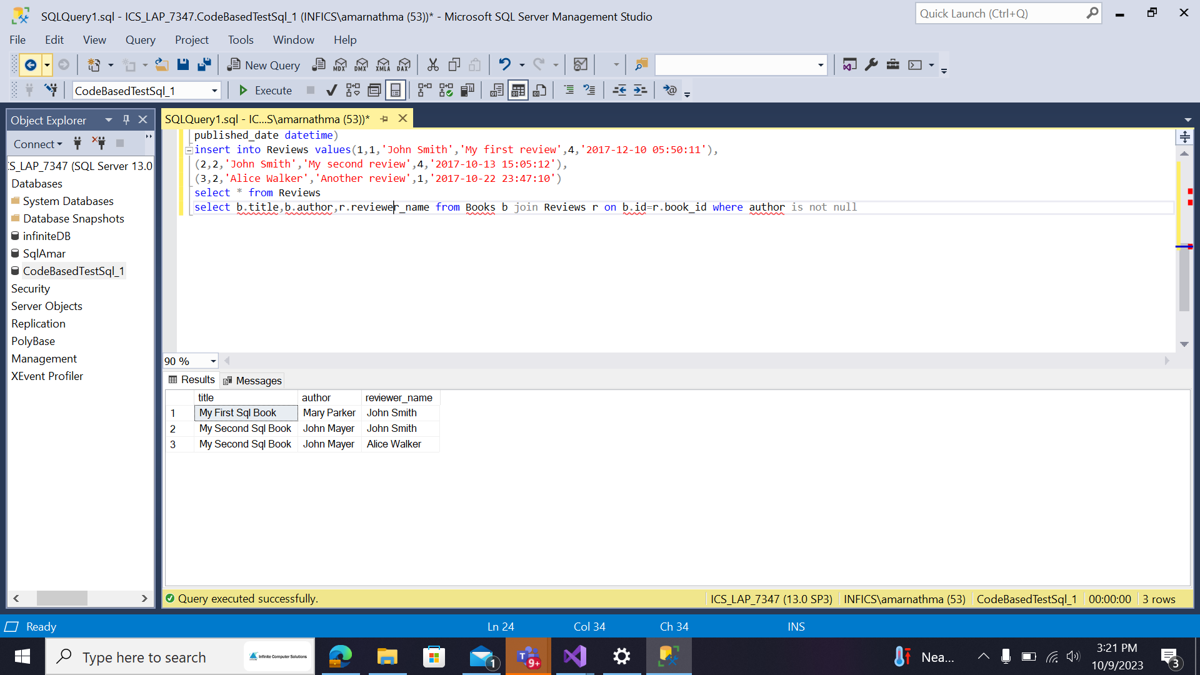
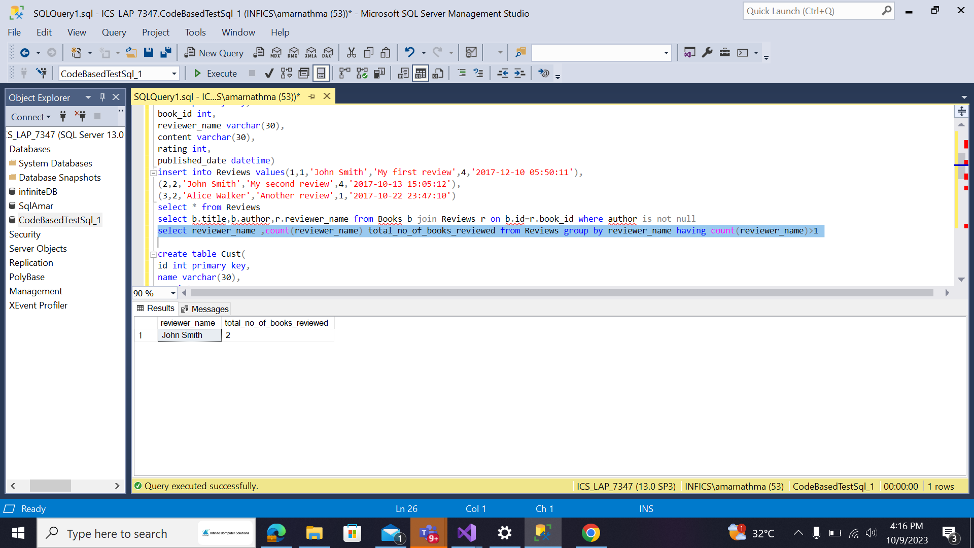
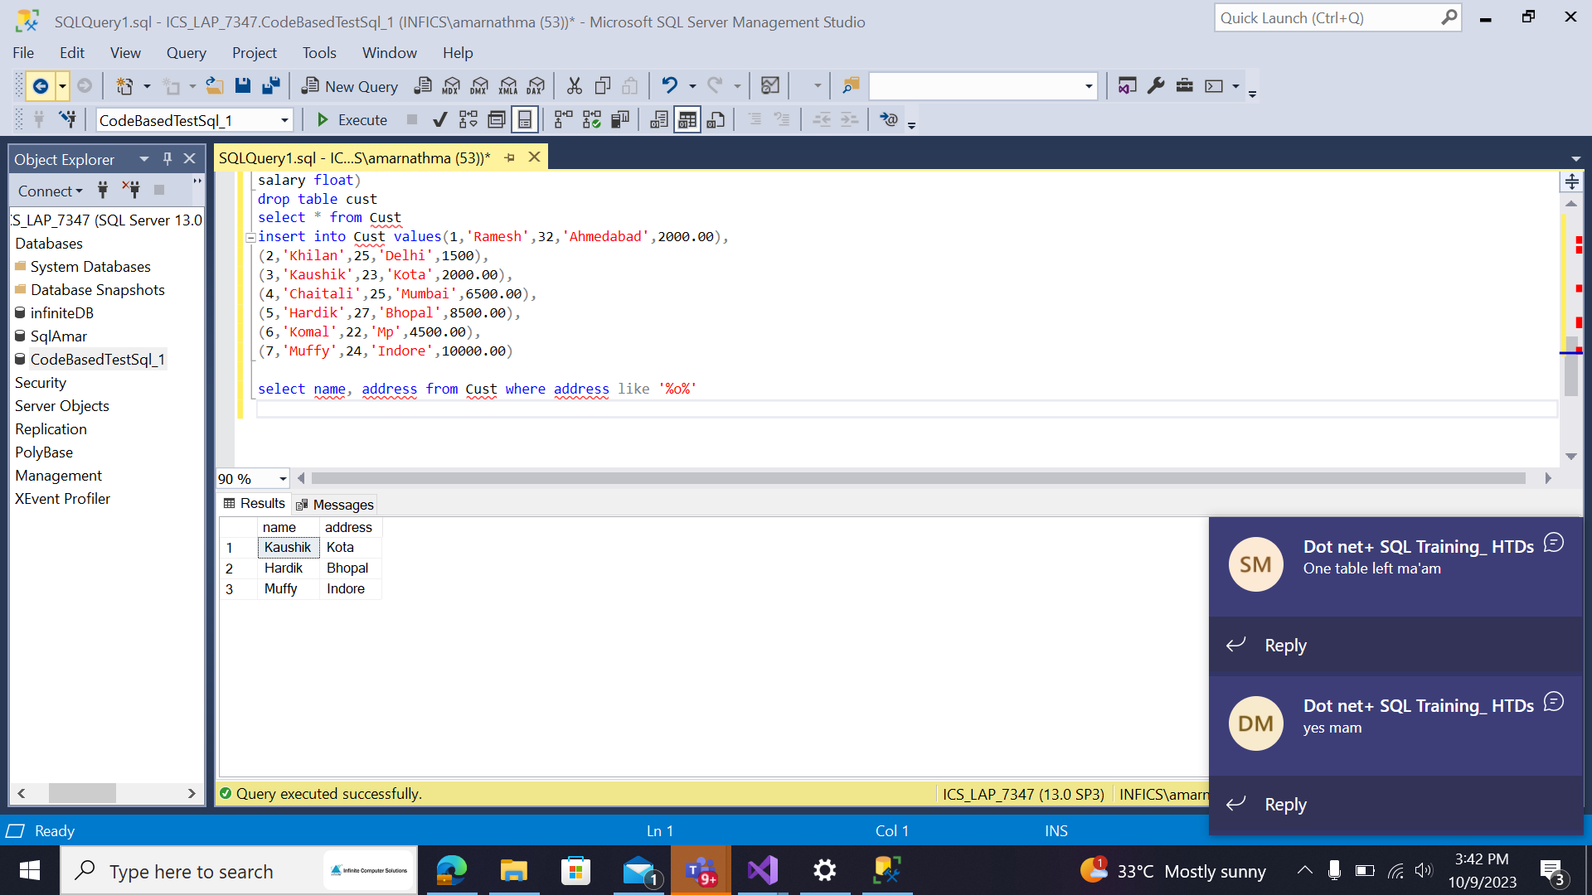
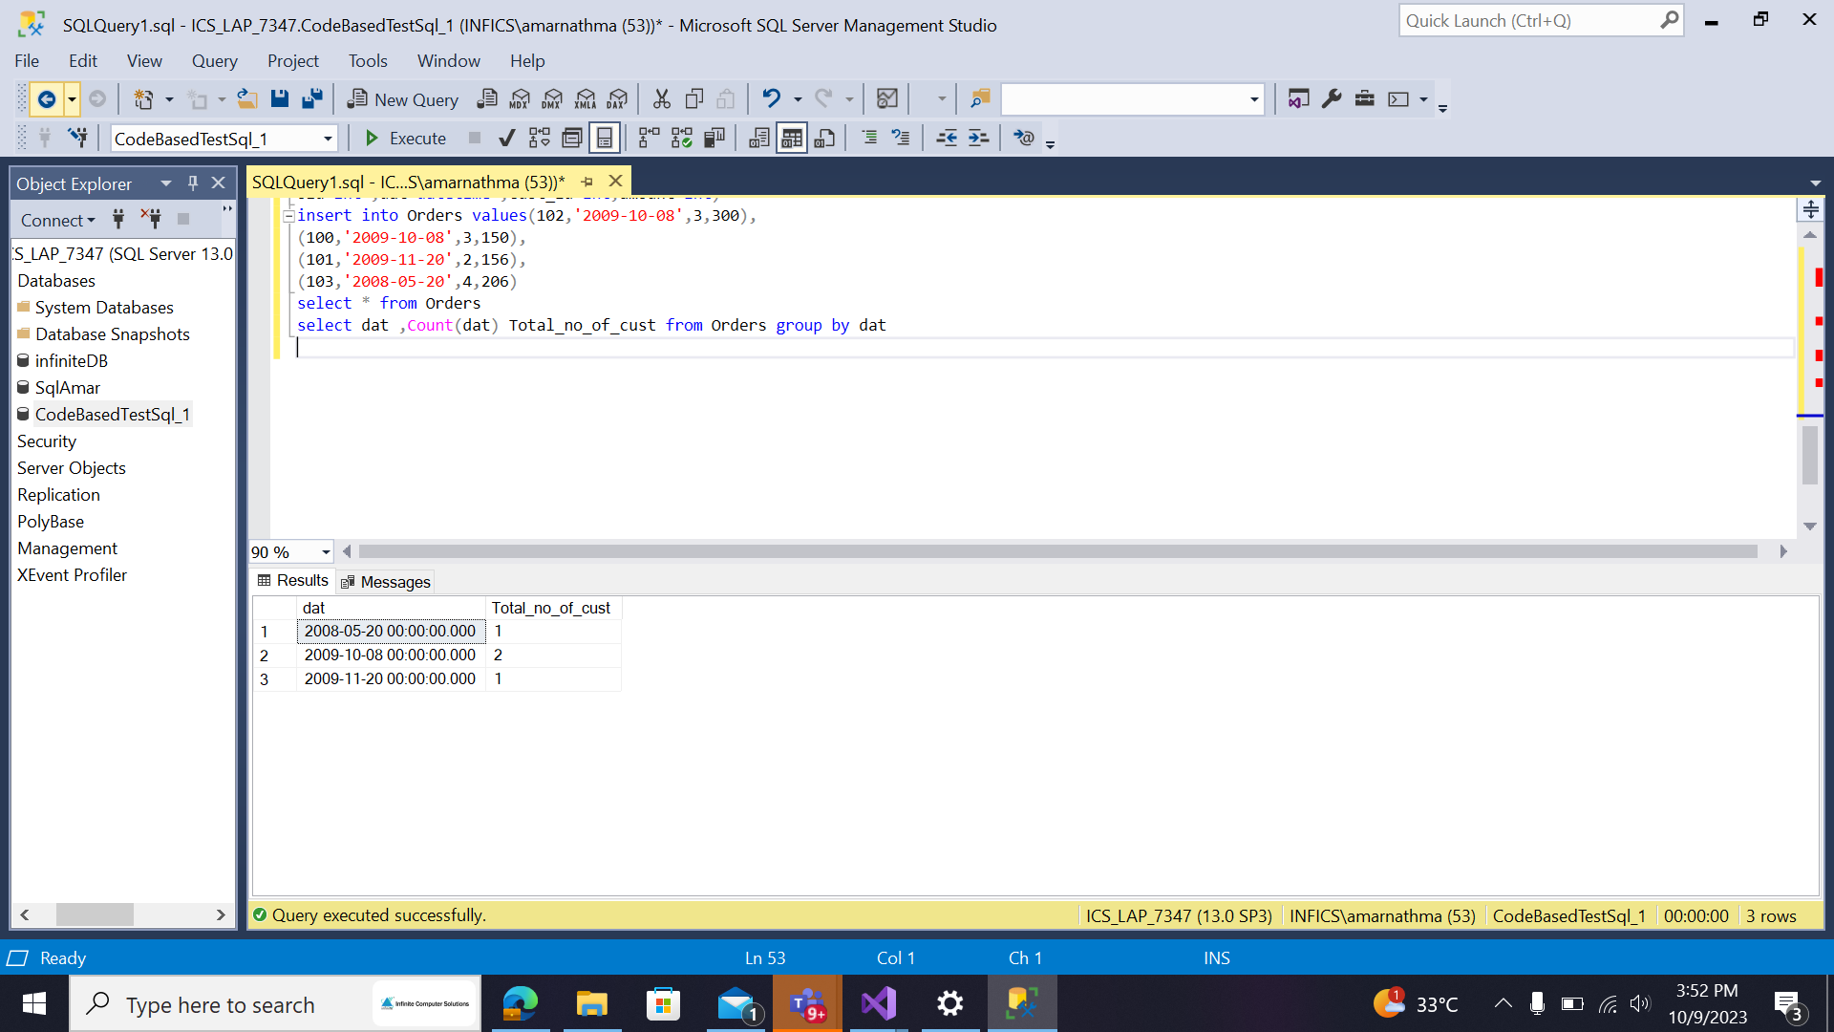
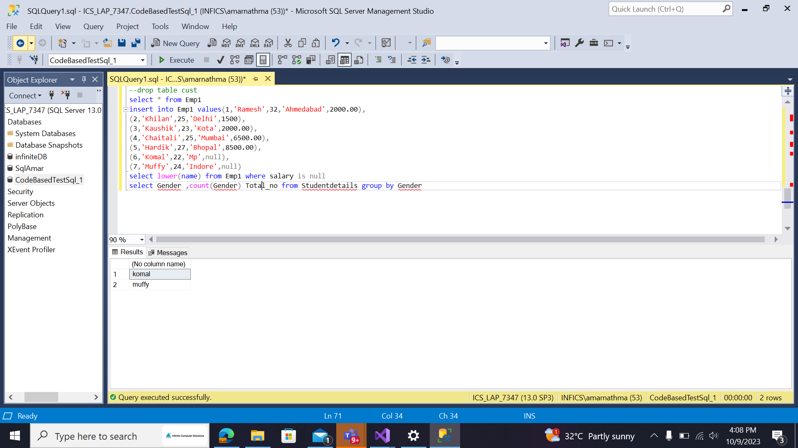
CodeBasedTestSql_1
Amarnath Goud M
1033392
Q1

create table Books(
id int primary key,
title varchar(40) ,
author varchar(30),
isbn bigint unique,
Published_date DateTime)
select * from Books
drop table Books
insert into Books values (1,'My First Sql Book','Mary Parker',981483029127,'2012-02-22 12:08:17'),
(2,'My Second Sql Book','John Mayer',857300923713,'1972-07-03 09:22:45'),
(3,'My Third Sql Book','Cary Fint',523120967812,'2015-10-18 14:05:44')
select *from Books where author like '%er'

Q2
create table Reviews(
id int primary key,
book_id int,
reviewer_name varchar(30),
content varchar(30),
rating int,
published_date datetime)
insert into Reviews values(1,1,'John Smith','My first review',4,'2017-12-10 05:50:11'),
(2,2,'John Smith','My second review',4,'2017-10-13 15:05:12'),
(3,2,'Alice Walker','Another review',1,'2017-10-22 23:47:10')
select * from Reviews
select b.title,b.author,r.reviewer_name from Books b join Reviews r on b.id=r.book_id where author is not null

Q3
select reviewer_name ,count(reviewer_name) total_no_of_books_reviewed from Reviews group by reviewer_name having count(reviewer_name)>1

Q4
create table Cust(
id int primary key,
name varchar(30),
age int,
address varchar(30),
salary float)
drop table cust
select * from Cust
insert into Cust values(1,'Ramesh',32,'Ahmedabad',2000.00),
(2,'Khilan',25,'Delhi',1500),
(3,'Kaushik',23,'Kota',2000.00),
(4,'Chaitali',25,'Mumbai',6500.00),
(5,'Hardik',27,'Bhopal',8500.00),
(6,'Komal',22,'Mp',4500.00),
(7,'Muffy',24,'Indore',10000.00)

select name, address from Cust where address like '%o%'

Q5
create table Orders(
oid int ,dat datetime ,Cust_id int,amount int)
insert into Orders values(102,'2009-10-08',3,300),
(100,'2009-10-08',3,150),
(101,'2009-11-20',2,156),
(103,'2008-05-20',4,206)
select * from Orders
select dat ,Count(dat) Total_no_of_cust from Orders group by dat

Q6
create table Emp1(
id int primary key,
name varchar(30),
age int,
address varchar(30),
salary float)
--drop table cust
select * from Emp1
insert into Emp1 values(1,'Ramesh',32,'Ahmedabad',2000.00),
(2,'Khilan',25,'Delhi',1500),
(3,'Kaushik',23,'Kota',2000.00),
(4,'Chaitali',25,'Mumbai',6500.00),
(5,'Hardik',27,'Bhopal',8500.00),
(6,'Komal',22,'Mp',null),
(7,'Muffy',24,'Indore',null)
select lower(name) from Emp1 where salary is null

Q7
select Gender ,count(Gender) Total_no from Studentdetails group by Gender

