**Unit - I**

**1.1Introduction**

A **control system** is a system of devices or set of devices, that manages, commands, directs or regulates the behavior of other device(s) or system(s) to achieve desire results. In other words the **definition of control system**can be rewritten as a control system is a system, which controls other system. As the human civilization is being modernized day by day the demand of automation is increasing accordingly. Automation highly requires control of devices. In recent years, **control systems** plays main role in the development and advancement of modern technology and civilization. Practically every aspects of our day-to-day life is affected less or more by some control system. A refrigerator, an air conditioner, a geezer, an automatic iron, an automobile all are control system. These systems are also used in industrial process for more output. We find control system in quality control of products, weapons system, transportation systems, power system, space technology, robotics and many more. The **principles of control theory** is applicable to engineering and non-engineering field both.

**Requirement of Good Control System**

**Accuracy:** Accuracy is the measurement tolerance of the instrument and defines the limits of the errors made when the instrument is used in normal operating conditions. Accuracy can be improved by using feedback elements. To increase accuracy of any control system error detector should be present in control system.

**Sensitivity:** The parameters of control system are always changing with change in surrounding conditions, internal disturbance or any other parameters. This change can be expressed in terms of sensitivity. Any control system should be insensitive to such parameters but sensitive to input signals only.

**Noise:** An undesired input signal is known as noise. A good control system should be able to reduce the noise effect for better performance.

**Stability:** It is an important characteristic of control system. For the bounded input signal, the output must be bounded and if input is zero then output must be zero then such a control system is said to be stable system.

**Bandwidth:** An operating frequency range decides the bandwidth of control system. Bandwidth should be large as possible for frequency response of good control system.

**Speed:** It is the time taken by control system to achieve its stable output. A good control system possesses high speed. The transient period for such system is very small.

**Oscillation:** A small numbers of oscillation or constant oscillation of output tend to system to be stable.

**1.2 Open Loop and Closed Loop Control Systems**

**Open Loop Control Systems*:***

A system in which the output has no effect on the control action is known as an open loop control system. For a given input the system produces a certain output. If there are any disturbances, the out put changes and there is no adjustment of the input to bring back the output to the original value. A perfect calibration is required to get good accuracy and the system should be free from any external disturbances. No measurements are made at the output. A traffic control system is a good example of an open loop system. The signals change according

to a preset time and are not affected by the density of traffic on any road. A washing machine is another example of an open loop control system. The quality of wash is not measured; every cycle like wash, rinse and dry' cycle goes according to a preset timing.

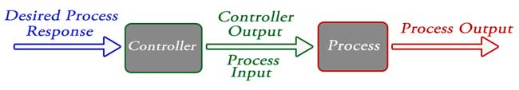

Fig.1. Open Loop control system

**Closed Loop Control Systems***:*

These are also known as feedback control systems. A system which maintains a prescribed relationship between the controlled variable and the reference input, and uses the difference between them as a signal to activate the control, is known as a feedback control system. The output or the controlled variable is measured and compared with the reference input and an error signal is generated. This is the activating signal to the controller which, by its action, tries to reduce the error. Thus, the controlled variable is continuously fedback and compared with the input signal. If the error is reduced to zero, the output is the desired output and is equal to the reference input signal.

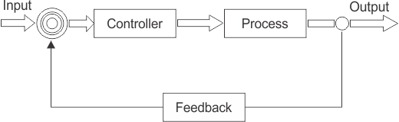

Fig.2. Closed Loop control system

**1.2.1 Open Loop Vs Closed Loop Control Systems**

The open loop systems are simple and easier to build. Open loop systems are cheaper and they should be preferred whenever there is a fixed relationship between the input and the output and there are no disturbances. Accuracy is not critical in such systems. Closed loop systems are more complex, use more number of elements to build and are costly. The stability is a major concern for closed loop systems. We have to ensure that the system is stable and will not cause undesirable oscillations in the output. The major advantage of closed loop system is that it is insensitive to external disturbances and variations in parameters. Comparatively cheaper components can be used to build these systems, as accuracy and tolerance do not affect the performance. Maintenance of closed loop systems is more difficult than open loop systems. Overall gain of the system is also reduced.

**Open Loop Systems**

*Advantages*

1. They are simple and easy to build.

2. They are cheaper, as they use less number of components to build.

3. They are usually stable.

4. Maintenance is easy.

*Disadvantages*

1. They are less accurate.

2. If external disturbances are present, output differs significantly from the desired value.

3. If there are variations in the parameters of the system, the output changes.

**Closed Loop Systems**

*Advantages*

1. They are more accurate.

2. The effect of external disturbance signals can be made very small.

3. The variations in parameters of the system do not affect the output of the system i.e. the output may be made less sensitive to variation is parameters. Hence forward path components can be of less precision. This reduces the cost of the system.

4. Speed of the response can be greatly increased.

*Disadvantages*

1. They are more complex and expensive

2. They require higher forward path gains.

3. The systems are prone to instability. Oscillations in the output many occur.

4. Cost of maintenance is high.

**Comparison of Closed Loop And Open Loop Control System:**

|  |  |  |  |
| --- | --- | --- | --- |
| **S. No.** | **Open loop control system** |  | **Closed loop control system** |
| **1** | **The feedback element is absent.** |  | **The feedback element is always present.** |
| **2** | **An error detector is not present.** |  | **An error detector is always present.** |
| **3** | **It is stable one.** |  | **It may become unstable.** |
| **4** | **Easy to construct.** |  | **Complicated construction.** |
| **5** | **It is an economical.** |  | **It is costly.** |
| **6** | **Having small bandwidth.** |  | **Having large bandwidth.** |
| **7** | **It is inaccurate.** |  | **It is accurate.** |
| **8** | **Less maintenance.** |  | **More maintenance.** |
| **9** | **It is unreliable.** |  | **It is reliable.** |
| **10** | **Examples: Hand drier, tea maker** |  | **Examples: Servo voltage stabilizer, perspiration** |

**Transfer Function**

The transfer function of a control system is defined as the ration of the Laplace transform of the output variable to Laplace transform of the input variable assuming all initial conditions to be zero.



Procedure for determining the transfer function of a control system are as follows

1. We form the equations for the system
2. Now we take Laplace transform of the system equations, assuming initial conditions as zero.
3. Specify system output and input
4. At the last we take the ratio of the Laplace transform of the output and the Laplace transform of the input which is the required transfer function

Methods of obtaining a Transfer function: There are major two ways of obtaining a transfer function for the control system. The ways are –

* Block diagram method: It is not convenient to derive a complete transfer function for a complex control system. Therefore the transfer function of each element of a control system is represented by a block diagram. Block diagram reduction techniques are applied to obtain the desired transfer function.
* Signal Flow graphs: The modified form of a block diagram is a signal flow graph. Block diagram gives a pictorial representation of a control system. Signal flow graph further shortens the representation of a control system.

**Modeling of Electric systems, Translational and rotational mechanical systems:**

**Electrical Systems:**

Most of the electrical systems can be modelled by three basic elements : Resistor, inductor, and capacitor. Circuits consisting of these three elements are analysed by using Kirchhoff's Voltage law and Current law.

**(a) Resistor***:* The circuit model of resistor is shown in Fig.

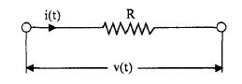

The mathematical model is given by the Ohm's law relationship,

V(t) = i(t) R

i(t) = V(t)/R

**(b) Inductor:**The circuit representation is shown in Fig.

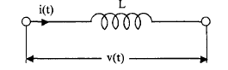

The input output relations are given by Faraday's law,

V(t) = L di(t)/dt



where Integral of v dt is known as the flux linkages. Thus



**(c) Capacitor:**The circuit symbol of a capacitor is given in Fig.

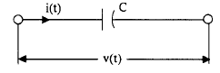

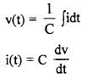

In eqn. idt is known as the charge on the capacitor and is denoted by *'q'.* Thus

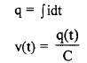

**Modeling of RL circuit:**

The transfer function is generally expressed in Laplace Transform and it is nothing but the relation between input and output of a system. Let us consider a system consists of a series connected resistance (R) and inductance (L) across a voltage source (V).

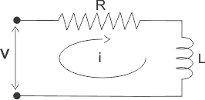

In this circuit, the current 'i' is the response due to applied voltage (V) as cause. Hence the voltage and current of the circuit can be considered as input and output of the system respectively. From the circuit, we get,



Now applying Laplace Transform, we get,

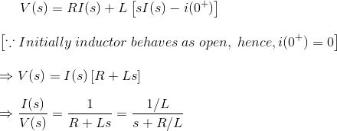

**Modeling of RC circuit:**

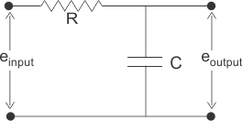

AIn the above network it is obvious that

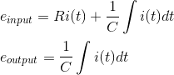

Let us assume,

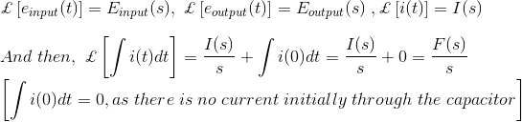

Taking the Laplace transform of above equations with considering the initial condition as zero, we get,

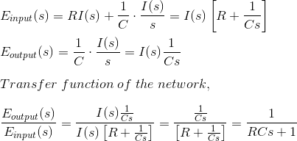

**Mechanical Systems:**

Mechanical systems can be divided into two basic systems.

1. Translational systems and (b) Rotational systems

We will consider these two systems separately and describe these systems in terms of three

fundamental linear elements.

**(a) Translational systems:**

**1. Mass:**This represents an element which resists the motion due to inertia. According to

Newton's second law of motion, the inertia force is equal to mass times acceleration.

fM= M a = M (dv/dt) = M (dx2/ dt2 )

Where a, v and x denote acceleration, velocity and displacement of the body respectively.

Symbolically, this element is represented by a block as shown in fig . (a)

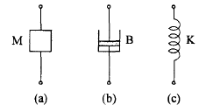

**Fig.3. Passive linear elements of translational motion (a) Mass (b) Dash pot (c) Spring.**

***2*. Dash pot:**This is an element which opposes motion due to friction. If the friction is viscous

friction, the frictional force is proportional to *velocity.* This force is also known as damp ling

force.

Thus we can write fB = Bv = B (dx/dt)

Where B is the damping coefficient. This element is called as dash pot and is symbolically

represented as in Fig.(b)

**3. Spring**:The third element which opposes motion is the spring. The restoring force of a spring

is proportional to the displacement.

Thus fK = K x

Where K is known as the stiffness of the spring or simply spring constant. The symbol used

for this element is shown in Fig.(c)

**(b) Rotational systems:**Corresponding to the three basic elements of translation systems, there are three basic elements representing rotational systems.

**1. Moment of Inertia:**This element opposes the rotational motion due to Moment oflnertia. Theopposing inertia torque is given by,



Where *a, ω* and ϴ are the angular acceleration, angular velocity and angular displacement

respectively. J is known as the moment of inertia of the body.

**2. Friction:**The damping or frictional torque which opposes the rotational motion is given by,



Where B is the rotational frictional coefficient.

**3. Spring:**The restoring torque of a spring is proportional to the angular displacement () and is

given by,



Where K is the torsimal stiffness of the spring. The three elements defined above are shown

in Fig.

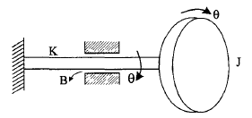

**Fig.4. Rotational elements**

Since the three elements ofrotational systems are similar in nature to those of translational systems

no separate symbols are necessary to represent these elements. Having defined the basic elements of mechanical systems, we must now be able to write differential equations for the system when these mechanical systems are subjected to external forces. This is done by using the D' Alembert's principle which is similar to the Kirchhoff's laws in Electrical Networks. Also, this principle is a modified version of Newton's second law of motion.

The D' Alembert's principle states that, "For any body, the algebraic sum of externally applied forces and the forces opposing the motion in any given direction is zero".To apply this principle to any body, a reference direction of motion is first chosen. All forces acting in this direction are taken positive and those against this direction are taken as negative. Let us apply this principle to a mechanical translation system shown in Fig.

A mass M is fixed to a wall with a spring K and the mass moves on the floor with a viscous friction. An external force f is applied to the mass. Let us obtain the differential equation governing the motion of the body.

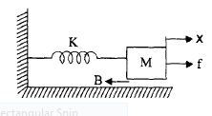

**Fig.5. A mechanical translational system**

Let us take a reference direction of motion of the body from left to right. Let the displacement of the mass be *x.* We assume that the mass is a rigid body, ie, every particle in the body has the same displacement, *x.* Let us enumerate the forces acting on the body.

( a) external force = f

(b) resisting forces :

(i) Inertia force, fM = - M (d2x/dt2)(ii) Damping force, fB = - B dt

(iii) Spring force, fK = - Kx

Resisting forces are taken to be negative because they act in a direction opposite to the chosen reference direction. Thus, using D' Alemberts principle we have,

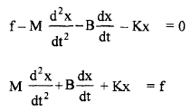

This is the differential equation governing the motion of the mechanical translation system. The transfer function can be easily obtained by taking Laplace transform of above



If velocity is chosen as the output variable,



Similarly, the differential equation governing the motion of rotational system can also be obtained. For the system in the following Fig., we have



The transfer function of this system is given by

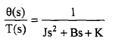

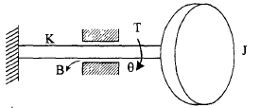

**Fig. 6. Mechanical rotatinal system**

**Block Diagrams ofControl System**

The block diagram is to represent a [control system](http://www.electrical4u.com/control-system-closed-loop-open-loop-control-system/) in diagram form. In other words practical representation of a control system is its block diagram. It is not always convenient to derive the entire [transfer function](http://www.electrical4u.com/transfer-function/) of a complex control system in a single function. It is easier and better to derive transfer function of control element connected to the system, separately. The [transfer function](http://www.electrical4u.com/transfer-function/) of each element is then represented by a block and they are then connected together with the path of signal flow. For simplifying a complex control system, block diagrams are used. Each element of the control system is represented with a block and the block is the symbolic representation of transfer function of that element. A complete control system can be represented with a required number of interconnected such blocks. In the figure below, there are two elements with [transfer function](http://www.electrical4u.com/transfer-function/) Gone(s) and Gtwo(s). Where Gone(s) is the transfer function of first element and Gtwo(s) is the transfer function of second element of the system.

In addition to that, the diagram also shows there is a feedback path through which output signal C(s) is fed back and compared with the input R(s) and the difference between input and output E(s) = R(s) – C(s) is acting as actuating signal or error signal.

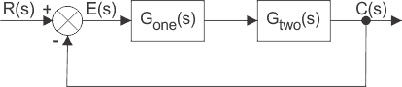

In each block of diagram, the output and input are related together by transfer function. Where, transfer function 

where, C(s) is the output and R(s) is the input of that particular block. Transfer Function

A complex control system consists of several blocks. Each of them has its own transfer function. But overall transfer function of the system is the ratio of transfer function of final output to transfer function of initial input of the system. This overall transfer function of the system can be obtained by simplifying the control system by combining this individual blocks, one by one. Technique of combining of these blocks is referred as **block diagram reduction technique**. For successful implementation of this technique, some rules for block diagram reduction to be followed. Let us discuss these rules, one by one for reduction of block diagram of control system.

If the transfer function of input of control system is R(s) and corresponding output is C(s), and the overall transfer function of the control system is G(s), then the control system can be represented as

Transfer Functionhttp://www.electrical4u.com/electrical/control-system-equations/block-diagram-of-control-system-1.gif

**Take off Point of Block Diagram**

when we need to apply one or same input to more than one blocks, we use **take off point**. A point is where the input gets more than one paths to propagate. This to be noted that the input does not get divided at a point, hence input propagates through all the paths connected to that point without affecting its value. Hence, by takeoff point same input signals can be applied to more than one systems or blocks. Representation of a common input signal to more than one blocks of control system is done by a common point as shown in the figure below with point X. 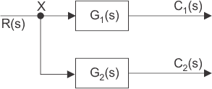

**Cascade Blocks**

When several systems or control blocks are connected in cascaded manner, the transfer function of the entire system will be the product of transfer function of all individual blocks. Here it also to be remembered that the output of any block will not be affected by the presence of other blocks in the cascaded system.

block diagram of parallel control system

Now,

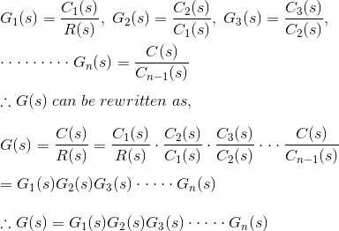

from the diagram it is seen that, Where, G(s) is the overall transfer function of cascaded control system.

http://www.electrical4u.com/electrical/control-system-equations/block-diagram-of-control-system-3.gif

**Summing Point of Block Diagram**

Instead of applying single input signal to different blocks as in the previous case, there may be such situation where different input signals are applied to same block. Here, resultant input signal is the summation of all input signals applied. Summation of input signals is represented by a point called summing point which is shown in the figure below by crossed circle. Here R(s), X(s) and Y(s) are the input signals. It is necessary to indicate the fine specifying the input signal entering a summing point in the block diagram of control system.

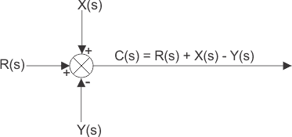

**Consecutive Summing Point**

A summing point with more than two inputs can be divided into two or more consecutive summing points, where alteration of the position of consecutive summing points does not effect the output of the signal. In other words - if there are more than one summing points directly inter associated, then they can be easily interchanged from their position without affecting the final output of the summing system

. 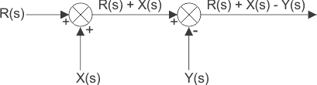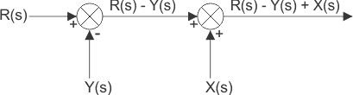

**Parallel Blocks**

When same input signal is applied different blocks and the output from each of them are added in a summing point for taking final output of the system then over all transfer function of the system will be the algebraic sum of transfer function of all individual blocks.

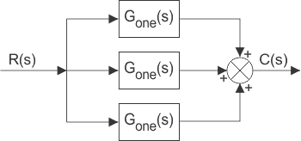

If Cone, Ctwo and Cthree are the outputs of the blocks with transfer function G one, Gtwo and Gthree, then

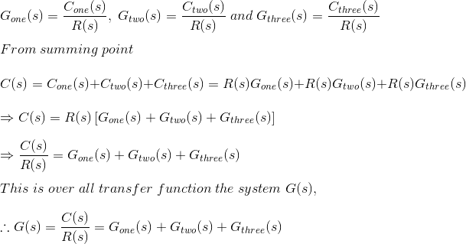

control system

**Shifting of Take off Point**

If same signal is applied to more than one system, then the signal is represented in the system by a point called take off point. Principle of **shifting of take off point** is that, it may be shifted either side of a block but final output of the branches connected to the take off point must be un-changed. The take off point can be shifted either sides of the block.

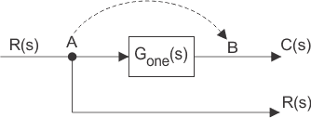

In the figure above the take off point is shifted from position A to B. The signal R(s) at take off point A will become G(s)R(s) at point B. Hence another block of inverse of transfer function G(s) is to be put on that path to get R(s) again.

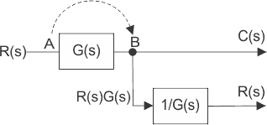

Now let us examine the situation when take off point is shifted before the block which was previously after the block.

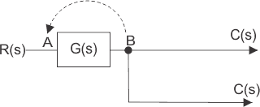

Here the output is C(s) and input is R(s) and hence

http://www.electrical4u.com/electrical/control-system-equations/block-diagram-of-control-system-5.gif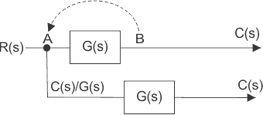

Here, we have to put one block of transfer function G(s) on the path so that output again comes as C(s).

http://www.electrical4u.com/electrical/control-system-equations/block-diagram-of-control-system-6.gif

**Shifting of Summing Point**

Let us examine the shifting of summing point from a position before a block to a position after a block. There are two input signals R(s) and ±X(s) entering in a summing point at position A. The output of the summing point is R(s) ± X(s). The resultant signal is the input of a control system block of transfer function G(s) and the final output of the system is

http://www.electrical4u.com/electrical/control-system-equations/block-diagram-of-control-system-7.gif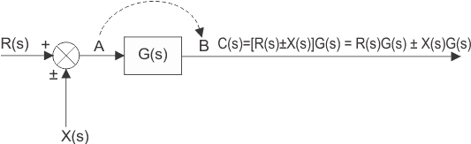

Hence, a summing point can be redrawn with input signals R(s)G(s) and ± X(s)G(s) 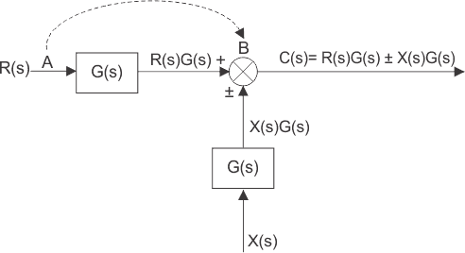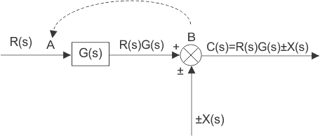

In the above block diagrams of control system output can be rewritten as http://www.electrical4u.com/electrical/control-system-equations/block-diagram-of-control-system-8.gif

The above equation can be represented by a block of transfer function G(s) and input R(s)±X(s)/G(s) again R(s)±X(s)/G(s) can be represented with a summing point of input signal R(s) and ±X(s)/G(s) and finally it can be drawn as below.

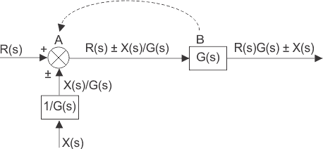

**Block Diagram of Closed Loop Control System**

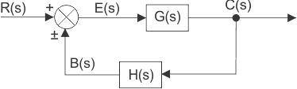

In a closed loop control system, a fraction of output is fed-back and added to input of the system. If H (s) is the transfer function of feedback path, then the transfer function of feedback signal will be B(s) = C(s)H(s). At summing point, the input signal R(s) will be added to B(s) and produces actual input signal or error signal of the system and it is denoted by E(s).

http://www.electrical4u.com/electrical/control-system-equations/block-diagram-of-control-system-9.gif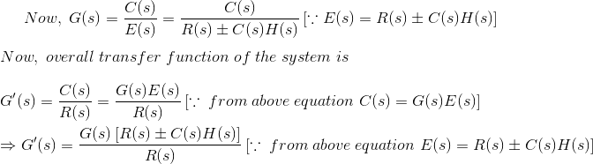

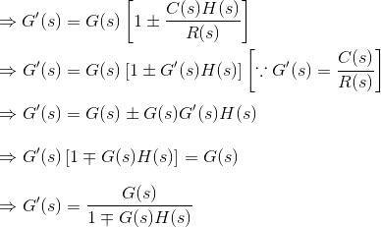

http://electrical4u.com/electrical/wp-content/uploads/2015/02/closed-loop-control-system-2.gif

**Signal Flow Graph of Control System**

Signal flow graph of control system is further simplification of block diagram of control system. Here, the blocks of transfer function, summing symbols and take off points are eliminated by branches and nodes.The transfer function is referred as transmittance in signal flow graph. Let us take an example of equation y = Kx. This equation can be represented with block diagram as below

signal-flow-diagram

The same equation can be represented by signal flow graph, where x is input variable node, y is output variable node and a is the transmittance of the branch connecting directly these two nodes.

simple signal flow graph

**Rules for Drawing Signal Flow Graph**

1. The signal always travels along the branch towards the direction of indicated arrow in the branch.
2. The output signal of the branch is the product of transmittance and input signal of that branch.
3. Input signal at a node is summation of all the signals entering at that node.
4. Signals propagate through all the branches, leaving a node.

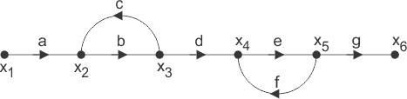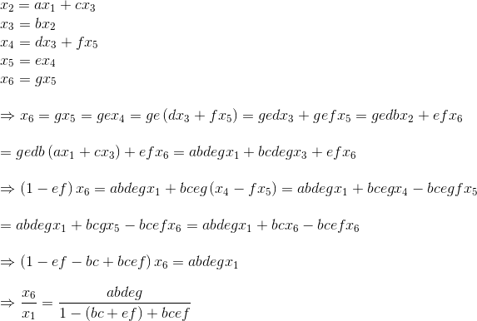

**Simple Process of Calculating Expression of Transfer Function for Signal Flow Graph**

* First, the input signal to be calculated at each node of the graph. The input signal to a node is summation of product of transmittance and the other end node variable of each of the branches arrowed towards the former node.
* Now by calculating input signal at all nodes will get numbers of equations which relating node variables and transmittance. More precisely, there will be one unique equation for each of the input variable node.
* By solving these equations we get, ultimate input and output of the entire signal flow graph of control system.
* Lastly by dividing inspiration of ultimate output to the expression of initial input we calculate the expiration of transfer function of that signal flow graph.

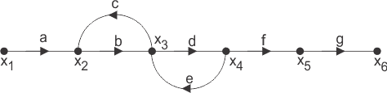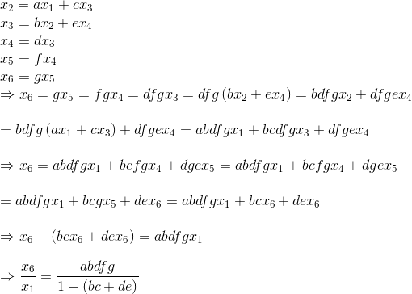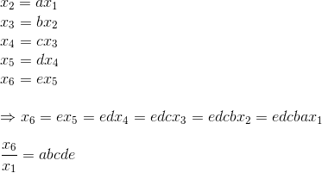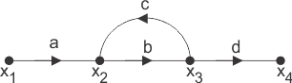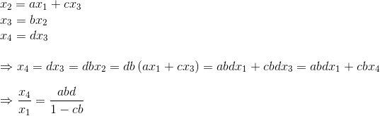

If P is the forward path transmittance between extreme input and output of a signal flow graph. L1, L 2…………………. loop transmittance of first, second,……..loop of the graph. Then for first signal flow graph of control system, the overall transmittance between extreme input and output is



http://www.electrical4u.com/electrical/control-system-equations/signal-flow-graph-5.gif

Then for second signal flow graph of control system, the overall transmittance between extreme input and output is

http://www.electrical4u.com/electrical/control-system-equations/signal-flow-graph-6.gif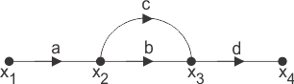

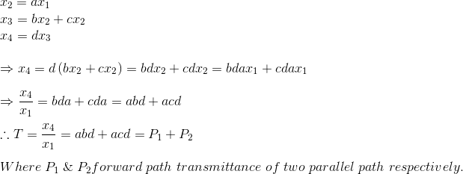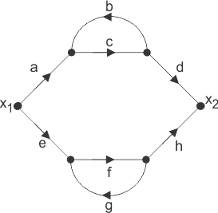

Here in the figure above, there are two parallel forward paths. Hence, overall transmittance of that signal flow graph of control system will be simple arithmetic sum of forward transmittance of these two parallel paths.

As the each of the parallel paths having one loop associated with it, the forward transmittances of these parallel paths are

http://www.electrical4u.com/electrical/control-system-equations/signal-flow-graph-8.gif

Therefore overall transmittance of the signal flow graph is

http://www.electrical4u.com/electrical/control-system-equations/signal-flow-graph-9.gif

**Mason's Gain Formula**

The overall transmittance or gain of signal flow graph of control system is given by Mason’s Gain Formula and as per the formula the overall transmittance is

http://www.electrical4u.com/electrical/control-system-equations/signal-flow-graph-10.gif

Where, Pk is the forward path transmittance of kth in path from a specified input is known to an output node. In arresting P k no node should be encountered more than once. Δ is the graph determinant which involves closed loop transmittance and mutual interactions between non-touching loops. Δ = 1 - (sum of all individual loop transmittances) + (sum of loop transmittance products of all possible pair of non-touching loops) - (sum of loop transmittance products of all possible triplets of non-touching loops) + (……) - (……) Δ k is the factor associated with the concerned path and involves all closed loop in the graph which are isolated from the forward path under consideration. The path factor Δ k for the k th path is equal to the value of grab determinant of its signal flow graph which exist after erasing the K thpath from the graph.

By using this formula one can easily determine the overall transfer function of control system by converting a block diagram of control system (if given in that form) to its equivalent signal flow graph. Let us illustrate the below given block diagram

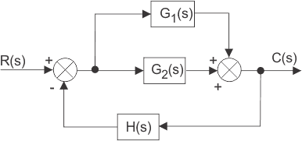

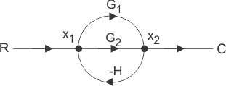

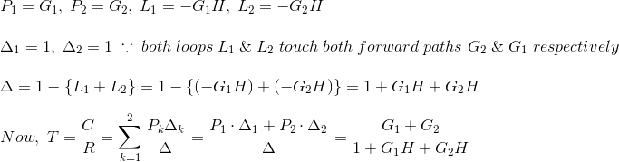

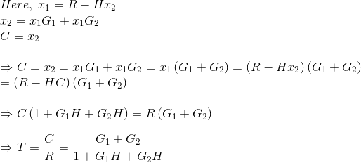

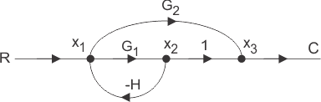

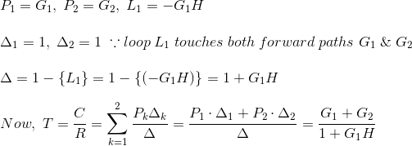

**UNIT-2**

**Controller Components:**

**Servomechanism : Theory and Working Principle of Servo Motor**

**Servomechanism**

A servo system mainly consists of three basic components - a controlled device, a output [sensor](https://www.electrical4u.com/sensor-types-of-sensor/), a feedback system.This is an automatic [closed loop control system](https://www.electrical4u.com/control-system-closed-loop-open-loop-control-system/). Here, instead of controlling a device by applying the variable input signal, the device is controlled by a feedback signal generated by comparing output signal and reference input signal.  
When reference input signal or command signal is applied to the system, it is compared with output reference signal of the system produced by output sensor, and a third signal produced by a feedback system. This third signal acts as an input signal of controlled device.

This input signal to the device presents as long as there is a logical difference between reference input signal and the output signal of the system. After the device achieves its desired output, there will be no longer the logical difference between reference input signal and reference output signal of the system. Then, the third signal produced by comparing theses above said signals will not remain enough to operate the device further and to produce a further output of the system until the next reference input signal or command signal is applied to the system. Hence, the primary task of a servomechanism is to maintain the output of a system at the desired value in the presence of disturbances.

**Working Principle of Servo Motor:**

A [servo motor](https://www.electrical4u.com/what-is-servo-motor/) is basically a [DC motor](https://www.electrical4u.com/dc-motor-or-direct-current-motor/) (in some special cases it is AC motor) along with some other special purpose components that make a DC motor a servo. In a servo unit, you will find a small DC motor, a [potentiometer](https://www.electrical4u.com/potentiometer-working-principle-of-potentiometer/), gear arrangement and an intelligent circuitry. The intelligent circuitry along with the potentiometer makes the servo to rotate accordingly. As we know, a small DC motor will rotate with high speed but the torque generated by its rotation will not be enough to move even a light load. This is where the gear system inside a servomechanism comes into the picture. The gear mechanism will take high input speed of the motor (fast) and at the output, we will get an output speed which is slower than original input speed but more practical and widely applicable.

Say at initial position of servo motor shaft, the position of the potentiometer knob is such that there is no electrical signal generated at the output port of the potentiometer. This output port of the potentiometer is connected with one of the input terminals of the error detector amplifier. Now an electrical signal is given to another input terminal of the error detector amplifier. Now difference between these two signals, one comes from potentiometer and another comes from external source, will be amplified in the error detector amplifier and feeds the DC motor. This amplified error signal acts as the input power of the DC motor and the motor starts rotating in desired direction. As the motor shaft progresses the potentiometer knob also rotates as it is coupled with motor shaft with help of gear arrangement. As the position of the potentiometer knob changes there will be an electrical signal produced at the potentiometer port. As the angular position of the potentiometer knob progresses the output or feedback signal increases. After desired angular position of motor shaft the potentiometer knob reaches at such position the electrical signal generated in the potentiometer becomes same as of external electrical signal given to amplifier. At this condition, there will be no output signal from the amplifier to the motor input as there is no difference between external applied signal and the signal generated at potentiometer. As the input signal to the motor is nil at that position, the motor stops rotating. This is how a simple conceptual servo motor works.

**Servo Motor Control**

For understanding ***servo motor control*** let us consider an example of servomotor that we have given a signal to rotate by an angle of 45o and then stop and wait for further instruction. The shaft of the [DC motor](https://www.electrical4u.com/dc-motor-or-direct-current-motor/) is coupled with another shaft called output shaft, with the help of gear assembly. This gear assembly is used to step down the high rpm of the motor's shaft to low rpm at the output shaft of the servo system.

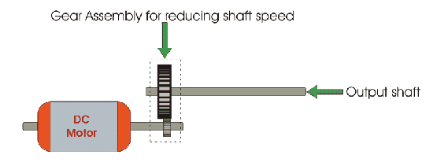

The [voltage](https://www.electrical4u.com/voltage-or-electric-potential-difference/) adjusting knob of a [potentiometer](https://www.electrical4u.com/potentiometer-working-principle-of-potentiometer/) is so arranged with the output shaft by means of another gear assembly, that during rotation of the shaft, the knob also rotates and creates an varying [electrical potential](https://www.electrical4u.com/voltage-or-electric-potential-difference/) according to the potentiometer.

This signal i.e. electrical potential is increased with angular movement of potentiometer knob along with the system shaft from 0o to 45o. This electrical potential or voltage is taken to the error detector feedback amplifier along with the input reference commends i.e. input signal voltage.

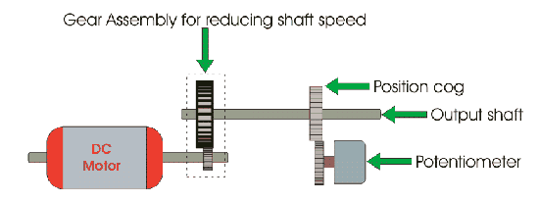

As the angle of rotation of the shaft increases from 0o to 45o the voltage from potentiometer increases. At 45o this voltage reaches to a value which is equal to the given input command voltage to the system. As at this position of the shaft, there is no difference between the signal voltage coming from the potentiometer and reference input voltage (command signal) to the system, the output voltage of the amplifier becomes zero.

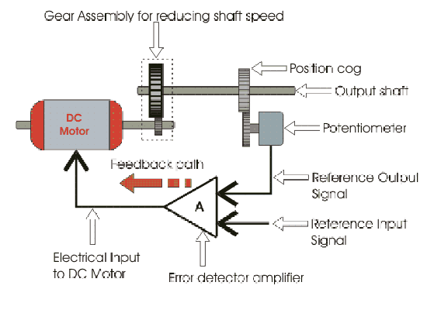

As per the picture given above the output electrical voltage signal of the amplifier, acts as input voltage of the DC motor. Hence, the motor will stop rotating after the shaft rotates by 45o. The motor will be at this rest position until another command is given to the system for further movement of the shaft in the desired direction. From this example we can understand the most basic **servo motor theory** and how **servo motor control** is achieved.  
 From this basic **working principle of servo motor** it can be concluded that the shaft of the servo is connected to a potentiometer. The circuitry inside the servo, to which the potentiometer is connected, knows the position of the servo. The [current](https://www.electrical4u.com/electric-current-and-theory-of-electricity/) position will be compared with the desired position continuously with the help of an Error Detection Amplifier. If a mismatch is found, then an error signal is provided at the output of the error amplifier and the shaft will rotate to go the exact location required. Once the desired location is reached, it stops and waits.

**DC Servo Motors | Theory of DC Servo Motor**

Any [electrical motor](https://www.electrical4u.com/electrical-motor-types-classification-and-history-of-motor/) can be utilized as [servo motor](https://www.electrical4u.com/servo-motor-servo-mechanism-theory-and-working-principle/) if it is controlled by servomechanism. Likewise, if we control a [DC motor](https://www.electrical4u.com/dc-motor-or-direct-current-motor/) by means of servomechanism, it would be referred as **DC servo motor**. There are different [types of DC motor](https://www.electrical4u.com/types-of-dc-motor-separately-excited-shunt-series-compound-dc-motor/), such [shunt wound DC motor](https://www.electrical4u.com/shunt-wound-dc-motor-dc-shunt-motor/), [series DC motor](https://www.electrical4u.com/series-wound-dc-motor-or-dc-series-motor/), Separately excited DC motor,[permanent magnet DC motor](https://www.electrical4u.com/permanent-magnet-dc-motor-or-pmdc-motor/), [Brushless DC motor](https://www.electrical4u.com/brushless-dc-motors/) etc. Among all mainly separately excited DC motor, [permanent magnet DC motor](https://www.electrical4u.com/permanent-magnet-dc-motor-or-pmdc-motor/) and [brush less DC motor](https://www.electrical4u.com/brushless-dc-motors/) are used as servo.

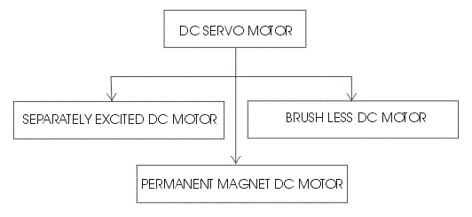**Separately Excited DC Servo Motor**

**DC Servo Motor Theory**

The motors which are utilized as DC servo motors, generally have separate DC source for field winding and [armature winding](https://www.electrical4u.com/armature-winding-pole-pitch-coil-span-commutator-pitch/). The control can be achieved either by controlling the field [current](https://www.electrical4u.com/electric-current-and-theory-of-electricity/) or armature current. Field control has some specific advantages over armature control and on the other hand armature control has also some specific advantages over field control. Which type of control should be applied to the DC servo motor, is being decided depending upon its specific applications.

Let's discus **DC servo motor working principle** for field control and armature control one by one.

**Field Controlled DC Servo Motor Theory**

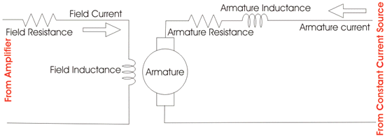

The figure illustrates the schematic diagram for a field controlled DC servo motor. In this arrangement the field of DC motor is excited be the amplified error signal and armature winding is energized by a constant [current source](https://www.electrical4u.com/ideal-dependent-independent-voltage-current-source/) . The field is controlled below the knee point of magnetizing saturation curve. At that portion of the curve the mmf linearly varies with excitation current. That means torque developed in the DC motor is directly proportional to the field current below the knee point of magnetizing saturation curve.

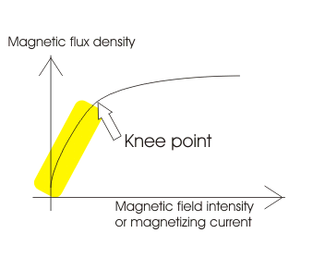

From general [torque equation of DC motor](https://www.electrical4u.com/torque-equation-of-dc-motor/) it is found that, torque T ∝φIa. Where, φ is field flux and Ia is armature current. But in field controlled DC servo motor, the armature is excited by constant current source, hence Ia is constant here. Hence, T ∝ φ

As field of this DC servo motor is excited by amplified error signal, the torque of the motor i.e. rotation of the motor can be controlled by amplified error signal. If the constant armature current is large enough then, every little change in field current causes corresponding change in torque on the motor shaft. The direction of rotation can be changed by changing polarity of the field. The direction of rotation can also be altered by using split field DC motor, where the field winding is divided into two parts, one half of the winding is wound in clockwise direction and other half in wound in anticlockwise direction. The amplified error signal is fed to the junction point of these two halves of the field as shown in the figure. The [magnetic field](https://www.electrical4u.com/what-is-magnetic-field/) of both halves of the field winding opposes each other. During operation of the motor, magnetic field strength of one half dominates other depending upon the value of amplified error signal fed between these halves. Due to this, the DC servo motor rotates in a particular direction according to the amplified error signal voltage.

The main disadvantage of field control DC servo motors, is that the dynamic response to the error is slower because of longer time constant of inductive field circuit. The field is an electromagnet so it is basically a highly inductive circuit hence due to sudden change in error signal voltage, the current through the field will reach to its steady state value after certain period depending upon the time constant of the field circuit. That is why field control DC servo motor arrangement is mainly used in small [servo motor applications](https://www.electrical4u.com/servo-motor-applications-in-robotics-solar-tracking-system-etc/). The main advantage of using field control scheme is that, as the motor is controlled by field - the controlling power requirement is much lower than rated power of the motor.

**Armature Controlled DC Servo Motor Theory**

The figure below shows the schematic diagram for an armature controlled DC servo motor. Here the armature is energized by amplified error signal and field is excited by a constant current source.

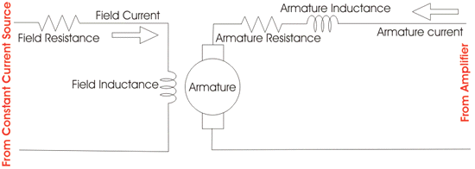

The field is operated at well beyond the knee point of magnetizing saturation curve. In this portion of the curve, for huge change in magnetizing current, there is very small change in mmf in the motor field. This makes the servo motor is less sensitive to change in field current. Actually for armature controlled DC servo motor, we do not want that, the motor should response to any change of field current.

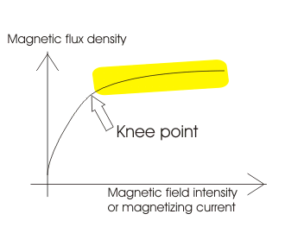

Again, at saturation the field flux is maximum. As we said earlier, the general [torque equation of DC motor](https://www.electrical4u.com/torque-equation-of-dc-motor/)is, torque T ∝φIa. Now if φ is large enough, for every little change in armature current Ia there will be a prominent changer in motor torque. That means servo motor becomes much sensitive to the armature current.

As the armature of DC motor is less inductive and more resistive, time constant of [armature winding](https://www.electrical4u.com/armature-winding-pole-pitch-coil-span-commutator-pitch/) is small enough. This causes quick change of armature current due to sudden change in armature voltage. That is why dynamic response of armature controlled DC servo motor is much faster than that of field controlled DC servo motor.

The direction of rotation of the motor can easily be changed by reversing the polarity of the error signal.

**Permanent Magnet DC Servo Motor**

Field control is not possible in the case of permanent magnet DC motor as the field is a permanent magnet here. DC [servo motor working principle](https://www.electrical4u.com/servo-motor-servo-mechanism-theory-and-working-principle/) in that case is similar to that of armature controlled motor.

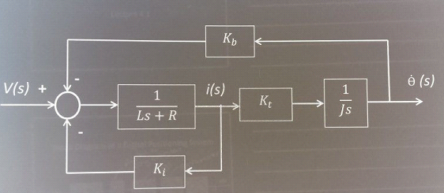

**Introduction**  
The servomotors used in industry today are used in a closed-loop servo system. To understand how the servomotor is used in the system, it is first necessary to review the entire system. the figure indicates a block diagram of a typical servo system.

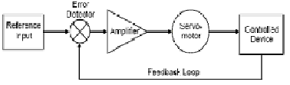

A reference input (typically called a velocity input) is sent to the servo amplifier, which controls the speed of the servomotor. Directly mounted to the machine (or to the servomotor) is a feedback device (either an encoder or resolver). This device changes mechanical motion into electrical signals and is used as a *feedback loop*. This feedback loop is then sent to the *error detector*, which compares the actual operation with that of the reference input. If there is an error, that error is fed directly to the amplifier, which makes the necessary corrections.

In many servo systems, both velocity and position are monitored. (Note: In servo systems, the word "velocity" is often used to describe speed control. Velocity indicates a rate of change of position, with respect to time. It also indicates a rate of motion in a particular direction, with respect to time.) The velocity loop control may take its command from the velocity loop feedback device-a resolver or tachometer mounted directly to the motor. The position loop control may take its command from the position feedback device-an encoder. Depending on the system, both devices may be mounted to the actual machine or controlled device.

The stability of the entire system is dependent upon the tuning of the components in the system and how well those components are matched. Tuning the system involves working with a PID (proportional integral derivative) control. This type of closed loop control is standard on all highaccuracy systems. The main factors in this closed loop system are the gain, integration time, and derivative time of the loop.

The amplifier gain must be set satisfactorily. The gain sets how responsive the amplifier will be during changes in error signal. A high gain will cause the motor to overshoot the intended speed target. Too low of a gain may mean that the target is reached late in the cycle, or possibly not at all.

The integration time allows the amplifier to respond to changes in the error signal, mostly at zero speed. The zero speed error signal is multiplied by the gain setting, and results in increased motor responsiveness (stiffness) and accuracy.

The derivative function is the most difficult to accurately adjust. This controls the dampening or oscillations of the system. This function basically dictates the amount of correction given per unit of error. The error signal can be corrected immediately (in milliseconds), or throughout a longer period of time (seconds).

If there is a difficult part to the tuning task, it would be during the derivative setup. The gain and integration time is interactive. One setting affects the other. Proper setup of the derivative function involves multiplying the position error by the position error rate (how much correction should take place per unit of time). If the system components are not matched, oscillations, overshoot, or undershoot of velocity can result, which means unstable operation.

Servomotors are special electromechanical devices that operate in precise degrees of rotation. This type of motor quickly responds to positive or negative signals from a servo amplifier. Fast and accurate speed, torque, and direction control are the mark of a servomotor's characteristics. Very high starting torque must be obtained from the servomotor. The standard AC induction motor's torque is measured in pound-feet. By contrast, the servomotor's torque is measured in inch-pounds.

In today's servo systems, three basic types of servomotors are used: AC, DC, and AC brushless. As one might expect, the AC design is based on AC induction motor characteristics. The DC design is based on the design of a DC motor. The brushless DC design is based on that of a synchronous motor. The basic principles of the DC and brushless DC servomotor have already been reviewed. We will therefore review the general characteristics of the AC servomotor. Linear devices will also be reviewed, since most of the position systems operate on linear technology.

The learning objectives of this technical note are:

1.Draw the equivalent DC servomotor circuit theory model.

2.State the equations of motion used to derive the electromechanical transfer function in the time domain and the s-domain.

3. Draw the DC servomotor signal block diagram.

4. Derive the DC servomotor electromechanical transfer function.

CIRCUIT THEORY MODEL

The circuit shown in Figure 2 models the DC servomotor. Note that an armature control current is created when the armature control voltage, Va, energizes the motor. The current flow through a series – connected armature resistance, an armature inductance, and the rotational component (the rotor) of the motor. The rotor shaft is typically drawn to the right with the torque (T m ) and angular displacement (θm) variables shown. The motor transfer function is the ratio of angular displacement to armature voltage.

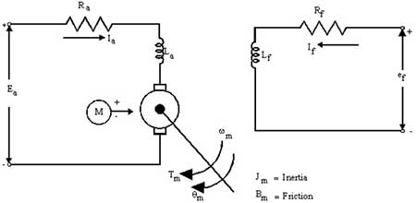

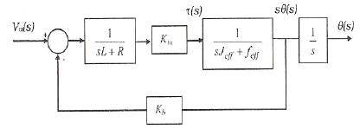

**Principle of Operating**

A [**DC servomotor**](https://www.pantechsolutions.net/control-system/transfer-function-of-dc-servo-motor) is used in a control system where an appreciable amount of shaft power is required. The [**DC servomotor**](https://www.pantechsolutions.net/control-system/transfer-function-of-dc-servo-motor) are either armature-controlled with fixed field, or field-controlled with fixed armature current. [**DC servomotor**](https://www.pantechsolutions.net/control-system/transfer-function-of-dc-servo-motor) used in instrument employ a fixed permanent-magnet field, and the control signal is applied to the armature terminals.

Tm = KmΦfia - (i)

Km = Proportionality constant

Tm = Motor torque Nf = Field flux ia = Armature current

In addition to the torque when conductor moves in magnetic field, voltage is generated across its terminals which opposes the current flow and hence called as Back e.m.f denoted as eb

eb= KmΦωm- (ii)

This back e.m.f is directly proportional to the shaft velocity Tm. Equations (i) and (ii) form the basic equation of d.c. servo motor operation.

**Basic Classification**

Basically d.c. servo motors are classified as:

* Variable magnetic flux motors.
* Constant magnetic flux motors.

In variable magnetic flux motors magnetic field is produced by the field windings which are connected to the external supply. These are also called as separately excited or field controlled motors.

**TRANSFER FUNCTION OF** [**DC SERVO MOTOR**](https://www.pantechsolutions.net/control-system/transfer-function-of-dc-servo-motor)



The constant magnetic flux motors are also known as permanent magnet d.c. motors. These motors have relatively linear torque-speed characteristics.

Derivation of transfer functions for

* Field controlled d.c. servo motor
* Armature controlled d.c. servo-motors.

**ii. Field Controlled** [**DC servo motor**](https://www.pantechsolutions.net/control-system/transfer-function-of-dc-servo-motor)

**Assumptions**

(1) Constant armature current is fed into the motor.

(2) Nf % If. Flux produced is proportional to field current. Nf = Kf If

(3) Torque is proportional to product of flux and armature current.

Tm % N Ia . Tm = K` N Ia = K’ Kf If Ia Tm = Km Kf If

Where

Km = K`

Ia = constant

Apply kirchoff’s law to field circuit.

L fdif / dt + Rf If = ef

Now shaft torque Tm is used for driving load against the inertia and frictional torque.

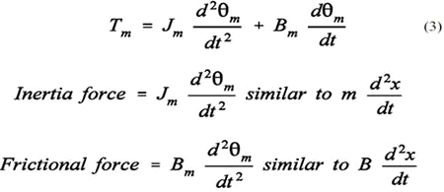

Finding Laplace Transforms of equations (1), (2) and (3) we get,

Tm (s) = Km Kf If(s) Ef (s) = (SLf + Rf) If (s) Tm (s) = Jms 2m (s) + Bms2m (s)



Eliminate If (s) from equations (4) and (5)Input = Ef(S)

Output = Rotational displacement 2m (S)

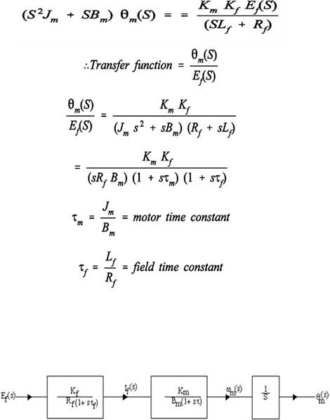  
**Armature Controlled D.C. Servo Motor**

**Assumptions**

(i) Flux is directly proportional to current through field winding.

Nm = Kf If = constant

(ii) Torque produced is proportional to product of flux and armature current.

T = K`m N Ia T = K`mKf If Ia

(iii) Back e.m.f is directly proportional to shaft velocity Tm, as flux N is constant.

 asωn = dθ(t) / dt

Eb = kbωm(d) = Kbsθm(s)

Apply Kirchhoff’s law to armature circuit:

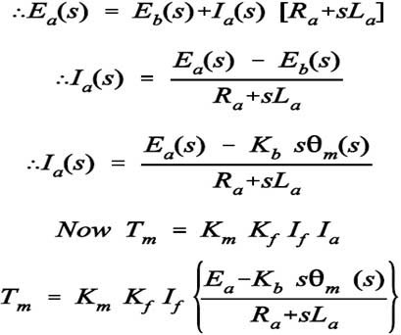

Where Jm = Jm/Bm and

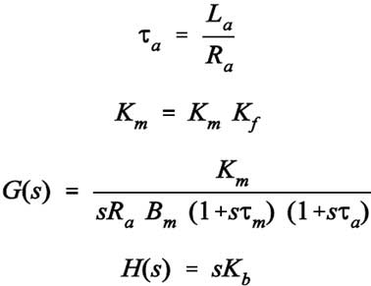

**Difference Between Servo Motor and DC Motor in the tabulated form is given below.**

|  |  |  |
| --- | --- | --- |
| **BASIC** | **SERVO MOTOR** | **DC MOTOR** |
| Wire system | The Servo motor is three wire system known as power, ground and control. | DC motor is two wire system known as power and ground |
| Assembly | It has an assembly of four things DC motor, gearing set, control circuit and a position sensor. | DC motor is an individual machine with no assembly. |
| Rotation | Servo motor does not rotate freely and continuously like DC motor. Its rotation is limited to 180⁰ | Movement of DC motor is continuous |
| Examples | They are used in robotic arms, legs or rudder control. | DC motor is used in car wheels, fans etc. |

The Servo Motor is basically a DC motor which does not run continuously for a longer period of time. It has a unique arrangement which allows the motor to rotate at a specific angle with greater accuracy and precision. This machine is controlled by a feedback system.

Direct Current (DC motor) as already discussed in the article DC machine, is a device which converts electrical energy into mechanical. It is based on the principle of Fleming’s left-hand rule that when a conductor is placed in a magnetic field which carries current in it, torque is generated which moves the motor.

According to Fleming’s left-hand rule index finger, middle finger and thumb when stretched perpendicular it represented the direction of the magnetic field, the direction of the current and the direction of the force respectively.

**Difference Between Servo Motor and DC Motor are explained below in detail.**

* The Servo motor comprises of three wire system known as Power, Ground and Control whereas DC motor is two wire system known as Power and Ground.
* Servo motor has an assembly of four things DC motor, gearing set, control circuit and a position sensor. DC Motor does not comprise of any assembly.
* Servo motor does not rotate freely and continuously like DC motor. Its rotation is limited to 180⁰ whereas DC motor rotates continuously.
* Servo motors are used in robotic arms, legs or rudder control system and toy cars. DC motors are used in fans, car wheels, etc

**AC Servomotors**   
This type of motor is basically a two-phase induction motor, capable of reverse operation. To achieve the dynamic requirements of a servo system, the servomotor must have a small diameter, low inertia, and high-resistance rotors. The low inertia allows for fast starts, stops, and reverse of direction. The high-resistance rotor provides for almost linear speed/ torque characteristics and accurate control.

An AC servomotor is designed with two phases set at right angles to each other. A fixed or reference winding is excited by a fixed voltage source. The control winding is excited by a variable voltage source, usually the servo amplifier. Both sets of windings are usually designed with the same voltage per turns ratio (meaning that with equal voltage applied to each winding, the same magnetic flux will be produced). This allows for maximum control of speed, with very little speed drift. In many cases, the design of the AC servomotor offers only reasonable efficiency, at the sacrifice of high starting torque and smooth speed response. The figure indicates a typical AC servomotor design.

The stator of the Two Phase AC Servo Motor has the two distributed windings which are displaced from each other by 90 degrees electrical. One winding is known as a Reference or Fixed Phase, which is supplied from a constant voltage source. The other one is known as Control Phase, and it is provided with a variable voltage

The connection diagram of the two Phase AC Servo motor is shown below.

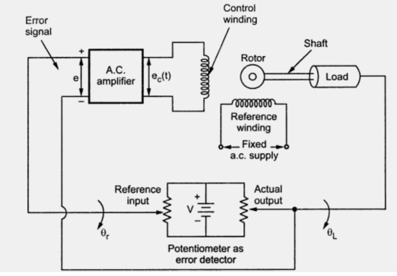

The control phase is usually supplied from a servo amplifier. The speed and torque of the rotor are controlled by the phase difference between the control voltage and the reference phase voltage. By reversing the phase difference from leading to lagging or vice versa, the direction of the rotation of the rotor can be reversed.

**Two Phase AC Servo Motor**

As we have already seen [What is a Servo Motor?](http://circuitglobe.com/servo-motor.html)In the previous article. Here I am going to discuss the Two Phase and Three Phase AC Servo motor. The stator of the Two Phase AC Servo Motor has the two distributed windings which are displaced from each other by 90 degrees electrical. One winding is known as a Reference or Fixed Phase, which is supplied from a constant voltage source. The other one is known as Control Phase, and it is provided with a variable voltage

The connection diagram of the two Phase AC Servo motor is shown below.

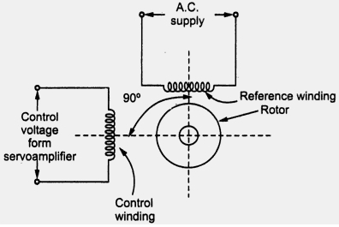

The control phase is usually supplied from a servo amplifier. The speed and torque of the rotor are controlled by the phase difference between the control voltage and the reference phase voltage. By reversing the phase difference from leading to lagging or vice versa, the direction of the rotation of the rotor can be reversed.

The torque speed characteristic of the two phase AC servomotor is shown in the figure below.

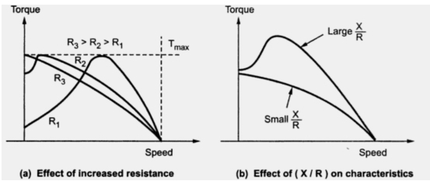

Features of A.C. Servomotor

The various features of a.c. servomotor are,

1. Light in weight for quick response.

2. Robust in construction.

3. It is reliable and its operation is stable in nature.

4. Smooth and noise free operation.

5. Large torque to weight ratio.

6. Large resistance to reactance ratio.

7. No brushes or slip rings are required. Hence maintenance free.

8. Driving circuits are simple to design.

9. The negative slope of the torque-slip characteristics adds more friction improving the damping. This improves the stability of the motor. This features is called internal electric damping of two phase a.c. servomotor.

The response of the motor to a light control signal is improved by reducing the weight and inertia of the motor in a design known as the Drag Cup Servo motor as shown in the figure below.

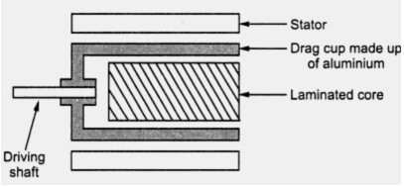

The rotor of the Drag cup servo motor is made of a thin cup of the nonmagnetic conducting material. A stationary iron core is placed in the middle of the conducting cup. This arrangement completes the magnetic circuit. As the rotor of the motor is made of thin material, its resistance will be high, which results in the high starting torque.

Applications of A.C. Servomotor

The a.c. servomotor are preferred for low power applications. Consider an a.c. position control system where load position is to be maintained constant. The driving motor used is two phase a.c. servomotor. The potentiometer arrangement compares the actual position with the reference position to generate the error voltage. The error voltage is amplifier which generates control voltage . This voltage is applied to the control winding of two phase a.c. servomotor. This control The torque and inturn controls the output position of the load. As driving motor is a.c. servomotor, the system is called as a.c. position control system.

The other applications of a.c. servomotors are,

1. Instrument servos 2. Process controllers 4. Robotics

4. Self balancing recorders 5. Machine tools

SYNCHROS:

Synchros play a very important role in the operation of Navy equipment. Synchros are found in just about every weapon system, communication system, underwater detection system, and navigation system used in the Navy. The importance of synchros is sometimes taken lightly because of their low failure rate. However, the technician who understands the theory of operation and the alignment procedures for synchros is well ahead of the problem when a malfunction does occur. The term "synchro" is an abbreviation of the word "synchronous." It is the name given to a variety of rotary, electromechanical, position-sensing devices. Figure shows a phantom view of typical synchro. A synchro resembles a small electrical motor in size and appearance and operates like a variable transformer. The synchro, like the transformer, uses the principle of electromagnetic induction.

**INTRODUCTION**

The term synchro is a generic name for a family of inductive devices which works on the principle of a rotating transformer (Induction motor). The trade names for synchronous are Selsyn, Autosyn and Telesyn. Basically they are electro mechanical devices or electromagnetic transducer which produces an output voltage depending upon angular position of the rotor.

A Synchro system is formed by interconnection of the devices called the [**Synchro Transmitter**](https://www.pantechsolutions.net/control-system/synchro-transmitter-and-receiver) and the [**synchro control transformer**](https://www.pantechsolutions.net/control-system/synchro-transmitter-and-receiver). They are also called as synchro pair. The synchro pair measures and compares two angular displacements and its output voltage is approximately linear with angular difference of the axis of both the shafts. They can be used in the following two ways.

i.   To control the angular position of load from a remote place / long distance.

ii.   For automatic correction of changes due to disturbance in the angular position of the load.

**Synchro Transmitter:**

The constructional features, electrical circuit and a schematic symbol of [**Synchro Transmitter**](https://www.pantechsolutions.net/control-system/synchro-transmitter-and-receiver) are shown in figure-2. The two major parts of [**Synchro Transmitters**](https://www.pantechsolutions.net/control-system/synchro-transmitter-and-receiver) are stator and rotor.The stators identical to the stator of three phase alternator. It is made of laminated silicon steel and slotted on the inner periphery to accommodate a balance three phase winding. The stator winding is concentric type with the axis of the three coil 120° apart. The stator winding is star connected(Y - connection).

The rotor is of dumb bell construction with a single winding. The ends of the rotor winding are terminated on two slip rings. A single phase AC excitation voltage is applied to the rotor through the slip rings.

**Working Principles:**

When the rotor is excited by AC voltage, the rotor current flows, and a magnetic field is produced. The rotor magnetic field induces an emf in the stator coil by transformer action. The effective voltage induced in any stator coil depends upon the angular position of the coils axis with respect to rotor axis.

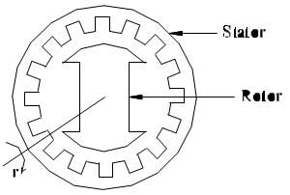

Figure - Constructional Features of [**Synchro Transmitter**](https://www.pantechsolutions.net/control-system/synchro-transmitter-and-receiver)

Figure- 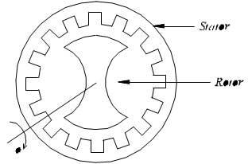

Figure - c Electrical Circuit ([**Synchro Transmitter**](https://www.pantechsolutions.net/control-system/synchro-transmitter-and-receiver))

Where,

Let    er =  Instantaneous value of AC voltage applied to rotor.

e ,e ,es1s2 s3  =  Instantaneous value of emf induced in stator coils S ,S , S with respect to12 3 neutral respectively.

Er  =  Maximum value of rotor excitation voltage.

T  = Angular frequency of rotor excitation voltage.

Kt  = Turns ratio of stator and rotor winding.

Kc  = Coupling coefficient.

2  = Angular displacement of rotor with respect to reference.

The instantaneous value of excitation voltage, e = ErsinrTt ---- (1)

Let the rotor rotates in antic lock wise direction. When the rotor rotates by an angle, 2 emfs are induced in stator coils. The frequency of induced emfs is same as that of rotor frequency. The magnitude of induced emfs is proportional to the turn’s ratio and coupling coefficient. The turns ratio , K is a constant, but a coupling coefficient, K is a function of rotor angular position.tc

Induced emf in stator coil = K K E since rTt------ (2 )

**Synchro Transmitter / Receiver:**

Let e be reference vector. With reference to figure 2, when 2 = 0, the flux linkage of coil s i Zero. Hence the flux linkage of coil S is function of cos22 (K = K ) Cos c1 2 for coil S ). The flux2 linkage of coil S will be maximum after a rotation of 120°in anti-clock wise direction and that3 of S after a rotation of 240°.

Coupling coefficient, K for coil – S1

Coupling coefficient, K for coil – S2

Coupling coefficient, K for coil – S3

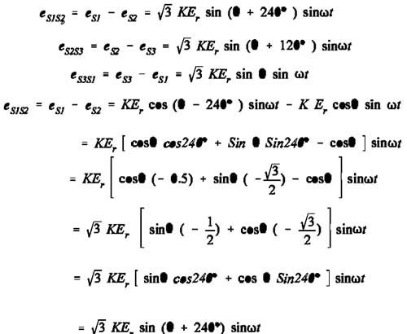

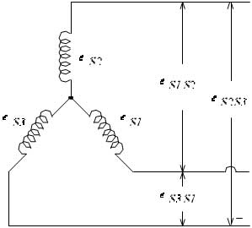

Figure - Induced emf in stator coils

When 2 = 0, from equation 3 we can say that maximum emf is induced in coil S. But from2 equation 8, it is observed that the coil - to coil voltage ES3S1 is zero. This position of the rotor is defined as the electrical zero of the transmitter

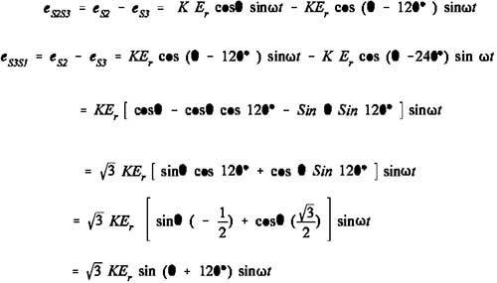

Synchro Transmitter / Receiver

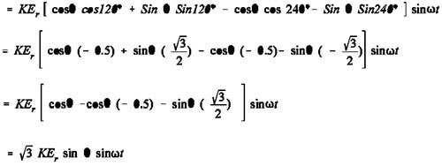

The angular position of its rotor shaft and the output is a set of three stator coil-to-coil voltages. By measuring and identifying the set of voltages at the stator terminals, it is possible to identify the angular position of the rotor. [A device called synchro / digital converter is available to measure the stator voltages and to calculate the angular measure and then display the direction and angle of rotation of the rotor].

Synchro Control Transformer:

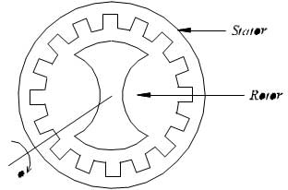Figure - a Constructional Features

The constructional features of [**synchro control transformer**](https://www.pantechsolutions.net/control-system/synchro-transmitter-and-receiver) are similar to that of [**Synchro Transmitter**](https://www.pantechsolutions.net/control-system/synchro-transmitter-and-receiver), except the shape of rotor. The rotor of the control transformer is made cylindrical so that the air gap is practically uniform. This feature of the control transformer minimizes the changes in the rotor impedance with the rotation of the shaft. The constructional features, electrical circuit and a schematic symbol of control transformer are shown in figure below.

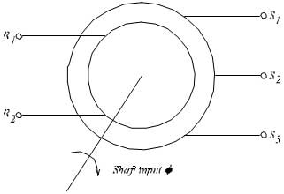  
Figure - b Schematic Symbol of [**synchro control transformer**](https://www.pantechsolutions.net/control-system/synchro-transmitter-and-receiver)

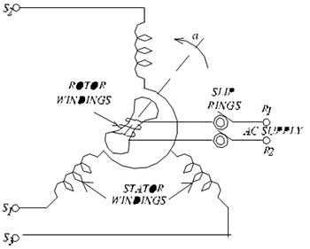

Figure - c Electrical Circuit of [**synchro control transformer**](https://www.pantechsolutions.net/control-system/synchro-transmitter-and-receiver)

**Working:**

The generated emf of the [**Synchro Transmitter**](https://www.pantechsolutions.net/control-system/synchro-transmitter-and-receiver) is applied as input to the stator coils of control transformer. The rotor shaft is connected to the load whose position has to be maintained at the desired value. Depending on the current position of the rotor and the applied emf on the stator, an emf is induced on the rotor winding. This emf can be measured and used to drive a motor so that the position of the load is corrected.

**Time Response Analysis:**

In a control system, there may be some energy storing elements attached to it. Energy storing elements are generally inductors and capacitors in case of electrical system. Due to presence of these energy storing elements, if the energy state of the system is disturbed, it will take certain time to change from one energy state to another. The exact time taken by the system for changing one energy state to another, is known as transient time and the value and pattern voltages and currents during this period is known as transient response. A transient response is normally associated with an oscillation, which may be sustained or decaying in nature. The exact nature of the system depends upon the parameters of the system. Any system can be represented with a linear differential equation. The solution of this linear differential equation gives the response of the system. The representation of a control system by linear differential equation of functions of time and its solution is collectively called **time domain analysis of control system**.

**Standard Test Signals:**

1. **Step Function:**

Let us take an independent [voltage source](http://www.electrical4u.com/ideal-dependent-independent-voltage-current-source/) or a [battery](http://www.electrical4u.com/battery-history-and-working-principle-of-batteries/) which is connected across a [voltmeter](http://www.electrical4u.com/working-principle-of-voltmeter-and-types-of-voltmeter/) via a switch, s. whenever the switch s is open, the voltage appears between the voltmeter terminals is zero. If the voltage between the voltmeter terminals is represented as v (t), the situation can be mathematically represented as



Now let us consider at t = 0, the switch is closed and instantly the battery voltage V volt appears across the voltmeter and that situation can be represented as,



Combining the above two equations we get



In the above equations if we put 1 in place of V, we will get a unit step function which can be defined as



Now let us examine the Laplace transform of unit step function. Laplace transform of any function can be obtained by multiplying this function by e-st and integrating multiplied from 0 to infinity. 

If input is R(s), then



1. **Ramp Function**

The function which is represented by an inclined straight line intersecting the origin is known as ramp function. That means this function starts from zero and increases or decreases linearly with time. A ramp function can be represented as,



Here in this above equation, k is the slope of the line.

Now let us examine the [Laplace transform](http://www.electrical4u.com/laplace-transformation/) of ramp function. As we told earlier Laplace transform of any function can be obtained by multiplying this function by e-st and integrating multiplied from 0 to infinity.





1. **Parabolic Function**

Here, the value of function is zero when time t<0 and is quadratic when time t>0. A parabolic function can be defined as,



Now let us examine the Laplace transform of parabolic function. As we told earlier Laplace transform of any function can be obtained by multiplying this function by e-st and integrating multiplied from 0 to infinity.





1. **Impulse Function**

Impulse signal is produced when input is suddenly applied to the system for infinitesimal duration of time. The waveform of such signal is represented as impulse function. If the magnitude of such function is unity, then the function is called unit impulse function. The first time derivative of step function is impulse function. Hence Laplace transform of unit impulse function is nothing but Laplace transform of first-time derivative of unit step function. 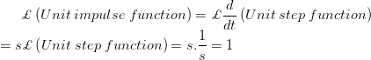

**Time Response of First Order Control Systems:**

Consider a feedback system with G(s) = 1 / Tsas show in Fig

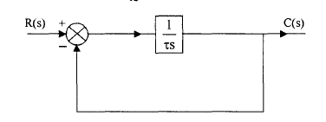

When the maximum power of s in the denominator of a transfer function is one, the transfer function represents a first order control system. Commonly, the first order control system can be represented as



***Time Response for Step Function***

Now a unit step input is given to the system, then let us analyze the expression of 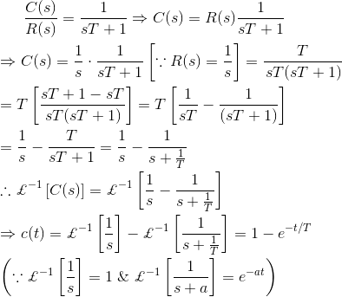

It is seen from the error equation that if the time approaching to infinity, the output signal reaches exponentially to the steady-state value of one unit. As the output is approaching towards input exponentially, the steady-state error is zero, when time approaches to infinity.

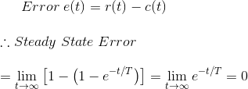

Let us put t = T in the output equation and then we get, 

This T is defined as the time constant of the response and the time constant of a response signal is that time for which the signal reaches to its 63.2 % of its final value. Now if we put t = 4T in the above output response equation, then we get, 

When actual value of response, reaches to the 98% of the desired value, then the signal is said to be reached to its steady-state condition. This required time for reaching the signal to 98 % of its desired value is known as setting time and naturally setting time is four times of the time constant of the response. The condition of response before setting time is known as transient condition and condition of the response after setting time is known as steady-state condition. From this explanation it is clear that if the time constant of the system is smaller, the response of the system reaches to its steady-state condition faster.

**Time Response for Ramp Function**

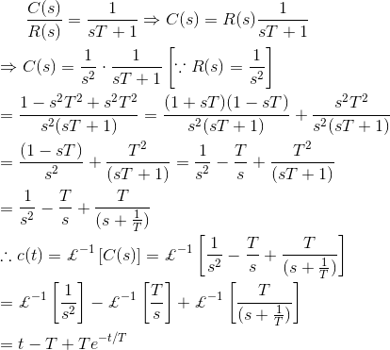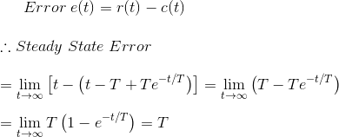

In this case during steady-state condition, the output signal lags behind input signal by a time equal to the time constant of the system. If the time constant of the system is smaller, the positional error of the response becomes lesser.

**Time Response for Impulse Function**

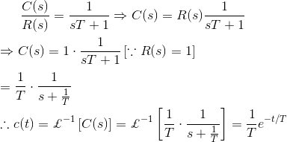

In the above explanation of time response of control system, we have seen that the step function is the first derivative of ramp function and the impulse function is the first derivative of step function. It is also found that the time response of step function is first derivative of time response of ramp function and time response of impulse function is first derivative of time response of step function.

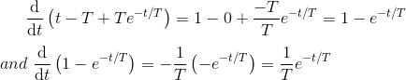

Definition of Final Value Theorem of Laplace Transform:

If f(t) and f'(t)both are Laplace Transformable and sF(s)has no pole in jw axis and in the R.H.P. (Right half Plane) then,

http://www.electrical4u.com/images/january16/1451903939.GIF

**Time Response of Second-Order Control System**

The order of a control system is determined by the power of s in the denominator of its transfer function. If the power of s in the denominator of transfer function of a control system is 2, then the system is said to be second-order control system.

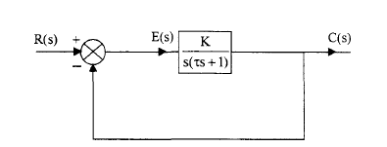

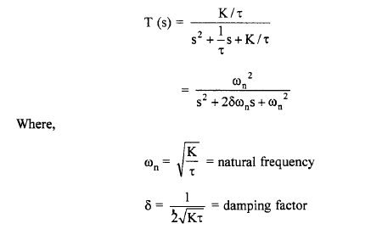

The general expression of transfer function of a second order control system is given as

http://www.electrical4u.com/electrical/control-system-equations/second-order-control-system-1.gif

Here, ζ and ωn are damping ratio and natural frequency of the system respectively and we will learn about these two terms in detail later on. Therefore, the output of the system is given as

http://www.electrical4u.com/electrical/control-system-equations/second-order-control-system-2.gif

If we consider a unit step function as the input of the system, then the output equation of the system can be rewritten as

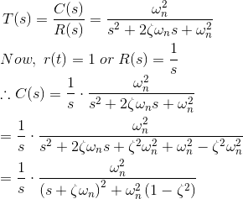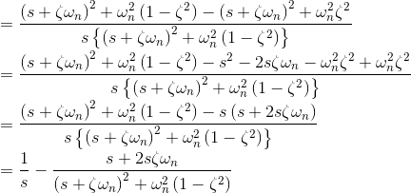http://www.electrical4u.com/electrical/control-system-equations/second-order-control-system-4.gif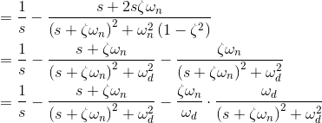

Taking inverse [Laplace transform](http://www.electrical4u.com/laplace-transformation/) of above equation, we get,

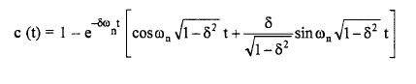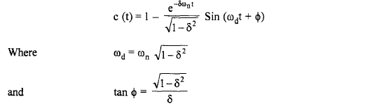

This response is plotted in Fig. The response is oscillatory and as *t* ~ ∞ , it approaches unity.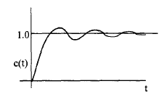

Step response of an underdamped second order system.

**Time Domain Specifications of a Second Order System**

The performance of a system is usually evaluated in terms of the following qualities.

I. How fast it is able to respond to the input,

2. How fast it is reaching the desired output,

3. What is the error between the desired output and the actual output, once the transients die down and steady state is achieved,

4. Does it oscillate around the desired value, and

5. Is the output continuously increasing with time or is it bounded.

The last aspect is concerned with the stability of the system and we would require the system to be stable. This aspect will be considered later. The first four questions will be answered in terms of time domain specifications of the system based on its response to a unit step input. These are the specifications to be given for the design of a controller for a given system. The step response of a typical underdamped second order system is plotted in Fig.

It is observed that, for an underdamped system, there are two complex conjugate poles. Usually, even if a system is of higher order, the two complex conjugate poles nearest to the *j OJ* - axis (called dominant poles) are considered and the system is approximated by a second order system. Thus, in designing any system, certain design specifications are given based on the typical underdamped step response shown as Fig.

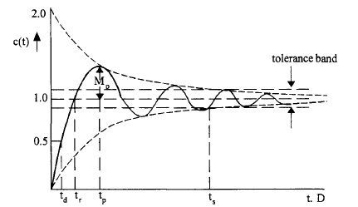

Time domain specifications of a second order system

**1. Delay time td***:* It is the time required for the response to reach 50% of the steady state value

for the first time

**2. Rise time tr:**It is the time required for the response to reach 100% of the steady state value

for under damped systems. However, for over damped systems, it is taken as the time required

for the response to rise from 10% to 90% of the steadystate value.

**3. Peak time tp***:* It is the time required for the response to reach the maximum or Peak value of

the response.

**4. Peak overshoot Mp:** It is defined as the difference between the peak value of the response and

the steady state value. It is usually expressed in percent of the steady state value. If the time for

the peak is *tp'* percent peak overshoot is given by,



For systems of type 1 and higher, the steady state value *c* (∞) is equal to unity, the same as the

input.

**5. Settling time ts:** It is the time required for the response to reach and remain within a specified

Tolerance limits (usually ± 2% or ± 5%) around the steady state value.

**6. Steady state error ess:** It is the error between the desired output and the actual output as *t* ~ ∞

or under steadystate conditions. The desired output is given by the reference input *r (t)* and therefore,



From the above specifications it can be easily seen that the time response of a system for a unit step input is almost fixed once these specifications are given. But it is to be observed that all the above specifications are not independent of each other and hence they have to be specified in such a way that they are consistent with others.

Let us now obtain the expressions for some of the above design specifications in terms of the damping factor and natural frequency.

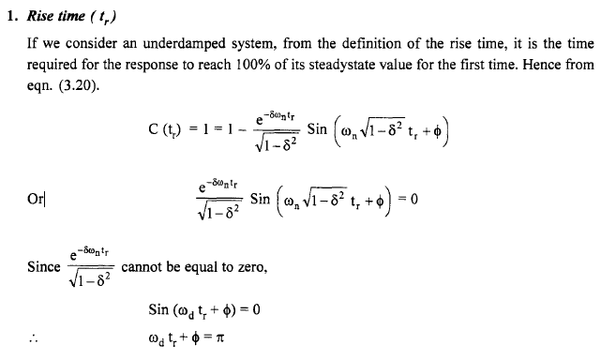

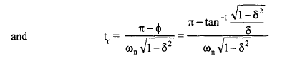

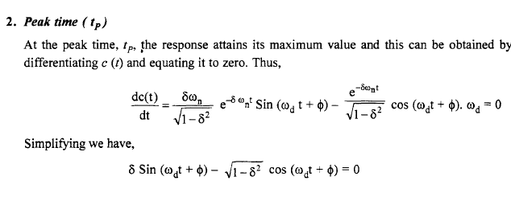

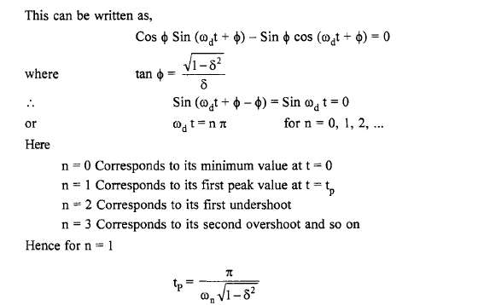

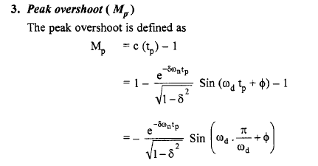

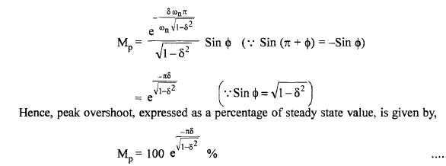

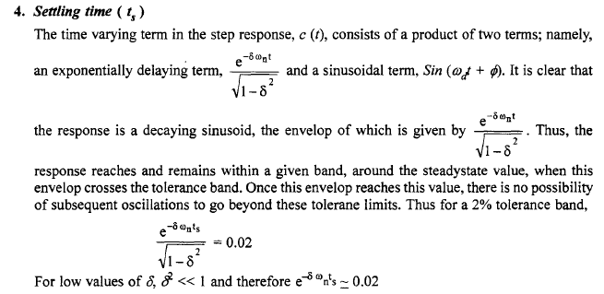

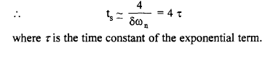

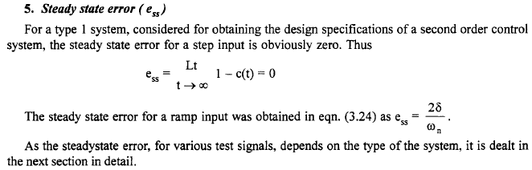

**Steady State Errors**

One of the important design specifications for a control system is the steady state error. The steady state output of any system should be as close to desired output as possible. If it deviates from this desired output, the performance of the system is not satisfactory under steady state conditions. The steady state error reflects the accuracy of the system. Among many reasons for these errors, the most important ones are the type of input, the type of the system and the nonlinearities present in the system. Since the actual input in a physical system is often a random signal, the steady state errors are obtained for the standard test signals, namely, step, ramp and parabolic signals.

**Error Constants**

Let us consider a feedback control system shown in Fig.

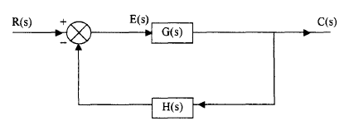

Feedback Control System.

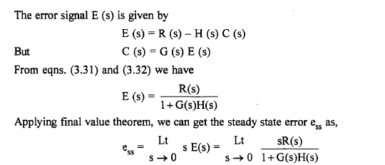

Above shows that the steady state error is a function of the input R(s) and the open loop transfer function G(s). Let us consider various standard test signals and obtain the steady state error for these inputs.

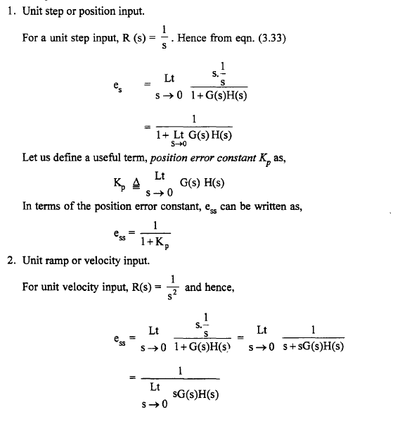

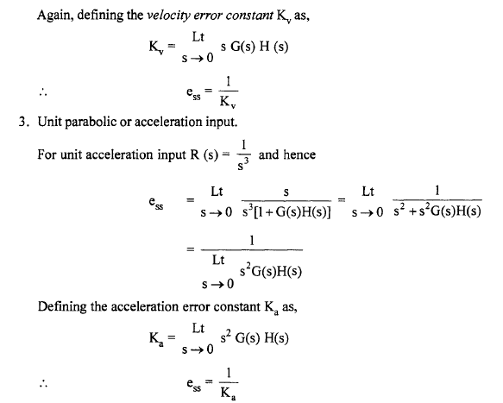

For the special case of unity of feedback system, H (s)=1, and above equations are modified as,

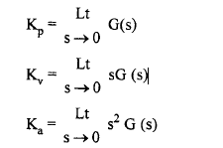

In design specifications, instead of specifying the steady state error, it is a common practice to specify the error constants which have a direct bearing on the steady state error.

**Dependence of Steadystate Error on Type of the System**

Let the loop transfer function G (s) H (s) or the open loop transfer function G (s) for a unity feedback system, be giv·en is time constant form.



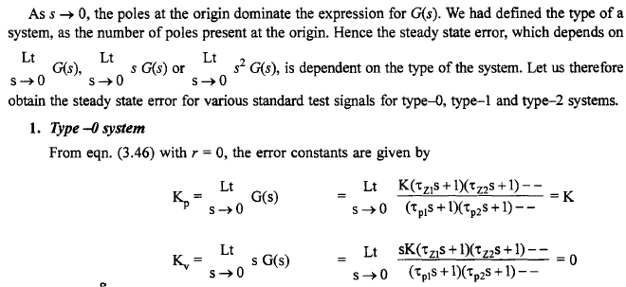



The steady state errors for unit step, velocity and acceleration inputs are respectively,

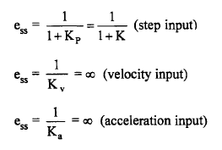

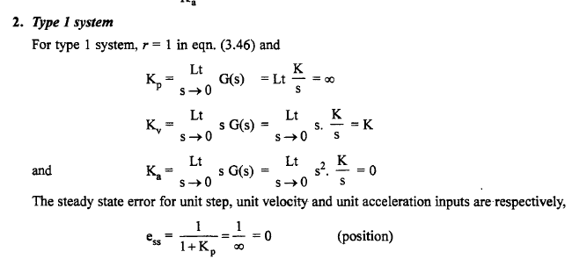

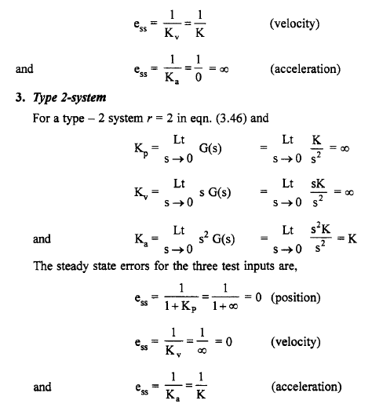

Thus a type zero system has a finite steady state error for a unit step input and is equal to



Where K is the system gain in the time constant from. It is customary to specify the gain of a type zero system by Kprather than K.

Similarly, a type -1 system has a finite steady state error for a velocity input only and is given by



Thus the gain of type -1 system in normally specified as Kv, A type -2 system has a finite steady state error only for acceleration input and is given by



As before, the gain of type -2 system is specified as Ka rather than K.

**Steady state errors for various inputs and type of systems:**

The steady state errors, for various standard inputs for type - 0, type - 1 and type - 2 are summarized in Table

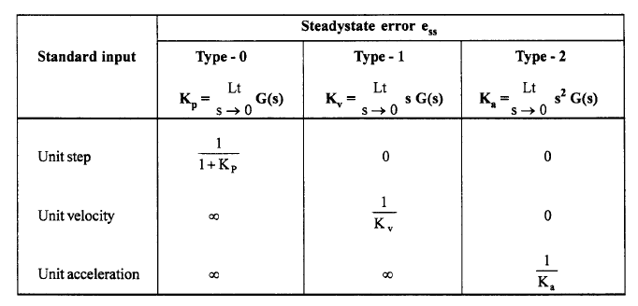

**UNIT-3**

**CONCEPTS OF STABILITY AND ALGEBRAIC CRITERIA**

**Stability:**

**Concept of Stability**

Closed-loop feedback system is either stable or unstable. This type of characterization is referred to as *absolute stability.*

Given that the system is stable, the degree of stability of the system is referred to as *relative stability*.

A *stable system* is defined as a system with bounded response to a bounded input.



**Theory of Network Synthesis**

**Network Functions**

As the name suggests, in **theory of network synthesis** we are going to study about the synthesis of various networks which consists of both the active ([resistor](http://www.electrical4u.com/types-of-resistor-carbon-composition-and-wire-wound-resistor/)s) and passive elements ([inductor](http://www.electrical4u.com/what-is-inductor-and-inductance-theory-of-inductor/)s and [capacitor](http://www.electrical4u.com/what-is-capacitor-and-what-is-dielectric/)s).

In the frequency domain, **network functions** are defined as the quotient obtained by dividing the phasor corresponding to the circuit output by the phasor corresponding to the circuit input.

In simple words, **network functions** are the ratio of output phasor to the input phasor when phasors exists in frequency domain. The general form of network functions are given below:

http://www.electrical4u.com/equations/tns-07-05-14-01.gif

Now with the help of the above general network function we are in position to describe the necessary conditions of the stability of all the network functions. There are three mains necessary conditions for the stability of these network functions and they are written below:

1. The degree of the numerator of F(s) should not exceed the degree of denominator by more than unity. In other words (m - n) should be less than or equal to one.
2. F(s) should not have multiple poles on the jω-axis or the y-axis of the pole-zero plot.
3. F(s) should not have poles on the right half of the s-plane.

**Hurwitz Polynomial**

If above all the stability criteria are fulfilled (i.e. we have stable network function) then the denominator of the F(s) is called the **Hurwitz polynomial**.

http://www.electrical4u.com/equations/tns-07-05-14-02.gif

Where, Q(s) is a **Hurwitz polynomial**.

**Properties of Hurwitz Polynomials:**

There are five important properties of Hurwitz polynomials and they are written below:

1. For all real values of s value of the function P(s) should be real.
2. The real part of every root should be either zero or negative.
3. Let us consider the coefficients of denominator of F(s) is bn, b(n-1), b(n-2). . . . b0. Here it should be noted that bn, b(n-1), b0 must be positive and bn and b(n-1) should not be equal to zero simultaneously.
4. The continued fraction expansion of even to the odd part of the **Hurwitz polynomial** should give all positive quotient terms, if even degree is higher or the continued fraction expansion of odd to the even part of the Hurwitz polynomial should give all positive quotient terms, if odd degree is higher.
5. In case of purely even or purely odd polynomial, we must do continued fraction with the of derivative of the purely even or purely odd polynomial and rest of the procedure is same as mentioned in the point number (4).

From the above discussion we conclude one very simple result,**If all the coefficients of the quadratic polynomial are real and positive then that quadratic polynomial is always a Hurwitz polynomial.**

**Positive Real Functions**

Any function which is in the form of F(s) will be called as a **positive real function** if fulfill these four important conditions:

1. F(s) should give real values for all real values of s.
2. P(s) should be a Hurwitz polynomial.
3. If we substitute s = jω then on separating the real and imaginary parts, the real part of the function should be greater than or equal to zero, means it should be non negative. This most important condition and we will frequently use this condition in order to find out the whether the function is positive real or not.
4. On substituting s = jω, F(s) should posses simple poles and the residues should be real and positive.

**Properties of Positive Real Function**

There are four very important properties of **positive real functions** and they are written below:

1. Both the numerator and denominator of F(s) should be Hurwitz polynomials.
2. The degree of the numerator of F(s) should not exceed the degree of denominator by more than unity. In other words (m-n) should be less than or equal to one.
3. If F(s) is positive real function then reciprocal of F(s) should also be positive real function.
4. Remember the summation of two or more positive real function is also a positive real function but in case of the difference it may or may not be positive real function.

Following are the four necessary but not the sufficient conditions for the functions to be a positive real function and they are written below:

1. The coefficient of the polynomial must be real and positive.
2. The degree of the numerator of F(s) should not exceed the degree of denominator by more than unity. In other words (m - n) should be less than or equal to one.
3. Poles and zeros on the imaginary axis should be simple.
4. Let us consider the coefficients of denominator of F(s) is bn, b(n-1), b(n-2). . . . b0.Here it should be noted that bn, b(n-1), b0 must be positive and bn and b(n-1) should not be equal to zero simultaneously.

Now there two necessary and sufficient conditions for the functions to be a positive real function and they are written below:

1. F(s) should have simple poles on the jω axis and the residues of these poles must be real and positive.
2. Summation of both numerator and denominator of F(s) must be a Hurwitz polynomial.

**Routh Hurwitz Stability Criterion**

If any pole of the system lies on the right hand side of the origin of the s plane, it makes the system unstable. On the basis of this condition A. Hurwitz and E.J.Routh started investigating the necessary and sufficient conditions of stability of a system. We will discuss two criteria for stability of the system. A first criterion is given by A. Hurwitz and this criterion is also known as **Hurwitz Criterion for stability** or **Routh Hurwitz Stability Criterion**.

**Hurwitz Criterion**

With the help of characteristic equation, we will make a number of Hurwitz determinants in order to find out the stability of the system. We define characteristic equation of the system as 

Now there are n determinants for nth order characteristic equation.

Let us see how we can write determinants from the coefficients of the characteristic equation. The step by step procedure for kth order characteristic equation is written below:

Determinant one : The value of this determinant is given by |a1| where a1 is the coefficient of sn-1 in the characteristic equation.

Determinant two : The value of this determinant is given by



Here number of elements in each row is equal to determinant number and we have determinant number here is two. The first row consists of first two odd coefficients and second row consists of first two even coefficients.

Determinant three : The value of this determinant is given by

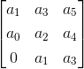

Here number of elements in each row is equal to determinant number and we have determinant number here is three. The first row consists of first three odd coefficients, second row consists of first three even coefficients and third row consists of first element as zero and rest of two elements as first two odd coefficients.

Determinant four: The value of this determinant is given by,

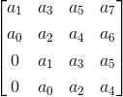

Here number of elements in each row is equal to determinant number and we have determinant number here is four. The first row consists of first three four coefficients, second row consists of first four even coefficients, third row consists of first element as zero and rest of three elements as first three odd coefficients the fourth row consists of first element as zero and rest of three elements as first three even coefficients. By following the same procedure we can generalize the determinant formation. The general form of determinant is given below: 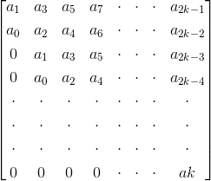

Now in order to check the stability of the above system, calculate the value of each determinant. The system will be stable if and only if the value of each determinant is greater than zero, i.e. the value of each determinant should be positive. In all the other cases the system will not be stable.

**Routh Stability Criterion**

This criterion is also known as modified Hurwitz Criterion of stability of the system. We will study this criterion in two parts. Part one will cover necessary condition for stability of the system and part two will cover the sufficient condition for the stability of the system.

Let us again consider the characteristic equation of the system as

1)

Part one (necessary condition for stability of the system): In this we have two conditions which are written below:

1. All the coefficients of the characteristic equation should be positive and real.
2. All the coefficients of the characteristic equation should be non zero.

2)Part two (sufficient condition for stability of the system): Let us first construct routh array. In order to construct the routh array follow these steps:

* The first row will consist of all the even terms of the characteristic equation. Arrange them from first (even term) to last (even term). The first row is written below: a0 a2 a4 a6............
* The second row will consist of all the odd terms of the characteristic equation. Arrange them from first (odd term) to last (odd term). The first row is written below: a1 a3 a5 a7...........
* The elements of third row can be calculated as:
* (1) First element : Multiply a0 with the diagonally opposite element of next column (i.e. a3) then subtract this from the product of a1 and a2 (where a2 is diagonally opposite element of next column) and then finally divide the result so obtain with a1. Mathematically we write as first element



(2) Second element : Multiply a0 with the diagonally opposite element of next to next column (i.e. a5) then subtract this from the product of a1 and a4 (where a4 is diagonally opposite element of next to next column) and then finally divide the result so obtain with a1.

Mathematically we write as second element



Similarly, we can calculate all the elements of the third row. (d) The elements of fourth row can be calculated by using the following procedure:

(1) First element : Multiply b1 with the diagonally opposite element of next column (i.e. a3) then subtract this from the product of a1 and b2 (where b2 is diagonally opposite element of next column) and then finally divide the result so obtain with b1. Mathematically we write as first element



(2) Second element :Multiply b1 with the diagonally opposite element of next to next column (i.e. a5) then subtract this from the product of a1 and b3 (where b3 is diagonally opposite element of next to next column) and then finally divide the result so obtain with a1. Mathematically we write as second element



Similarly, we can calculate all the elements of the fourth row. Similarly, we can calculate all the elements of all the rows. Stability criteria if all the elements of the first column are positive then the system will be stable.

However if anyone of them is negative the system will be unstable. Now there are some special cases related to Routh Stability Criteria which are discussed below:

(1) Case one: If the first term in any row of the array is zero while the rest of the row has at least one non zero term. In this case we will assume a very small value (ε) which is tending to zero in place of zero. By replacing zero with (ε) we will calculate all the elements of the Routh array. After calculating all the elements we will apply the limit at each element containing (ε). On solving the limit at every element if we will get positive limiting value then we will say the given system is stable otherwise in all the other condition we will say the given system is not stable.

(2) Case second : When all the elements of any row of the Routh array are zero. In this case we can say the system has the symptoms of marginal stability. Let us first understand the physical meaning of having all the elements zero of any row. The physical meaning is that there are symmetrically located roots of the characteristic equation in the s plane. Now in order to find out the stability in this case we will first find out auxiliary equation. Auxiliary equation can be formed by using the elements of the row just above the row of zeros in the Routh array. After finding the auxiliary equation we will differentiate the auxiliary equation to obtain elements of the zero row. If there is no sign change in the new routh array formed by using auxiliary equation, then in this we say the given system is limited stable. While in all the other cases we will say the given system is unstable.

**THE ROOT LOCUS TECHNIQUE:**

Any physical system is represented by a transfer function in the form of

http://www.electrical4u.com/equations/controlsystem/rlt-17-06-14-01.gif

We can find poles and zeros from G(s). The location of poles and zeros are crucial keeping view stability, relative stability, transient response and error analysis. When the system put to service stray [inductance](http://www.electrical4u.com/what-is-inductor-and-inductance-theory-of-inductor/) and [capacitance](http://www.electrical4u.com/what-is-capacitor-and-what-is-dielectric/) get into the system, thus changes the location of poles and zeros. In **root locus technique in control system** we will evaluate the position of the roots, their locus of movement and associated information. These information will be used to comment upon the system performance.

Some of the advantages of root locus technique are written below.

**Advantages of Root Locus Technique**

1. Root locus technique in control system is easy to implement as compared to other methods.
2. With the help of root locus we can easily predict the performance of the whole system.
3. Root locus provides the better way to indicate the parameters.

Now there are various terms related to root locus technique that we will use frequently in this article.

1. Characteristic Equation Related to Root Locus Technique :

1 + G(s)H(s) = 0 is known as characteristic equation.

Now on differentiating the characteristic equation and on equating dk/ds equals to zero, we can get break away points.

1. Break away Points : Suppose two root loci which start from pole and moves in opposite direction collide with each other such that after collision they start moving in different directions in the symmetrical way. Or the break away points at which multiple roots of the characteristic equation 1 + G(s)H(s)= 0 occur.

The value of K is maximum at the points where the branches of root loci break away. Break away points may be real, imaginary or complex.

1. Break in Point : Condition of break in to be there on the plot is written below : Root locus must be present between two adjacent zeros on the real axis.
2. Centre of Gravity : It is also known centroid and is defined as the point on the plot from where all the asymptotes start. Mathematically, it is calculated by the difference of summation of poles and zeros in the transfer function when divided by the difference of total number of poles and total number of zeros. Centre of gravity is always real & it is denoted by σA.

http://www.electrical4u.com/equations/controlsystem/rlt-17-06-14-07.gif

Where, N is number of poles and M is number of zeros.

1. Asymptotes of Root Loci : Asymptote originates from the center of gravity or centroid and goes to infinity at definite some angle. Asymptotes provide direction to the root locus when they depart break away points.
2. Angle of Asymptotes : Asymptotes makes some angle with the real axis and this angle can be calculated from the given formula,

http://www.electrical4u.com/equations/controlsystem/rlt-17-06-14-02.gif

Where, p = 0, 1, 2 ....... (N-M-1) N is the total number of poles M is the total number of zeros.

1. Angle of Arrival or Departure : We calculate angle of departure when there exists complex poles in the system. Angle of departure can be calculated as 180-{(sum of angles to a complex pole from the other poles)-(sum of angle to a complex pole from the zeros)}.
2. Intersection of Root Locus with the Imaginary Axis : In order to find out the point of intersection root locus with imaginary axis, we have to use Routh Hurwitz criterion. First, we find the auxiliary equation then the corresponding value of K will give the value of the point of intersection.
3. Gain Margin : We define gain margin as a by which the design value of the gain factor can be multiplied before the system becomes unstable. Mathematically it is given by the formula

http://www.electrical4u.com/equations/controlsystem/rlt-17-06-14-03.gif

1. Phase Margin : Phase margin can be calculated from the given formula:

http://www.electrical4u.com/equations/controlsystem/rlt-17-06-14-04.gif

1. Symmetry of Root Locus : Root locus is symmetric about the x axis or the real axis.

How to determine the value of K at any point on the root loci ? Now there are two ways of determining the value of K, each way is described below.

1. **Magnitude Criteria** : At any points on the root locus we can apply magnitude criteria as, http://www.electrical4u.com/equations/controlsystem/rlt-17-06-14-05.gif
2. Using this formula we can calculate the value of K at any desired point.
3. Using Root Locus Plot : The value of K at any s on the root locus is given by

http://www.electrical4u.com/equations/controlsystem/rlt-17-06-14-06.gif

**Root Locus Plot**

This is also known as root locus technique in control system and is used for determining the stability of the given system. Now in order to determine the stability of the system using the root locus technique we find the range of values of K for which the complete performance of the system will be satisfactory and the operation is stable. Now there are some results that one should remember in order to plot the root locus. These results are written below:

1. Region where root locus exists : After plotting all the poles and zeros on the plane, we can easily find out the region of existence of the root locus by using one simple rule which is written below,

Only that segment will be considered in making root locus if the total number of poles and zeros at the right hand side of the segment is odd.

1. How to calculate the number of separate root loci ? : A number of separate root loci are equal to the total number of roots if number of roots are greater than the number of poles otherwise number of separate root loci is equal to the total number of poles if number of roots are greater than the number of zeros.

**Procedure to Plot Root Locus**

Keeping all these points in mind we are able to draw the **root locus plot** for any kind of system. Now let us discuss the procedure of making a root locus.

1. Find out all the roots and poles from the open loop transfer function and then plot them on the complex plane.
2. All the root loci starts from the poles where k = 0 and terminates at the zeros where K tends to infinity. The number of branches terminating at infinity equals to the difference between the number of poles & number of zeros of G(s)H(s).
3. Find the region of existence of the root loci from the method described above after finding the values of M and N.
4. Calculate break away points and break in points if any.
5. Plot the asymptotes and centroid point on the complex plane for the root loci by calculating the slope of the asymptotes.
6. Now calculate angle of departure and the intersection of root loci with imaginary axis.
7. Now determine the value of K by using any one method that I have described above.

By following above procedure you can easily draw the **root locus plot** for any open loop transfer function.

1. Calculate the gain margin.
2. Calculate the phase margin.
3. You can easily comment on the stability of the system by using Routh array.

Sketch the root locus of the following unity feedback system with

G(s) = K / [s(s + 2)(s 2 + 2s + 4)]

(a) Find the value ofK at breakaway points

(b) Find the value of K and the closed loop poles at which the damping factor is 0.6.

*Sol:*

*Step 1:* Plot the poles and zeros Zeros: nil

Poles : 0, - 2, - 1 ± j √3

*Step 2:* There are 4 root locus branches starting from the open loop poles. All these branches go to zeros at infInity.

*Step* 3: Angles of asymptotes.

Since n- m = 4,

ø = 45, 135,225, and 315°

*Step* 4: Centroid = [0-2-1-1] / 4 = -1

*Step 5:* The root locus branch on real axis lies between 0 and - 2 only.

*Step* 6: Breakaway points dK/ ds = 0

K = - s (s + 2) (s2 + 2s + 4)

= (s4 + 4s3 + 8s2 + 8s)

dK / ds = 4s3 + 12s2 + 16s + 8 = 0

It is easy to see that *(s* + 1) is a root of this equation as the sum of the coefficients of odd powers of *s* is equal to the sum of the even powers of *s.* The other two roots can be obtained easily as.

s=- 1± j 1.

The roots of dK / ds are s = - 1, - 1± j 1.

Centroid = - 1 is a point on the root locus lying on the real axis and hence it is a breakaway point. We have to test whether the points - 1 ± j 1 lie on the root locus or not.

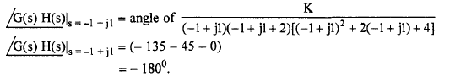

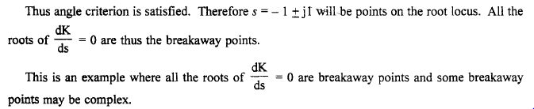

*Step* 7:

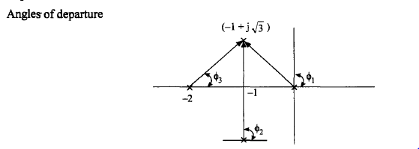

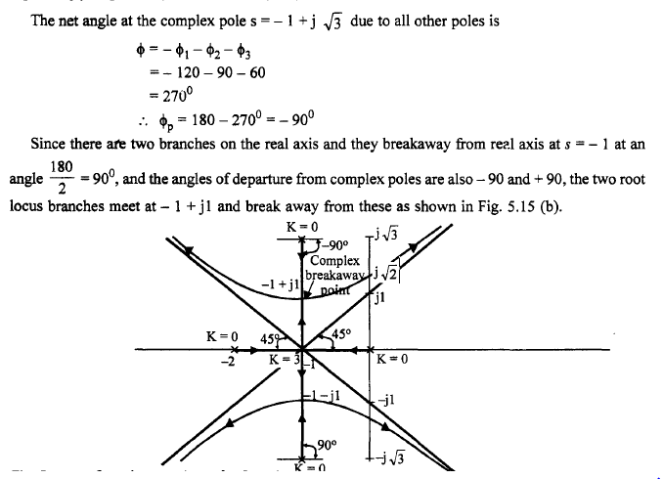

Step8: