The **Object class** is the parent class of all the classes in java by default. In other words, it is the topmost class of java.

 If a class does not extend any other class then it is a direct child class of **Object** and if extends another class then it is indirectly derived. Therefore the Object class methods are available to all Java classes.

**Note:** The Object class is beneficial if you want to refer any object whose type you don't know. Notice that parent class reference variable can refer the child class object.

Let's take an example, there is getObject() method that returns an object but it can be of any type like Employee, Student etc, we can use Object class reference to refer that object.

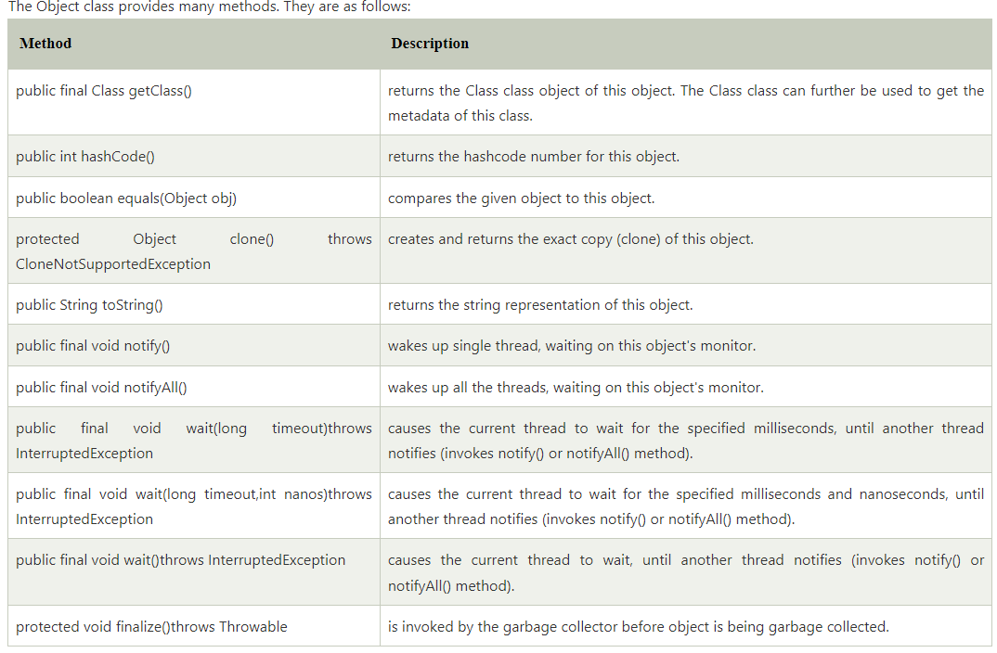

Example1:

class point

{

int x;

int y;

point(int x,int y)

{

this.x=x;

this.y=y;

}

public static void main(String args[])

{

point p1=new point(10,20);

System.out.println(p1.toString());

System.out.println(p1.hashCode());

System.out.println(p1.getClass());

}

}

Example2:

import java.util.*;

public class ObjectClass

{

public static void main(String[] args)

{

Date date = new Date();

System.out.println(date.toString());

Date date2 = (Date) date.clone();

System.out.println(date2.toString());

}

}