**Raspberry PI based Motor speed control**

**ABSTRACT**

The project is designed to control the speed of a DC motor using a Raspberry Pi board. The speed of DC motor is directly proportional to the voltage applied across its terminals. Hence, if voltage across motor terminal is varied, then speed can also be varied.

This project uses the above principle to control the speed of the motor by varying the duty cycle of the pulse applied to it (popularly known as PWM control). The project uses keyboard as input interfaced to the board, which are used to control the speed of motor. PWM (Pulse Width Modulation) is generated at the output by the board as per the program. The program can be written in wiring Pi/PHP. The average voltage given or the average current flowing through the motor will change depending on the duty cycle (ON and OFF time of the pulses), so the speed of the motor will change. A motor driver IC is interfaced to the board for receiving PWM signals and delivering desired output for speed control of a small DC motor.

Further the project can be enhanced by using power electronic devices such as IGBTs to achieve speed control higher capacity industrial motors.

**BLOCK DIAGRAM**

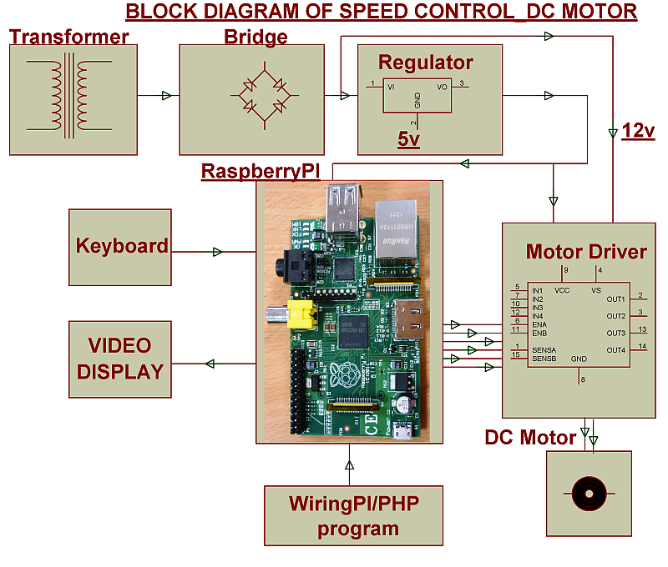

**SOFTWARE REQUIREMENTS:**

Wiring Pi / PHP program

**HARDWARE REQUIREMENTS:**

Raspberry Pi board, PC Monitor or TV,DC Motor, Motor Driver IC, LED, Resistors, Capacitors, Diodes, Transformer, Voltage Regulator,