* **Brief of Slides:**
* We are using MongoDB as a database.
* In order to smoot the process of communication btw the DB and node we would be using Mongoose.
* Heroku is used to hosting our nodejs Application.
* To maintain the state of site we would use cookies like Session etc.
* The processing of Authenticity is done on node with the help of fetched data from Mongo.
* React will be using to handle the front end along with real time update at client side.
* Actual interaction with the client will be from web-browser.
* **Features of Database:**
* Can be accessed by the individuals or the serving hospital only after signIn.
* Each time the API will take their credential along with request parameter in return will send JSON file that basically contains the info of the requested items. May be like:- Hospital wanted to know the previous history of client etc.
* **Features of API**
* curl https://api.base_address?query=from &max_results=10 -H "Authorization: Bearer $BEARER_TOKEN"
* Verbs may of types:
  + For the Individual
* Get (Health History)
* Post (only for personal Info)
  + For Hospital
* Get (customer || hospital status)
* Post(customer || hospital status)
* Put
* Delete
* Query parameters:

|  |  |  |
| --- | --- | --- |
| Name | Type | Description |
| from required | String | Unique id of customer or hospital/doctor |
| start_date OPTIONAL | Date | Start date of customer health history. |
| end_date OPTIONAL | Date | End date at which history needed |
| max_results OPTIONAL | Int | Max number of result returned by the object |

* Response fields

|  |  |  |
| --- | --- | --- |
| Name | Type | Description |
| text | String | Any prescription by the hospital/doctor |
| Created_at | Date | Creation time of request |
| author_id | String | Name of post entity in order to tract the update done by whom. |
| Attachments | Object | Type of attachment if any present. |
| geo | Object | Will contain the location of update |
|  |  |  |

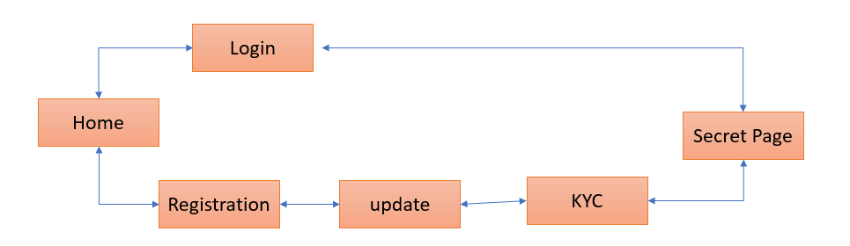

* **Registration will be done in two ways:**
* Third party Authentication: OAuth 2.0 (google)/ facebook
* Personal signIn method
* **Security of data:**
* Password and user name will be in encrypted form.
* Access modifiers are applied to the users.

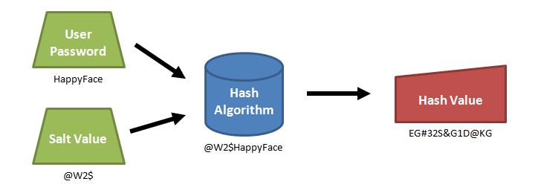

* **Process of Login:**

**Customer:**

* SignUp(OAuth,personal ) 🡪 Update Profile 🡪KYC

**Hospital:**

* SignUp(Reg Id) 🡪SetUp password 🡪 update profile(doctor name, doctor list etc)
* **Process of Intraction:**

**Customer:**

* Medical History available as view content
* Can able to edit or update personal info
* May request for validation of billing or treatment.

**Hospital:**

* Able to post billing stuff, Prescriptions (auto updated by the name of entity)
* Able to mark the symptoms.
* **Process of KYC:**

KYC can be mimicked if possible we would go for actual method of govt. site.

Process of SignUP:

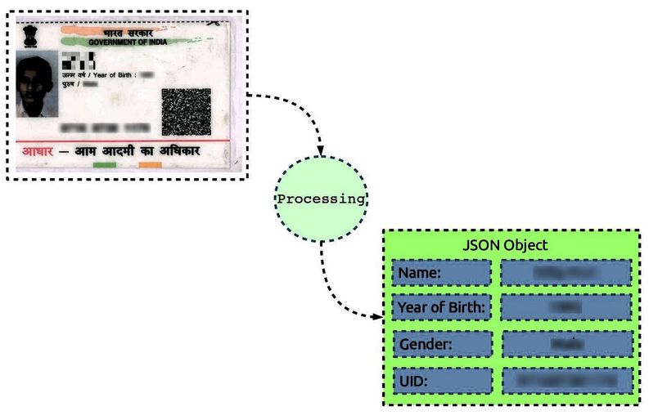

API: https://<host>/<ver>/<ac>/<uid[0]>/<uid[1]>/<asalk>

https://uidai.gov.in/images/FrontPageUpdates/aadhaar_authentication_api_2_0.pdf