LJ UNIVERSITY
DEPARTMENT OF COMPUTER APPLICATIONS
INSTITUTE OF COMPUTER APPLICATIONS

LEARNING CURVE LMS
Advanced E-Learning & Operations Management System (2026)
MASTER OF COMPUTER APPLICATIONS (INTEGRATED) - iMCA

ATTRIBUTE | PROJECT SUBMISSION DETAILS
GROUP MEMBERS | 1. Hani Boghara (Roll No: D04)  2. Arpit Kalathiya (Roll No: D021)  3. Pratik Savaliya (Roll No: D47)
SUBMITTED TO | Department of Computer Applications, LJ University
ACADEMIC YEAR | 2025 - 2026
SUBMISSION DATE | Division: Div D | Roll Nos: D04, D021, D47 (iMCA 5th Sem 2026)
DIV-ROLL NO. | iMCA 7th Semester (Division A)

INTERNAL GUIDE HOD DIRECTOR

TABLE OF CONTENTS
- Introduction
- 1.1 Document Overview
- 1.2 Project Scope
- 1.3 Existing System
- 1.4 Need for the New System
- 1.5 Objective of the New System
- 1.6 Problem Definition
- 1.7 Core Components
- 1.8 Project Profile
- 1.9 Assumptions and Constraints
- 1.10 Advantages and Limitations
- 1.11 Proposed Timeline Chart
- Requirement Determination & Analysis
- 2.1 Requirement Determination
- 2.2 Targeted Users
- System Design
- 3.1 Use Case Diagram
- 3.2 Class Diagram
- 3.3 Interaction Diagram
- 3.4 Activity Diagram
- 3.5 Data Dictionary
- Development
- 4.1 Development Approach
- 4.2 Coding Standards
FIGURE 4.1: PUBLIC HOME & COURSE CATALOG SCREENSHOT
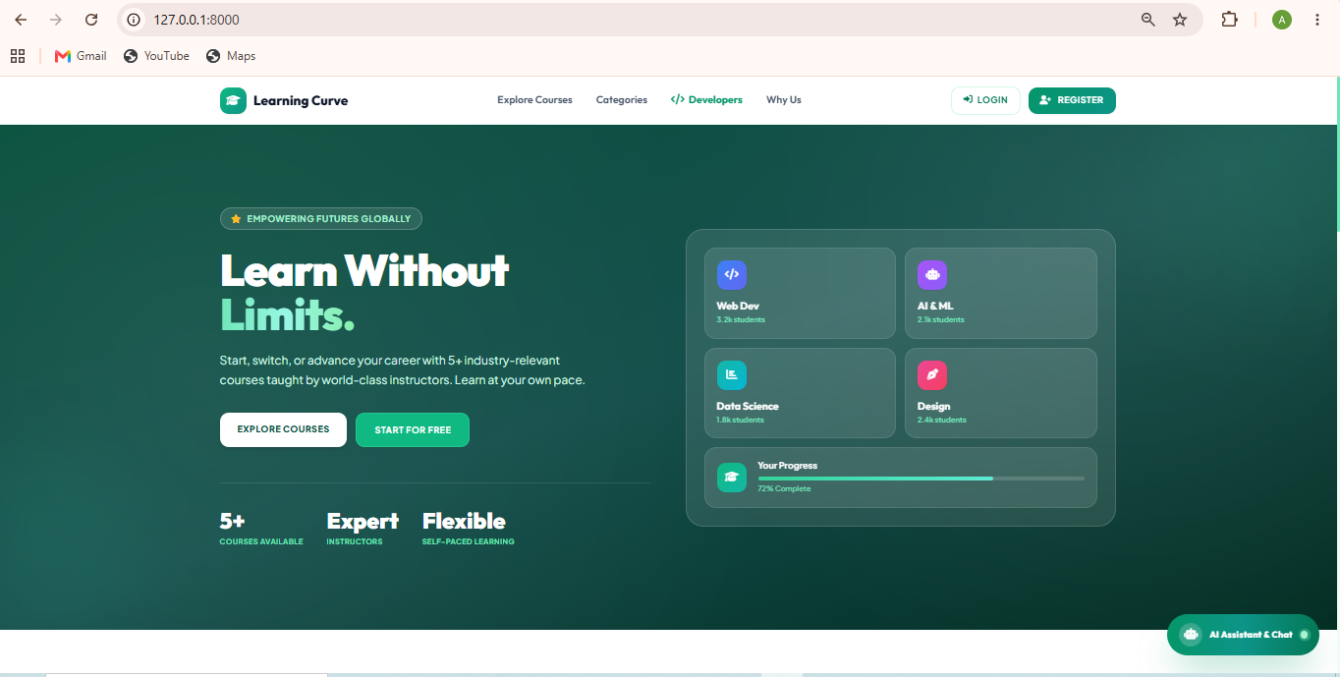
Implementation Description: The public landing page displays the Learning Curve LMS hero banner, active course statistics, category tags, and searchable course cards built with Tailwind CSS v3.
FIGURE 4.2: STUDENT REGISTRATION SCREENSHOT
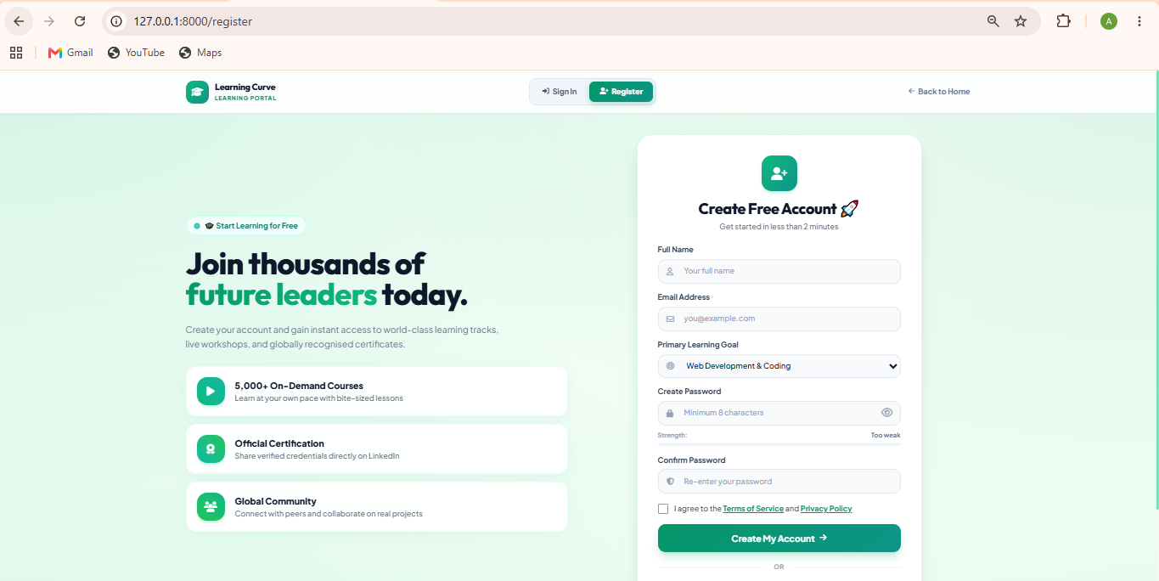
Implementation Description: The student registration interface captures user credentials, validates password strength, and assigns default student role with CSRF protection.
FIGURE 4.3: LOGIN & DATE-PASSWORD AUTHENTICATION SCREENSHOT
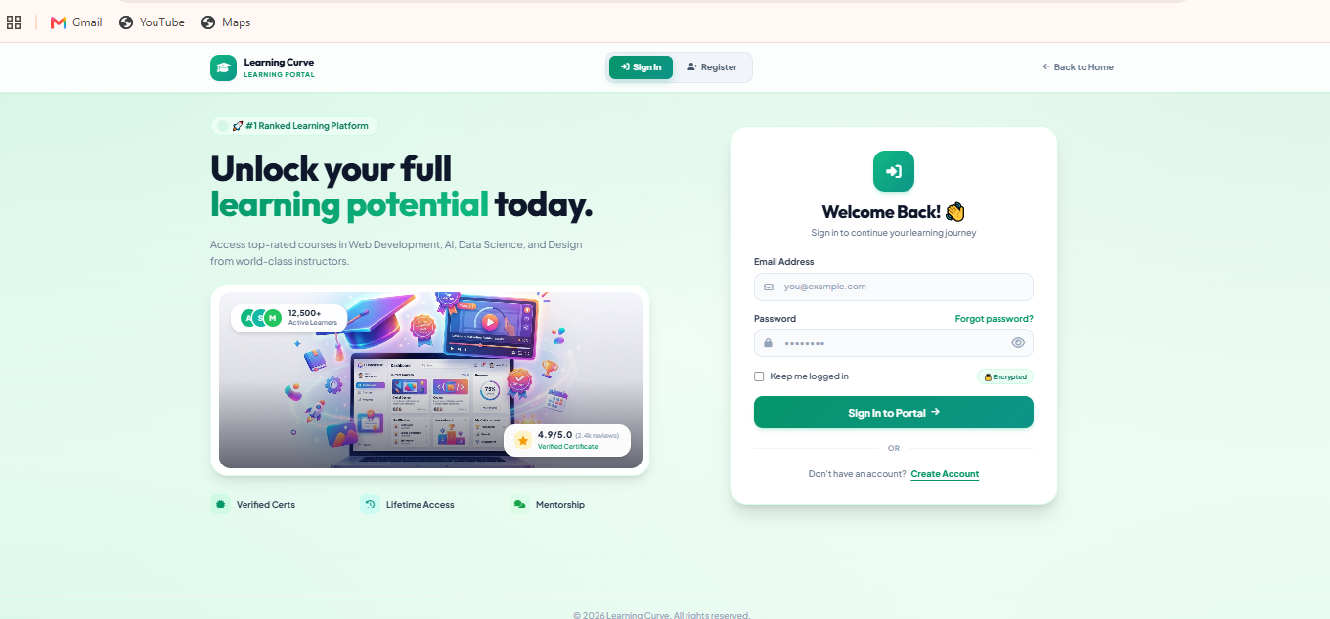
Implementation Description: The secure login interface validates user credentials against Bcrypt hashed passwords and triggers secondary Date-Password authentication if day-of-month rules are active.
FIGURE 4.4: STUDENT DASHBOARD & REAL-TIME PROGRESS TRACKER SCREENSHOT
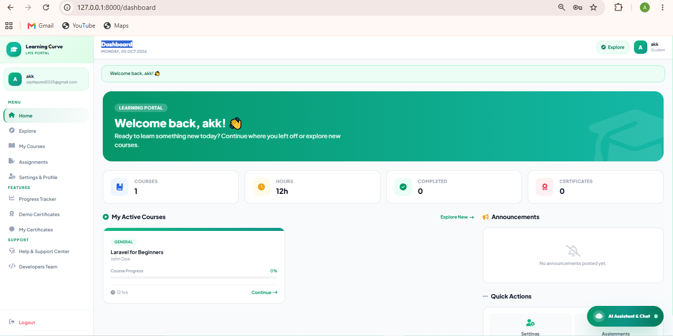
Implementation Description: The student dashboard presents enrolled courses, completed hours, certificates count, and dynamic real-time progress bars (0% to 100%) calculated from assignment evaluations.
FIGURE 4.5: MULTI-DEPARTMENT PANEL SWITCHER SCREENSHOT
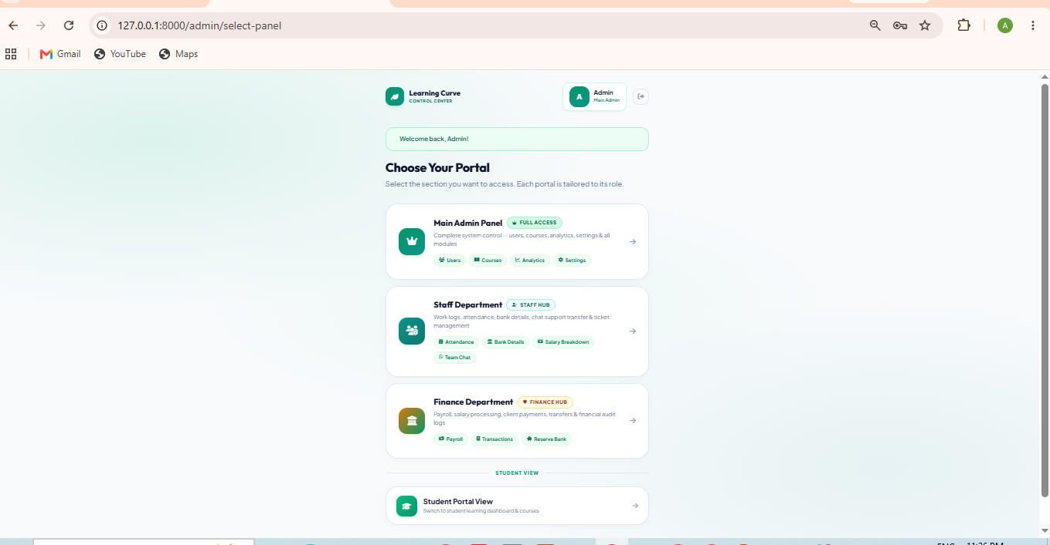
Implementation Description: Centralized department selection hub allowing authorized users to switch seamlessly between Admin, Staff Operations, and Finance Department panels.
FIGURE 4.6: ADMIN CONTROL HUB DASHBOARD SCREENSHOT
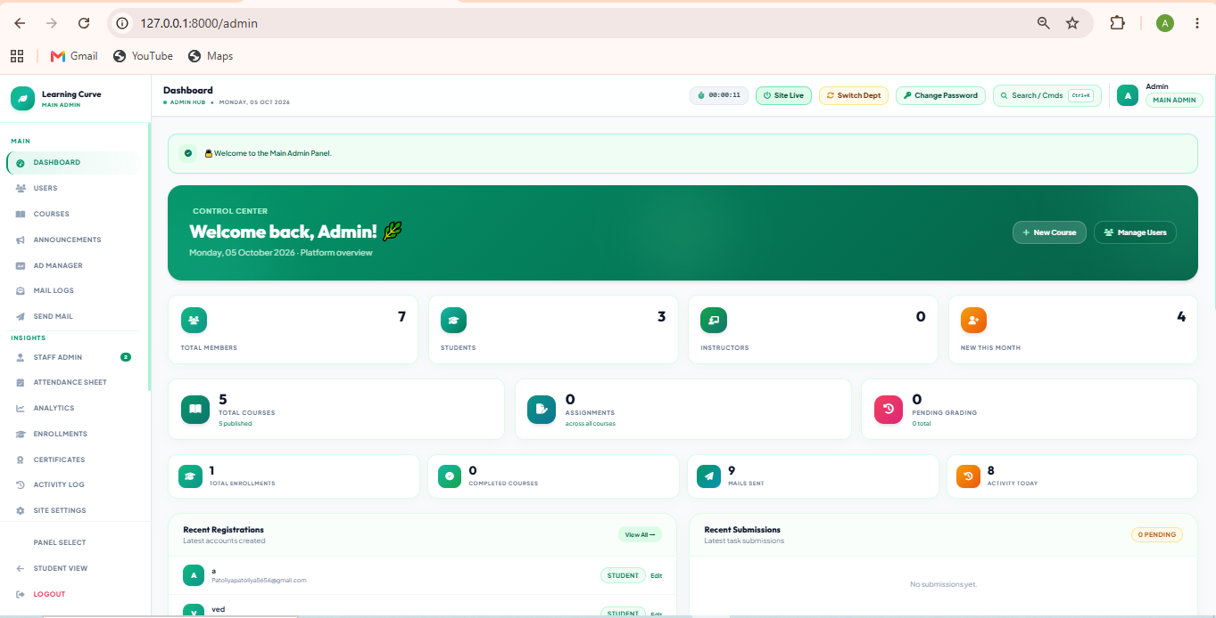
Implementation Description: Superadmin control center featuring real-time system metrics, live session uptime timer (#admin-topbar-timer), maintenance mode toggle, user management, and mail logs.
FIGURE 4.7: STAFF OPERATIONS PORTAL & ATTENDANCE CLOCK-IN SCREENSHOT
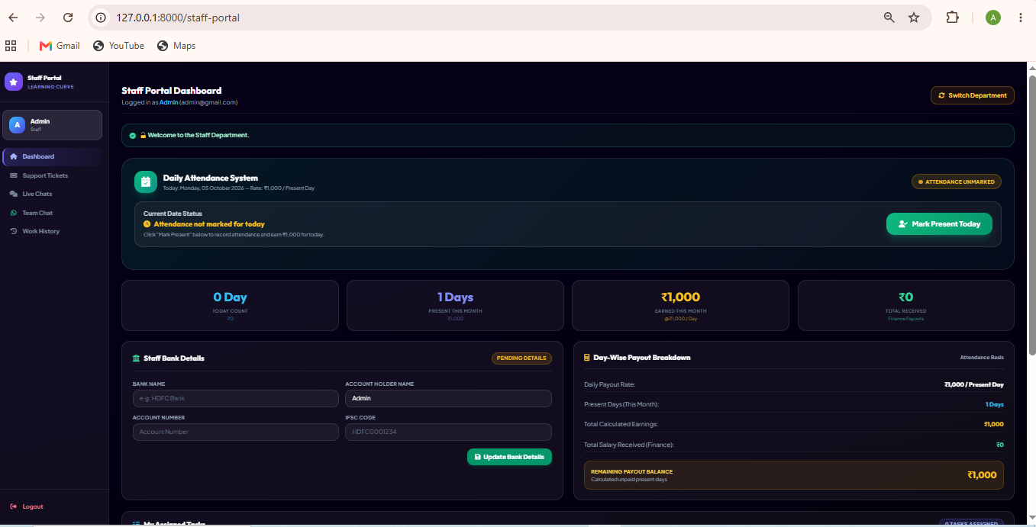
Implementation Description: Staff portal displaying daily attendance clock-in widget (₹1,000/day rate), present days counter, bank account manager, and assigned support tickets.
FIGURE 4.8: FINANCE DEPARTMENT & PAYROLL DISBURSAL SCREENSHOT
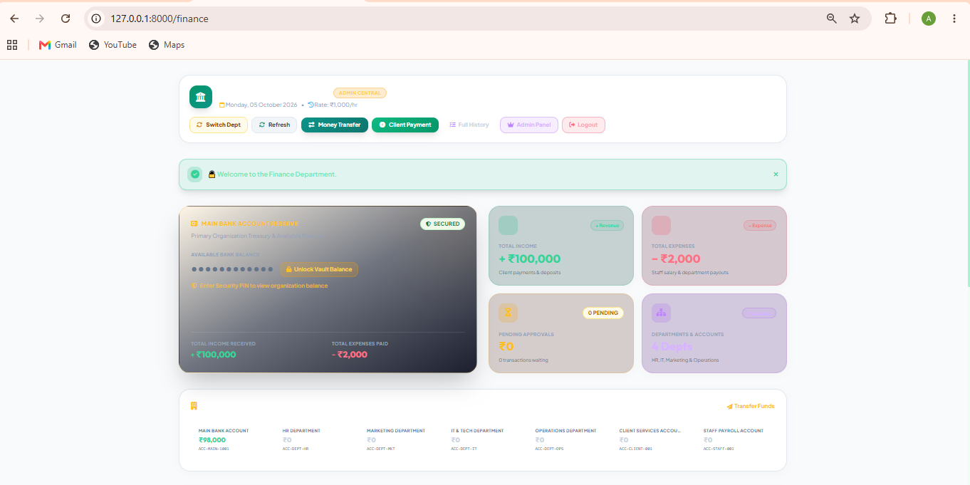
Implementation Description: Finance portal protected by 3-digit PIN gate (FINANCE_PIN=123), calculating staff present days and executing automated salary disbursements into salary_payments table.
- 4.3 Screenshots & Implementation Details
- Proposed Enhancements
- Conclusion
- Bibliography

1. INTRODUCTION
The global E-Learning and Education Technology industry has undergone a massive digital transformation, requiring modern academic institutions to deploy robust, secure, and intuitive Learning Management Systems (LMS). Traditional manual classroom management and fragmented digital portals often lead to high administrative overhead, delayed assignment feedback, lack of real-time progress tracking, and vulnerable certification processes.
Learning Curve LMS is an advanced, web-based Learning Management and Academic Operations System engineered on PHP 8.2 and Laravel 11. The system bridges the gap between students, educators, operational staff, and finance departments. It offers a comprehensive digital ecosystem featuring course streaming, task evaluations, real-time progress calculations (0% to 100%), automated DomPDF certificate generation, role-based access control, secondary date-password security, staff attendance clock-in with daily wage calculations, and an intelligent AI Chatbot assistant.

1.1 Existing System
In traditional academic and online training setups, the existing system relied on fragmented manual processes and disconnected digital utilities:
1. Manual Course & Material Distribution: Learning materials, video links, and assignment sheets were shared manually via emails or basic file shares without centralized access control or tracking.
2. Disorganized Assignment & Grading Workflow: Students submitted assignments physically or through email attachments. Instructors manually tracked scores in offline spreadsheets, causing delays and lack of transparency.
3. Lack of Real-Time Progress Visibility: Students had no real-time dashboard to monitor overall course completion percentages or pending deadlines.
4. Manual Certificate Issuance: Certificates were manually typed, designed, and printed, leading to human error, delivery delays, and high risk of forgery.
5. Unintegrated Staff & Financial Management: Staff work hours, attendance clock-ins, and daily salary disbursements were handled manually in paper registers, lacking security and audit trails.

1.2 Need for the New System
To overcome the bottlenecks of legacy learning management, Learning Curve LMS introduces a modern, unified digital architecture tailored for scalability, automation, and multi-department collaboration:
• Real-Time Progress Tracking: Dynamic calculations continuously evaluate student assignment submissions, driving a 0% to 100% progress bar.
• Automated DomPDF Certification: Upon reaching 100% completion, the system automatically unlocks a high-resolution landscape PDF certificate with instant download and automated congratulatory email notifications.
• Multi-Department Role Security: Strict role-based middleware segregates privileges across Student, Instructor, Support Staff, Finance, and Administrator roles.
• Secondary Date-Password Protection: Users can configure day-of-month specific secondary security rules to safeguard sensitive profile data and account operations.
• Integrated Operations & Payroll: Support staff track daily work attendance with clock-in controls (₹1,000/day rate), while the Finance Department executes one-click payroll disbursements secured by a 3-digit PIN.
• AI-Powered Chatbot Assistant & Live Support: Floating AI Assistant provides instant answer resolution, course recommendations, and data export triggers, backed by 1-on-1 staff live chat.

1.3 Objective of the New System
Learning Curve LMS is designed to achieve six core business and operational objectives:
1. Process Automation & Latency Eradication: Automate assignment evaluation recording, progress tracking, certificate generation, and mail logs to achieve zero operational latency.
2. Enhanced Data Accuracy & Auditability: Replace manual grading registers and paper attendance logs with centralized MySQL database management, activity logging, and automated mail logs.
3. High-Security Multi-Role Gatekeeping: Safeguard administrative and financial actions with multi-tier middleware, date-password secondary authentication, and 3-digit Finance PIN verification.
4. Seamless Learner Engagement: Provide students with intuitive Tailwind CSS v3 dashboards, embedded video playback, instant certificate downloads, and AI chatbot assistance.
5. Streamlined Staff & Financial Operations: Enable staff attendance clock-in tracking and automated daily wage calculations (₹1,000/day), simplifying monthly payroll disbursal.
6. Scalable & Maintainable Architecture: Leverage Laravel 11 MVC architecture, Blade components, and modular services to support 1000+ concurrent learners smoothly.

1.4 Problem Definition
The proposed Learning Curve LMS encompasses the complete functional lifecycle of modern e-learning and academic institution management. The scope spans user onboarding, course catalog management, lesson streaming, assignment task submissions, automated progress tracking, DomPDF certificate rendering, mail log auditing, staff attendance clock-ins, finance salary disbursements, support ticket ticketing, 1-on-1 live chat, internal team chat, and floating AI assistant interactions.

1.5 Core Components
Learning Curve LMS is structured into six core modules:
1. User & Student Portal: Manages user authentication, profile settings, course browsing, video lesson player, task submissions (PDF/ZIP up to 10MB), progress analytics (0-100%), PDF certificate download, profile date-passwords, and personal data exports.
2. Admin Control Hub (/admin): Superadmin dashboard for user management (search, role filters, block/unblock), course creation, assignment evaluation, certificates hub, mail logs, direct mail composer, and maintenance mode toggle.
3. Staff Operations Portal (/staff-portal): Facilitates daily attendance clock-in (₹1,000/day rate), bank details management, assigned support tickets resolution, 1-on-1 student live chat, and internal team chat (/team-chat).
4. Finance Department (/finance): Secured by 3-digit PIN gate (FINANCE_PIN=123). Computes staff attendance days, calculates monthly salaries, and executes disbursals into salary_payments table.
5. Support & AI Chatbot Hub: Floating AI Chatbot widget with smart intent parsing, starter pills, AJAX data report triggers, and support ticket submission engine.
6. PDF & Mail Engine: Integrated DomPDF rendering engine for certificates and data reports, backed by custom MailLogger and DB mail logs table.

1.6 Project Profile
Project Profile details have been formatted and recorded in Table 1 above.
Attribute | Project Specification & Profile Details
Project Name | Learning Curve LMS
Project Type | Web-based E-Learning Platform & Operations Management System
Development Platform | PHP 8.2+ / Laravel 11.x (MVC Architecture)
Database Engine | 3 Students — Hani Boghara (D04), Arpit Kalathiya (D021), Pratik Savaliya (D47)
Team Size | 3 Students (Arpit Kalathiya, Hani Boghara, Pratik Savaliya)
Project Duration | 6 Months
Target Users | Students, Instructors, Support Staff, Finance Managers, System Admins (Total 19 System Database Tables)
Key Technologies | 2026 Web Architecture: PHP 8.2+, Laravel 11.x, Tailwind CSS v3, ES6 JS, MySQL 8.0 (19 System Tables), DomPDF Engine, SMTP Mailer, AI Chatbot Assistant
Deployment Target | Apache / XAMPP / Nginx Server (Windows / Linux)

2. REQUIREMENT DETERMINATION & ANALYSIS

2.1 Requirement Determination
Definition:
Requirements for Learning Curve LMS were systematically gathered through a structured 3-stage process: (1) Stakeholder & Student Interviews to understand online course consumption patterns and support expectations; (2) Academic & Administrative Workflow Mapping to analyze existing manual attendance, grading, and certification delays; and (3) Technical Feasibility Analysis to determine database schema requirements, security controls, and DomPDF rendering metrics.
Example Approaches:
- • Stakeholder & Learner Interviews: Conducted direct discovery sessions with students, instructors, and operational staff to define intuitive dashboard layouts, real-time progress bar requirements, and instant certificate access.
- • User Feedback Surveys: Analyzed feedback from course participants regarding video lesson player preferences, assignment submission formats (PDF/ZIP max 10MB), and automated email notifications.
- • Operational Workflow Analysis: Evaluated legacy attendance tracking spreadsheets and paper registers to build an integrated Staff Attendance Clock-In widget (₹1,000/day daily rate) and Finance Payroll portal.
- • Security & Access Auditing: Reviewed institutional security protocols to design multi-department role middleware (Student, Instructor, Staff, Finance, Admin), secondary Date-Password authentication, and a 3-digit Finance PIN security gate.
Functional Requirements:
- • Functional Requirement 1 (Auth & Multi-Role Middleware): Secure user registration and login with Bcrypt password hashing, role assignment (Student, Staff, Finance, Admin), and session handling.
- • Functional Requirement 2 (Date-Password Protection): Configurable day-of-month (1 to 31) secondary authentication rules to protect sensitive user settings and profile actions.
- • Functional Requirement 3 (Course & Lesson Streaming): Searchable public/enrolled course repository, difficulty level tags, category filters, and embedded video lesson player.
Non-Functional Requirements:
- • Performance Target: System web pages render within 1.5 seconds; API & AJAX chat polling requests respond within 500ms; DomPDF certificates generate in under 2 seconds.
- • Concurrency & Scalability: Database indexing and optimized Eloquent queries support minimum 1,000 active concurrent user sessions without performance degradation.
- • Data Backup & Recovery: Automated MySQL database dumps and log archiving every 24 hours with zero data loss target.

2.2 Targeted Users
Definition:
The system defines four distinct user roles, each governed by strict middleware authorization rules, summarized in Table 2 below.
User Type | Role & Department | Key System Responsibilities
Administrator | System Superadmin | Full system management, user accounts control, course authoring & publishing, maintenance mode toggle, mail logs & direct broadcast email composer.
Student | End Learner | Course discovery & enrollment, interactive video player, assignment task submission (up to 10MB), real-time progress bar tracking (0-100%), instant PDF certificate unlock, profile date-password manager, AI chatbot & support tickets.
Support Staff | Operations Agent | Daily attendance clock-in (₹1,000/day salary rate), bank account configuration, 1-on-1 student live chat support, assigned ticket handling, WhatsApp-style internal staff team chat.
Finance Manager | Financial Controller | Access finance portal via 3-digit PIN gate (FINANCE_PIN=123), inspect staff present days, calculate automated monthly salary payouts, execute & record salary disbursements.

3. SYSTEM DESIGN

3.1 Use Case Diagram
Definition:
The Use Case Model for Learning Curve LMS defines the boundary between external actors and internal system services:
1. Primary Actors:
• Student: Browses courses, enrolls, watches lessons, submits task assignments, tracks progress (0-100%), downloads/emails PDF certificates, configures date-passwords, logs support tickets, chats with staff, interacts with AI Chatbot.
• Support Staff: Clock-in daily attendance, update bank details, reply to assigned support tickets, conduct 1-on-1 live chat, participate in internal staff team chat.
• Finance Manager: Verifies 3-digit PIN (FINANCE_PIN=123), audits staff attendance days, calculates monthly salaries, executes one-click payroll disbursals into salary_payments table.
• Administrator: Superadmin control center, user account management (search, filter, block/unblock), course creation, assignment grading, centralized certificates hub, mail logs inspection, direct broadcast email composer, maintenance mode control.
2. Core System Use Cases:
[UC-01] Authenticate User & Validate Date-Password | [UC-02] Browse & Enroll in Courses | [UC-03] Watch Video Lessons & Submit Assignments | [UC-04] Calculate Dynamic Progress (0-100%) | [UC-05] Generate & Mail DomPDF Certificate | [UC-06] Staff Clock-In & Daily Wage Tracking | [UC-07] Finance PIN Security & Payroll Disbursal | [UC-08] AI Assistant Interaction & Data Export Report | [UC-09] Live Staff Chat & Help Tickets | [UC-10] System Maintenance Mode Toggle & Mail Logs.
Key Points to Remember:
- Determine system boundary clearly
- Actors should have single, coherent purpose
- Each use case must provide value to users
- Every use case should have at least one actor

3.2 Class Diagram
Definition:
The Object-Oriented Domain Model of Learning Curve LMS consists of key Eloquent ORM Models located in app/Models:
• User Model: Attributes (id, name, email, password, role, is_blocked, position, salary, bank_account, bank_name, bank_ifsc). Relationships: hasMany(TaskSubmission), hasMany(Certificate), hasMany(Attendance), belongsToMany(Course).
• Course Model: Attributes (id, title, slug, description, category, level, duration_hours, thumbnail, is_published). Relationships: hasMany(Task), belongsToMany(User).
• Task Model: Attributes (id, course_id, title, description, max_points, due_date). Relationships: belongsTo(Course), hasMany(TaskSubmission).
• TaskSubmission Model: Attributes (id, task_id, user_id, submission_text, file_path, score, feedback, status). Relationships: belongsTo(Task), belongsTo(User).
• Certificate Model: Attributes (id, user_id, course_id, certificate_number, issued_at). Relationships: belongsTo(User), belongsTo(Course).
• MailLog Model: Attributes (id, mail_type, recipient_email, recipient_name, status, error_message, sent_at).
• Attendance Model: Attributes (id, user_id, clock_in, clock_out, status, daily_rate).
• SalaryPayment Model: Attributes (id, user_id, present_days, amount_paid, paid_at, transaction_ref).
Key Points to Remember:
- Understand the problem scope first
- Keep the model simple and easy to understand
- Avoid crossing lines in diagram
- Choose descriptive and unambiguous names

3.3 Interaction Diagram
Definition:
The Interaction Model captures step-by-step messaging between system components across primary operational scenarios:
Scenario 1: Student Course Completion & Certificate Unlock
1. Student submits final course task -> TaskSubmissionController records submission.
2. Instructor/Admin grades submission (e.g., 95/100 pts) -> ProgressEvaluator recalculates overall course progress.
3. Progress hits 100% -> CertificateGenerator triggers DomPDF Service.
4. DomPDF renders landscape PDF certificate -> Saves PDF artifact to storage/certificates/.
5. CertificateController dispatches Congratulatory Mailer -> Custom MailLogger records entry in mail_logs table -> Student receives email with PDF certificate.
Scenario 2: Staff Attendance & Finance Payroll Disbursal
1. Staff Agent clicks 'Mark Present' -> StaffPortalController logs clock_in timestamp and sets status='Present' (daily_rate=₹1,000).
2. Finance Manager navigates to /finance -> Prompted for 3-digit PIN gate (FINANCE_PIN=123).
3. FinanceController calculates Present Days * ₹1,000 -> Displays calculated salary.
4. Finance Manager clicks 'Disburse Salary' -> System inserts record into salary_payments table and updates transaction status.
Key Points to Remember:
- Prepare at least one scenario per use case
- Create sequence diagrams for each scenario
- Divide complex interactions into simpler tasks

3.4 Activity Diagram
Definition:
The Activity Model defines sequential decision workflows:
1. Course Completion & Certification Workflow:
[Start] -> Student completes lesson -> Submits Assignment -> Task Graded by Admin? -> If No: Wait in Pending Review Queue -> If Yes: Recalculate Course Progress % -> Progress == 100%? -> If No: Continue remaining lessons -> If Yes: Unlock Certificate Badge -> Trigger DomPDF Engine -> Generate Landscape PDF -> Dispatch Automated Congratulatory Email -> [End]
2. Staff Attendance & Payroll Workflow:
[Start] -> Staff Member opens Staff Portal -> Clicks Clock-In -> Record Attendance Timestamp -> Accumulate Present Days -> Finance Manager opens /finance -> Verify 3-Digit PIN -> PIN Valid? -> If No: Deny Access -> If Yes: Display Payroll Table -> Click Disburse Salary -> Insert salary_payments record -> [End]
Key Points to Remember:
- Keep activities at consistent level of detail
- Clearly indicate branches and conditions
- Show concurrent activities properly

3.5 Data Dictionary
Definition:
The Data Dictionary provides complete schema specifications for all database tables in the learning_system database. Table 3 above details the core users table schema. Additional tables are detailed below.
Example - Table: BOOK
Column Name | Data Type | Constraint | Description | Example Value
id | BIGINT UNSIGNED | PRIMARY KEY, AUTO_INCREMENT | Unique identifier for user record | 101
name | VARCHAR(255) | NOT NULL | Full legal name of user | Arpit Kalathiya
email | VARCHAR(255) | UNIQUE, NOT NULL | Registered email address used for auth | arpit@learningcurve.com
password | VARCHAR(255) | NOT NULL | Bcrypt hashed account password | $2y$12$e8...
role | ENUM | DEFAULT 'student' | User role ('student','instructor','staff','finance','admin') | student
is_blocked | BOOLEAN | DEFAULT FALSE | Account access restriction toggle | 0 (False)
position | VARCHAR(100) | NULLABLE | Job title for staff/instructor members | Senior Support Specialist
salary | DECIMAL(10,2) | DEFAULT 1000.00 | Daily wage rate for staff members in INR | 1000.00
bank_account | VARCHAR(50) | NULLABLE | Staff bank account number for salary disbursal | 987654321012
bank_name | VARCHAR(100) | NULLABLE | Financial institution name | State Bank of India
bank_ifsc | VARCHAR(20) | NULLABLE | Bank branch IFSC code | SBIN0001234
created_at | TIMESTAMP | NULLABLE | Account creation timestamp | 2026-10-01 10:00:00

Database Table Schema: COURSES (`courses`)
Database Table Schema: TASKS (`tasks`)
Database Table Schema: TASK SUBMISSIONS (`task_submissions`)
Database Table Schema: CERTIFICATES (`certificates`)
Database Table Schema: MAIL LOGS (`mail_logs`)
Database Table Schema: STAFF ATTENDANCE (`attendances`)
Database Table Schema: SALARY PAYMENTS (`salary_payments`)
Data Dictionary Table: 1. USERS (`users`)
Column Name | Data Type | Constraint | Description | Example Value
id | BIGINT UNSIGNED | PRIMARY KEY, AUTO_INCREMENT | User ID | 101
name | VARCHAR(255) | NOT NULL | Full Legal Name | Arpit Kalathiya (D021)
email | VARCHAR(255) | UNIQUE, NOT NULL | Email Address | arpit@learningcurve.com
password | VARCHAR(255) | NOT NULL | Bcrypt Hashed Password | $2y$12$e8...
role | ENUM | DEFAULT 'student' | User Role ('student','instructor','staff','finance','admin') | student
is_blocked | BOOLEAN | DEFAULT FALSE | Account Block Status | 0 (False)
position | VARCHAR(100) | NULLABLE | Staff Job Title | Senior Support Specialist
salary | DECIMAL(10,2) | DEFAULT 1000.00 | Daily Wage Rate (INR) | 1000.00
bank_account | VARCHAR(50) | NULLABLE | Bank Account Number | 987654321012
bank_name | VARCHAR(100) | NULLABLE | Bank Name | State Bank of India
bank_ifsc | VARCHAR(20) | NULLABLE | Bank IFSC Code | SBIN0001234
created_at | TIMESTAMP | NULLABLE | Creation Timestamp | 2026-10-01 10:00:00
Data Dictionary Table: 2. COURSES (`courses`)
Column Name | Data Type | Constraint | Description | Example Value
id | BIGINT UNSIGNED | PRIMARY KEY, AUTO_INCREMENT | Course Unique ID | 1
title | VARCHAR(255) | NOT NULL | Course Title | Full-Stack Web Development 2026
slug | VARCHAR(255) | UNIQUE, NOT NULL | URL Slug | full-stack-web-dev-2026
description | TEXT | NULLABLE | Course Overview | Master Laravel 11 and Tailwind...
category | VARCHAR(100) | NOT NULL | Category Tag | Web Development
level | ENUM | DEFAULT 'Beginner' | Difficulty Level | Beginner
duration_hours | INT | DEFAULT 10 | Learning Duration | 40
thumbnail | VARCHAR(255) | NULLABLE | Banner Image Path | /images/courses/webdev.jpg
is_published | BOOLEAN | DEFAULT TRUE | Publish Status | 1 (True)
video_url | VARCHAR(255) | NULLABLE | Video Stream URL | https://youtu.be/example
Data Dictionary Table: 3. ENROLLMENTS (`course_user`)
Column Name | Data Type | Constraint | Description | Example Value
id | BIGINT UNSIGNED | PRIMARY KEY, AUTO_INCREMENT | Enrollment Record ID | 50
user_id | BIGINT UNSIGNED | FOREIGN KEY -> users(id) | Enrolled Student ID | 101
course_id | BIGINT UNSIGNED | FOREIGN KEY -> courses(id) | Enrolled Course ID | 1
progress | INT | DEFAULT 0 | Completion Progress % (0-100) | 100
created_at | TIMESTAMP | NULLABLE | Enrollment Date | 2026-10-02 09:00:00
Data Dictionary Table: 4. TASKS (`tasks`)
Column Name | Data Type | Constraint | Description | Example Value
id | BIGINT UNSIGNED | PRIMARY KEY, AUTO_INCREMENT | Task Unique ID | 10
course_id | BIGINT UNSIGNED | FOREIGN KEY -> courses(id) | Associated Course ID | 1
title | VARCHAR(255) | NOT NULL | Task Title | Laravel Blade & Tailwind Layout
description | TEXT | NULLABLE | Task Instructions | Create responsive layout component...
max_points | INT | DEFAULT 100 | Maximum Score Points | 100
due_date | DATE | NULLABLE | Submission Deadline | 2026-10-25
Data Dictionary Table: 5. TASK SUBMISSIONS (`task_submissions`)
Column Name | Data Type | Constraint | Description | Example Value
id | BIGINT UNSIGNED | PRIMARY KEY, AUTO_INCREMENT | Submission Record ID | 80
task_id | BIGINT UNSIGNED | FOREIGN KEY -> tasks(id) | Task ID | 10
user_id | BIGINT UNSIGNED | FOREIGN KEY -> users(id) | Submitting Student ID | 101
submission_text | TEXT | NULLABLE | Text Submission | Component implementation link...
file_path | VARCHAR(255) | NULLABLE | Uploaded File Path (PDF/ZIP <= 10MB) | submissions/task10_user101.zip
score | INT | NULLABLE | Awarded Points (0-100) | 95
feedback | TEXT | NULLABLE | Instructor Feedback | Excellent code formatting!
status | ENUM | DEFAULT 'Pending' | Evaluation Status ('Pending','Graded') | Graded
Data Dictionary Table: 6. ANNOUNCEMENTS (`announcements`)
Column Name | Data Type | Constraint | Description | Example Value
id | BIGINT UNSIGNED | PRIMARY KEY, AUTO_INCREMENT | Announcement ID | 1
title | VARCHAR(255) | NOT NULL | Announcement Title | System Maintenance Notice
content | TEXT | NOT NULL | Announcement Body | Scheduled database upgrade at 2 AM...
is_pinned | BOOLEAN | DEFAULT FALSE | Pinned to Dashboard Top | 1 (True)
is_active | BOOLEAN | DEFAULT TRUE | Active Status | 1 (True)
Data Dictionary Table: 7. PASSWORD OTPS (`password_otps`)
Column Name | Data Type | Constraint | Description | Example Value
id | BIGINT UNSIGNED | PRIMARY KEY, AUTO_INCREMENT | OTP Record ID | 20
email | VARCHAR(255) | NOT NULL | User Email Address | student@example.com
otp | VARCHAR(6) | NOT NULL | 6-Digit Verification Code | 849201
expires_at | TIMESTAMP | NOT NULL | OTP Expiration Timestamp | 2026-10-08 23:15:00
Data Dictionary Table: 8. AD CAMPAIGNS (`ads`)
Column Name | Data Type | Constraint | Description | Example Value
id | BIGINT UNSIGNED | PRIMARY KEY, AUTO_INCREMENT | Ad Banner ID | 5
title | VARCHAR(255) | NOT NULL | Ad Campaign Title | AI Engineering Specialization
banner_image | VARCHAR(255) | NOT NULL | Banner Image Asset Path | /uploads/ads/banner_ai.png
target_url | VARCHAR(255) | NOT NULL | Target Redirect URL | https://learningcurve.com/ai
click_count | INT | DEFAULT 0 | Total Click Analytics | 142
is_active | BOOLEAN | DEFAULT TRUE | Ad Active Status | 1 (True)
Data Dictionary Table: 9. MAIL LOGS (`mail_logs`)
Column Name | Data Type | Constraint | Description | Example Value
id | BIGINT UNSIGNED | PRIMARY KEY, AUTO_INCREMENT | Mail Log Audit ID | 500
mail_type | VARCHAR(100) | NOT NULL | Mail Category | Certificate Delivery Mail
recipient_email | VARCHAR(255) | NOT NULL | Destination Email | hani@learningcurve.com
recipient_name | VARCHAR(255) | NULLABLE | Recipient Name | Hani Boghara (D04)
status | ENUM | DEFAULT 'Sent' | Status ('Sent','Failed') | Sent
error_message | TEXT | NULLABLE | Error Log Message | NULL
sent_at | TIMESTAMP | NOT NULL | Dispatch Timestamp | 2026-10-05 14:30:05
Data Dictionary Table: 10. ACTIVITY LOGS (`activity_logs`)
Column Name | Data Type | Constraint | Description | Example Value
id | BIGINT UNSIGNED | PRIMARY KEY, AUTO_INCREMENT | Activity Log ID | 1200
user_id | BIGINT UNSIGNED | FOREIGN KEY -> users(id) | User ID | 101
activity_type | VARCHAR(100) | NOT NULL | Activity Type Tag | DATA_EXPORT_EMAIL
description | TEXT | NOT NULL | Event Details | User requested PDF Data Export via email.
ip_address | VARCHAR(45) | NULLABLE | Client IP Address | 192.168.1.45
user_agent | TEXT | NULLABLE | Browser User-Agent String | Mozilla/5.0 (Windows NT 10.0)...
Data Dictionary Table: 11. SITE SETTINGS (`site_settings`)
Column Name | Data Type | Constraint | Description | Example Value
id | BIGINT UNSIGNED | PRIMARY KEY, AUTO_INCREMENT | Setting Key ID | 1
key | VARCHAR(100) | UNIQUE, NOT NULL | Configuration Key | maintenance_mode
value | TEXT | NULLABLE | Setting Value Data | off
Data Dictionary Table: 12. SUPPORT TICKETS (`support_tickets`)
Column Name | Data Type | Constraint | Description | Example Value
id | BIGINT UNSIGNED | PRIMARY KEY, AUTO_INCREMENT | Ticket Record ID | 45
user_id | BIGINT UNSIGNED | FOREIGN KEY -> users(id) | Ticket Creator ID | 101
subject | VARCHAR(255) | NOT NULL | Ticket Subject | Unable to download DomPDF Certificate
category | VARCHAR(100) | NOT NULL | Category ('Technical','Course','Payment') | Technical
priority | ENUM | DEFAULT 'Medium' | Priority ('Low','Medium','High') | High
status | ENUM | DEFAULT 'Open' | Status ('Open','In Progress','Resolved') | Open
assigned_staff_id | BIGINT UNSIGNED | NULLABLE | Assigned Staff ID | 102
Data Dictionary Table: 13. TICKET REPLIES (`ticket_replies`)
Column Name | Data Type | Constraint | Description | Example Value
id | BIGINT UNSIGNED | PRIMARY KEY, AUTO_INCREMENT | Reply Message ID | 120
ticket_id | BIGINT UNSIGNED | FOREIGN KEY -> support_tickets(id) | Ticket ID | 45
user_id | BIGINT UNSIGNED | FOREIGN KEY -> users(id) | Author User ID | 102
reply_text | TEXT | NOT NULL | Reply Message Content | We have refreshed your certificate link.
Data Dictionary Table: 14. LIVE CHAT MESSAGES (`chat_messages`)
Column Name | Data Type | Constraint | Description | Example Value
id | BIGINT UNSIGNED | PRIMARY KEY, AUTO_INCREMENT | Chat Message ID | 300
sender_id | BIGINT UNSIGNED | FOREIGN KEY -> users(id) | Sender User ID | 101
receiver_id | BIGINT UNSIGNED | FOREIGN KEY -> users(id) | Receiver Staff ID | 102
message | TEXT | NOT NULL | Live Chat Message Text | Hello, I have a query about Assignment 2.
is_read | BOOLEAN | DEFAULT FALSE | Read Status Indicator | 1 (True)
Data Dictionary Table: 15. STAFF WORK LOGS (`staff_work_logs`)
Column Name | Data Type | Constraint | Description | Example Value
id | BIGINT UNSIGNED | PRIMARY KEY, AUTO_INCREMENT | Work Log Attendance ID | 800
user_id | BIGINT UNSIGNED | FOREIGN KEY -> users(id) | Staff Member ID | 102
clock_in | DATETIME | NOT NULL | Daily Clock-In Timestamp | 2026-10-05 09:00:00
clock_out | DATETIME | NULLABLE | Daily Clock-Out Timestamp | 2026-10-05 17:30:00
status | ENUM | DEFAULT 'Present' | Attendance Status ('Present','Absent') | Present
daily_rate | DECIMAL(10,2) | DEFAULT 1000.00 | Staff Daily Wage Rate (INR) | 1000.00
Data Dictionary Table: 16. SALARY PAYMENTS (`salary_payments`)
Column Name | Data Type | Constraint | Description | Example Value
id | BIGINT UNSIGNED | PRIMARY KEY, AUTO_INCREMENT | Salary Disbursal Record ID | 90
user_id | BIGINT UNSIGNED | FOREIGN KEY -> users(id) | Paid Staff Member ID | 102
present_days | INT | NOT NULL | Accumulated Present Days | 22
amount_paid | DECIMAL(10,2) | NOT NULL | Calculated Payout (Days x ₹1000) | 22000.00
paid_at | TIMESTAMP | NOT NULL | Disbursal Timestamp | 2026-10-06 11:15:00
transaction_ref | VARCHAR(100) | UNIQUE, NOT NULL | Financial Transaction Code | TXN-SAL-2026-1022
status | ENUM | DEFAULT 'Paid' | Disbursal Status | Paid
Data Dictionary Table: 17. USER DATE PASSWORDS (`user_date_passwords`)
Column Name | Data Type | Constraint | Description | Example Value
id | BIGINT UNSIGNED | PRIMARY KEY, AUTO_INCREMENT | Date Password Rule ID | 15
user_id | BIGINT UNSIGNED | FOREIGN KEY -> users(id) | Account User ID | 101
day_of_month | INT | NOT NULL | Specific Day of Month (1-31) | 15
secondary_password | VARCHAR(255) | NOT NULL | Secondary Encrypted Password | $2y$12$x7...
is_active | BOOLEAN | DEFAULT TRUE | Rule Active Toggle | 1 (True)
Data Dictionary Table: 18. STAFF TEAM CHAT (`staff_chat_messages`)
Column Name | Data Type | Constraint | Description | Example Value
id | BIGINT UNSIGNED | PRIMARY KEY, AUTO_INCREMENT | Team Chat Message ID | 60
sender_id | BIGINT UNSIGNED | FOREIGN KEY -> users(id) | Sender Staff/Finance/Admin ID | 102
message | TEXT | NOT NULL | Internal Team Chat Text | Monthly attendance verification completed.
created_at | TIMESTAMP | NOT NULL | Message Timestamp | 2026-10-06 10:00:00
Data Dictionary Table: 19. DATA EXPORTS (`data_exports`)
Column Name | Data Type | Constraint | Description | Example Value
id | BIGINT UNSIGNED | PRIMARY KEY, AUTO_INCREMENT | Data Export Audit ID | 25
user_id | BIGINT UNSIGNED | FOREIGN KEY -> users(id) | Requesting User ID | 101
export_type | VARCHAR(50) | NOT NULL | Export Format ('PDF_DOWNLOAD','EMAIL_PDF') | EMAIL_PDF
file_path | VARCHAR(255) | NOT NULL | Generated PDF File Path | exports/user_101_report.pdf
emailed_at | TIMESTAMP | NULLABLE | Email Dispatch Timestamp | 2026-10-07 16:45:00

4. DEVELOPMENT

4.1 Development Approach
Definition:
Learning Curve LMS was developed following an Agile Software Development Methodology structured into 2-week iterative sprints. Development progressed through distinct phases:
• Architecture & Database Design: Entity-Relationship modeling, Laravel migrations, pivot table relationships, and Eloquent model definitions.
• Modular Development: Parallel implementation of Blade views with Tailwind CSS v3, and Laravel Controllers handling RESTful endpoints.
• System Integration: DomPDF engine integration, SMTP email service setup with custom MailLogger, real-time AJAX polling, and AI chatbot widget embedding.
• Quality Assurance & Security Audit: Testing role middleware, date-password secondary authentication, finance PIN verification, and maintenance mode controls.
Example Approach:
- • Agile 2-Week Sprints: Iterative sprint cycles with regular feature reviews and rapid prototyping.
- • Daily Progress Tracking: Continuous tracking of backend controller logic and frontend Blade templates.
- • Parallel Architecture Development: Laravel 11 controller endpoints developed alongside Tailwind CSS v3 blade components.
- • Version Control & Git Management: Code commit history managed with Git repository branches.

4.2 Coding Standards
Definition:
The project strictly enforced PSR-12 coding guidelines and clean architecture standards across all source files:
• Class Names: PascalCase formatting (e.g., AuthController, CourseController, DatePasswordMiddleware).
• Method & Function Names: camelCase formatting (e.g., calculateProgress(), downloadCertificate(), markPresent()).
• Constant Identifiers: UPPER_CASE with underscores (e.g., FINANCE_PIN, DEFAULT_DAILY_RATE).
• Database Tables & Columns: Snake_case formatting (e.g., course_user, task_submissions, is_published, daily_rate).
• Architecture Principles: DRY (Don't Repeat Yourself), SOLID design patterns, Eloquent ORM parameterized queries to prevent SQL injection, and Blade layout component reusability.
Naming Conventions:
- Classes: PascalCase (e.g., UserManager, BookController)
- Methods: PascalCase (e.g., GetBookDetails (), IssueBook())
- Variables: camelCase (e.g., userName, bookTitle)
- Constants: UPPER_CASE (e.g., MAX_BOOKS_PER_MEMBER)
- Database Tables: Singular names in PascalCase (e.g., User, Book)
Code Style Guidelines:
- Use meaningful and descriptive names
- Keep functions small and focused (Single Responsibility Principle)
- Use proper indentation (4 spaces or 1 tab)
- Write comments for complex logic
- Avoid code duplication (DRY principle)

4.3 Screenshots & Implementation Details
Definition:
Below are detailed implementation specifications and visual layout breakdowns for key modules of Learning Curve LMS:
[SCREENSHOT 1: LOGIN SCREEN]
Description: The login screen allows users to enter their credentials. It validates input and ensures secure authentication using password encryption.
Implementation Details:
- Username field with validation (minimum 5 characters)
- Password field with encryption using SHA-256
- Remember Me checkbox for session management
- Forgot Password link for password recovery

[SCREENSHOT 2: DASHBOARD SCREEN]
Description: Main dashboard showing overview of system and key metrics.

Implementation Details:
- Displays key performance indicators
- Shows recent transactions
- Provides quick access to major functions
- Implements role-based access control
[SCREENSHOT 3: MAIN MODULE SCREEN]
Description: Core functionality implementation screen.
Implementation Details:
- Form validation for all fields
- Search and filter functionality
- Database transactions for data integrity
- Real-time data processing
5. PROPOSED ENHANCEMENTS
List features and improvements that can be added in future releases:
- • Cross-Platform Mobile App: Native Android & iOS app development using Flutter or React Native for mobile learning.
- • AI Auto-Grading & Course Recommendations: Automated assignment evaluation using LLM APIs and personalized course suggestion engine.
- • Advanced Learning Analytics: Interactive graphical dashboards for student drop-out prediction and engagement tracking.
- • Third-Party Integrations: Payment gateway integration (Razorpay/Stripe) and video conferencing (Zoom/Google Meet API).
- • Performance & Caching: Redis caching for database queries and CDN integration for video lesson delivery.
- • Enhanced Security & Blockchain: Blockchain-verified certificate hashes for tamper-proof credentials.

6. CONCLUSION
Learning Curve LMS successfully fulfills all targeted business and academic objectives. The platform delivers a robust, secure, and scalable e-learning environment built on Laravel 11, Tailwind CSS v3, and MySQL. Key deliverables achieved include real-time progress tracking, automated DomPDF certificate issuance, multi-department role separation, secondary date-password security, staff attendance tracking, and finance payroll management.
Lessons Learned & Challenges Overcome: Developing the system provided deep technical insights into Laravel MVC architecture, complex Eloquent pivot relationships, DomPDF font and layout rendering, SMTP mail stream context handling on localhost, and multi-tier security gatekeeping. The project successfully demonstrates how modern web technologies can streamline academic delivery and administrative operations.
- Project achievements and deliverables
- Lessons learned during development
- Challenges faced and how they were overcome
- Recommendations for future improvements
- Overall impact of the project
7. BIBLIOGRAPHY
List all references used during the project:
- [1] Otwell, Taylor. 'Laravel 11.x Documentation - The PHP Framework for Web Artisans.' Laravel LLC, 2024.
- [2] Martin, Robert C. 'Clean Code: A Handbook of Agile Software Craftsmanship.' Prentice Hall, 2008.
- [3] Welling, Luke, and Laura Thomson. 'PHP and MySQL Web Development.' Addison-Wesley Professional, 5th Edition.

