We love dogs, but same times WeRateDogs!!!!!!! One Twitter account is completely dedicated to that.

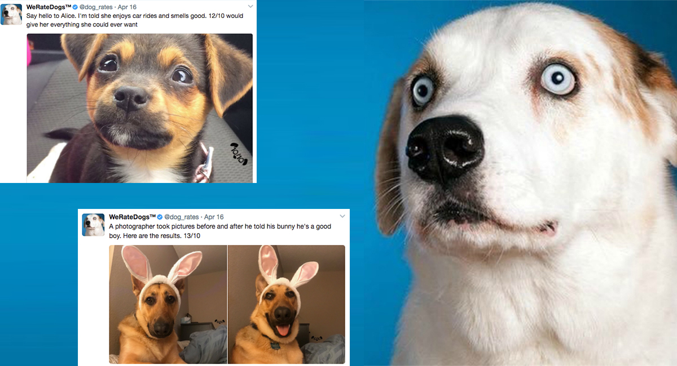

The most unique characteristic of the popular WeRateDogs (@dog_rates) account is its rating scheme where dogs are rated in a 0 to 10 scale. In this particular scale, the dogs usually achieve 11, 12, 13… because "they're good dogs Brent." Over time the ratings had growth as the populate of the account. Since July 2016 the dogs that are rated below 10 are very few (and probably a mistake of the text interpreter).

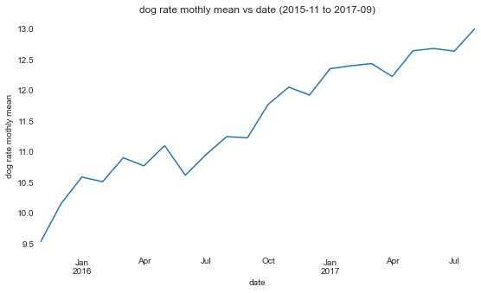

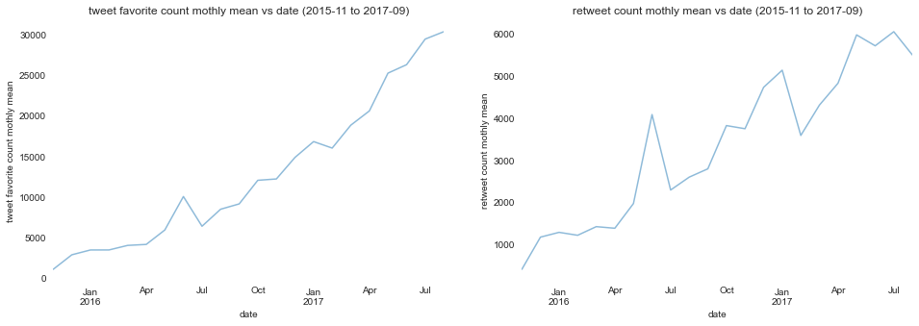

We can clearly observe that the dog rates that exceed the limit of 10 are the most favourited and retweeted. However, if it is because of the cuteness of the dog or uniqueness of the rating scheme is yet to be discovered.

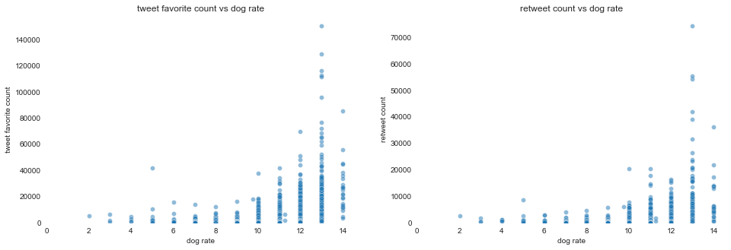

Golden retriever is the most common breed (137), followed by Labrador (94), Pembroke (88), Chihuahua (78), and pug (54).

The best-rated breeds on average are Saluki, Briard, Tibetan Mastiff, Border Terrier and Silky Terrier. The most favourited ones are Saluki, French bulldog, Afghan Hound, Giant Schnauzer, and Flat-Coated Retriever. The median gives different results, the best rating are, Afghan Hound, Saluki, Samoyed, Greater Swiss Mountain dog and French bulldog. The most favourited by the median are Irish Water Spaniel, Saluki, Afghan Hound, Giant Schnauzer, Flat-Coated Retriever, Bedlington terrier. With this data wide distribution, with so many outliers, this difference anticipated.

There are much more pupper (166) than puppo (21), doggo (58), and floofer (10). However, the puppos, doggos, and floofers have much more favourite counts, two to four times comparing the median. 