CIND 110 ASSIGNMENT 1 – 2022 ST_ID : 501213603 St_name: AMARPREET KAUR

Part II:

#Question 1.

List the names, ids and major of students who are majored in Computer Engineering(CE)

USE registrardb

SELECT DISTINCT S.St_Name, S.St_Id, S.Major

FROM student AS S

WHERE Major = 'CE';

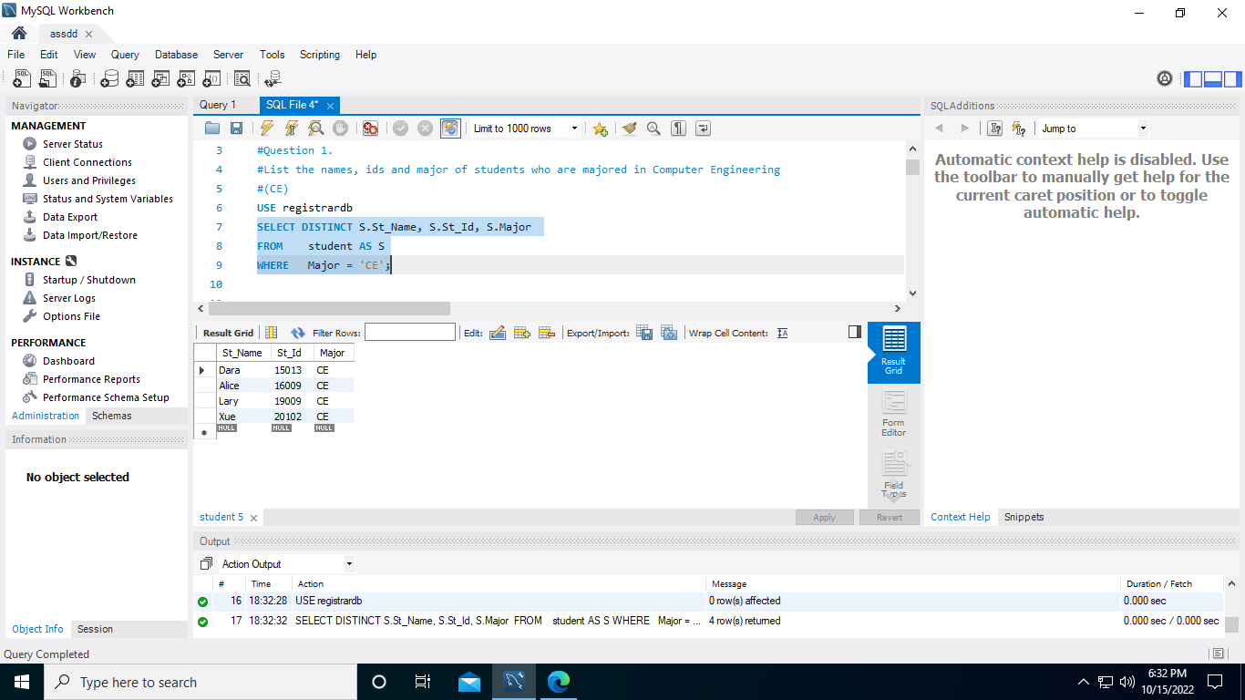

#Question 2.

List the grade of students who passed the course id 'CPS510' with this format:

<StudentName StudentId SectionId CourseId Term Year ProfName Grade>

USE registrardb

SELECT DISTINCT S.St_Name as StudentName,S.St_Id as StudentId,

SE.S_Id as SectionId, SE.C_Id as CourseId,

SE.Term,SE.Year, SE.P_Name as ProfName, G.Grade

FROM student AS S

JOIN grade AS G

ON G.St_Id = S.St_Id

JOIN section AS SE

ON SE.s_id= G.s_id

WHERE SE.c_id= 'CPS510';

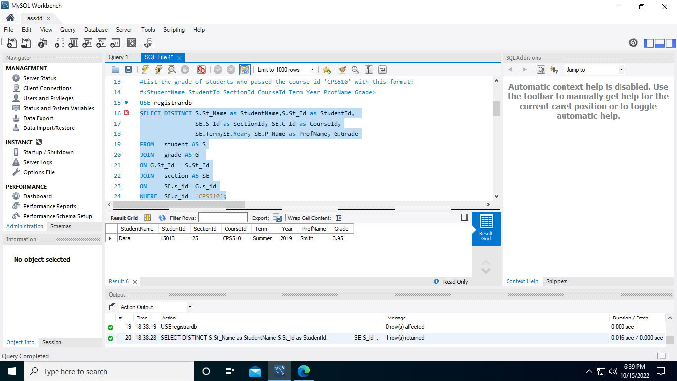

#Question 3.

List the student id, student name, course id and course name for all students enrolled in Fall 2021; sort the output in ascending order by student id

USE registrardb

SELECT DISTINCT S.St_Id, S.St_Name, SE.C_Id, C.C_Name

FROM student AS S

JOIN grade AS G

ON G.St_id =S.St_Id

JOIN section AS SE

ON SE.S_Id = G.S_Id

JOIN course AS C

ON C.C_Id = SE.C_Id

WHERE SE.Year = '2021' AND SE.Term = 'Fall'

ORDER BY S.St_Id ASC;

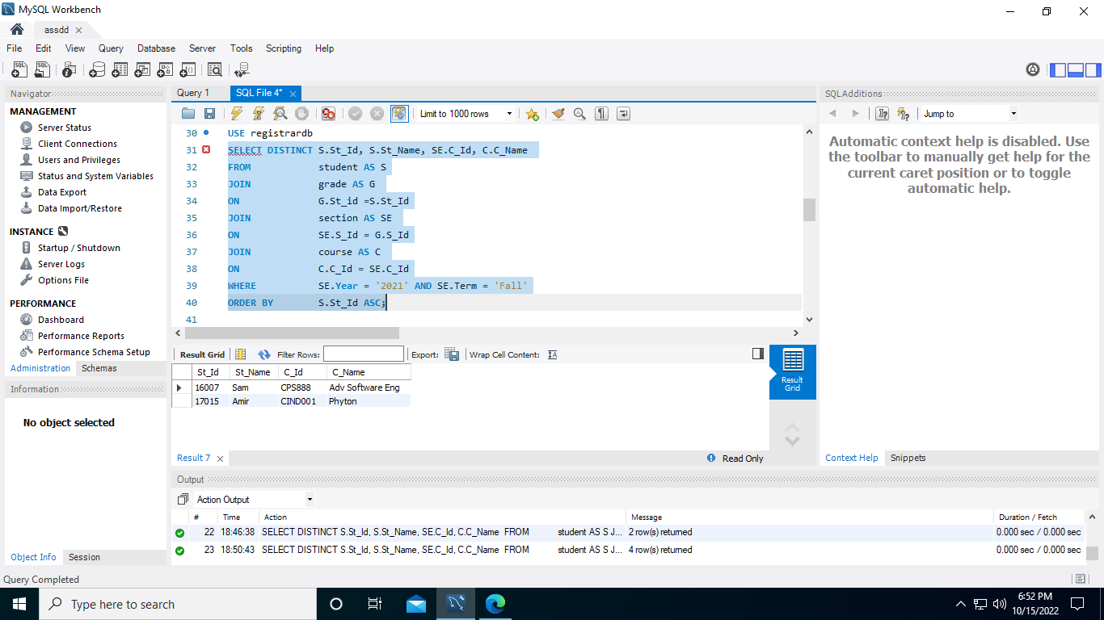

#Question 4.

List the name, id, major, degree, and gpa of all students who have a GPA between 3.0 and 4.0 inclusively.

USE registrardb

SELECT DISTINCT S.St_Name, S.St_Id, S.Major,S.Degree,GPA

FROM student AS S

WHERE GPA BETWEEN 3.0 AND 4.0;

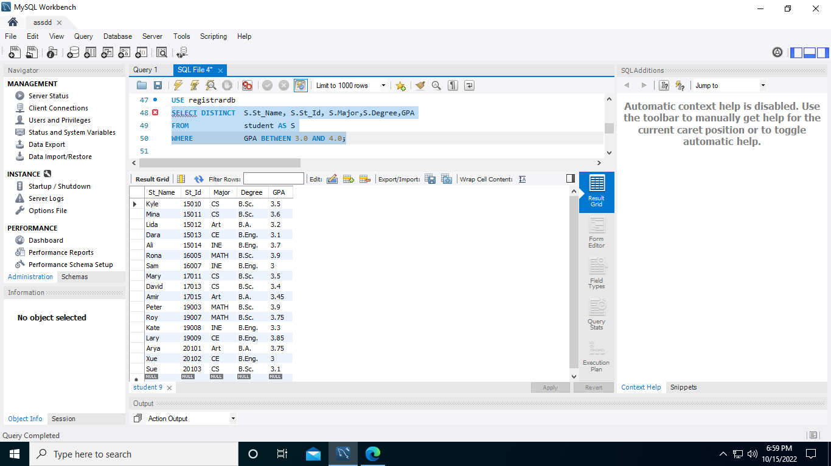

#Question 5.

List the name of all Professors who can teach 'CIND110', from the Teach pool table,along with the course id, but havenÃ¢â‚¬â„¢t taught the course, from the Section table

USE registrardb

SELECT DISTINCT TP.P_Name, TP.C_Id

FROM teach_pool AS TP

WHERE TP.c_id = 'CIND110'

AND

NOT EXISTS ( SELECT SE.C_Id

FROM section AS SE

WHERE TP.P_Name = SE.P_Name AND

TP.C_Id = SE.C_Id);

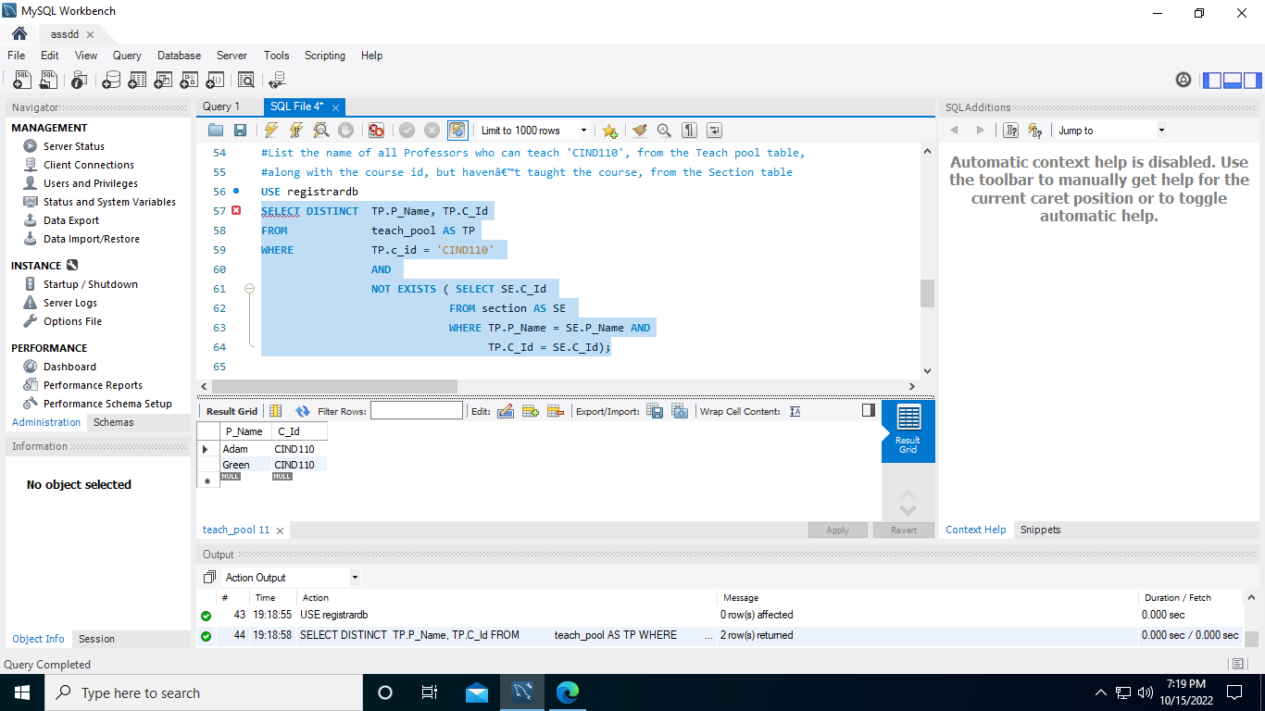

#Question 6.

Create a View as Ã¢â‚¬â„¢Report Winter 2022Ã¢â‚¬â„¢ from all attributes of potential Professors who will be available to teach in the Winter term along with their course ids, sort the output in

ascending order based on names; Display Report Winter 2022

USE registrardb

CREATE VIEW Report_Winter_2022_

AS SELECT DISTINCT P.P_Name, P.P_Phone, P.P_Email, TP.C_Id

FROM professor AS P

JOIN teach_pool AS TP

ON P.P_Name = TP.P_Name

WHERE TP.Term = "Winter"

ORDER BY P.P_name ASC;

SELECT * FROM registrardb.Report_Winter_2022_;

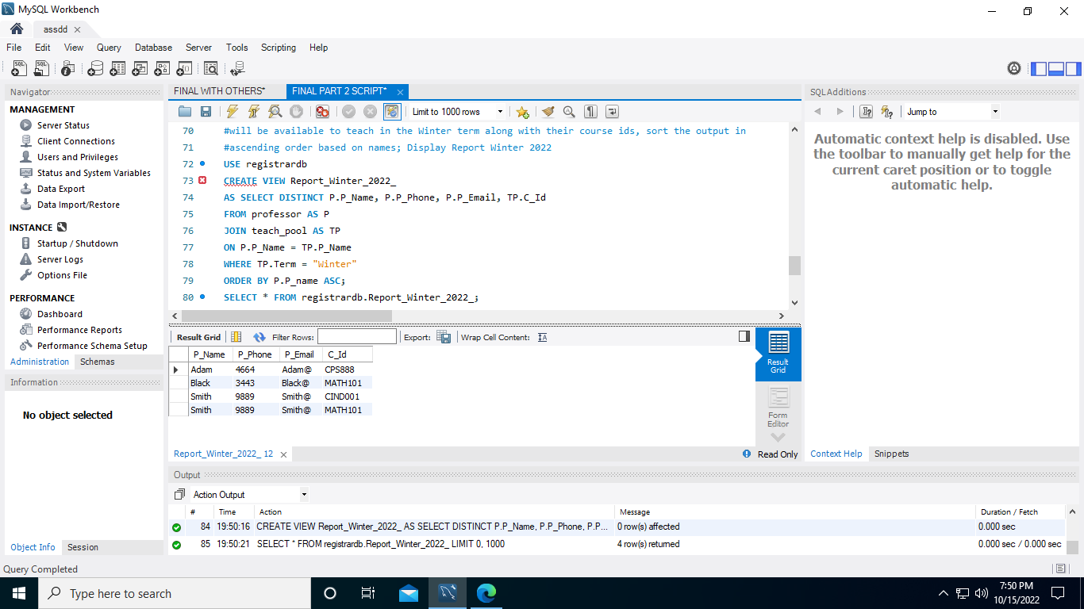

#Question 7.

Find the Minimum, Maximum, Average, Variance, and Standard deviation of the GPA of all students and display them.

USE registrardb

SELECT MIN(S.GPA) AS Minimum, MAX(S.GPA) AS Maximum,

AVG(S.GPA) AS Average, variance(S.GPA) AS Variance, STD(S.GPA) AS Standard_deviation

FROM student AS S;

