# Exercise: Configure vendor collaboration

## Verify External Roles

1. In **USMF**, navigate to **System administration>Security>External roles**
2. Verify that **Vendor (external)** and **Vendor admin (external)** roles are listed.

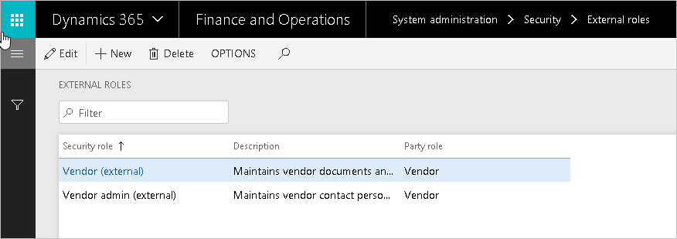

1. Navigate to **Procurement and sourcing>Vendors>All vendors**
2. Click the vendor 1001 link to open the details page.
3. In the **Collaboration activation** field,select **Active (PO is not auto-confirmed)**
4. Select **Add contacts** from the action pane

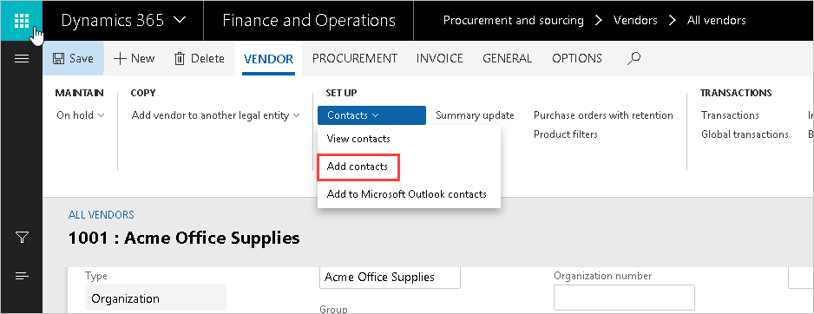

1. In the first name field select **Alex Darrow**
2. Click **Save**.
3. Click **Provision vendor user**

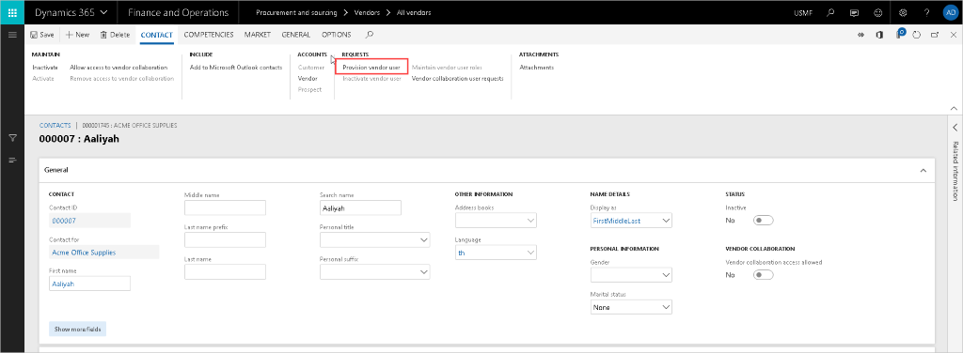

1. Setup the email alias such as someone@microsoft.com.
2. Type Demo vendor collaboration in the **Business justification** field.
3. Select **Vendor collaboration access allowed** check box under Legal entities the person is a contact for.

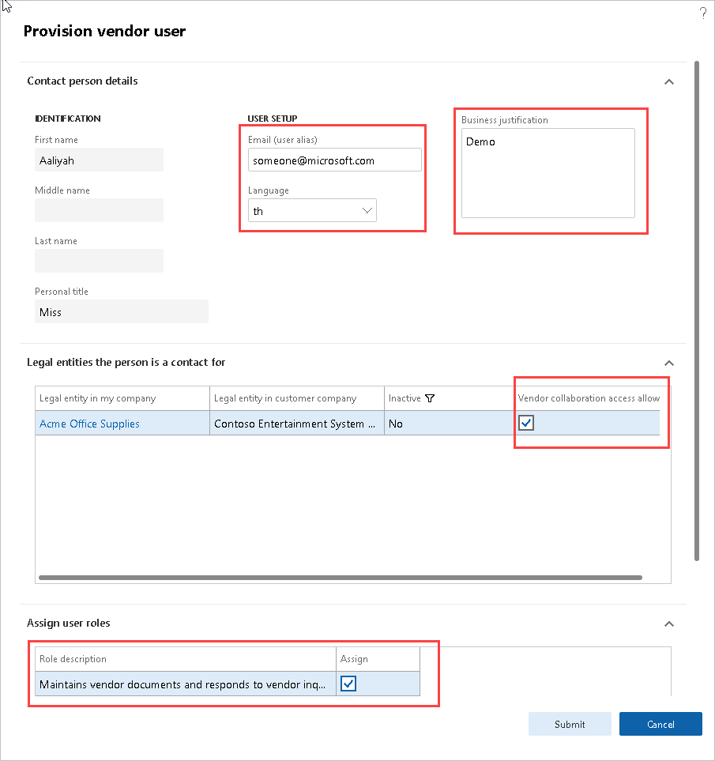

1. Select **Assign** check box under Assign user roles
2. Click **Submit**