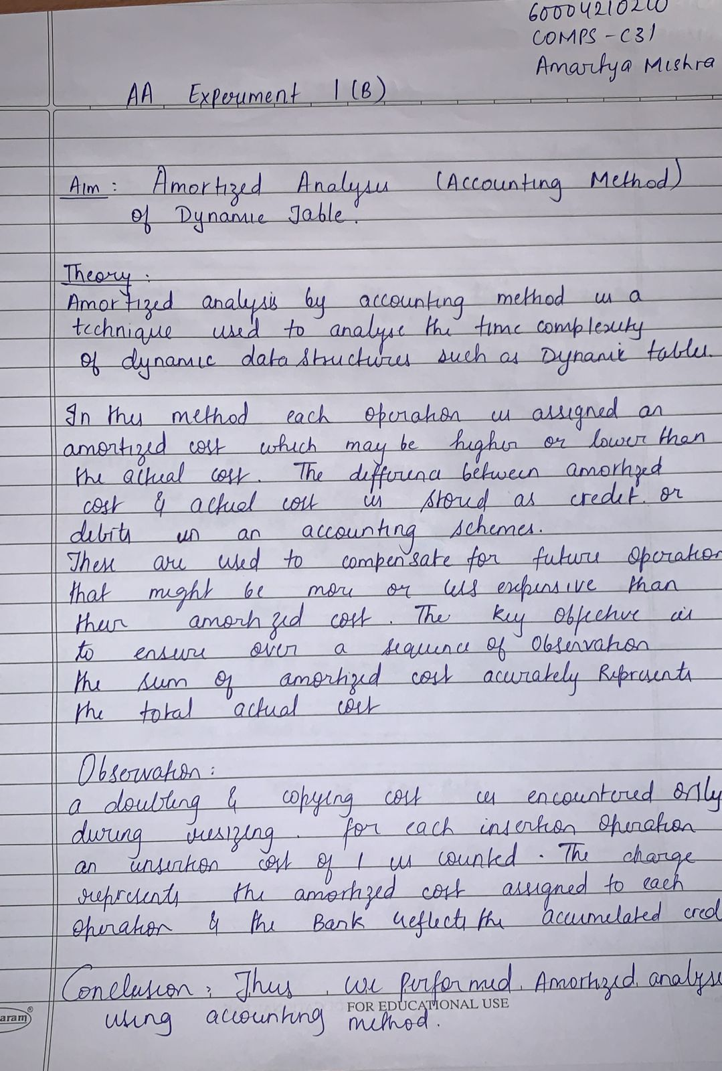

AA Exp 1 (B)

60004210210

Amartya Mishra

COMP C31

Code:

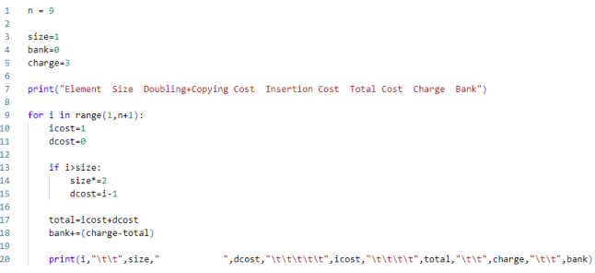

Output:

