2-DOF ROBOTIC ARM
Physics-Informed Adaptive
Domain Randomization
Research Roadmap, Mathematical Design,
Implementation Plan, and Publication Strategy
Eureka → RAPP → PINN → Adaptive DR → Robust Sim-to-Real

Document type: | Second-stage research document
Date: | 15 September 2026
Benchmark: | 2-DOF planar reaching in Isaac Lab
Optimization: | PPO · 4096 parallel environments

Status convention: material about the existing 2-DOF experiments is treated as established project evidence. The PINN-informed adaptive domain-randomization mechanism is a proposed research design and must be validated experimentally.
Table of Contents

1. Executive Summary 1
2. Current System: Mathematical Baseline 2
2.1 Robot and simulator 2
2.2 Observation, action, and kinematics 3
2.3 Target distribution 4
3. Existing Rewards and What They Taught Us 4
3.1 Human reward 4
3.2 Eureka reward 5
3.3 The observed precision fingerprint 5
4. Why the Next Problem Is Domain Randomization 5
4.1 The new research question 6
5. RAPP: Keep It, Do Not Throw It Away 7
5.1 Example: friction 8
5.2 Static versus adaptive formulation 8
6. Proposed Research Architecture 9
7. Robot Dynamics: The Physics the PINN Must Understand 9
7.1 Residual dynamics 10
7.2 Parameterized dynamics 10
8. PINN Design 10
8.1 Inputs 11
8.2 Outputs 11
8.3 Candidate physics parameters 11
8.4 PINN loss 12
9. PINN Uncertainty 13
10. Per-Environment Domain Randomization in Isaac Lab 14
11. Monitoring 4096 Environments Correctly 15
11.1 Population statistics 15
11.2 Physics-conditioned performance 16
12. Physics–Performance Map 16
Example 17
13. From Binary RAPP to a Continuous Feasible Set 17
14. Adaptive DR Distribution 18
14.1 First implementation: truncated distributions 19
14.2 Simple curriculum 19
14.3 Physics + policy difficulty score 20
15. Formal Adaptive-DR Objective 20
16. Why the PINN Should Be Frozen First 21
17. PINN Dataset Design 22
18. Exact PPO / Adaptive-DR Loop 23
19. Pseudocode 25
20. Experimental Matrix 25
20.1 The most important comparison 25
21. Evaluation Protocol 26
21.1 Precision curve 26
21.2 Dynamic and effort metrics 26
21.3 Robustness metrics 27
22. Distribution-Shift Tests 28
23. What Not to Do 29
24. Coding Roadmap 30
Phase 0 — freeze the baseline 31
Phase 1 — static DR 31
Phase 2 — RAPP 32
Phase 3 — PINN 33
Phase 4 — adaptive DR 34
Phase 5 — paper experiments 35
25. Debugging and Verification 35
25.1 Required logging schema 36
26. Publication and Novelty Positioning 36
26.1 Existing literature that must be distinguished 37
27. Current Literature Signals 37
28. Research Hypotheses 37
29. What Would Count as a Strong Result? 38
30. Sim-to-Real Strategy 39
31. Final Mathematical Summary 39
32. Immediate Checklist 41
33. Final Research Decision 43
34. References and Source Basis 45
Appendix A — Interpretation Examples 46
Policy strong everywhere 46
Policy fails at high friction 46
PINN uncertain but policy robust 46
PINN predicts impossible parameters 47
Distribution collapses 47
Appendix B — Researcher Mental Model 47
Closing Perspective 48

Note: This Table of Contents is generated via field codes. To ensure page number accuracy after editing, please right-click the TOC and select “Update Field.”

1. Executive Summary
The project has already established a controlled 2-DOF planar reaching benchmark in Isaac Lab. The arm is torque controlled, targets are randomized in Cartesian space, 4096 environments run in parallel, physics runs at 120 Hz, policy actions are applied at 30 Hz, and PPO is the low-level optimizer. The completed study compares a human-designed reward against an LLM-generated Eureka reward.
The existing results are scientifically useful because they expose a concrete weakness in automated reward discovery. The human reward produced high fine precision after longer training, whereas the Eureka reward rapidly produced coarse 5 cm reaching but poor 2 cm and 1 cm precision. The important conclusion is not that Eureka is universally worse; rather, reward structure changes the behavior PPO is incentivized to learn.
The next stage should move from nominal RL toward robust RL under uncertain dynamics. The first step is to implement per-environment physics randomization and reproduce DrEureka's Reward-Aware Physics Prior (RAPP). RAPP should remain in the project because it gives a task-aware initial feasible physics envelope and creates a direct literature baseline.
The proposed research extension is to use RAPP as an initialization and then maintain an adaptive distribution over simulator physics. A pretrained residual PINN acts as a physics observer, estimating dynamics and ideally uncertainty. Per-environment policy performance is then correlated with physics parameters. A slow outer-loop controller updates the domain-randomization distribution during PPO training.
The core mathematical transition is from a fixed distribution p(ξ) to a time-varying distribution p_ψt(ξ). RAPP constrains the support. The PINN supplies physics evidence and uncertainty. Policy statistics supply task difficulty. Adaptive DR decides where to allocate future simulation experience. PPO continues to optimize the policy.
The recommended implementation order is deliberately conservative: freeze the existing baseline; implement static per-environment DR; reproduce RAPP; train and validate a frozen PINN independently; add uncertainty; integrate adaptive DR; perform a full ablation matrix; evaluate on shifted physics; and only then attempt physical hardware.

2. Current System: Mathematical Baseline

2.1 Robot and simulator
The documented benchmark is a two-link planar serial arm with two revolute joints. Link lengths are 0.5 m and 0.5 m, masses are 1.0 kg and 0.5 kg, joint limits are approximately [−π,π], torque limits are ±20 Nm, and velocity limits are approximately ±5 rad/s. The effective end-effector is the tip of link 2.
Table 1. Documented 2-DOF benchmark configuration
Item | Documented configuration
Robot | 2-DOF planar serial arm
Link lengths | 0.5 m, 0.5 m
Link masses | 1.0 kg, 0.5 kg
Torque | ±20 Nm
Observation | 8-D
Action | 2-D normalized
Physics | 120 Hz
Control | 30 Hz
Decimation | 4
Episode | 10 s
Parallel envs | 4096
PPO | 8→256→128→64, ELU
γ / GAE λ | 0.99 / 0.95
Clip / entropy | 0.2 / 0.005

2.2 Observation, action, and kinematics
s_t = [q₁,q₂,q̇₁,q̇₂,x_t,y_t,x_t−x_ee,y_t−y_ee]
τ_i = 20 · clip(a_i, −1, 1)
For a standard two-link planar arm, the end-effector is given by:
x_ee = l₁ cos(q₁) + l₂ cos(q₁+q₂)
y_ee = l₁ sin(q₁) + l₂ sin(q₁+q₂)
d_t = ‖p_t − p_ee,t‖₂
This chain is the mathematical backbone: q → forward kinematics → end-effector position → Cartesian error → reward → PPO objective.

2.3 Target distribution
r ~ U(0.20,0.85), θ ~ U(0,2π)
x_t = r cos θ, y_t = r sin θ
The target distribution is deliberately simple. That is an advantage for research because changes in performance can be attributed more easily to reward and dynamics rather than a complicated task generator.

3. Existing Rewards and What They Taught Us

3.1 Human reward
R_vanilla = −d + 5 I(d<0.05) − 0.005 ‖a‖²
This reward continuously values smaller distance. The success bonus is present, but its magnitude is modest relative to the distance term, so fine positioning continues to matter after the arm enters the 5 cm region.

3.2 Eureka reward
R_Eureka = exp(−10d) + 100 I(d<0.05) − 0.01 ‖q̇‖² − 0.1
The Eureka reward introduces exponential distance shaping, a very large success bonus, a joint-velocity penalty, and a constant time penalty. The large success term strongly rewards entering the 5 cm region quickly.

3.3 The observed precision fingerprint
Table 2. Observed precision fingerprint of the completed reward comparison
Metric | Vanilla PPO | Eureka 500 | Eureka ≈1500
Iterations | 5000 | 500 | ≈1500
<5 cm | 99.49% | 97.90% | 95.3%
<2 cm | 98.36% | 19.02% | 18.1%
<1 cm | 79.74% | 3.56% | 5.3%
Mean error | 7.6 mm | 33.5 mm | 45.5 mm
Median error | 6.3 mm | 34.6 mm | 33.3 mm
Mean velocity | 0.315 rad/s | 4.844 rad/s | 4.79 rad/s
Mean effort | ≈0.218 | ≈2.198 | ≈2.54
The most important interpretation is that the discovered reward made crossing the 5 cm boundary economically dominant. Once inside the boundary, the difference between 4.9 cm, 1 cm, and 1 mm was comparatively weak in the reward. The later ≈1500-iteration run showed that more PPO iterations did not fundamentally repair this objective mismatch.
Project source basis: the supplied 2-DOF technical review and compiled technical report document these metrics and explicitly interpret the result as a coarse-reaching versus fine-precision tradeoff.

4. Why the Next Problem Is Domain Randomization
A nominal simulator corresponds to one physics setting. Real robots occupy a neighborhood around that setting. Let ξ denote uncertain physical parameters:
ξ = [m₁,m₂,f₁,f₂,b₁,b₂,α₁,α₂,d_ext,σ_sensor,...]
Here m denotes mass, f friction, b damping, α actuator effectiveness, d_ext disturbance, and σ_sensor observation noise. The initial vector should be deliberately small.
Static domain randomization replaces one simulator with a population:
ξ ~ p(ξ)
PPO then optimizes expected performance across this population rather than only at the nominal simulator. The difficulty is choosing p(ξ): too narrow and the policy remains brittle; too broad and training can become unnecessarily difficult or unstable.

4.1 The new research question
The key question is whether p(ξ) should remain fixed while π changes. A natural alternative is:
ξ ~ p_ψt(ξ), ψ_t → ψ_{t+1} as training progresses
The hypothesis is that the policy's robustness envelope changes during learning. Physics that was initially too difficult may become learnable later, while regions that were easy may no longer be the most informative.

5. RAPP: Keep It, Do Not Throw It Away
RAPP—Reward-Aware Physics Prior—is the DrEureka mechanism that makes domain randomization task-aware. For each parameter, it searches candidate values while keeping other parameters at their default values. The initial policy is rolled out, and the candidate is considered feasible if the success criterion is satisfied.
S.p = r → τ = S(π_initial) → F(τ) ∈ {0,1}
l_p = min{r : F(τ_r)=1}, h_p = max{r : F(τ_r)=1}
The resulting [l_p,h_p] interval is not itself the final DrEureka DR distribution. In DrEureka, the RAPP ranges are supplied to the LLM, which selects a subset of randomizable parameters and proposes DR configurations inside those ranges.
DrEureka source basis: the supplied paper explicitly defines RAPP as a search for maximally diverse parameter ranges in which the initial policy remains performant, and then passes those ranges to the LLM for DR generation. It also states that its reported experiments use initial DR configurations rather than intra-training adaptation.

5.1 Example: friction
Suppose nominal friction is 0.5 and the candidate search is {0.1,0.2,...,0.9}. If successful values are 0.2 through 0.8, RAPP returns approximately:
C_f^RAPP = [0.2,0.8]
The proposed work keeps this interval as a hard initial envelope. The adaptive method is then allowed to move probability mass inside it rather than immediately searching arbitrary simulator values.

5.2 Static versus adaptive formulation
DrEureka-style: p(ξ) = p₀(ξ)
Proposed: p(ξ) = p_ψt(ξ)
This distinction is the cleanest way to explain the novelty: the static reward-aware prior becomes an evolving physics-aware prior.

6. Proposed Research Architecture
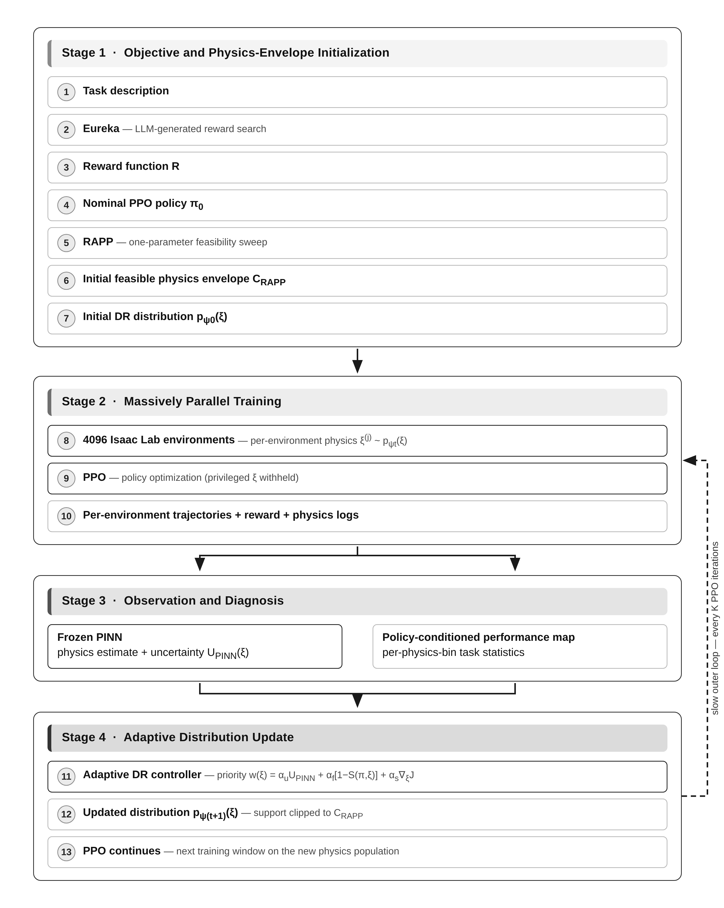
Figure 1. Proposed research architecture: reward discovery and RAPP envelope initialization (Stage 1), massively parallel PPO training (Stage 2), observation by the frozen PINN and the policy-conditioned performance map (Stage 3), and the adaptive DR update that closes the loop (Stage 4).
The roles are intentionally separated: Eureka discovers the objective; RAPP defines an initial feasible physics envelope; the PINN interprets dynamics; adaptive DR changes the future training distribution; PPO changes the policy.
Table 3. Component roles and initial restrictions in the proposed architecture
Component | Role | Initial restriction
Eureka | Reward discovery | Does not modify physics
RAPP | Initial task-aware feasible range | One-parameter search
PINN | Physics observer / uncertainty estimator | Frozen during PPO
Adaptive DR | Update p_ψt(ξ) | Slow outer loop
PPO | Policy optimizer | Does not receive privileged ξ

7. Robot Dynamics: The Physics the PINN Must Understand
A conceptual two-link rigid-body model is:
M(q)q̈ + C(q,q̇)q̇ + g(q) + F(q̇) = τ + d_ext
M is inertia, C captures Coriolis/centrifugal effects, g gravity, F friction/damping, and d_ext external disturbance. Isaac Lab already solves the simulator dynamics. The PINN should not replace Isaac Lab; it should provide a structured estimate of the mismatch between nominal and observed dynamics.

7.1 Residual dynamics
q̈_real = q̈_nominal + Δf_φ(q,q̇,τ)
Residual learning is preferable to asking a network to rediscover all rigid-body mechanics from scratch. The nominal model already supplies strong structure; the learned component focuses on uncertain or unmodeled effects.

7.2 Parameterized dynamics
q̈_hat = M(q;ξ)⁻¹ [τ − C(q,q̇;ξ)q̇ − g(q;ξ) − F(q̇;ξ)]
This formulation makes the connection to DR explicit. The same ξ that defines a simulator environment can be treated as the latent physical quantity the PINN is trying to infer or constrain.

8. PINN Design

8.1 Inputs
z_t = [q_t,q̇_t,τ_t,q̈_t]
For initial training, simulator-provided acceleration is preferable to numerical differentiation because it avoids unnecessary derivative noise. Once the model is stable, a hardware version can be trained from measured histories.

8.2 Outputs
- Option A: point estimate ξ_hat = fφ(D).
- Option B: uncertainty-aware pφ(ξ|D), represented by mean/variance, an ensemble, or another calibrated representation.
Option A should be implemented first. Option B is the stronger final research direction because adaptive DR needs to know not only what the PINN believes but how uncertain it is.

8.3 Candidate physics parameters
ξ = [m₁,m₂,f₁,f₂,b₁,b₂,α₁,α₂]
Start with friction, damping, mass, and actuator effectiveness. Do not randomize link lengths initially. Link-length changes modify kinematics and workspace, which introduces a second source of task-distribution change.

8.4 PINN loss
L_total = λ_data L_data + λ_phys L_phys + λ_reg L_reg
L_data = (1/N) Σ_t ‖q̈_t − q̈_hat,t‖²
r_phys,t = M(q_t;ξ_hat)q̈_t + C(q_t,q̇_t;ξ_hat)q̇_t + g(q_t;ξ_hat) + F(q̇_t;ξ_hat) − τ_t
L_phys = (1/N) Σ_t ‖r_phys,t‖²
L_reg constrains parameters to physically meaningful ranges. For example, masses must remain positive, actuator effectiveness must remain plausible, and friction/damping should not become physically nonsensical.

9. PINN Uncertainty
A point prediction such as friction = 0.55 is not enough. A trajectory with poor excitation may provide little information about friction. The adaptive controller therefore benefits from an uncertainty estimate:
pφ(ξ|D_t) ≈ N(μ_t,Σ_t)
- Deep ensemble: train several PINNs and use prediction variance.
- Probabilistic output head: predict μ and log σ².
- Bootstrap: train models on resampled transition data.
- Monte-Carlo dropout: simple but often less well calibrated.
- Posterior approximation: explicitly model a distribution over physical parameters.
For the first serious implementation, a small ensemble is a practical choice because it is easy to inspect and plot. The ensemble variance can become U_PINN(ξ), the uncertainty term in the adaptive priority function.

10. Per-Environment Domain Randomization in Isaac Lab
The correct training population is 4096 distinct physics instances sharing one policy:
ξ^(1), ξ^(2), ..., ξ^(4096) ~ p_ψt(ξ)
Do not copy one randomized physics configuration to every environment. Scene replication is an efficiency mechanism; it should not be confused with a requirement that all environments remain identical after per-environment randomization.
Represent the randomizable physics explicitly:
physics_params.shape = [num_envs, num_physics_parameters]
For example, with eight parameters the tensor is 4096×8. Row j is the physics vector for environment j.
Table 4. Uncertainty types, examples, and recommended randomization timing
Uncertainty type | Examples | Recommended timing
Static robot parameters | mass, friction, damping | episode reset
Actuator properties | effectiveness, delay | reset or slow update
External disturbance | push torque, force impulse | within episode
Sensor noise | observation noise | per observation
Target | x_t, y_t | episode reset

11. Monitoring 4096 Environments Correctly
The adaptive algorithm needs per-environment records before aggregation. Conceptually:
D_t = {(ξ_j,τ_j,m_j)}_{j=1}^{4096}
m_j = [P5cm,j, P2cm,j, P1cm,j, E_d,j, E_v,j, E_τ,j, T_settle,j, E_PINN,j]
This allows questions such as “which physics conditions cause poor 1 cm precision?” rather than only “what is the average reward?”

11.1 Population statistics
P1cm = (1/4096) Σ_j I(d_j<0.01)
Q50 = median_j(d_j), Q90 = percentile90(d_j)
Use robust population statistics to update DR. Do not let one unstable environment cause a global distribution update.

11.2 Physics-conditioned performance
Bin one parameter, for example friction, and compute:
P(d<1cm | f∈B_k)
This gives a physics-performance map. The map is one of the most valuable diagnostic artifacts in the entire research project.

12. Physics–Performance Map
M : ξ → [P5cm, P2cm, P1cm, E_d, E_v, E_τ, E_PINN]
For two parameters, such as friction and actuator effectiveness, visualize a two-dimensional slice. For more parameters, use one-at-a-time sweeps, pairwise slices, or low-dimensional projections.
S_i ≈ [J(ξ_i+Δ) − J(ξ_i−Δ)]/(2Δ)
A high absolute sensitivity means that parameter deserves finer study. This turns DR design into a measurable scientific object instead of an arbitrary configuration file.

Example
Suppose P1cm is 0.42 when actuator effectiveness α≈0.60 and 0.83 when α≈0.90. The adaptive controller has evidence that low actuator effectiveness is a robustness bottleneck for fine precision. It should allocate more training probability there, provided that region remains inside the physically plausible RAPP envelope.

13. From Binary RAPP to a Continuous Feasible Set
RAPP uses a binary criterion:
F(π,ξ) ∈ {0,1}
For the proposed work, estimate a probability of success:
S(π,ξ) = P(success | π,ξ)
Then define an α-feasible set:
C_α(π) = {ξ : S(π,ξ) ≥ α}
For example, C_0.95 contains physics conditions where the policy succeeds at least 95% of the time. The crucial dynamic object is:
C_t = {ξ : S(π_t,ξ) ≥ α}
As π_t changes, C_t changes. The proposed method is therefore trying to track a moving feasible region.

14. Adaptive DR Distribution

14.1 First implementation: truncated distributions
ξ_i ~ TruncNormal(μ_i,t, σ_i,t²; [l_i^RAPP, h_i^RAPP])
Truncation is important. It prevents the adaptive algorithm from escaping the RAPP envelope while the method is still being validated.

14.2 Simple curriculum
σ_{t+1} = σ_t (1+α) if J_t > J_high
σ_{t+1} = σ_t if J_low ≤ J_t ≤ J_high
σ_{t+1} = σ_t (1−β) if J_t < J_low
This is easy but resembles conventional adaptive DR. It should be treated as an intermediate baseline, not the final novelty claim.

14.3 Physics + policy difficulty score
w(ξ) = α_u U_PINN(ξ) + α_f [1−S(π,ξ)] + α_s ‖∇_ξJ(π,ξ)‖
- U_PINN(ξ): uncertainty in the physics model.
- 1−S(π,ξ): policy weakness at that physics condition.
- ‖∇ξJ‖: sensitivity of task performance to the physics parameter.
p_adaptive(ξ) ∝ p_base(ξ) · w(ξ)
This is the stronger conceptual target: simulation budget is concentrated on physically credible regions that are uncertain, difficult, or highly sensitive.

15. Formal Adaptive-DR Objective
A compact mathematical specification is:
max_ψ J_task(ψ) + λ_H H[p_ψ] − λ_E E_PINN[p_ψ]
subject to:
J_task(ψ) ≥ J_min
support(p_ψ) ⊆ C_RAPP
J_task rewards performance, entropy preserves diversity, and the physics term prevents drift into implausible regions. The implementation does not need to solve this objective with a full differentiable optimizer; weighted resampling or parameter updates are acceptable as long as the update rule is explicit and reproducible.
H(N(μ,Σ)) = 0.5 log[(2πe)^d ‖Σ‖]

16. Why the PINN Should Be Frozen First
The first main experiment should use a pretrained, frozen PINN. Online PINN training should be a later ablation. If the PINN, PPO policy, and DR distribution all change simultaneously, it becomes difficult to determine which component caused improvement.
Table 5. PINN usage variants across the experimental matrix
Variant | PINN | Purpose
G | Frozen after pretraining | Main proposed method
H | Online update | Later extension
A–F | Absent | Ablations
The frozen model also provides a stable measurement instrument. If its predictions are changing during the experiment, the adaptive DR controller cannot tell whether the world changed or the observer changed.

17. PINN Dataset Design
The PINN should be trained on a dedicated dynamics dataset, not only on one PPO policy's narrow state distribution.
- Sample physics vectors from a controlled broad distribution.
- Generate trajectories using scripted excitation, random torque excitation, and multiple policy behaviors.
- Record q, q̇, τ, and q̈ at high frequency.
- Split validation by physics configuration, not merely by random time samples.
- Measure acceleration prediction error and recovered-parameter error.
- Test interpolation and extrapolation separately.
The split must prevent leakage. If random time points from the same physics configuration appear in both training and validation, the PINN may appear to generalize while merely memorizing that configuration.

18. Exact PPO / Adaptive-DR Loop
- Initialize πθ from the same baseline procedure.
- Compute C_RAPP using the nominal policy and one-parameter sweeps.
- Initialize pψ0 inside C_RAPP.
- At reset, sample a separate ξ(j) for each environment j.
- Run PPO normally; do not provide ξ(j) to the policy in the main experiment.
- Log per-environment physics, reward components, distance, precision, velocity, and effort.
- Every K PPO iterations, estimate physics prediction/uncertainty using the frozen PINN.
- Estimate policy performance conditioned on physics bins or local neighborhoods.
- Compute w(ξ).
- Update pψt to pψt+1.
- Clip/truncate the new distribution to C_RAPP.
- Continue PPO.
- At evaluation checkpoints, freeze the policy and test on nominal, training, shifted, and boundary distributions.
Do not update DR every simulator step. PPO benefits from a relatively stationary data distribution. The DR controller should operate on a much slower outer loop.
Table 6. Loop timing: processes and initial recommendations
Process | Initial recommendation
Physics | 120 Hz
Policy | 30 Hz
Episode | 10 s
PINN inference | slow outer window
DR update | every 25–100 PPO iterations as a starting sweep
Shifted evaluation | major checkpoints

19. Pseudocode
RAPP-Initialized Physics-Informed Adaptive Domain Randomization
Input: simulator S, initial policy π0, search sets R, frozen PINN fφ,
initial distribution pψ0, adaptation interval K

1. Train/load π0 on nominal physics.
2. For each parameter p:
For each candidate r in R[p]:
set p = r; keep all other physics nominal
roll out π0 multiple times
estimate success probability S(π0, r)
record feasible lower/upper bounds
3. Build C_RAPP = product of all parameter intervals.
4. Initialize pψ0 with support inside C_RAPP.
5. For PPO iteration t:
sample ξ(j) ~ pψt for j = 1..4096
apply ξ(j) to environment j
collect trajectories and update πθ
log per-env physics + task metrics
if t mod K == 0:
run frozen PINN inference
estimate U_PINN and physics consistency
estimate S(πθ, ξ)
compute w(ξ)
update pψt → pψt+1
clip support to C_RAPP
6. Evaluate on unseen physics distributions.
7. Compare all baselines across seeds.

20. Experimental Matrix
Table 7. Experimental matrix: variants A–H
ID | Reward | DR | PINN | Purpose
A | Human | None | None | Existing precision baseline
B | Eureka | None | None | Existing reward baseline
C | Human | Static DR | None | Robustness independent of Eureka
D | Eureka | RAPP + static DR | None | DrEureka-style baseline
E | Eureka | Adaptive DR | None | Generic adaptation baseline
F | Eureka | RAPP + Adaptive DR | None | RAPP contribution
G | Eureka | RAPP + PINN-Adaptive DR | Frozen | Main proposed method
H | Eureka | RAPP + PINN-Adaptive DR | Online | Future extension

20.1 The most important comparison
D versus G is the central comparison. Both use the same Eureka reward. D represents a static RAPP-derived DR approach; G adds physics-informed adaptation during PPO. If G consistently improves unseen-physics robustness and fine precision across seeds, the causal story is much cleaner than comparing unrelated reward functions.

21. Evaluation Protocol

21.1 Precision curve
P(d<ε), ε ∈ {5 cm, 2 cm, 1 cm, 5 mm, 2 mm, 1 mm}
The existing study proves why this is necessary: two policies can have almost identical 5 cm success while being dramatically different at 1 cm.

21.2 Dynamic and effort metrics
- Mean/median terminal error.
- Settling time.
- Maximum joint velocity.
- Mean and peak torque.
- Overshoot and oscillation.
- Accumulated squared torque/action.
- Failure rate by physics bin.
- Training iterations and wall-clock time.

21.3 Robustness metrics
- Training-distribution performance.
- Unseen shifted-distribution performance.
- RAPP lower and upper boundary performance.
- Worst-decile performance.
- Seed-to-seed variance.
- Performance under correlated parameter shifts.

22. Distribution-Shift Tests
The strongest test is not “does the policy work on the distribution it was trained on?” but “does it work on a distribution it did not see?”
Train: f ~ U(0.30,0.70)
Test: f ~ U(0.20,0.80)
A stronger test uses correlations. If training samples friction and actuator effectiveness independently but the real system exhibits correlated changes, then:
p_test(f,α) ≠ p_train(f,α)
This tests whether the policy has learned robust behavior rather than memorizing independent marginal variations.

23. What Not to Do
- Do not combine online PINN learning, adaptive DR, reward rewriting, and privileged policy conditioning in the first experiment.
- Do not randomize every simulator parameter simultaneously at the beginning.
- Do not randomize static physical parameters every policy step.
- Do not use one shared randomized physics vector for all 4096 environments.
- Do not use only average reward as the adaptation signal.
- Do not compare raw return across differently scaled rewards.
- Do not claim sim-to-real success without real-hardware validation.
- Do not call the method PINN-based DrEureka unless the algorithm clearly changes the DrEureka pipeline.
- Do not feed PINN estimates into the policy in the main experiment.
- Do not let adaptive DR escape the RAPP envelope in the first version.

24. Coding Roadmap

Phase 0 — freeze the baseline
- Archive the exact environment configuration.
- Archive the exact reward and PPO configuration.
- Save a final checkpoint.
- Record seeds and evaluation scripts.
- Verify observation/action validation logic.

Phase 1 — static DR
- Create physics_params [4096,N].
- Implement friction randomization at reset.
- Verify per-environment values.
- Implement actuator effectiveness.
- Log environment ID + physics vector + outcome.
- Run fixed-policy sweeps.

Phase 2 — RAPP
- Train the no-DR policy.
- Choose a success criterion.
- Sweep one parameter at a time.
- Use repeated rollouts.
- Estimate lower/upper feasible bounds.
- Store the RAPP envelope in JSON/YAML.

Phase 3 — PINN
- Generate a dedicated dynamics dataset.
- Train residual/parameter model.
- Validate on unseen configurations.
- Measure prediction and parameter error.
- Add ensemble uncertainty.

Phase 4 — adaptive DR
- Implement simple variance curriculum.
- Implement physics-conditioned performance bins.
- Add PINN uncertainty.
- Implement combined priority score.
- Add RAPP support constraints.

Phase 5 — paper experiments
- Run A–G across seeds.
- Evaluate shifted distributions.
- Produce physics-performance maps.
- Produce precision curves.
- Run statistical tests.
- Prepare hardware transfer only after simulation evidence.

25. Debugging and Verification
Table 8. Debugging and verification tests
Test | Expected result
Sample 4096 friction values | Empirical distribution matches requested p(f)
Inspect first 20 envs | Physics values differ
Fixed policy, varied friction | Trajectory statistics change
RAPP sweep | Success changes systematically
PINN validation | Low error on unseen configurations
Adaptive update | Distribution changes only at scheduled updates
RAPP clipping | No sample leaves allowed bounds
The most dangerous implementation failure is a silent randomizer that does not actually modify the simulator. Every randomizer must have a unit test or diagnostic experiment before it is used in a publication run.

25.1 Required logging schema
{
"iteration": int,
"env_id": int,
"physics": {"mass_1": float, "mass_2": float,
"friction_1": float, "friction_2": float,
"damping_1": float, "damping_2": float,
"actuator_eff_1": float, "actuator_eff_2": float},
"task": {"terminal_distance": float,
"success_5cm": bool, "success_2cm": bool,
"success_1cm": bool},
"dynamics": {"mean_velocity": float,
"max_velocity": float, "effort": float},
"pinn": {"prediction_error": float, "uncertainty": float},
"dr": {"mean": [...], "std": [...], "priority": float}
}

26. Publication and Novelty Positioning
The broad ingredients are not individually new. Adaptive domain randomization is established; Bayesian simulator-parameter inference is established; RAPP/DrEureka is established; physics-informed robot dynamics models are established; and recent work has explicitly explored physics-informed dynamics randomization. Therefore the paper cannot claim novelty merely from “PINN + DR + RL.”
The intended algorithmic contribution is narrower: use RAPP as a task-aware initialization, use a physics-informed model as a structured observer of simulator/robot dynamics, and adapt the DR distribution during PPO according to both physical uncertainty and policy-conditioned difficulty.
RAPP initialization → frozen physics inference → policy-conditioned adaptive DR
Candidate contribution statement: “We propose a RAPP-initialized physics-informed adaptive domain-randomization framework that updates simulator-parameter distributions during RL using learned dynamics uncertainty and policy-conditioned performance while constraining adaptation to a task-feasible physics envelope.”

26.1 Existing literature that must be distinguished
Table 9. Existing literature directions and the required distinctions
Direction | What is already established | Required distinction
Adaptive DR | Distributions can be tuned during training | Our update also uses physics-informed uncertainty and RAPP feasibility
BayesSim | Probabilistic inference over simulator parameters | Our PINN is structured by robot dynamics and embedded in reward-aware adaptive DR
DrEureka/RAPP | Reward-aware feasible ranges + LLM DR | We evolve the prior during PPO instead of stopping at static DR
Physics-informed DR | Physical knowledge can improve randomization | We make the physics prior adaptive and policy-conditioned
Context-conditioned policies | Dynamics context can help transfer | Main policy remains context-free; inferred physics controls the training distribution
The literature search must be refreshed immediately before submission because this area is moving quickly.

27. Current Literature Signals
BayesSim demonstrates probabilistic simulator-parameter inference for adaptive domain randomization. “Understanding Domain Randomization for Sim-to-Real Transfer” provides a theoretical view of DR as learning over a family of MDPs. A 2026 IEEE Access paper, “Sim-to-Real Transfer of Learning-Based Control for a Flexible-Wheeled Balancing Robot via Physics-Informed Dynamics Randomization,” demonstrates that physics-informed actuator characteristics can already be used to construct more realistic dynamics randomization. Phys2Real (ICRA 2026) further shows that online adaptation and physics-context estimation are active directions in manipulation.
Web research consulted for this roadmap: BayesSim (arXiv:1906.01728); Understanding Domain Randomization for Sim-to-Real Transfer (arXiv:2110.03239); Yoon & Cho, IEEE Access 2026, DOI 10.1109/ACCESS.2026.3705484; Phys2Real, ICRA 2026.
The practical consequence is positive but demanding: the project has a defensible research direction only if the adaptive update rule and its RAPP/PINN integration are made explicit and demonstrated through strong ablations.

28. Research Hypotheses
Table 10. Research hypotheses H1–H7
ID | Hypothesis
H1 | Static DR improves robustness to unseen dynamics relative to no DR.
H2 | RAPP-constrained DR is easier to train than unconstrained broad DR.
H3 | Adaptive DR improves shifted-distribution performance without simply widening the training range.
H4 | PINN-informed adaptation finds physically plausible but policy-challenging regions better than reward-only adaptation.
H5 | RAPP + PINN-Adaptive DR preserves fine precision better than static RAPP DR under dynamics uncertainty.
H6 | Benefits are strongest for parameters with high policy-performance sensitivity.
H7 | A frozen PINN gives a cleaner and more reproducible first-stage contribution than online PINN learning.

29. What Would Count as a Strong Result?
- The proposed method preserves high 5 cm success while improving 2 cm and 1 cm success under randomized dynamics.
- It outperforms static RAPP DR on an unseen shifted distribution.
- Physics-performance maps show adaptive sampling concentrated in difficult but learnable regions.
- PINN uncertainty correlates with actual model mismatch or prediction error.
- Removing the PINN reduces robustness and removing adaptation reduces robustness.
- The effect survives multiple seeds.
- PINN inference and adaptive updates are computationally cheap enough to leave PPO training practical.
A negative result is also scientifically useful if it explains why the PINN does not improve DR—for example, if the learned dynamics representation cannot identify the parameters that actually affect task performance, or if RAPP already covers a region in which policy performance is nearly flat.

30. Sim-to-Real Strategy
Hardware should be the final validation layer, not the first debugging layer. Before hardware, demonstrate robustness to simulator shifts.
Table 11. Sim-to-real validation stages
Stage | Question
Nominal simulation | Does the controller solve the task?
Training DR | Does it learn under uncertainty?
Unseen simulation | Does it generalize beyond the training distribution?
Boundary tests | Does it remain stable near feasible extremes?
System identification | What parameter region does the real arm occupy?
Hardware transfer | Does the learned controller transfer without retraining?
If real data are used, report exactly how much data and what it was used for. Distinguish zero-shot sim-to-real from calibrated transfer.

31. Final Mathematical Summary
s_t = [q_t, q̇_t, p_t, p_t−p_ee,t]
a_t ~ πθ(a|s_t)
τ_t = 20·clip(a_t, −1, 1)
M(q)q̈ + C(q,q̇)q̇ + g(q) + F(q̇) = τ + d_ext
ξ = [m₁, m₂, f₁, f₂, b₁, b₂, α₁, α₂, ...]
ξ ~ p_ψt(ξ)
C_RAPP = Π_i [l_i^RAPP, h_i^RAPP]
C_α(π_t) = {ξ : P(success|π_t,ξ) ≥ α}
r_phys = M(q;ξ̂)q̈ + C(q,q̇;ξ̂)q̇ + g(q;ξ̂) + F(q̇;ξ̂) − τ
w(ξ) = α_u U_PINN(ξ) + α_f [1−S(π,ξ)] + α_s ‖∇_ξJ(π,ξ)‖
p_adaptive(ξ) ∝ p_base(ξ) w(ξ), support(p_adaptive) ⊆ C_RAPP
max_ψ E_{ξ~pψ}[J(π,ξ)] + λ_H H[pψ] − λ_E E_PINN[pψ]
Read these equations as one causal chain: the physics vector defines the simulator; the simulator generates trajectories; trajectories determine task performance; the PINN interprets dynamics; performance plus physics evidence update the DR distribution; the new distribution creates the next population of simulators; PPO then learns on that population.

32. Immediate Checklist
- Freeze the current 2-DOF environment and PPO baseline.
- Implement physics_params with shape [4096,N].
- Implement friction randomization only.
- Verify all 4096 environments receive distinct values.
- Run a fixed-policy friction sweep and plot terminal error versus friction.
- Add actuator effectiveness randomization.
- Reproduce RAPP one parameter at a time.
- Store RAPP bounds in JSON/YAML.
- Do not build the adaptive controller yet.
- Train the standalone PINN on a dedicated dynamics dataset.
- Validate the PINN on unseen physics combinations.
- Add uncertainty via a small ensemble.
- Connect PINN inference to the slow outer loop.
- Run generic adaptive DR before PINN-adaptive DR.
- Run the full A–G ablation matrix.
- Evaluate on shifted and boundary distributions.
- Only then plan hardware experiments.

33. Final Research Decision
Keep RAPP. Do not remove it. Treat it as the initial task-aware physics prior. The proposed research contribution is the evolution of that static prior into an adaptive, physics-informed distribution.
Eureka = reward discovery
RAPP = initial task-aware physics feasibility
PINN = physics observer / uncertainty estimator
Adaptive DR = evolving simulator distribution
PPO = policy optimizer
The final loop is:
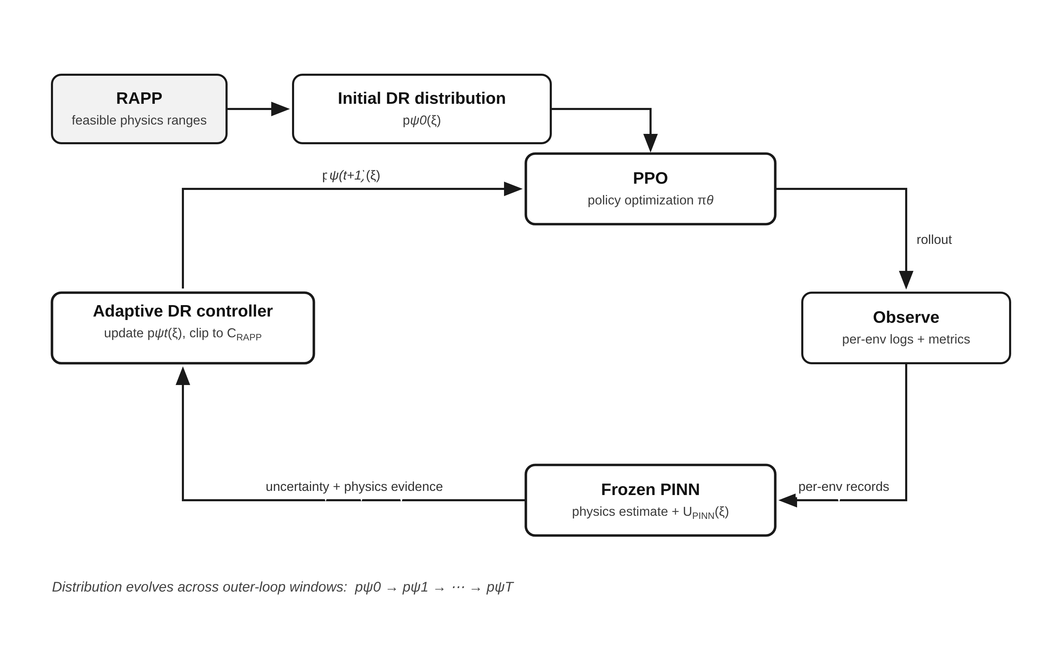
Figure 2. The final adaptive loop: RAPP initializes p_ψ0; each outer-loop window observes per-environment behavior, infers physics with the frozen PINN, adapts the DR distribution inside C_RAPP, and returns the updated distribution to PPO — evolving p_ψ0 through p_ψT.
If this system demonstrates statistically significant improvement over static RAPP/DrEureka and conventional adaptive DR on unseen physics while preserving fine precision, it becomes a credible candidate for a separate research paper. The novelty claim must still be verified against the most recent literature immediately before submission.

34. References and Source Basis
- Supplied source: 2-DOF Robotic Arm Technical Review.pdf — completed environment, PPO configuration, rewards, evaluation, and project conclusions.
- Supplied source: 2DOF_Robotic_Arm_Complete_Technical_Report.pdf — compiled technical baseline and previous project synthesis.
- Supplied source: DrEureka.pdf — RAPP definition, one-parameter feasibility search, and LLM-generated DR configuration procedure.
- Ramos, F., Possas, R. C., & Fox, D. (2019). BayesSim: adaptive domain randomization via probabilistic inference for robotics simulators. arXiv:1906.01728.
- Chen, X., Hu, J., Jin, C., Li, L., & Wang, L. (2021). Understanding Domain Randomization for Sim-to-Real Transfer. arXiv:2110.03239.
- Yoon, C.-Y. & Cho, B.-K. (2026). Sim-to-Real Transfer of Learning-Based Control for a Flexible-Wheeled Balancing Robot via Physics-Informed Dynamics Randomization. IEEE Access. DOI: 10.1109/ACCESS.2026.3705484.
- Wang, M. et al. (2026). Phys2Real: Fusing VLM Priors with Interactive Online Adaptation for Uncertainty-Aware Sim-to-Real Manipulation. ICRA 2026.
- NVIDIA Isaac Lab documentation and examples on simulation-to-real transfer and event-based domain randomization were consulted as implementation context.

Appendix A — Interpretation Examples

Policy strong everywhere
If P1cm remains above 95% throughout the RAPP envelope, aggressive adaptation is unnecessary. Maintain broad coverage and diversity.

Policy fails at high friction
Increase training density near the high-friction region, provided it is physically plausible and inside RAPP.

PINN uncertain but policy robust
Do not automatically oversample. Uncertainty is a signal to investigate, not a command to make the simulator harder.

PINN predicts impossible parameters
Block the adaptive update and inspect the PINN. A bad physics observer must never control the simulator distribution.

Distribution collapses
Increase entropy/minimum-variance constraints. Robustness requires coverage, not optimization of one easy configuration.

Appendix B — Researcher Mental Model
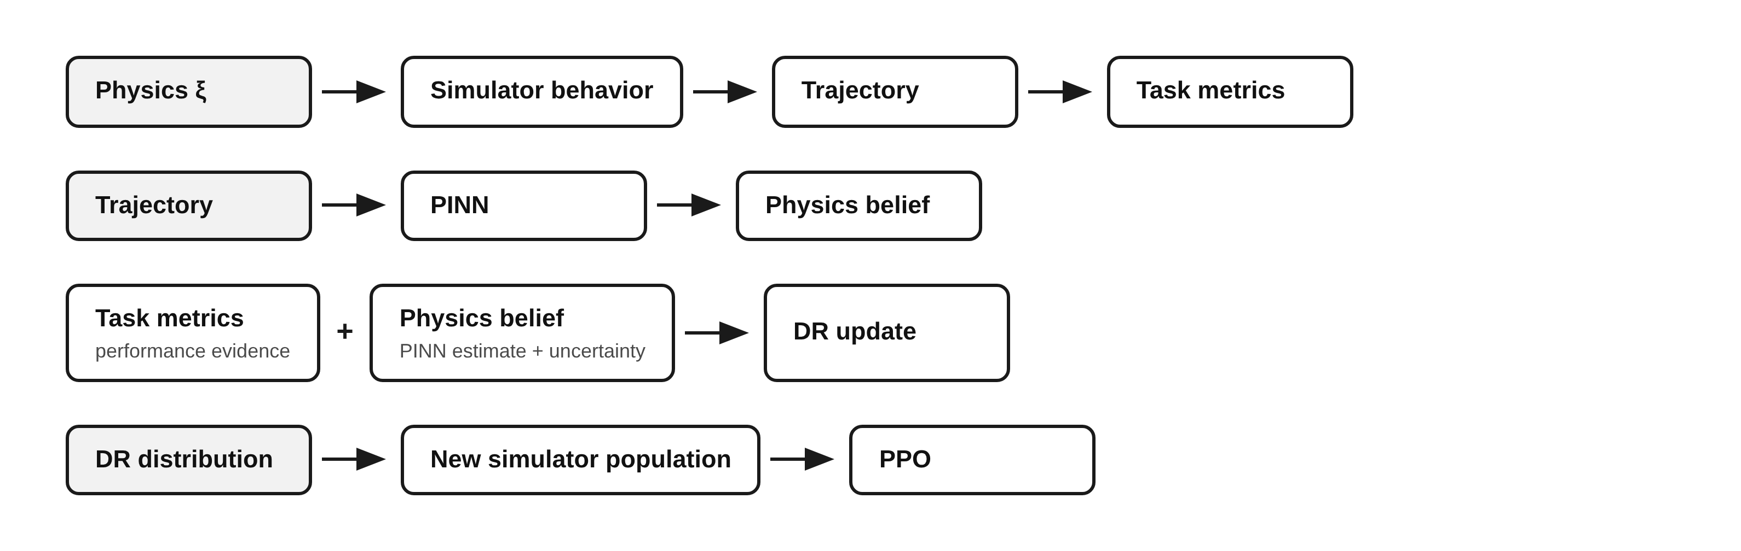
Figure 3. Researcher mental model: every component of the project maps to one arrow of the causal chain from physics to policy training.
If a piece of code cannot be mapped to one of these arrows, ask why it exists. This discipline keeps the project interpretable.

Closing Perspective
The project has reached the point where another isolated PPO run is less valuable than a controlled robustness framework. The existing experiments already show that reward design changes behavior. The next scientific question is whether automated reward discovery can remain effective when the simulator itself is uncertain and evolving as a training population.
RAPP provides the principled starting point. The PINN supplies structured physics information. Adaptive DR changes where simulation experience is spent. PPO remains the policy optimizer. The research will become strong only if each contribution is isolated, mathematically specified, tested through ablations, and evaluated on unseen dynamics.
Immediate next action: per-environment static DR → RAPP reproduction → standalone PINN validation → adaptive DR.

