SUMMER TRAINING/INTERNSHIP REPORT (Term Aug-Dec 2026)

SOCRATES RESEARCH ENGINE: AUTONOMOUS QUANTITATIVE RESEARCH TERMINAL

Submitted by
Amartya Sen Registration Number: 12417174

School of Computer Science and Engineering



DECLARATION
I hereby declare that the summer training report on “Socrates Research Engine: Autonomous Quantitative Research Terminal” is an authentic record of my own work as requirements for the Summer Training/Internship during the period from 11/06/2026 to 21/07/2026 for the award of degree of B.Tech in Computer Science and Engineering (AI & ML), under the guidance of Rohit Bharti.

Amartya Sen 15/07/2026

Signature: 

CERTIFICATE
This is to certify that the summer training report titled “Socrates Research Engine: Autonomous Quantitative Research Terminal” submitted by Amartya Sen (Registration Number: 12417174) is a bonafide record of the work carried out by him under my supervision and guidance.
Rohit Bharti

ACKNOWLEDGEMENT
I would like to express my profound gratitude to Lovely Professional University for providing me with the opportunity to undertake my summer internship. I extend my deepest appreciation to my industry mentor, Rohit Bharti, for their continuous support, technical insights, and guidance throughout the development of the Socrates Research Engine.
Amartya Sen Signature:

TABLE OF CONTENTS

- INTRODUCTION OF ORGANIZATION

- SUMMER TRAINING COURSE/INTERNSHIP CONTENT DETAIL

- SUMMER TRAINING/ INTERNSHIP PROJECT DETAIL

- PROBLEM STATEMENT

- PROJECT OUTCOMES

- TECHNOLOGIES USED

- SOURCE CODE OR SYSTEM SNAPSHOTS

- BIBLIOGRAPHY

INTRODUCTION OF ORGANIZATION

Lovely Professional University (LPU) is a premier academic institution in India, widely recognized for its expansive technological infrastructure and commitment to fostering innovation and research. The university’s overarching mission is to transform education through academic rigor, practical exposure, and global standards, ultimately developing highly skilled professionals equipped to solve complex, real-world challenges. With a strong emphasis on industry-academia alignment, LPU provides a dynamic ecosystem that encourages students to push the boundaries of modern technology.
Within this academic framework, the School of Computer Science and Engineering focuses on equipping students with cutting-edge technical proficiencies. It was under this department that I undertook an intensive two-month Summer Training and Internship program. Designed to bridge the gap between foundational theory and applied industry practices, this internship provided an immersive environment tailored for computer science students specializing in Artificial Intelligence and Machine Learning. The program operated as a dedicated technical lab, emphasizing hands-on development and practical problem-solving.
During this tenure, I was assigned to a specialized AI training cohort under the direct mentorship of Mr. Rohit Bharti. The core domain of our work revolved around advanced Artificial Intelligence frameworks and modern generative technologies. Specifically, our practical implementations focused heavily on the architecture and application of Large Language Models (LLMs), Retrieval-Augmented Generation (RAG) pipelines, and Agentic AI systems. By working extensively with modern API integrations and intelligent autonomous agents, this training provided critical, hands-on experience in building and deploying responsive, AI-driven applications.

2. SUMMER TRAINING COURSE/INTERNSHIP CONTENT DETAIL
During the internship period, the core focus was on the intersection of Quantitative Finance, Large Language Models (LLMs), and highly resilient Systems Engineering. The training encompassed:
- Market Microstructure & Security Layers: Understanding the complexities of financial data ingestion, rate-limiting, and Web Application Firewalls (WAFs). Training involved orchestrating multiple institutional APIs (Alpaca, FMP, Finnhub, Polygon) to bypass cloud-server IP bans.
- Retrieval-Augmented Generation (RAG): Training on semantic slicing of massive unstructured datasets (SEC 10-K and 20-F filings) and utilizing enterprise-grade embedding models (Cohere) and vector databases to provide contextual memory to LLMs.
- Resilient Systems Architecture: Learning to design asynchronous FastAPI backends and non-blocking React frontends that can handle heavy background vectorization processes without UI race conditions or HTTP timeouts.

3. SUMMER TRAINING/ INTERNSHIP PROJECT DETAIL
PROBLEM STATEMENT Modern retail quantitative trading and research systems suffer from critical infrastructural flaws:
- API Brittleness: Cloud-deployed servers are frequently IP-banned by major financial data providers via strict Web Application Firewalls, leading to fatal data pipeline crashes.
- Synthetic Valuation Errors: Calculating live market capitalizations using delayed SEC share counts results in mathematically flawed valuations due to unrecorded share dilution or buybacks.
- UX Race Conditions & Timeouts: Deep RAG vectorization of 200+ page financial documents causes synchronous frontend applications to freeze, drop network connections, or crash due to server-side HTTP 504 timeouts.
PROJECT OUTCOMES To resolve these institutional challenges, the Socrates Research Engine was engineered. It is a fully autonomous, production-ready data engineering and AI inference pipeline. The key outcomes include:
- 5-Layer “Fail-Fast” Valuation Cascade: A self-healing backend infrastructure designed to guarantee a 100% success rate for structural valuation metrics by cascading through multiple security layers:
- Layer A (The “True Engineer” Approach): Pulls live broker pricing via the Alpaca Trade API SDK and multiplies it by the official SEC EDGAR SharesOutstanding XBRL tag.
- Layer B (Primary Authenticated Fallback): Utilizes Financial Modeling Prep (FMP) and Finnhub for live Market Cap, P/E, and EPS.
- Layer C (Emergency Gateway): Cascades to Polygon.io as an emergency authenticated fallback.
- Layer D (Mathematical Derivation): Reconstructs missing metrics mathematically via historical share floats.
- Strict Fail-Fast Logic: The system instantly aborts if an API explicitly returns a $0.00 price (e.g., Finnhub c=0), identifying fake tickers to protect API limit burn.
- Deep SEC RAG Vectorization Engine: An automated, non-blocking pipeline that downloads and chunks massive 10-K filings using LangChain’s RecursiveCharacterTextSplitter. It utilizes the Cohere API (embed-english-v3.0) to generate high-quality dense vectors, inserting them directly into a Supabase pgvector database via asynchronous FastAPI BackgroundTasks.
- Advanced NLP Ensemble: The system leverages the Groq API (Llama-3.3-70b-versatile) for blazing-fast inference. It processes semantic vector queries (Risks, Growth, Financials) alongside live institutional news streams from Alpaca/Benzinga to synthesize a holistic, conflict-free trading thesis.
- Immortal Terminal UI: A Next.js frontend built on a 12-column CSS grid featuring a persistent telemetry terminal. It uses functional React state updates and interval polling to stream execution logs dynamically without unmounting during heavy LLM inference.
TECHNOLOGIES USED
- Framework & Server: FastAPI (0.111.0), Uvicorn (0.30.1), Pydantic (2.13.3).
- Frontend: Next.js 14, React 18, Tailwind CSS, TypeScript.
- AI & Vectorization: Groq API (Llama-3.3-70B), Cohere API (Embeddings), LangChain (langchain-text-splitters).
- Database & Cloud: Supabase (PostgreSQL + pgvector extension).
- Market Data & Scraping: Alpaca Trade API, SEC EDGAR (sec-edgar-downloader), Financial Modeling Prep (FMP), Finnhub, Polygon.io, yfinance.

4. SOURCE CODE OR SYSTEM SNAPSHOTS
System Snapshot: Supabase PostgreSQL Database Cache The following snapshot illustrates the soc_company_fundamentals table, demonstrating the successful ingestion and caching of live market valuations, EPS, Revenue, and Debt across multiple institutional assets (e.g., NVDA, MSFT, AAPL, AMZN) via the 5-layer fail-fast cascade.

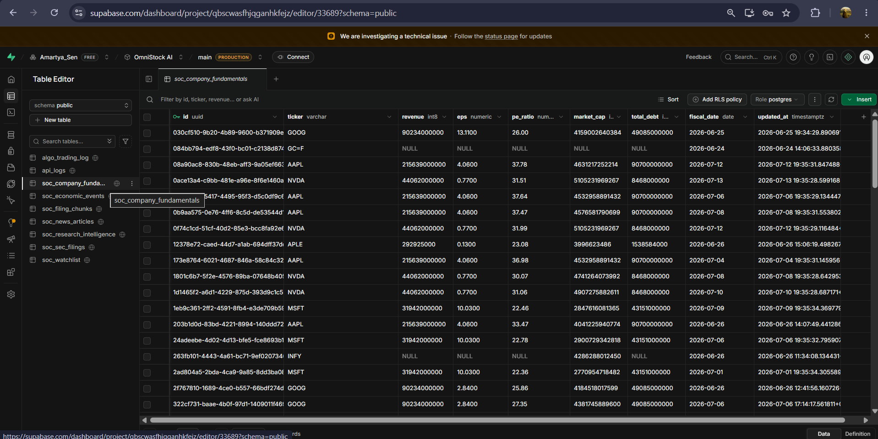
Figure 1: Socrates Database Cache containing global equity fundamentals.

Source Code: Fail-Fast Security Layer (Finnhub API Integration) This snippet demonstrates the defensive programming architecture used within Layer B of the Valuation Cascade to prevent API rate-limit burn when intercepting invalid entities.
# --- LAYER B: FINNHUB AUTHENTICATED FALLBACK ---
if market_cap is None or current_price is None:
log_update(ticker_upper, "FMP unavailable. Switching to Finnhub Gateway...")
try:
if current_price is None:
quote_res = requests.get(f"https://finnhub.io/api/v1/quote?symbol={ticker_upper}&token={api_key}", timeout=5)
if quote_res.status_code == 200:
q_data = quote_res.json()
# FAIL FAST: Finnhub returns c=0 for completely fake tickers
if q_data.get('c') == 0 and q_data.get('d') is None:
raise ValueError(f"Target explicitly rejected as invalid by Finnhub.")
if q_data.get('c') is not None:
current_price = float(q_data['c'])
except ValueError as ve:
raise ve # Halts cascade immediately to preserve API limits

BIBLIOGRAPHY

- Alpaca Securities LLC. (2024). Alpaca Trading API Documentation. Retrieved from https://alpaca.markets/docs/
- Cohere Inc. (2024). Cohere Embed API Reference. Retrieved from https://docs.cohere.com/docs/embeddings
- FastAPI Documentation. (2024). FastAPI: High performance, easy to learn, fast to code, ready for production. Retrieved from https://fastapi.tiangolo.com/
- Financial Modeling Prep. (2024). FMP API Documentation. Retrieved from https://site.financialmodelingprep.com/developer/docs
- Finnhub. (2024). Finnhub Stock API. Retrieved from https://finnhub.io/docs/api
- Groq Inc. (2024). Llama 3 on Groq LPU Inference Engine. Retrieved from https://console.groq.com/docs/quickstart
- Polygon.io. (2024). Polygon Market Data APIs. Retrieved from https://polygon.io/docs/stocks/getting-started
- Supabase. (2024). pgvector: Vector columns for PostgreSQL. Retrieved from https://supabase.com/docs/guides/database/extensions/pgvector
- U.S. Securities and Exchange Commission. (2024). EDGAR Application Programming Interfaces. Retrieved from https://www.sec.gov/edgar/sec-api-documentation

