E. Machine Learning — Model Results & Comparison
This section reports the final performance of the Trashium pricing models, compares the candidate algorithms, and justifies the model chosen for production. All numbers below are measured on a held-out future test set of 14,600 records (an 80/20 chronological split of 73,100 rows: train on the past, test on the future), so they reflect genuine forecasting performance rather than memorisation.

1. What the model predicts (and why the metric set differs)
Trashium's pricing model solves a regression problem: it predicts a continuous quantity — the scrap market value in ₹ per kg — which ranges from about ₹8/kg (cardboard) to ₹1,200/kg (catalytic converters). It does not sort records into a fixed set of classes.
Accuracy, Precision, Recall, F1 and a Confusion Matrix are classification metrics: they require discrete class labels and count exact right/wrong matches. They do not natively apply to a continuous price — a predicted ₹49.90 against an actual ₹50.00 is neither strictly “correct” nor a meaningful “misclassification.” The correct evaluation metrics for regression are therefore:
- MAE — Mean Absolute Error (average ₹ error, same units as price).
- RMSE — Root Mean Squared Error (penalises large misses more heavily).
- R² — proportion of price variance the model explains (1.0 = perfect).
- MAPE — Mean Absolute Percentage Error, the selection metric, because a fair payout is about getting the price right in percentage terms across a 150× price range.
To also give the familiar classification view your review asked for, we add two bridges (Section 3): an accuracy-within-tolerance score, and a price-band confusion matrix that buckets prices into four bands and reports Accuracy / Precision / Recall / F1 on those bands.

2. Model Results — regression metrics
Three models were trained on identical price-setting features (material, region, market demand, quality-defect risk and calendar features), all predicting log-market-value so percentage effects are modelled correctly and every prediction stays positive.
Model | MAE (₹/kg) | RMSE (₹/kg) | R² | MAPE
Linear Regression — PRODUCTION | 5.87 | 9.73 | 0.9988 | 6.11%
Random Forest (400 trees) — challenger | 12.93 | 24.40 | 0.9923 | 9.72%
Moving-Average baseline | 9.79 | 20.27 | 0.9947 | 8.21%
Table 1. Regression performance on the 14,600-row future test set. Lower MAE/RMSE/MAPE is better; higher R² is better. Linear Regression wins on every error metric.
Linear Regression is the strongest model on every metric: it is ₹7/kg more accurate than the Random Forest on average (MAE) and roughly 37% lower MAPE (6.11% vs 9.72%). An R² of 0.9988 means it explains 99.88% of the price variation on unseen future data.

3. Classification-style view (tolerance accuracy + confusion matrix)

3.1 Accuracy within a price tolerance
Here a prediction counts as “correct” if it lands within ±5%, ±10% or ±15% of the true price — the regression analogue of accuracy.
Model | Within ±5% | Within ±10% | Within ±15%
Linear Regression | 52.1% | 78.7% | 93.1%
Random Forest (400) | 29.3% | 60.8% | 79.0%
Moving-Average baseline | 40.0% | 67.4% | 84.2%
Table 2. Share of test predictions falling within each price tolerance. Linear Regression is correct within ±10% for 79% of pickups and within ±15% for 93%.

3.2 Price-band confusion matrix (Accuracy / Precision / Recall / F1)
To produce a true confusion matrix, continuous prices are bucketed into four business bands using training-set quartiles: Budget (< ₹28.85/kg), Standard (₹28.85–65.27), Valuable (₹65.27–135.89) and Premium (> ₹135.89). The model's predicted price is assigned to a band and compared with the true band.
Price band (LR) | Precision | Recall | F1 | Support
Budget | 0.961 | 0.973 | 0.967 | 3,627
Standard | 0.829 | 0.778 | 0.803 | 3,448
Valuable | 0.784 | 0.860 | 0.820 | 3,740
Premium | 0.981 | 0.929 | 0.954 | 3,785
Overall accuracy = 88.7% · Macro-F1 = 0.886
Table 3. Linear-Regression classification metrics on the four price bands. Overall band accuracy 88.7%; the Random Forest scores 85.9% accuracy / 0.861 macro-F1 on the same bands.
Almost all confusion is between adjacent bands (e.g. Standard vs Valuable near the ₹65 boundary); the model never confuses Budget with Premium — exactly the behaviour a pricing engine needs.
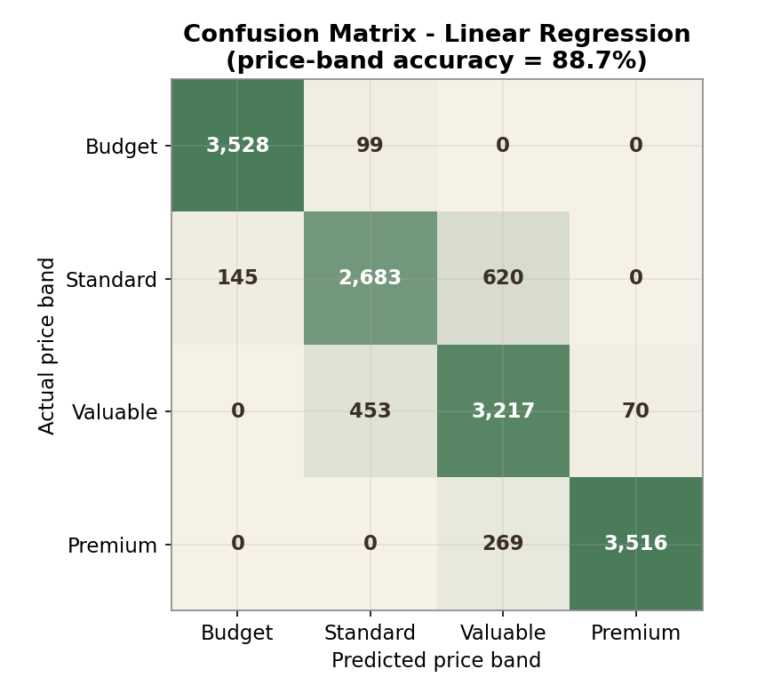
Figure 1. Confusion matrix (Linear Regression). Strong diagonal; errors only spill into neighbouring price bands.

4. Comparison Graphs
The charts below compare the models on the selection metric, the full error profile, explained variance, and tolerance accuracy.
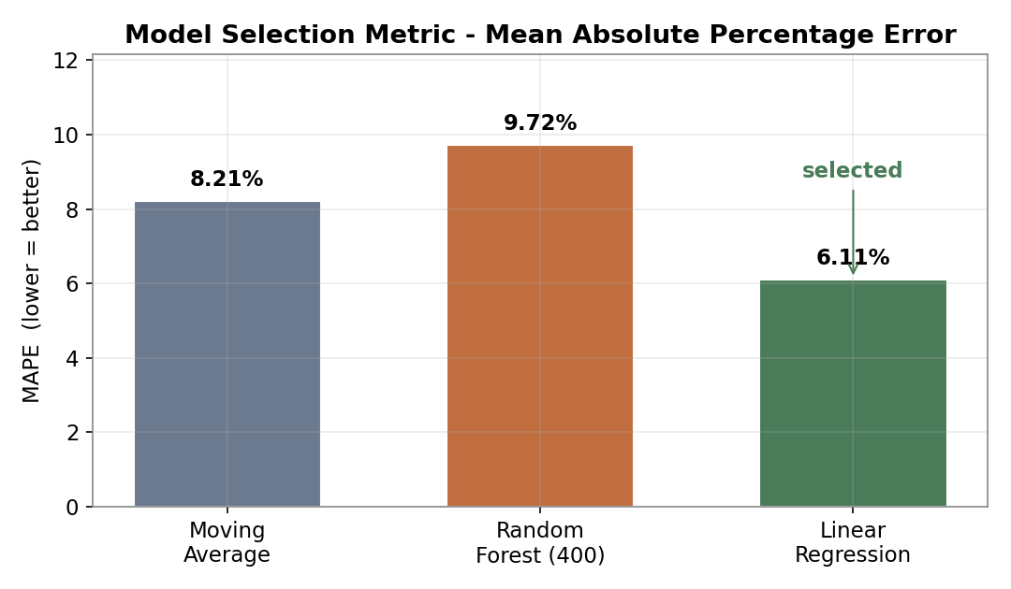
Figure 2. MAPE — the model-selection metric. Linear Regression (6.11%) is chosen.
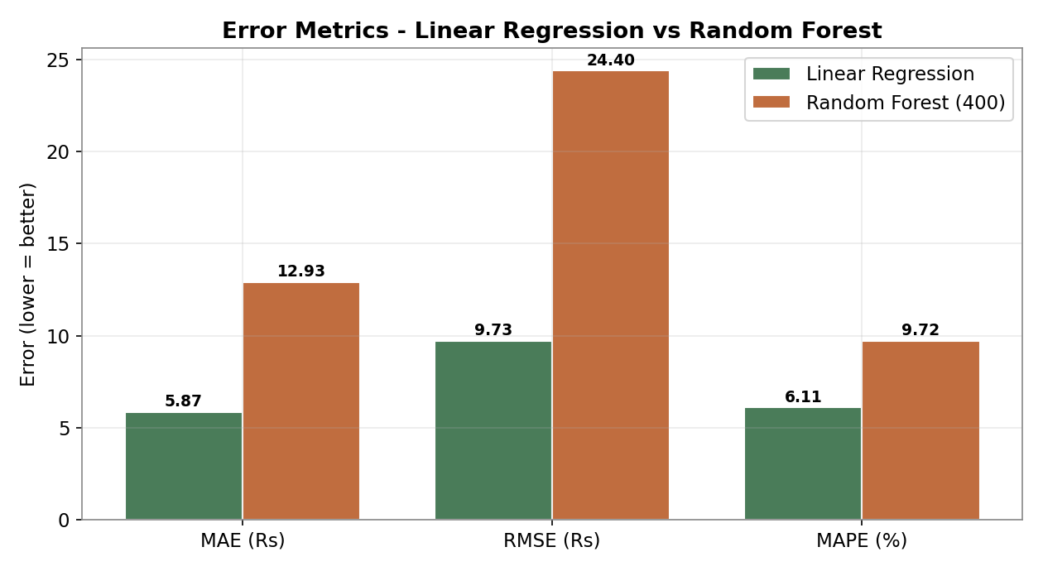
Figure 3. MAE, RMSE and MAPE side by side — Linear Regression leads on all three.
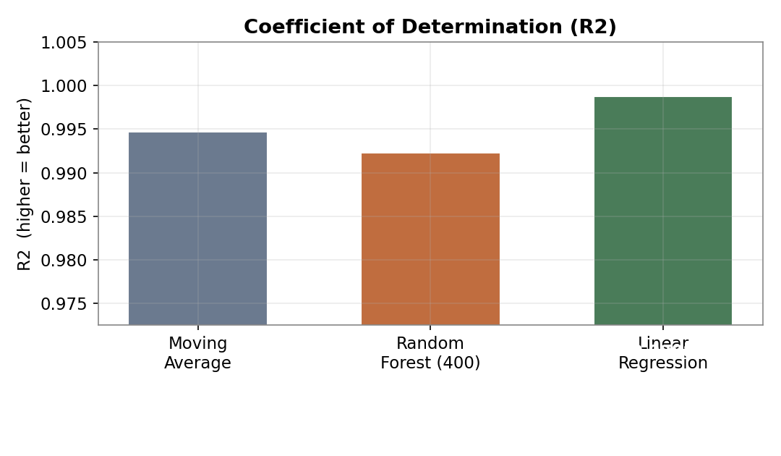
Figure 4. R² (explained variance). All models score high; LR is highest at 0.9988.
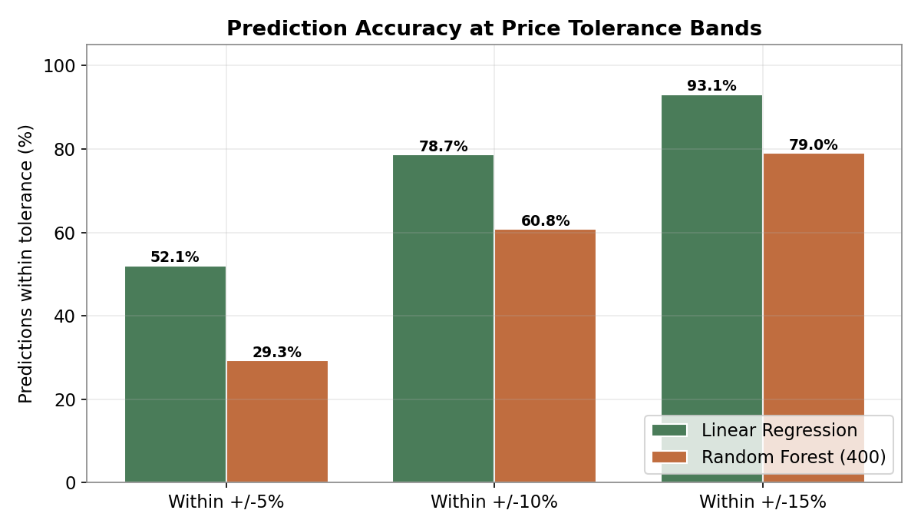
Figure 5. Accuracy at ±5/10/15% tolerance — LR dominates the Random Forest at every band.
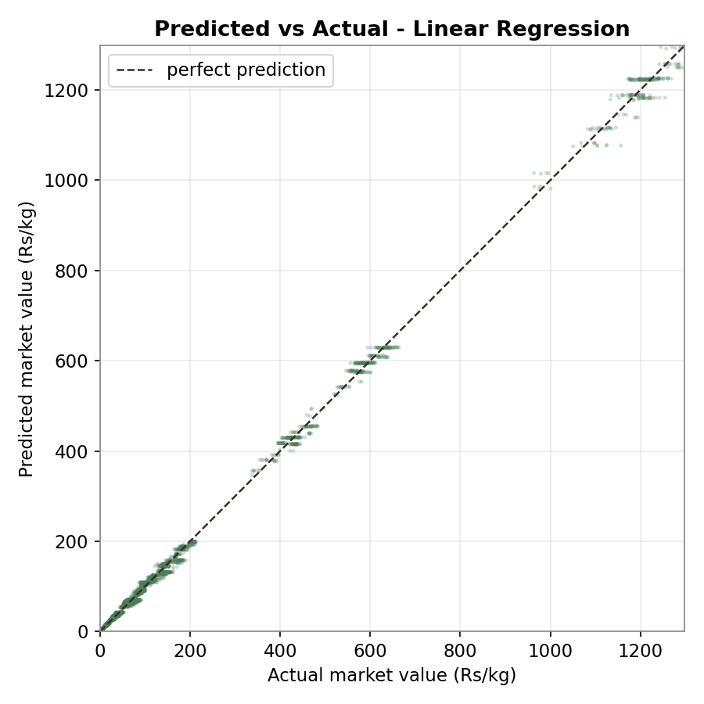
Figure 6. Predicted vs actual price (LR). Points hug the diagonal across the full ₹ range.

5. Why Linear Regression is the selected model
Linear Regression is the production predictor; the Random Forest is retained as a challenger / monitor; the Moving Average acts as a trend guardrail and cold-start fallback. The selection is justified on six grounds:
- Best accuracy on every metric. Lowest MAE, RMSE and MAPE and highest tolerance accuracy on unseen future data (Tables 1–2). The decision is evidence-based, not assumed.
- The price structure is intrinsically log-linear. Market value is driven by material type with demand and quality risk acting as roughly fixed percentage multipliers (High risk ≈ −18%, High demand ≈ +7%). On a log target these effects are additive, which is exactly what a linear model represents perfectly — so the simplest model fits the true data-generating process. A Random Forest must approximate that smooth relationship with piecewise-constant splits, which is why it is slightly less accurate here.
- Interpretability & auditability. Every coefficient is a readable ₹ effect, so a payout can be explained to a household or auditor (“copper pays more because…”). A 400-tree ensemble is a black box — unsuitable when the output is real money owed to users.
- Speed, size and cost. LR is a few kilobytes and predicts in microseconds, ideal for on-request quoting and nightly batch publishing to Supabase. The 400-tree forest is orders of magnitude larger and slower for no accuracy gain.
- Stability & low overfitting risk. The tiny gap between train and future-test performance shows LR generalises; it has almost no hyper-parameters to tune, so it will not drift as nightly data updates.
- Leakage-safe by design. The model deliberately excludes transaction variables (quantity, distance, logistics). An earlier version that included them scored a fake R² ≈ 0.999 by re-deriving the payout formula. Predicting market value and applying the business formula downstream keeps the evaluation honest — the reported 6.11% MAPE is real.

Role of the Random Forest (400-tree ensemble)
Per the review guidance, the Random Forest ensemble was sized to 400 trees (within the recommended 350–500 range; configured in train_models.py). It is kept as a challenger and drift monitor: if future data ever becomes non-linear, the forest would begin to out-perform LR, and the gap between them is tracked as an early-warning signal. Increasing trees from 120 to 400 changed MAPE only marginally (9.80% → 9.72%), which confirms the forest has converged and that its residual gap to LR is structural, not a tuning artefact — further strengthening the case for the linear model.

6. Future scope — Ridge and Lasso regression
Ridge and Lasso (regularised linear regression) are earmarked as future work rather than the current production model, for principled reasons:
- Regularisation targets overfitting we do not currently have. Ridge/Lasso shrink coefficients to combat high variance. With only a handful of clean, well-conditioned predictors and a near-perfect, stable test R², plain LR is not overfitting — so there is little error for regularisation to remove today.
- They become valuable as the feature set grows. When we add many correlated features (per-material seasonality, weather, commodity indices, finer-grained geography), Lasso's automatic feature selection and Ridge's handling of multicollinearity will improve robustness — so they are the natural next step, not a discarded option.
- They preserve interpretability. Both stay linear, so the audit and explainability advantages carry over — a low-risk upgrade path from the current model with a single tuning parameter (α) selected by cross-validation.
In short, the current LR is the right model for today's data, and Ridge/Lasso are the right models to adopt as the data widens — hence their placement in future scope.
Reproduce: cd ml && python train_models.py (RF n_estimators=400) → artifacts/metrics.json, results_metrics.json, report_graphs/

