Hormonal care and neurodegenerative diagnostic recording in Chile

Methods

Study purpose and relation to the two study parts
This health-services extension evaluated menopause-related care and diagnostic recording in Chile, then examined whether earlier hormonal-care recording was associated with later neurological caseload in facilities with usable observations. It extends the connected reproductive and neurodegenerative analyses in Part II; Part I supplies the separate descriptive burden context. The present Methods and Results report new raw-source re-extraction and public-aggregate analyses completed on 29 October 2026. Hospital discharges, coded public-hospital episodes, programme entries and December caseloads retain their own observation units and denominators.
Realised service use and diagnostic recording are measurable in these administrative data. Unmet need, ability to obtain appropriate care when required, hormone concentrations, prescribing eligibility, adherence and clinical onset are not directly measured. Geographical analyses concern facility location and reporting visibility. General-access survey questions identified in the earlier feasibility work were not newly analysed in this administrative extension.

Primary care source scope and observation units
Original DEIS REM Series A and P files for 2019–2025 were examined at their recorded facility, month, programme code and data-column grain. Series A measures activity flows, while the analysis of Series P used the December reference snapshot. Women may contribute more than once across months, activities or snapshots. These aggregate sources were not linked at patient level and provide no individual symptom chronology, hormone exposure duration or medication adherence.
The extension operationalised recorded programme participation, symptom assessment, recorded menopausal hormone therapy (MHT) and diagnostic-service activity. These are utilisation and recording measures. They do not directly observe eligibility, waiting time, affordability, geographic travel barriers, unmet need or a clinical diagnosis of menopause.

Annual code mapping and changes in source definitions
Every target code and data-column mapping was checked against the local official coded Excel template for the relevant source year. The audit preserves workbook hashes, sheet names, source rows, column coordinates and surrounding headers. P1 care, assessed MRS, elevated MRS and recorded MHT use codes P1030301, P1060040, P1060050 and P1060060. Their age 45–64 field is Col01 in 2019–2024 and Col02 in 2025. The 2025 Col01 is younger than 45; additional demographic fields are overlapping subsets and were not added to the age counts.
P1700101, P1700102 and P1700103 were introduced in the inspected 2025 template for MRS at entry, MRS at follow-up and improved or persistently low follow-up MRS. They were not backfilled into earlier years. The current P1 manual defines assessment histories over the preceding 11 months and 29 days; entry and follow-up histories may overlap. The improved/low row is an aggregate recording indicator, not an estimate of MHT effectiveness.

MRS contexts and programme entry activity
A03G codes 03600180, 03600190, 03600210, 03600220 and 03600230 were mapped in 2021–2025 for MRS applications, high total scores and the three symptom domains. Col01 denotes programme entry, Col02 follow-up without recorded MHT and Col03 follow-up with recorded MHT. The inspected 2019–2020 A03 templates contained no mapped corresponding rows. No age-specific population rate was calculated from these undivided activity fields. The current Series A manual describes ages 40–64; the aggregate cells cannot reconstruct a common 45–64 age group.
The A03 high-score row uses total MRS ≥15, while the current P1 elevated-MRS definition also includes specified domain thresholds. These two high-score measures were therefore kept separate. Ratios used facility-month-context pairs with numeric high-score and application counts and positive applications. A sensitivity excluded pairs where high-score counts exceeded applications, without modifying the source counts. Entry and follow-up contexts are selected assessment populations, not exchangeable treatment groups.
A05D code 01080090 measures new climacteric programme entries. The available total is not age-stratified and was described as an annual activity flow, without a 45–64 denominator and without interpreting entry as symptom onset or a newly diagnosed hormonal disorder.

Climacteric consultations FSH and ultrasound
A29 codes 29101711, 29101712 and 29101713 identify climacteric gynaecological consultations, follicle-stimulating hormone (FSH) blood tests and transvaginal/rectal ultrasound in 2023–2025. The common 45–64 age field changes from Col02 in 2023–2024 to Col03 in 2025; the latter introduces a separate 40–44 field. Legacy 2021–2022 package and FSH codes 29101160 and 29101210 have different source scope and were retained as separate series.
Age sums were checked only where the total and every applicable component were numeric; partial age fields remained partial. For 2025 FSH and ultrasound, both remote modality cells are grey and locked in the coded template and were excluded as structurally inapplicable. Gynaecological consultations retain all four active modality cells. Earlier unqualified in-person/remote columns were not assumed equivalent to the explicitly institutional 2025 labels. Modality sums were screened for descriptive consistency and were not used to infer a complete partition of services.

Duplicate handling and source visibility
Identical complete source rows were removed once. Any remaining nonidentical duplicate natural key, comprising month, service, year, establishment and programme code, was quarantined in full. No conflicting value was chosen arbitrarily. Explicit numeric zero, a blank applicable cell and an absent source row were preserved as different states. A template field absent by design was labelled separately from a missing observation.
Annual counts sum observed numeric cells only. Facility reporting counts, numeric months and blank cells accompany the activity totals; the presence of all 12 months nationally does not establish 12-month reporting at every facility. Count-order checks were reported as data-quality screens rather than automatic clinical corrections. Administrative counts were plotted without sampling confidence intervals; reporting incompleteness and selection uncertainty remain unquantified.

Age specific enrolment and geographic summaries
December female FONASA age bands were parsed from the source labels and apportioned to ages 45–64 using municipal INE single-year female age structure. In 2019–2023 the overlapping bands were 40–59 and 60–79; in 2024–2025 they were 40–49, 50–59 and 60–69. Facility-to-municipality linkage used the public facility catalogue. Missing age shares remained missing. No 45–64 denominator was reused for unstratified programme entries or the undivided A03 age scope.
Matched rates used the sum of numeric programme records divided by the estimated same-year enrolment of those same numeric-reporting facilities. Rates are therefore conditional on source visibility and do not represent national treatment coverage. Facility maps also display denominator-eligible locations with blank cells or absent rows, avoiding a visual zero-fill. Catalogue coordinates represent providers rather than residence or travel time. Mainland Chile and a Santiago enlargement use WGS84 coordinates, stated logarithmic scales and BCN public boundaries.

Reproducibility and source attribution
The raw-refresh workflow preserves the selected original cells on the authorised external volume and rebuilds public facility and source-quality aggregates. A separate public-only workflow regenerates all presented tables, figures and manuscript paragraphs from the shared aggregates and public cartography, without the external volume. Python, pandas, NumPy and Matplotlib versions, source and output hashes, validation results and exact rebuild commands accompany the extension.
Source definitions were obtained from DEIS annual REM coded templates and the official REM Series A 2025–2026 version 1.3 manual (A03, A05 and A29 sections) and REM P 2025 version 1.2 manual (P1 section F). Enrolment derives from FONASA; age structure from INE; catalogue and administrative geography from the cited public sources. Integration JSON files are technical manifests and are not scientific data sources.

Neurological programme records and annual dictionary validation
This component rebuilt neurological REM inputs for 2019–2025 from the original selected source rows, sharing one physical extraction with the menopausal-care component. The seven target codes were A05 dementia entries 05901801–05901803, P6 dementia caseload P6222300/P6230100/P6230200 and P3 Parkinson caseload P3140200. All 49 code-year combinations were checked against their annual official A05, P3 and P6 coded templates. Col02/Col03 report men/women totals; Col04–Col37 provide alternating sex cells for 17 exhaustive age bands from 0–4 to ≥80.
A05 was treated as an annual flow requiring all three stage rows in each of 12 months for a complete total. P6 was a December snapshot requiring all three stage rows; P3 required its single December Parkinson row. Repeated annual snapshots are not unique people or individual follow-up. No absent code, stage or month was turned into zero from another programme row.

Explicit numeric cells accounting identification and missing records
Within a present row, the reported sex total and exhaustive nonnegative age partition were used to identify coarse age counts. Let R be the sex total minus the sum of known age cells. A requested band is exact when its cells are all numeric, R is zero, or all missing age cells lie inside that band; the latter case adds R to the known band cells. Other cases retain lower and upper bounds; negative residuals, negative cells and nonnumeric nonblank values are flagged as conflicts. No total is inferred from the other sex.
Raw numeric zeros, accounting-identified zeros, blank cells and absent rows are exported separately. Complete counts require every expected component row and an identified count in every row. Identical full source rows were removed; any remaining nonidentical year/month/establishment/code duplicate would be quarantined rather than resolved with a maximum or latest value.

Same year enrolment and association ready data
Same-year FONASA December enrolment counts were independently reconciled at facility, sex and age-band level against the raw annual source files. The original 20-year age groups in 2019–2023 change to 10-year groups from 2024. The common 60–79, ≥80 and ≥60 denominators are exact in all years; 60–69 and 70–79 denominators are exact only from 2024, without prorating earlier years. All-age enrolment includes unknown-age records with known sex, whereas age ≥60 denominators exclude unknown ages. These are annual snapshot counts, not observed person-time.
The canonical table is establishment by year by recorded sex by age group by measure. It retains count identification, row/month/stage coverage, bounds, explicit-zero fields and same-year denominators. Primary eligibility checks require both 60–79 and ≥80 counts identified and positive denominators. Exposure intersection and association models are performed separately by the coordinating analysis.

Hospital source scope and operational diagnostic definitions
This extension used the full national DEIS principal-diagnosis hospital-discharge files for 2001–2024 and full FONASA public-hospital GRD episode files for 2019–2024. DEIS covers public and private establishments. GRD retains hospital stays, major ambulatory surgery and other coded activities; the primary GRD population was women aged 45 years or older at the recorded admission. The sources were analysed separately, without patient linkage between DEIS and GRD and without an individual medication history.
The primary narrow recorded menopause definition was N95.1. The broader menopause/perimenopause definition was N95.1, N95.8 or N95.9. N95.3, E28.3 and E89.4 were retained as separate artificial-menopause, primary-ovarian-failure and postprocedural-ovarian-failure codes. A clearly labelled mixed clinical composite used these six codes without Z90.7. Z90.7 was a separate acquired-genital-organ-absence status, with no assumption of ovarian bilaterality, operation date or MHT use. N95.0 and N95.2 were separate additional recorded-condition comparators. Codes were verified against the DEIS-hosted WHO/PAHO 2018 tabular volume and August 2026 Chilean dictionary; this verifies code validity and does not establish uniform historical recording.
Codes were uppercased and punctuation removed. Clinical four-character groups were matched exactly, while established neurological groups used their configured ICD-10 prefixes. Dementia included F00–F03, G30, G31.0, G31.1 and G31.8; parkinsonism included G20–G23. The principal code was the first GRD diagnosis, and any-position flags used all 35 diagnostic positions. In DEIS, only DIAG1 was analysed: DIAG2 is an external-cause field and was not treated as a comorbidity.

Denominators repeated records and descriptive analysis
DEIS ratios used female discharges within the same source year, supported age band and establishment-sector category. Ages were retained as <40, 40–49, 50–59, 60–69, 70–79 and ≥80 years; no 45–64 band was manufactured from decade bands. Region-of-residence and sector aggregates remain available separately. Counts per 10,000 records describe recording among discharges or episodes and do not estimate population prevalence, access to treatment or disease incidence.
GRD episode denominators retained all eligible female episodes, including those without an identifier. Raw complete-source eligibility and all code-group numerators at age ≥45 were independently reconciled to the previously prepared GRD diagnosis extract. Source-level unknown sex, missing age, missing identifiers and discharge-condition distributions were preserved in QC. Age >110 was flagged and examined as a sensitivity, without silently deleting those observations.
The first-person sensitivity used 2021–2024, evaluated empirical adjacent-year ID overlap despite the 2024 column-name change, and excluded missing identifiers and identifiers with discordant observed female/male sex in the full eligible all-sex frame. For each remaining person, the first eligible female-coded observed episode was selected by file year, admission date and hospital, preserving source-file order for remaining ties. Later episodes did not contribute to that sensitivity. This first record is not a lifetime first event or clinical onset.
Co-recording was tabulated using complete two-by-two same-episode cells for menopause-related and dementia/parkinsonism codes, including the complement with neither core neurological code. Sparse joint clinical counts did not support a clinically interpretable adjusted regression or longitudinal effect model, so none was fitted. Hospital variation was summarised among providers with at least 1,000 eligible female episodes in a year, retaining providers with zero codes. Quantile bands show distributional spread, not confidence intervals. Diagnostic-depth whiskers show IQRs. All plotted rates are observed aggregate ratios, without inferential confidence intervals or significance testing. No multiplicity-adjusted confirmatory claim is made.

Connecting earlier hormonal care with later neurological recording
We treated the administrative sources as one health-services sequence: documented hormonal-care activity, neurological reporting feasibility, and conditional association within facilities that could support both measurements. The analysis did not link a woman’s hormonal treatment to her neurological diagnosis. REM contains aggregate facility records; DEIS and GRD were analysed as separate hospital recording sources. The rules for the new facility models were written on 29 October 2026 before estimating their coefficients, after reviewing earlier project findings and source feasibility. The extension remains exploratory and was not preregistered.
The exposure was pooled December 2019–2021 recorded MHT observations divided by the sum of same-year estimated enrolled women aged 45–64, multiplied by 1,000. The model contrast was 10 additional records per 1,000. The strict sample required numeric care and MHT cells, including explicit source zeros, and positive denominators in all three years. Blank cells, absent source rows and conflicting records were excluded from eligible exposure years. A relaxed sensitivity required at least two exposure years. Repeated December records can include the same women; the denominator sum is a sum of enrolment snapshots and is not individual follow-up time.
The focal outcome was female dementia caseload at age 60+ summed across December 2022–2025 snapshots, requiring all three stage rows and identified counts in both 60–79 and ≥80 age bands with positive same-year sex-specific enrolment. The strict sample required all four outcome years; the relaxed sample required at least two. Male dementia and female and male Parkinson caseload were secondary recording comparisons. Annual dementia programme entries failed the complete monthly and stage-reporting requirement for a longitudinal provider sample and were not forced into a count association model.

Expected counts and conditional mean models
For each neurological measure, sex, year and age band, the internal reference recording rate was the sum of complete identified counts divided by the sum of enrolled persons among all eligible reporting facilities, before intersection with hormonal exposure. Expected counts for each study facility summed its same-year enrolled persons multiplied by the corresponding reference rates across the observed age-year cells. The facility outcome was the sum of the matching observed counts. These internally standardised recording comparisons are not national prevalence estimates.
We fitted a Poisson conditional mean model with log expected count as an offset. Covariates were earlier MHT recording, regional indicators, facility-type indicators, contemporary municipal multidimensional poverty and rural share, and log mean outcome-window older-person enrolment. Poverty and rural share were coded per 10 percentage points. Contemporary contextual covariates do not establish historical circumstances or a causal adjustment set. Covariance clustered score contributions by municipality, with finite-sample factor G/(G−1)×(N−1)/(N−p); nominal 95% intervals and two-sided P values used a t distribution with G−1 degrees of freedom. We checked full design-matrix rank, convergence and at least 30 municipal clusters before fitting. The independent manual score-sandwich calculation was compared numerically with the library cluster covariance.
Poisson variance was not assumed for inference: municipal-cluster covariance was used because record counts were markedly overdispersed and providers shared context. Inference is conditional on the observed reporting sample, fixed internal reference rates and denominator estimates; uncertainty in population proration and reference-rate construction was not propagated. We reported Pearson dispersion as a diagnostic. High dispersion, influential facilities and a small number of clusters in some subsets limit stability even when the model converges.

Sensitivity analyses and geographical dependence
Programme-intensity models added pooled earlier climacteric-care records per 100 estimated enrolled women. A baseline sensitivity required all three 2019–2021 same-outcome snapshots and added log(1+baseline records per 1,000 same-year enrolled older persons); the before-adjustment baseline comparison used exactly the same restricted facilities. A source-consistency sensitivity removed facilities whose pooled care or MHT numerator exceeded the corresponding exposure-window enrolled denominator. Such a flag may indicate a catchment mismatch rather than a false source value; the original observations were retained in the base models and public audit.
A raw-numeric-only sensitivity excluded all accounting-identified outcome counts. After independent audit of the initial fits, we added a post hoc stricter source screen that excluded any facility with care or MHT above its enrolled denominator in any individual exposure year, even when its pooled ratio was below one. These supplementary rules did not replace the original focal analysis.
Paired-sex models retained exactly the same facilities for women and men and interacted all contextual covariates with sex. We estimated the women-to-men ratio of exposure coefficients on the multiplicative scale, using joint municipal-cluster covariance. Holm adjustment covered the three secondary strict base outcome/sex associations and, separately, the two paired-sex contrasts. Other sensitivities retain nominal P values and do not form independent confirmatory claims.
Exploratory Moran diagnostics used municipal sums of observed and fitted counts from each strict base model, divided by the square root of fitted counts. Municipality coordinates were the mean included-facility coordinates. We used a symmetrised four-nearest-neighbour binary graph based on great-circle distances and 999 permutations with seed 20261029. This is a residual pattern check; municipal clustering does not model all dependence between neighbouring municipalities. Facility maps show service location and source visibility, not residence, road travel time, appointment availability or geographical access when care is needed.

Methodological references
1. DEIS open data catalogue and annual REM files. https://deis.minsal.cl/#datosabiertos (accessed 29 October 2026).
2. DEIS REM 2025–2026 Series P manual version 1.2, sections P1, P3 and P6. https://repositoriodeis.minsal.cl/ContenidoSitioWeb2020/REM/2025/SERIE/MANUAL_REM_P_2025_Version_1.2.pdf (accessed 29 October 2026).
3. DEIS REM 2025–2026 Series A BS BM D manual version 1.3, sections A03, A05 and A29. https://repositoriodeis.minsal.cl/ContenidoSitioWeb2020/REM/2025/SERIE/Manual_Series_REM_2025_2026_SERIE_A_BS_BM_D_V1.3.pdf (accessed 29 October 2026).
4. FONASA registered primary-care population by facility and year. https://public.tableau.com/views/ReporteInscritosCentrosAPS/ReporteAPS?:showVizHome=no (accessed 29 October 2026).
5. FONASA GRD open data and financing portal. https://datosabiertos.fonasa.cl/dimensiones-financiamientos/ (accessed 29 October 2026).
6. DEIS hospital discharge data specification, including principal diagnosis and external cause. https://repositoriodeis.minsal.cl/deis/egresos_2003/Estructura_2003.htm (accessed 29 October 2026).
7. DEIS WHO PAHO ICD10 tabular volume 2018. https://repositoriodeis.minsal.cl/ContenidoSitioWeb2020/uploads/2020/12/CIE-10_2018_VOL1.pdf (accessed 29 October 2026).
8. DEIS Chilean ICD10 tabular list August 2026. https://repositoriodeis.minsal.cl/ContenidoSitioWeb2020/uploads/2021/03/Lista%20tabular%20CIE-10%20-%20agosto%202026.xlsx (accessed 29 October 2026).
9. INE population projections by municipality age and sex, base 2017. https://www.ine.gob.cl/estadisticas-por-tema/demografia-y-poblacion/estimaciones-y-proyecciones-de-poblacion (accessed 29 October 2026).
10. MDSF municipal poverty estimates 2024. https://observatorio.ministeriodesarrollosocial.gob.cl/pobreza-comunal-2024 (accessed 29 October 2026).
11. Biblioteca del Congreso Nacional Mapoteca vector boundaries. https://www.bcn.cl/siit/siit/mapas_vectoriales/ (accessed 29 October 2026).

Results

Reading the connected administrative evidence
The results proceed from menopause-care recording and source visibility, through neurological programme completeness and hospital diagnostic coding, to the facility association analyses. The complete table and figure bank retains descriptive detail and sensitivity estimates for later manuscript selection. None of the sources is treated as interchangeable with another source’s clinical or population measurement.
The new source audit supersedes earlier zero-filled or differently labelled REM summaries for the measures explicitly re-extracted here. Exact duplicate rows in 2021 were removed, while conflicting keys were quarantined. A03 entry and follow-up assessments were separated, and the scope of A29 diagnostic services was harmonised only within compatible code years. Earlier project files remain versioned historical outputs; they should not be pooled with these corrected series without applying the same definitions.

December climacteric care and MHT recording
Observed numeric P1 counts at ages 45–64 were 164,317 for care and 12,265 for recorded MHT in 2019, compared with 183,234 and 27,779 in 2025. The 2025 assessed-MRS and elevated-MRS counts were 127,000 and 64,584, respectively. These are source-recorded programme counts rather than population prevalence or an individually linked treatment cascade.
The source audit confirmed that the original core analysis had selected the correct 2025 age field. The new core national totals differ from the frozen outputs only in 2021, following removal of exact duplicate rows: care decreased from 135,825 to 135,772, assessed MRS from 56,853 to 56,843, elevated MRS from 28,603 to 28,598 and MHT from 11,893 to 11,891. Historical outputs remain preserved and the explicit comparison table records these corrections.

Source visibility and the conditional denominator
Among 2,028 facilities with positive estimated female enrolment at ages 45–64 in 2025, the MHT field was positive in 1,135, explicitly zero in 5, blank in 5 and absent in 883. Absence and blankness were not reclassified as non-use. The source-status tables show corresponding annual states for care and assessment fields.
The 2025 MHT matched rate was 15.32 records per 1,000 estimated enrolled women, using 27,061 records and 1,766,656 estimated enrollees from 1,140 numeric-reporting facilities. This conditional rate differs in scope from a national numerator divided by an entire population denominator.
Before imposing neurological outcome requirements, 369 facilities had numeric care and MHT values with a positive same-year age-specific denominator in all three exposure years 2019–2021; 561 had at least two such years. Explicit zeros were eligible. Any subsequent complete-case association analysis pertains to the further selected provider cohort, not the national network.

New assessment history fields in 2025
The new 45–64 P1 fields recorded 87,352 entry-MRS histories, 74,832 follow-up histories and 25,013 improved/low follow-up histories. Their sum is not expected to equal the 127,000 assessed-MRS count because the histories overlap and the definitions differ.
The improved/low count exceeded the follow-up count in 79 facilities with both values numeric. This is a source consistency warning and was not repaired by capping or interpreted as a treatment response. Separate age-younger-than-45 counts are available in the evidence table and were not pooled with ages 45–64.

Programme entry flows and reporting coverage
A05 recorded 37,058 new programme entries in 2019, 12,774 in 2020 and 50,969 in 2025. The represented facility counts were 1,200, 955 and 1,163, respectively. All 12 calendar months were represented nationally in each year, with incomplete within-facility numeric reporting. Changes therefore combine observed programme activity and reporting composition.

MRS applications across entry and follow up contexts
In 2025, the observed A03 application counts were 53,365 at programme entry, 34,613 at follow-up without MHT and 11,665 at follow-up with MHT. Blank source cells and unequal context visibility prevent interpreting these groups as a common patient cohort.
Among matched positive-application cells, the 2025 high-total-score/application ratios were 64.02% for entry, 49.05% for follow-up without MHT, 51.19% for follow-up with MHT. After excluding count-order violations, the corresponding ratios were 63.51%, 48.51%, 50.34%. These are descriptive assessment ratios; selection, repeated assessments and missing context cells preclude a hormone-treatment comparison.

Climacteric diagnostic service recording
The source-supported 2023–2025 A29 series adds service-specific evidence beyond programme caseload. In 2025, observed all-age totals were 10,558 consultations, 11,210 FSH tests, 8,339 ultrasound examinations.
At ages 45–64, the 2025 counts were 9,930 consultations, 9,480 FSH tests, 7,426 ultrasound examinations. Corresponding represented facility counts were 202, 161, 189. These are recorded service events, not unique women, diagnostic yield, clinical appropriateness or a measured unmet need.
Across the nine service-year combinations in 2023–2025, all 3,872 complete numeric age-component sets agreed with their total, and no known partial age sum exceeded the total. In 2025, modality sums disagreed with totals in 29 consultation, 49 FSH and 62 ultrasound facility-months with every applicable modality numeric. Remote FSH/ultrasound fields were structurally inapplicable, not missing; modality partitions were not used as substantive access measures.

Geographic recording patterns and observation limits
The 2025 mainland map includes 1,995 facilities with a positive age-specific denominator and usable coordinates. Positive care and MHT ratios are shown alongside explicit-zero, blank-cell and absent-row symbols. Thus the map displays the observation process as well as recorded activity. Its provider locations do not identify residential accessibility, travel time, regional need or underdiagnosis.

Source corrections and reproducibility checks
The complete-row duplicate audit found 11 removable Series P rows in 2021 across the combined hormonal/neurological code cache, three Series A rows in 2021 and 12 Series A rows in 2024. Two remaining conflicting 2024 Series A keys concerned MRS applications and programme entries at one facility-month; all four nonidentical rows were quarantined. Neuro-specific duplicate changes are documented in the separate neurological section. The public source audit retains these decisions without disclosing patient records.
Annual source templates, source-cell states, age-component checks and a comparison with frozen totals are available for inspection. The public rebuild re-creates tables and figures from shared aggregates, while a separate authorised raw refresh re-runs source selection, deduplication, definition mapping and denominator construction.

Reporting feasibility and exact count eligibility
Annual A05 reporting was too sparse to support a routinely complete annual numerator. Among establishments with any dementia-stage row, the median distinct-month coverage ranged from 2 to 3 months. With all three stages, both older-age bands and positive enrolment required, the annual eligibility table contains 2 eligible sex-specific facility-years in total, all in 2025; these represent one establishment in each sex, and no establishment had three complete eligible years in 2022–2025. A05 associations therefore require a separately labelled coverage-limited or positive-record analysis rather than an assumed complete annual disease rate.
For December P6 dementia caseload, 223 establishments in women and 224 in men had identified counts in both older-age bands and positive enrolment in all four years of 2022–2025. The corresponding numbers with at least three years were 345 and 347. These are outcome and denominator feasibility counts before intersection with menopausal-care exposure and covariates, not final model sample sizes.
For December P3 Parkinson caseload, 833 establishments in women and 830 in men met all-four-year eligibility; 1,120 and 1,103, respectively, met at-least-three-year eligibility. Presence of an outcome row or accounting identification does not establish reporting completeness or clinical diagnostic validity.
The uncorrected source-cell sums reproduce the legacy zero-filled rem_long totals exactly for every examined year, measure, sex and all-age/age ≥60 group. Three exact duplicate neurological P rows were removed in 2021 and no nonidentical neurological keys were quarantined. This reduces women’s dementia caseload by 3 all-age records and 2 at age ≥60, and men’s Parkinson caseload by 2 in both age scopes. These are transparent data corrections; accounting-based identification and reporting restrictions remain separate from that reconciliation.
All denominator source checks matched exactly. The complete-provider sample is selected and cannot be interpreted as the complete primary-care network, national neurological prevalence, diagnostic delay or an effect of menopausal treatment.

Identified caseload patterns among annually paired providers
The annually paired P6 sample contained 188 establishments in 2019 and 483 in 2025. Within those changing selected samples, recorded dementia caseload at age ≥60 totalled 4,194 records in women and 1,866 in men in 2019, and 17,739 and 8,829, respectively, in 2025. These counts describe identified recorded caseload among the eligible providers and cannot be interpreted as national totals or changes in a fixed cohort.
In 2025, within-age female/male dementia recording ratios per enrolment were 1.18 at 60–79 and 1.38 at ≥80, using the same paired providers in both sexes. The figure and source tables retain both caseload numerators, enrolment denominators and annual provider counts. These are descriptive service-recording ratios rather than clinical disease-risk estimates.
Pooling the selected P6 snapshots in 2022–2025, advanced-stage records accounted for 22.0% of the staged caseload in women and 18.5% in men. The three-stage distribution is conditional on complete identified stage rows; repeat annual records and changing provider eligibility prevent an individual progression interpretation.

Hospital recording of menopause related conditions
The national DEIS files contained 38,818,057 discharges in 2001–2024, including 22,644,329 with classifiable female sex. The GRD files contained 5,808,535 episodes in 2019–2024; the primary female age ≥45 denominator was 1,496,044 episodes. DEIS source QC retained 1,111,524 records with unclassified sex; the asterisk was the dominant raw value. These records were not reassigned to women from their diagnosis.
In GRD women aged ≥45, the broad N95.1/N95.8/N95.9 group appeared in 1,080 episodes in any position and 63 as principal diagnosis. Separate any-position counts were 15 for N95.3, 144 for E28.3 and 1 for E89.4. Z90.7 appeared in 33,684 episodes, but this broad status is not an individual hormone-exposure or BSO measure.
The broad N95 group co-occurred with a dementia or parkinsonism code in 16 episodes, among 62,200 core-neurological coded episodes and 1,433,844 other eligible episodes. The first-observed-episode sensitivity retained 645,328 women, with 652 broad N95-coded first episodes and 10 joint records. These sparse joint cells, source selection and coding-depth differences prevent a hormonal-effect interpretation.
Principal-only national discharges and any-position public-hospital episodes capture different recording processes. A low hospital frequency of a menopause code does not measure low menopausal symptom burden, lack of outpatient care, untreated symptoms or MHT availability. Provider variation may reflect case mix, clinical services, coding depth and reporting practice; it does not by itself establish access differences.

What the cross source association sample can support
The strict female dementia analysis linked 97 facilities in 61 municipalities, from 369 facilities with all three eligible exposure years and 223 with all four eligible female dementia snapshots before intersection. Its outcome comprised 19,470 repeated caseload records with 16,464.5 internally expected records. The selected sample’s median earlier MHT recording was 8.48 per 1,000 estimated enrolled women aged 45–64, with range 0.37–1,423.81. Those very different values require examination of denominator compatibility.
The focal context-adjusted recording ratio was 1.027 (1.012–1.042) per 10 additional earlier MHT records per 1,000, with nominal P<0.001. Its Pearson dispersion was 59.7. Adding earlier climacteric-care intensity gave 1.005 (0.983–1.027). Removing one flagged small-denominator hospital left 96 facilities and 60 clusters and gave 0.999 (0.924–1.079). Thus the positive base-model coefficient was not stable to this source-consistency sensitivity.
The flagged hospital had pooled earlier MHT recording of 1,423.81 per 1,000 and care recording of 264.00 per 100 estimated enrolled women aged 45–64; its exposure denominator sum was 67.42. These ratios are retained as observed, and may reflect a provider catchment that differs from its enrolled population. A national causal or protective MHT conclusion cannot be drawn from the coefficient with that provider included or excluded.
The baseline-adjusted female dementia sensitivity retained 39 facilities in 30 municipalities and gave 0.974 (0.940–1.008); the same subset before baseline adjustment gave 1.018 (0.927–1.119). The reduced sample and its limited cluster count are part of the interpretation. The relaxed two-year reporting rule included 244 facilities in 125 municipalities and had a base recording ratio of 1.016 (1.008–1.024), describing a different selected reporting population.

Secondary neurological and sex comparisons
The strict female Parkinson model retained 231 facilities in 109 municipalities and gave a recording ratio of 1.012 (0.996–1.028). Corresponding strict male ratios were 1.022 (1.010–1.034) for dementia and 1.010 (0.998–1.023) for Parkinson. The secondary-family and sensitivity tables retain every fitted comparison and its null results; clinical interpretation is constrained by the shared service and reporting process.
Raw-numeric-only dementia counts were available in 26 women’s facilities across 19 municipalities and 24 men’s facilities across 18 municipalities. Both models were withheld by the 30-cluster rule. Most facilities in the focal sample therefore rely on exact accounting identification within present source rows, rather than imputation of absent records. The post hoc any-year source-flag sensitivity additionally removed a facility with a small single-year care-denominator mismatch; its estimates are retained in the complete sensitivity tables.
The fully interacted paired-facility women-to-men ratio of recording ratios was 1.005 (1.000–1.009) for dementia, with Holm-adjusted P=0.098 across the two sex contrasts. The Parkinson contrast was 1.002 (0.994–1.010), with adjusted P=0.585. These comparisons did not provide multiplicity-adjusted evidence for sex heterogeneity and do not distinguish hormonal, access, case-mix or recording mechanisms.
The female dementia municipal residual diagnostic had Moran I=-0.021 and a two-sided permutation P=0.947 under the specified neighbour graph. The other strict-model diagnostic P values ranged 0.356–0.989. These checks did not identify a residual pattern under that particular construction; they do not demonstrate that spatial confounding or dependence is absent.

Table 1. Annual source definitions and column mapping
Annual source templates are authoritative; not-in-template fields are distinct from unobserved cells.
Component | Codes | Mapped years | Age scope | Interpretation
P1 core care/MRS/MHT | P1030301; P1060040; P1060050; P1060060 | 2019–2025 | 45–64 | Snapshot; 2025 Col02, earlier Col01
P1 entry/follow-up/improved MRS | P1700101; P1700102; P1700103 | 2025 | <45 and 45–64 | Overlapping previous-year histories
A03 MRS applications/high/domains | 03600180; 03600190; 03600210; 03600220; 03600230 | 2021–2025 | Source-defined climacteric ages | Entry; follow-up without MHT; follow-up with MHT
A05 programme entries | 01080090 | 2019–2025 | Unstratified | Annual activity flow, not diagnosis onset
A29 climacteric consultation/FSH/ultrasound | 29101711; 29101712; 29101713 | 2023–2025 | 45–64 and 65+; adds 40–44 in 2025 | Age 45–64: Col02 in 2023–24, Col03 in 2025
Legacy A29 package/FSH | 29101160; 29101210 | 2021–2022 | Unstratified | Different source scope, kept separate
Table 2. P1 national counts and conditional matched rates
All-source counts sum observed numeric P1 age 45–64 cells. Matched rates use only the numerator-reporting facilities with a positive same-year estimated enrolment; they are not national treatment coverage. New history rows are available only in 2025.
Year | Measure | All-source count | Source rows | Numeric cells | Blank cells | Matched facilities | Matched count | Estimated enrolled 45–64 | Matched /1,000
2019 | Climacteric care | 164,317 | 1,282 | 1,282 | 0 | 1,120 | 158,390 | 1,478,551.6 | 107.125
2019 | MHT recorded | 12,265 | 607 | 607 | 0 | 558 | 12,023 | 1,031,397.7 | 11.657
2019 | MRS assessed | 63,011 | 1,116 | 1,116 | 0 | 978 | 60,568 | 1,337,887.8 | 45.271
2019 | Elevated MRS | 25,897 | 925 | 925 | 0 | 835 | 25,017 | 1,300,665.4 | 19.234
2019 | Educational workshop | 1,223 | 200 | 200 | 0 | 186 | 1,190 | 341,338.4 | 3.486
2020 | Climacteric care | 128,311 | 1,152 | 1,152 | 0 | 1,038 | 123,505 | 1,431,880.2 | 86.254
2020 | MHT recorded | 9,041 | 567 | 567 | 0 | 537 | 8,851 | 941,672.3 | 9.399
2020 | MRS assessed | 45,125 | 973 | 973 | 0 | 878 | 43,404 | 1,275,323.6 | 34.034
2020 | Elevated MRS | 20,718 | 832 | 832 | 0 | 773 | 20,064 | 1,210,926.9 | 16.569
2020 | Educational workshop | 340 | 36 | 36 | 0 | 30 | 327 | 44,981.7 | 7.270
2021 | Climacteric care | 135,772 | 1,292 | 1,292 | 0 | 1,182 | 130,962 | 1,569,462.7 | 83.444
2021 | MHT recorded | 11,891 | 703 | 703 | 0 | 664 | 11,562 | 1,145,453.6 | 10.094
2021 | MRS assessed | 56,843 | 1,189 | 1,189 | 0 | 1,090 | 54,552 | 1,476,039.8 | 36.958
2021 | Elevated MRS | 28,598 | 1,074 | 1,074 | 0 | 997 | 27,567 | 1,433,882.9 | 19.225
2021 | Educational workshop | 351 | 63 | 63 | 0 | 59 | 340 | 76,785.8 | 4.428
2022 | Climacteric care | 140,980 | 1,432 | 1,432 | 0 | 1,323 | 135,585 | 1,708,904.2 | 79.340
2022 | MHT recorded | 15,390 | 849 | 849 | 0 | 812 | 14,970 | 1,344,914.8 | 11.131
2022 | MRS assessed | 76,496 | 1,341 | 1,341 | 0 | 1,244 | 73,192 | 1,649,086.0 | 44.383
2022 | Elevated MRS | 39,051 | 1,229 | 1,229 | 0 | 1,155 | 37,317 | 1,633,544.6 | 22.844
2022 | Educational workshop | 701 | 139 | 139 | 0 | 134 | 693 | 240,537.9 | 2.881
2023 | Climacteric care | 162,504 | 1,502 | 1,502 | 0 | 1,419 | 156,724 | 1,822,642.0 | 85.987
2023 | MHT recorded | 20,938 | 1,007 | 1,007 | 0 | 976 | 20,365 | 1,562,689.1 | 13.032
2023 | MRS assessed | 95,642 | 1,455 | 1,455 | 0 | 1,376 | 91,705 | 1,795,361.9 | 51.079
2023 | Elevated MRS | 49,719 | 1,333 | 1,333 | 0 | 1,276 | 47,670 | 1,751,103.2 | 27.223
2023 | Educational workshop | 2,442 | 190 | 190 | 0 | 185 | 2,406 | 359,424.4 | 6.694
2024 | Climacteric care | 179,557 | 1,592 | 1,592 | 0 | 1,516 | 173,834 | 1,935,145.4 | 89.830
2024 | MHT recorded | 29,341 | 1,123 | 1,123 | 0 | 1,081 | 28,706 | 1,704,376.8 | 16.843
2024 | MRS assessed | 115,221 | 1,540 | 1,540 | 0 | 1,465 | 111,231 | 1,907,658.2 | 58.308
2024 | Elevated MRS | 59,906 | 1,439 | 1,439 | 0 | 1,377 | 57,739 | 1,895,262.9 | 30.465
2024 | Educational workshop | 3,172 | 235 | 235 | 0 | 224 | 3,091 | 447,735.3 | 6.904
2025 | Climacteric care | 183,234 | 1,622 | 1,610 | 12 | 1,535 | 177,516 | 1,976,260.4 | 89.824
2025 | MHT recorded | 27,779 | 1,195 | 1,190 | 5 | 1,140 | 27,061 | 1,766,655.9 | 15.318
2025 | MRS assessed | 127,000 | 1,574 | 1,563 | 11 | 1,492 | 122,647 | 1,957,464.1 | 62.656
2025 | MRS at entry | 87,352 | 1,480 | 1,473 | 7 | 1,410 | 83,634 | 1,886,597.5 | 44.331
2025 | MRS at follow-up | 74,832 | 1,378 | 1,372 | 6 | 1,305 | 72,705 | 1,830,350.0 | 39.722
2025 | Elevated MRS | 64,584 | 1,475 | 1,467 | 8 | 1,405 | 62,422 | 1,936,586.0 | 32.233
2025 | Improved / low follow-up MRS | 25,013 | 975 | 968 | 7 | 927 | 24,198 | 1,374,791.3 | 17.601
2025 | Educational workshop | 4,188 | 281 | 281 | 0 | 274 | 4,125 | 522,073.1 | 7.901
Table 3. Source visibility among denominator-eligible facilities
Positive, explicit zero, blank applicable cell and absent row are mutually exclusive source states. The enrolled-facility universe is not an assertion that every provider must report each programme row.
Year | Measure | Absent source row | Blank source cell | Explicit zero | Positive
2019 | Climacteric care | 622 | 0 | 0 | 1,120
2019 | Educational workshop | 1,556 | 0 | 0 | 186
2019 | Elevated MRS | 907 | 0 | 0 | 835
2019 | MHT recorded | 1,184 | 0 | 0 | 558
2019 | MRS assessed | 764 | 0 | 0 | 978
2020 | Climacteric care | 767 | 0 | 0 | 1,038
2020 | Educational workshop | 1,775 | 0 | 0 | 30
2020 | Elevated MRS | 1,032 | 0 | 0 | 773
2020 | MHT recorded | 1,268 | 0 | 0 | 537
2020 | MRS assessed | 927 | 0 | 0 | 878
2021 | Climacteric care | 683 | 0 | 0 | 1,182
2021 | Educational workshop | 1,806 | 0 | 0 | 59
2021 | Elevated MRS | 868 | 0 | 0 | 997
2021 | MHT recorded | 1,201 | 0 | 0 | 664
2021 | MRS assessed | 775 | 0 | 0 | 1,090
2022 | Climacteric care | 588 | 0 | 0 | 1,323
2022 | Educational workshop | 1,777 | 0 | 0 | 134
2022 | Elevated MRS | 756 | 0 | 0 | 1,155
2022 | MHT recorded | 1,099 | 0 | 0 | 812
2022 | MRS assessed | 667 | 0 | 0 | 1,244
2023 | Climacteric care | 561 | 0 | 0 | 1,419
2023 | Educational workshop | 1,795 | 0 | 0 | 185
2023 | Elevated MRS | 704 | 0 | 0 | 1,276
2023 | MHT recorded | 1,004 | 0 | 0 | 976
2023 | MRS assessed | 604 | 0 | 0 | 1,376
2024 | Climacteric care | 494 | 0 | 0 | 1,516
2024 | Educational workshop | 1,786 | 0 | 0 | 224
2024 | Elevated MRS | 633 | 0 | 0 | 1,377
2024 | MHT recorded | 929 | 0 | 0 | 1,081
2024 | MRS assessed | 545 | 0 | 0 | 1,465
2025 | Climacteric care | 483 | 10 | 3 | 1,532
2025 | Educational workshop | 1,754 | 0 | 1 | 273
2025 | Elevated MRS | 615 | 8 | 3 | 1,402
2025 | Improved / low follow-up MRS | 1,094 | 7 | 2 | 925
2025 | MHT recorded | 883 | 5 | 5 | 1,135
2025 | MRS assessed | 527 | 9 | 4 | 1,488
2025 | MRS at entry | 613 | 5 | 3 | 1,407
2025 | MRS at follow-up | 717 | 6 | 10 | 1,295

Table 4. Explicit correction of the frozen 2021 core counts
Historical outputs are preserved. These four count differences result from exact full-row deduplication; no 2025 age-column error was found in the original core analysis.
Year | Measure | Legacy frozen count | New deduplicated count | New minus legacy
2021 | Climacteric care | 135,825 | 135,772 | -53
2021 | MRS assessed | 56,853 | 56,843 | -10
2021 | Elevated MRS | 28,603 | 28,598 | -5
2021 | MHT recorded | 11,893 | 11,891 | -2

Table 5. Observed activity flows and reporting scope
Totals are sums of numeric activity cells, not necessarily unique women or complete annual activity. Legacy package/FSH rows retain their different source scope. No 45–64 denominator is applied to unstratified flows.
Year | Activity | Age scope | Observed numeric count | Reporting facilities | Blank source cells | Calendar months represented
2019 | New programme entries | unstratified | 37,058 | 1,200 | 0 | 12
2020 | New programme entries | unstratified | 12,774 | 955 | 0 | 12
2021 | MRS applications at programme entry | source-defined climacteric ages | 27,048 | 1,016 | 310 | 12
2021 | New programme entries | unstratified | 30,026 | 1,165 | 0 | 12
2021 | Legacy climacteric package | unstratified | 2,925 | 88 | 0 | 12
2021 | Legacy FSH test | unstratified | 6,471 | 111 | 0 | 12
2022 | MRS applications at programme entry | source-defined climacteric ages | 40,100 | 1,225 | 466 | 12
2022 | New programme entries | unstratified | 42,004 | 1,351 | 0 | 12
2022 | Legacy climacteric package | unstratified | 4,893 | 141 | 0 | 12
2022 | Legacy FSH test | unstratified | 8,902 | 158 | 0 | 12
2023 | MRS applications at programme entry | source-defined climacteric ages | 51,893 | 1,389 | 549 | 12
2023 | New programme entries | unstratified | 53,192 | 1,439 | 0 | 12
2023 | Gynaecological consultation | all reported ages | 10,372 | 209 | 0 | 12
2023 | FSH blood test | all reported ages | 12,557 | 213 | 0 | 12
2023 | Transvaginal / rectal ultrasound | all reported ages | 9,469 | 199 | 0 | 12
2024 | MRS applications at programme entry | source-defined climacteric ages | 59,377 | 1,446 | 691 | 12
2024 | New programme entries | unstratified | 58,016 | 1,466 | 0 | 12
2024 | Gynaecological consultation | all reported ages | 11,742 | 242 | 0 | 12
2024 | FSH blood test | all reported ages | 14,026 | 224 | 0 | 12
2024 | Transvaginal / rectal ultrasound | all reported ages | 9,495 | 224 | 0 | 12
2025 | MRS applications at programme entry | source-defined climacteric ages | 53,365 | 1,173 | 564 | 12
2025 | New programme entries | unstratified | 50,969 | 1,163 | 1 | 12
2025 | Gynaecological consultation | all reported ages | 10,558 | 202 | 0 | 12
2025 | FSH blood test | all reported ages | 11,210 | 161 | 0 | 12
2025 | Transvaginal / rectal ultrasound | all reported ages | 8,339 | 189 | 0 | 12
Table 6. Matched MRS recording by assessment context
Ratios use positive-application facility-month pairs. The sensitivity omits high-score counts above applications. Unmatched or blank cells remain unobserved; contexts cannot establish treatment effectiveness.
Year | Context | Matched application count | Matched high-score count | High-score ratio per 100 | Ratio after count-order screen | Matched facility-month cells | Count-order violations | Unmatched or blank cells
2021 | At programme entry | 24,167 | 15,068 | 62.349 | 59.430 | 3,920 | 45 | 1,475
2021 | Follow-up with MHT | 3,210 | 2,100 | 65.421 | 60.000 | 988 | 31 | 3,341
2021 | Follow-up without MHT | 14,995 | 8,258 | 55.072 | 53.421 | 2,495 | 49 | 2,518
2022 | At programme entry | 36,084 | 21,872 | 60.614 | 58.186 | 5,833 | 56 | 2,253
2022 | Follow-up with MHT | 4,671 | 2,784 | 59.602 | 52.389 | 1,714 | 32 | 4,417
2022 | Follow-up without MHT | 20,942 | 11,023 | 52.636 | 50.710 | 3,416 | 43 | 3,658
2023 | At programme entry | 48,358 | 29,117 | 60.211 | 57.605 | 7,218 | 75 | 2,346
2023 | Follow-up with MHT | 7,375 | 3,924 | 53.207 | 51.681 | 2,444 | 32 | 5,023
2023 | Follow-up without MHT | 26,071 | 12,708 | 48.744 | 47.269 | 4,368 | 52 | 4,187
2024 | At programme entry | 56,200 | 34,043 | 60.575 | 58.779 | 8,191 | 79 | 2,438
2024 | Follow-up with MHT | 10,599 | 5,477 | 51.675 | 50.905 | 3,201 | 35 | 5,019
2024 | Follow-up without MHT | 33,701 | 16,241 | 48.191 | 47.336 | 5,359 | 72 | 4,185
2025 | At programme entry | 50,562 | 32,370 | 64.020 | 63.510 | 7,099 | 37 | 1,916
2025 | Follow-up with MHT | 10,908 | 5,584 | 51.192 | 50.340 | 2,927 | 39 | 4,227
2025 | Follow-up without MHT | 32,163 | 15,776 | 49.050 | 48.505 | 4,815 | 55 | 3,417
Table 7. Separate 2025 assessment histories by age scope
Entry, follow-up and improved/low MRS histories can overlap. Counts younger than 45 are kept separate. Numeric reporting facilities include explicit zeros.
Measure | Age group | Observed recorded count | Numeric reporting facilities | Blank source cells | Explicit-zero facilities
Climacteric care | 45-64 | 183,234 | 1,610 | 12 | 4
Climacteric care | <45 | 11,326 | 1,140 | 482 | 373
MHT recorded | 45-64 | 27,779 | 1,190 | 5 | 6
MHT recorded | <45 | 1,010 | 848 | 347 | 473
MRS assessed | 45-64 | 127,000 | 1,563 | 11 | 4
MRS assessed | <45 | 4,612 | 1,094 | 480 | 362
MRS at entry | 45-64 | 87,352 | 1,473 | 7 | 3
MRS at entry | <45 | 3,563 | 1,034 | 446 | 362
MRS at follow-up | 45-64 | 74,832 | 1,372 | 6 | 10
MRS at follow-up | <45 | 1,963 | 931 | 447 | 443
Elevated MRS | 45-64 | 64,584 | 1,467 | 8 | 3
Elevated MRS | <45 | 2,999 | 1,016 | 459 | 392
Improved / low follow-up MRS | 45-64 | 25,013 | 968 | 7 | 2
Improved / low follow-up MRS | <45 | 529 | 665 | 310 | 438
Educational workshop | 45-64 | 4,188 | 281 | 0 | 1
Educational workshop | <45 | 223 | 213 | 68 | 131
Table 8. Climacteric consultation, FSH and ultrasound by supported age band
2023–2024 support 45–64 and 65+; 2025 adds 40–44 and changes the 45–64 source column. Missing younger-band fields in earlier years are not zero.
Year | Activity | Age group | Observed numeric activity count | Represented facilities | Numeric facility-month cells | Blank facility-month cells
2023 | Gynaecological consultation | 45-64 | 9,962 | 209 | 869 | 8
2023 | Gynaecological consultation | 65+ | 410 | 209 | 458 | 419
2023 | FSH blood test | 45-64 | 12,225 | 213 | 1,006 | 15
2023 | FSH blood test | 65+ | 332 | 213 | 542 | 479
2023 | Transvaginal / rectal ultrasound | 45-64 | 9,230 | 199 | 828 | 4
2023 | Transvaginal / rectal ultrasound | 65+ | 239 | 199 | 490 | 342
2024 | Gynaecological consultation | 45-64 | 11,491 | 242 | 1,010 | 1
2024 | Gynaecological consultation | 65+ | 251 | 242 | 523 | 488
2024 | FSH blood test | 45-64 | 13,401 | 224 | 1,102 | 10
2024 | FSH blood test | 65+ | 625 | 224 | 551 | 561
2024 | Transvaginal / rectal ultrasound | 45-64 | 9,283 | 224 | 930 | 2
2024 | Transvaginal / rectal ultrasound | 65+ | 212 | 224 | 526 | 406
2025 | Gynaecological consultation | 40-44 | 486 | 202 | 437 | 385
2025 | Gynaecological consultation | 45-64 | 9,930 | 202 | 814 | 8
2025 | Gynaecological consultation | 65+ | 142 | 202 | 339 | 483
2025 | FSH blood test | 40-44 | 1,188 | 161 | 374 | 395
2025 | FSH blood test | 45-64 | 9,480 | 161 | 761 | 8
2025 | FSH blood test | 65+ | 542 | 161 | 263 | 506
2025 | Transvaginal / rectal ultrasound | 40-44 | 622 | 189 | 345 | 363
2025 | Transvaginal / rectal ultrasound | 45-64 | 7,426 | 189 | 699 | 9
2025 | Transvaginal / rectal ultrasound | 65+ | 291 | 189 | 308 | 400
Table 9. Diagnostic-service age and modality source checks
Checks require every applicable component numeric. Remote FSH/ultrasound cells are grey and locked in the 2025 template. Historical mode labels are not assumed equivalent to explicit institutional/purchased 2025 categories; sums are source screens, not imposed partitions.
Year | Activity | Rows | Full age sets | Age sum errors | Partial > total | Mode fields | Full mode sets | Mode sum errors | Inactive fields
2023 | FSH blood test | 1,021 | 536 | 0 | 0 | 4 | 479 | 253 | None identified in inspected coded template
2023 | Gynaecological consultation | 877 | 452 | 0 | 0 | 4 | 344 | 137 | None identified in inspected coded template
2023 | Transvaginal / rectal ultrasound | 832 | 489 | 0 | 0 | 4 | 402 | 218 | None identified in inspected coded template
2024 | FSH blood test | 1,112 | 546 | 0 | 0 | 4 | 478 | 239 | None identified in inspected coded template
2024 | Gynaecological consultation | 1,011 | 522 | 0 | 0 | 4 | 397 | 145 | None identified in inspected coded template
2024 | Transvaginal / rectal ultrasound | 932 | 525 | 0 | 0 | 4 | 415 | 225 | None identified in inspected coded template
2025 | FSH blood test | 769 | 220 | 0 | 0 | 2 | 235 | 49 | Institutional remote; purchased remote
2025 | Gynaecological consultation | 822 | 318 | 0 | 0 | 4 | 218 | 29 | None identified in inspected coded template
2025 | Transvaginal / rectal ultrasound | 708 | 264 | 0 | 0 | 2 | 247 | 62 | Institutional remote; purchased remote
Table 10. Annual neurological outcome eligibility with both older-age bands
Requires identified counts in both 60–79 and ≥80 bands and positive same-year FONASA enrolment. All three December P6 stages, the single December P3 row, or all 36 annual A05 stage-month rows must be present. Before MHT-exposure or covariate intersection.
year | Dementia caseload — Men | Dementia caseload — Women | Dementia entries — Men | Dementia entries — Women | Parkinson caseload — Men | Parkinson caseload — Women
2019 | 190 | 190 | 0 | 0 | 975 | 992
2020 | 212 | 211 | 0 | 0 | 981 | 1,004
2021 | 288 | 286 | 0 | 0 | 1,027 | 1,041
2022 | 351 | 351 | 0 | 0 | 1,098 | 1,102
2023 | 383 | 383 | 0 | 0 | 1,164 | 1,181
2024 | 438 | 436 | 0 | 0 | 1,231 | 1,241
2025 | 485 | 484 | 1 | 1 | 1,267 | 1,265

Table 11. Multi-year neurological recording eligibility, 2022–2025
At-least-three-year eligibility includes all-four-year eligibility. These are selected establishments with complete identified recorded counts and denominators; they are not final association-model samples or evidence of complete clinical ascertainment.
Outcome | Sex | At least 3 identified years | All 4 identified years
Dementia caseload | Women | 345 | 223
Dementia caseload | Men | 347 | 224
Parkinson caseload | Women | 1120 | 833
Parkinson caseload | Men | 1103 | 830
Dementia entries | Women | 0 | 0
Dementia entries | Men | 0 | 0

Table 12. Neurological source-sum reconciliation and duplicate corrections
Fourteen checks per outcome and sex cover seven years and two age scopes. Raw-minus-legacy differences are zero throughout. All-age and age ≥60 corrections overlap and must not be added. The complete 84-row audit is retained separately as neuro_legacy_reconciliation.csv; the legacy blank-as-zero rule is used solely for this source reconciliation.
Outcome | Sex | Checks | Max |raw − legacy| | Duplicate correction all ages | Duplicate correction age ≥60 | Correction years
Dementia caseload | Men | 14 | 0 | 0 | 0 | None
Dementia caseload | Women | 14 | 0 | -3 | -2 | 2021
Dementia entries | Men | 14 | 0 | 0 | 0 | None
Dementia entries | Women | 14 | 0 | 0 | 0 | None
Parkinson caseload | Men | 14 | 0 | -2 | -2 | 2021
Parkinson caseload | Women | 14 | 0 | 0 | 0 | None
Table 13. Caseload recording in annually paired eligible establishments
Each annual outcome sample requires both older-age bands identified with positive same-year enrolment in both sexes. Counts are repeated December caseload records in selected changing providers, not national totals or unique people. Pooled age ≥60 recording rates retain that age mix; female/male ratios are additionally shown within each age band. No individual-risk or causal interpretation is assigned.
Year | Outcome | Paired facilities | Women recorded caseload | Men recorded caseload | Women records per 1000 enrolled age ≥60 | Men records per 1000 enrolled age ≥60 | Female/male ratio age 60–79 | Female/male ratio age ≥80
2019 | Dementia caseload | 188 | 4,194 | 1,866 | 8.51 | 5.15 | 1.279 | 1.547
2019 | Parkinson caseload | 952 | 8,697 | 8,169 | 6.87 | 8.46 | 0.769 | 0.754
2020 | Dementia caseload | 211 | 4,672 | 2,300 | 8.21 | 5.49 | 1.211 | 1.352
2020 | Parkinson caseload | 960 | 8,785 | 7,888 | 6.83 | 8.07 | 0.803 | 0.773
2021 | Dementia caseload | 286 | 6,773 | 3,278 | 8.87 | 5.86 | 1.284 | 1.327
2021 | Parkinson caseload | 1,008 | 9,803 | 8,403 | 7.10 | 8.02 | 0.859 | 0.779
2022 | Dementia caseload | 350 | 9,406 | 4,446 | 10.51 | 6.73 | 1.369 | 1.343
2022 | Parkinson caseload | 1,075 | 8,902 | 8,672 | 6.22 | 7.94 | 0.737 | 0.725
2023 | Dementia caseload | 381 | 11,694 | 5,686 | 11.90 | 7.84 | 1.267 | 1.353
2023 | Parkinson caseload | 1,150 | 9,230 | 8,851 | 6.17 | 7.71 | 0.754 | 0.744
2024 | Dementia caseload | 436 | 15,696 | 7,575 | 14.14 | 9.19 | 1.239 | 1.402
2024 | Parkinson caseload | 1,217 | 12,645 | 10,902 | 8.03 | 8.98 | 0.871 | 0.788
2025 | Dementia caseload | 483 | 17,739 | 8,829 | 14.55 | 9.71 | 1.180 | 1.376
2025 | Parkinson caseload | 1,249 | 11,747 | 11,463 | 7.02 | 8.91 | 0.748 | 0.720

Table 14. Recorded dementia-stage composition in paired eligible provider snapshots, 2022–2025
Only P6 establishment-years with all three stage rows identified in both sexes and positive denominators in both older-age bands contribute. Establishment snapshots and caseload records repeat establishments and people across years. Percentages are conditional on this selected recorded caseload and do not measure individual severity progression.
Sex | Recorded stage | Establishment snapshots 2022-2025 | Recorded caseload snapshots | Percentage of same-sex staged caseload
Men | mild | 1,650 | 10,301 | 38.820
Men | moderate | 1,650 | 11,332 | 42.700
Men | advanced | 1,650 | 4,903 | 18.480
Women | mild | 1,650 | 19,122 | 35.060
Women | moderate | 1,650 | 23,391 | 42.890
Women | advanced | 1,650 | 12,022 | 22.040

Table 15. Recorded code frequencies in the common 2019–2024 window
DEIS denominator 5,217,158 female discharges; GRD denominator 1,496,044 female episodes. Age scopes and source coverage differ. Components and composites can overlap. Z90.7 is broad acquired genital-organ absence; it is not a BSO or hormone-exposure proxy. N95.0 and N95.2 are additional recorded-condition comparators, outside the primary broad N95.1/8/9 definition.
Recorded group | DEIS principal, all female ages | GRD principal, female ≥45 | GRD any position, female ≥45
N95.1: climacteric states | 56 | 6 | 835
N95.1/N95.8/N95.9 | 418 | 63 | 1,080
N95.3: artificial menopause | 4 | 0 | 15
E28.3: primary ovarian failure | 4 | 0 | 144
E89.4: postprocedural ovarian failure | 1 | 0 | 1
Z90.7: genital absence status | 0 | 3 | 33,684
N95.0: postmenopausal bleeding | 1,932 | 1,177 | 2,782
N95.2: atrophic vaginitis | 9 | 3 | 116
Table 16. Same-episode co-recording among GRD women aged ≥45, 2019–2024
The denominator is 1,496,044 episodes, not unique people. Dementia/parkinsonism denotes a code in any available diagnostic position in the same episode. These unadjusted two-by-two cells describe selected hospital records and cannot estimate disease risk, treatment effects or unmet need. No clinical regression was fitted because joint clinical cells were sparse.
Recorded group | Both | Group only | Dementia/parkinsonism only | Neither
N95.1: climacteric states | 12 | 823 | 62,188 | 1,433,021
N95.1/N95.8/N95.9 | 16 | 1,064 | 62,184 | 1,432,780
Mixed clinical composite | 16 | 1,224 | 62,184 | 1,432,620
Z90.7: genital absence status | 845 | 32,839 | 61,355 | 1,401,005
Table 17. Observation-unit sensitivity for broad menopause-code recording, age ≥45
Comparable observed-ID window 2021–2024. 346 female episodes had no usable identifier; 2,505 identifiers in the all-sex eligible frame had discordant recorded sex, involving 4,115 female episodes. These episodes remain in the full episode summary and are excluded from the ID-consistent and first-person summaries. First observed episode means the first eligible episode in the available window, not lifetime first attendance, menopause onset or incident neurological disease.
Observation unit | Denominator | N95.1/8/9 coded | Also dementia/parkinsonism | Per 10,000 observations
Episodes 2021–2024 | 1,012,574 | 902 | 15 | 8.910
ID-consistent episodes 2021–2024 | 1,008,113 | 901 | 15 | 8.940
First observed episode per woman 2021–2024 | 645,328 | 652 | 10 | 10.100
Table 18. Source totals and eligibility audit, 2019–2024
The full DEIS scan covers 2001–2024. Unclassified sex is retained in source QC, and is not imputed from the diagnosis. The dominant non-classifiable DEIS value is the literal asterisk. GRD episode summaries do not exclude missing identifiers. Missing/negative ages are retained in QC and excluded only by the explicit age ≥45 eligibility rule. Age >110 is flagged and a separate sensitivity is supplied. Raw GRD age ≥45 counts and every analysed code-group numerator reconcile with the independently prepared GRD diagnosis files.
Year | DEIS all discharges | DEIS women | DEIS sex unclassified | GRD all episodes | GRD women ≥45 | GRD women ≥45 ID missing
2019 | 1,667,180 | 950,375 | 43,845 | 1,151,475 | 296,500 | 390
2020 | 1,330,477 | 751,497 | 37,542 | 781,912 | 186,970 | 72
2021 | 1,467,062 | 820,159 | 35,656 | 816,909 | 202,467 | 81
2022 | 1,597,118 | 906,127 | 39,584 | 932,839 | 238,224 | 120
2023 | 1,612,267 | 854,914 | 128,108 | 1,039,587 | 275,249 | 74
2024 | 1,667,349 | 934,086 | 28,382 | 1,085,813 | 296,634 | 71
Table 19. National principal menopause-code recording by available age band and sector, 2019–2024
SNSS denotes establishments belonging to the National Health Services System; Non-SNSS is the source non-belonging category and should not be equated with a fully characterised insurance/private-ownership group. The female denominator includes only records with classifiable female sex. Decade age bands are retained; 45–64 cannot be reconstructed for 2019–2023. The source sex-unclassified records are reported separately.
Age band | Sector | Female discharges | N95.1/8/9 principal | Per 10,000 discharges
<40 | SNSS | 1,704,778 | 11 | 0.065
<40 | Non-SNSS | 950,069 | 13 | 0.137
40–49 | SNSS | 307,170 | 59 | 1.921
40–49 | Non-SNSS | 298,897 | 45 | 1.506
50–59 | SNSS | 302,537 | 73 | 2.413
50–59 | Non-SNSS | 240,703 | 88 | 3.656
60–69 | SNSS | 342,530 | 51 | 1.489
60–69 | Non-SNSS | 213,179 | 44 | 2.064
70–79 | SNSS | 321,500 | 19 | 0.591
70–79 | Non-SNSS | 148,521 | 7 | 0.471
≥80 | SNSS | 281,786 | 7 | 0.248
≥80 | Non-SNSS | 105,488 | 1 | 0.095
Table 20. Facility eligibility across exposure and outcome reporting rules
Strict: all three 2019–2021 exposure years and all four 2022–2025 outcome snapshots. Relaxed: at least two years in each window. Both age bands 60–79 and ≥80 must be identified in every included outcome year. Flagged ratios mean pooled care or MHT records exceed the estimated age-specific enrolled denominator. These values are retained in the base models and examined separately.
Outcome | Sex | Reporting rule | Exposure eligible | Outcome eligible | Joint facilities | Municipalities | Flagged facilities
Dementia | Women | strict | 369 | 223 | 97 | 61 | 1
Dementia | Women | relaxed | 561 | 454 | 244 | 125 | 2
Dementia | Men | strict | 369 | 224 | 97 | 61 | 1
Dementia | Men | relaxed | 561 | 453 | 244 | 125 | 2
Parkinson | Women | strict | 369 | 833 | 231 | 109 | 4
Parkinson | Women | relaxed | 561 | 1,319 | 454 | 174 | 23
Parkinson | Men | strict | 369 | 830 | 232 | 109 | 5
Parkinson | Men | relaxed | 561 | 1,313 | 453 | 176 | 23
Table 21. Strict facility associations between earlier MHT recording and later neurological caseload
Ratio per 10 additional MHT records per 1,000 estimated enrolled women aged 45–64. Poisson mean models use internal sex-age-year expected-count offsets, regional and facility-type indicators, poverty, rural share and log mean older enrolment. Nominal 95% municipal-cluster t intervals use df=clusters−1. Holm adjustment covers the three secondary strict base outcome/sex comparisons; the women’s dementia comparison is the focal exploratory contrast. Large Pearson dispersion is reported; Poisson model-based standard errors are not used. Reference-rate and denominator-estimation uncertainty are not propagated.
Outcome | Sex | Facilities | Municipal clusters | Recording ratio (95% CI) | Nominal P | Holm P | Dispersion
Dementia | Women | 97 | 61 | 1.027 (1.012–1.042) | <0.001 |  | 59.7
Dementia | Men | 97 | 61 | 1.022 (1.010–1.034) | <0.001 | 0.001 | 30.8
Parkinson | Women | 231 | 109 | 1.012 (0.996–1.028) | 0.132 | 0.217 | 44.1
Parkinson | Men | 232 | 109 | 1.010 (0.998–1.023) | 0.108 | 0.217 | 15.5
Table 22. All completed model specifications in women
All 18 specifications for this sex are shown, including null, direction-changing and withheld estimates. Programme intensity adds pooled earlier climacteric-care records per 100 estimated enrolled women. Baseline recording is log(1+baseline records per 1,000 same-year enrolled older persons) in facilities with all three baseline snapshots; its matched subset comparison retains identical facilities. Different reporting rules change the selected population. These sensitivity P values are nominal and are not separate confirmatory tests.
Outcome | Reporting rule | Specification | Facilities | Clusters | Recording ratio (95% CI) | Nominal P
Dementia | strict | Context adjusted | 97 | 61 | 1.027 (1.012–1.042) | <0.001
Dementia | strict | Add climacteric care | 97 | 61 | 1.005 (0.983–1.027) | 0.662
Dementia | strict | Baseline subset before adjustment | 39 | 30 | 1.018 (0.927–1.119) | 0.697
Dementia | strict | Add baseline recording | 39 | 30 | 0.974 (0.940–1.008) | 0.131
Dementia | strict | Exclude pooled numerator flags | 96 | 60 | 0.999 (0.924–1.079) | 0.969
Dementia | strict | Exclude any-year flags post hoc | 95 | 60 | 0.998 (0.923–1.079) | 0.959
Dementia | strict | Raw numeric counts only | 26 | 19 | Not estimated | Cluster gate
Dementia | relaxed | Context adjusted | 244 | 125 | 1.016 (1.008–1.024) | <0.001
Dementia | relaxed | Add climacteric care | 244 | 125 | 1.012 (1.005–1.019) | <0.001
Parkinson | strict | Context adjusted | 231 | 109 | 1.012 (0.996–1.028) | 0.132
Parkinson | strict | Add climacteric care | 231 | 109 | 1.010 (0.992–1.028) | 0.275
Parkinson | strict | Baseline subset before adjustment | 193 | 99 | 1.005 (0.985–1.025) | 0.619
Parkinson | strict | Add baseline recording | 193 | 99 | 0.999 (0.981–1.018) | 0.928
Parkinson | strict | Exclude pooled numerator flags | 227 | 109 | 1.009 (0.962–1.059) | 0.703
Parkinson | strict | Exclude any-year flags post hoc | 221 | 109 | 1.011 (0.961–1.064) | 0.673
Parkinson | strict | Raw numeric counts only | 130 | 70 | 1.006 (0.935–1.082) | 0.867
Parkinson | relaxed | Context adjusted | 454 | 174 | 1.002 (1.000–1.004) | 0.019
Parkinson | relaxed | Add climacteric care | 454 | 174 | 1.001 (0.999–1.004) | 0.303
Table 23. All completed model specifications in men
All 18 specifications for this sex are shown, including null, direction-changing and withheld estimates. Programme intensity adds pooled earlier climacteric-care records per 100 estimated enrolled women. Baseline recording is log(1+baseline records per 1,000 same-year enrolled older persons) in facilities with all three baseline snapshots; its matched subset comparison retains identical facilities. Different reporting rules change the selected population. These sensitivity P values are nominal and are not separate confirmatory tests.
Outcome | Reporting rule | Specification | Facilities | Clusters | Recording ratio (95% CI) | Nominal P
Dementia | strict | Context adjusted | 97 | 61 | 1.022 (1.010–1.034) | <0.001
Dementia | strict | Add climacteric care | 97 | 61 | 1.005 (0.983–1.028) | 0.655
Dementia | strict | Baseline subset before adjustment | 39 | 30 | 1.002 (0.920–1.092) | 0.956
Dementia | strict | Add baseline recording | 39 | 30 | 0.976 (0.953–1.000) | 0.046
Dementia | strict | Exclude pooled numerator flags | 96 | 60 | 1.000 (0.921–1.086) | 0.995
Dementia | strict | Exclude any-year flags post hoc | 95 | 60 | 0.999 (0.920–1.085) | 0.982
Dementia | strict | Raw numeric counts only | 24 | 18 | Not estimated | Cluster gate
Dementia | relaxed | Context adjusted | 244 | 125 | 1.012 (1.005–1.019) | 0.001
Dementia | relaxed | Add climacteric care | 244 | 125 | 1.008 (1.003–1.013) | 0.004
Parkinson | strict | Context adjusted | 232 | 109 | 1.010 (0.998–1.023) | 0.108
Parkinson | strict | Add climacteric care | 232 | 109 | 1.005 (0.992–1.019) | 0.451
Parkinson | strict | Baseline subset before adjustment | 190 | 98 | 1.001 (0.981–1.020) | 0.947
Parkinson | strict | Add baseline recording | 190 | 98 | 0.982 (0.973–0.991) | <0.001
Parkinson | strict | Exclude pooled numerator flags | 227 | 109 | 1.008 (0.969–1.049) | 0.685
Parkinson | strict | Exclude any-year flags post hoc | 221 | 109 | 1.010 (0.967–1.055) | 0.659
Parkinson | strict | Raw numeric counts only | 120 | 64 | 0.975 (0.921–1.033) | 0.386
Parkinson | relaxed | Context adjusted | 453 | 176 | 1.002 (1.000–1.004) | 0.101
Parkinson | relaxed | Add climacteric care | 453 | 176 | 1.001 (0.998–1.003) | 0.505
Table 24. Paired facility comparison of women and men
Identical facilities contribute women and men. A joint Poisson mean model has sex-specific intercepts and all covariates interacted with sex, with municipal-cluster covariance across both observations per facility and t inference. Holm adjustment is across the two sex contrasts. A sex difference or its absence does not identify a hormonal mechanism.
Outcome | Paired facilities | Clusters | Women to men ratio of ratios (95% CI) | Nominal P | Holm P
Dementia | 97 | 61 | 1.005 (1.000–1.009) | 0.049 | 0.098
Parkinson | 231 | 109 | 1.002 (0.994–1.010) | 0.585 | 0.585
Table 25. Unadjusted grouped description in the strict female dementia sample
Quartiles are defined by facility exposure values using pandas qcut. Observed and expected counts sum the same four December snapshots. These unadjusted aggregate ratios do not estimate a dose response or a treatment effect; the last quartile includes the flagged small-denominator hospital.
MHT quartile | Facilities | Minimum MHT /1,000 | Maximum MHT /1,000 | Observed records | Expected records | Observed / expected
Q1 | 25 | 0.37 | 4.80 | 5,920 | 4,016.2 | 1.474
Q2 | 24 | 4.80 | 8.48 | 3,801 | 3,685.8 | 1.031
Q3 | 24 | 8.78 | 15.49 | 4,496 | 4,516.6 | 0.995
Q4 | 24 | 15.67 | 1,423.81 | 5,253 | 4,245.9 | 1.237

Table 26. Exploratory spatial diagnostic of municipal residuals
Residuals aggregate observed and fitted facility counts within municipalities, standardised by the square root of fitted counts. Coordinates are mean included-facility coordinates, not residential centroids. Binary weights use a symmetrised four-nearest-neighbour graph with great-circle distances; 999 permutations, seed 20261029. Two-sided P values compare deviations from the permutation mean. This diagnostic does not prove absence of spatial confounding and does not estimate a spatial exposure effect.
Outcome | Sex | Municipalities | Moran I | Permutation P
Dementia | Women | 61 | -0.021 | 0.947
Dementia | Men | 61 | -0.016 | 0.989
Parkinson | Women | 109 | -0.060 | 0.356
Parkinson | Men | 109 | 0.010 | 0.745

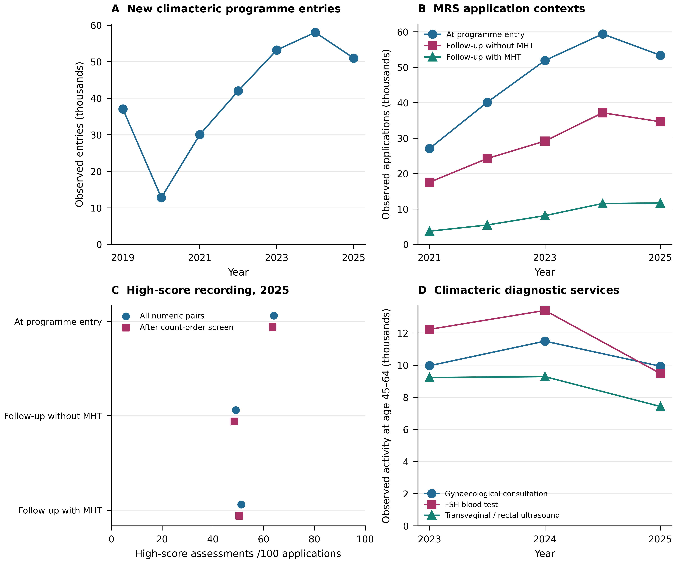
Figure 1. Source-verified menopause programme activity. A: annual A05 programme entries (01080090), without an age-specific denominator. B: annual A03 Menopause Rating Scale (MRS) applications at programme entry and follow-up with or without recorded menopausal hormone therapy (MHT), 2021–2025; no corresponding A03G rows were mapped in the inspected 2019–2020 templates. C: 2025 high-MRS/application ratios from facility-month pairs with numeric counts and positive applications. Squares exclude pairs with high-score counts above applications as a sensitivity screen. The three assessment contexts are selected populations and cannot estimate MHT effects. D: A29 consultations, follicle-stimulating hormone (FSH) blood tests and transvaginal/rectal ultrasound at ages 45–64; the source age column changes from Col02 in 2023–2024 to Col03 in 2025. Legacy 2021–2022 package/FSH codes have different scope. Counts sum observed numeric cells after exact-row deduplication and conflict quarantine. Blank cells and absent rows remain unobserved; reporting facilities change over time. Activity is not a patient-linked pathway, and repeated records may concern the same woman. Reporting and selection uncertainty is not quantified by sampling intervals. Sources: annual DEIS REM coded templates and original Series A files.
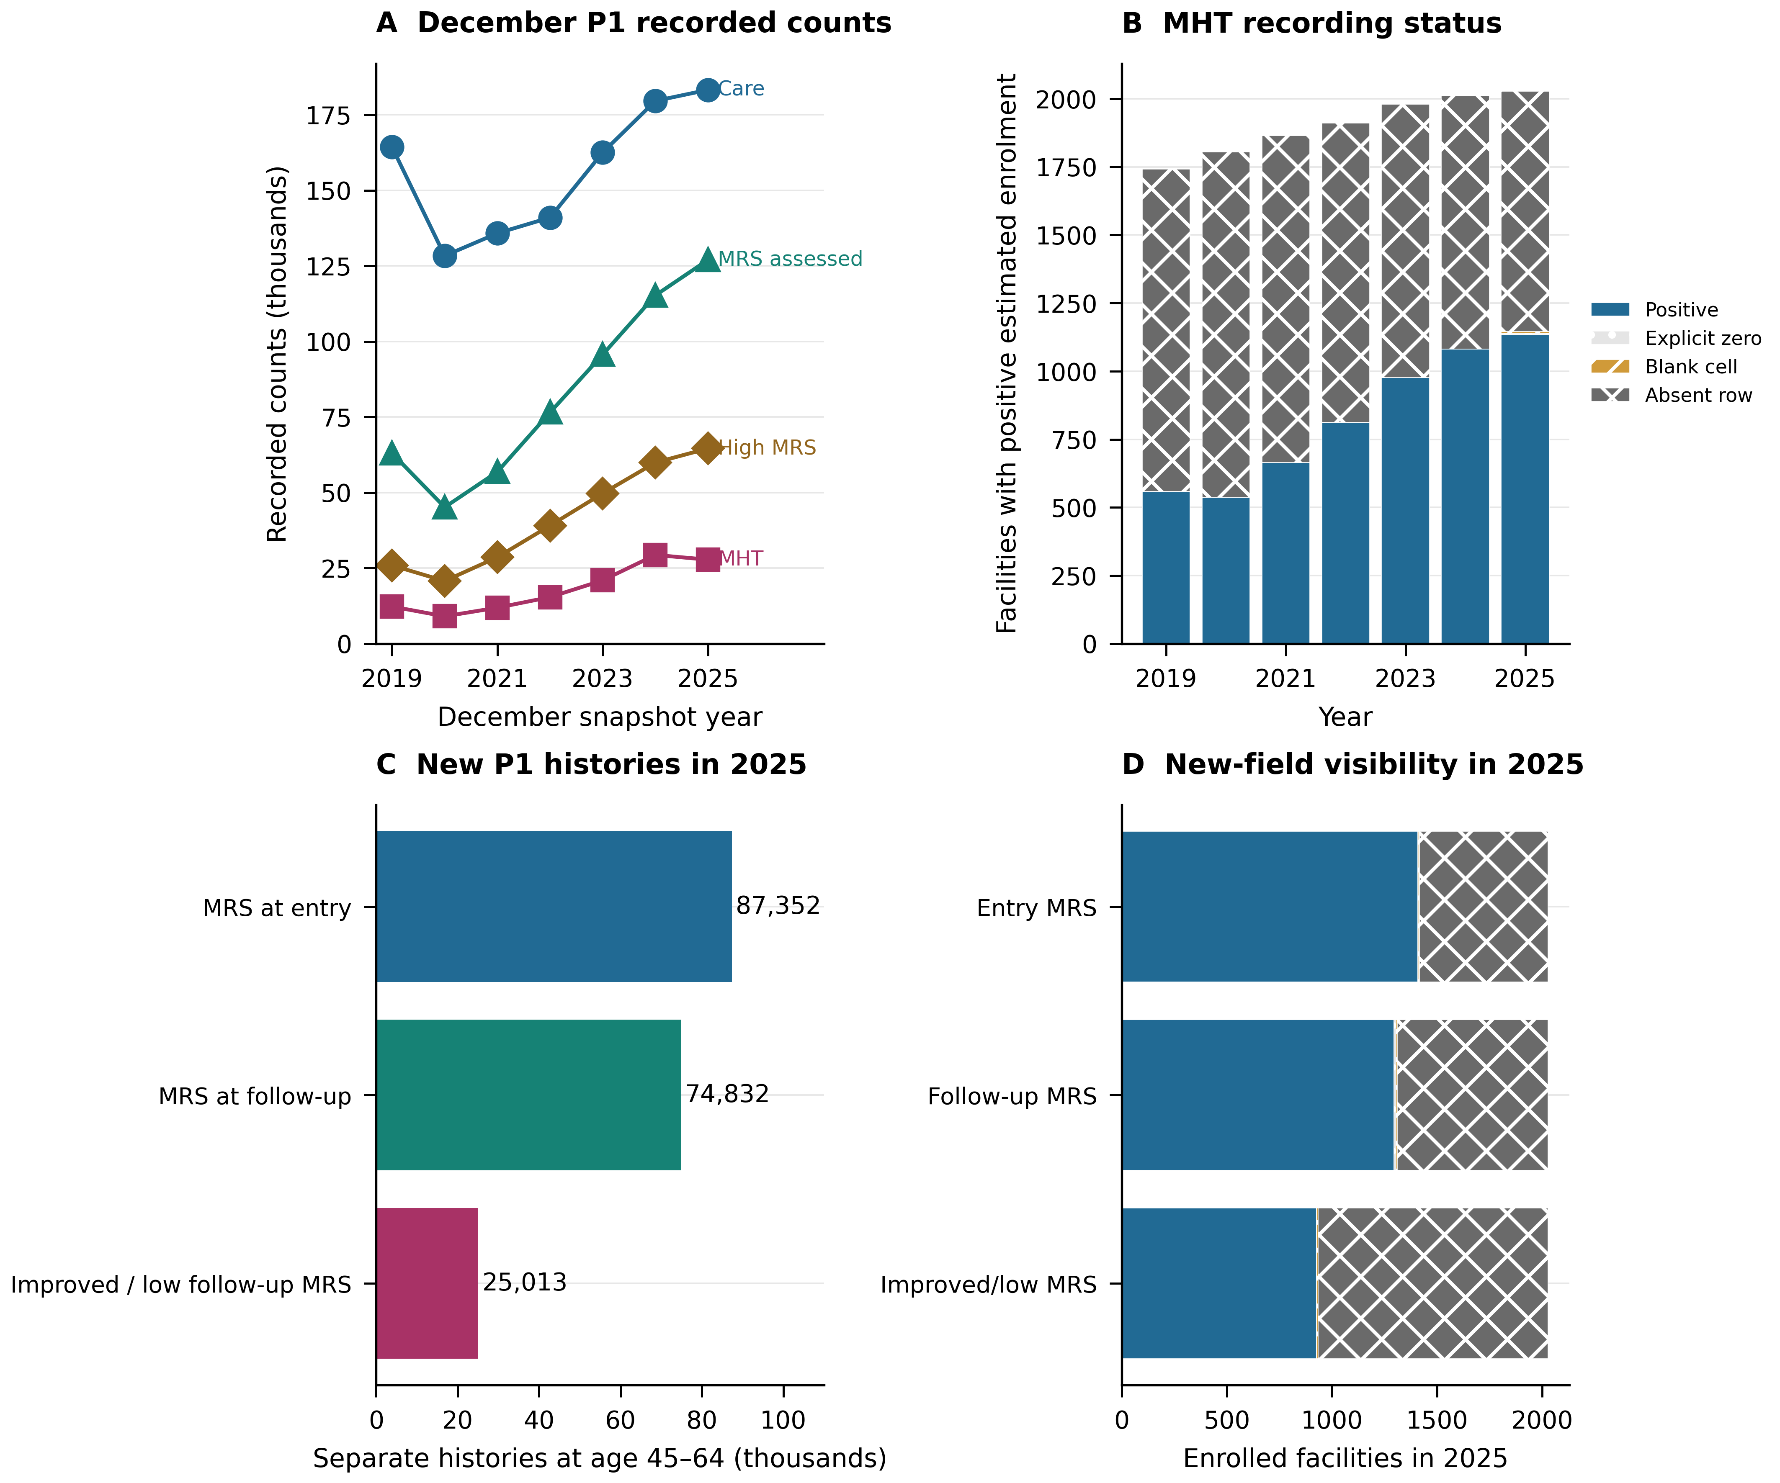
Figure 2. December source recording and new P1 history fields. A: deduplicated P1 counts at ages 45–64, 2019–2025, using Col02 in 2025 and Col01 earlier. Exact duplicate removal changes the frozen 2021 totals by 53 care, 10 assessed, five high-MRS and two MHT records. B: MHT source status among facilities with positive same-year estimated female enrolment at ages 45–64; explicit zero, blank cell and absent row remain separate. C: new 2025 entry-MRS, follow-up-MRS and improved/low follow-up fields. These overlapping assessment histories are not a disjoint cascade or treatment-response comparison. D: visibility of those fields among the 2025 enrolled facilities. Blank or absent observations cannot identify women who did not receive care. Enrolment derives from FONASA age bands apportioned using municipal INE female age structure; missing age shares remain missing. Counts can repeat women across snapshots and do not establish access, need or effectiveness. Sources: annual DEIS REM coded templates, original Series P files, FONASA and INE.
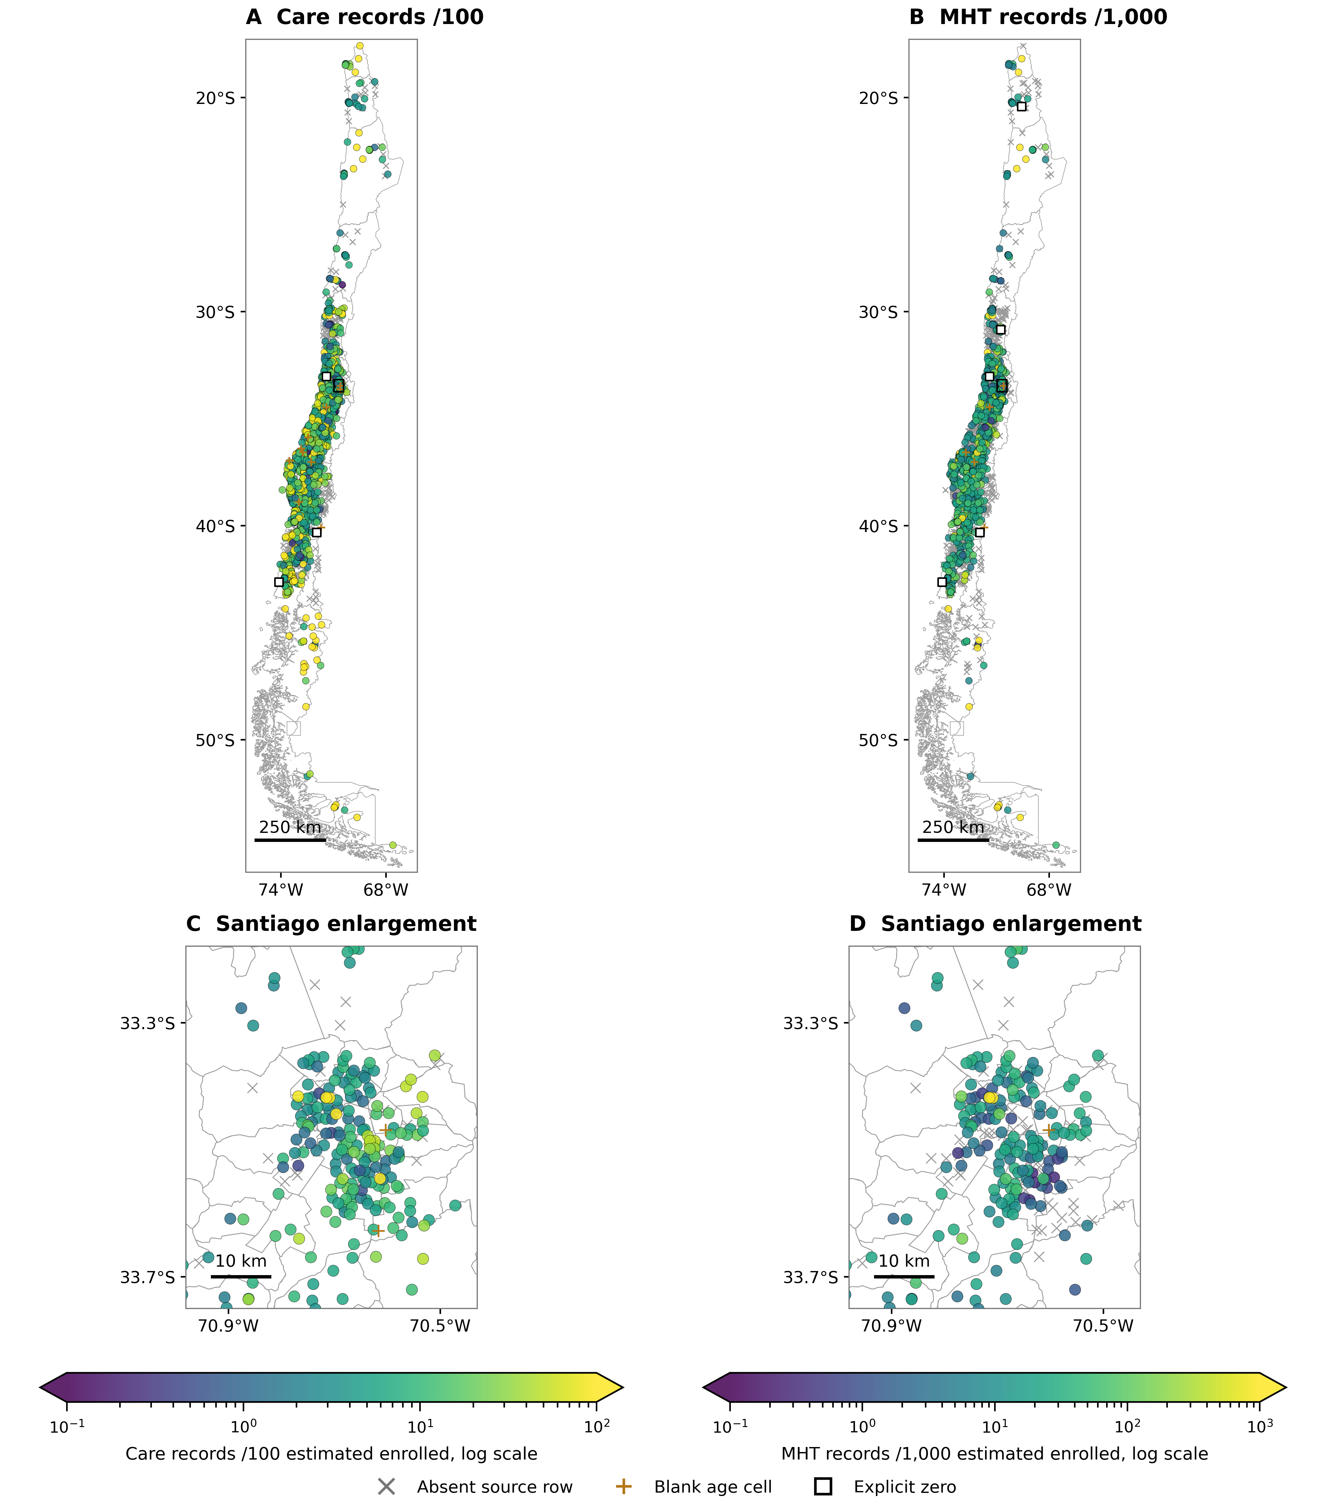
Figure 3. Facility geography of recorded menopause care and source visibility in 2025. A–B: December care records per 100 and MHT records per 1,000 estimated enrolled women aged 45–64. C–D: Santiago enlargements with the same respective scales. The mapped universe contains 1,995 facilities with positive same-year age-specific enrolment and usable mainland catalogue coordinates, including facilities without a source row. Coloured circles indicate positive numeric values, open squares explicit zeros, plus signs blank age cells in represented rows, and grey crosses absent rows. No unobserved value is set to zero. Positive colour scales are logarithmic; observations beyond their limits use the end colours. Differences can reflect care, reporting, provider selection, age-denominator estimation and geography, rather than measured access or underdiagnosis. Catalogue locations identify facilities, not residence or travel time. WGS84 coordinates, latitude-adjusted aspect ratios and approximate 250 km/10 km scale bars are used. Oceanic and Antarctic territories are omitted. Sources: DEIS REM, FONASA, INE and the public facility catalogue; boundaries from Biblioteca del Congreso Nacional de Chile, Mapoteca.
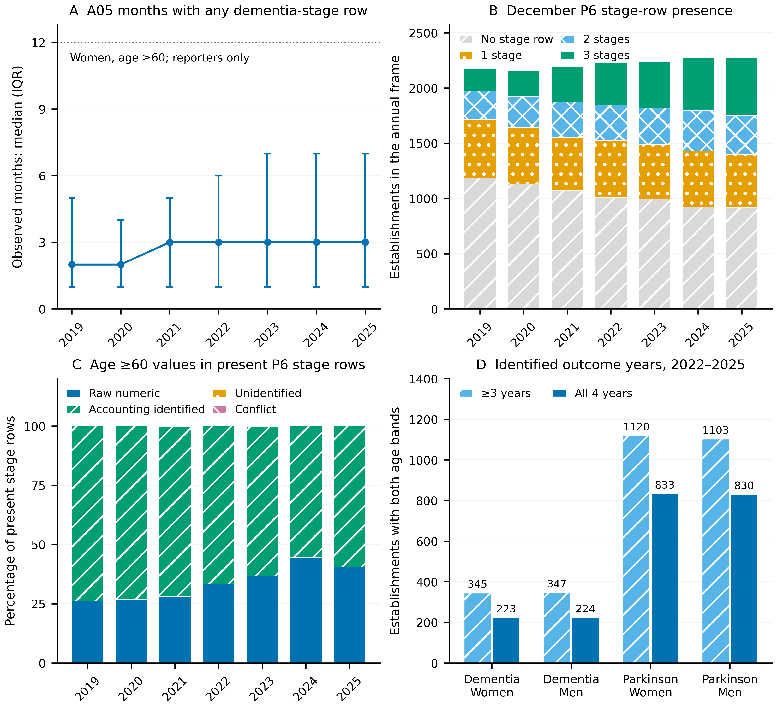
Figure 4. Reporting presence and count identification in REM, 2019–2025. A: median and interquartile range of distinct months containing any A05 dementia-stage row among establishments with at least one such row; women aged ≥60 are used, but physical row presence is shared across sexes. The dotted line is 12 months, not an imputed reporting assumption. B: zero, one, two or all three December P6 dementia-stage rows present in the annual union of establishments found in selected REM rows or FONASA enrolment records. No stage row is not interpreted as zero caseload. C: classification of age ≥60 counts in present December P6 stage rows in women. Raw numeric values have all needed cells recorded; accounting identification uses a nonnegative residual from the exhaustive age partition and reported sex total. Unidentified values retain bounds, and inconsistent totals are conflicts. D: establishments with exact counts in both 60–79 and ≥80 age bands and positive same-year enrolment, for at least three or all four years in 2022–2025; all three P6 stages or the single P3 Parkinson row are required each year. Counts precede any MHT-exposure intersection, covariate restriction or association model. IQRs describe establishment dispersion, not confidence intervals. Annual entry flows and repeated December snapshots are distinct recording units and are not incidence or individual follow-up.
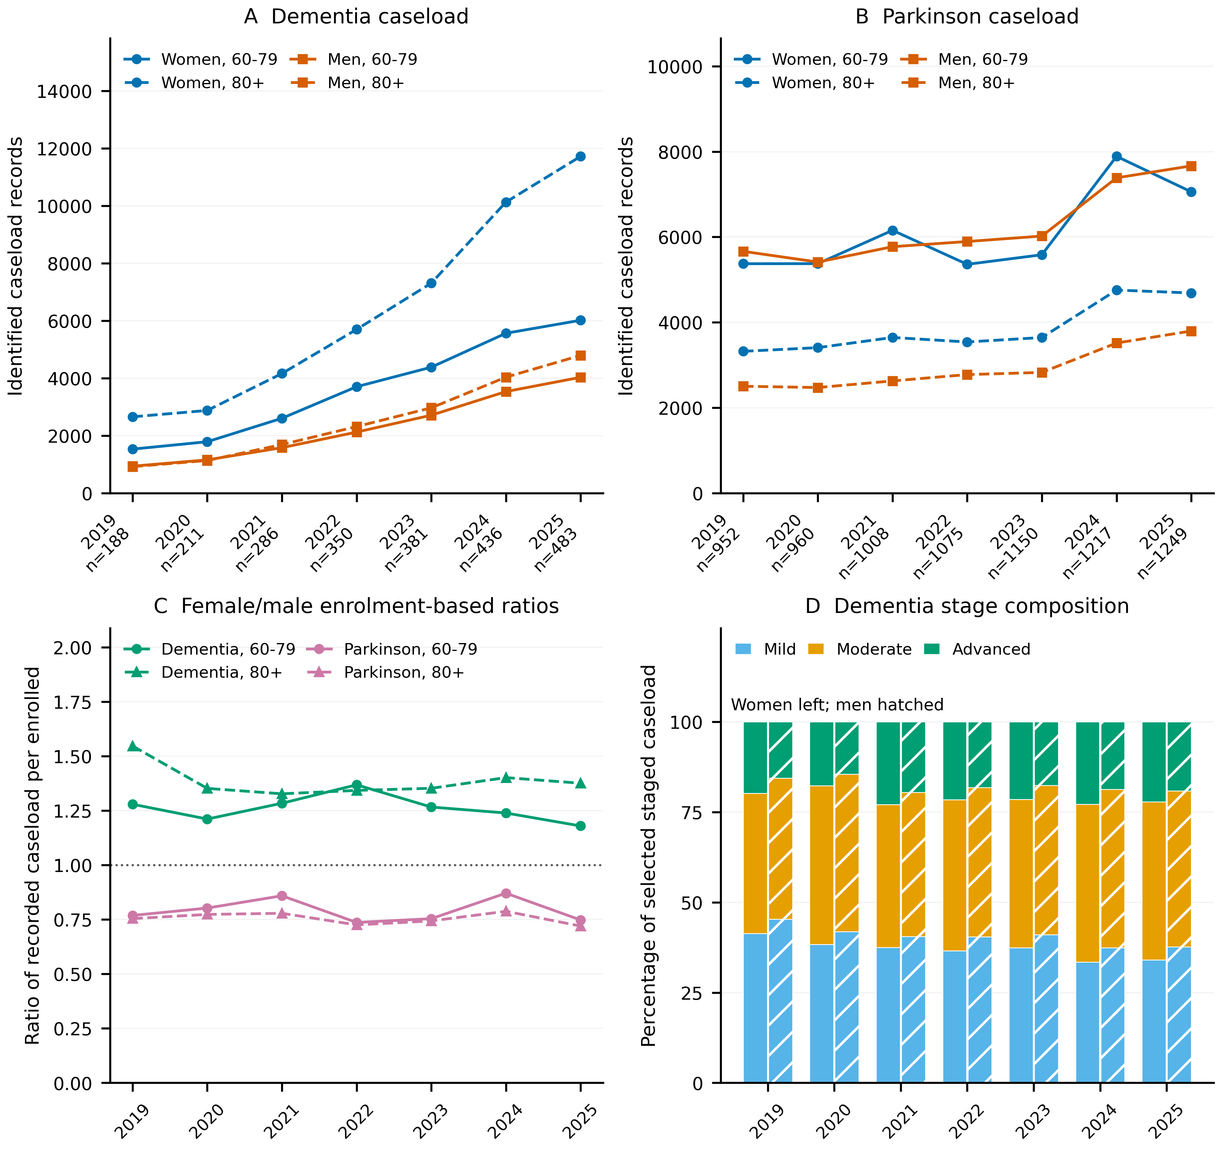
Figure 5. Identified neurological caseload in selected paired reporting establishments, 2019–2025. A–B: December dementia and Parkinson caseload records by recorded sex and age band, summed only over establishments where both 60–79 and ≥80 counts are identified and same-year enrolment is positive in both sexes. The annual provider count n is printed under each year; these changing selected samples are not national totals or a fixed longitudinal cohort. Women are blue circles, men orange squares; solid lines denote age 60–79 and dashed lines age ≥80. C: female/male ratios of caseload records per FONASA enrolment within the same age band and paired establishment set. These descriptive ratios are not individual clinical-risk ratios and no inferential intervals are assigned. D: mild, moderate and advanced dementia shares among the same selected P6 establishment-years with all three stage rows identified; women are left, men right with hatching. Stocks repeat people between years; stage proportions do not measure individual severity progression. Selection and provider composition vary by year, and absence of a stage row remains missing. Reported sex totals and exhaustive age partitions identify some blank age cells by accounting; this is retained separately from raw numeric cells. Source tables preserve counts, denominators and provider samples.
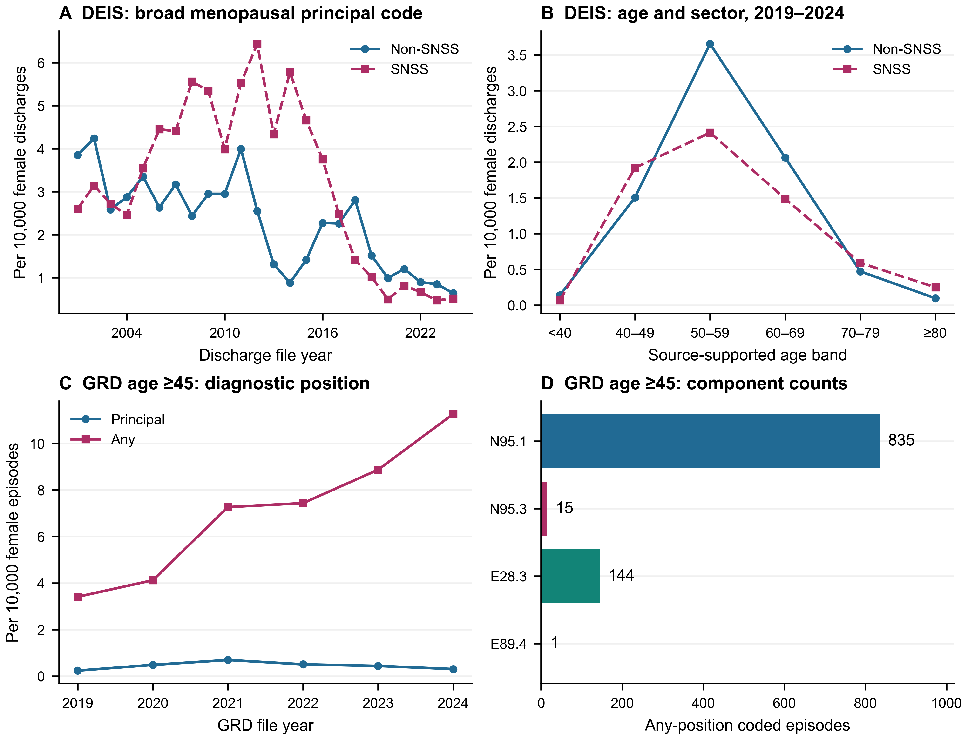
Figure 6. Source-specific menopause-related diagnostic recording. A: annual DEIS principal N95.1/N95.8/N95.9 codes per 10,000 female discharges, 2001–2024, by SNSS membership. B: pooled 2019–2024 DEIS ratios within source-supported decade age bands. C: principal versus any-position GRD N95.1/8/9 recording per 10,000 female episodes at age ≥45, 2019–2024. D: separate any-position GRD component counts at age ≥45. N95.1 is a subset of the broad group; the artificial and ovarian-failure codes retain their own definitions. Each panel retains its numerator, age scope and source denominator. Lines join observed annual aggregates; no inferential intervals or fitted trends are shown. SNSS membership is an establishment-sector field, not a complete insurance or ownership classification. These are hospital-recording frequencies, not clinical menopause prevalence, outpatient access or MHT use.
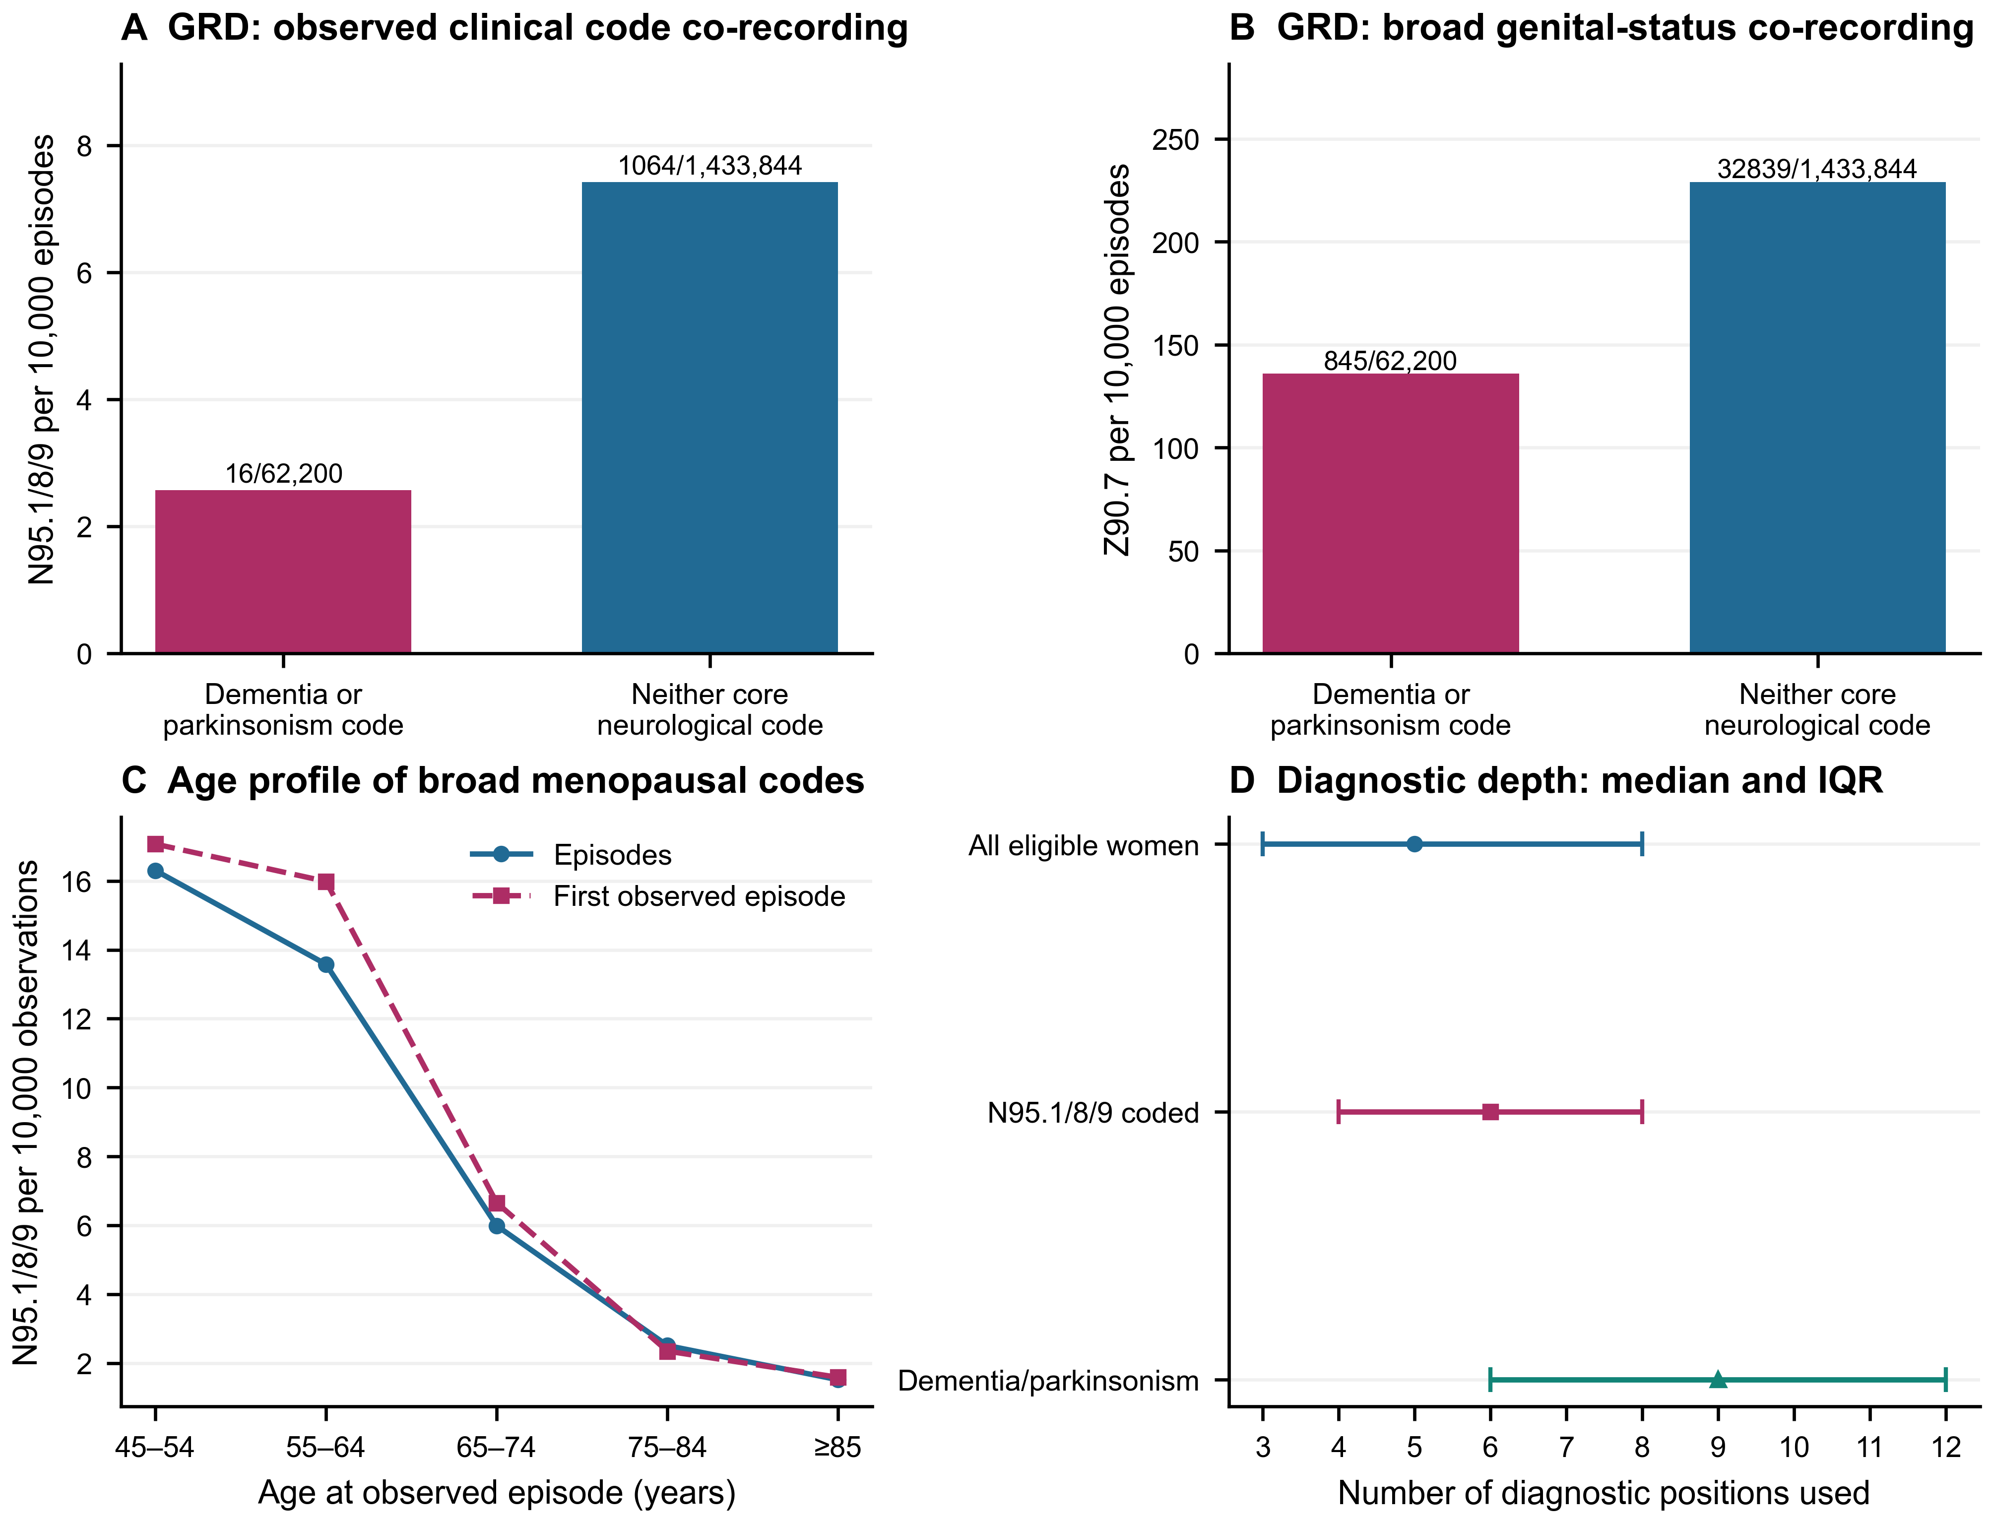
Figure 7. Same-episode co-recording and ascertainment context among GRD women aged ≥45. A: broad N95.1/N95.8/N95.9 recording per 10,000 episodes with versus without a dementia/parkinsonism code; labels give numerator/denominator. B: the same display for broad acquired-genital-organ-absence status Z90.7, which is not a BSO or hormone-treatment proxy. A–B use all eligible 2019–2024 episodes and are unadjusted descriptive ratios. C: age profiles using 2021–2024 episodes and one first eligible observed episode per woman after identifier/sex-consistency checks. D: median number of used diagnosis positions with 25th–75th percentile whiskers, for all eligible women, broad N95-coded episodes and dementia/parkinsonism-coded episodes in 2019–2024. These whiskers are IQRs, not confidence intervals. Different age distributions, hospital selection and diagnostic intensity can influence co-recording. Sparse joint clinical cells did not support an adjusted clinical-effect model; none was fitted.
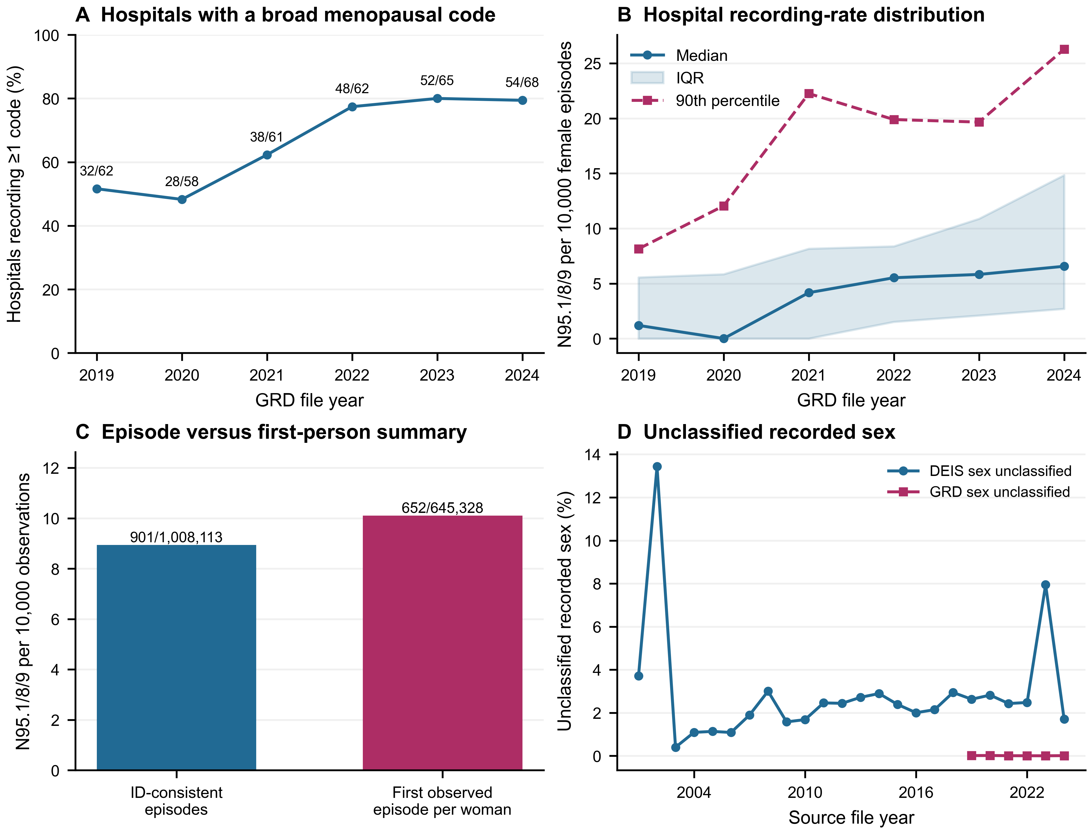
Figure 8. Provider heterogeneity, observation unit and source completeness. A: percentage of GRD hospitals with at least one broad N95.1/N95.8/N95.9 record among providers with ≥1,000 eligible female episodes aged ≥45 in that year; labels give positive/eligible hospital counts. Zero-recording providers are retained. B: unweighted hospital distribution of broad N95 recording ratios per 10,000 female episodes, showing median, IQR and 90th percentile; these are provider distributions, not confidence intervals or performance thresholds. C: broad N95 recording among ID-consistent 2021–2024 episodes versus one first observed episode per woman, with numerators and denominators. D: source records with unclassified recorded sex as a proportion of all records; the DEIS series covers 2001–2024 and GRD 2019–2024. Unclassified sex was not imputed from diagnosis. All displays describe the available records and selected hospital populations; they do not quantify unmet menopausal care or individual hormone exposure.
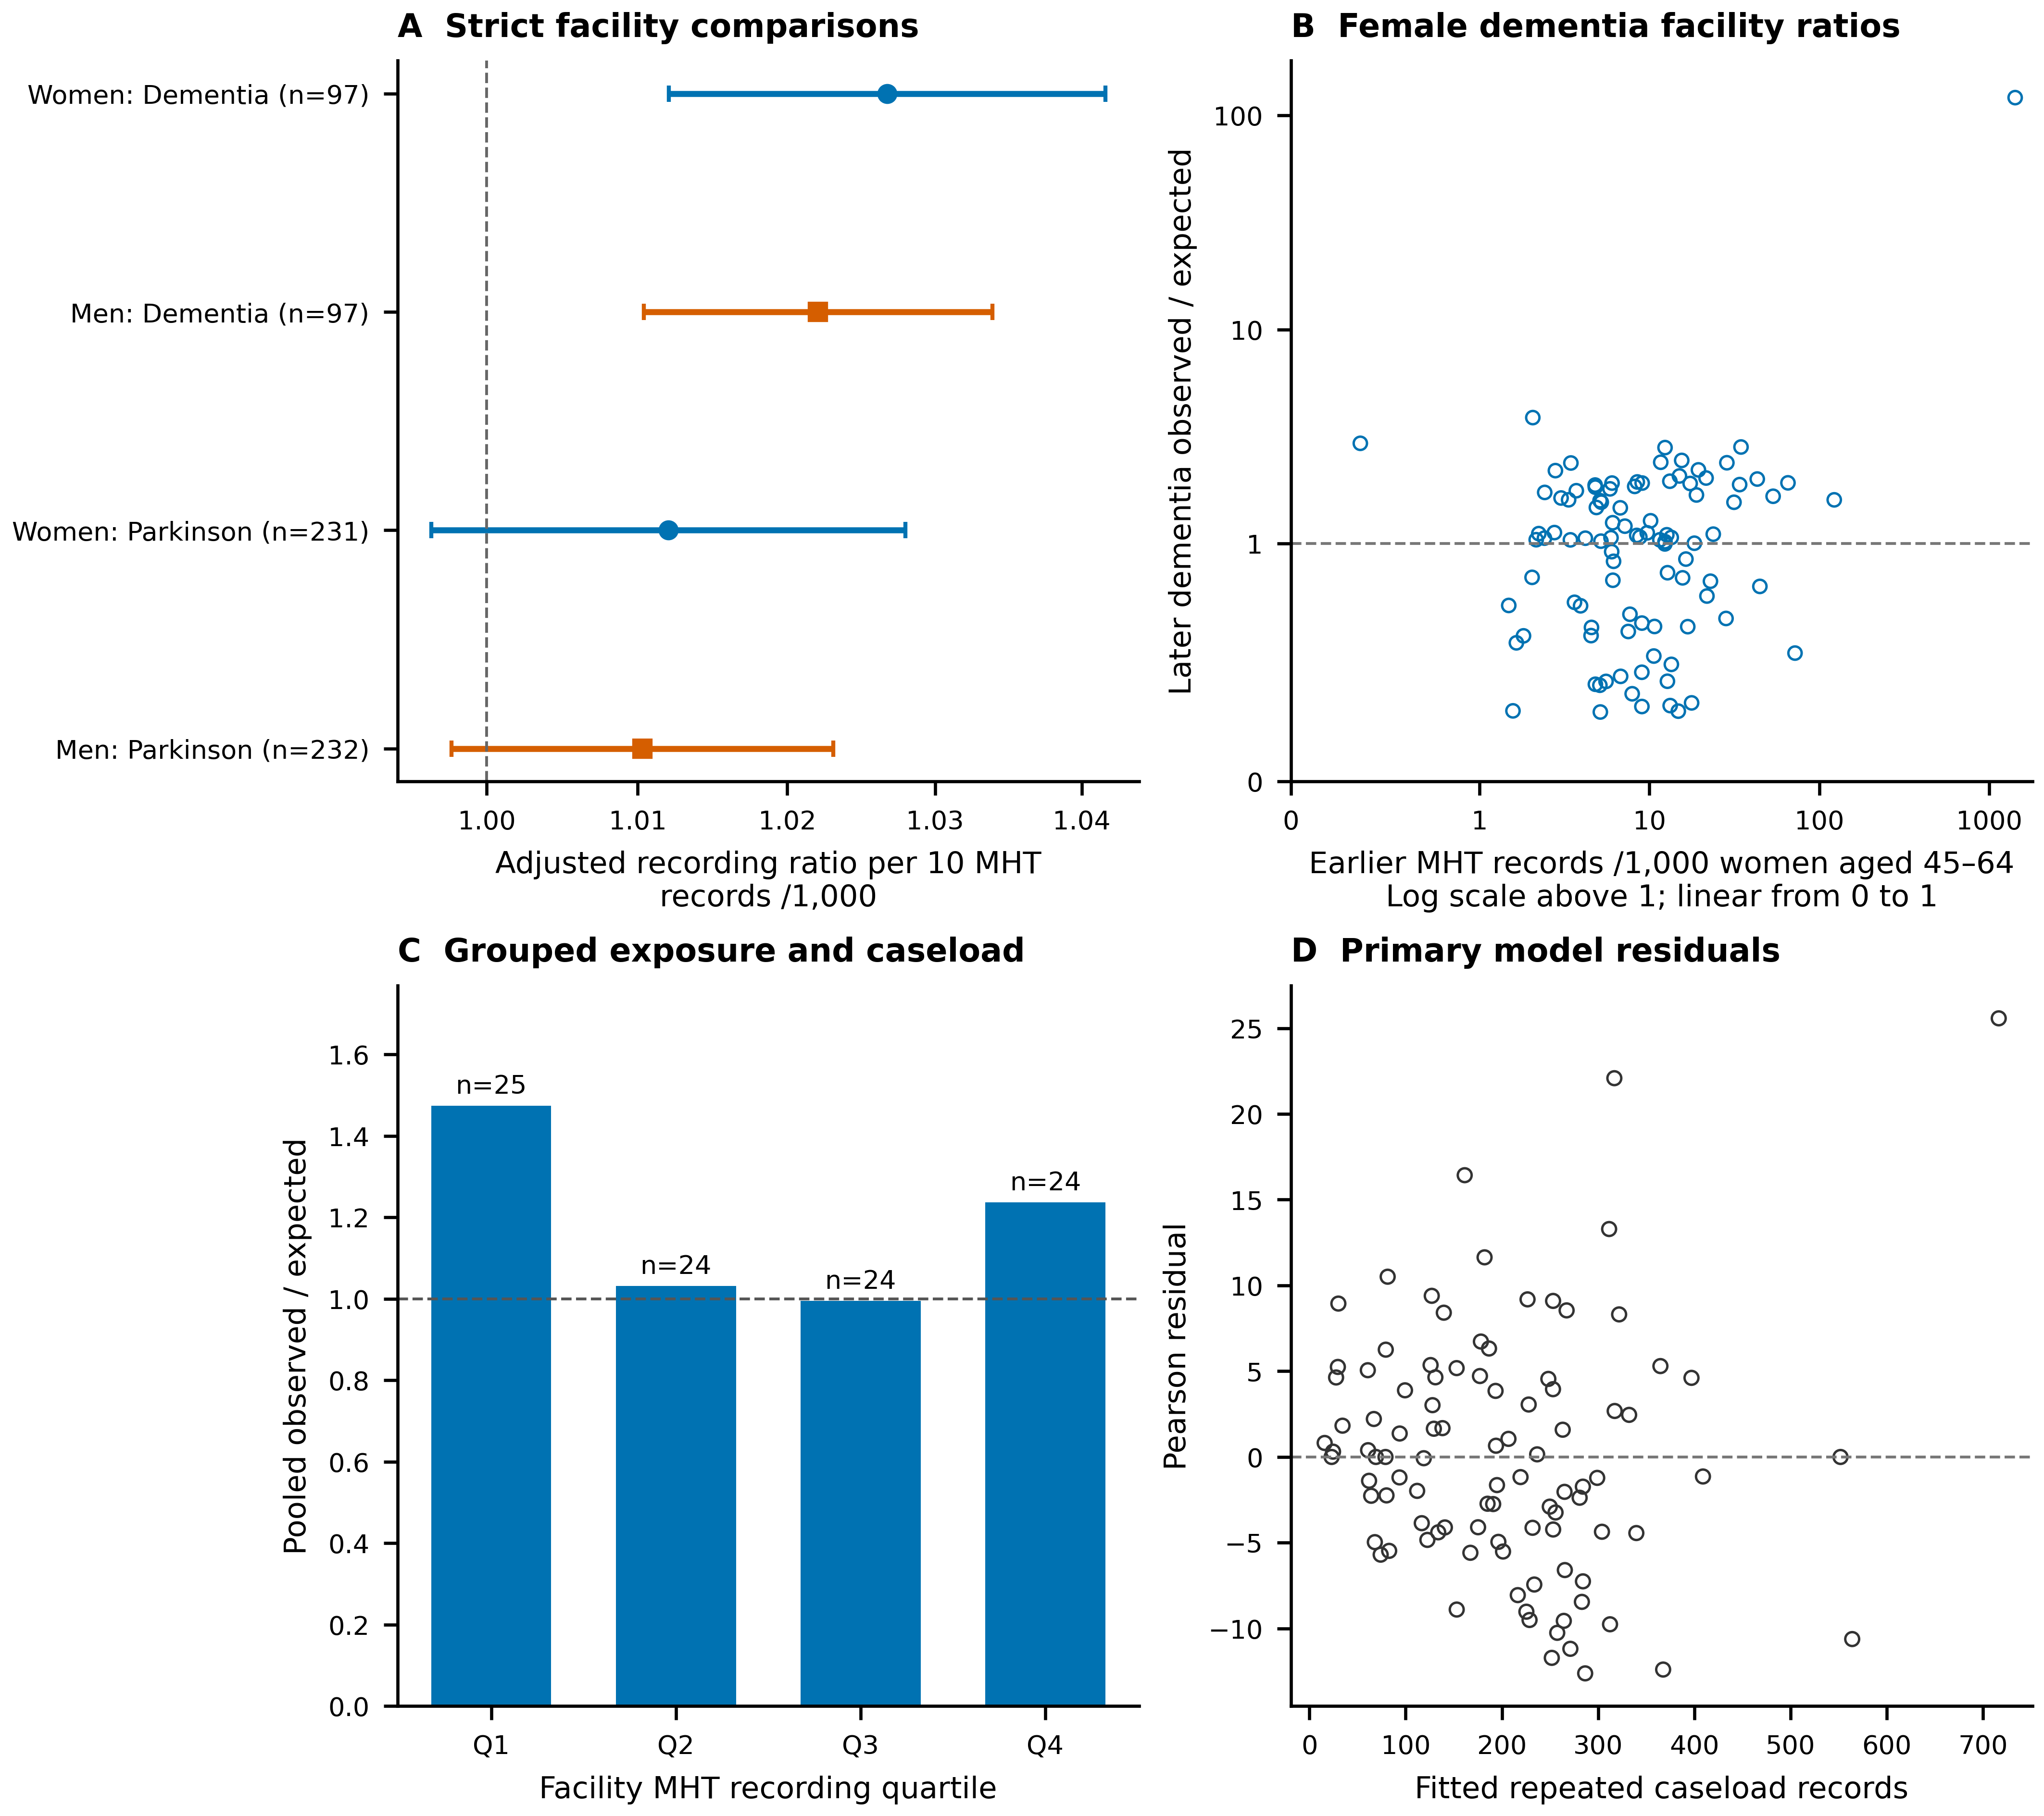
Figure 9. Earlier menopausal hormone therapy recording and later neurological caseload in selected reporting facilities. A: adjusted Poisson mean-model ratios per 10 additional MHT records per 1,000 estimated enrolled women aged 45–64 in pooled 2019–2021 December snapshots; outcomes are female or male dementia and Parkinson caseload records at age 60+ summed across four 2022–2025 December snapshots. Points and nominal 95% municipal-cluster t intervals use df=municipal clusters−1. Models include regional and facility-type indicators, contemporary municipal multidimensional poverty and rural share, and log mean older-person enrolment; offsets use source-internal sex/age/year expected counts. Sex-specific models have separately selected samples and are not formal sex contrasts. B–D: the strict female-dementia sample, showing unadjusted facility observed/expected ratios, grouped exposure-quartile ratios without sampling intervals, and primary-model Pearson residuals. Both axes in B use symmetric log scaling, linear between −1 and 1, to retain the extreme denominator-inconsistent hospital and the smaller facility values together. Quartile boundaries and component counts are in the source table. Repeated stocks are not unique women, incident diagnoses or person-time. Reporting and denominator restrictions select the analysed providers; these ecological comparisons do not identify an individual MHT effect.
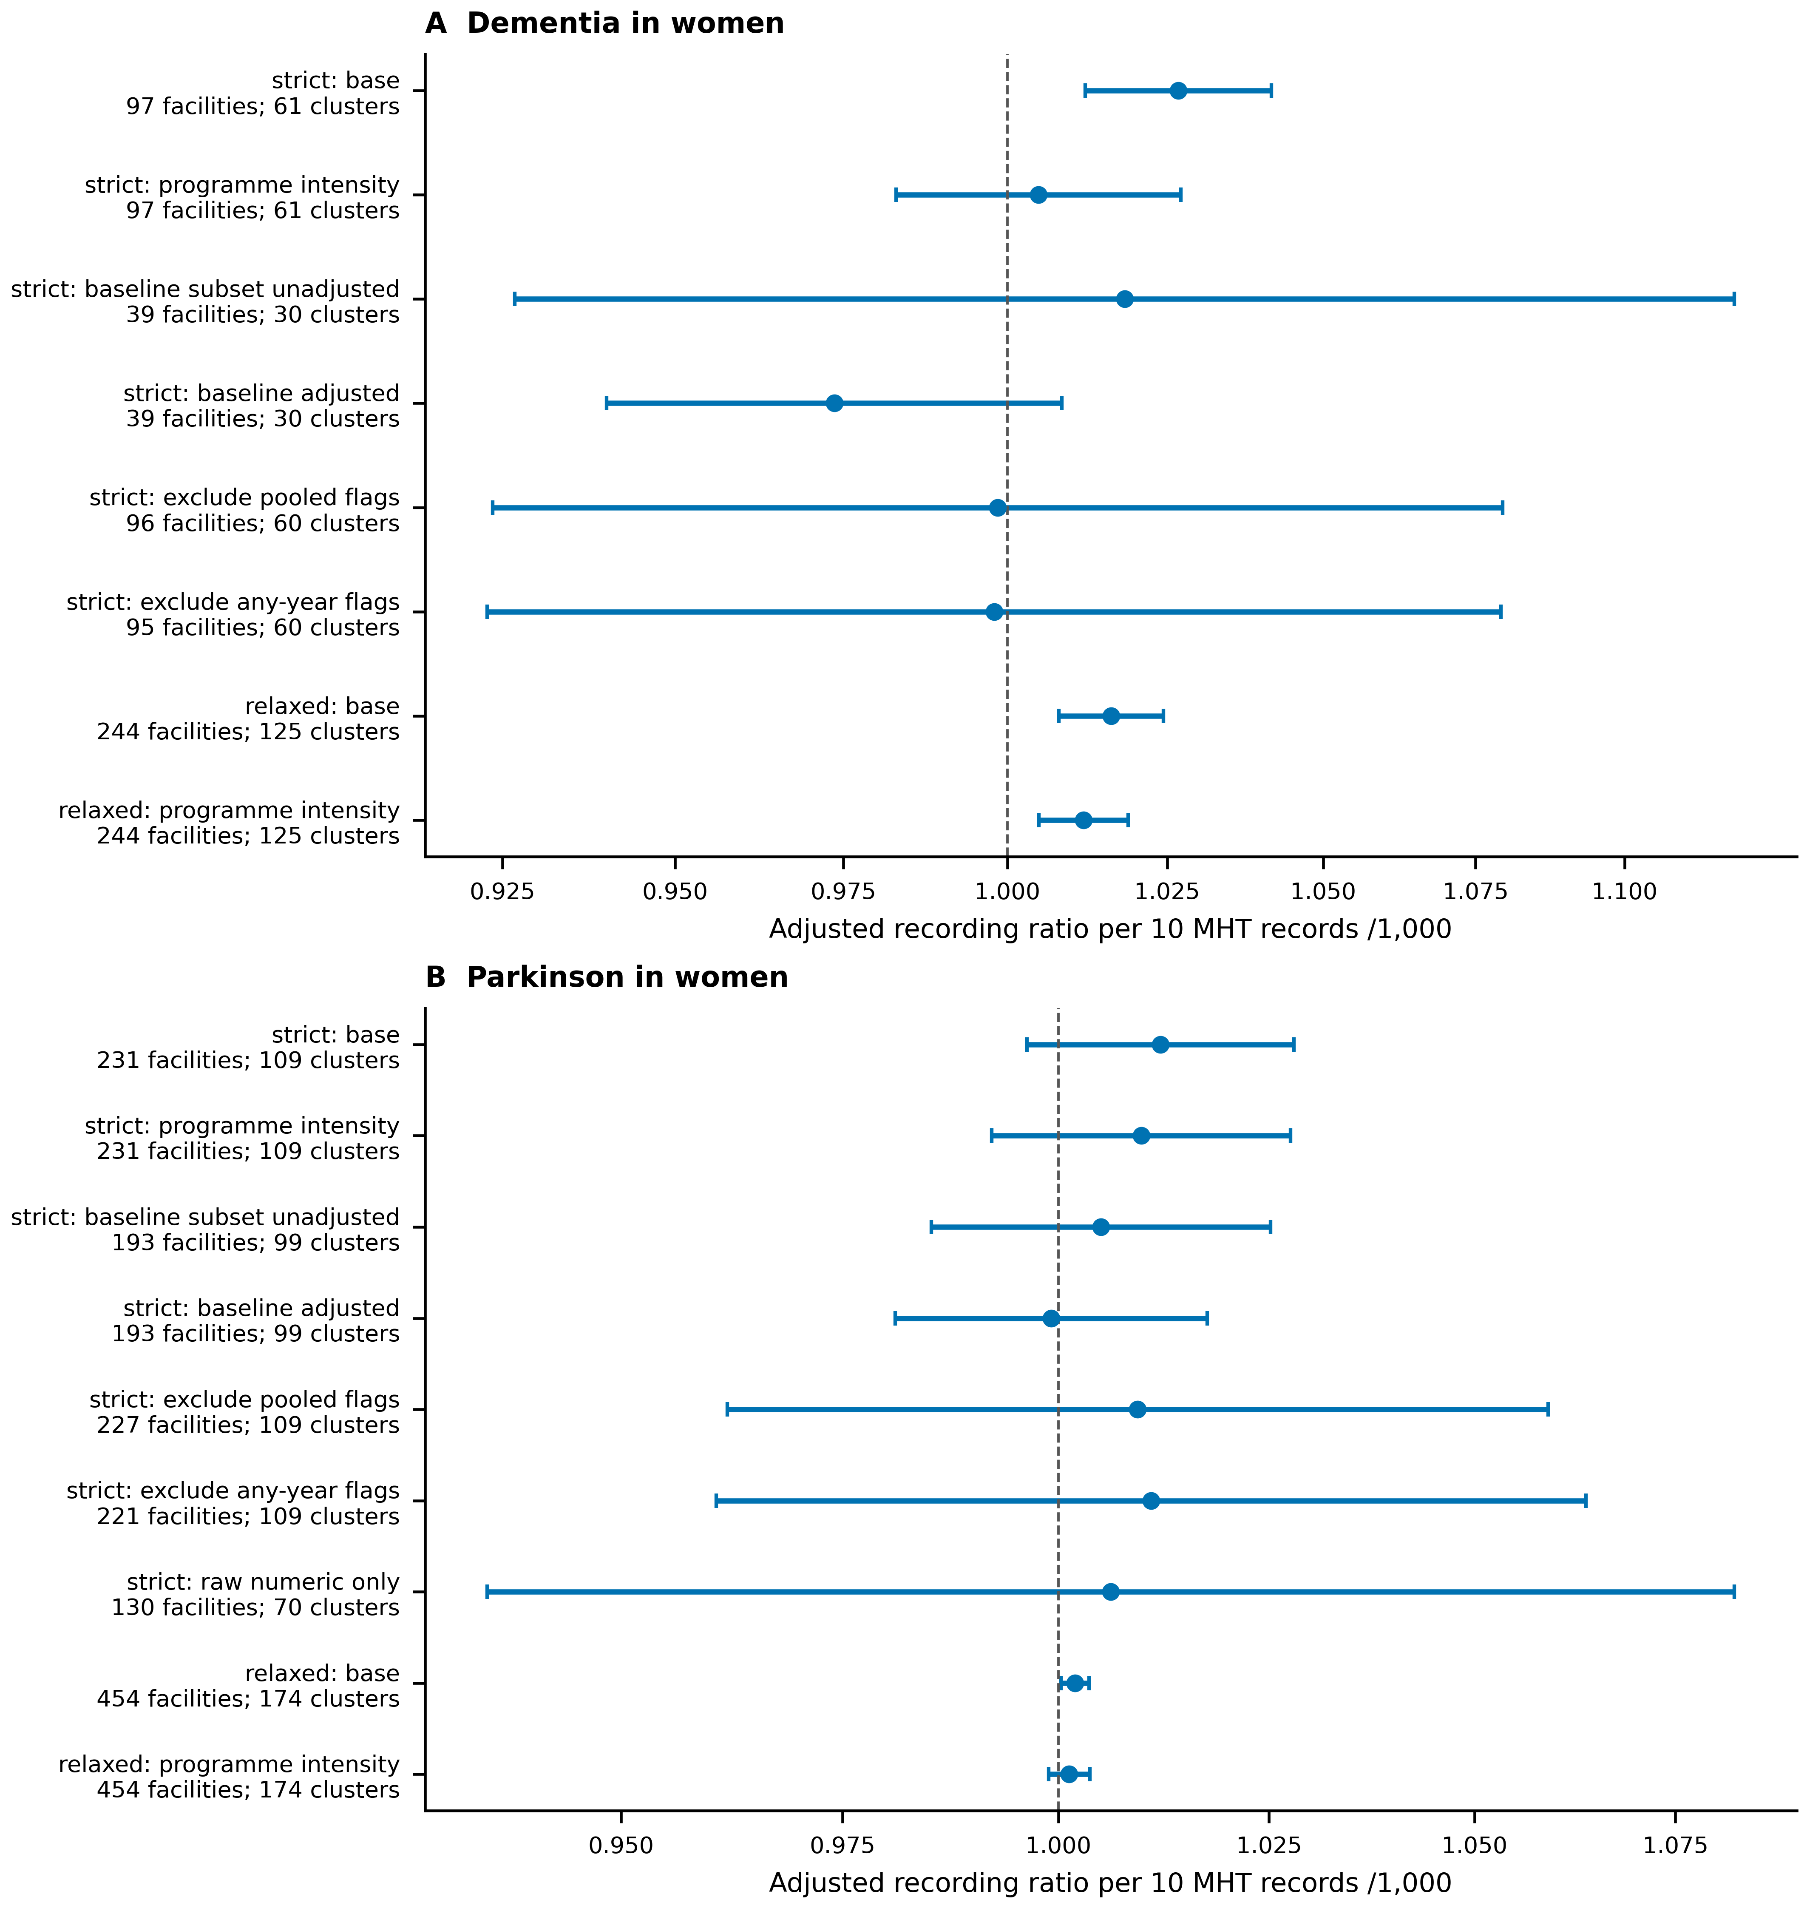
Figure 10. Sensitivity of female facility recording associations to reporting selection and programme intensity. Both panels show Poisson mean-model ratios and nominal 95% municipal-cluster t intervals per 10 additional earlier MHT records per 1,000 estimated enrolled women aged 45–64. Strict samples require three exposure years and four outcome snapshots; relaxed samples require at least two years in each window and therefore represent a different selected population. Programme-intensity models additionally include earlier climacteric-care records per 100 estimated enrolled women. Baseline models are displayed only when all three 2019–2021 same-outcome snapshots and all covariates support a full-rank model with at least 30 municipal clusters; the unadjusted baseline subset uses exactly the same facilities as the baseline-adjusted model. The source table records specifications withheld by these gates. The any-year source-flag sensitivity was added after independent audit of the initial fits and is explicitly post hoc. Raw-numeric-only models exclude exact accounting identification; female and male dementia subsets have fewer than 30 municipal clusters and are withheld. Intervals do not correct for all exploratory comparisons. Changes between differently selected samples cannot be attributed solely to covariate adjustment.

