Complete figure and table selection bank for the descriptive study in Chile

Methods
These candidate analyses use the corrected aggregate evidence underlying the descriptive study. Individual GRD identifiers are not distributed in this bank. Source definitions, periods, observation units, denominators, uncertainty and exclusions are specified in each caption or table note. The core Methods and Results document provides the common study design and definitions.
The bank includes recorded mortality, hospital GRD activity including coded ambulatory activity, principal-diagnosis discharges, primary-care entries and repeated caseload snapshots. These sources are retained separately. Maps describe registration in the observed population and facility samples; observed-to-expected ratios do not identify individual clinical risk or causes of variation. Exploratory spatial and network contrasts are qualified separately from descriptive estimates.
Every candidate is generated by a saved script from inspectable aggregate inputs, with fixed analysis definitions and seeds where applicable. Source-data CSVs and editable SVG and vector PDF versions accompany the native-resolution PNG images. All candidate material is in English.

Results
This complete selection document contains 24 multi-panel figures and 24 tables: the original working set and all additional candidates. Every item is included here for author selection. Identifiers do not assign material to the main article or supplement.

Age sex temporal patterns and health services
Figure S1. Annual mortality across six diagnostic groups, Chile, 2002–2024.
Figure S2. Dementia-subtype patterns by age and source.
Figure S3. Long-term DEIS discharges and the diagnostic-position gap in GRD.
Figure S4. Age at death or first observed GRD record, by recorded sex and condition.
Figure S5. Primary-care dementia records at age ≥60 by programme stage, sex and year, 2019–2025.
Figure S6. Complete set of sex-specific centre-level funnel plots, 2019–2025, age ≥60.
Table S1. Dementia: annual mortality and sex ratios, 2002–2024.
Table S2. Alzheimer's disease: annual mortality and sex ratios, 2002–2024.
Table S3. Age-specific sex ratios across conditions and routine sources.
Table S4. Age at recorded event and records before 65 years.
Table S5. Annual DEIS hospital discharges with dementia or parkinsonism.
Table S6. Dementia programme stages at age ≥60, 2019–2025.
Table S7. Complete centre-registration summary and precision subsamples.
Table S8. REM age-total consistency checks for the three main outcomes.

Regional and facility geospatial analyses
Figure S7. Regional mortality from dementia and parkinsonism, official deaths 2019–2023.
Figure S8. Female-to-male ratios of regional directly standardised mortality rates, 2019–2023 official deaths.
Figure S9. Dementia caseload (P6) across public primary-care centres, 2019–2025.
Figure S10. Parkinson caseload (P3) across public primary-care centres, 2019–2025.
Figure S11. Ratios of the sex-specific smoothed observed/expected (O/E) registration in each centre, 2019–2025, for dementia entries, dementia caseload and Parkinson caseload.
Figure S12. Neighbour-definition sensitivity for the same 637-centre dementia-entry sample used in the primary spatial analysis.
Figure S13. Regional distributions of smoothed observed/expected (O/E) activity among all 1,589 selected primary-care centres, 2019–2025, by sex and outcome.
Figure S14. Scope and selection of the centre-level analysis.
Table S9. Regional all-age standardised mortality and sex ratios.
Table S10. Regional recorded hospital activity by source and sex.
Table S11. Municipal variance components and spatial association across outcomes.
Table S12. Catalogue baseline and selected spatial samples by region and facility type.
Table S13. Neighbour-graph sensitivity of global spatial association.
Table S14. Regional counts outside Poisson funnel control limits.

Comorbidity networks and coding profiles
Figure S15. Unadjusted comorbidity networks of unique people aged ≥60 with recorded public-hospital GRD episodes in 2021–2024, including day surgery and other coded activities.
Figure S16. Adjusted networks of unique people aged ≥60 with public-hospital GRD episodes, 2021–2024, including day surgery and other coded activities.
Figure S17. Differences in coded comorbidity percentages between women and men with public-hospital GRD episodes, among unique people aged ≥60 in 2021–2024.
Figure S18. Case-dropping stability of the six unadjusted unique-person networks, 2021–2024.
Table S15. Unique-person sample by disease and sex.
Table S16. Coded prevalence of the 21 network nodes by disease and sex.
Table S17. Node centrality in Alzheimer disease networks.
Table S18. Node centrality in unspecified dementia networks.
Table S19. Node centrality in Parkinson disease networks.
Table S20. Ten largest absolute unadjusted edge weights in each unique-person network.
Table 1. Data sources and observation units
Source | Period | Unit and coverage | Volume
DEIS deaths | 2002–2024* | Death; underlying cause; national coverage | 2 371 230
DEIS discharges | 2001–2024 | Discharge; principal diagnosis; public and private hospitals | 38 818 057
GRD | 2019–2024 | Episode; up to 35 diagnoses; public hospitals, including coded ambulatory activity | 5 808 535
REM A05 P6 P3 | 2019–2025 | Facility, sex and age counts; entries and caseload snapshots | Aggregate counts
FONASA | 2019–2025 | December enrolment by facility, sex and age band | 1 589 facilities
DEIS facility catalogue | Current | Facility type, municipality and coordinates | —
INE | 2002–2025 | National base-2024 and territorial base-2017 population denominators | —
*Deaths in 2024 are preliminary and displayed separately; trends use 2002–2023 only. Sources are neither pooled nor linked to each other. Included facilities form a sample defined by programme availability and enrolment criteria, rather than all primary-care providers. Annual caseload snapshots may repeatedly include the same person.

Table 2. Female to male ratios of recorded rates
Outcome | Source and window | All ages | <45 | 45–64 | 65–79 | ≥80
Dementia | Deaths 2019–2023 | 1·17 (1·14–1·20) | 0·56 (0·23–1·34) | 0·91 (0·74–1·13) | 0·88 (0·83–0·94) | 1·29 (1·25–1·33)
Dementia | GRD episodes 2019–2024 | 0·98 (0·97–1·00) | 1·10 (0·92–1·32) | 0·80 (0·75–0·85) | 0·87 (0·85–0·89) | 1·09 (1·07–1·11)
Dementia | GRD persons 2021–2024 | 0·99 (0·98–1·01) | 1·01 (0·80–1·29) | 0·80 (0·73–0·87) | 0·87 (0·84–0·90) | 1·12 (1·09–1·15)
Dementia | Primary-care entries 2019–2025 | 1·30 (1·28–1·32) | 1·28 (1·18–1·39) | 1·16 (1·10–1·23) | 1·24 (1·21–1·27) | 1·40 (1·37–1·43)
Dementia | Primary-care caseload Dec 2024 | 1·50 (1·47–1·54) | 2·41 (2·17–2·68) | 1·59 (1·45–1·73) | 1·29 (1·24–1·34) | 1·52 (1·47–1·57)
Alzheimer | Deaths 2019–2023 | 1·31 (1·26–1·36) | — | 1·10 (0·75–1·61) | 1·11 (1·02–1·20) | 1·38 (1·33–1·44)
Alzheimer | GRD episodes 2019–2024 | 1·20 (1·17–1·22) | 1·14 (0·57–2·26) | 1·05 (0·91–1·21) | 1·12 (1·08–1·16) | 1·25 (1·22–1·29)
Alzheimer | GRD persons 2021–2024 | 1·20 (1·17–1·24) | 0·63 (0·25–1·56) | 0·91 (0·74–1·11) | 1·10 (1·05–1·16) | 1·28 (1·24–1·33)
Parkinsonism | Deaths 2019–2023 | 0·55 (0·51–0·58) | — | 0·47 (0·35–0·65) | 0·49 (0·44–0·55) | 0·59 (0·55–0·64)
Parkinsonism | GRD episodes 2019–2024 | 0·60 (0·59–0·61) | 0·81 (0·69–0·95) | 0·65 (0·61–0·70) | 0·60 (0·58–0·62) | 0·56 (0·54–0·58)
Parkinsonism | GRD persons 2021–2024 | 0·60 (0·58–0·62) | 0·71 (0·57–0·88) | 0·65 (0·59–0·71) | 0·60 (0·57–0·62) | 0·56 (0·53–0·59)
Parkinsonism | Primary-care caseload Dec 2024 | 0·90 (0·88–0·92) | 1·43 (1·16–1·75) | 1·02 (0·96–1·08) | 0·87 (0·84–0·90) | 0·84 (0·80–0·87)
Huntington disease and ataxias | Deaths 2019–2023 | 0·99 (0·70–1·39) | 0·84 (0·40–1·77) | 1·14 (0·68–1·91) | 0·87 (0·49–1·57) | —
Huntington disease and ataxias | GRD episodes 2019–2024 | 0·97 (0·87–1·09) | 1·01 (0·87–1·17) | 1·09 (0·88–1·34) | 0·78 (0·61–1·00) | 0·30 (0·16–0·57)
Huntington disease and ataxias | GRD persons 2021–2024 | 1·02 (0·86–1·20) | 1·06 (0·84–1·33) | 1·30 (0·97–1·75) | 0·74 (0·52–1·05) | 0·28 (0·13–0·61)
Ratios of age-standardised rates with 95% confidence intervals. Cells with fewer than five records in either sex are omitted. Sources retain their own coverage, observation unit and window. GRD persons denotes the first observed record during 2021–2024. REM counts are programme entries or caseload, not incidence. P3 denotes the Parkinson's disease programme, rather than the full G20–G23 spectrum in deaths and GRD. The final REM age band is ≥80 and cannot reproduce the 80–84/≥85 subdivision in deaths and GRD.
Table 3. Registration and variation across primary care facilities
Measure ≥60 | Sex | Facilities | Counts | Outside 99·8% | Between sex ρ | Municipal ICC | ICC n
Dementia entries | Women | 1 589 | 35 048 | 30·5 | 0·64 | 0·40 | 638
Dementia entries | Men | 1 589 | 18 084 | 21·1 | 0·64 | 0·35 | 638
Dementia caseload | Women | 1 589 | 90 320 | 42·9 | 0·71 | 0·32 | 730
Dementia caseload | Men | 1 589 | 44 278 | 36·0 | 0·71 | 0·35 | 730
Parkinson caseload | Women | 1 589 | 69 081 | 38·1 | 0·65 | 0·36 | 766
Parkinson caseload | Men | 1 589 | 63 630 | 39·9 | 0·65 | 0·41 | 766
Counts accumulated over 2019–2025: caseload snapshots are repeated annual observations, not unique people. Percentages outside limits refer to Poisson funnels. ρ is Spearman correlation of smoothed O/E ratios in all 1,589 paired facilities. ICCs are based on log smoothed O/E models restricted to facilities with ≥5 expected events in both sexes and excluding rural posts; their sample sizes therefore differ. The concordance figure uses a different subset with ≥5 expected events in both sexes and retains all facility types.
Table 4. Exploratory network contrasts in unique people
Comparison A / B | Model | n A / B | Strength A / B | Strength p | Strength Holm p | M | Structure p | Structure Holm p
Alzheimer men / women | Unadjusted | 6 721 / 12 565 | 9·19 / 9·32 | 0·846 | 1·000 | 0·125 | 0·940 | 1·000
Alzheimer men / women | Age and coding | 6 721 / 12 565 | 8·33 / 8·60 | 0·705 | 1·000 | 0·121 | 0·967 | 1·000
Unspecified men / women | Unadjusted | 8 106 / 12 210 | 9·92 / 9·92 | 0·990 | 1·000 | 0·193 | 0·043 | 0·301
Unspecified men / women | Age and coding | 8 106 / 12 210 | 9·18 / 8·44 | 0·258 | 1·000 | 0·204 | 0·018 | 0·144
Parkinson men / women | Unadjusted | 7 784 / 6 204 | 9·59 / 10·92 | 0·130 | 0·909 | 0·144 | 0·917 | 1·000
Parkinson men / women | Age and coding | 7 784 / 6 204 | 8·52 / 10·29 | 0·047 | 0·376 | 0·177 | 0·521 | 1·000
Unspecified / Alzheimer in women | Unadjusted | 12 210 / 12 565 | 9·92 / 9·32 | 0·298 | 1·000 | 0·129 | 0·525 | 1·000
Unspecified / Alzheimer in women | Age and coding | 12 210 / 12 565 | 8·44 / 8·60 | 0·777 | 1·000 | 0·100 | 0·969 | 1·000
First eligible year per person in 2021–2024, age ≥60. Global strength is the sum of absolute edge weights; M is the maximum absolute difference in weights. Holm correction was applied separately to eight global-strength and eight structural contrasts, with 1,000 permutations per contrast and penalty selection repeated. Tests assume label exchangeability and are exploratory. They establish neither equivalence nor temporal stability. The resolution of 1,000 permutations is insufficient to interpret absent Holm-significant results across 210 edges.
Table S1. Dementia: annual mortality and sex ratios, 2002–2024
Year | Deaths, women | Deaths, men | Standardised rate, women | Standardised rate, men | Women / men | Status
2002 | 1,542 | 965 | 14.73 (13.99–15.50) | 16.50 (15.47–17.58) | 0.89 (0.82–0.97) | Official
2003 | 1,667 | 1,047 | 15.07 (14.35–15.82) | 17.30 (16.26–18.39) | 0.87 (0.81–0.94) | Official
2004 | 1,806 | 1,032 | 15.74 (15.02–16.50) | 16.47 (15.47–17.51) | 0.96 (0.89–1.03) | Official
2005 | 1,883 | 1,026 | 15.77 (15.06–16.52) | 15.58 (14.64–16.57) | 1.01 (0.94–1.09) | Official
2006 | 1,968 | 1,026 | 15.77 (15.07–16.50) | 15.00 (14.09–15.95) | 1.05 (0.97–1.13) | Official
2007 | 2,334 | 1,279 | 17.77 (17.05–18.52) | 18.01 (17.03–19.03) | 0.99 (0.92–1.06) | Official
2008 | 2,321 | 1,231 | 17.17 (16.47–17.91) | 16.53 (15.62–17.49) | 1.04 (0.97–1.11) | Official
2009 | 2,333 | 1,224 | 16.33 (15.66–17.02) | 15.59 (14.72–16.49) | 1.05 (0.98–1.12) | Official
2010 | 2,455 | 1,284 | 16.38 (15.73–17.06) | 15.68 (14.84–16.57) | 1.04 (0.98–1.12) | Official
2011 | 2,349 | 1,166 | 15.05 (14.44–15.69) | 13.55 (12.78–14.36) | 1.11 (1.03–1.19) | Official
2012 | 2,615 | 1,255 | 16.19 (15.57–16.85) | 13.89 (13.13–14.69) | 1.17 (1.09–1.25) | Official
2013 | 2,422 | 1,188 | 14.11 (13.54–14.70) | 12.51 (11.81–13.25) | 1.13 (1.05–1.21) | Official
2014 | 2,262 | 1,163 | 12.67 (12.14–13.22) | 11.61 (10.95–12.30) | 1.09 (1.02–1.17) | Official
2015 | 2,169 | 1,077 | 11.60 (11.10–12.13) | 10.16 (9.56–10.79) | 1.14 (1.06–1.23) | Official
2016 | 2,218 | 1,153 | 11.36 (10.87–11.87) | 10.32 (9.73–10.94) | 1.10 (1.02–1.18) | Official
2017 | 2,354 | 1,295 | 11.50 (11.02–12.00) | 11.06 (10.46–11.68) | 1.04 (0.97–1.11) | Official
2018 | 2,664 | 1,368 | 12.42 (11.93–12.92) | 11.18 (10.59–11.80) | 1.11 (1.04–1.19) | Official
2019 | 2,741 | 1,432 | 12.29 (11.82–12.79) | 11.18 (10.60–11.78) | 1.10 (1.03–1.17) | Official
2020 | 2,919 | 1,507 | 12.71 (12.24–13.21) | 11.22 (10.66–11.82) | 1.13 (1.06–1.21) | Official
2021 | 3,503 | 1,781 | 14.73 (14.23–15.25) | 12.80 (12.21–13.42) | 1.15 (1.09–1.22) | Official
2022 | 3,984 | 1,909 | 16.30 (15.79–16.85) | 13.32 (12.73–13.95) | 1.22 (1.16–1.29) | Official
2023 | 4,031 | 1,942 | 16.14 (15.63–16.67) | 13.05 (12.47–13.66) | 1.24 (1.17–1.31) | Official
2024 | 4,560 | 2,203 | 17.43 (16.92–17.98) | 14.00 (13.42–14.62) | 1.24 (1.18–1.31) | Preliminary
Rates per 100,000 resident person-years, all ages, directly standardised to normalised WHO world weights; gamma 95% CIs. Female-to-male rate ratios have log-normal 95% CIs. Underlying-cause codes define the administrative outcome. 2024 is preliminary (release cut-off 23 June 2026); it is excluded from official-year trend models. Counts are deaths, not unique incident cases.
Table S2. Alzheimer's disease: annual mortality and sex ratios, 2002–2024
Year | Deaths, women | Deaths, men | Standardised rate, women | Standardised rate, men | Women / men | Status
2002 | 402 | 218 | 4.01 (3.62–4.43) | 3.66 (3.19–4.19) | 1.10 (0.93–1.29) | Official
2003 | 416 | 248 | 3.90 (3.53–4.31) | 4.05 (3.56–4.59) | 0.96 (0.82–1.13) | Official
2004 | 514 | 265 | 4.72 (4.32–5.16) | 4.13 (3.65–4.66) | 1.14 (0.99–1.33) | Official
2005 | 586 | 299 | 5.09 (4.68–5.53) | 4.45 (3.96–4.99) | 1.14 (0.99–1.32) | Official
2006 | 668 | 318 | 5.52 (5.10–5.97) | 4.57 (4.08–5.10) | 1.21 (1.06–1.38) | Official
2007 | 785 | 389 | 6.12 (5.69–6.57) | 5.39 (4.86–5.96) | 1.14 (1.00–1.28) | Official
2008 | 819 | 393 | 6.31 (5.87–6.77) | 5.18 (4.68–5.73) | 1.22 (1.08–1.37) | Official
2009 | 898 | 413 | 6.50 (6.07–6.95) | 5.21 (4.72–5.74) | 1.25 (1.11–1.40) | Official
2010 | 953 | 473 | 6.61 (6.19–7.07) | 5.71 (5.21–6.26) | 1.16 (1.04–1.29) | Official
2011 | 947 | 423 | 6.32 (5.91–6.75) | 4.87 (4.42–5.36) | 1.30 (1.15–1.46) | Official
2012 | 1,071 | 514 | 6.88 (6.46–7.32) | 5.68 (5.20–6.20) | 1.21 (1.09–1.35) | Official
2013 | 1,178 | 578 | 7.09 (6.69–7.53) | 6.08 (5.59–6.60) | 1.17 (1.06–1.29) | Official
2014 | 1,166 | 599 | 6.65 (6.27–7.06) | 5.98 (5.51–6.48) | 1.11 (1.01–1.23) | Official
2015 | 1,253 | 570 | 6.82 (6.44–7.23) | 5.39 (4.95–5.85) | 1.27 (1.15–1.40) | Official
2016 | 1,187 | 563 | 6.26 (5.90–6.65) | 5.07 (4.66–5.51) | 1.24 (1.12–1.37) | Official
2017 | 1,263 | 639 | 6.31 (5.95–6.69) | 5.49 (5.07–5.94) | 1.15 (1.04–1.27) | Official
2018 | 1,355 | 658 | 6.41 (6.06–6.78) | 5.41 (5.01–5.85) | 1.18 (1.08–1.30) | Official
2019 | 1,378 | 658 | 6.24 (5.90–6.60) | 5.15 (4.77–5.57) | 1.21 (1.10–1.33) | Official
2020 | 1,482 | 698 | 6.60 (6.26–6.97) | 5.21 (4.83–5.62) | 1.27 (1.16–1.39) | Official
2021 | 1,832 | 879 | 7.86 (7.49–8.25) | 6.31 (5.90–6.75) | 1.25 (1.15–1.35) | Official
2022 | 2,148 | 957 | 8.91 (8.53–9.32) | 6.68 (6.27–7.13) | 1.33 (1.23–1.44) | Official
2023 | 2,196 | 924 | 8.91 (8.53–9.31) | 6.18 (5.79–6.60) | 1.44 (1.33–1.56) | Official
2024 | 2,436 | 1,024 | 9.35 (8.98–9.76) | 6.50 (6.11–6.93) | 1.44 (1.34–1.55) | Preliminary
Rates per 100,000 resident person-years, all ages, directly standardised to normalised WHO world weights; gamma 95% CIs. Female-to-male rate ratios have log-normal 95% CIs. Underlying-cause codes define the administrative outcome. 2024 is preliminary (release cut-off 23 June 2026); it is excluded from official-year trend models. Counts are deaths, not unique incident cases.
Table S3. Age-specific sex ratios across conditions and routine sources
Condition | Source and window | Records women / men | All ages | <45 | 45–64 | 65–79 | ≥80
Dementia | Deaths, 2019–2023 | 17,178 / 8,571 | 1.17 (1.14–1.20) | 0.56 (0.23–1.34) | 0.91 (0.74–1.13) | 0.88 (0.83–0.94) | 1.29 (1.25–1.33)
Dementia | GRD episodes, 2019–2024 | 50,861 / 33,885 | 0.98 (0.97–1.00) | 1.10 (0.92–1.32) | 0.80 (0.75–0.85) | 0.87 (0.85–0.89) | 1.09 (1.07–1.11)
Dementia | GRD persons, 2021–2024 | 27,556 / 18,169 | 0.99 (0.98–1.01) | 1.01 (0.80–1.29) | 0.80 (0.73–0.87) | 0.87 (0.84–0.90) | 1.12 (1.09–1.15)
Dementia | REM entries, 2019–2025 | 47,669 / 25,854 | 1.30 (1.28–1.32) | 1.28 (1.18–1.39) | 1.16 (1.10–1.23) | 1.24 (1.21–1.27) | 1.40 (1.37–1.43)
Dementia | REM caseload, Dec 2024 | 22,133 / 10,808 | 1.50 (1.47–1.54) | 2.41 (2.17–2.68) | 1.59 (1.45–1.73) | 1.29 (1.24–1.34) | 1.52 (1.47–1.57)
Alzheimer's disease | Deaths, 2019–2023 | 9,036 / 4,116 | 1.31 (1.26–1.36) | — | 1.10 (0.75–1.61) | 1.11 (1.02–1.20) | 1.38 (1.33–1.44)
Alzheimer's disease | GRD episodes, 2019–2024 | 23,781 / 12,898 | 1.20 (1.17–1.22) | 1.14 (0.57–2.26) | 1.05 (0.91–1.21) | 1.12 (1.08–1.16) | 1.25 (1.22–1.29)
Alzheimer's disease | GRD persons, 2021–2024 | 13,067 / 7,047 | 1.20 (1.17–1.24) | 0.63 (0.25–1.56) | 0.91 (0.74–1.11) | 1.10 (1.05–1.16) | 1.28 (1.24–1.33)
Vascular dementia | Deaths, 2019–2023 | 602 / 489 | 0.73 (0.65–0.82) | — | 0.80 (0.39–1.63) | 0.40 (0.31–0.52) | 0.95 (0.82–1.09)
Vascular dementia | GRD episodes, 2019–2024 | 3,456 / 4,240 | 0.57 (0.54–0.59) | 1.03 (0.55–1.94) | 0.48 (0.41–0.56) | 0.50 (0.47–0.54) | 0.68 (0.63–0.72)
Vascular dementia | GRD persons, 2021–2024 | 2,022 / 2,441 | 0.58 (0.55–0.62) | 0.81 (0.36–1.79) | 0.52 (0.43–0.64) | 0.52 (0.48–0.57) | 0.67 (0.61–0.73)
Unspecified dementia | Deaths, 2019–2023 | 7,318 / 3,743 | 1.11 (1.07–1.16) | — | 0.71 (0.51–0.99) | 0.74 (0.67–0.82) | 1.24 (1.19–1.30)
Unspecified dementia | GRD episodes, 2019–2024 | 23,717 / 16,346 | 0.94 (0.92–0.96) | 0.95 (0.68–1.31) | 0.81 (0.74–0.89) | 0.81 (0.79–0.84) | 1.05 (1.02–1.08)
Unspecified dementia | GRD persons, 2021–2024 | 14,240 / 9,678 | 0.96 (0.93–0.98) | 0.85 (0.57–1.27) | 0.81 (0.72–0.91) | 0.84 (0.80–0.88) | 1.07 (1.04–1.11)
Parkinsonism | Deaths, 2019–2023 | 1,896 / 2,244 | 0.55 (0.51–0.58) | — | 0.47 (0.35–0.65) | 0.49 (0.44–0.55) | 0.59 (0.55–0.64)
Parkinsonism | GRD episodes, 2019–2024 | 14,251 / 17,886 | 0.60 (0.59–0.61) | 0.81 (0.69–0.95) | 0.65 (0.61–0.70) | 0.60 (0.58–0.62) | 0.56 (0.54–0.58)
Parkinsonism | GRD persons, 2021–2024 | 6,906 / 8,733 | 0.60 (0.58–0.62) | 0.71 (0.57–0.88) | 0.65 (0.59–0.71) | 0.60 (0.57–0.62) | 0.56 (0.53–0.59)
Parkinsonism | REM caseload, Dec 2024 | 14,398 / 12,465 | 0.90 (0.88–0.92) | 1.43 (1.16–1.75) | 1.02 (0.96–1.08) | 0.87 (0.84–0.90) | 0.84 (0.80–0.87)
Motor neuron group (G12) | Deaths, 2019–2023 | 467 / 608 | 0.64 (0.56–0.72) | 0.54 (0.32–0.92) | 0.53 (0.43–0.65) | 0.73 (0.62–0.87) | 0.86 (0.58–1.27)
Motor neuron group (G12) | GRD episodes, 2019–2024 | 1,532 / 1,992 | 0.70 (0.66–0.76) | 0.73 (0.66–0.82) | 0.59 (0.52–0.67) | 0.75 (0.66–0.85) | 0.76 (0.60–0.97)
Motor neuron group (G12) | GRD persons, 2021–2024 | 756 / 929 | 0.72 (0.65–0.80) | 0.81 (0.66–0.99) | 0.63 (0.53–0.74) | 0.68 (0.57–0.80) | 0.82 (0.62–1.09)
Huntington / hereditary ataxias | Deaths, 2019–2023 | 73 / 65 | 0.99 (0.70–1.39) | 0.84 (0.40–1.77) | 1.14 (0.68–1.91) | 0.87 (0.49–1.57) | —
Huntington / hereditary ataxias | GRD episodes, 2019–2024 | 682 / 688 | 0.97 (0.87–1.09) | 1.01 (0.87–1.17) | 1.09 (0.88–1.34) | 0.78 (0.61–1.00) | 0.30 (0.16–0.57)
Huntington / hereditary ataxias | GRD persons, 2021–2024 | 328 / 316 | 1.02 (0.86–1.20) | 1.06 (0.84–1.33) | 1.30 (0.97–1.75) | 0.74 (0.52–1.05) | 0.28 (0.13–0.61)
Ratios of directly age-standardised recorded-event rates with 95% log-normal CIs. Only display cells with at least five records in both sexes are shown; original counts are retained. Deaths use underlying cause; GRD uses any diagnostic position and includes major ambulatory surgery and other activities; persons are first observed coded GRD records within 2021–2024. P3 describes Parkinson disease programme records, whereas mortality/GRD parkinsonism spans G20–G23. REM has a single ≥80 band, unlike the 80–84/≥85 split in mortality and GRD. All national ratios use resident INE denominators and are not incidence or provider coverage.
Table S4. Age at recorded event and records before 65 years
Condition | Source and window | Sex | Records | Median age (IQR) | Before 65, % (95% CI) | Before 45, %
Dementia | Deaths, 2019–2023 | Women | 17,178 | 88.0 (83.0–93.0) | 1.0 (0.9–1.2) | 0.0
Dementia | Deaths, 2019–2023 | Men | 8,571 | 85.0 (79.0–90.0) | 2.2 (1.9–2.5) | 0.2
Dementia | GRD persons, 2021–2024 | Women | 27,556 | 84.0 (78.2–89.2) | 4.1 (3.8–4.3) | 0.5
Dementia | GRD persons, 2021–2024 | Men | 18,169 | 80.9 (74.8–86.5) | 7.0 (6.6–7.4) | 0.8
Alzheimer's disease | Deaths, 2019–2023 | Women | 9,036 | 88.0 (82.0–92.0) | 0.7 (0.5–0.9) | 0.0
Alzheimer's disease | Deaths, 2019–2023 | Men | 4,116 | 85.0 (79.0–90.0) | 1.2 (0.9–1.6) | 0.0
Alzheimer's disease | GRD persons, 2021–2024 | Women | 13,067 | 84.3 (79.2–89.0) | 1.5 (1.3–1.7) | 0.1
Alzheimer's disease | GRD persons, 2021–2024 | Men | 7,047 | 82.1 (77.0–87.0) | 2.9 (2.5–3.3) | 0.2
Vascular dementia | Deaths, 2019–2023 | Women | 602 | 88.0 (82.0–92.0) | 2.3 (1.4–3.9) | 0.0
Vascular dementia | Deaths, 2019–2023 | Men | 489 | 83.0 (76.0–89.0) | 3.5 (2.2–5.5) | 0.0
Vascular dementia | GRD persons, 2021–2024 | Women | 2,022 | 80.9 (74.5–86.5) | 7.7 (6.6–9.0) | 0.5
Vascular dementia | GRD persons, 2021–2024 | Men | 2,441 | 77.8 (71.1–83.4) | 11.0 (9.8–12.3) | 0.6
Unspecified dementia | Deaths, 2019–2023 | Women | 7,318 | 90.0 (84.0–94.0) | 0.9 (0.7–1.1) | 0.0
Unspecified dementia | Deaths, 2019–2023 | Men | 3,743 | 86.0 (80.0–91.0) | 2.4 (1.9–2.9) | 0.2
Unspecified dementia | GRD persons, 2021–2024 | Women | 14,240 | 84.3 (78.3–89.7) | 4.2 (3.9–4.6) | 0.3
Unspecified dementia | GRD persons, 2021–2024 | Men | 9,678 | 81.2 (74.8–86.8) | 7.1 (6.6–7.7) | 0.6
Parkinsonism | Deaths, 2019–2023 | Women | 1,896 | 84.0 (78.0–89.0) | 3.3 (2.6–4.2) | 0.1
Parkinsonism | Deaths, 2019–2023 | Men | 2,244 | 81.0 (75.0–86.0) | 5.4 (4.5–6.4) | 0.2
Parkinsonism | GRD persons, 2021–2024 | Women | 6,906 | 77.6 (70.6–83.6) | 13.7 (12.9–14.5) | 2.0
Parkinsonism | GRD persons, 2021–2024 | Men | 8,733 | 76.4 (69.4–82.1) | 15.4 (14.6–16.2) | 2.3
Motor neuron group (G12) | Deaths, 2019–2023 | Women | 467 | 69.0 (60.5–76.0) | 37.0 (32.8–41.5) | 4.7
Motor neuron group (G12) | Deaths, 2019–2023 | Men | 608 | 65.0 (57.0–72.0) | 49.2 (45.2–53.1) | 6.4
Motor neuron group (G12) | GRD persons, 2021–2024 | Women | 756 | 64.1 (47.3–74.3) | 52.8 (49.2–56.3) | 23.9
Motor neuron group (G12) | GRD persons, 2021–2024 | Men | 929 | 61.3 (46.4–71.8) | 58.8 (55.6–61.9) | 24.0
Huntington / hereditary ataxias | Deaths, 2019–2023 | Women | 73 | 61.0 (49.0–72.0) | 61.6 (50.2–71.9) | 17.8
Huntington / hereditary ataxias | Deaths, 2019–2023 | Men | 65 | 61.0 (49.0–70.0) | 64.6 (52.5–75.1) | 23.1
Huntington / hereditary ataxias | GRD persons, 2021–2024 | Women | 328 | 46.5 (18.8–62.8) | 79.3 (74.6–83.3) | 47.3
Huntington / hereditary ataxias | GRD persons, 2021–2024 | Men | 316 | 48.9 (14.6–66.6) | 71.8 (66.6–76.5) | 47.5
Death age uses 2019–2023 underlying-cause events. GRD age is at the first observed condition-coded episode in 2021–2024 and includes major ambulatory surgery and other activities; earlier care history is incomplete. IQR is the 25th–75th percentile, not an uncertainty interval. Proportions before 65 have Wilson 95% CIs. These are ages at event/record, not clinical onset.
Table S5. Annual DEIS hospital discharges with dementia or parkinsonism
Condition | Year | Discharges women / men | Rate women (95% CI) | Rate men (95% CI) | Women / men (95% CI)
Dementia | 2001 | 468 / 348 | 5.23 (4.76–5.73) | 5.70 (5.12–6.34) | 0.92 (0.80–1.05)
Dementia | 2002 | 273 / 259 | 2.93 (2.59–3.30) | 4.04 (3.56–4.57) | 0.72 (0.61–0.86)
Dementia | 2003 | 550 / 439 | 5.63 (5.17–6.13) | 6.74 (6.12–7.41) | 0.84 (0.74–0.95)
Dementia | 2004 | 571 / 392 | 5.63 (5.17–6.12) | 5.85 (5.28–6.46) | 0.96 (0.85–1.10)
Dementia | 2005 | 475 / 349 | 4.58 (4.17–5.02) | 4.95 (4.44–5.50) | 0.93 (0.81–1.06)
Dementia | 2006 | 494 / 385 | 4.64 (4.23–5.08) | 5.32 (4.80–5.88) | 0.87 (0.76–1.00)
Dementia | 2007 | 507 / 415 | 4.54 (4.15–4.97) | 5.57 (5.05–6.13) | 0.82 (0.72–0.93)
Dementia | 2008 | 479 / 387 | 4.16 (3.79–4.56) | 4.97 (4.49–5.49) | 0.84 (0.73–0.96)
Dementia | 2009 | 560 / 384 | 4.62 (4.24–5.03) | 4.70 (4.24–5.20) | 0.98 (0.86–1.12)
Dementia | 2010 | 469 / 395 | 3.77 (3.43–4.14) | 4.64 (4.19–5.12) | 0.81 (0.71–0.93)
Dementia | 2011 | 511 / 377 | 3.98 (3.63–4.35) | 4.24 (3.83–4.70) | 0.94 (0.82–1.07)
Dementia | 2012 | 504 / 388 | 3.77 (3.44–4.13) | 4.18 (3.78–4.62) | 0.90 (0.79–1.03)
Dementia | 2013 | 470 / 382 | 3.45 (3.14–3.79) | 3.97 (3.59–4.40) | 0.87 (0.76–1.00)
Dementia | 2014 | 492 / 394 | 3.47 (3.17–3.81) | 3.96 (3.58–4.37) | 0.88 (0.77–1.00)
Dementia | 2015 | 521 / 428 | 3.53 (3.23–3.86) | 4.11 (3.73–4.52) | 0.86 (0.76–0.98)
Dementia | 2016 | 478 / 396 | 3.17 (2.89–3.48) | 3.68 (3.33–4.07) | 0.86 (0.75–0.99)
Dementia | 2017 | 429 / 410 | 2.71 (2.46–3.00) | 3.68 (3.33–4.06) | 0.74 (0.64–0.85)
Dementia | 2018 | 436 / 377 | 2.70 (2.45–2.98) | 3.24 (2.92–3.59) | 0.83 (0.73–0.96)
Dementia | 2019 | 456 / 347 | 2.73 (2.48–3.01) | 2.85 (2.56–3.18) | 0.96 (0.83–1.10)
Dementia | 2020 | 376 / 338 | 2.22 (1.99–2.47) | 2.67 (2.40–2.98) | 0.83 (0.71–0.96)
Dementia | 2021 | 397 / 360 | 2.20 (1.98–2.44) | 2.76 (2.48–3.06) | 0.80 (0.69–0.92)
Dementia | 2022 | 400 / 362 | 2.22 (2.00–2.46) | 2.67 (2.40–2.96) | 0.83 (0.72–0.96)
Dementia | 2023 | 397 / 335 | 2.17 (1.95–2.41) | 2.39 (2.14–2.67) | 0.91 (0.78–1.05)
Dementia | 2024 | 430 / 389 | 2.30 (2.08–2.55) | 2.70 (2.43–2.99) | 0.85 (0.74–0.98)
Parkinsonism | 2001 | 177 / 227 | 2.14 (1.83–2.48) | 3.47 (3.03–3.96) | 0.62 (0.51–0.75)
Parkinsonism | 2002 | 126 / 164 | 1.47 (1.23–1.76) | 2.41 (2.05–2.82) | 0.61 (0.48–0.77)
Parkinsonism | 2003 | 160 / 207 | 1.83 (1.56–2.14) | 3.00 (2.60–3.44) | 0.61 (0.50–0.75)
Parkinsonism | 2004 | 142 / 169 | 1.58 (1.33–1.87) | 2.37 (2.02–2.76) | 0.67 (0.53–0.83)
Parkinsonism | 2005 | 150 / 169 | 1.63 (1.38–1.92) | 2.30 (1.97–2.68) | 0.71 (0.57–0.88)
Parkinsonism | 2006 | 142 / 173 | 1.49 (1.25–1.76) | 2.29 (1.96–2.66) | 0.65 (0.52–0.81)
Parkinsonism | 2007 | 158 / 155 | 1.57 (1.33–1.84) | 1.99 (1.69–2.33) | 0.79 (0.63–0.99)
Parkinsonism | 2008 | 140 / 139 | 1.38 (1.15–1.63) | 1.73 (1.45–2.04) | 0.80 (0.63–1.01)
Parkinsonism | 2009 | 137 / 158 | 1.29 (1.08–1.54) | 1.90 (1.62–2.23) | 0.68 (0.54–0.86)
Parkinsonism | 2010 | 98 / 156 | 0.89 (0.72–1.09) | 1.82 (1.55–2.13) | 0.49 (0.38–0.63)
Parkinsonism | 2011 | 113 / 146 | 0.99 (0.82–1.21) | 1.63 (1.38–1.92) | 0.61 (0.48–0.78)
Parkinsonism | 2012 | 133 / 159 | 1.12 (0.94–1.34) | 1.74 (1.48–2.03) | 0.65 (0.51–0.82)
Parkinsonism | 2013 | 137 / 189 | 1.19 (1.00–1.42) | 1.99 (1.72–2.30) | 0.60 (0.48–0.75)
Parkinsonism | 2014 | 148 / 205 | 1.18 (1.00–1.40) | 2.09 (1.82–2.41) | 0.56 (0.46–0.70)
Parkinsonism | 2015 | 125 / 177 | 1.00 (0.83–1.20) | 1.74 (1.49–2.01) | 0.57 (0.45–0.72)
Parkinsonism | 2016 | 126 / 171 | 0.97 (0.80–1.17) | 1.61 (1.38–1.88) | 0.60 (0.48–0.76)
Parkinsonism | 2017 | 131 / 192 | 1.03 (0.86–1.24) | 1.76 (1.52–2.03) | 0.59 (0.47–0.74)
Parkinsonism | 2018 | 133 / 187 | 1.02 (0.85–1.22) | 1.69 (1.45–1.95) | 0.60 (0.48–0.75)
Parkinsonism | 2019 | 137 / 167 | 0.97 (0.81–1.16) | 1.42 (1.21–1.65) | 0.68 (0.54–0.86)
Parkinsonism | 2020 | 69 / 142 | 0.48 (0.37–0.62) | 1.22 (1.02–1.44) | 0.39 (0.29–0.53)
Parkinsonism | 2021 | 111 / 152 | 0.75 (0.61–0.91) | 1.26 (1.06–1.48) | 0.60 (0.46–0.76)
Parkinsonism | 2022 | 108 / 187 | 0.74 (0.60–0.91) | 1.51 (1.30–1.75) | 0.49 (0.38–0.63)
Parkinsonism | 2023 | 122 / 199 | 0.79 (0.65–0.96) | 1.54 (1.33–1.78) | 0.51 (0.41–0.65)
Parkinsonism | 2024 | 148 / 207 | 0.98 (0.82–1.17) | 1.56 (1.35–1.80) | 0.63 (0.50–0.78)
Principal diagnosis, public and private hospitals, 2001–2024. Direct-standardised rates per 100,000 resident person-years use WHO weights combined into the available DEIS age groups: <40, 40–49, 50–59, 60–69, 70–79, ≥80. Gamma intervals apply to standardised rates; ratio intervals are log-normal. Counts are discharges and may repeat people. These source-specific rates do not directly measure incidence or the diagnostic-position sensitivity of GRD.
Table S6. Dementia programme stages at age ≥60, 2019–2025
Measure | Year | Sex | Mild | Moderate | Advanced | Total age ≥60 | Per 100,000 age ≥60
Dementia caseload (P6) | 2019 | Women | 3,617 | 2,780 | 1,056 | 7,453 | 413.8
Dementia caseload (P6) | 2019 | Men | 1,734 | 1,333 | 390 | 3,457 | 236.2
Dementia caseload (P6) | 2020 | Women | 3,578 | 3,383 | 1,146 | 8,107 | 432.6
Dementia caseload (P6) | 2020 | Men | 1,859 | 1,703 | 470 | 4,032 | 264.4
Dementia caseload (P6) | 2021 | Women | 4,367 | 4,083 | 1,952 | 10,402 | 535.0
Dementia caseload (P6) | 2021 | Men | 2,314 | 2,071 | 824 | 5,209 | 329.1
Dementia caseload (P6) | 2022 | Women | 5,510 | 5,502 | 2,437 | 13,449 | 667.5
Dementia caseload (P6) | 2022 | Men | 2,896 | 2,694 | 1,004 | 6,594 | 401.8
Dementia caseload (P6) | 2023 | Women | 6,443 | 6,470 | 3,015 | 15,928 | 762.1
Dementia caseload (P6) | 2023 | Men | 3,390 | 3,322 | 1,216 | 7,928 | 464.9
Dementia caseload (P6) | 2024 | Women | 7,353 | 8,629 | 4,133 | 20,115 | 927.2
Dementia caseload (P6) | 2024 | Men | 3,986 | 4,283 | 1,647 | 9,916 | 559.2
Dementia caseload (P6) | 2025 | Women | 8,069 | 9,384 | 4,365 | 21,818 | 970.6
Dementia caseload (P6) | 2025 | Men | 4,457 | 4,688 | 1,930 | 11,075 | 601.8
Dementia entries (A05) | 2019 | Women | 2,186 | 1,615 | 670 | 4,471 | 248.2
Dementia entries (A05) | 2019 | Men | 1,072 | 816 | 294 | 2,182 | 149.1
Dementia entries (A05) | 2020 | Women | 1,204 | 1,229 | 555 | 2,988 | 159.5
Dementia entries (A05) | 2020 | Men | 693 | 702 | 257 | 1,652 | 108.3
Dementia entries (A05) | 2021 | Women | 2,122 | 2,221 | 1,026 | 5,369 | 276.1
Dementia entries (A05) | 2021 | Men | 1,143 | 1,186 | 474 | 2,803 | 177.1
Dementia entries (A05) | 2022 | Women | 2,909 | 2,816 | 1,178 | 6,903 | 342.6
Dementia entries (A05) | 2022 | Men | 1,568 | 1,413 | 568 | 3,549 | 216.2
Dementia entries (A05) | 2023 | Women | 3,492 | 3,455 | 1,374 | 8,321 | 398.1
Dementia entries (A05) | 2023 | Men | 1,918 | 1,798 | 632 | 4,348 | 255.0
Dementia entries (A05) | 2024 | Women | 3,653 | 3,722 | 1,465 | 8,840 | 407.5
Dementia entries (A05) | 2024 | Men | 2,107 | 2,057 | 664 | 4,828 | 272.2
Dementia entries (A05) | 2025 | Women | 3,181 | 3,370 | 1,470 | 8,021 | 356.8
Dementia entries (A05) | 2025 | Men | 1,754 | 1,890 | 715 | 4,359 | 236.8
Clinical discharges (A05) | 2019 | Women | 596 | 384 | 217 | 1,197 | 66.5
Clinical discharges (A05) | 2019 | Men | 300 | 232 | 139 | 671 | 45.9
Clinical discharges (A05) | 2020 | Women | 286 | 344 | 205 | 835 | 44.6
Clinical discharges (A05) | 2020 | Men | 166 | 156 | 110 | 432 | 28.3
Clinical discharges (A05) | 2021 | Women | 493 | 548 | 360 | 1,401 | 72.1
Clinical discharges (A05) | 2021 | Men | 273 | 309 | 172 | 754 | 47.6
Clinical discharges (A05) | 2022 | Women | 501 | 524 | 370 | 1,395 | 69.2
Clinical discharges (A05) | 2022 | Men | 245 | 271 | 223 | 739 | 45.0
Clinical discharges (A05) | 2023 | Women | 534 | 619 | 604 | 1,757 | 84.1
Clinical discharges (A05) | 2023 | Men | 313 | 355 | 268 | 936 | 54.9
Clinical discharges (A05) | 2024 | Women | 593 | 699 | 712 | 2,004 | 92.4
Clinical discharges (A05) | 2024 | Men | 340 | 430 | 367 | 1,137 | 64.1
Clinical discharges (A05) | 2025 | Women | 654 | 735 | 633 | 2,022 | 90.0
Clinical discharges (A05) | 2025 | Men | 378 | 422 | 323 | 1,123 | 61.0
Counts are restricted to age ≥60 bands and rates use residents of the same age/sex; all-age Total rows are not the numerator. Caseload is the December stock; entries and clinical discharges are annual flows. A person can recur between years, and measures should not be summed across stock, entries and discharges. Stages are recorded programme categories. The numeric source file retains the original stage-level rates, all-age counts and denominators.
Table S7. Complete centre-registration summary and precision subsamples
Summary metric | Dementia entries (A05) — Women | Dementia entries (A05) — Men | Dementia caseload (P6) — Women | Dementia caseload (P6) — Men | Parkinson caseload (P3) — Women | Parkinson caseload (P3) — Men
Selected centres | 1,589 | 1,589 | 1,589 | 1,589 | 1,589 | 1,589
Enrolment person-years age ≥60 | 11,557,155 | 8,923,850 | 11,557,155 | 8,923,850 | 11,557,155 | 8,923,850
Observed records / summed snapshots | 35,048 | 18,084 | 90,320 | 44,278 | 69,081 | 63,630
Expected records | 35,184.1 | 18,244.9 | 90,019.5 | 44,111.8 | 69,252.2 | 63,882.2
Raw O/E, 10th percentile | 0.000 | 0.000 | 0.000 | 0.000 | 0.000 | 0.000
Raw O/E, 90th percentile | 3.129 | 3.220 | 4.083 | 3.893 | 5.295 | 4.809
Smoothed O/E, 10th percentile | 0.002 | 0.001 | 0.093 | 0.054 | 0.100 | 0.097
Smoothed O/E, 90th percentile | 3.127 | 3.215 | 3.886 | 3.648 | 4.605 | 4.281
Outside 95% Poisson limits (%) | 42.6 | 33.7 | 57.1 | 50.7 | 54.4 | 55.9
Outside 99.8% Poisson limits (%) | 30.5 | 21.1 | 42.9 | 36.0 | 38.1 | 39.9
Spearman rho, women/men paired centres | 0.636 | 0.636 | 0.707 | 0.707 | 0.645 | 0.645
Paired centres for rho | 1,589 | 1,589 | 1,589 | 1,589 | 1,589 | 1,589
Municipal ICC on log-smoothed O/E | 0.404 | 0.346 | 0.316 | 0.348 | 0.364 | 0.410
Centres in ICC subsample | 638 | 638 | 730 | 730 | 766 | 766
Municipalities in ICC subsample | 276 | 276 | 288 | 288 | 292 | 292
National records outside enrolled centres (%) | 19.6 | 20.9 | 5.0 | 5.8 | 7.5 | 8.5
Selected centres report nonzero climacteric P1 activity and ≥50 woman-years of enrolment age 45–64; these criteria do not define all primary-care providers. Records are pooled 2019–2025; December stocks repeat people between years and are not unique cases. Expected counts use the wider enrolled-centre reference before P1 selection. The enrolment denominator repeats across outcome columns and must not be added. Raw O/E percentiles describe centre distributions, not confidence intervals. Rho uses all 1,589 pairs; ICC uses centres with ≥5 expected in both sexes and excludes rural posts (638/730/766 by outcome). National records outside enrolled centres use the wider national comparison and do not equal exclusion by P1. Variation is descriptive, not a validated centre-performance measure.
Table S8. REM age-total consistency checks for the three main outcomes
Measure / stage | REM code | Year | Reported women | Sum ages, women | Reported men | Sum ages, men | Max discrepancy (%) | Check
Dementia entries (A05) / Mild | 05901801 | 2019 | 2,433 | 2,433 | 1,197 | 1,197 | 0.000 | Within 2%
Dementia entries (A05) / Mild | 05901801 | 2020 | 1,289 | 1,289 | 749 | 749 | 0.000 | Within 2%
Dementia entries (A05) / Mild | 05901801 | 2021 | 2,253 | 2,253 | 1,255 | 1,255 | 0.000 | Within 2%
Dementia entries (A05) / Mild | 05901801 | 2022 | 3,069 | 3,070 | 1,680 | 1,682 | 0.119 | Within 2%
Dementia entries (A05) / Mild | 05901801 | 2023 | 4,048 | 4,033 | 2,175 | 2,172 | 0.371 | Within 2%
Dementia entries (A05) / Mild | 05901801 | 2024 | 3,819 | 3,819 | 2,234 | 2,234 | 0.000 | Within 2%
Dementia entries (A05) / Mild | 05901801 | 2025 | 3,274 | 3,273 | 1,837 | 1,838 | 0.054 | Within 2%
Dementia entries (A05) / Moderate | 05901802 | 2019 | 1,737 | 1,737 | 940 | 940 | 0.000 | Within 2%
Dementia entries (A05) / Moderate | 05901802 | 2020 | 1,304 | 1,304 | 768 | 768 | 0.000 | Within 2%
Dementia entries (A05) / Moderate | 05901802 | 2021 | 2,298 | 2,299 | 1,287 | 1,287 | 0.044 | Within 2%
Dementia entries (A05) / Moderate | 05901802 | 2022 | 2,943 | 2,944 | 1,521 | 1,521 | 0.034 | Within 2%
Dementia entries (A05) / Moderate | 05901802 | 2023 | 3,595 | 3,595 | 1,919 | 1,919 | 0.000 | Within 2%
Dementia entries (A05) / Moderate | 05901802 | 2024 | 3,831 | 3,831 | 2,204 | 2,204 | 0.000 | Within 2%
Dementia entries (A05) / Moderate | 05901802 | 2025 | 3,434 | 3,434 | 1,969 | 1,969 | 0.000 | Within 2%
Dementia entries (A05) / Advanced | 05901803 | 2019 | 789 | 789 | 396 | 396 | 0.000 | Within 2%
Dementia entries (A05) / Advanced | 05901803 | 2020 | 611 | 611 | 321 | 321 | 0.000 | Within 2%
Dementia entries (A05) / Advanced | 05901803 | 2021 | 1,104 | 1,104 | 553 | 553 | 0.000 | Within 2%
Dementia entries (A05) / Advanced | 05901803 | 2022 | 1,252 | 1,252 | 638 | 638 | 0.000 | Within 2%
Dementia entries (A05) / Advanced | 05901803 | 2023 | 1,515 | 1,515 | 722 | 722 | 0.000 | Within 2%
Dementia entries (A05) / Advanced | 05901803 | 2024 | 1,556 | 1,556 | 742 | 742 | 0.000 | Within 2%
Dementia entries (A05) / Advanced | 05901803 | 2025 | 1,528 | 1,528 | 747 | 747 | 0.000 | Within 2%
Dementia caseload (P6) / Mild | P6222300 | 2019 | 4,096 | 4,096 | 1,958 | 1,958 | 0.000 | Within 2%
Dementia caseload (P6) / Mild | P6222300 | 2020 | 3,901 | 3,901 | 2,011 | 2,011 | 0.000 | Within 2%
Dementia caseload (P6) / Mild | P6222300 | 2021 | 4,614 | 4,613 | 2,469 | 2,469 | 0.022 | Within 2%
Dementia caseload (P6) / Mild | P6222300 | 2022 | 5,837 | 5,837 | 3,062 | 3,062 | 0.000 | Within 2%
Dementia caseload (P6) / Mild | P6222300 | 2023 | 6,959 | 6,962 | 3,609 | 3,614 | 0.139 | Within 2%
Dementia caseload (P6) / Mild | P6222300 | 2024 | 7,907 | 7,907 | 4,231 | 4,231 | 0.000 | Within 2%
Dementia caseload (P6) / Mild | P6222300 | 2025 | 8,406 | 8,406 | 4,625 | 4,625 | 0.000 | Within 2%
Dementia caseload (P6) / Moderate | P6230100 | 2019 | 3,040 | 3,040 | 1,599 | 1,599 | 0.000 | Within 2%
Dementia caseload (P6) / Moderate | P6230100 | 2020 | 3,595 | 3,595 | 1,847 | 1,847 | 0.000 | Within 2%
Dementia caseload (P6) / Moderate | P6230100 | 2021 | 4,298 | 4,298 | 2,240 | 2,240 | 0.000 | Within 2%
Dementia caseload (P6) / Moderate | P6230100 | 2022 | 5,794 | 5,794 | 2,894 | 2,894 | 0.000 | Within 2%
Dementia caseload (P6) / Moderate | P6230100 | 2023 | 6,773 | 6,773 | 3,482 | 3,482 | 0.000 | Within 2%
Dementia caseload (P6) / Moderate | P6230100 | 2024 | 9,140 | 9,140 | 4,548 | 4,548 | 0.000 | Within 2%
Dementia caseload (P6) / Moderate | P6230100 | 2025 | 9,671 | 9,671 | 4,843 | 4,843 | 0.000 | Within 2%
Dementia caseload (P6) / Advanced | P6230200 | 2019 | 1,301 | 1,301 | 470 | 470 | 0.000 | Within 2%
Dementia caseload (P6) / Advanced | P6230200 | 2020 | 1,496 | 1,496 | 597 | 597 | 0.000 | Within 2%
Dementia caseload (P6) / Advanced | P6230200 | 2021 | 2,513 | 2,513 | 1,028 | 1,028 | 0.000 | Within 2%
Dementia caseload (P6) / Advanced | P6230200 | 2022 | 3,132 | 3,132 | 1,266 | 1,266 | 0.000 | Within 2%
Dementia caseload (P6) / Advanced | P6230200 | 2023 | 4,064 | 4,064 | 1,570 | 1,570 | 0.000 | Within 2%
Dementia caseload (P6) / Advanced | P6230200 | 2024 | 5,086 | 5,086 | 2,029 | 2,029 | 0.000 | Within 2%
Dementia caseload (P6) / Advanced | P6230200 | 2025 | 4,775 | 4,775 | 2,070 | 2,070 | 0.000 | Within 2%
Parkinson caseload (P3) / Total | P3140200 | 2019 | 11,640 | 11,640 | 11,287 | 11,285 | 0.018 | Within 2%
Parkinson caseload (P3) / Total | P3140200 | 2020 | 11,367 | 11,366 | 10,575 | 10,575 | 0.009 | Within 2%
Parkinson caseload (P3) / Total | P3140200 | 2021 | 12,623 | 12,623 | 11,044 | 11,043 | 0.009 | Within 2%
Parkinson caseload (P3) / Total | P3140200 | 2022 | 10,758 | 10,758 | 10,424 | 10,424 | 0.000 | Within 2%
Parkinson caseload (P3) / Total | P3140200 | 2023 | 11,034 | 11,034 | 10,588 | 10,588 | 0.000 | Within 2%
Parkinson caseload (P3) / Total | P3140200 | 2024 | 14,398 | 14,398 | 12,465 | 12,465 | 0.000 | Within 2%
Parkinson caseload (P3) / Total | P3140200 | 2025 | 14,203 | 14,203 | 13,694 | 13,694 | 0.000 | Within 2%
Each row compares reported all-age sex totals against the sum of decoded age bands for a code and year. Series P uses December; series A uses annual months. Maximum discrepancy is the larger absolute relative difference in women or men; the operational layout threshold is 2%. These checks assess decoding/aggregation consistency and do not validate clinical diagnoses, reporting completeness or person-level uniqueness. Only the main outcomes A05 dementia entries, P6 dementia stock and P3 Parkinson stock are included; other REM checks remain in the original control file.
Table S9. Regional all-age standardised mortality and sex ratios
Harmonised region | Condition | Women deaths | Women rate (95% CI) | Men deaths | Men rate (95% CI) | Female/male ratio (95% CI)
01 Tarapacá and Arica | Dementia | 447 | 18.24 (16.58–20.07) | 225 | 13.82 (12.07–15.77) | 1.32 (1.12–1.55)
02 Antofagasta | Dementia | 459 | 21.08 (19.19–23.15) | 201 | 16.12 (13.95–18.54) | 1.31 (1.11–1.55)
03 Atacama | Dementia | 198 | 14.16 (12.23–16.42) | 97 | 10.26 (8.32–12.59) | 1.38 (1.08–1.76)
04 Coquimbo | Dementia | 706 | 14.08 (13.04–15.23) | 357 | 10.67 (9.58–11.88) | 1.32 (1.16–1.50)
05 Valparaíso | Dementia | 2 280 | 16.09 (15.42–16.80) | 1 142 | 13.69 (12.91–14.53) | 1.17 (1.09–1.26)
06 O'Higgins | Dementia | 796 | 14.31 (13.32–15.40) | 433 | 10.82 (9.82–11.93) | 1.32 (1.18–1.49)
07 Maule | Dementia | 843 | 12.89 (12.02–13.85) | 505 | 11.25 (10.29–12.31) | 1.15 (1.03–1.28)
08 Biobío and Ñuble | Dementia | 2 044 | 15.43 (14.76–16.15) | 1 103 | 13.17 (12.40–13.98) | 1.17 (1.09–1.26)
09 La Araucanía | Dementia | 1 110 | 16.76 (15.77–17.84) | 601 | 14.20 (13.08–15.43) | 1.18 (1.07–1.30)
10 Los Lagos and Los Ríos | Dementia | 1 325 | 17.46 (16.52–18.48) | 778 | 16.25 (15.13–17.46) | 1.07 (0.98–1.17)
11 Aysén | Dementia | 77 | 15.44 (12.16–19.95) | 36 | 10.38 (7.27–14.80) | 1.49 (1.00–2.21)
12 Magallanes | Dementia | 193 | 19.83 (17.11–23.20) | 88 | 13.53 (10.85–16.94) | 1.47 (1.14–1.89)
13 Metropolitan | Dementia | 6 700 | 15.45 (15.07–15.83) | 3 005 | 13.11 (12.64–13.59) | 1.18 (1.13–1.23)
01 Tarapacá and Arica | Parkinsonism | 53 | 2.23 (1.66–2.97) | 65 | 3.98 (3.07–5.10) | 0.56 (0.39–0.80)
02 Antofagasta | Parkinsonism | 49 | 2.37 (1.74–3.17) | 48 | 3.67 (2.70–4.90) | 0.64 (0.43–0.96)
03 Atacama | Parkinsonism | 19 | 1.40 (0.83–2.36) | 27 | 2.81 (1.85–4.19) | 0.50 (0.27–0.90)
04 Coquimbo | Parkinsonism | 82 | 1.69 (1.34–2.18) | 93 | 2.87 (2.31–3.57) | 0.59 (0.44–0.80)
05 Valparaíso | Parkinsonism | 285 | 2.19 (1.93–2.50) | 324 | 4.00 (3.57–4.48) | 0.55 (0.47–0.64)
06 O'Higgins | Parkinsonism | 93 | 1.84 (1.48–2.32) | 110 | 2.78 (2.29–3.40) | 0.66 (0.50–0.87)
07 Maule | Parkinsonism | 87 | 1.43 (1.14–1.82) | 119 | 2.68 (2.22–3.24) | 0.53 (0.40–0.71)
08 Biobío and Ñuble | Parkinsonism | 249 | 2.01 (1.77–2.31) | 302 | 3.67 (3.27–4.13) | 0.55 (0.46–0.65)
09 La Araucanía | Parkinsonism | 128 | 2.23 (1.84–2.73) | 161 | 3.93 (3.34–4.63) | 0.57 (0.45–0.72)
10 Los Lagos and Los Ríos | Parkinsonism | 169 | 2.38 (2.02–2.82) | 200 | 4.27 (3.70–4.93) | 0.56 (0.45–0.69)
11 Aysén | Parkinsonism | 8 | 2.02 (0.86–4.82) | 11 | 3.13 (1.56–6.16) | 0.65 (0.26–1.62)
12 Magallanes | Parkinsonism | 19 | 2.15 (1.28–3.87) | 29 | 4.48 (3.00–6.77) | 0.48 (0.27–0.86)
13 Metropolitan | Parkinsonism | 655 | 1.64 (1.52–1.78) | 755 | 3.29 (3.06–3.54) | 0.50 (0.45–0.55)
Official deaths 2019–2023; rates per 100,000 resident person-years, WHO standard with ≥80 terminal age group and INE base-2017 denominators. Gamma 95% intervals for rates; log-normal intervals for ratios. Ratio omitted if either sex has fewer than five deaths. Thirteen harmonised regions combine Arica with Tarapacá, Ñuble with Biobío and Los Ríos with Los Lagos. These regional rates use a different population vintage and terminal age grouping from the primary national series.
Table S10. Regional recorded hospital activity by source and sex
Source and scope | Condition | Harmonised region | Women records | Women crude rate (95% interval) | Men records | Men crude rate (95% interval)
DEIS principal-diagnosis discharges | Dementia | 01 Tarapacá and Arica | 44 | 2.29 (1.66–3.07) | 37 | 1.89 (1.33–2.61)
DEIS principal-diagnosis discharges | Dementia | 02 Antofagasta | 60 | 2.87 (2.19–3.69) | 41 | 1.94 (1.39–2.63)
DEIS principal-diagnosis discharges | Dementia | 03 Atacama | 42 | 4.46 (3.22–6.03) | 32 | 3.34 (2.28–4.71)
DEIS principal-diagnosis discharges | Dementia | 04 Coquimbo | 65 | 2.49 (1.92–3.18) | 54 | 2.16 (1.62–2.81)
DEIS principal-diagnosis discharges | Dementia | 05 Valparaíso | 223 | 3.67 (3.20–4.18) | 195 | 3.35 (2.90–3.85)
DEIS principal-diagnosis discharges | Dementia | 06 O'Higgins | 84 | 2.79 (2.22–3.45) | 100 | 3.32 (2.70–4.04)
DEIS principal-diagnosis discharges | Dementia | 07 Maule | 112 | 3.20 (2.63–3.85) | 121 | 3.58 (2.97–4.28)
DEIS principal-diagnosis discharges | Dementia | 08 Biobío and Ñuble | 460 | 6.82 (6.21–7.47) | 372 | 5.83 (5.25–6.46)
DEIS principal-diagnosis discharges | Dementia | 09 La Araucanía | 184 | 5.87 (5.05–6.78) | 160 | 5.35 (4.55–6.24)
DEIS principal-diagnosis discharges | Dementia | 10 Los Lagos and Los Ríos | 302 | 7.62 (6.79–8.53) | 297 | 7.65 (6.80–8.57)
DEIS principal-diagnosis discharges | Dementia | 11 Aysén | 23 | 7.19 (4.55–10.78) | 27 | 8.27 (5.45–12.03)
DEIS principal-diagnosis discharges | Dementia | 12 Magallanes | 32 | 6.02 (4.12–8.50) | 26 | 4.73 (3.09–6.93)
DEIS principal-diagnosis discharges | Dementia | 13 Metropolitan | 818 | 3.27 (3.05–3.51) | 666 | 2.73 (2.53–2.95)
DEIS principal-diagnosis discharges | Parkinsonism | 01 Tarapacá and Arica | 11 | 0.57 (0.29–1.02) | 31 | 1.58 (1.08–2.25)
DEIS principal-diagnosis discharges | Parkinsonism | 02 Antofagasta | 4 | 0.19 (0.05–0.49) | 16 | 0.76 (0.43–1.23)
DEIS principal-diagnosis discharges | Parkinsonism | 03 Atacama | 7 | 0.74 (0.30–1.53) | 12 | 1.25 (0.65–2.19)
DEIS principal-diagnosis discharges | Parkinsonism | 04 Coquimbo | 26 | 1.00 (0.65–1.46) | 39 | 1.56 (1.11–2.13)
DEIS principal-diagnosis discharges | Parkinsonism | 05 Valparaíso | 60 | 0.99 (0.75–1.27) | 73 | 1.25 (0.98–1.58)
DEIS principal-diagnosis discharges | Parkinsonism | 06 O'Higgins | 29 | 0.96 (0.64–1.38) | 39 | 1.29 (0.92–1.77)
DEIS principal-diagnosis discharges | Parkinsonism | 07 Maule | 27 | 0.77 (0.51–1.12) | 45 | 1.33 (0.97–1.78)
DEIS principal-diagnosis discharges | Parkinsonism | 08 Biobío and Ñuble | 95 | 1.41 (1.14–1.72) | 170 | 2.66 (2.28–3.10)
DEIS principal-diagnosis discharges | Parkinsonism | 09 La Araucanía | 62 | 1.98 (1.52–2.54) | 88 | 2.94 (2.36–3.62)
DEIS principal-diagnosis discharges | Parkinsonism | 10 Los Lagos and Los Ríos | 84 | 2.12 (1.69–2.62) | 116 | 2.99 (2.47–3.58)
DEIS principal-diagnosis discharges | Parkinsonism | 11 Aysén | 5 | 1.56 (0.51–3.65) | 4 | 1.23 (0.33–3.14)
DEIS principal-diagnosis discharges | Parkinsonism | 12 Magallanes | 10 | 1.88 (0.90–3.46) | 14 | 2.55 (1.39–4.27)
DEIS principal-diagnosis discharges | Parkinsonism | 13 Metropolitan | 274 | 1.10 (0.97–1.23) | 401 | 1.64 (1.49–1.81)
GRD any-position episodes | Dementia | 01 Tarapacá and Arica | 1 758 | 91.31 (87.09–95.68) | 1 227 | 62.73 (59.27–66.34)
GRD any-position episodes | Dementia | 02 Antofagasta | 1 477 | 70.66 (67.10–74.36) | 808 | 38.19 (35.60–40.91)
GRD any-position episodes | Dementia | 03 Atacama | 1 052 | 111.80 (105.15–118.77) | 717 | 74.78 (69.40–80.46)
GRD any-position episodes | Dementia | 04 Coquimbo | 2 268 | 86.92 (83.38–90.57) | 1 418 | 56.64 (53.73–59.66)
GRD any-position episodes | Dementia | 05 Valparaíso | 5 888 | 96.77 (94.31–99.28) | 3 736 | 64.16 (62.12–66.25)
GRD any-position episodes | Dementia | 06 O'Higgins | 1 916 | 63.61 (60.80–66.53) | 1 399 | 46.45 (44.05–48.95)
GRD any-position episodes | Dementia | 07 Maule | 3 409 | 97.27 (94.03–100.59) | 2 548 | 75.45 (72.55–78.44)
GRD any-position episodes | Dementia | 08 Biobío and Ñuble | 6 697 | 99.27 (96.91–101.68) | 4 510 | 70.70 (68.65–72.79)
GRD any-position episodes | Dementia | 09 La Araucanía | 3 151 | 100.53 (97.05–104.10) | 2 278 | 76.14 (73.05–79.33)
GRD any-position episodes | Dementia | 10 Los Lagos and Los Ríos | 3 156 | 79.64 (76.89–82.47) | 2 292 | 59.02 (56.63–61.49)
GRD any-position episodes | Dementia | 11 Aysén | 335 | 104.66 (93.75–116.49) | 203 | 62.17 (53.91–71.34)
GRD any-position episodes | Dementia | 12 Magallanes | 853 | 160.57 (149.98–171.72) | 619 | 112.61 (103.92–121.85)
GRD any-position episodes | Dementia | 13 Metropolitan | 18 873 | 75.54 (74.47–76.62) | 12 107 | 49.62 (48.74–50.52)
GRD any-position episodes | Parkinsonism | 01 Tarapacá and Arica | 400 | 20.78 (18.79–22.91) | 625 | 31.95 (29.50–34.56)
GRD any-position episodes | Parkinsonism | 02 Antofagasta | 318 | 15.21 (13.59–16.98) | 466 | 22.02 (20.07–24.12)
GRD any-position episodes | Parkinsonism | 03 Atacama | 235 | 24.97 (21.88–28.38) | 326 | 34.00 (30.41–37.90)
GRD any-position episodes | Parkinsonism | 04 Coquimbo | 634 | 24.30 (22.44–26.27) | 834 | 33.31 (31.09–35.65)
GRD any-position episodes | Parkinsonism | 05 Valparaíso | 1 361 | 22.37 (21.20–23.59) | 1 692 | 29.06 (27.69–30.48)
GRD any-position episodes | Parkinsonism | 06 O'Higgins | 573 | 19.02 (17.50–20.65) | 730 | 24.24 (22.51–26.06)
GRD any-position episodes | Parkinsonism | 07 Maule | 1 035 | 29.53 (27.76–31.39) | 1 241 | 36.75 (34.73–38.85)
GRD any-position episodes | Parkinsonism | 08 Biobío and Ñuble | 2 195 | 32.54 (31.19–33.93) | 2 785 | 43.66 (42.05–45.31)
GRD any-position episodes | Parkinsonism | 09 La Araucanía | 1 158 | 36.94 (34.85–39.13) | 1 567 | 52.38 (49.82–55.04)
GRD any-position episodes | Parkinsonism | 10 Los Lagos and Los Ríos | 1 069 | 26.98 (25.38–28.64) | 1 428 | 36.77 (34.89–38.73)
GRD any-position episodes | Parkinsonism | 11 Aysén | 122 | 38.11 (31.65–45.51) | 150 | 45.94 (38.88–53.91)
GRD any-position episodes | Parkinsonism | 12 Magallanes | 208 | 39.15 (34.01–44.85) | 284 | 51.67 (45.83–58.04)
GRD any-position episodes | Parkinsonism | 13 Metropolitan | 4 940 | 19.77 (19.22–20.33) | 5 747 | 23.56 (22.95–24.17)
Both sources cover 2019–2024, with all-age INE base-2017 resident person-years as denominator. Rates are crude records per 100,000 resident person-years, not standardised mortality, clinical incidence or coverage. DEIS uses principal diagnosis in public/private discharges; GRD uses any diagnostic position in participating public hospitals, including day surgery and other coded activities. Repeated episodes remain; the sources are not pooled or directly interchangeable. Count-Poisson intervals do not account for repeated people. Records without usable region or sex are excluded; exclusion counts are in the accompanying provenance JSON.
Table S11. Municipal variance components and spatial association across outcomes
Outcome | Measure | ICC centres | ICC municipalities | Municipal ICC | Spatial centres | Moran I k=8 | Permutation p | Holm p across 9
Dementia entries (A05) | Women | 638 | 276 | 0.404 | 637 | 0.191 | 0.001 | 0.009
Dementia entries (A05) | Men | 638 | 276 | 0.346 | 637 | 0.196 | 0.001 | 0.009
Dementia entries (A05) | Women/men relative O/E | — | — | — | 637 | 0.017 | 0.332 | 0.996
Dementia caseload (P6) | Women | 730 | 288 | 0.316 | 729 | 0.188 | 0.001 | 0.009
Dementia caseload (P6) | Men | 730 | 288 | 0.348 | 729 | 0.200 | 0.001 | 0.009
Dementia caseload (P6) | Women/men relative O/E | — | — | — | 729 | -0.012 | 0.485 | 0.996
Parkinson caseload (P3) | Women | 766 | 292 | 0.364 | 765 | 0.339 | 0.001 | 0.009
Parkinson caseload (P3) | Men | 766 | 292 | 0.410 | 765 | 0.347 | 0.001 | 0.009
Parkinson caseload (P3) | Women/men relative O/E | — | — | — | 765 | -0.008 | 0.643 | 0.996
ICCs are existing random-intercept variance fractions for log smoothed O/E, restricted to both-sex E≥5 and excluding rural posts. Spatial samples additionally require usable mainland coordinates and differ by outcome: 637 dementia-entry, 729 dementia-caseload and 765 Parkinson-caseload centres. Global Moran tests use 999 newly seeded label permutations, using the same permuted vector in focal and lagged factors; Holm correction covers these nine outcome-by-measure tests. The ratio has no ICC estimate in the existing analysis. These exploratory association tests do not identify disease risk or causal geographic mechanisms. No new local clusters are tested.
Table S12. Catalogue baseline and selected spatial samples by region and facility type
Stratum | Older-enrolled catalogue | Selected | Selected with coordinates | Selected missing coordinates | A05 precision | A05 spatial | P6 spatial | P3 spatial
National | 2 034 | 1 589 | 1 581 | 8 | 638 | 637 | 729 | 765
Region 01 Tarapacá and Arica | 47 | 34 | 34 | 0 | 15 | 15 | 20 | 21
Region 02 Antofagasta | 31 | 26 | 26 | 0 | 12 | 12 | 18 | 19
Region 03 Atacama | 29 | 25 | 25 | 0 | 19 | 19 | 19 | 19
Region 04 Coquimbo | 140 | 94 | 94 | 0 | 26 | 26 | 31 | 34
Region 05 Valparaíso | 168 | 143 | 142 | 1 | 84 | 84 | 92 | 95
Region 06 O'Higgins | 126 | 110 | 110 | 0 | 32 | 32 | 36 | 39
Region 07 Maule | 237 | 190 | 188 | 2 | 49 | 48 | 56 | 59
Region 08 Biobío and Ñuble | 320 | 270 | 268 | 2 | 102 | 102 | 115 | 119
Region 09 La Araucanía | 268 | 214 | 212 | 2 | 50 | 50 | 70 | 75
Region 10 Los Lagos and Los Ríos | 336 | 208 | 208 | 0 | 58 | 58 | 65 | 74
Region 11 Aysén | 23 | 9 | 9 | 0 | 4 | 4 | 5 | 5
Region 12 Magallanes | 12 | 8 | 8 | 0 | 7 | 7 | 7 | 7
Region 13 Metropolitan | 297 | 258 | 257 | 1 | 180 | 180 | 195 | 199
Type: Family health centre | 618 | 599 | 597 | 2 | 576 | 575 | 585 | 586
Type: Community family health centre | 279 | 236 | 236 | 0 | 29 | 29 | 101 | 133
Type: Rural health post | 1 067 | 702 | 696 | 6 | 0 | 0 | 0 | 0
Type: Hospital | 55 | 52 | 52 | 0 | 33 | 33 | 43 | 46
Type: Community mental health centre | 1 | 0 | 0 | 0 | 0 | 0 | 0 | 0
Type: Other | 14 | 0 | 0 | 0 | 0 | 0 | 0 | 0
The catalogue baseline is positive mean FONASA enrolment at age ≥60 during 2019–2025 (2,034 centres), not all 5,717 catalogue entries and not a census of primary care. Selected centres require recorded climacteric-programme activity and ≥50 women-years aged 45–64. Precision requires E≥5 in each sex and excludes rural posts; spatial samples additionally require mainland coordinates. Regional and facility-type breakdowns overlap and must not be summed across breakdown types. Region definitions follow Table S9.
Table S13. Neighbour-graph sensitivity of global spatial association
Measure | k | Centres | Moran I | Permutation p | Holm p across 9 | Permutations | Seed | Primary k8 I
Men | 4 | 637 | 0.228845 | 0.001 | 0.009 | 999 | 20261429 | —
Women | 4 | 637 | 0.217037 | 0.001 | 0.009 | 999 | 20261428 | —
Women/men relative O/E | 4 | 637 | 0.019238 | 0.457 | 0.664 | 999 | 20261430 | —
Men | 8 | 637 | 0.195628 | 0.001 | 0.009 | 999 | 20261829 | 0.195628
Women | 8 | 637 | 0.190825 | 0.001 | 0.009 | 999 | 20261828 | 0.190825
Women/men relative O/E | 8 | 637 | 0.017062 | 0.332 | 0.664 | 999 | 20261830 | 0.017062
Men | 12 | 637 | 0.169761 | 0.001 | 0.009 | 999 | 20262229 | —
Women | 12 | 637 | 0.164222 | 0.001 | 0.009 | 999 | 20262228 | —
Women/men relative O/E | 12 | 637 | 0.027396 | 0.073 | 0.219 | 999 | 20262230 | —
Same 637 dementia-entry centres in all nine tests. Moran I uses log smoothed O/E or log female/male O/E ratio, directed kNN with row-standardised weights and the original coordinate approximation. In each label permutation, the same permuted vector enters both focal and lagged factors. Two-sided tests compare absolute observed and permuted statistics; p=(extreme+1)/1,000. Holm is applied across all nine k-by-measure tests. At k=8 the observed I reproduces the primary analysis to tolerance 1e−12; new fixed-seed permutation p values may differ. This is exploratory neighbour sensitivity, not nine independent replications or evidence of a causal spatial process.
Table S14. Regional counts outside Poisson funnel control limits
Region | Outcome | Sex | Selected centres | Observed records | Expected records | Above 99.8% | Below 99.8% | Outside (%)
01 Tarapacá and Arica | Dementia caseload (P6) | Men | 34 | 851 | 1 250.1 | 2 | 8 | 29.4
02 Antofagasta | Dementia caseload (P6) | Men | 26 | 1 382 | 900.4 | 7 | 4 | 42.3
03 Atacama | Dementia caseload (P6) | Men | 25 | 251 | 750.8 | 0 | 15 | 60.0
04 Coquimbo | Dementia caseload (P6) | Men | 94 | 1 300 | 1 960.3 | 10 | 18 | 29.8
05 Valparaíso | Dementia caseload (P6) | Men | 143 | 3 357 | 5 093.3 | 17 | 49 | 46.2
06 O'Higgins | Dementia caseload (P6) | Men | 110 | 1 288 | 2 342.4 | 5 | 32 | 33.6
07 Maule | Dementia caseload (P6) | Men | 190 | 2 223 | 3 307.7 | 12 | 33 | 23.7
08 Biobío and Ñuble | Dementia caseload (P6) | Men | 270 | 6 318 | 5 720.2 | 52 | 34 | 31.9
09 La Araucanía | Dementia caseload (P6) | Men | 214 | 1 882 | 2 945.4 | 19 | 41 | 28.0
10 Los Lagos and Los Ríos | Dementia caseload (P6) | Men | 208 | 5 090 | 3 503.4 | 49 | 26 | 36.1
11 Aysén | Dementia caseload (P6) | Men | 9 | 237 | 168.8 | 4 | 1 | 55.6
12 Magallanes | Dementia caseload (P6) | Men | 8 | 1 238 | 424.2 | 6 | 0 | 75.0
13 Metropolitan | Dementia caseload (P6) | Men | 258 | 18 861 | 15 744.9 | 76 | 52 | 49.6
01 Tarapacá and Arica | Dementia caseload (P6) | Women | 34 | 1 874 | 2 385.0 | 4 | 8 | 35.3
02 Antofagasta | Dementia caseload (P6) | Women | 26 | 2 960 | 1 934.8 | 9 | 5 | 53.8
03 Atacama | Dementia caseload (P6) | Women | 25 | 613 | 1 297.3 | 1 | 14 | 60.0
04 Coquimbo | Dementia caseload (P6) | Women | 94 | 2 763 | 3 803.3 | 17 | 22 | 41.5
05 Valparaíso | Dementia caseload (P6) | Women | 143 | 6 885 | 10 769.9 | 24 | 64 | 61.5
06 O'Higgins | Dementia caseload (P6) | Women | 110 | 2 152 | 4 153.9 | 7 | 42 | 44.5
07 Maule | Dementia caseload (P6) | Women | 190 | 3 758 | 5 839.2 | 16 | 39 | 28.9
08 Biobío and Ñuble | Dementia caseload (P6) | Women | 270 | 11 339 | 11 004.1 | 58 | 41 | 36.7
09 La Araucanía | Dementia caseload (P6) | Women | 214 | 3 667 | 5 567.1 | 21 | 50 | 33.2
10 Los Lagos and Los Ríos | Dementia caseload (P6) | Women | 208 | 10 418 | 6 626.6 | 61 | 26 | 41.8
11 Aysén | Dementia caseload (P6) | Women | 9 | 481 | 295.9 | 5 | 1 | 66.7
12 Magallanes | Dementia caseload (P6) | Women | 8 | 2 535 | 843.9 | 6 | 0 | 75.0
13 Metropolitan | Dementia caseload (P6) | Women | 258 | 40 875 | 35 498.5 | 76 | 64 | 54.3
01 Tarapacá and Arica | Dementia entries (A05) | Men | 34 | 417 | 517.0 | 2 | 5 | 20.6
02 Antofagasta | Dementia entries (A05) | Men | 26 | 442 | 372.3 | 2 | 2 | 15.4
03 Atacama | Dementia entries (A05) | Men | 25 | 139 | 310.5 | 0 | 7 | 28.0
04 Coquimbo | Dementia entries (A05) | Men | 94 | 458 | 810.8 | 4 | 14 | 19.1
05 Valparaíso | Dementia entries (A05) | Men | 143 | 1 312 | 2 106.7 | 7 | 28 | 24.5
06 O'Higgins | Dementia entries (A05) | Men | 110 | 468 | 968.8 | 3 | 25 | 25.5
07 Maule | Dementia entries (A05) | Men | 190 | 888 | 1 368.0 | 5 | 21 | 13.7
08 Biobío and Ñuble | Dementia entries (A05) | Men | 270 | 2 834 | 2 365.9 | 32 | 18 | 18.5
09 La Araucanía | Dementia entries (A05) | Men | 214 | 515 | 1 218.3 | 6 | 28 | 15.9
10 Los Lagos and Los Ríos | Dementia entries (A05) | Men | 208 | 1 802 | 1 449.0 | 20 | 16 | 17.3
11 Aysén | Dementia entries (A05) | Men | 9 | 98 | 69.8 | 1 | 0 | 11.1
12 Magallanes | Dementia entries (A05) | Men | 8 | 608 | 175.4 | 5 | 1 | 75.0
13 Metropolitan | Dementia entries (A05) | Men | 258 | 8 103 | 6 512.1 | 63 | 20 | 32.2
01 Tarapacá and Arica | Dementia entries (A05) | Women | 34 | 975 | 931.5 | 6 | 6 | 35.3
02 Antofagasta | Dementia entries (A05) | Women | 26 | 1 068 | 755.7 | 5 | 2 | 26.9
03 Atacama | Dementia entries (A05) | Women | 25 | 237 | 506.8 | 1 | 9 | 40.0
04 Coquimbo | Dementia entries (A05) | Women | 94 | 927 | 1 486.9 | 4 | 14 | 19.1
05 Valparaíso | Dementia entries (A05) | Women | 143 | 2 558 | 4 211.1 | 12 | 48 | 42.0
06 O'Higgins | Dementia entries (A05) | Women | 110 | 784 | 1 622.5 | 4 | 29 | 30.0
07 Maule | Dementia entries (A05) | Women | 190 | 1 409 | 2 280.9 | 9 | 29 | 20.0
08 Biobío and Ñuble | Dementia entries (A05) | Women | 270 | 4 971 | 4 300.0 | 51 | 34 | 31.5
09 La Araucanía | Dementia entries (A05) | Women | 214 | 990 | 2 176.7 | 8 | 39 | 22.0
10 Los Lagos and Los Ríos | Dementia entries (A05) | Women | 208 | 3 431 | 2 590.3 | 30 | 28 | 27.9
11 Aysén | Dementia entries (A05) | Women | 9 | 197 | 115.6 | 5 | 0 | 55.6
12 Magallanes | Dementia entries (A05) | Women | 8 | 1 006 | 329.9 | 5 | 1 | 75.0
13 Metropolitan | Dementia entries (A05) | Women | 258 | 16 495 | 13 876.2 | 71 | 35 | 41.1
01 Tarapacá and Arica | Parkinson caseload (P3) | Men | 34 | 1 542 | 1 853.1 | 3 | 7 | 29.4
02 Antofagasta | Parkinson caseload (P3) | Men | 26 | 1 918 | 1 362.0 | 7 | 3 | 38.5
03 Atacama | Parkinson caseload (P3) | Men | 25 | 161 | 1 082.4 | 1 | 19 | 80.0
04 Coquimbo | Parkinson caseload (P3) | Men | 94 | 2 774 | 2 783.8 | 21 | 12 | 35.1
05 Valparaíso | Parkinson caseload (P3) | Men | 143 | 7 670 | 7 298.3 | 37 | 23 | 42.0
06 O'Higgins | Parkinson caseload (P3) | Men | 110 | 916 | 3 428.8 | 9 | 46 | 50.0
07 Maule | Parkinson caseload (P3) | Men | 190 | 5 307 | 4 826.7 | 57 | 20 | 40.5
08 Biobío and Ñuble | Parkinson caseload (P3) | Men | 270 | 8 257 | 8 309.2 | 52 | 40 | 34.1
09 La Araucanía | Parkinson caseload (P3) | Men | 214 | 3 341 | 4 177.9 | 30 | 33 | 29.4
10 Los Lagos and Los Ríos | Parkinson caseload (P3) | Men | 208 | 4 859 | 5 040.0 | 56 | 35 | 43.8
11 Aysén | Parkinson caseload (P3) | Men | 9 | 47 | 238.9 | 1 | 5 | 66.7
12 Magallanes | Parkinson caseload (P3) | Men | 8 | 95 | 616.1 | 0 | 7 | 87.5
13 Metropolitan | Parkinson caseload (P3) | Men | 258 | 26 743 | 22 864.9 | 70 | 40 | 42.6
01 Tarapacá and Arica | Parkinson caseload (P3) | Women | 34 | 1 453 | 1 895.4 | 4 | 8 | 35.3
02 Antofagasta | Parkinson caseload (P3) | Women | 26 | 2 029 | 1 530.2 | 5 | 4 | 34.6
03 Atacama | Parkinson caseload (P3) | Women | 25 | 171 | 1 021.5 | 2 | 18 | 80.0
04 Coquimbo | Parkinson caseload (P3) | Women | 94 | 2 510 | 2 894.9 | 20 | 11 | 33.0
05 Valparaíso | Parkinson caseload (P3) | Women | 143 | 8 390 | 8 136.9 | 37 | 33 | 49.0
06 O'Higgins | Parkinson caseload (P3) | Women | 110 | 1 200 | 3 289.1 | 9 | 45 | 49.1
07 Maule | Parkinson caseload (P3) | Women | 190 | 5 212 | 4 605.1 | 36 | 18 | 28.4
08 Biobío and Ñuble | Parkinson caseload (P3) | Women | 270 | 9 215 | 8 551.8 | 48 | 39 | 32.2
09 La Araucanía | Parkinson caseload (P3) | Women | 214 | 3 355 | 4 213.0 | 21 | 36 | 26.6
10 Los Lagos and Los Ríos | Parkinson caseload (P3) | Women | 208 | 4 840 | 5 074.9 | 58 | 32 | 43.3
11 Aysén | Parkinson caseload (P3) | Women | 9 | 67 | 231.2 | 3 | 5 | 88.9
12 Magallanes | Parkinson caseload (P3) | Women | 8 | 160 | 643.5 | 0 | 7 | 87.5
13 Metropolitan | Parkinson caseload (P3) | Women | 258 | 30 479 | 27 164.7 | 46 | 60 | 41.1
All 1,589 selected centres per outcome/sex are retained, including zero observed activity and rural posts. Counts sum 2019–2025 programme entries or repeated December caseload snapshots; they are not unique people. Flags reuse the original unsmoothed O/E Poisson 99.8% funnel limits and are descriptive model-reference departures, not multiplicity-adjusted clinical outliers or validated quality indicators. Expected counts use internal age/sex reference rates and FONASA enrolment. Regional variation can reflect programme reporting, coding and small denominators as well as recorded activity.
Table S15. Unique-person sample by disease and sex
Disease | Sex | People, n | Age, median (IQR), years | Aged ≥80, % | Distinct coded diagnoses, mean | Episodes in baseline year, mean | Death coded at discharge, %
Alzheimer disease | Women | 12,565 | 84.3 (79.3–89.0) | 72.2 | 11.63 | 1.29 | 18.5
Alzheimer disease | Men | 6,721 | 82.2 (77.2–87.1) | 61.7 | 12.35 | 1.35 | 24.3
Unspecified dementia | Women | 12,210 | 84.7 (78.9–90.0) | 70.8 | 12.14 | 1.32 | 18.2
Unspecified dementia | Men | 8,106 | 81.6 (75.6–87.2) | 57.5 | 13.20 | 1.39 | 23.0
Parkinson disease | Women | 6,204 | 78.6 (72.5–84.2) | 43.3 | 10.99 | 1.31 | 12.1
Parkinson disease | Men | 7,784 | 77.4 (71.7–82.7) | 37.4 | 11.03 | 1.33 | 15.5
Unique people aged ≥60 with GRD episodes in public hospitals, 2021–2024, including day surgery and other coded activities. The baseline is each person's first eligible year; all diagnoses from episodes in that year are combined and later years are not reused. Identifiers with discordant recorded sex are excluded. Alzheimer disease and unspecified dementia are disjoint at baseline; Parkinson disease may coexist with dementia. These groups must not be summed as mutually exclusive populations. Death is any discharge coded as death in the baseline year's included episodes; it is not long-term or all-cause mortality follow-up.
Table S16. Coded prevalence of the 21 network nodes by disease and sex
Condition | ICD-10 prefixes | Alzheimer: women, % | Alzheimer: men, % | Unspecified: women, % | Unspecified: men, % | Parkinson: women, % | Parkinson: men, %
Parkinsonism / dementia* | PARK: G20–G23; DEM: F00–F03, G30, G31.0, G31.1, G31.8 | 3.7 | 7.4 | 4.5 | 7.2 | 19.8 | 17.6
Hypertension | I10, I11, I12, I13, I15 | 70.4 | 68.9 | 76.0 | 72.3 | 70.8 | 68.3
Diabetes | E10, E11, E12, E13, E14 | 30.9 | 33.5 | 34.4 | 36.6 | 34.6 | 34.1
Dyslipidaemia | E78 | 12.9 | 12.6 | 13.4 | 12.8 | 14.4 | 13.4
Ischaemic heart disease | I20, I21, I22, I23, I24, I25 | 6.6 | 11.6 | 7.9 | 11.7 | 6.6 | 11.3
Heart failure | I50 | 11.4 | 10.6 | 16.0 | 14.0 | 12.1 | 11.2
Atrial fibrillation or flutter | I48 | 10.1 | 11.9 | 13.3 | 13.9 | 9.0 | 11.5
Cerebrovascular disease | I60, I61, I62, I63, I64, I65, I66, I67, I68, I69 | 14.5 | 18.1 | 17.4 | 22.8 | 12.5 | 15.3
Chronic kidney disease | N18 | 14.2 | 16.8 | 16.1 | 20.0 | 11.5 | 14.0
Hypothyroidism | E01, E02, E03, E890 | 19.7 | 11.2 | 20.0 | 10.9 | 23.0 | 10.1
Chronic lower respiratory disease | J40, J41, J42, J43, J44, J45, J46, J47 | 12.0 | 14.1 | 15.1 | 16.7 | 14.4 | 12.6
Osteoarthritis | M15, M16, M17, M18, M19 | 12.3 | 6.9 | 15.0 | 8.3 | 18.8 | 8.9
Cancer | C | 5.8 | 9.8 | 6.6 | 10.4 | 9.2 | 11.5
Hearing loss | H90, H91 | 7.1 | 9.2 | 10.3 | 13.3 | 5.9 | 7.5
Epilepsy | G40, G41 | 3.7 | 4.0 | 4.0 | 6.2 | 3.6 | 3.6
Depression | F32, F33 | 4.0 | 2.3 | 6.3 | 4.0 | 7.6 | 4.1
Anaemia (non-acute) | D50, D51, D52, D53, D55, D56, D57, D58, D59, D60, D61, D63, D64 | 18.9 | 16.2 | 21.1 | 19.6 | 16.3 | 13.8
Delirium | F05 | 13.4 | 14.0 | 13.2 | 15.5 | 8.9 | 8.9
Pressure ulcer | L89 | 24.0 | 24.1 | 21.2 | 23.1 | 16.6 | 16.7
Dysphagia | R13 | 9.8 | 12.5 | 8.1 | 10.6 | 7.8 | 9.3
Malnutrition | E40, E41, E42, E43, E44, E45, E46 | 8.6 | 9.1 | 8.0 | 9.7 | 6.1 | 5.7
Unique people aged ≥60 with GRD episodes in public hospitals, 2021–2024, including day surgery and other coded activities. The baseline is each person's first eligible year; all diagnoses from episodes in that year are combined and later years are not reused. Identifiers with discordant recorded sex are excluded. Alzheimer disease and unspecified dementia are disjoint at baseline; Parkinson disease may coexist with dementia. These groups must not be summed as mutually exclusive populations. Percentages are unweighted coded diagnoses in these care populations, not population prevalence. *The first node is parkinsonism in the dementia networks and dementia in Parkinson disease networks. Prefixes are matched after punctuation removal; C means any cancer code beginning with C. Node selection was fixed from the original combined neurodegenerative population (≥2% in every sex/year), then retained in every network.
Table S17. Node centrality in Alzheimer disease networks
Condition | Strength: women | Strength: men | Adjusted strength: women | Adjusted strength: men | Expected influence: women | Expected influence: men | Bridge strength: women | Bridge strength: men
Parkinsonism (PARK) | 0.39 | 0.57 | 0.32 | 0.53 | -0.06 | -0.01 | 0.39 | 0.57
Hypertension (HTN) | 1.29 | 1.56 | 1.28 | 1.57 | 1.17 | 1.27 | 0.20 | 0.36
Diabetes (DM) | 1.02 | 1.09 | 1.08 | 1.09 | 0.46 | 0.31 | 0.33 | 0.38
Dyslipidaemia (DLP) | 0.91 | 0.57 | 0.88 | 0.65 | 0.47 | 0.57 | 0.43 | 0.26
Ischaemic heart disease (IHD) | 0.52 | 0.88 | 0.51 | 0.81 | 0.52 | 0.45 | 0.09 | 0.37
Heart failure (HF) | 1.54 | 1.52 | 1.49 | 1.40 | 1.19 | 1.23 | 0.45 | 0.50
Atrial fibrillation or flutter (AF) | 1.20 | 1.04 | 1.04 | 0.85 | 0.65 | 0.51 | 0.26 | 0.24
Cerebrovascular disease (CVD) | 1.16 | 0.98 | 1.09 | 0.87 | 0.59 | 0.57 | 0.68 | 0.60
Chronic kidney disease (CKD) | 0.87 | 0.94 | 0.83 | 0.78 | 0.69 | 0.74 | 0.41 | 0.51
Hypothyroidism (THYR) | 0.27 | 0.24 | 0.26 | 0.24 | 0.19 | 0.24 | 0.16 | 0.17
Chronic lower respiratory disease (CLRD) | 0.32 | 0.47 | 0.35 | 0.51 | 0.32 | 0.31 | 0.22 | 0.29
Osteoarthritis (OA) | 0.90 | 0.89 | 0.82 | 0.86 | 0.50 | 0.42 | 0.40 | 0.48
Cancer (CANC) | 0.70 | 0.32 | 0.58 | 0.32 | 0.02 | 0.04 | 0.46 | 0.19
Hearing loss (HEAR) | 0.64 | 0.67 | 0.57 | 0.77 | 0.24 | 0.28 | 0.47 | 0.53
Epilepsy (EPI) | 0.60 | 0.65 | 0.57 | 0.55 | 0.26 | 0.23 | 0.46 | 0.47
Depression (DEPR) | 0.76 | 1.13 | 0.72 | 1.02 | 0.57 | 0.59 | 0.34 | 0.76
Anaemia (non-acute) (ANEM) | 1.08 | 1.04 | 0.82 | 0.82 | 0.86 | 1.04 | 0.87 | 0.78
Delirium (DEL) | 0.92 | 0.84 | 0.71 | 0.33 | 0.75 | 0.70 | 0.74 | 0.66
Pressure ulcer (PU) | 1.13 | 0.98 | 1.21 | 0.87 | 0.42 | 0.46 | 0.63 | 0.48
Dysphagia (DYS) | 1.06 | 0.82 | 0.89 | 0.77 | 0.75 | 0.65 | 0.59 | 0.34
Malnutrition (MALN) | 1.35 | 1.18 | 1.19 | 1.05 | 0.71 | 0.84 | 0.78 | 0.57
Unique people aged ≥60 with GRD episodes in public hospitals, 2021–2024, including day surgery and other coded activities. The baseline is each person's first eligible year; all diagnoses from episodes in that year are combined and later years are not reused. Identifiers with discordant recorded sex are excluded. Alzheimer disease and unspecified dementia are disjoint at baseline; Parkinson disease may coexist with dementia. These groups must not be summed as mutually exclusive populations. Strength is the sum of absolute incident edge weights; expected influence is their signed sum; bridge strength is the sum of absolute edges to other predefined communities. Adjusted strength conditions on age and log(1 + other distinct diagnoses). All 21 nodes are included without selection on magnitude or significance. These are descriptive point estimates; the table does not rank clinical priorities or report calibrated confidence intervals.
Table S18. Node centrality in unspecified dementia networks
Condition | Strength: women | Strength: men | Adjusted strength: women | Adjusted strength: men | Expected influence: women | Expected influence: men | Bridge strength: women | Bridge strength: men
Parkinsonism (PARK) | 0.55 | 1.06 | 0.57 | 1.03 | -0.10 | -0.47 | 0.55 | 1.06
Hypertension (HTN) | 1.17 | 1.49 | 1.17 | 1.52 | 0.93 | 1.08 | 0.22 | 0.40
Diabetes (DM) | 1.12 | 1.03 | 1.08 | 1.07 | 0.48 | 0.24 | 0.41 | 0.43
Dyslipidaemia (DLP) | 0.89 | 0.76 | 0.74 | 0.76 | 0.60 | 0.66 | 0.47 | 0.42
Ischaemic heart disease (IHD) | 0.76 | 0.79 | 0.65 | 0.81 | 0.40 | 0.54 | 0.33 | 0.32
Heart failure (HF) | 1.47 | 1.46 | 1.39 | 1.41 | 1.23 | 0.98 | 0.38 | 0.47
Atrial fibrillation or flutter (AF) | 1.25 | 0.81 | 1.13 | 0.71 | 0.50 | 0.53 | 0.36 | 0.05
Cerebrovascular disease (CVD) | 1.33 | 1.50 | 1.28 | 1.43 | 0.65 | 0.35 | 0.74 | 1.06
Chronic kidney disease (CKD) | 1.06 | 1.02 | 0.92 | 0.97 | 0.75 | 0.70 | 0.56 | 0.56
Hypothyroidism (THYR) | 0.21 | 0.58 | 0.20 | 0.59 | 0.10 | 0.30 | 0.07 | 0.44
Chronic lower respiratory disease (CLRD) | 0.72 | 0.70 | 0.70 | 0.54 | 0.29 | 0.19 | 0.40 | 0.52
Osteoarthritis (OA) | 0.92 | 0.93 | 0.75 | 0.84 | 0.39 | 0.48 | 0.51 | 0.59
Cancer (CANC) | 0.48 | 0.53 | 0.38 | 0.52 | 0.14 | -0.06 | 0.36 | 0.29
Hearing loss (HEAR) | 0.56 | 0.55 | 0.28 | 0.32 | 0.08 | 0.10 | 0.30 | 0.29
Epilepsy (EPI) | 1.00 | 0.61 | 0.85 | 0.61 | 0.20 | 0.06 | 0.73 | 0.47
Depression (DEPR) | 0.87 | 0.39 | 0.57 | 0.37 | 0.41 | 0.21 | 0.51 | 0.30
Anaemia (non-acute) (ANEM) | 1.27 | 1.09 | 0.92 | 0.80 | 0.86 | 0.94 | 0.91 | 0.92
Delirium (DEL) | 0.84 | 0.76 | 0.29 | 0.46 | 0.84 | 0.56 | 0.61 | 0.60
Pressure ulcer (PU) | 1.09 | 1.20 | 0.91 | 1.13 | 0.72 | 0.61 | 0.66 | 0.76
Dysphagia (DYS) | 1.15 | 1.17 | 1.01 | 1.10 | 0.87 | 1.07 | 0.67 | 0.71
Malnutrition (MALN) | 1.13 | 1.45 | 1.11 | 1.36 | 0.59 | 0.49 | 0.58 | 0.87
Unique people aged ≥60 with GRD episodes in public hospitals, 2021–2024, including day surgery and other coded activities. The baseline is each person's first eligible year; all diagnoses from episodes in that year are combined and later years are not reused. Identifiers with discordant recorded sex are excluded. Alzheimer disease and unspecified dementia are disjoint at baseline; Parkinson disease may coexist with dementia. These groups must not be summed as mutually exclusive populations. Strength is the sum of absolute incident edge weights; expected influence is their signed sum; bridge strength is the sum of absolute edges to other predefined communities. Adjusted strength conditions on age and log(1 + other distinct diagnoses). All 21 nodes are included without selection on magnitude or significance. These are descriptive point estimates; the table does not rank clinical priorities or report calibrated confidence intervals.
Table S19. Node centrality in Parkinson disease networks
Condition | Strength: women | Strength: men | Adjusted strength: women | Adjusted strength: men | Expected influence: women | Expected influence: men | Bridge strength: women | Bridge strength: men
Dementia (DEM) | 1.14 | 0.64 | 1.21 | 0.70 | -0.01 | 0.14 | 1.14 | 0.64
Hypertension (HTN) | 1.46 | 1.39 | 1.40 | 1.33 | 1.12 | 1.09 | 0.45 | 0.27
Diabetes (DM) | 1.27 | 0.74 | 1.24 | 0.69 | 0.53 | 0.40 | 0.34 | 0.23
Dyslipidaemia (DLP) | 0.59 | 0.94 | 0.59 | 0.90 | 0.31 | 0.68 | 0.32 | 0.64
Ischaemic heart disease (IHD) | 0.84 | 0.76 | 0.80 | 0.76 | 0.54 | 0.39 | 0.31 | 0.18
Heart failure (HF) | 1.88 | 1.60 | 1.77 | 1.40 | 0.95 | 1.15 | 0.82 | 0.63
Atrial fibrillation or flutter (AF) | 1.29 | 0.74 | 1.37 | 0.73 | 0.63 | 0.61 | 0.30 | 0.17
Cerebrovascular disease (CVD) | 1.28 | 0.98 | 1.43 | 0.95 | 0.61 | 0.67 | 0.79 | 0.60
Chronic kidney disease (CKD) | 1.14 | 1.30 | 1.02 | 1.07 | 0.99 | 0.67 | 0.56 | 0.90
Hypothyroidism (THYR) | 0.18 | 0.52 | 0.17 | 0.44 | 0.18 | 0.39 | 0.09 | 0.26
Chronic lower respiratory disease (CLRD) | 0.69 | 0.57 | 0.76 | 0.39 | 0.36 | 0.42 | 0.54 | 0.42
Osteoarthritis (OA) | 0.98 | 0.61 | 0.92 | 0.58 | 0.21 | 0.15 | 0.65 | 0.25
Cancer (CANC) | 0.76 | 0.57 | 0.62 | 0.52 | -0.29 | 0.05 | 0.57 | 0.33
Hearing loss (HEAR) | 0.89 | 0.49 | 0.79 | 0.19 | 0.30 | 0.35 | 0.62 | 0.19
Epilepsy (EPI) | 0.66 | 0.92 | 0.79 | 0.90 | 0.28 | 0.27 | 0.60 | 0.63
Depression (DEPR) | 0.56 | 0.58 | 0.48 | 0.59 | 0.27 | 0.30 | 0.34 | 0.42
Anaemia (non-acute) (ANEM) | 1.20 | 1.21 | 0.89 | 0.91 | 1.07 | 1.04 | 0.85 | 0.96
Delirium (DEL) | 0.99 | 0.89 | 0.66 | 0.58 | 0.99 | 0.74 | 0.73 | 0.69
Pressure ulcer (PU) | 1.44 | 1.22 | 1.23 | 1.08 | 0.79 | 0.85 | 0.89 | 0.68
Dysphagia (DYS) | 1.20 | 1.33 | 1.16 | 1.22 | 0.82 | 0.90 | 0.70 | 0.81
Malnutrition (MALN) | 1.38 | 1.18 | 1.30 | 1.11 | 0.88 | 0.69 | 0.81 | 0.51
Unique people aged ≥60 with GRD episodes in public hospitals, 2021–2024, including day surgery and other coded activities. The baseline is each person's first eligible year; all diagnoses from episodes in that year are combined and later years are not reused. Identifiers with discordant recorded sex are excluded. Alzheimer disease and unspecified dementia are disjoint at baseline; Parkinson disease may coexist with dementia. These groups must not be summed as mutually exclusive populations. Strength is the sum of absolute incident edge weights; expected influence is their signed sum; bridge strength is the sum of absolute edges to other predefined communities. Adjusted strength conditions on age and log(1 + other distinct diagnoses). All 21 nodes are included without selection on magnitude or significance. These are descriptive point estimates; the table does not rank clinical priorities or report calibrated confidence intervals.
Table S20. Ten largest absolute unadjusted edge weights in each unique-person network
Disease | Sex | Rank | Edge | Unadjusted weight | Adjusted weight | Bootstrap 2.5th percentile | Bootstrap 97.5th percentile | Non-zero in bootstrap, %
Alzheimer disease | Women | 1 | HF–AF | 0.447 | 0.424 | 0.408 | 0.496 | 100.0
Alzheimer disease | Women | 2 | HTN–DM | 0.410 | 0.419 | 0.376 | 0.448 | 100.0
Alzheimer disease | Women | 3 | PU–MALN | 0.262 | 0.235 | 0.210 | 0.301 | 100.0
Alzheimer disease | Women | 4 | CVD–DYS | 0.254 | 0.268 | 0.208 | 0.301 | 100.0
Alzheimer disease | Women | 5 | IHD–HF | 0.253 | 0.241 | 0.194 | 0.311 | 100.0
Alzheimer disease | Women | 6 | PU–DYS | 0.240 | 0.193 | 0.197 | 0.285 | 100.0
Alzheimer disease | Women | 7 | CKD–ANEM | 0.230 | 0.210 | 0.193 | 0.265 | 100.0
Alzheimer disease | Women | 8 | CVD–EPI | 0.219 | 0.215 | 0.161 | 0.280 | 100.0
Alzheimer disease | Women | 9 | HTN–DLP | 0.218 | 0.217 | 0.177 | 0.266 | 100.0
Alzheimer disease | Women | 10 | HF–CLRD | 0.216 | 0.206 | 0.164 | 0.269 | 100.0
Alzheimer disease | Men | 1 | HTN–DM | 0.451 | 0.462 | 0.416 | 0.499 | 100.0
Alzheimer disease | Men | 2 | HF–AF | 0.419 | 0.411 | 0.355 | 0.475 | 100.0
Alzheimer disease | Men | 3 | PU–MALN | 0.291 | 0.254 | 0.237 | 0.351 | 100.0
Alzheimer disease | Men | 4 | IHD–HF | 0.271 | 0.267 | 0.199 | 0.340 | 100.0
Alzheimer disease | Men | 5 | CKD–ANEM | 0.253 | 0.214 | 0.204 | 0.307 | 100.0
Alzheimer disease | Men | 6 | CVD–EPI | 0.232 | 0.230 | 0.148 | 0.326 | 100.0
Alzheimer disease | Men | 7 | ANEM–MALN | 0.216 | 0.183 | 0.149 | 0.285 | 100.0
Alzheimer disease | Men | 8 | PU–DYS | 0.215 | 0.172 | 0.168 | 0.261 | 100.0
Alzheimer disease | Men | 9 | HTN–DLP | 0.208 | 0.218 | 0.136 | 0.269 | 100.0
Alzheimer disease | Men | 10 | HF–CLRD | 0.207 | 0.199 | 0.135 | 0.282 | 100.0
Unspecified dementia | Women | 1 | HF–AF | 0.435 | 0.420 | 0.397 | 0.471 | 100.0
Unspecified dementia | Women | 2 | HTN–DM | 0.374 | 0.405 | 0.343 | 0.409 | 100.0
Unspecified dementia | Women | 3 | CVD–DYS | 0.268 | 0.275 | 0.217 | 0.326 | 100.0
Unspecified dementia | Women | 4 | HF–CLRD | 0.265 | 0.257 | 0.224 | 0.310 | 100.0
Unspecified dementia | Women | 5 | CVD–EPI | 0.246 | 0.220 | 0.187 | 0.296 | 100.0
Unspecified dementia | Women | 6 | IHD–HF | 0.244 | 0.239 | 0.183 | 0.295 | 100.0
Unspecified dementia | Women | 7 | CKD–ANEM | 0.240 | 0.211 | 0.206 | 0.285 | 100.0
Unspecified dementia | Women | 8 | ANEM–MALN | 0.224 | 0.194 | 0.178 | 0.266 | 100.0
Unspecified dementia | Women | 9 | PU–MALN | 0.218 | 0.194 | 0.176 | 0.269 | 100.0
Unspecified dementia | Women | 10 | PU–DYS | 0.211 | 0.182 | 0.155 | 0.261 | 100.0
Unspecified dementia | Men | 1 | HF–AF | 0.439 | 0.429 | 0.392 | 0.482 | 100.0
Unspecified dementia | Men | 2 | HTN–DM | 0.390 | 0.406 | 0.349 | 0.431 | 100.0
Unspecified dementia | Men | 3 | IHD–HF | 0.279 | 0.270 | 0.215 | 0.338 | 100.0
Unspecified dementia | Men | 4 | CVD–EPI | 0.248 | 0.224 | 0.191 | 0.304 | 100.0
Unspecified dementia | Men | 5 | PU–MALN | 0.247 | 0.220 | 0.192 | 0.305 | 100.0
Unspecified dementia | Men | 6 | CVD–DYS | 0.239 | 0.242 | 0.183 | 0.291 | 100.0
Unspecified dementia | Men | 7 | ANEM–MALN | 0.224 | 0.202 | 0.173 | 0.282 | 100.0
Unspecified dementia | Men | 8 | DYS–MALN | 0.223 | 0.210 | 0.145 | 0.293 | 100.0
Unspecified dementia | Men | 9 | CKD–ANEM | 0.213 | 0.174 | 0.165 | 0.269 | 100.0
Unspecified dementia | Men | 10 | HTN–DLP | 0.210 | 0.216 | 0.146 | 0.269 | 100.0
Parkinson disease | Women | 1 | HF–AF | 0.476 | 0.443 | 0.412 | 0.546 | 100.0
Parkinson disease | Women | 2 | HTN–DM | 0.407 | 0.425 | 0.359 | 0.459 | 100.0
Parkinson disease | Women | 3 | CVD–EPI | 0.318 | 0.317 | 0.227 | 0.409 | 100.0
Parkinson disease | Women | 4 | PU–MALN | 0.278 | 0.255 | 0.200 | 0.351 | 100.0
Parkinson disease | Women | 5 | DEM–PU | 0.258 | 0.231 | 0.188 | 0.322 | 100.0
Parkinson disease | Women | 6 | AF–CVD | 0.238 | 0.249 | 0.149 | 0.325 | 100.0
Parkinson disease | Women | 7 | HF–CLRD | 0.235 | 0.214 | 0.170 | 0.313 | 100.0
Parkinson disease | Women | 8 | ANEM–MALN | 0.234 | 0.215 | 0.139 | 0.340 | 100.0
Parkinson disease | Women | 9 | HF–CKD | 0.225 | 0.211 | 0.142 | 0.295 | 100.0
Parkinson disease | Women | 10 | IHD–HF | 0.224 | 0.226 | 0.142 | 0.327 | 100.0
Parkinson disease | Men | 1 | HTN–DM | 0.411 | 0.420 | 0.372 | 0.450 | 100.0
Parkinson disease | Men | 2 | HF–AF | 0.383 | 0.359 | 0.322 | 0.437 | 100.0
Parkinson disease | Men | 3 | IHD–HF | 0.328 | 0.326 | 0.267 | 0.388 | 100.0
Parkinson disease | Men | 4 | PU–MALN | 0.316 | 0.269 | 0.250 | 0.403 | 100.0
Parkinson disease | Men | 5 | CKD–ANEM | 0.298 | 0.245 | 0.242 | 0.353 | 100.0
Parkinson disease | Men | 6 | CVD–EPI | 0.269 | 0.264 | 0.196 | 0.349 | 100.0
Parkinson disease | Men | 7 | CANC–ANEM | 0.242 | 0.249 | 0.193 | 0.310 | 100.0
Parkinson disease | Men | 8 | HTN–DLP | 0.237 | 0.233 | 0.182 | 0.303 | 100.0
Parkinson disease | Men | 9 | PU–DYS | 0.231 | 0.208 | 0.169 | 0.294 | 100.0
Parkinson disease | Men | 10 | ANEM–MALN | 0.229 | 0.180 | 0.147 | 0.315 | 100.0
Unique people aged ≥60 with GRD episodes in public hospitals, 2021–2024, including day surgery and other coded activities. The baseline is each person's first eligible year; all diagnoses from episodes in that year are combined and later years are not reused. Identifiers with discordant recorded sex are excluded. Alzheimer disease and unspecified dementia are disjoint at baseline; Parkinson disease may coexist with dementia. These groups must not be summed as mutually exclusive populations. Within each of six disease/sex networks, all 210 pairs were ordered by absolute unadjusted weight; the first ten were retained, with node-name order breaking exact ties. This display rule was fixed before generating the table and does not select on significance or bootstrap results. Signed weights are retained. Adjusted weights refer to the same selected pairs, not a separately selected top ten. The bootstrap uses 200 independent-person resamples and reselects EBIC in each. Percentiles are diagnostics of the regularised estimator, not calibrated confidence intervals or tests against zero. A point estimate may fall outside these percentiles because of selection and regularisation. Non-zero frequency is a resampling selection frequency, not the probability that an edge exists. No causal or multiplicity-adjusted edge claims are made. Abbreviations follow table S16 and figures S15–S16.

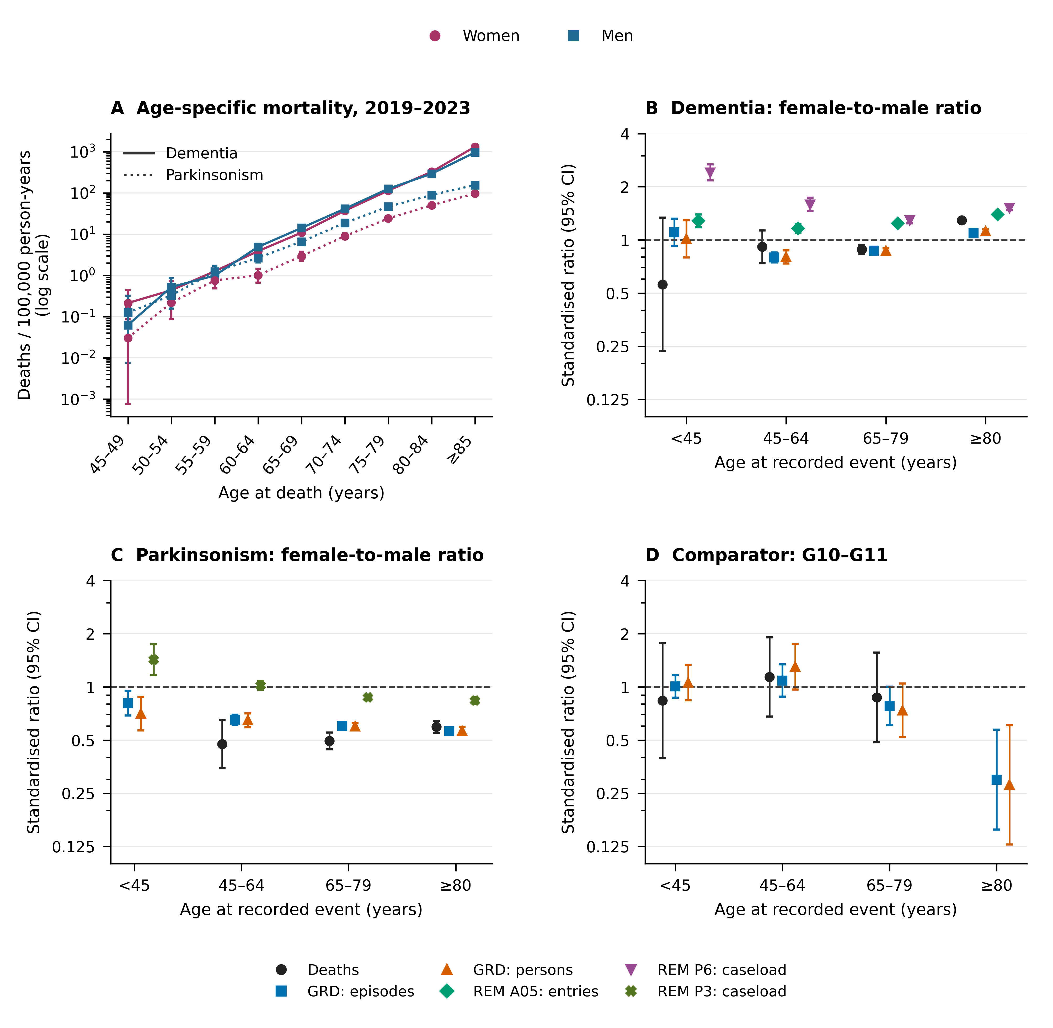
Figure 1. Age and sex patterns across routine sources. A: age-specific mortality with dementia or parkinsonism as underlying cause, 2019–2023, with 95% confidence intervals; all positive counts are shown, including those below five. Zero counts are not plotted on the logarithmic axis. B–D: female-to-male ratios of age-standardised rates with 95% confidence intervals by age class at recorded event. The threshold of at least five records in each sex applies only to ratios in B–D; absent symbols do not indicate zero. Series represent deaths (2019–2023), GRD episodes (2019–2024), first observed GRD records per person (2021–2024), REM A05 entries (2019–2025), and programme caseload/dependency in December 2024. Each source retains its unit and denominator; counts are not pooled or interpreted as incidence. G10–G11 denotes Huntington disease and hereditary ataxias. Ages refer to recorded events or death, not clinical onset. Sources: DEIS, GRD, REM and INE.
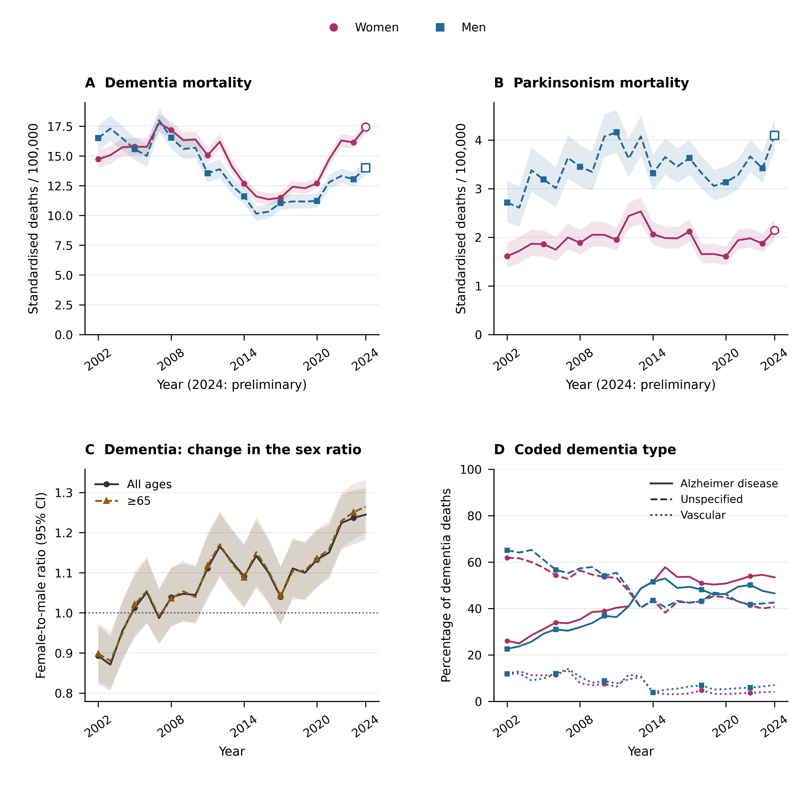
Figure 2. Mortality trends and coding, 2002–2024. A–B: age-standardised mortality rates at all ages in women and men; bands indicate 95% confidence intervals. Open symbols identify preliminary 2024 data, released with a cut-off of 23 June 2026. C: female-to-male dementia mortality ratios for all ages and age ≥65, with 95% confidence intervals; the horizontal line indicates equal rates. D: proportions of dementia deaths coded as Alzheimer disease, unspecified dementia or vascular dementia by sex. These categories do not necessarily exhaust the broad dementia definition; this panel describes underlying-cause coding rather than clinically validated subtypes. Rates and ratios come from the mortality tables and do not represent the Poisson-regression trend in death counts. Sources: DEIS deaths and INE; WHO standard population.
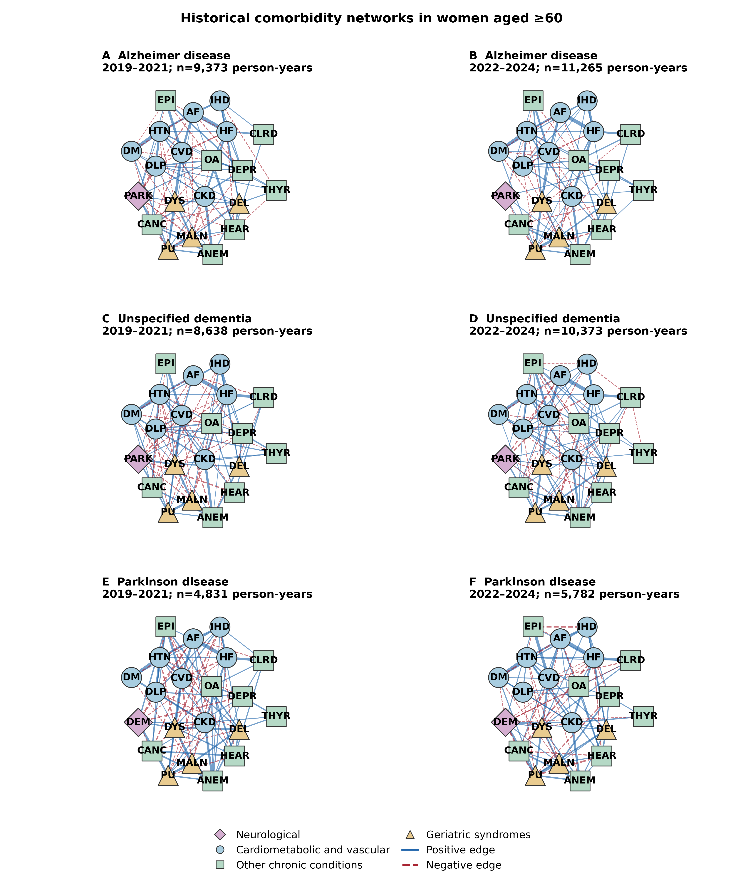
Figure 3. Historical comorbidity networks in women aged ≥60 with Alzheimer disease (A–B), unspecified dementia (C–D), or Parkinson disease (E–F) recorded in public-hospital GRD episodes, 2019–2024, including day surgery (CMA) and other coded activities. Each row compares 2019–2021 with 2022–2024. The unit is the person-year; a woman can contribute multiple years, and 2019–2020 identifiers do not support deduplication between years. These are descriptive displays without historical temporal tests or confidence intervals. Edges are regularised partial correlations from graphical lasso of tetrachoric correlations, EBIC γ=0.5, and the original selection threshold. All non-zero edges are retained. All panels share node positions, constant node size and edge-width scale; solid blue edges indicate positive associations and dashed red edges negative associations. Shapes and colours identify communities. Node size does not encode prevalence or centrality. DEM replaces PARK in Parkinson disease networks. Associations between recorded diagnoses do not identify causal mechanisms. PARK, parkinsonism; DEM, dementia; HTN, hypertension; DM, diabetes; DLP, dyslipidaemia; IHD, ischaemic heart disease; HF, heart failure; AF, atrial fibrillation; CVD, cerebrovascular disease; CKD, chronic kidney disease; THYR, hypothyroidism; CLRD, chronic respiratory disease; OA, osteoarthritis; CANC, cancer; HEAR, hearing loss; EPI, epilepsy; DEPR, depression; ANEM, anaemia; DEL, delirium; PU, pressure ulcer; DYS, dysphagia; MALN, malnutrition.
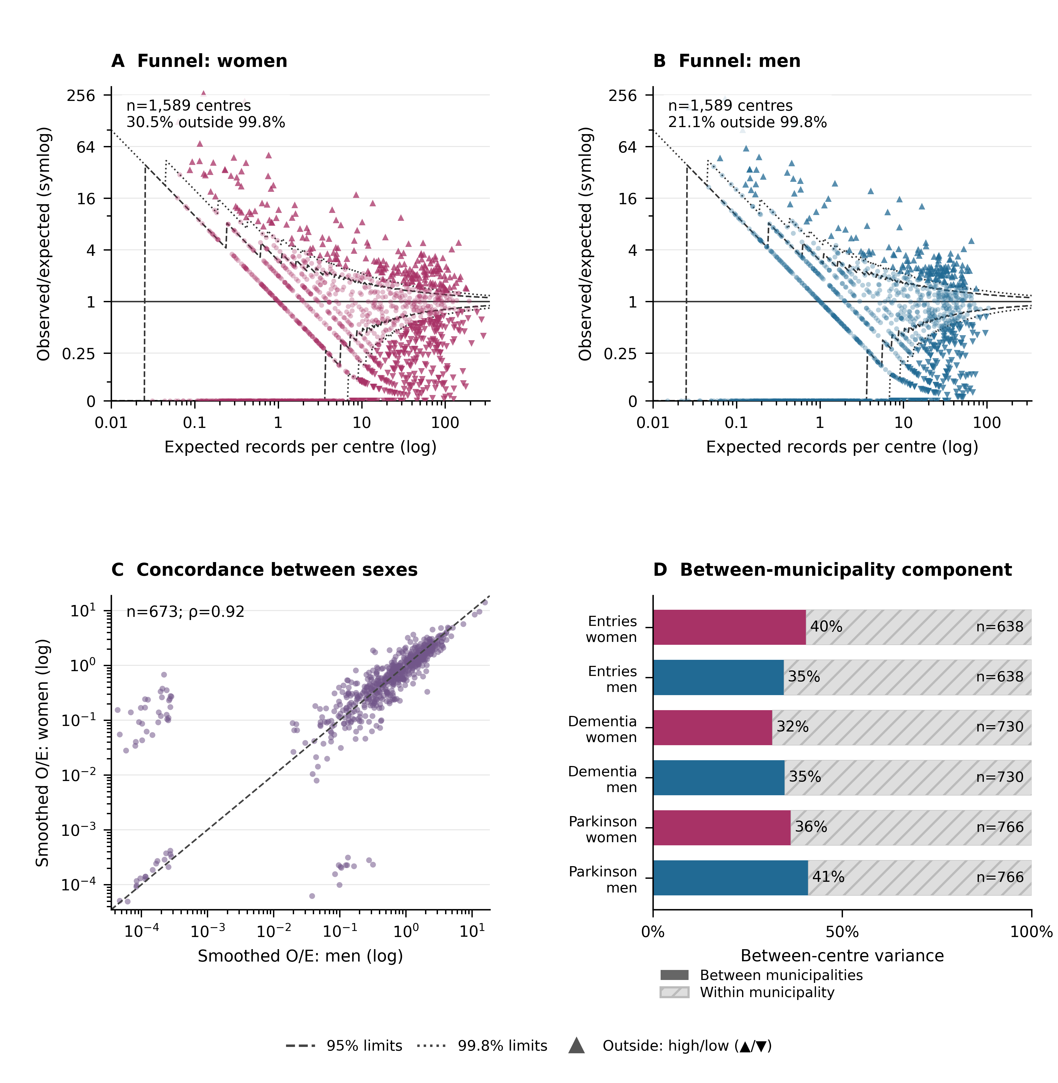
Figure 4. Variation in dementia and Parkinson registration between primary-care centres, 2019–2025. A–B: REM A05 dementia entries at age ≥60, observed/expected (O/E) per centre against expected records based on internal sex- and age-specific rates (60–79 and ≥80) and FONASA enrolment. Poisson control limits are 95% (dashed) and 99.8% (dotted); triangles identify values outside the 99.8% limits. All centres and zeros are retained; x axis is logarithmic and y axis uses symlog with a linear segment from 0 to 0.25. C: Poisson–gamma smoothed O/E in both sexes, restricted to centres with ≥5 expected records in each sex; diagonal: equality; Spearman ρ is calculated in this common sample. D: percentage of between-centre variance attributable to municipality differences from the random-intercept model of log smoothed O/E in the original analysis sample; hatched grey denotes variation within municipalities. These are neither clinical risk intervals nor validated performance indicators. Sources: REM, FONASA and DEIS establishment catalogue. In D, n denotes centres: entries, 638 in 276 municipalities; dementia caseload, 730 in 288 municipalities; Parkinson caseload, 766 in 292 municipalities. Within each outcome, the same samples are used for both sexes.
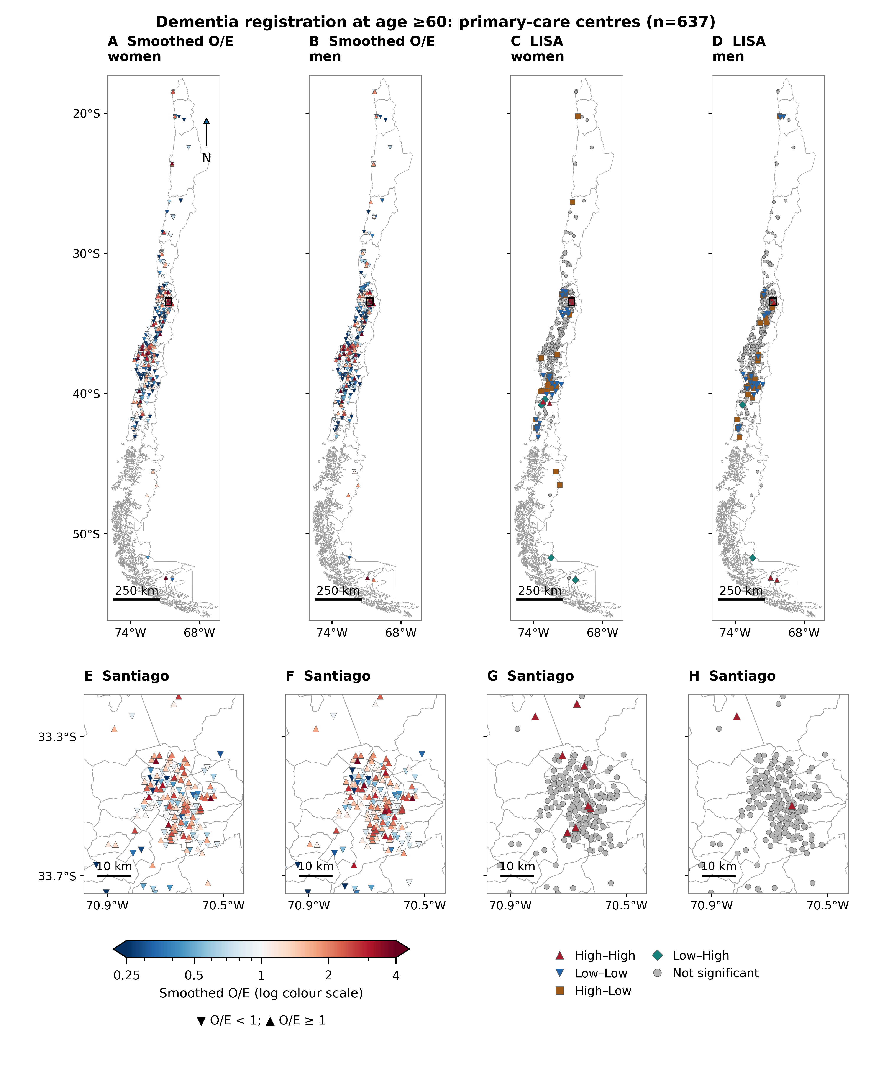
Figure 5. Spatial distribution of dementia registration in primary-care centres, 2019–2025. A–B: Poisson–gamma smoothed O/E of dementia entries at age ≥60 in women and men. C–D: local LISA clusters and spatial outliers by sex. E–H: the same centres in the Santiago enlargement, indicated by rectangles on the national maps. The original spatial sample of 637 centres is retained (precision criteria, rural-post exclusion and available coordinates); this sample does not represent the entire primary-care network. O/E colour limits are shared and logarithmic, from 0.25 to 4; colourbar extensions indicate observations beyond these limits, shown in the extreme colour. Each LISA category uses both shape and colour: High–High and Low–Low indicate local concordance; High–Low and Low–High indicate outliers. LISA uses log O/E, eight nearest neighbours, 999 conditional resamples with replacement and p<0.05 without multiple-comparison correction; clusters are exploratory. Coordinates are WGS84; aspect ratios are adjusted for mean latitude; scale bars are approximate (250 km nationally and 10 km in Santiago). Mainland Chile is shown with regional boundaries and Santiago with municipal boundaries; oceanic and Antarctic territories are omitted. Sources: REM, FONASA, DEIS and project-derived cartography. Downward triangles indicate O/E<1 and upward triangles O/E≥1 in the O/E maps.
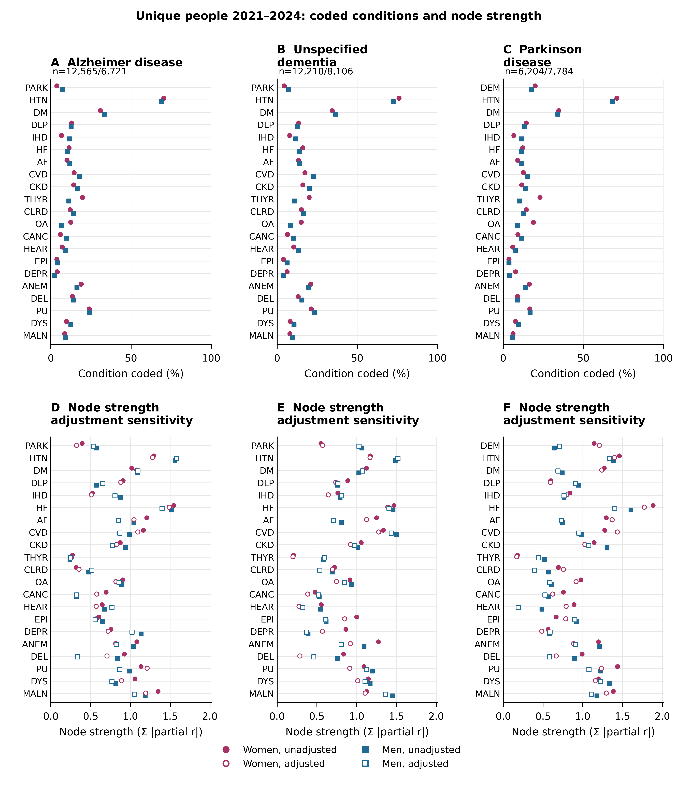
Figure 6. Independent-person sensitivity at age ≥60 with public-hospital GRD episodes, 2021–2024, including day surgery (CMA) and other coded activities. A–C: percentages of people with each condition coded; sample sizes are women/men. D–F: node strength (sum of absolute partial correlations), unadjusted and conditional on age and coding depth. Filled symbols denote unadjusted estimates and open symbols adjusted estimates; shapes identify sex. Each person's first eligible year and all diagnoses recorded in their episodes that year are used; later years are not reused, and identifiers with discordant sex are excluded. Disease membership is fixed in that year; Alzheimer disease and unspecified dementia are disjoint, whereas Parkinson disease may coexist with dementia. Abbreviations follow Figure 3. Percentages describe hospital coding, not population prevalence. These networks use a different unit and window from the historical networks. These are descriptive point estimates without uncertainty bars; adjustment is neither a temporal contrast nor a causal effect. Source: GRD.
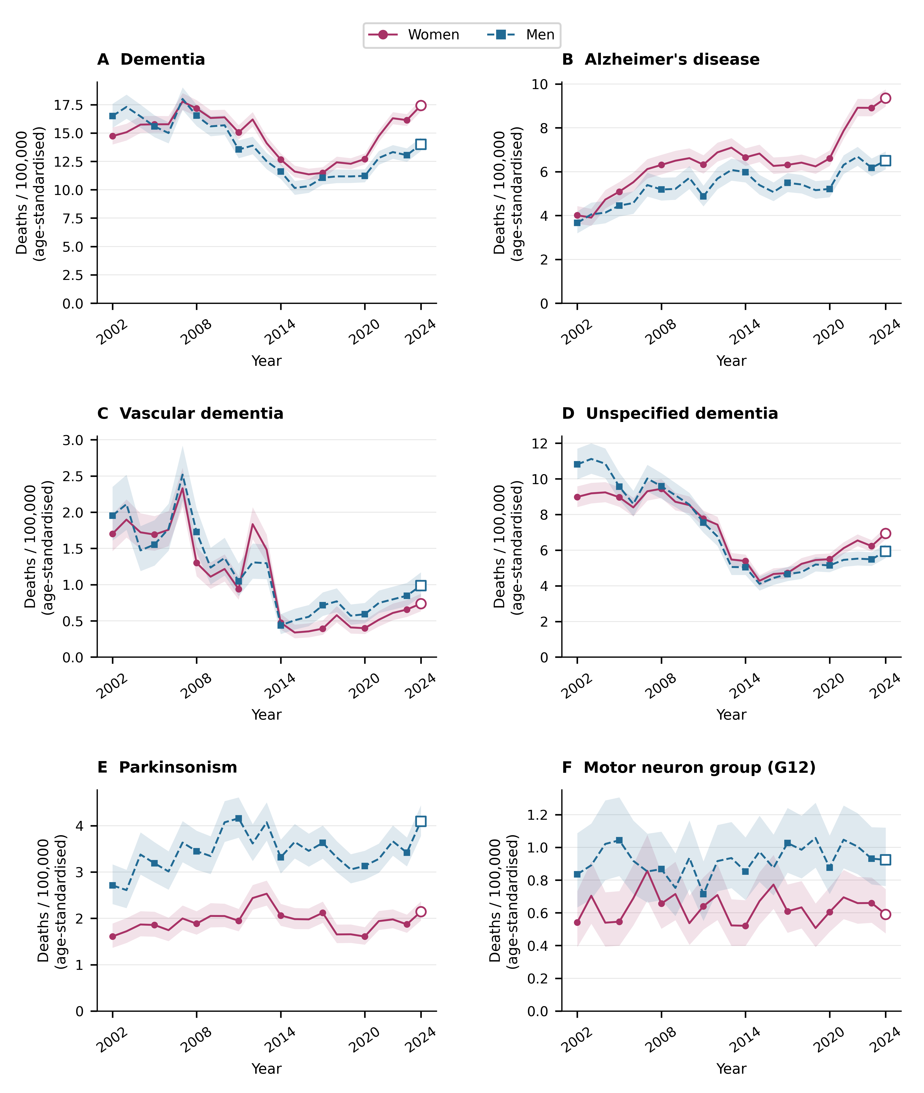
Figure S1. Annual mortality across six diagnostic groups, Chile, 2002–2024. Panels A–F show dementia, Alzheimer disease, vascular dementia, unspecified dementia, parkinsonism and the G12 motor neuron group. Lines and symbols identify recorded sex; shaded bands are gamma 95% CIs for directly age-standardised rates per 100,000 resident person-years at all ages. Each panel has its own explicitly labelled vertical scale with a zero baseline; magnitudes should be read from the axes. Open symbols denote preliminary 2024 deaths (cut-off 23 June 2026). The dementia group includes overlapping subgroups; panels cannot be summed. These are underlying-cause records, not incidence or an estimate of diagnostic accuracy. The plot contains annual rates, not quasi-Poisson annual percentage-change coefficients.
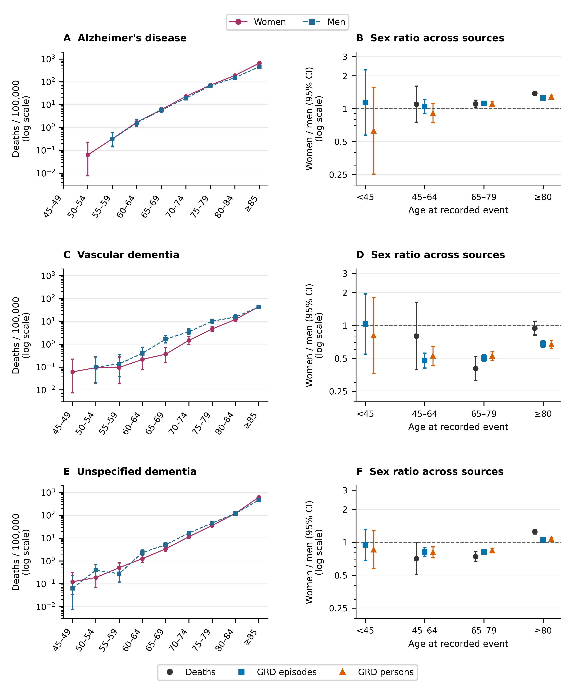
Figure S2. Dementia-subtype patterns by age and source. A, C and E show sex-specific underlying-cause mortality in 2019–2023 at ages ≥45, with exact Poisson 95% CIs and shared logarithmic vertical ranges; positive counts below five remain visible, and zero-count rates are omitted on the log scale. B, D and F show female-to-male directly standardised rate ratios (95% CIs) by age class for deaths (2019–2023), GRD episodes in any diagnostic position (2019–2024), and people at their first observed coded GRD record (2021–2024). Ratios with fewer than five records in either sex are omitted only from display; an absent symbol does not denote zero. Source units and windows differ and are not pooled. GRD includes major ambulatory surgery and other coded activities in public hospitals. Ages are ages at recorded event, not clinical onset. Alzheimer, vascular and unspecified subgroups are administrative code definitions; they do not exhaust the broad dementia group.
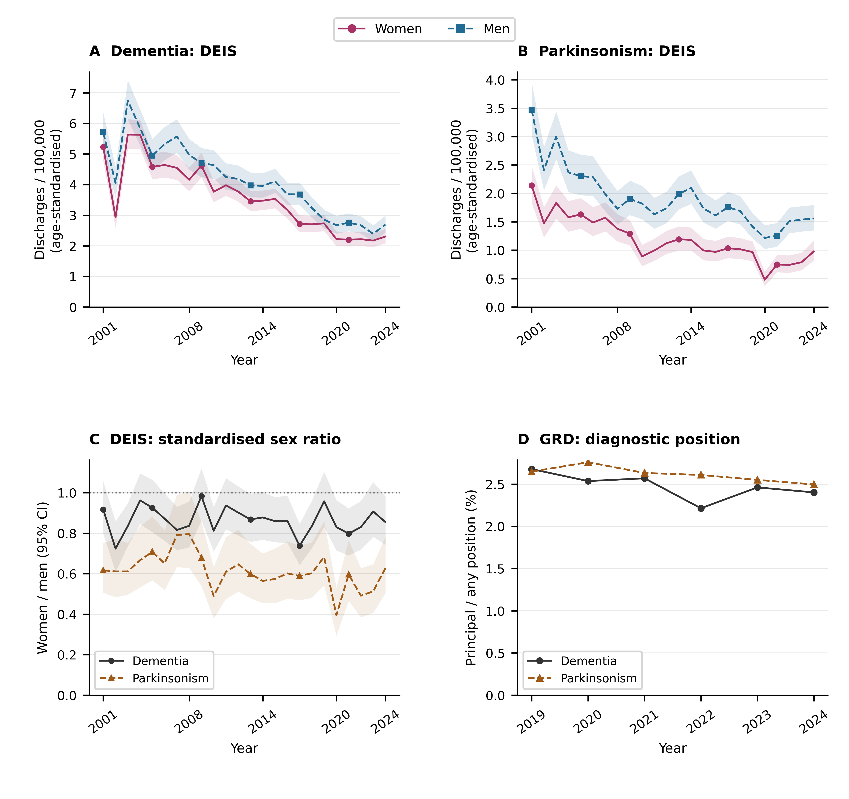
Figure S3. Long-term DEIS discharges and the diagnostic-position gap in GRD. A–B: discharges with dementia or parkinsonism as principal diagnosis, 2001–2024, public and private hospitals, by recorded sex; directly standardised rates and gamma 95% CIs use resident denominators and the available DEIS age bands (<40, 40–49, 50–59, 60–69, 70–79, ≥80). C: female-to-male standardised DEIS rate ratios with log-normal 95% CIs. D: the number of GRD episodes with the condition as principal diagnosis divided by the number with that condition in any diagnostic position, 2019–2024, multiplied by 100; sexes are combined. The denominator is the condition-specific episode count, not all GRD activity. GRD covers recorded public-hospital activities including major ambulatory surgery; its coverage, age detail and diagnostic fields differ from DEIS. The panels do not estimate differences in incidence or sensitivity of either source; a secondary code is not a new clinical diagnosis. No uncertainty interval is assigned to the diagnostic-position proportion.
Figure S4. Age at death or first observed GRD record, by recorded sex and condition. A–B: points are medians and horizontal whiskers the interquartile range (25th–75th percentiles), not confidence intervals. C–D: proportion of condition-specific records occurring before 65 years, with Wilson 95% CIs. Deaths use underlying cause in 2019–2023; GRD persons use the first observed condition-coded episode within 2021–2024, including major ambulatory surgery and other coded activities. Axes are shared within each row. The original age distributions and sample counts remain in the numeric data and Table S4. Different events and windows are being described: these statistics do not measure clinical onset, disease duration or an individual follow-up contrast.
Figure S5. Primary-care dementia records at age ≥60 by programme stage, sex and year, 2019–2025. Rows show December caseload (P6), annual entries (A05) and annual clinical discharges from the programme (A05); columns show women and men. Stage is the recorded mild, moderate or advanced category, without individual clinical re-adjudication. Numerators include only age ≥60 bands and denominators are residents of the same age and sex from national INE base 2024 estimates. The three stages are not added across different measures: entries, discharges and stock have distinct units, and annual caseloads can contain the same person repeatedly. Vertical ranges are shared between sexes within each measure. Counts and programmatic rates are shown without a stochastic interval; they do not estimate incidence, individual stage transitions or recovery.
Figure S6. Complete set of sex-specific centre-level funnel plots, 2019–2025, age ≥60. Rows show dementia entries (A05), summed December dementia caseloads (P6), and summed December Parkinson disease caseloads (P3). Each point is a selected primary-care centre; no centre is removed for a zero observed count. Horizontal position is the internally age-standardised expected count from enrolment at ages 60–79 and ≥80; the vertical value is unsmoothed O/E. Dashed and dotted curves are exact Poisson 95% and 99.8% control limits, used as descriptive references. X is logarithmic; Y is symmetric-logarithmic with a linear segment 0–0.25 that retains zeros. Axis ranges are common across panels and retain every observation. The 1,589-centre cohort was selected by nonzero climacteric-programme P1 activity and ≥50 woman-years age 45–64, rather than constituting a census of all primary-care providers. Missing derived REM records are treated as zero and cannot be distinguished from non-reporting. Stocks summed across years contain repeat observations, not unique cases. Departures from limits do not establish clinical risk, centre performance or a causal recording mechanism.
Figure S7. Regional mortality from dementia and parkinsonism, official deaths 2019–2023. Panels A–B show all-age directly age-standardised rates; C–D show rates at age ≥65, with WHO weights renormalised within that age range. Points distinguish women and men and horizontal bars are 95% gamma intervals. The regional analysis uses 13 historically harmonised territories and INE base-2017 communal population estimates, with the terminal age group ≥80; it therefore differs from the national base-2024 denominator and ≥85 terminal age group. Codes 01, 08 and 10 include Arica and Parinacota, Ñuble and Los Ríos respectively. Mortality refers to underlying-cause coding, not incidence or age at clinical onset. Regions follow historical region-code order. Source: burden_region.csv, DEIS deaths and INE.
Figure S8. Female-to-male ratios of regional directly standardised mortality rates, 2019–2023 official deaths. Symbols distinguish all ages, age <65 and age ≥65; horizontal bars are the existing 95% log-normal intervals, and the dashed reference denotes equal recorded rates. A ratio is displayed only when both sexes have at least five records within the region, condition and age scope. All interval endpoints are retained on a logarithmic scale; missing symbols reflect the display rule and not zero rates. The same 13 harmonised regions and INE base-2017 denominators as Figure S7 are used. Interval widths describe modelled count variability, not uncertainty from coding or under-registration; they do not establish regional biological differences or clinical risk. Source: burden_region.csv.
Figure S9. Dementia caseload (P6) across public primary-care centres, 2019–2025. National and Santiago panels show sex-specific Poisson–gamma smoothed observed/expected (O/E) registration among 729 centres with at least five expected records in each sex, excluding rural health posts and requiring valid mainland coordinates. The numerator sums December programme caseload snapshots over seven years; the same person can be counted repeatedly. Expected counts use enrolled FONASA residents in age bands 60–79 and ≥80, with internal sex-specific reference rates. Colours share logarithmic limits 0.25–4; extended colourbar ends retain extreme values, and triangle direction redundantly marks O/E below or above one. These values describe relative recorded caseload, not prevalence, incidence or provider performance. WGS84 coordinates and mean-latitude aspect corrections are used; approximate scale bars are 250 km nationally and 10 km in Santiago. National rectangles identify the enlarged Santiago viewport. Source: centers_panel.csv and local public geographic boundaries.
Figure S10. Parkinson caseload (P3) across public primary-care centres, 2019–2025. National and Santiago panels show sex-specific Poisson–gamma smoothed observed/expected (O/E) registration among 765 centres with at least five expected records in each sex, excluding rural health posts and requiring valid mainland coordinates. The numerator sums December programme caseload snapshots over seven years; the same person can be counted repeatedly. Expected counts use enrolled FONASA residents in age bands 60–79 and ≥80, with internal sex-specific reference rates. Colours share logarithmic limits 0.25–4; extended colourbar ends retain extreme values, and triangle direction redundantly marks O/E below or above one. These values describe relative recorded caseload, not prevalence, incidence or provider performance. WGS84 coordinates and mean-latitude aspect corrections are used; approximate scale bars are 250 km nationally and 10 km in Santiago. National rectangles identify the enlarged Santiago viewport. Source: centers_panel.csv and local public geographic boundaries.
Figure S11. Ratios of the sex-specific smoothed observed/expected (O/E) registration in each centre, 2019–2025, for dementia entries, dementia caseload and Parkinson caseload. Both-sex expected counts must be ≥5; rural posts and centres without valid mainland coordinates are excluded. Samples differ by outcome (Dementia entries (A05): 637, Dementia caseload (P6): 729, Parkinson caseload (P3): 765). Each O/E is referenced to its own sex-specific internal age profile. Their ratio therefore compares relative registration against different reference rates; it is not a female-to-male clinical risk ratio, and a value of one does not imply equal absolute rates in women and men. Shared logarithmic colour limits are 0.25–4 with extreme-colour extensions and redundant triangle direction. Bottom panels enlarge Santiago; national rectangles locate the enlargement. Approximate scales and geographic exclusions follow Figures S9–S10. Source: centers_panel.csv; no new local significance tests are performed.
Figure S12. Neighbour-definition sensitivity for the same 637-centre dementia-entry sample used in the primary spatial analysis. A: Moran's I for log smoothed O/E in women and men and log of their ratio, using directed row-standardised k-nearest-neighbour graphs with k=4, 8 or 12. B: two-sided absolute-statistic permutation p values, corrected by Holm across the nine displayed tests; the dashed vertical reference is 0.05. Each test uses 999 label permutations with a fixed, separately recorded seed; the same permuted vector enters both focal and lagged factors of univariate Moran's I. The k=8 observed statistics reproduce the primary results within numerical precision; permutation p values are newly generated and may differ from the primary run. All graphs use the same coordinates, approximation and centre ordering, without self-neighbours. These post hoc exploratory sensitivities do not identify causal spatial mechanisms. Source data and seeds are supplied in the figure CSV and Table S13.
Figure S13. Regional distributions of smoothed observed/expected (O/E) activity among all 1,589 selected primary-care centres, 2019–2025, by sex and outcome. Unlike the spatial map samples, these panels retain rural posts, low-expected-count centres and centres lacking coordinates, provided the region is recorded. Horizontal boxes show the median and interquartile range, whiskers extend to the most extreme observation within 1.5 interquartile ranges, and every remaining observation is retained as a small point. Whiskers are distribution summaries, not confidence intervals. All panels share one logarithmic axis; smoothing makes zero observed counts positive, so zero-observed centres remain represented. Region codes match Table S9. Very small expected counts and incomplete programme reporting can produce extreme relative values; no centres are silently removed because of their O/E. The distributions describe heterogeneous recorded activity, not disease risk or validated quality of care. Source: centers_panel.csv.
Figure S14. Scope and selection of the centre-level analysis. A maps selected centres with usable mainland coordinates; grey points indicate unselected catalogue facilities with positive mean older-person FONASA enrolment during 2019–2025. Shapes distinguish selected facility types. B shows the catalogue baseline, selected sample and nested dementia-entry precision and spatial subsets. C gives selected facilities divided by the same older-enrolled catalogue baseline within each harmonised region, with numerator/denominator labels. D compares facility-type counts in the baseline and selected samples. The baseline has 2,034 facilities and is a data-availability definition, not a census of all primary-care providers or a population-coverage denominator. The study sample of 1,589 additionally requires recorded climacteric-programme activity and at least 50 women-years aged 45–64; this inherited selection can affect representativeness. Eight selected centres lack usable coordinates. The A05 precision subset has 638 centres with ≥5 expected events in both sexes and excludes rural posts; one lacks coordinates, leaving 637 mapped centres. Regional fractions do not measure patient access or quality. Source: DEIS facility catalogue, FONASA and centers_panel.csv.
Figure S15. Unadjusted comorbidity networks of unique people aged ≥60 with recorded public-hospital GRD episodes in 2021–2024, including day surgery and other coded activities. Rows show Alzheimer disease (A–B), unspecified dementia (C–D) and Parkinson disease (E–F); women are on the left and men on the right. Each person contributes their first eligible year and all diagnoses from episodes in that year; identifiers with discordant recorded sex are excluded. Alzheimer disease and unspecified dementia are disjoint at baseline; Parkinson disease may coexist with dementia. Edges are selected regularised partial correlations estimated with graphical lasso on tetrachoric correlations, EBIC γ=0.5 and a 50-point penalty-grid rule. These networks are not conditioned on age or coding depth. All selected non-zero edges are retained. Figures S15 and S16 share one deterministic layout, constant node area and the same edge-width scale across all twelve panels. Solid blue edges are positive; dashed red edges are negative. Shapes and colours distinguish predefined communities. Node size does not encode prevalence or centrality. Edge counts depend on sample size and selection threshold. Associations among recorded diagnoses are descriptive and do not identify causal mechanisms. PARK, parkinsonism; DEM, dementia (replaces PARK in Parkinson disease networks); HTN, hypertension; DM, diabetes; DLP, dyslipidaemia; IHD, ischaemic heart disease; HF, heart failure; AF, atrial fibrillation or flutter; CVD, cerebrovascular disease; CKD, chronic kidney disease; THYR, hypothyroidism; CLRD, chronic lower respiratory disease; OA, osteoarthritis; CANC, cancer; HEAR, hearing loss; EPI, epilepsy; DEPR, depression; ANEM, anaemia (non-acute); DEL, delirium; PU, pressure ulcer; DYS, dysphagia; MALN, malnutrition.
Figure S16. Adjusted networks of unique people aged ≥60 with public-hospital GRD episodes, 2021–2024, including day surgery and other coded activities. Rows show Alzheimer disease (A–B), unspecified dementia (C–D) and Parkinson disease (E–F); women are on the left and men on the right. Each person contributes their first eligible year and all diagnoses recorded in that year's episodes; identifiers with discordant recorded sex are excluded. Alzheimer disease and unspecified dementia are disjoint at baseline; Parkinson disease may coexist with dementia. Edges are regularised partial correlations from graphical lasso on tetrachoric correlations, EBIC γ=0.5 and 50 penalty-grid points, conditional on age and log(1 + other distinct diagnoses) as continuous nodes. All selected non-zero edges remain. Figures S15–S16 share deterministic positions, constant node area and edge-width scaling across twelve panels. Solid blue edges are positive; dashed red edges negative. Shapes and colours identify predefined communities. Node size encodes neither prevalence nor centrality; edge counts depend on sample size and selection threshold. Recorded-diagnosis associations are descriptive, without causal interpretation. PARK, parkinsonism; DEM, dementia (replaces PARK in Parkinson disease networks); HTN, hypertension; DM, diabetes; DLP, dyslipidaemia; IHD, ischaemic heart disease; HF, heart failure; AF, atrial fibrillation or flutter; CVD, cerebrovascular disease; CKD, chronic kidney disease; THYR, hypothyroidism; CLRD, chronic lower respiratory disease; OA, osteoarthritis; CANC, cancer; HEAR, hearing loss; EPI, epilepsy; DEPR, depression; ANEM, anaemia (non-acute); DEL, delirium; PU, pressure ulcer; DYS, dysphagia; MALN, malnutrition.
Figure S17. Differences in coded comorbidity percentages between women and men with public-hospital GRD episodes, among unique people aged ≥60 in 2021–2024. Cells show women minus men in percentage points, calculated directly from the unweighted percentages in each disease and sex group. Positive values indicate more frequent coding in women and negative values more frequent coding in men. A common symmetric colour scale is centred on zero; numbers provide a colour-independent reading. The first row is parkinsonism (PARK) in the Alzheimer and unspecified dementia groups and dementia (DEM) in the Parkinson disease group; these are different conditions. All 21 fixed node positions are retained. The figure shows descriptive point differences without confidence intervals, hypothesis tests or multiplicity-adjusted claims. Percentages reflect recorded diagnoses in this selected care population, not population prevalence or causal sex effects. The same baseline eligibility and disease definitions as figures S15–S16 apply.
Figure S18. Case-dropping stability of the six unadjusted unique-person networks, 2021–2024. Rows show Alzheimer disease, unspecified dementia and Parkinson disease; women are left and men right. At each fraction removed (10–70%), the existing analysis drew 50 subsamples without replacement and re-estimated the network with the same 50-point EBIC penalty-grid rule. Pearson correlations compare each subsample vector with the full-sample vector, separately for node strength and all 210 edge weights. Solid lines show mean correlations and dashed lines their fifth percentiles; neither is a confidence interval. CS is the largest tested fraction dropped whose fifth-percentile correlation reaches 0.70. A displayed CS ≥0.70 means the criterion still holds at the largest tested removal fraction, so it is a lower bound on the unexplored range. Shared axes and a horizontal 0.70 threshold permit direct inspection of sampling stability. The figure describes resampling robustness of these selected networks and does not establish temporal stability, clinical importance or equivalence between sexes.

