Reproductive factors and neurodegenerative outcomes in Chile

Methods

Study design and separation of observation units
The programme combined three complementary secondary-data components: cross-sectional survey analyses of reproductive history and self-reported remembering or concentrating difficulty; descriptions of ovarian-intervention coding in public-hospital diagnosis-related-group (GRD) episodes, with a bounded within-GRD linkage feasibility analysis; and repeated December primary-care programme returns linked to administrative enrolment denominators. Each component retained its own eligibility rules, observation unit, period and denominator. Survey participants were not linked to GRD surgery, REM treatment records or neurological diagnoses.
Sex was analysed as recorded in each source. Survey associations concern reported symptoms, GRD flags concern coded episodes, and REM indicators concern recorded programme activity. None directly measures cognitive decline, individual lifetime hormonal exposure, age at clinical onset or a causal pathway from reproductive history through surgery or menopausal hormone therapy (MHT) to neurodegeneration.

Survey populations and variable definitions
CASEN 2024 supplied the reported number of live-born children (s5), age at first child (s6), remembering or concentrating difficulty (h7d), respondent sex and age, schooling, rural residence, indigenous identification, health-insurance classification and survey-design fields. Negative source codes in the specified reproductive, difficulty, schooling, insurance and indigenous variables were converted to missing during extraction. The primary reproductive-history analysis included respondents aged 60 years or older with valid difficulty and child-number responses and complete model covariates. Children were grouped as 0, 1, 2, 3–4 and ≥5, with two children as the reference. Any difficulty was h7d≥2 and severe difficulty was h7d≥3. These are symptom thresholds, not dementia diagnoses.
ENCAVI 2023–2024 was analysed separately with its own instrument and weights. A negative response to having children was coded as zero; otherwise valid p1_12_rec categories 1–7 were retained, with code 7 an open-ended category. Remembering or concentrating difficulty was derived from p4_4_4 on its five-category scale. Any difficulty was ≥2; the individual-analysis severe threshold was ≥4 to exclude moderate difficulty. CASEN and ENCAVI thresholds and child-history wording were not treated as interchangeable measures.
The official ENCAVI methodological report, page 8, defines an urban and rural target population. The database manual, page 8, instead describes urban residents when discussing expansion weights. The extraction and analytic code impose no urban restriction and retain no rurality variable. We therefore describe the prepared ENCAVI sample without an urban-only claim; geographic coverage and the population represented by its calibration require clarification before geographic-domain comparisons.

Full-frame survey design and reportable inference
For the validated CASEN analyses, the full extracted sample of 218,367 respondents was used to construct the survey design before defining analytic domains. The design specified expansion weights expr, pseudo-strata varstrat and primary sampling units varunit nested within strata. The saved full frame contained 12,512 primary sampling units in 756 strata, with positive weights and no genuine full-design singleton stratum. No finite-population correction was supplied. R used survey::svydesign(ids=~varunit, strata=~varstrat, weights=~expr, nest=TRUE), followed by domain subsetting; survey.lonely.psu was set to fail and survey.adjust.domain.lonely to FALSE.
Weighted logistic regression was fitted in R using survey::svyglm with quasibinomial variance and strict convergence settings (epsilon=10⁻¹², maximum 100 iterations). An independent Python binomial GLM used weights normalised to the domain mean. Taylor-linearised score totals were reindexed to the complete original stratum–PSU frame, assigning zero scores to PSUs with no domain observations. Within each full-design stratum, centred score cross-products were multiplied by n_h/(n_h−1), then combined with the model bread matrix to form the sandwich covariance. Domain-created singleton strata were therefore not discarded or treated as certainty strata.
Reportable 95% odds-ratio intervals used the t critical value with each subset-model residual degrees of freedom, defined as degf(subset design)+1−model rank. Global interaction tests used the corresponding Wald F statistic and residual denominator degrees of freedom. Normal intervals and chi-square tests were retained only for comparison with legacy outputs. Independent R–Python checks verified the primary coefficient, standard-error, interval, sample-size and degrees-of-freedom results. Numerical validation of the survey estimator does not validate the symptom construct, exposure matching or causal interpretation.

Primary CASEN reproductive-history models
The primary parity models included 28,669 women and 22,797 men aged ≥60. Logistic models adjusted for age categories 60–64, 65–69, 70–74, 75–79, 80–84 and ≥85 years; schooling 0–5, 6–8, 9–12 and ≥13 years; rural residence; 13 harmonised regions; FONASA status; and indigenous identification. The joint model included sex interactions with all child-number and adjustment terms, allowing the four parity contrasts to be tested together rather than comparing whether separate sex-specific intervals included one.
All four child-number contrasts were retained for each sex. Sex-specific t intervals used residual degrees of freedom 9,909 in women and 9,065 in men; the joint four-term interaction used F with 4 and 10,601 degrees of freedom. The reported odds ratios describe cross-sectional complete-case associations and are not prevalence ratios or effects of pregnancy, parenting or hormones.

Inherited survey extensions and limits of their inference
Stored age-at-first-child, severe-difficulty and ENCAVI association estimates were retained as separately labelled legacy analyses when displayed. The legacy implementation fitted weighted binomial GLMs after analytic filtering and formed stratum–PSU sandwich variances using only PSUs retained in the filtered domain; strata with fewer than two retained PSUs contributed no variance. Consequently, those stored intervals and p values have not received the full-frame domain repair applied to the primary CASEN models. They must not be described as independently validated full-design inference.
New descriptive displays assembled from existing aggregate results do not constitute a refit of the participant-level models. Urban CASEN, severe CASEN, instrument-specific ENCAVI models and new design-based prevalence intervals require their own complete-frame estimation and validation. No new participant-level refit is claimed for these additional displays.

Lagged municipal MHT exposure and validated contextual CASEN models
The primary contextual analysis assigned the saved 2019–2023 municipal MHT indicator to CASEN 2024 respondents aged 60–69 with FONASA coverage. The exposure was 1,000 times summed December REM P1 MHT records divided by summed estimated FONASA enrolment observations for women aged 45–64 in the municipality; municipalities required at least 200 summed estimated enrolment observations. Effects were scaled per 10 additional records per 1,000 estimated enrolled women. The inherited construction joined numerator and denominator tables by facility and year, filled absent activity cells with zero, then aggregated to municipalities. This frozen exposure was not reconstructed or causally validated by the survey-variance repair.
CASEN municipality was obtained by rejoining folio and id_persona to the original estrato variable with a one-to-one check, then taking floor(estrato/100). The municipal exposure table was joined many-to-one with a uniqueness check. Complete-case models adjusted for age group 60–64/65–69, schooling, rural residence, indigenous identification, harmonised region and a continuous municipal multidimensional-poverty covariate (SAE 2024). The same current municipality was used for the whole prior exposure window; residential history was unavailable.
The validated sample contained 12,949 women and 10,379 men across 312 municipalities. Full-frame survey estimation followed the procedure above; residual degrees of freedom were 6,905, 5,847 and 8,431 in the women, men and joint models. The joint model interacted MHT and all adjustment terms with sex, and tested the MHT-by-sex coefficient using F(1,8431). This design measures an area-level programme association with an individual symptom outcome. It does not establish individual MHT receipt, eligibility, timing, formulation, duration or adherence.

GRD source processing, coding and dates
GRD files labelled 2019–2024 were processed in chunks using all available diagnostic positions (35) and procedure positions (30). Diagnostic strings were upper-cased and periods removed before configured prefix matching; procedure codes were matched as complete tokens after period removal. A row represented an episode containing at least one matching code, not an individual procedure. All recorded activity types were retained, including inpatient, major ambulatory surgery and other coded activities in participating public hospitals.
The patient identifier was selected from ID_BENEFICIARIO when available, otherwise CIP_ENCRIPTADO; blank and sentinel strings were invalidated. Admission, birth and discharge dates were parsed using ISO and day–month–year formats, with invalid strings set to missing. Age was (admission date−birth date)/365.25 rounded to two decimals; surgical analyses floored that proxy. Length of stay was the discharge-minus-admission day difference, and death coding was derived from the discharge-type string. The extracted admission date is neither a procedure date nor a clinical diagnosis date. File year and admission year can differ for long stays.
Cross-year person analyses were restricted to the identifier namespace in files labelled 2021–2024. Files before 2021 were not assumed to support linkage across the identifier change. Neurological and surgical extracts remained on the external data volume; the project retained aggregate summaries and audit metadata only. The present extracts do not retain individual procedure codes, operation dates, discharge dates, hospital identifiers, costs or GRD weights for the proposed extensions. Their presence in an original header is not evidence that they were extracted or analysed.

Surgical coding population and reference intervals
The primary descriptive surgical denominator comprised recorded women with a configured hysterectomy-family flag, a floored admission-age proxy of 20–45 years and a specified-benign diagnosis hierarchy in GRD files 2019–2024. Diagnosis categories were assigned from any diagnostic position in the following priority: gynaecological cancer, genetic/family-risk coding, breast cancer, specified benign conditions, then other/unspecified. Only the specified-benign category entered the primary denominator. The hierarchy describes recorded coexisting diagnoses and has not been validated as the operative indication.
The bilateral-oophorectomy (BSO) flag included codes 65.51–65.54 and 65.61–65.64, including configured removal-of-a-remaining-ovary codes. The hysterectomy-family mapping used the explicit list 68.31, 68.39, 68.41, 68.49, 68.51, 68.59, 68.61, 68.69, 68.71, 68.79, 68.8 and 68.9. Code 68.8 is under a specific classification review; the existing binary extract cannot quantify its separate contribution. Until that review and a targeted re-extraction are complete, this is a configured composite rather than a fully validated anatomical hysterectomy definition.
The endpoint was a BSO flag in the same episode as the hysterectomy-family flag. It does not identify simultaneous operations or confirm preserved ovaries when absent. Annual, age-specific, insurance and indication summaries were descriptive. Wilson 95% binomial reference intervals assumed independent episodes and did not account for repeated people, hospital clustering or coding uncertainty. Sensitivities used ages 20–39, 20–44, 20–45, below 46 and 20–49. A 2021–2024 person sensitivity retained the first observed eligible dated episode per valid identifier and compared first-episode with any-observed BSO coding; neither definition identifies first-ever surgery.

Bounded surgery-to-neurological-record linkage
For linkage feasibility, the first observed specified-benign hysterectomy-family episode at ages 20–45 was selected per valid identifier from GRD files labelled 2021–2024, after parsing admission dates and excluding dates after 31 December 2024. The BSO flag in that index episode defined the two groups. The dated neurological extract was joined many-to-one to the index table by identifier. Unique people with dementia, parkinsonism or Parkinson-disease coding were counted for admission dates before, equal to and strictly after the index admission. People could contribute to more than one timing category; strictly-after counts without any observed before/same-date record were also supplied.
The audit separately counted invalid dates, same-identifier/date repeat episodes, undated neurological matches and discordant recorded sex. Exact zero was preserved; positive cells of one to four people were displayed as <5. The potential calendar window was 31 December 2024 minus index admission date, not established follow-up or person-time. Neither continuous observation nor complete outpatient capture, mortality censoring, prior surgical history or a disease-free washout was available. No incidence, hazard ratio, treatment-effect model, hypothesis test or dementia-attributable fraction was fitted from this feasibility linkage.

REM programme extraction and age-layout harmonisation
REM series A and P records were extracted for 2019–2025 according to the configured programme-code mapping. Series A represented annual flows summed across months; series P retained June and December snapshots, with the present menopause-care analysis restricted to December. The four P1 F stages were women recorded in climacteric care, MRS assessed, elevated MRS and MHT recorded. The programmed age-layout switch used Col01 for the 45–64 category through 2024 and Col02 from 2025, retaining Col01 separately as <45 in 2025. These source-layout assumptions require confirmation against the annual official dictionaries.
The derivation converted nonnumeric numeric cells to zero and omitted non-positive source cells from the long extract. Absence of a derived cell therefore cannot distinguish an explicitly reported zero, missing reporting or a derivation-stage conversion. The new care audit preserved missing cells after joining the recorded stages to denominators and did not relabel every absent record as confirmed zero service provision. Programme stages are aggregate records, not a patient-linked assessment–treatment cascade, and women can recur in successive December snapshots.

FONASA denominators and same-unit matching
Annual FONASA APS enrolment was the December count by facility, recorded sex and available age band. Women aged 45–64 were estimated by multiplying each relevant FONASA band by the proportion of women in that target age range within the same municipality and year in INE base-2017 single-age population projections. The facility procedure used broad 20-year bands before 2024 and 10-year bands from 2024; the municipal procedure parsed the source band endpoints directly. These are prorated enrolment snapshots, not exact registered ages or measured person-time.
The care audit aggregated each stage to one facility–year and required denominator keys to be unique. An outer one-to-one join retained unmatched numerator and denominator observations for quality checks. For pooled facility and regional rates, positive denominator observations were selected within the same facility–year or municipality–year before summing numerator and denominator. Unmatched annual counts remained in the quality-control exports rather than being included in those pooled rate numerators. National indicators separately used all extracted national numerator records and the national summed estimated enrolment; their numerator can therefore differ from the matched regional total.

Menopause-care indicators and recording-quality audit
Annual indicators were climacteric-care records per 100 estimated enrolled women aged 45–64, MHT records per 1,000 estimated enrolled women, MRS-assessed records per 100 climacteric-care records, elevated-MRS records per 100 assessed records and MHT records per 100 climacteric-care records. Ratios were computed from summed counts, rather than averaging facility percentages. No confidence interval was attached to these administrative descriptive totals; this does not imply freedom from reporting error or denominator uncertainty.
Quality checks counted duplicate facility–year–stage rows, facilities with positive estimated enrolment, facilities with any positive climacteric record, numerator records without a positive matching denominator, and facility stage/enrolment ratios above 100%. Above-range ratios were retained and flagged as numerator–denominator inconsistencies rather than automatically trimmed or interpreted as audited errors. Recorded assessment, severity and treatment ratios cannot identify initiation, duration, adherence, contraindications or the proportion of eligible women treated.

Geographic definitions and care maps
Facility geography used the DEIS catalogue, retaining one catalogue record per establishment code in the programmed source order. Facility codes were linked to municipality, 13 historically harmonised regional groups, facility type and catalogue coordinates. Regional groups combined Arica and Parinacota with Tarapacá, Ñuble with Biobío, and Los Ríos with Los Lagos. SAE 2024 poverty and 2024 rural-population composition were contextual descriptors rather than historical individual exposures. Simplified regional and municipal basemap polygons came from the Biblioteca del Congreso Nacional de Chile Mapoteca, as traced through the original shapefile metadata; they provide a referential administrative backdrop rather than geodetic boundary verification.
Pooled care maps selected facilities with any positive climacteric recording, at least 50 summed estimated enrolment observations and usable mainland coordinates. Numerators and denominators were paired within facility–year before pooling. Coordinates were WGS84 longitude/latitude; aspect ratios were adjusted for mean latitude, with approximate 250-km national and 10-km Santiago scale bars. Oceanic and Antarctic territories were omitted. Crosses denoted no positive record for a mapped measure within the selected positive-programme sample, without claiming a confirmed reporting zero. Logarithmic colour limits retained extreme colours beyond the limits. Maps were descriptive; geographic differences did not establish access, quality or causal spatial effects.

Inherited MRS and later neurological-registration models
The inherited facility-level analysis pooled December MRS and MHT records in women aged 45–64 during 2019–2021, requiring at least 30 MRS-assessed records and defined exposure ratios. Elevated MRS was 100×elevated/assessed, scaled per 10 percentage points. The moderator was 100×MHT/elevated-MRS records, centred at its eligible-facility median and scaled per 10 units. Because these records are not linked within women, this moderator is a ratio of programme counts rather than treatment coverage among identified symptomatic women.
Later outcomes were summed dementia programme entries (A05), repeated December dementia caseload (P6) and repeated December Parkinson caseload (P3) during 2022–2025 at ages ≥60. Expected counts used internal sex- and age-band reference rates and summed FONASA enrolment for bands 60–79 and ≥80. Poisson models used the observed count as the response and log(expected count) as offset, with MRS×MHT interaction, facility-deprivation quintile from FONASA group A, facility type, log older-enrolment size and municipality fixed effects. Municipality–sex strata were retained only with at least two facilities and a positive outcome total. Redundant design columns were removed while preserving exposure terms. Standard errors were clustered by municipality; combined-sex models interacted exposure and adjustment terms with sex.
Stored model ratios and 1.96-standard-error intervals were presented as inherited exploratory estimates, not new independently validated effects. Exposure and neurological-outcome records can come from different women, men, cohorts and age groups. The MRS coefficient is conditional on centred MHT; the interaction coefficient is multiplicative on the model scale and does not demonstrate biological or causal moderation.

Missingness, selection and multiplicity
Survey models used complete cases for their own response, exposure and adjustment set; no multiple imputation or nonresponse-weight recalibration was performed in the audited primary analysis. Sample-flow tables preserved counts at the original frame, age restriction, prepared base and complete-case stages. Missing or invalid identifiers and dates were audited separately for GRD person analyses. REM absent cells were left distinct from confirmed observed counts wherever the new audit permitted; older cached contextual exposures retain their original zero-fill rule.
Each figure and table retained its stated source period and observation unit. Repeated episodes, repeated annual caseloads and unique people were not pooled. All specified comparison categories displayed in the primary models were retained, including null-compatible intervals. Reported primary and legacy intervals were nominal unless an explicitly documented family-wise correction was stated. A difference between separate within-sex significance decisions was not used as a test of a sex interaction; non-significant tests were not interpreted as equivalence or absence of association.

Software, provenance and ethical declarations
The saved validated survey analyses used Python 3.14.3 with NumPy 2.4.3, pandas 2.3.3, SciPy 1.17.1 and statsmodels 0.14.6; the independent implementation used R 4.5.2 and survey 4.5. Figures used Matplotlib 3.10.8. Analysis-specific scripts, source hashes, aggregate model outputs, covariance matrices, design metadata and validation reports were retained to distinguish numerical replication from clinical or construct validation. Record-level extracts and linkage identifiers remained outside the project; only aggregate summaries and public facility geography were exported.
This was a secondary analysis of existing administrative and survey data, without participant contact. [The authors must state the responsible ethics committee, approval or exemption decision, reference and date, or the documented reason approval was not required.] [The authors must confirm data-use permissions, confidentiality safeguards and funding sources and the role of funders.] No approval, waiver, consent exemption or funding declaration was inferred from the availability of encrypted identifiers or survey extracts.

Model specification and available uncertainty
Stored logistic models compare 0, 1, 3–4 and at least 5 children against 2, separately by recorded sex. Age-only models include 60–64, 65–69, 70–74, 75–79, 80–84 and 85+ years. CASEN schooling uses 0–5, 6–8, 9–12 and 13+ completed years, while ENCAVI education is categorical as provided. CASEN full adjustment additionally includes schooling, rural residence, harmonised region, FONASA status and indigenous identification; ENCAVI includes education category and harmonised region. Both age-only and full models retain every contrast. First-birth models are outside this extension.
Global tests retain the four child-number×sex terms jointly. The validated CASEN any/full contrast uses the R survey Wald F convention; other stored tests retain chi-square conventions. All displayed intervals and p values are nominal across this broader set of outcomes, covariate models and instruments. No significance stars, outcome selection or equivalence claim is used.

Aggregate transformations reproducibility and pending analyses
Weighted age-specific point prevalences are taken directly from individual_prevalence.csv. Their variances, full weighting distributions and covariance information are absent, so binomial or Poisson confidence intervals are not substituted from unweighted sample sizes. Differences between the 85+ and 60–64 age summaries are descriptive percentage-point differences, not longitudinal change or significance tests.
For each instrument, sex, outcome and child category, the full/age-only odds-ratio ratio is calculated from the two stored point estimates. It is not given a confidence interval because their cross-model covariance is unavailable. Differences can reflect both adjustment and complete-case selection; they do not quantify mediation or a causal effect.

Procedure definitions and remaining ovarian tissue
The configured combined BSO flag contains 65.51, 65.53, 65.61 and 65.63 for both-ovary removal, with or without tubes, and 65.52, 65.54, 65.62 and 65.64 for removal of a remaining ovary, with or without its tube. The government ICD-9-CM procedure-code reference supports separating these two code groups. It does not validate local Chilean recording, past ovarian surgery or actual ovarian function. Binary BSO aggregates cannot quantify these subtypes. Individual-code counts are consequently marked unavailable rather than inferred.
Unilateral procedure codes are 65.31, 65.39, 65.41 and 65.49. The inherited hysterectomy flag uses 68.31, 68.39, 68.41, 68.49, 68.51, 68.59, 68.61, 68.69, 68.71, 68.79, 68.8 and 68.9. Code 68.8 denotes pelvic evisceration in the external reference; it should be distinguished from ordinary hysterectomy routes. Its frequency and effect on eligibility cannot be quantified from the present binary aggregates. A sensitivity excluding it and a separate mixed-code category are required after controlled code extraction. A negative BSO flag does not establish ovarian conservation.

Descriptive measures and uncertainty
The principal proportion is the number of eligible hysterectomy episodes with a BSO flag in that same episode divided by all eligible hysterectomy episodes. Age- and diagnosis-specific denominators are retained explicitly. Annual counts are not population incidence. Procedure-age composition is the proportion of episodes aged at least 20 in each five-year band within a procedure group. Activity proportions use all BSO-coded episodes, not a joint age-by-indication-by-activity analysis; those joint cells are unavailable in the saved aggregates.

Comparable provider panels and within-facility changes
The extension reads the saved facility-year audit rather than individual patient records. Facility-year uniqueness is checked. For each stage, annual positive-record comparisons require a positive recorded count and positive same-year estimated enrolment. A separate balanced panel requires those two conditions in every December snapshot from 2019 through 2025. The balanced care and MHT sets are stage-specific and selected on complete positive future recording; they are used only as a descriptive comparability sensitivity. Missing or non-positive source cells are not reclassified as confirmed zeros.
Annual panel rates are the stage-count sum divided by the estimated-enrolment sum, multiplied by 100 for care and 1,000 for MHT. Paired changes subtract each facility’s 2019 rate from its 2025 rate. Median, quartiles and the numbers increasing, equal or decreasing describe provider heterogeneity. Empirical cumulative distributions retain all changes and use a symmetric logarithmic horizontal scale with a linear interval from −1 to 1. These between-facility distributions are not confidence intervals.

Contemporary territorial comparisons and denominator sensitivity
For 2024, the matched municipality-year file is joined one to one to saved municipal context. Multidimensional poverty and rural share are verified as fractions within zero to one and displayed as percentages. Source poverty quintiles and rurality categories are retained. Indicator-specific group rates use only municipalities with a positive stage count, positive same-year enrolment and observed grouping variable; numerator and denominator are summed within exactly that set. The scatter plots show logarithmic positive rates with all complete observations retained. Spearman coefficients use average tied ranks and equal municipality weights and are independently checked against Pearson correlations of the ranks. No spatial-independence-based significance test is assigned.
A separate 2024 facility sensitivity imposes minimum estimated enrolment thresholds of 0, 50, 250 and 1,000. At each threshold, registered rates are recomputed with and without stage counts greater than estimated enrolment. Removing flagged ratios is explicitly a screening sensitivity and does not validate clinical counts or the estimated denominators. Positive-record coverage by facility type uses positive-enrolment facilities as its annual denominator; contemporary type is not assumed to reconstruct historical type.

Mapping change at the same public facilities
Change maps use the stage-specific balanced provider panels and additionally require at least 50 estimated enrollees in both 2019 and 2025 and usable mainland longitude and latitude. National panels and Santiago enlargements share the respective indicator’s scale. Diverging scales are centred at zero, symmetric logarithmic outside ±1 and linear within ±1, with full limits covering every mapped change. Triangle direction redundantly encodes the sign of change. Public facility coordinates use WGS84 with latitude-adjusted aspect ratios and approximate distance bars; oceanic and Antarctic territories are omitted. These provider maps do not locate patients or establish spatial causal effects.

Results

One question across reproductive history intervention and care
The available Chilean data support a connected investigation of reproductive and family history, recorded ovarian intervention, and the organisation of menopause-related care. The common question is which links between reproductive factors, cognitive difficulties and neurodegenerative registration can actually be examined with the available Chilean data. The analysis begins with people and their reported family histories, moves to a recorded medical intervention involving the ovaries, and then examines the primary-care setting in which menopause is assessed and hormone therapy is recorded.
This order is a narrative across complementary evidence, not a reconstructed sequence in the same women. CASEN and ENCAVI respondents are not linked to GRD surgical records or REM programme returns. The three sources have different populations, ages, periods and units. They can identify associations and service patterns, and sharpen hypotheses about biological and social explanations. They cannot jointly estimate the effect of ovarian surgery or menopausal hormone therapy on dementia.
The analysis now includes a repaired primary CASEN model in 51,466 older respondents, an audited surgical denominator of 14,812 specified-benign hysterectomy episodes at ages 20–45, and independently recalculated menopause-care indicators for December 2019–2025. Results and unresolved steps are distinguished throughout.

Reproductive histories provide the individual starting point
CASEN 2024 asks about lifetime live-born children and age at the first child. Its remembering/concentrating item has four categories; any difficulty uses categories 2–4 and severe difficulty categories 3–4. The primary analysis compares child-number categories with two children in women and men aged at least 60. It adjusts for age group, schooling, rural residence, harmonised region, FONASA status and indigenous identification. These covariates define an adjusted association; they do not establish a causal model of pregnancy or family formation.
The full derived CASEN file contains 218,367 respondents, including 51,861 aged at least 60. The complete parity analysis retains 28,669 women and 22,797 men. The joint selection rules remove 395 older respondents. Missingness counts overlap and must not be added: 33 lack the children measure, 13 lack the outcome and 288 lack schooling. The sample-flow table makes eligibility and completeness visible.
Women reporting at least five rather than two children have adjusted OR 1.20 (1.07–1.34). Men reporting no rather than two children have OR 1.31 (1.13–1.51). The four-interaction joint test gives F(4, 10,601)=5.045, p=0.000464. The complete contrast table and Figure 1 retain all eight comparisons. A joint interaction does not establish that every child-number contrast differs by sex. Because the outcome is common, odds ratios should not be described as relative prevalence or relative clinical risk.
The primary covariance calculation was repaired using the full derived survey design before defining analysis domains. CASEN contains 756 pseudo-strata and 12,512 sampling units, with no genuine singleton full-design stratum. Restricting the frame first to complete-case women or men removes sampling units and creates apparent singleton strata. The repair restores zero score contributions for out-of-domain sampling units before centring within the original strata. Independent R survey models and an explicit Python calculation agree across 80 numerical checks; all eight legacy parity point estimates are preserved. The reported intervals use the R domain-model t convention, and the interaction uses its F convention. This verification applies to the primary parity models only; the contextual MHT primary models are validated separately below.
ENCAVI 2023–2024 supplies related information in 6,755 older respondents in the derived frame, including 6,742 complete child-number observations. It asks whether and how many children respondents have, rather than explicitly defining lifetime live births. Its five-level health-related difficulty item places severe difficulty in categories 4–5. These differences make ENCAVI an instrument-specific consistency analysis rather than a direct replication. The saved estimates are not labelled urban-only: the official methodological report describes urban and rural coverage, while the database manual contains an inconsistent urban-only weighting statement; the current extraction imposes no urban restriction and retains no rurality variable. The older ENCAVI and first-birth estimates remain preliminary until domain calculations and geographic calibration are clarified. Common-covariate comparisons, flexible age adjustment and design-based marginal prevalence differences are further analyses.
The resulting question is therefore about reported difficulties and reproductive or family histories in surviving respondents. Social conditions, selection and reporting can contribute to the patterns. To assess the feasibility of studying a more directly recorded ovarian exposure in relation to neurodegenerative outcomes, the next analysis turns to surgical episodes. That shift adds a different observation; it does not explain the survey associations by linking the same individuals.

Age patterns differ across the measured instruments
In the saved CASEN women’s analytic sample, weighted any-difficulty prevalence is 20.7% at 60–64 and 59.7% at 85+, a 38.9 percentage-point contrast between age groups. The corresponding ENCAVI women’s summaries are 49.4% and 65.7%. These descriptive profiles retain every sex/age/severity cell; their uncertainty cannot be recovered from the saved prevalence table.
Higher ENCAVI any-difficulty estimates cannot be read as more neurodegenerative disease: question wording, response categories, unresolved coverage/calibration and selected samples differ. Severe responses in ENCAVI occupy a different threshold and show a different age pattern. Neither survey establishes a dementia diagnosis.

Adjustment and severe-outcome sensitivity remain visible
For CASEN women reporting at least 5 versus 2 live-born children, the any-difficulty point estimate moves from age-only OR 1.502 to fully adjusted OR 1.198; the full/age point ratio is 0.798. Every other category, both sexes and both severity definitions are displayed alongside this example. This change is descriptive and combines a change in covariates with a small change in included respondents.
The stored severe CASEN estimates and all stored ENCAVI estimates are shown rather than filtered by statistical significance. Their wider or null-crossing intervals do not establish equivalence, while an interval excluding one does not resolve the incomplete variance repair or broader multiplicity. Comparing separate p values is not a test of a difference between instruments or severity outcomes.
The next executable analyses require remounted external data: weighted prevalence by sex×children with design intervals, urban CASEN sensitivity, severe CASEN and separate full-design ENCAVI fits, followed by independent covariance and summary checks. These remain explicitly pending. This extension provides auditable aggregate analysis and comprehensive displays of the available evidence.

Surgical records locate a medical intervention within the story
GRD provides public-hospital records for 2019–2024, including coded ambulatory and other activities. The gynecological extract contains 76,188 episodes, including 59,144 with hysterectomy and 21,850 with a bilateral-oophorectomy flag. Procedure groups overlap, and an episode may contain several procedures. These are recorded episodes rather than unique operations or national incidence.
The focused question is the proportion of hysterectomy episodes for a specified benign diagnosis with bilateral-oophorectomy coding in the same episode. The diagnosis hierarchy assigns gynecological cancer, genetic/family risk, breast cancer, specified benign condition and other/unspecified categories in that order. The primary denominator retains only the specified-benign category. This is a reproducible classification from diagnoses anywhere in the episode, rather than a validated operative indication.
The harmonised adult range is 20–45 years. Among 14,812 eligible episodes, 1,123 include a BSO flag: 7.58% (Wilson 95% reference interval 7.17–8.02). The legacy below-46 denominator additionally included 11 episodes below age 20, one with BSO. The annual proportions and age patterns are shown without interpreting endpoint differences as an adjusted trend or policy effect.
Comparable identifiers permit a shorter-period person sensitivity for 2021–2024. In the primary surgical population, 10,542 episodes include 2 with missing identifiers. Among 10,529 identified people, retaining the first eligible observed episode gives 774 with BSO coding (7.35%). This is not first-ever surgery and does not recover lifetime ovarian status.
The BSO mapping includes removal of a remaining ovary. A negative BSO flag therefore cannot establish verified ovarian conservation, and the presence of a BSO flag does not identify the number of ovaries present before this admission. The extract also has 61 episodes carrying both unilateral and bilateral flags. Age derived from admission and birth dates is a proxy; menopausal status and exact procedure timing are unavailable. Individual-code review, remaining-ovary separation and validation of the diagnosis hierarchy must precede clinical interpretation.
Hospital identifiers exist in the original headers but were not retained in this extract. A targeted controlled extraction could support adjusted comparisons of practice by provider after age, diagnosis mix, activity type and recording have been reviewed. Current cumulative-risk and attributable-fraction files are modelled scenarios and do not enter the main evidence here. The surgical analysis measures a recorded intervention; it cannot estimate dementia effects or classify procedures as unnecessary.
This places a medically recorded ovarian intervention beside the earlier family-history findings. The next question concerns care organisation: where menopause-related assessments and treatment are recorded, and how those observations vary over time and place. REM can describe that setting, but it cannot establish which operated women entered care or received treatment.

Procedure activity and the limits of episode counts
The audited gynecological extract contains 76,188 episodes, including 59,144 with the inherited hysterectomy flag and 21,850 with the combined BSO flag. These groups overlap. Annual coded activity has a trough in 2020; the descriptive series does not identify its cause or a change in clinical need.
Among all 21,850 BSO-coded episodes, 21,602 (98.86%) are classified as hospital activity and 248 (1.14%) as ambulatory/other activity. This is a marginal activity description across all ages. The available saved data cannot establish whether the activity difference persists within age, operative indication or hospital.

Age and diagnosis change the observed denominator
The adult primary analysis contains 14,812 specified-benign hysterectomy episodes at ages 20–45, of which 1,123 have same-episode BSO coding (7.58%). The pooled adult-age proportions are 20–39: 6.24% (260/4,164); 40–45: 8.10% (863/10,648); 46–49: 15.99% (1,482/9,269); 50–54: 32.45% (2,012/6,201); 55 or older: 37.25% (3,025/8,121). These are comparisons of recorded case mixes, not causal age effects.
The all-age indication table preserves the full hierarchy and every numerator and denominator. It is deliberately distinct from the adult specified-benign primary analysis. Cancer, family-risk and unspecified groups cannot be pooled into a claim about discretionary or preventable ovarian removal. The five-year procedure-age profiles and annual indication composition provide descriptive context without assuming that administrative categories identify menopause.

Episode and person analyses answer related but different questions
During GRD file years 2021–2024, the adult specified-benign episode analysis includes 774/10,542 (7.34%) with same-episode BSO coding. The first-eligible-person sensitivity includes 774/10,529 (7.35%). The saved audit identifies 11 records beyond each person's first eligible episode and fewer than five episodes with missing identifiers. The small numerical difference does not validate complete history or establish statistical equivalence.
The direct neurodegenerative comparison remains infeasible in this primary cohort because both groups have zero observed strictly later dementia or Parkinson-related admissions. The surgical contribution to the connected cognitive-health narrative is therefore the documented intervention and a transparent endpoint-feasibility result. It does not fill the unobserved causal link between ovarian surgery and later cognitive disease.

What individual procedure codes would add
The combined flag currently merges both-ovary-removal codes with remaining-ovary-removal codes. Neither subtype count, their overlap nor the effect of excluding pelvic-evisceration code 68.8 can be recovered from the saved binary aggregates. The coding table separates these definitions and marks empirical counts unavailable. The 61 episodes with both unilateral and combined BSO flags warrant review, but that flag combination is not itself proof of a coding error.
A future controlled refresh can supply episode-level code-group aggregates and hospital-code completeness after validating source order and counts. It must not be described as completed in the present report. Provider comparisons would still require coverage, case-mix and clustering checks. No adjusted provider analysis, definitive ovarian-conservation measure or clinical menopausal-status estimate is available from this extension.

What the within-GRD linkage can test
A bounded linkage within GRD now tests whether the surgical exposure can support a directly recorded neurodegenerative endpoint. The first eligible observed hysterectomy episode defines 774 people with BSO coding and 9,755 with no BSO code. Valid comparable identifiers from GRD file years 2021–2024 are joined to the neurological extract; no individual identifiers are exported. Matching other neurological-extract records confirms that this is an operational identifier namespace, rather than simply an empty cross-source match.
Neither group has a dementia-, parkinsonism- or Parkinson-disease-coded episode with an admission date strictly later than the index hysterectomy admission. No dementia-coded episode is observed at any available timing in either group. Fewer than five people in the no-BSO-code group have Parkinson/parkinsonism coding on the same admission date. These are observed hospital-record patterns, not evidence of absence of disease or safety of ovarian removal.
The maximum potential calendar windows to 31 December 2024 are 1,456 and 1,491 days; their medians are 681 and 616 days. They are source-window bounds, not established individual follow-up or time at risk. Admission dates can precede the year labelling a GRD file: the no-BSO-code cohort includes an admission dated 1 December 2020 in the selected file years. Procedure dates, diagnosis dates, complete outpatient capture, mortality censoring and continuous residence are not established.
The current primary surgical cohort therefore cannot estimate the proposed association with subsequent neurodegenerative hospital admission: there are no such observed events to compare. No effect model is fitted. A neurodegenerative-outcome manuscript would require appropriate longer and more complete outcome linkage, validated surgical exposure and temporal definitions. The existing data can describe ovarian-intervention coding, while its later neurodegenerative consequence remains an explicitly unfilled link in the common narrative.

Menopause care supplies the service and territorial context
REM P1 December snapshots distinguish women recorded in climacteric care, those with the Menopause Rating Scale (MRS) applied, those with elevated MRS and those with menopausal hormone therapy (MHT) recorded. The denominator is estimated FONASA enrolment at ages 45–64. Grouped enrolment is prorated using the municipal INE age structure. It is not an individually observed age-specific cohort or longitudinal person-time.
National MHT recording is 6.75 per 1,000 estimated enrolled women in 2019 and 13.23 in 2025. Over the same years, recorded climacteric care is 9.05% and 8.73%. MRS assessment relative to recorded care is 38.3% and 69.3%. These series describe recorded programme patterns. Their different movement does not by itself identify changes in clinical need, treatment appropriateness or individual access.
The four programme categories are not linked patient transitions. Elevated symptoms do not establish treatment eligibility, and the MHT/MRS ratio is not a treatment gap among eligible women. The formulation tables can also contain overlapping medicine categories, such as estrogen and progesterone recorded for the same regimen. They should be analysed as separate recorded categories rather than summed into a mutually exclusive treatment distribution.
The new facility-year audit pairs counts with positive annual enrolment before constructing pooled facility rates. Unmatched annual counts remain in the quality-control export. Regional rates likewise match municipality-year numerators and denominators before pooling. This avoids assigning a count from an unmatched year to another year’s denominator. The matched regional MHT numerator sums to 126,091 December observations, compared with 126,647 in the national numerator reference; these scopes are reported separately.
The geographic analysis maps 1,579 facilities with positive climacteric recording, at least 50 summed estimated enrolment observations in matched years and usable mainland coordinates. The national maps and Santiago enlargements show care and MHT registration on explicit separate units. They do not represent all eligible providers. The corrected matched-year ratios still exceed 100% for climacteric care in 74 mapped facilities; such observations require numerator–denominator investigation before provider comparisons.
The annual audit retains facilities with positive enrolment even when no positive climacteric record is found. The derived REM file omits non-positive cells, so that state cannot separate confirmed zero activity from absent reporting. A longitudinal analysis must describe provider entry and exit, missing reports, the 2025 numerator-layout change and the 2024 denominator age-band change. The balanced positive-record panel below assesses comparability within a selected fixed provider set; stable coding and denominator definitions still require review. SAE 2024 deprivation can describe contemporary territorial context; treating it as a historical exposure for every earlier year would need justification.
A Chilean clinical-record study illustrates the distinction between administrative programme counts and individually assessed treatment eligibility: it reviewed symptoms, clinical criteria and treatment indication in three primary-care centres. The national REM/FONASA analysis has wider time and geographic scope but lacks that individual clinical detail. Its service indicators should retain their narrower interpretation. Severino-Orellana and colleagues, 2024.

Provider comparability and territorial context refine the service evidence
The climacteric care comparability sensitivity retains 735 facilities with positive stage records and positive estimated enrolment in every December snapshot from 2019 through 2025. Their pooled rate is 10.58 per 100 in 2019 and 10.09 in 2025, an absolute difference of -0.49 in the same unit. The median within-facility difference is -0.12 (IQR -18.40 to 3.33); 359 facilities increase and 376 decrease. These complete-positive-record sets improve within-provider comparability while selecting on future reporting; they do not establish population access or a treatment effect.
The MHT comparability sensitivity retains 292 facilities with positive stage records and positive estimated enrolment in every December snapshot from 2019 through 2025. Their pooled rate is 13.41 per 1,000 in 2019 and 17.63 in 2025, an absolute difference of 4.22 in the same unit. The median within-facility difference is 4.73 (IQR -3.96 to 16.16); 192 facilities increase and 100 decrease. These complete-positive-record sets improve within-provider comparability while selecting on future reporting; they do not establish population access or a treatment effect.
The paired maps locate these increases and decreases at the same facilities. Restricting the denominator to larger estimated enrolment and excluding counts above enrolment changes the registered ratios to different degrees. The full sensitivity table preserves every selected threshold and both screened and unscreened values. Screening is a diagnostic, not a correction of the underlying data.
The 2024 municipal analysis adds a contemporary social and territorial comparison. Poverty-quintile and rurality summaries recompute rates from their own summed counts and positive matching denominators, while the scatter panels retain all complete positive-record municipalities and show unweighted rank correlations. Neither approach identifies the clinical eligibility or actual treatment history of individual women. No geographical independence-based p value is attached to these selected ecological comparisons.
These additional service analyses qualify the contextual bridge to neurodegenerative registration. Reporting expansion, selection of stable providers, small or inconsistent denominators and municipal context can all change an area-level exposure without identifying a hormonal mechanism. The balanced-panel, screening and contemporary-context results are therefore presented beside the cognitive and neurological models rather than interpreted as evidence that MHT prevents dementia.

Direct cognitive and neurodegenerative outcome models
The neurodegenerative focus becomes direct at this contextual step. The inherited facility analysis relates elevated-MRS recording in women aged 45–64 during 2019–2021 to later dementia entries (REM A05), dementia caseload (P6) and Parkinson caseload (P3) at ages 60 or older during 2022–2025. MRS and MHT are facility-level exposures; the people contributing to the later neurological outcomes are not identified as the same assessed women. Different age groups and cohorts therefore remain part of the interpretation.
The primary stored women’s dementia-entry ratio per 10 percentage-point higher elevated-MRS proportion is 0.985 (95% CI 0.920–1.054), conditional on the source model’s centered MHT value. The complete table and Figure 14 retain women and men across all three REM outcomes, including the Parkinson estimates and the MRS×MHT interaction. They avoid selecting only a favourable disease, sex or age result. Primary dementia estimates and moderation intervals include the null; this does not establish no effect or equivalence.
These source models use Poisson counts with an expected-count offset, facility covariates and municipal fixed effects, with municipality-clustered errors. Their stored estimates are presented as inherited exploratory analyses, rather than newly validated final effects. The programme numerator/denominator audit in this report does not retroactively re-estimate those models. Baseline registration, impossible programme ratios, provider selection, broader multiple testing and post-result addenda require their own sensitivity review. A positive Parkinson association cannot by itself distinguish disease mechanisms from shared registration or care patterns.
A second contextual route assigns municipal MHT recording in 2019–2023 to CASEN 2024 respondents aged 60–69 with FONASA coverage and examines remembering/concentrating difficulty. This creates an individual outcome with an area-level exposure. It does not identify who used MHT, when they moved, duration of use or treatment indication. Its interpretation must remain separate from both individual reproductive-history associations and diagnosed neurodegeneration.
The CASEN contextual MHT primary model has also been re-estimated using the full derived survey design. The table preserves both sexes. The joint sex contrast has p=0.428; a women-only interval excluding one alongside a men-only interval including one does not establish a sex difference. Repairing the covariance addresses survey-domain estimation; it does not resolve exposure misclassification, contextual confounding, spatial dependence or residential history. ENCAVI contextual results still require a separate instrument- and design-specific analysis.
The connected neurodegenerative hypothesis is therefore testable only in parts: individual family-history associations, surgery-linked outcome feasibility, and exploratory territorial associations with later neurological registration. These pieces motivate a common programme without producing a linked causal chain from reproduction through surgery or MHT to dementia.

What the connected evidence supports
The three analyses describe different positions in a common scientific question. The survey analysis identifies sex-specific associations of reported reproductive or family history with later-life difficulties. The surgical analysis quantifies a recorded ovarian intervention in a defined clinical coding group. The programme analysis describes the distribution of menopause-related assessment and treatment records. Together, they identify questions about reproductive experience and care context that can be pursued with the available data.
Their agreement or coexistence cannot establish a single endocrine explanation. The survey, GRD and REM components are not linked to one another, and the main surgical and programme ages are younger than the survey outcome population. The bounded surgery-to-neurological join is within GRD and has no later-admission events in the primary cohort. A regional concentration of surgery or MHT recording cannot be assigned to a survey respondent’s actual lifetime exposure. Sex contrasts do not by themselves separate biological mechanisms from social circumstances or measurement differences.
The existing lagged MHT and MRS analyses provide an explicit attempt to test part of this bridge at a contextual level. The MHT analysis assigns earlier municipal programme coverage to later survey respondents, while the MRS analysis relates earlier facility-level symptom recording to later neurodegenerative registration. Both require their own design, denominator, timing and selection review. The primary CASEN contextual MHT covariance has now been repaired separately, while its cached exposure definition still requires review. The inherited MRS model family remains exploratory and has not been independently refitted here. Both contextual approaches must retain null and discordant results and cannot establish individual hormonal protection.
This connected account defines three manuscript questions at different levels of readiness: reproductive/family history and reported cognitive difficulties; ovarian intervention as a candidate neurodegenerative exposure, conditional on outcome feasibility and coding validation; and menopause-care context in relation to cognitive difficulty and later neurodegenerative registration. The descriptive neurodegeneration article remains the population-burden context. Reusing its maps or networks alone would not add a new question. The analysis roadmap below distinguishes completed evidence from the work needed for each next inference.

Table 1. The sources contribute different observations
Observation unit | Sources and periods | Population | Contribution | Current boundary
Individual survey respondents | CASEN 2024; ENCAVI 2023–2024 | Age ≥60 | Reproductive/family history and reported difficulties | Primary CASEN model repaired; survey measures differ
Public-hospital episodes | GRD 2019–2024; person sensitivity 2021–2024 | Primary age 20–45 | Same-episode BSO at specified-benign hysterectomy | No later neurodegenerative admissions in the primary cohort; coding validation remains
Facilities and municipalities | REM/FONASA December 2019–2025 | Programme women 45–64 | Recorded care, assessment and MHT geography | Matched-year rates; reporting and denominator review remain
Conceptual connection does not imply participant linkage or a shared longitudinal cohort.

Table 2. All primary CASEN child-number contrasts
Sex | Children versus 2 | Model n | Adjusted OR (95% CI)
Women | 0 | 28669 | 0.98 (0.84–1.14)
Women | 1 | 28669 | 1.03 (0.91–1.17)
Women | 3-4 | 28669 | 1.15 (1.05–1.26)
Women | 5+ | 28669 | 1.20 (1.07–1.34)
Men | 0 | 22797 | 1.31 (1.13–1.51)
Men | 1 | 22797 | 1.04 (0.88–1.22)
Men | 3-4 | 22797 | 1.01 (0.91–1.12)
Men | 5+ | 22797 | 1.08 (0.93–1.25)
Full-design covariance independently checked in Python and R; t-based 95% intervals. Estimates are adjusted associations, not prevalence ratios or causal effects.
Table 3. Survey analysis flow
Sex | Analysis population | Respondents, n
Women | Age ≥60 in derived frame | 28893
Women | Prepared base | 28703
Women | Complete primary parity model | 28669
Men | Age ≥60 in derived frame | 22968
Men | Prepared base | 22829
Men | Complete primary parity model | 22797
Counts are unweighted. Eligibility/completeness losses overlap across variables. Full-frame design information is retained for variance estimation.

Table 4. Age-specific weighted difficulty profiles
Instrument | Sex | Age | Analytic n | Any difficulty (%) | Severe difficulty (%)
CASEN 2024 | Women | 60–64 | 7,897 | 20.7 | 3.5
CASEN 2024 | Women | 65–69 | 6,593 | 24.3 | 4.1
CASEN 2024 | Women | 70–74 | 5,131 | 28.3 | 5.1
CASEN 2024 | Women | 75–79 | 3,818 | 34.6 | 7.5
CASEN 2024 | Women | 80–84 | 2,719 | 43.6 | 13.3
CASEN 2024 | Women | 85+ | 2,545 | 59.7 | 25.4
CASEN 2024 | Men | 60–64 | 6,438 | 14.7 | 2.5
CASEN 2024 | Men | 65–69 | 5,636 | 19.2 | 3.1
CASEN 2024 | Men | 70–74 | 4,285 | 24.8 | 5.0
CASEN 2024 | Men | 75–79 | 3,051 | 32.2 | 6.7
CASEN 2024 | Men | 80–84 | 1,970 | 40.8 | 12.5
CASEN 2024 | Men | 85+ | 1,449 | 49.1 | 19.2
ENCAVI 2023–2024 | Women | 60–64 | 1,206 | 49.4 | 4.0
ENCAVI 2023–2024 | Women | 65–69 | 1,126 | 49.2 | 3.5
ENCAVI 2023–2024 | Women | 70–74 | 926 | 51.0 | 4.5
ENCAVI 2023–2024 | Women | 75–79 | 658 | 55.4 | 5.4
ENCAVI 2023–2024 | Women | 80–84 | 397 | 60.3 | 6.8
ENCAVI 2023–2024 | Women | 85+ | 242 | 65.7 | 6.1
ENCAVI 2023–2024 | Men | 60–64 | 528 | 37.3 | 4.3
ENCAVI 2023–2024 | Men | 65–69 | 515 | 39.9 | 4.9
ENCAVI 2023–2024 | Men | 70–74 | 467 | 42.2 | 2.8
ENCAVI 2023–2024 | Men | 75–79 | 346 | 52.4 | 3.8
ENCAVI 2023–2024 | Men | 80–84 | 222 | 52.8 | 6.0
ENCAVI 2023–2024 | Men | 85+ | 110 | 56.4 | 2.9
Saved weighted point estimates among the reproductive-history analytic sample. CASEN additionally conditions on available schooling. These are not prevalence estimates for all outcome-eligible older adults. Design variances/covariances are absent from this saved table, so no confidence intervals or tests are manufactured. CASEN severe means categories 3–4; ENCAVI severe means 4–5. ENCAVI coverage/calibration are unresolved and instruments differ.
Table 5. CASEN 2024: all parity contrasts and adjustment sensitivity
Outcome | Sex | Children versus 2 | Age-only OR (95% CI) | Fully adjusted OR (95% CI) | Full/age point OR | Model n: age / full
Any difficulty | Women | 0 | 0.97 (0.84–1.12) | 0.98 (0.84–1.14) | 1.013 | 28,703 / 28,669
Any difficulty | Women | 1 | 1.04 (0.92–1.18) | 1.03 (0.91–1.17) | 0.991 | 28,703 / 28,669
Any difficulty | Women | 3-4 | 1.24 (1.14–1.35) | 1.15 (1.05–1.26) | 0.929 | 28,703 / 28,669
Any difficulty | Women | 5+ | 1.50 (1.35–1.67) | 1.20 (1.07–1.34) | 0.798 | 28,703 / 28,669
Any difficulty | Men | 0 | 1.48 (1.29–1.71) | 1.31 (1.13–1.51) | 0.880 | 22,829 / 22,797
Any difficulty | Men | 1 | 1.08 (0.92–1.27) | 1.04 (0.88–1.22) | 0.960 | 22,829 / 22,797
Any difficulty | Men | 3-4 | 1.03 (0.93–1.14) | 1.01 (0.91–1.12) | 0.979 | 22,829 / 22,797
Any difficulty | Men | 5+ | 1.21 (1.06–1.39) | 1.08 (0.93–1.25) | 0.890 | 22,829 / 22,797
Severe difficulty | Women | 0 | 1.23 (0.95–1.60) | 1.24 (0.95–1.62) | 1.009 | 28,703 / 28,669
Severe difficulty | Women | 1 | 0.89 (0.70–1.13) | 0.88 (0.69–1.11) | 0.985 | 28,703 / 28,669
Severe difficulty | Women | 3-4 | 1.23 (1.04–1.45) | 1.15 (0.98–1.36) | 0.940 | 28,703 / 28,669
Severe difficulty | Women | 5+ | 1.51 (1.27–1.80) | 1.27 (1.05–1.52) | 0.839 | 28,703 / 28,669
Severe difficulty | Men | 0 | 2.05 (1.60–2.61) | 1.69 (1.32–2.16) | 0.828 | 22,829 / 22,797
Severe difficulty | Men | 1 | 0.84 (0.60–1.16) | 0.78 (0.56–1.08) | 0.930 | 22,829 / 22,797
Severe difficulty | Men | 3-4 | 1.03 (0.83–1.26) | 0.98 (0.80–1.21) | 0.957 | 22,829 / 22,797
Severe difficulty | Men | 5+ | 1.47 (1.17–1.84) | 1.24 (0.98–1.56) | 0.840 | 22,829 / 22,797
All contrasts use 2 children as reference. Full/age is a ratio of point estimates, not a tested difference or mediated proportion; covariates and complete-case samples both change. CASEN full adjustment: age group, schooling, rural residence, harmonised region, FONASA and indigenous identification. Fully adjusted any-difficulty intervals use independently validated full-domain R survey t inference. Age-only and all severe-outcome intervals remain inherited nominal normal intervals with domain repair pending.
Table 6. ENCAVI 2023–2024: all parity contrasts and adjustment sensitivity
Outcome | Sex | Children versus 2 | Age-only OR (95% CI) | Fully adjusted OR (95% CI) | Full/age point OR | Model n: age / full
Any difficulty | Women | 0 | 0.82 (0.50–1.35) | 0.80 (0.49–1.31) | 0.976 | 4,555 / 4,554
Any difficulty | Women | 1 | 1.08 (0.80–1.47) | 1.09 (0.79–1.52) | 1.009 | 4,555 / 4,554
Any difficulty | Women | 3-4 | 0.92 (0.75–1.13) | 0.90 (0.72–1.12) | 0.974 | 4,555 / 4,554
Any difficulty | Women | 5+ | 0.90 (0.65–1.23) | 0.83 (0.59–1.16) | 0.924 | 4,555 / 4,554
Any difficulty | Men | 0 | 1.11 (0.67–1.83) | 1.06 (0.66–1.70) | 0.959 | 2,188 / 2,188
Any difficulty | Men | 1 | 0.89 (0.55–1.43) | 0.86 (0.53–1.38) | 0.964 | 2,188 / 2,188
Any difficulty | Men | 3-4 | 0.90 (0.66–1.23) | 0.89 (0.65–1.23) | 0.984 | 2,188 / 2,188
Any difficulty | Men | 5+ | 0.85 (0.55–1.30) | 0.82 (0.53–1.28) | 0.974 | 2,188 / 2,188
Severe difficulty | Women | 0 | 0.95 (0.36–2.48) | 1.20 (0.50–2.88) | 1.257 | 4,555 / 4,554
Severe difficulty | Women | 1 | 0.50 (0.24–1.08) | 0.54 (0.25–1.16) | 1.069 | 4,555 / 4,554
Severe difficulty | Women | 3-4 | 0.96 (0.59–1.55) | 0.86 (0.51–1.45) | 0.902 | 4,555 / 4,554
Severe difficulty | Women | 5+ | 0.96 (0.53–1.74) | 0.77 (0.41–1.46) | 0.804 | 4,555 / 4,554
Severe difficulty | Men | 0 | 1.55 (0.45–5.38) | 1.50 (0.42–5.32) | 0.969 | 2,188 / 2,188
Severe difficulty | Men | 1 | 0.91 (0.22–3.72) | 0.80 (0.20–3.24) | 0.883 | 2,188 / 2,188
Severe difficulty | Men | 3-4 | 1.22 (0.44–3.33) | 1.22 (0.47–3.20) | 1.007 | 2,188 / 2,188
Severe difficulty | Men | 5+ | 1.47 (0.43–5.01) | 1.47 (0.44–4.86) | 1.002 | 2,188 / 2,188
All contrasts use 2 children as reference. Full/age is a ratio of point estimates, not a tested difference or mediated proportion; covariates and complete-case samples both change. ENCAVI adjustment: age group, education category and harmonised region; all intervals are inherited nominal normal intervals, with full-domain repair pending. Its has-children wording differs from CASEN lifetime live births; target coverage/calibration remain unresolved because the methodological report describes urban and rural coverage while the manual’s page-8 weighting text says urban, and rurality is absent from the prepared extract. No direct replication or equality is inferred.
Table 7. All stored global parity-by-sex contrasts
Instrument | Outcome | Adjustment | Test | Statistic | df | Nominal p | Variance status
CASEN 2024 | Any difficulty | Age only | Legacy Wald chi-square | 49.522 | 4 | 4.54362e-10 | Inherited variance; repair pending
CASEN 2024 | Any difficulty | Full adjustment | Survey Wald F | 5.045 | 4, 10,601 | 0.00046408 | Full-domain variance independently validated
CASEN 2024 | Severe difficulty | Age only | Legacy Wald chi-square | 16.979 | 4 | 0.00195133 | Inherited variance; repair pending
CASEN 2024 | Severe difficulty | Full adjustment | Legacy Wald chi-square | 7.890 | 4 | 0.0956968 | Inherited variance; repair pending
ENCAVI 2023–2024 | Any difficulty | Age only | Legacy Wald chi-square | 1.405 | 4 | 0.843252 | Inherited variance; repair pending
ENCAVI 2023–2024 | Any difficulty | Full adjustment | Legacy Wald chi-square | 1.498 | 4 | 0.826936 | Inherited variance; repair pending
ENCAVI 2023–2024 | Severe difficulty | Age only | Legacy Wald chi-square | 0.595 | 4 | 0.96363 | Inherited variance; repair pending
ENCAVI 2023–2024 | Severe difficulty | Full adjustment | Legacy Wald chi-square | 0.916 | 4 | 0.92221 | Inherited variance; repair pending
Four child-number interaction terms are evaluated jointly. The one validated CASEN any/full test uses a survey Wald F; remaining rows retain legacy chi-square conventions and unrepaired domain variance. P values are nominal across this wider family. Comparing separate p values across sexes, outcomes or instruments is not a test that associations differ. Non-significant results do not establish equivalence.

Table 8. Same-episode BSO coding at ages 20–45
Year | Specified-benign hysterectomy episodes | Same-episode BSO records | BSO (%)
2019 | 2817 | 223 | 7.92
2020 | 1453 | 126 | 8.67
2021 | 1932 | 171 | 8.85
2022 | 2453 | 187 | 7.62
2023 | 3008 | 202 | 6.72
2024 | 3149 | 214 | 6.80
Public-hospital episodes including coded ambulatory/other activity; diagnosis hierarchy does not validate operative indication. BSO includes removal of a remaining ovary.
Table 9. Procedure definitions empirical availability and overlapping units
Recorded category | Configured codes | Episodes 2019–2024 | Interpretation
Combined BSO flag | 65.51–65.54; 65.61–65.64 | 21850 | Both-ovary and remaining-ovary groups merged
Both-ovary-removal group | 65.51, 65.53, 65.61, 65.63 | Unavailable | Individual-code extraction not completed
Remaining-ovary-removal group | 65.52, 65.54, 65.62, 65.64 | Unavailable | Prior ovarian history not established
Both code groups in one episode | Overlap of preceding groups | Unavailable | Must remain a separate mixed category
Unilateral flag | 65.31, 65.39, 65.41, 65.49 | 17331 | Can overlap the combined BSO flag
Inherited hysterectomy flag | 68.31, 68.39, 68.41, 68.49, 68.51, 68.59, 68.61, 68.69, 68.71, 68.79, 68.8, 68.9 | 59144 | Includes pelvic-evisceration code 68.8
Pelvic evisceration | 68.8 | Unavailable | Exclude in a code-validated hysterectomy sensitivity
BSO and unilateral flags in one episode | Overlapping binary flags | 61 | Review; do not assume error
Counts refer to episodes, not unique operations or people, and categories overlap. Government ICD-9-CM labels corroborate the two BSO code groups and identify 68.8 as pelvic evisceration; this does not validate Chilean coding. Individual-code frequencies and hospital comparisons were not available for this aggregate-only extension. Reference: https://www.michigan.gov/mdhhs/-/media/Project/Websites/mdhhs/Medicaid-Provider-Assets/Provider-Alerts-Assets/ICD-9-Surgical-Procedure-Codes-with-Documentation-Requirements.pdf?hash=CC6FA99B729513632D38EC969973DC21&rev=614c39b769724c58abb8022dbbd72ccd

Table 10. Same-episode BSO among specified-benign hysterectomy episodes by adult age
Age at admission | Hysterectomy episodes | Same-episode BSO | BSO % | Wilson 95% reference interval
20–39 | 4164 | 260 | 6.24 | 5.55–7.02
40–45 | 10648 | 863 | 8.10 | 7.60–8.64
46–49 | 9269 | 1482 | 15.99 | 15.26–16.75
50–54 | 6201 | 2012 | 32.45 | 31.29–33.62
55 or older | 8121 | 3025 | 37.25 | 36.20–38.31
Pooled 2019–2024. Age is the floored inherited admission-age proxy; menopausal status is unavailable. All groups use the specified-benign hierarchy, excluding higher-priority cancer/risk categories and other/unspecified. Unadjusted Wilson intervals assume independent episodes and do not include provider clustering or coding uncertainty.
Table 11. Same-episode BSO across the full hysterectomy diagnosis hierarchy
Hierarchical category | Hysterectomy episodes | Same-episode BSO | BSO % | Wilson 95% reference interval
Gynaecological cancer | 9116 | 5230 | 57.37 | 56.35–58.38
Genetic/family risk | 363 | 109 | 30.03 | 25.54–34.93
Breast cancer | 679 | 470 | 69.22 | 65.65–72.58
Specified benign | 38414 | 7643 | 19.90 | 19.50–20.30
Other/unspecified | 10572 | 3630 | 34.34 | 33.44–35.25
All ages, 2019–2024; this table is not the age 20–45 primary population. Categories are mutually exclusive under the any-diagnosis hierarchy, not validated operative indications. Other/unspecified is not classified benign. Reference intervals assume independent episodes. No appropriateness or preventability conclusion follows.
Table 12. Adult primary proportions and specified age and observation-unit sensitivities
Definition and period | Denominator | Same-episode BSO | BSO % | Observation unit
Age 20–45; 2019 | 2817 | 223 | 7.92 | Episodes
Age 20–45; 2020 | 1453 | 126 | 8.67 | Episodes
Age 20–45; 2021 | 1932 | 171 | 8.85 | Episodes
Age 20–45; 2022 | 2453 | 187 | 7.62 | Episodes
Age 20–45; 2023 | 3008 | 202 | 6.72 | Episodes
Age 20–45; 2024 | 3149 | 214 | 6.80 | Episodes
Age 20–45; pooled 2019–2024 | 14812 | 1123 | 7.58 | Episodes
Age 20–44; 2019–2024 | 12589 | 905 | 7.19 | Episodes
Age 20–49; 2019–2024 | 24081 | 2605 | 10.82 | Episodes
All eligible episodes; age 20–45; 2021–2024 | 10542 | 774 | 7.34 | Episodes
First eligible episode per person; age 20–45; 2021–2024 | 10529 | 774 | 7.35 | People
Every row uses the specified-benign hysterectomy hierarchy. Age-cutoff changes alter case mix. The person sensitivity uses comparable identifiers in 2021–2024, retains the first observed eligible episode and omits fewer than five missing-identifier episodes; it is not first-ever surgery. Episode and person estimates do not establish equivalence or a temporal treatment effect.

Table 13. Within-GRD neurodegenerative outcome feasibility
Group | Eligible people | Recorded outcome | People with a later-admission record
BSO code at index hysterectomy | 774 | Dementia | 0
BSO code at index hysterectomy | 774 | Parkinsonism | 0
BSO code at index hysterectomy | 774 | Parkinson disease | 0
No BSO code at index hysterectomy | 9755 | Dementia | 0
No BSO code at index hysterectomy | 9755 | Parkinsonism | 0
No BSO code at index hysterectomy | 9755 | Parkinson disease | 0
Comparable GRD file years 2021–2024; index is the first eligible observed hysterectomy episode at age 20–45. Later means a strictly later episode admission date, not a diagnosis or procedure date. Exact 0 and positive cells <5 are distinguished. No incidence, treatment effect or safety inference is made.

Table 14. National December programme indicators
Year | In-care records | MHT records | Care / 100 enrolled | MHT / 1,000 enrolled | MRS assessed / 100 in care
2019 | 164317 | 12265 | 9.05 | 6.75 | 38.35
2020 | 128311 | 9041 | 6.91 | 4.87 | 35.17
2021 | 135825 | 11893 | 7.19 | 6.30 | 41.86
2022 | 140980 | 15390 | 7.29 | 7.95 | 54.26
2023 | 162504 | 20938 | 8.17 | 10.53 | 58.86
2024 | 179557 | 29341 | 8.77 | 14.32 | 64.17
2025 | 183234 | 27779 | 8.73 | 13.23 | 69.31
Counts are repeated snapshots, not unique women across years. National numerator and denominator scope differs from the matched local-rate analyses. MRS categories are not a linked treatment cascade.
Table 15. Matched municipality-year programme rates by region
Code | Harmonised region | MHT snapshot observations | Estimated enrolment observations | MHT / 1,000 | Care / 100
1 | Tarapacá and Arica | 2902 | 434766 | 6.67 | 4.39
2 | Antofagasta | 5036 | 355724 | 14.16 | 6.02
3 | Atacama | 1854 | 211669 | 8.76 | 5.09
4 | Coquimbo | 3200 | 559353 | 5.72 | 5.22
5 | Valparaíso | 10253 | 1376269 | 7.45 | 12.58
6 | O’Higgins | 7497 | 678996 | 11.04 | 6.95
7 | Maule | 5388 | 851057 | 6.33 | 7.11
8 | Biobío and Ñuble | 22818 | 1705621 | 13.38 | 9.33
9 | La Araucanía | 9403 | 791612 | 11.88 | 8.53
10 | Los Lagos and Los Ríos | 9137 | 1027854 | 8.89 | 4.11
11 | Aysén | 163 | 63469 | 2.57 | 13.05
12 | Magallanes | 1521 | 122565 | 12.41 | 5.37
13 | Metropolitan | 46919 | 5044379 | 9.30 | 8.76
Numerators and positive denominators are matched within municipality-year before pooling. Enrolment display is rounded; calculations retain the original values. Regional counts are not all nationally recorded MHT observations.
Table 16. Facility-year recording and denominator checks
Year | Positive-enrolment facilities | Any positive climacteric record | No positive climacteric record | Any stage / enrolment >100% | Positive record without positive enrolment
2019 | 1742 | 1121 | 621 | 201 | 162
2020 | 1805 | 1039 | 766 | 143 | 114
2021 | 1865 | 1182 | 683 | 161 | 110
2022 | 1911 | 1324 | 587 | 168 | 109
2023 | 1980 | 1427 | 553 | 173 | 85
2024 | 2010 | 1521 | 489 | 136 | 79
2025 | 2028 | 1534 | 494 | 102 | 74
No positive record cannot distinguish zero activity from absent reporting. Above-100% counts use positive-record facilities with positive denominators; unmatched positive-record facilities are a separate set.
Table 17. Matched annual and balanced positive-record panel rates
Metric | Unit | Year | Annual facilities | Annual rate | Balanced facilities | Balanced rate
Climacteric care | per 100 | 2019 | 1120 | 10.71 | 735 | 10.58
Climacteric care | per 100 | 2020 | 1038 | 8.63 | 735 | 8.52
Climacteric care | per 100 | 2021 | 1182 | 8.35 | 735 | 8.30
Climacteric care | per 100 | 2022 | 1323 | 7.93 | 735 | 8.68
Climacteric care | per 100 | 2023 | 1419 | 8.60 | 735 | 9.26
Climacteric care | per 100 | 2024 | 1516 | 8.98 | 735 | 9.80
Climacteric care | per 100 | 2025 | 1532 | 8.99 | 735 | 10.09
MHT | per 1,000 | 2019 | 558 | 11.66 | 292 | 13.41
MHT | per 1,000 | 2020 | 537 | 9.40 | 292 | 9.87
MHT | per 1,000 | 2021 | 664 | 10.10 | 292 | 11.99
MHT | per 1,000 | 2022 | 812 | 11.13 | 292 | 14.20
MHT | per 1,000 | 2023 | 976 | 13.03 | 292 | 16.39
MHT | per 1,000 | 2024 | 1081 | 16.84 | 292 | 17.98
MHT | per 1,000 | 2025 | 1135 | 15.34 | 292 | 17.63
Rates are ratios of summed recorded counts to summed positive same-year estimated enrolment. The balanced stage-specific panel requires a positive stage record and denominator in every December snapshot, 2019–2025. It is selected using future reporting and is a descriptive comparability sensitivity, not a causal population or representative provider panel. No missing stage is imputed as zero.
Table 18. Within-facility recorded rate changes from 2019 to 2025
Metric | Unit | Balanced facilities | Median change | Change IQR | Decrease | Equal | Increase | Map eligible
Climacteric care | per 100 | 735 | -0.12 | -18.40 to 3.33 | 376 | 0 | 359 | 563
MHT | per 1,000 | 292 | 4.73 | -3.96 to 16.16 | 100 | 0 | 192 | 271
Each public facility contributes one change in the same rate unit. IQR describes between-facility spread; it is not a confidence interval. Balanced positive-record panels differ between care and MHT. Maps additionally require at least 50 estimated enrollees at each endpoint and mainland coordinates. No individual follow-up or treatment response is measured.
Table 19. Denominator and above-100-percent screening sensitivity in 2024
Metric | Unit | Minimum enrolment | Positive-record facilities | Above-100% flagged | Recorded rate | Screened rate | Screened facilities
Climacteric care | per 100 | 0 | 1516 | 135 | 8.98 | 8.62 | 1381
Climacteric care | per 100 | 50 | 1183 | 11 | 8.65 | 8.56 | 1172
Climacteric care | per 100 | 250 | 800 | 1 | 8.31 | 8.29 | 799
Climacteric care | per 100 | 1000 | 518 | 0 | 7.98 | 7.98 | 518
MHT | per 1,000 | 0 | 1081 | 29 | 16.84 | 14.36 | 1052
MHT | per 1,000 | 50 | 929 | 2 | 16.49 | 14.16 | 927
MHT | per 1,000 | 250 | 694 | 1 | 16.09 | 13.78 | 693
MHT | per 1,000 | 1000 | 465 | 1 | 15.61 | 13.11 | 464
Thresholds apply to estimated facility enrolment. Screening excludes stage counts above the estimated denominator; it does not correct or validate either count. MHT units are per 1,000, so a count exceeding enrolment corresponds to a rate above 1,000. The same indicator-specific positive-record set supplies numerator and denominator.
Table 20. Contemporary municipal care recording by poverty and rurality in 2024
Metric | Context | Group | Positive-record municipalities | Recorded count | Estimated enrolment | Rate | Unit
Climacteric care | Multidimensional poverty quintile | Q1 lowest | 62 | 64303 | 588731 | 10.92 | per 100
Climacteric care | Multidimensional poverty quintile | Q2 | 64 | 21390 | 301395 | 7.10 | per 100
Climacteric care | Multidimensional poverty quintile | Q3 | 67 | 34761 | 435592 | 7.98 | per 100
Climacteric care | Multidimensional poverty quintile | Q4 | 62 | 29732 | 350607 | 8.48 | per 100
Climacteric care | Multidimensional poverty quintile | Q5 highest | 62 | 28319 | 356509 | 7.94 | per 100
Climacteric care | Rural population category | Mixed >10–40% rural | 126 | 43145 | 526506 | 8.19 | per 100
Climacteric care | Rural population category | Rural >40% rural | 110 | 17633 | 187164 | 9.42 | per 100
Climacteric care | Rural population category | Urban ≤10% rural | 81 | 117727 | 1319164 | 8.92 | per 100
MHT | Multidimensional poverty quintile | Q1 lowest | 57 | 11202 | 581708 | 19.26 | per 1,000
MHT | Multidimensional poverty quintile | Q2 | 58 | 4000 | 291790 | 13.71 | per 1,000
MHT | Multidimensional poverty quintile | Q3 | 64 | 5183 | 433096 | 11.97 | per 1,000
MHT | Multidimensional poverty quintile | Q4 | 57 | 4144 | 336034 | 12.33 | per 1,000
MHT | Multidimensional poverty quintile | Q5 highest | 53 | 4713 | 347297 | 13.57 | per 1,000
MHT | Rural population category | Mixed >10–40% rural | 117 | 7987 | 513883 | 15.54 | per 1,000
MHT | Rural population category | Rural >40% rural | 95 | 2522 | 169068 | 14.92 | per 1,000
MHT | Rural population category | Urban ≤10% rural | 77 | 18733 | 1306974 | 14.33 | per 1,000
Poverty quintiles and rurality categories retain the saved municipal context definitions. Each metric uses municipalities with a positive recorded count, positive matched enrolment and non-missing group. Group rates use summed counts and denominators. The observed sets differ; absence of a positive record is not confirmed zero. These service-recording patterns do not identify eligible women, individual access or endocrine effects.
Table 21. Descriptive rank associations with contemporary municipal context
Metric | Context variable | Positive-record municipalities | Spearman rho | Interpretation
Climacteric care | Multidimensional poverty | 317 | -0.103 | Unweighted descriptive rank association; no spatial independence assumed
Climacteric care | Rural population share | 317 | -0.036 | Unweighted descriptive rank association; no spatial independence assumed
MHT | Multidimensional poverty | 289 | -0.071 | Unweighted descriptive rank association; no spatial independence assumed
MHT | Rural population share | 289 | 0.048 | Unweighted descriptive rank association; no spatial independence assumed
Spearman correlations are recalculated from the displayed 2024 municipality-level data with average ranks for ties and checked against a separate rank-correlation calculation. Every municipality has equal rank weight. No hypothesis-test p values or confidence limits are assigned because spatial dependence and reporting selection have not been modelled.
Table 22. Positive recording among enrolled facilities by public facility type
Metric | Facility type | 2019 positive / enrolled facilities | 2019 positive record (%) | 2025 positive / enrolled facilities | 2025 positive record (%)
Climacteric care | Rural health post | 447 / 845 | 52.9 | 675 / 1062 | 63.6
Climacteric care | Family health centre | 480 / 596 | 80.5 | 584 / 616 | 94.8
Climacteric care | Community family centre | 153 / 239 | 64.0 | 229 / 279 | 82.1
Climacteric care | Hospital | 40 / 53 | 75.5 | 44 / 56 | 78.6
Climacteric care | Other | 0 / 9 | 0.0 | 0 / 15 | 0.0
MHT | Rural health post | 119 / 845 | 14.1 | 382 / 1062 | 36.0
MHT | Family health centre | 331 / 596 | 55.5 | 531 / 616 | 86.2
MHT | Community family centre | 83 / 239 | 34.7 | 186 / 279 | 66.7
MHT | Hospital | 25 / 53 | 47.2 | 36 / 56 | 64.3
MHT | Other | 0 / 9 | 0.0 | 0 / 15 | 0.0
Denominators are facilities with positive estimated enrolment in the specified year, not all public providers. Numerators have a positive stage record. Type is the saved contemporary facility classification; changing codes or type history are not validated. Absence of a positive record cannot distinguish absent reporting from zero activity.

Table 23. Re-estimated CASEN contextual MHT models
Sex | Respondents, n | Adjusted OR (95% CI)
Women | 12949 | 0.920 (0.851–0.994)
Men | 10379 | 0.963 (0.879–1.054)
Municipal exposure per 10 additional MHT records per 1,000 estimated enrolled women; individual any-difficulty outcome. Full-design results are kept separate from the inherited MRS models. Exposure matching and causal interpretation remain unresolved even after survey covariance repair.

Table 24. Stored MRS and later neurodegenerative registration models
Outcome | Sex | Term | Source-model ratio (95% CI) | Facilities | Outcome snapshot/entry observations
Dementia entries (A05) | Women | Elevated MRS, per 10 percentage points | 0.985 (0.920–1.054) | 572 | 16553
Dementia entries (A05) | Women | MRS × MHT interaction | 1.006 (0.992–1.021) | 572 | 16553
Dementia entries (A05) | Men | Elevated MRS, per 10 percentage points | 0.979 (0.914–1.049) | 555 | 8437
Dementia entries (A05) | Men | MRS × MHT interaction | 1.008 (0.992–1.025) | 555 | 8437
Dementia caseload (P6) | Women | Elevated MRS, per 10 percentage points | 1.003 (0.952–1.057) | 578 | 43142
Dementia caseload (P6) | Women | MRS × MHT interaction | 1.000 (0.988–1.013) | 578 | 43142
Dementia caseload (P6) | Men | Elevated MRS, per 10 percentage points | 1.006 (0.957–1.058) | 575 | 21049
Dementia caseload (P6) | Men | MRS × MHT interaction | 1.004 (0.993–1.015) | 575 | 21049
Parkinson caseload (P3) | Women | Elevated MRS, per 10 percentage points | 1.099 (1.029–1.175) | 571 | 26032
Parkinson caseload (P3) | Women | MRS × MHT interaction | 0.993 (0.980–1.005) | 571 | 26032
Parkinson caseload (P3) | Men | Elevated MRS, per 10 percentage points | 1.051 (0.996–1.110) | 572 | 23457
Parkinson caseload (P3) | Men | MRS × MHT interaction | 1.000 (0.989–1.010) | 572 | 23457
Inherited exploratory Poisson models from mf18; not independently refitted in this report. Exposure 2019–2021; outcomes 2022–2025, age ≥60. MRS coefficient is conditional on the model’s centered MHT ratio. Facility samples differ by outcome and sex. Intervals retain the source cluster-robust assumptions and are not corrected for the full analysis family.
Table 25. All source sex contrasts for the three REM outcomes
Outcome | Contrast | Ratio (95% CI) | Unadjusted p
Dementia entries (A05) | MRS × sex | 1.006 (0.978–1.034) | 0.6817
Dementia entries (A05) | MRS × MHT × sex | 0.998 (0.992–1.005) | 0.6279
Dementia caseload (P6) | MRS × sex | 0.997 (0.973–1.022) | 0.8254
Dementia caseload (P6) | MRS × MHT × sex | 0.997 (0.990–1.004) | 0.3627
Parkinson caseload (P3) | MRS × sex | 1.046 (1.002–1.091) | 0.0390
Parkinson caseload (P3) | MRS × MHT × sex | 0.993 (0.985–1.001) | 0.0810
Source-model Wald contrasts, exploratory and uncorrected across the wider outcome/age/specification family. Non-significant contrasts do not establish equivalence.
Table 26. Analysis roadmap for the connected programme
Evidence strand | Completed here | Next analysis with available data | Interpretation boundary
Reproductive/family history | Primary parity models independently validated | Urban CASEN sensitivity; ENCAVI domain repair; common covariates; marginal prevalence contrasts; first-birth and severe-outcome repair | Individual-level association; no diagnosed dementia or decline
Ovarian intervention | Adult denominator and person sensitivity audited; within-GRD linkage operational, zero later-admission neurodegenerative outcomes | Longer and more complete neurodegenerative outcome capture; procedure and remaining-ovary validation; operative indication; exact timing | Exposure-coding description available; current data cannot estimate a later neurodegenerative outcome effect
Menopause-care context | National matching and QC; stage-specific balanced panels; paired changes and maps; 2024 denominator and territorial sensitivities | Code-year reporting validation; historical provider classification; numerator/denominator validation; spatial modelling if justified | Registered service patterns; no treatment eligibility or individual uptake
Contextual bridge | Primary CASEN contextual MHT covariance separately validated; MRS source models mapped | Cached MHT exposure; ENCAVI domain repair; lag specification; residential history; baseline registration; multiplicity | Exploratory territorial associations; no individual endocrine effect
Future analyses are proposed and have not been silently promoted to completed results. Existing C7/C8 plans include post-result addenda that must remain labelled exploratory.

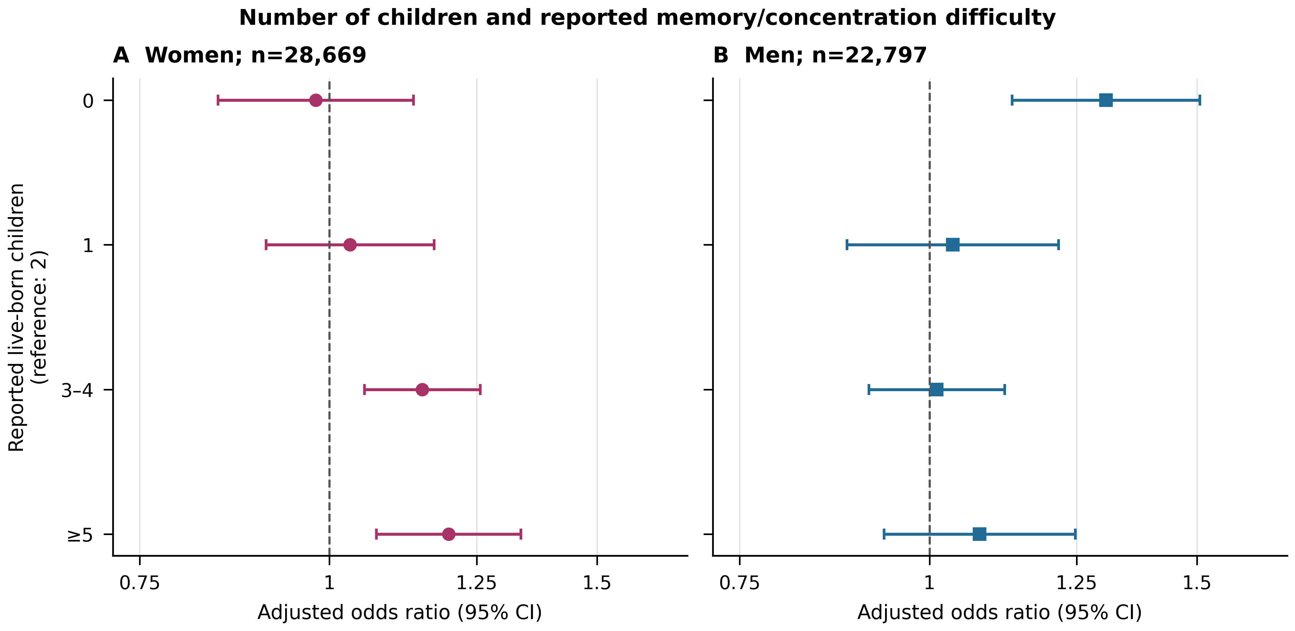
Figure 1. Number of reported live-born children and any self-reported remembering or concentrating difficulty in CASEN 2024 respondents aged 60 years or older. A: women; B: men. Two children is the reference. Points are weighted logistic odds ratios adjusted for age group, schooling, rural residence, harmonised region, FONASA status and indigenous identification. Intervals use full-frame survey linearisation and R survey domain-model residual degrees of freedom; coefficients and standard errors were independently reproduced in Python and R. All four displayed contrasts per sex are retained. The joint parity-by-sex F test evaluates the four interactions together and does not imply that each individual contrast differs by sex. These are cross-sectional associations in complete-case respondents, not dementia diagnoses, cognitive decline or effects of pregnancy or hormones. The odds ratio is not a prevalence ratio. No participant linkage to GRD surgery or REM treatment records is available.
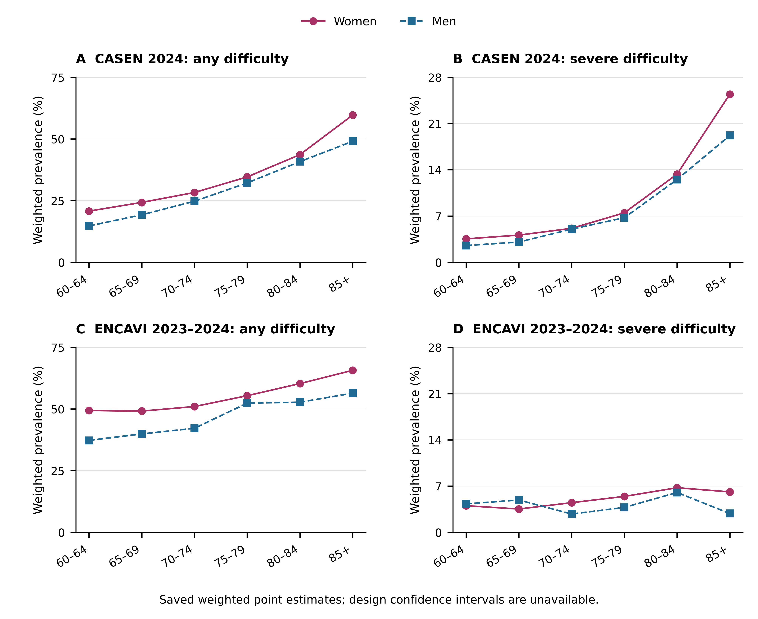
Figure 2. Age-specific weighted remembering/concentrating difficulty in the saved reproductive-history analytic samples. Panels A–B show CASEN 2024 and C–D ENCAVI 2023–2024; any and severe outcomes use separate labelled y scales, common within each outcome across instruments. Sex is encoded by colour and marker/line pattern. Values are weighted point estimates only; the saved source lacks design variances, so confidence intervals are unavailable. Lines join observed age-group summaries and do not represent longitudinal trajectories. CASEN severe means categories 3–4 and ENCAVI severe categories 4–5. ENCAVI uses a different health-related item and has an unresolved target-coverage/calibration conflict; between-instrument differences are not interpreted as disease differences.
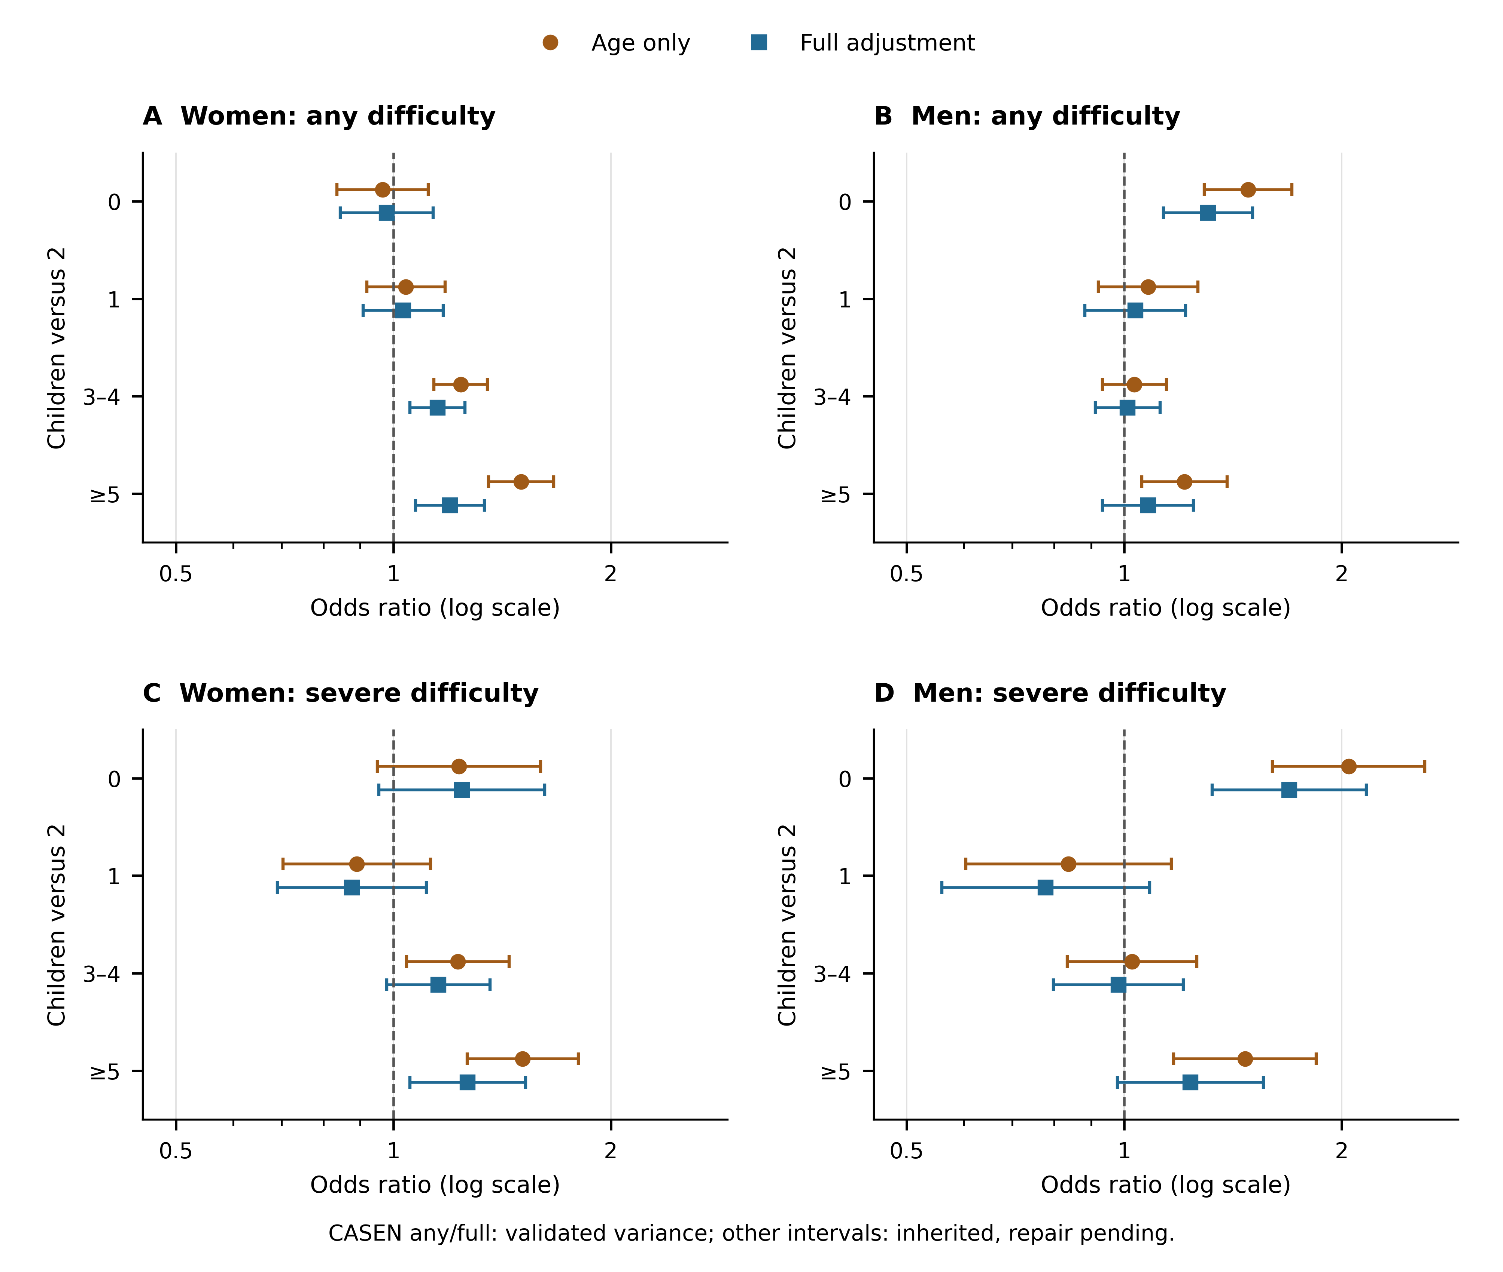
Figure 3. CASEN 2024 child-number associations with any and severe self-reported difficulty, retaining every contrast versus two children in women and men aged 60 or older. Panels A–B show any difficulty and C–D severe difficulty. Orange circles show age-only and blue squares fully adjusted logistic odds ratios with available nominal 95% intervals. Fully adjusted any-difficulty intervals are the independently validated R survey t intervals; age-only and severe intervals remain inherited normal intervals with domain repair pending. The horizontal axis is logarithmic. Adjustment can change both the covariate set and the analytic sample; shifts are descriptive and do not identify confounding removal or mediation. Severe means categories 3–4. These outcomes are not diagnosed dementia or cognitive decline.
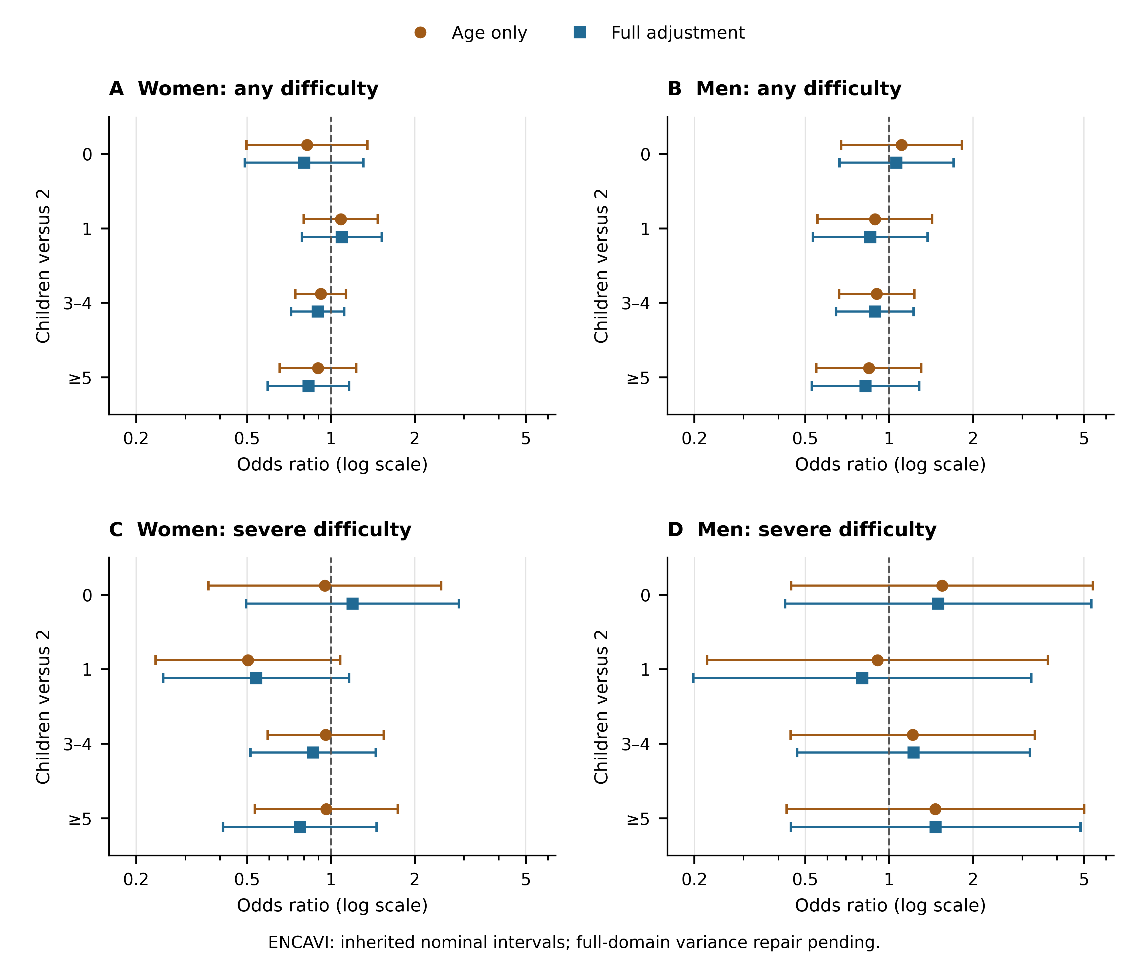
Figure 4. ENCAVI 2023–2024 analysed as a separate instrument: all stored child-number contrasts versus two children for any and severe health-related remembering/concentrating difficulty in prepared ENCAVI respondents aged 60 or older. Any means categories 2–5; severe means 4–5. Orange circles show age-only and blue squares age/education/region-adjusted odds ratios. The logarithmic axis retains all nominal 95% source intervals, including wide intervals; full-domain variance repair has not been executed because the external person files are unavailable. This survey asks whether/how many children respondents have rather than explicit lifetime live births. The panels cannot establish direct replication, absence of association or equivalence with CASEN.
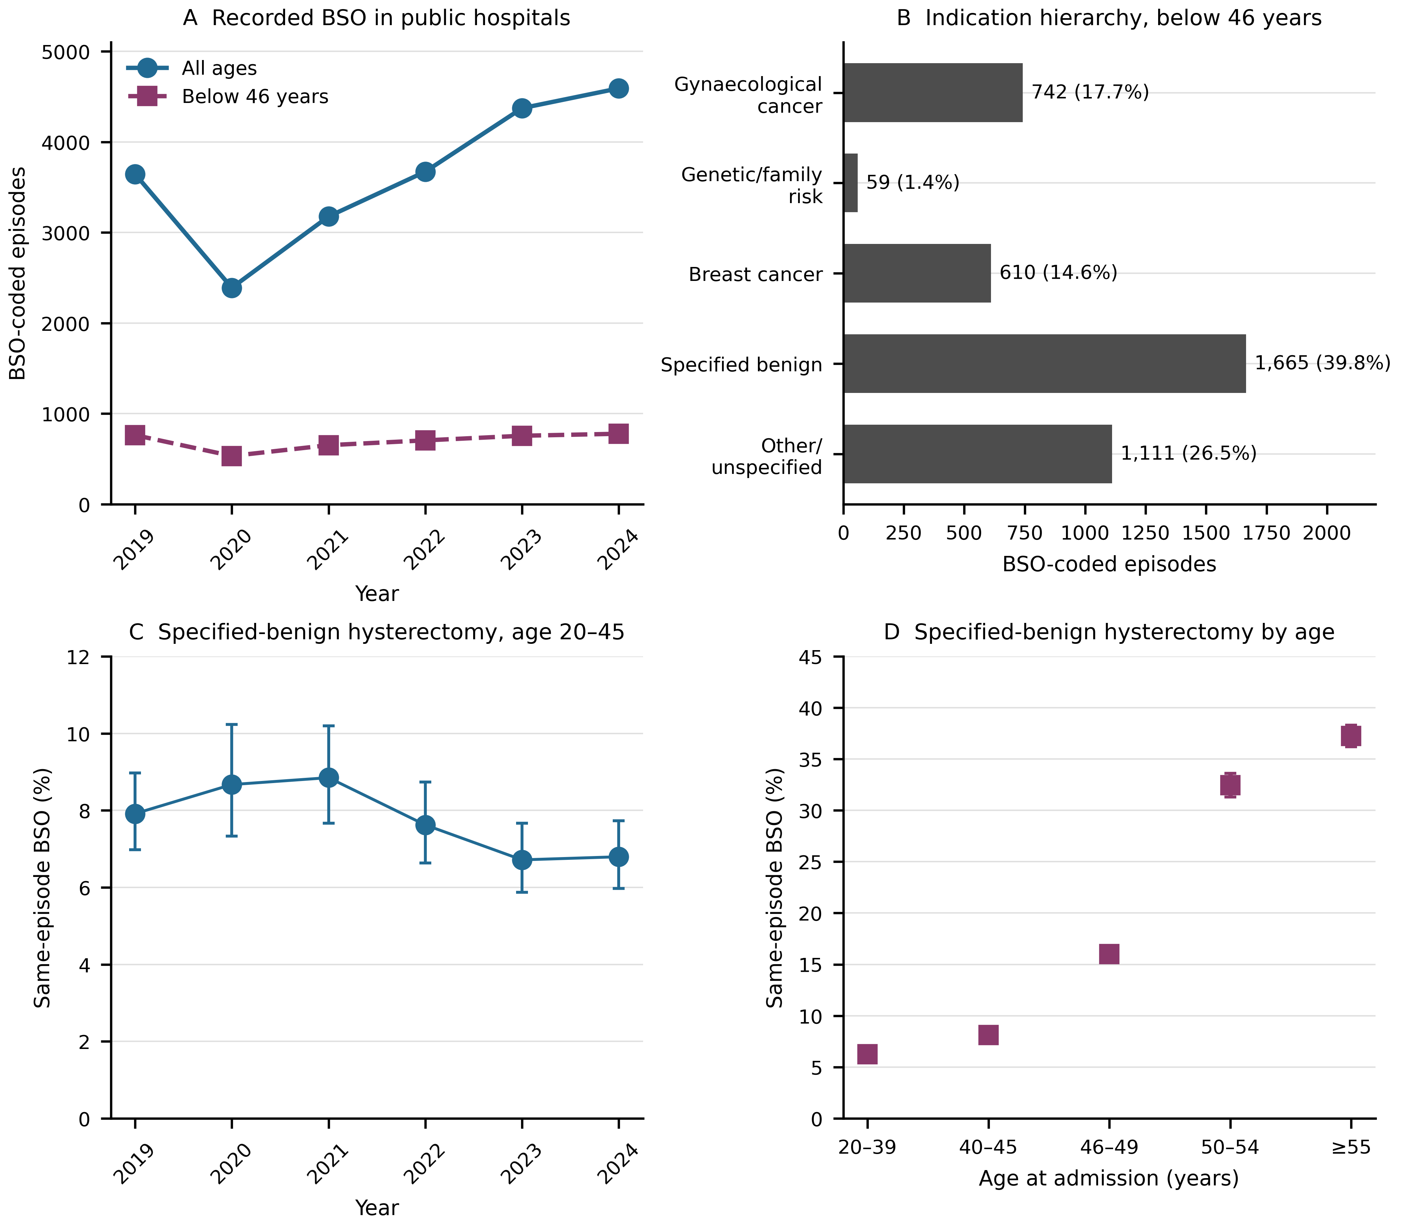
Figure 5. Coded ovarian surgery in public-hospital GRD episodes, 2019–2024. A: episodes with a bilateral-oophorectomy (BSO) flag at all ages and below 46 years; ambulatory/other coded activities are retained. B: hierarchical diagnosis classification among BSO-coded episodes below 46; categories are mutually exclusive, but a diagnosis is not a validated operative indication. C: proportion of specified-benign hysterectomy episodes at ages 20–45 with a BSO flag in the same episode, by year. D: the same proportion by age group, pooled over 2019–2024, restricted to ages ≥20. C–D show unadjusted Wilson 95% binomial reference intervals assuming independent episodes; these do not incorporate repeated people, provider clustering, incomplete recording or selection. The primary denominator excludes gynaecological cancer, genetic/family risk, breast cancer and other/unspecified hierarchical categories. Individual procedures may occur at different times within an episode. BSO mapping includes removal of a remaining ovary; a negative flag does not prove ovarian preservation. Age is a proxy derived from admission and birth dates; below 46 is not recorded menopausal status. No statistical test, causal claim or estimate of preventable dementia is displayed.
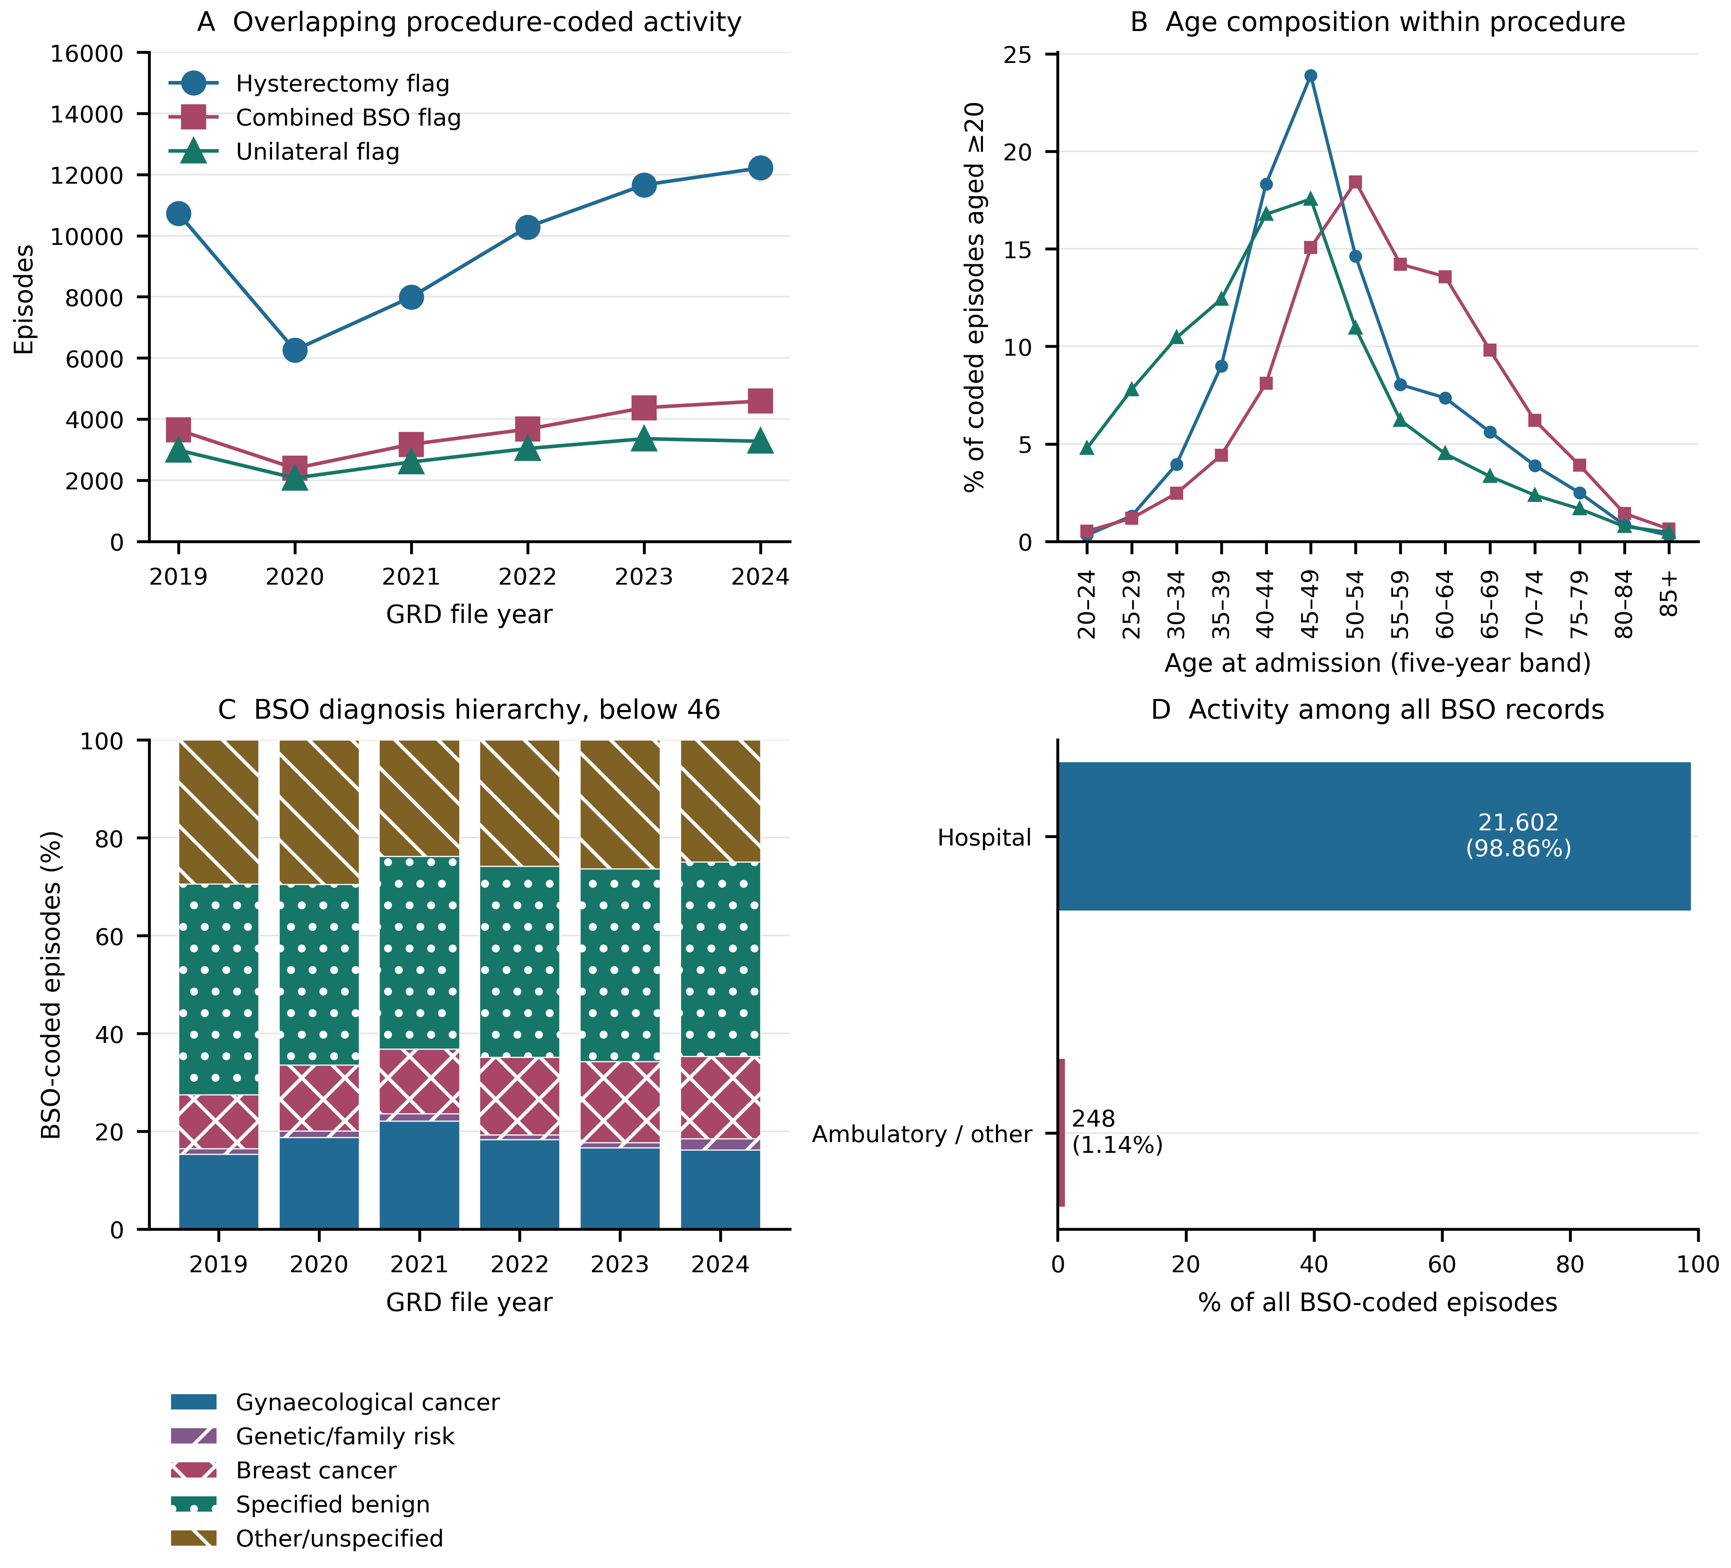
Figure 6. Procedure-coded activity and case composition in public-hospital GRD file years 2019–2024. A: annual episodes with hysterectomy, combined BSO or unilateral flags; the groups overlap. B: distribution across five-year age bands among episodes aged at least 20, expressed within each procedure group; curves are composition, not population incidence. C: annual hierarchical diagnosis composition among BSO-coded episodes below 46, including the small number below age 20; categories are mutually exclusive under the stated any-position hierarchy. D: hospital versus ambulatory/other activity among all BSO-coded episodes, across all ages and indications. The combined BSO flag merges both-ovary and remaining-ovary codes. No menopause, clinical appropriateness, provider performance or causal interpretation is assigned. These are descriptive recorded counts without stochastic intervals.
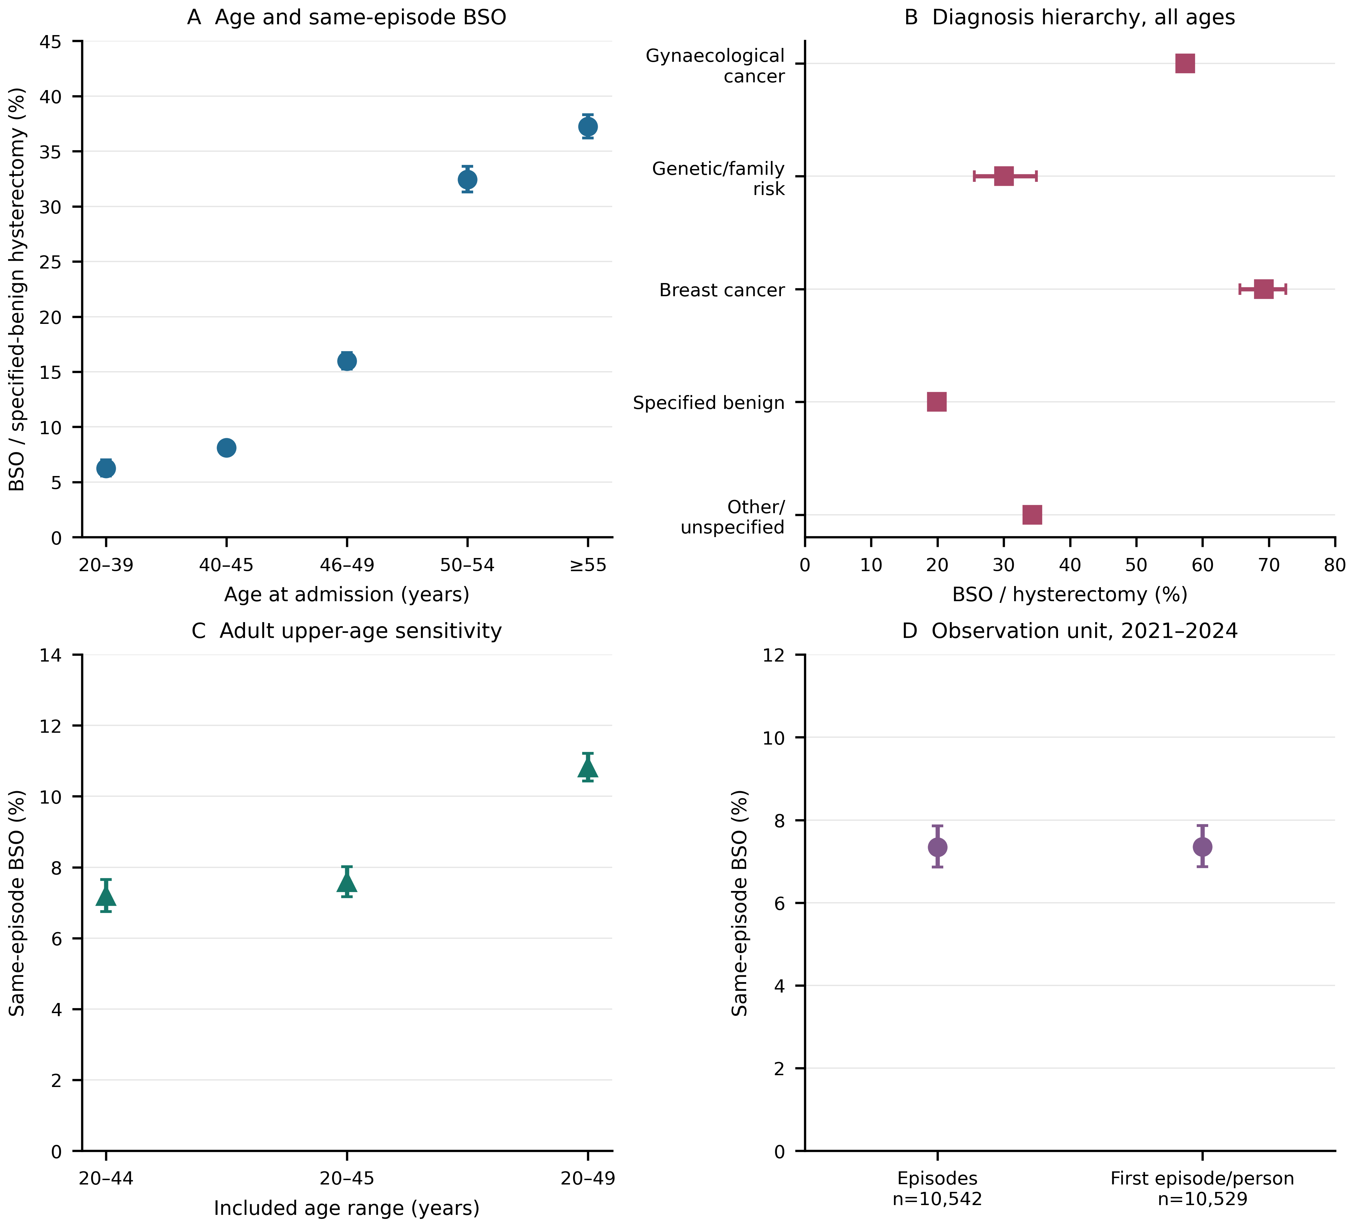
Figure 7. Denominator and observation-unit sensitivities for BSO coding at hysterectomy. A: pooled 2019–2024 specified-benign episodes at adult ages, with the exact numerators and denominators in the accompanying age table. B: all-age 2019–2024 hysterectomy episodes under each mutually exclusive diagnosis hierarchy category; this population differs from A. C: specified-benign episodes restricted to adult age ranges 20–44, 20–45 and 20–49; changing the upper age changes case mix. D: all eligible age 20–45 episodes in GRD file years 2021–2024 versus the first observed eligible episode per valid person identifier in those file years. Counts with missing identifiers are excluded only from the person sensitivity. Whiskers are unadjusted Wilson 95% binomial reference intervals; episode intervals assume independent episodes, and none includes provider clustering or coding/selection uncertainty. The comparison does not establish equivalence or effects of age, surgery or clinical care. No BSO code does not confirm preserved ovarian tissue; the BSO flag includes remaining-ovary removal.
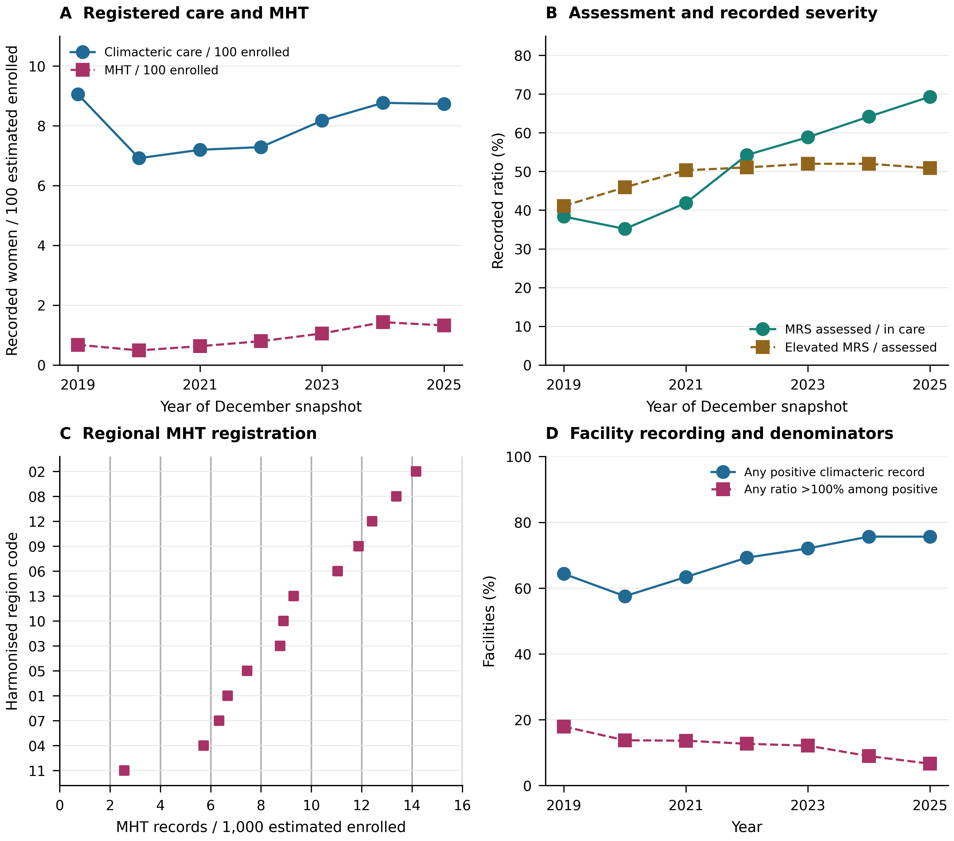
Figure 8. Menopause-care indicators from December REM P1 records and estimated FONASA enrolment, 2019–2025. A: climacteric-care and MHT records per 100 estimated enrolled women aged 45–64, with separate labelled series on one scale. B: MRS-assessed women relative to recorded care and elevated MRS relative to assessed women. These are aggregate ratios and do not establish a linked clinical cascade. C: MHT counts in municipality-years with positive matching denominators, summed across December snapshots and divided by summed estimated enrolment within 13 harmonised regions; points are descriptive and no confidence intervals are shown. D: facilities with positive climacteric records among those with positive estimated enrolment, and facilities with at least one stage/enrolment ratio above 100% among those with positive records. The latter flags numerator–denominator inconsistency, not an audited error rate. Counts may repeat women across years. Denominators for ages 45–64 are prorated using municipal population age structure. Missing source cells cannot distinguish zero activity from absent reporting. The 2025 numerator layout and 2024 denominator age-band changes require explicit harmonisation checks before final longitudinal inference.
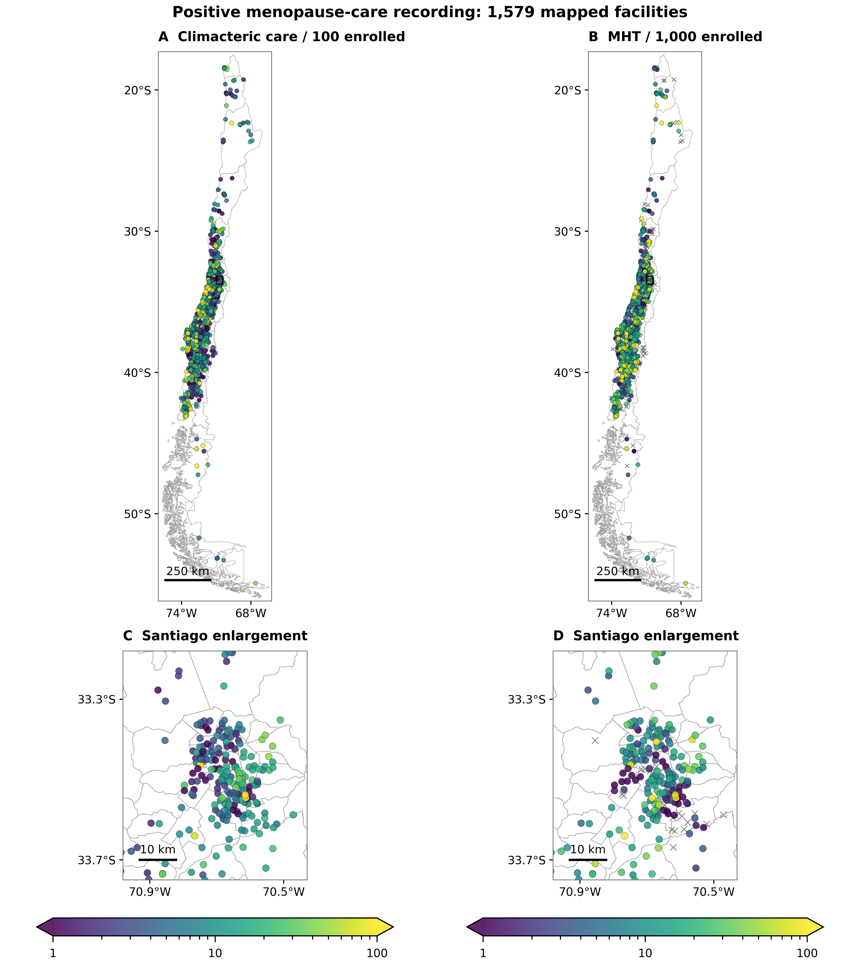
Figure 9. Facility geography of positive menopause-care recording in Chile, pooled December snapshots 2019–2025. A–B: recorded climacteric care per 100 and MHT per 1,000 estimated enrolled women aged 45–64. C–D: the same measures in the Santiago enlargement marked on the national maps. The 1,579 mapped facilities have any positive climacteric recording, at least 50 summed estimated enrolment observations and usable mainland coordinates; the map is not a census of eligible providers or a map of individual treatment uptake. Grey crosses denote facilities in this positive-record sample with no positive record for the particular mapped measure; derived files cannot separate confirmed zero from absent reporting. Colour scales are logarithmic from 1 to 100 in the distinct stated units; observations beyond the limits retain extreme colours. Numerators and denominators are first matched within facility-year with positive estimated enrolment, then summed; unmatched annual counts are excluded from mapped ratios and retained in the QC export. Women can recur across December snapshots. Age denominators are estimated from grouped FONASA enrolment using municipal INE age structure. WGS84 longitude and latitude are displayed with latitude-adjusted aspect ratios and approximate 250 km and 10 km scale bars. Oceanic and Antarctic territories are omitted. Spatial differences can reflect recording, selection and denominator construction as well as service provision; no new cluster tests or causal comparisons are made. Basemap boundaries: Biblioteca del Congreso Nacional de Chile, Mapoteca.
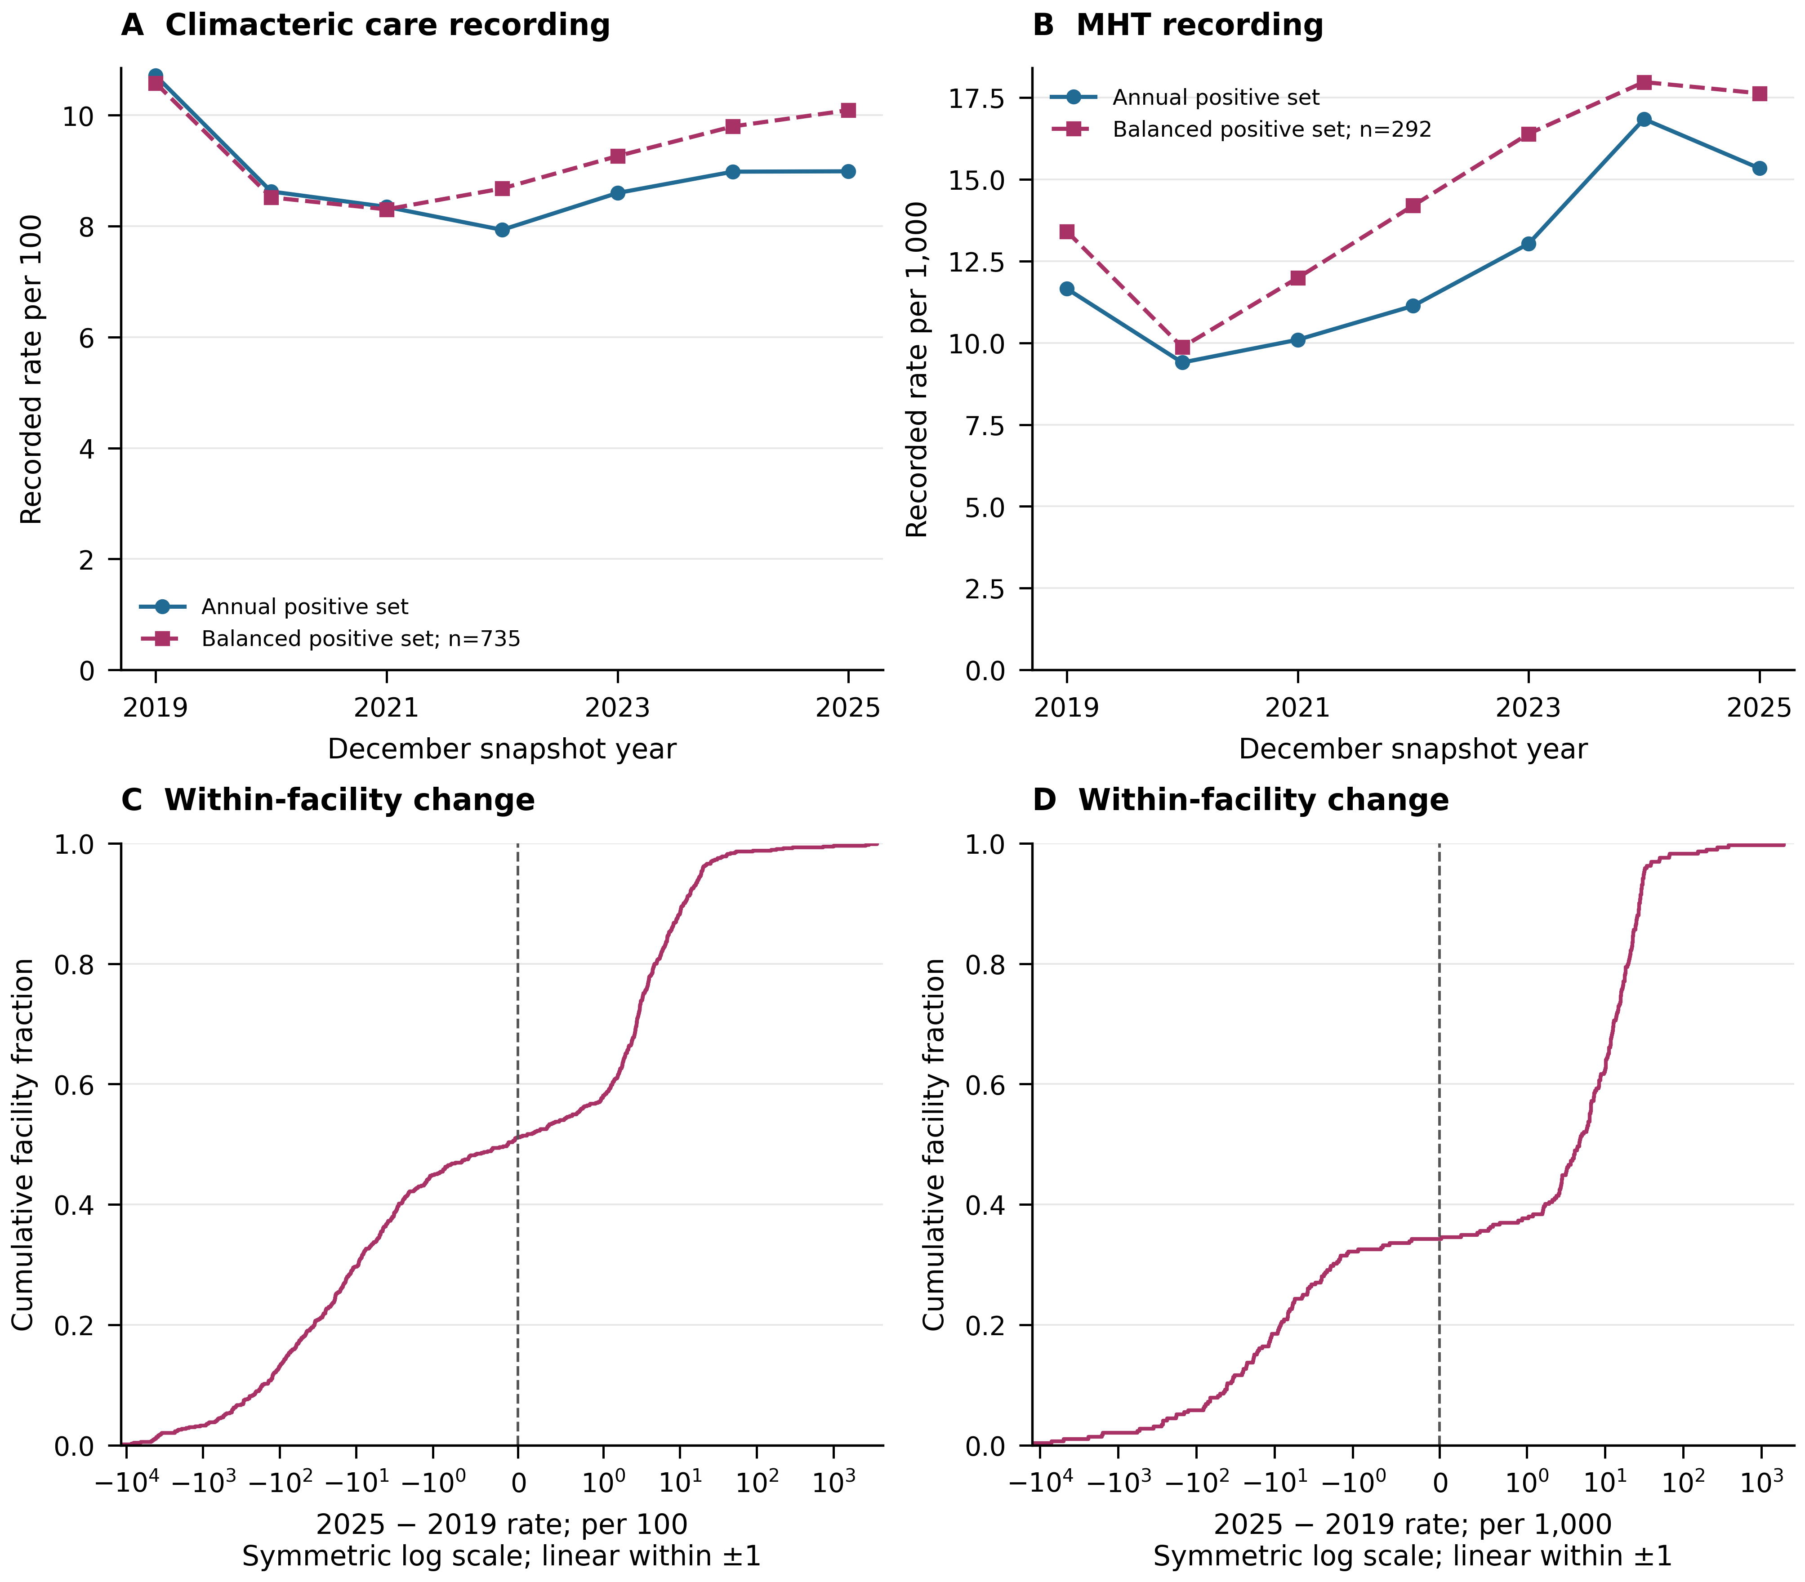
Figure 10. Annual recording and within-facility comparability sensitivity. A–B: stage-specific ratios of summed counts to summed positive same-year estimated enrolment in all annual positive-record facilities and in facilities with positive stage records and denominators in all seven December snapshots, 2019–2025. Balanced sets are selected on complete positive recording and differ by metric. C–D: empirical cumulative distributions of each balanced facility’s 2025 minus 2019 rate change. The horizontal scale is symmetric logarithmic outside the interval −1 to 1, which is linear; all observed changes are retained. Care uses records per 100 and MHT per 1,000 estimated enrolled women aged 45–64. No missing record is imputed as zero. Lines and distributions are descriptive; no uncertainty interval or causal trend is estimated. Numerator-layout and denominator age-band changes can affect temporal comparability.
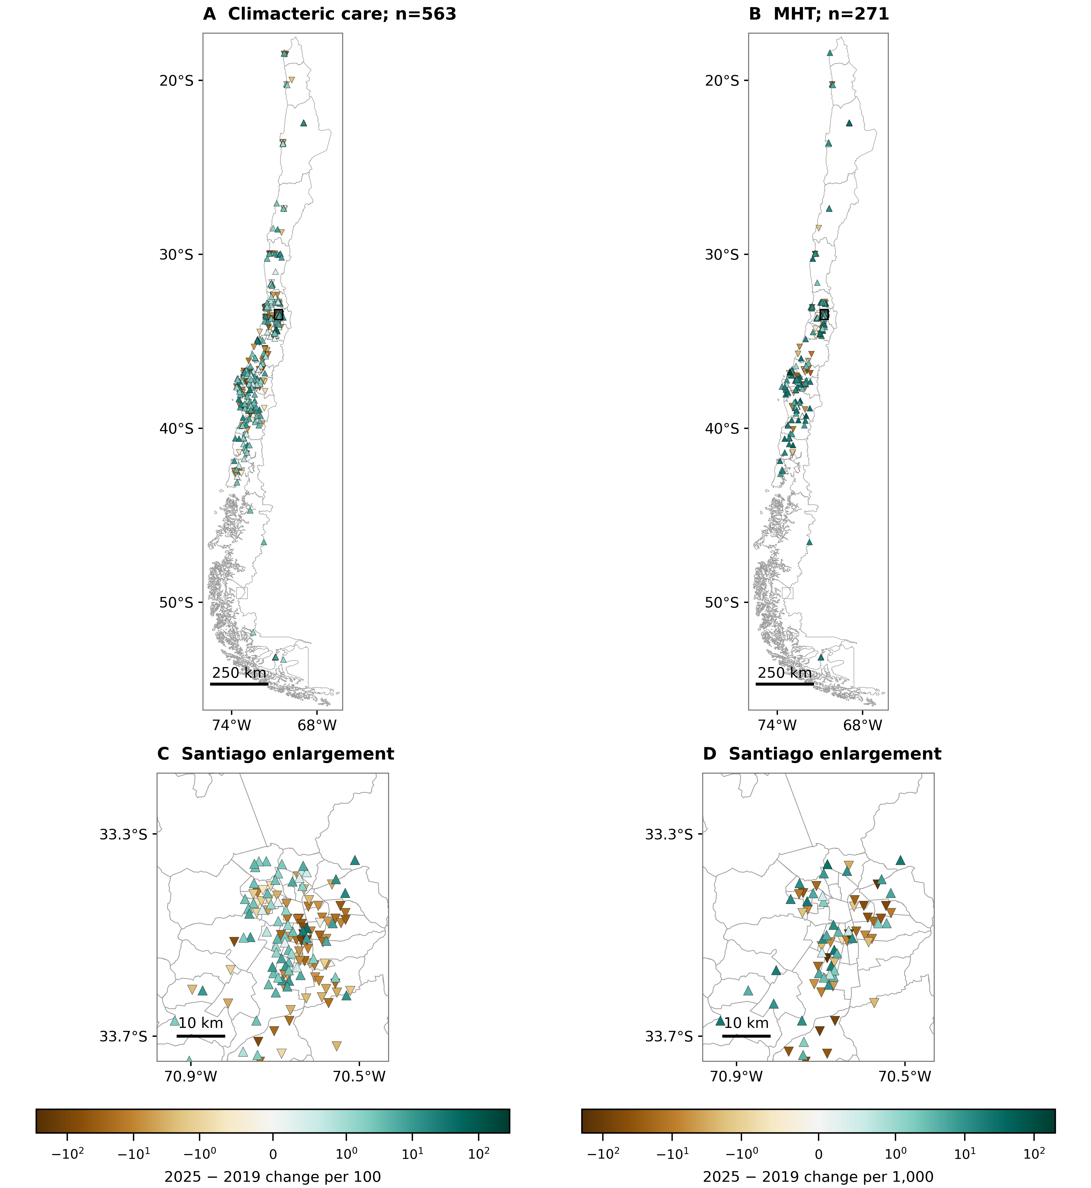
Figure 11. Geography of within-facility recording change in balanced positive-record panels. A–B: public facilities with positive care or MHT recording and positive estimated enrolment in all seven December snapshots, 2019–2025; panels retain distinct stage-specific sets. C–D: Santiago enlargements at the same colour scale as the respective national map. Change is 2025 minus 2019 in care records per 100 or MHT records per 1,000 estimated enrolled women aged 45–64. Triangles point upward for non-negative and downward for negative change. Each diverging scale is centred at zero, symmetric logarithmic outside ±1 and linear within ±1; its full range retains every mapped value. Map eligibility additionally requires at least 50 estimated enrollees at both endpoints and mainland WGS84 coordinates. Latitude-adjusted aspect ratios and approximate 250 km and 10 km scale bars are shown. These selected provider comparisons are not individual treatment changes, population access or spatial causal effects; changing source layouts and denominators remain relevant. Basemap boundaries: Biblioteca del Congreso Nacional de Chile, Mapoteca.
Figure 12. Municipal programme recording and contemporary territorial context in 2024. A–B: care per 100 estimated enrolled women aged 45–64 versus municipal multidimensional poverty and rural population share. C–D: MHT per 1,000 against the same contextual measures. Each point is one municipality with a positive stage count, positive same-year enrolment and observed covariate. Vertical axes are logarithmic; absent positive records are excluded rather than interpreted as zeros. Shapes redundantly identify saved rurality categories. Spearman coefficients use equal municipality weights, average tied ranks and the complete displayed pairwise data. All points are retained; no fitted causal curve, p value or independence-based confidence interval is shown. Poverty and rurality refer to the saved contemporary context and are not assigned as historical lifetime exposures. Facility recording, denominator construction, regional composition and spatial dependence can contribute to these ecological patterns.
Figure 13. Recording scope and denominator sensitivity. A–B: percentage of facilities with a positive recorded care or MHT count among those with positive estimated enrolment, by saved facility type and December snapshot year, 2019–2025. Labels show percentages; non-positive source cells cannot distinguish absent reporting from confirmed zero activity. Contemporary facility type is held as supplied; historical reclassification is not reconstructed. C–D: 2024 ratios of summed stage counts to summed enrolment after minimum-enrolment thresholds of 0, 50, 250 and 1,000, retaining positive-record facilities. Blue circles include all such records; purple squares exclude stage counts above estimated enrolment. The screening sensitivity does not correct or validate numerator or denominator. Care uses records per 100, and MHT per 1,000. These are descriptive registered-service ratios, with no causal or population-coverage interpretation.
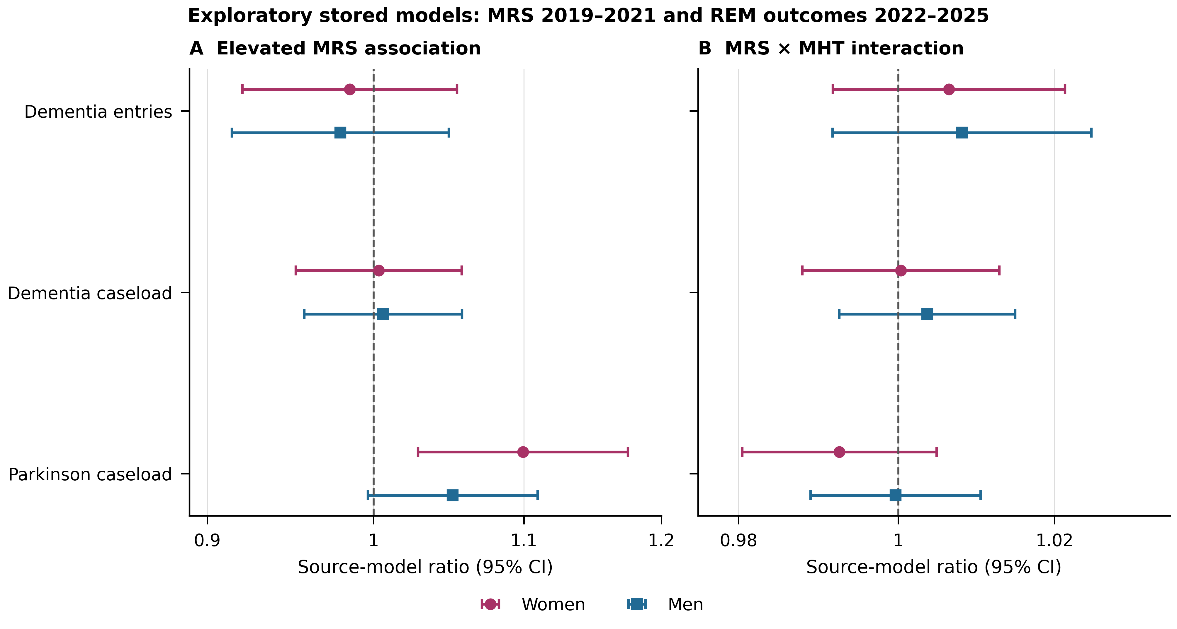
Figure 14. Stored exploratory facility-level MRS and later neurodegenerative registration models. A: source Poisson ratios for a 10 percentage-point higher proportion of elevated MRS among assessed women during 2019–2021, conditional on the model’s centered MHT ratio. B: multiplicative MRS×MHT interaction terms, where MRS is scaled per 10 percentage points and MHT per 10 users per 100 elevated-MRS records. Outcomes are dementia entries, repeated December dementia caseload and repeated December Parkinson caseload at ages ≥60 in 2022–2025. Both recorded sexes are displayed for all three outcomes. Models use expected-count offsets, source covariates, municipal fixed effects and municipality-clustered standard errors; retained samples differ by sex and outcome. Points and 95% intervals reproduce mf18 saved results and have not been independently refitted in this report. Intervals are not corrected for the wider analysis family. Exposure and outcome populations need not contain the same individuals or cohorts. Associations reflect registration and selected facility populations as well as possible clinical variation; they do not estimate individual hormone effects or demonstrate causal moderation.

Additional methods for REM instruments

Source definitions and complementary observation units
We extended the multisource study with REM functional classifications, mobility assessments, dementia programme reassessments and caregiver measures. Definitions and annual field mappings were obtained from the DEIS annual REM files and coded dictionaries, the REM Series A manual and the REM Series P manual. The seven annual coded templates were checked individually for 2019–2025; a manual description alone was not treated as evidence of a standalone data field.
Series P describes populations recorded under control at the December cut-off; Series A records activities during reporting months. Instrument-specific classifications and activity counts were analysed separately. The data do not establish raw cognitive scores, individual progression, dementia incidence, treatment effectiveness or patient-level linkage between menopause care and neurodegeneration. Functional dependence, fall risk and depression measures were retained as complementary clinical context rather than neurodegenerative diagnoses.

REM P5 functional and mobility classifications
We analysed the original December REM Series P snapshots from 2019 through 2025, validating each code and column against its corresponding annual coded official workbook. The unit of analysis was the reporting establishment, classification category and December snapshot. EFAM categories (autonomous without risk, autonomous with risk and dependency risk) and four Barthel dependency categories formed a seven-category functional distribution for adults aged 65 years or older under control. Timed Up and Go (normal, mild fall risk, high fall risk) and single-leg stance (normal, altered) were analysed as separate instruments with separate classified-population denominators. These administrative category counts do not contain individual test scores or person-linked trajectories.
Exact duplicate rows were removed once. Nonidentical records for the same establishment, category and snapshot were quarantined, as were negative, noninteger or nonnumeric observed counts and complete total/sex triplets that did not satisfy total = men + women. An establishment entered an instrument-specific analysis only when every required category row had numeric total, male and female counts and a consistent source region. Blank cells, explicit zeros and absent rows were retained as distinct source states; no unobserved count was imputed as zero. The denominator for a category share was the sum of all classifications for the same instrument, establishment sample, sex and snapshot. Positive denominators were required.
Age-specific analyses additionally required all source age components to be numeric and nonnegative and to reconcile to the corresponding sex total in every instrument category. We harmonised 65–69, 70–74, 75–79 and 80+ years; the detailed 80–84 through 100+ bands introduced in 2023 were summed to 80+. The latest complete snapshot, December 2025, was examined by sex, age and source region. We report crude regional shares and, within the same stricter age-reconciled provider samples, directly age-standardised shares; neither estimates resident-population prevalence. A balanced-provider sensitivity retained establishments satisfying instrument completeness in every year from 2019 through 2025. Repeated snapshots were not summed as unique people.
For geography, we directly age-standardised regional adverse-classification shares using four common age bands and, separately for each instrument, the pooled national female and male age distribution in the 2025 age-reconciled classified sample as the common standard. Each regional sex-specific proportion was weighted by this same instrument-specific distribution. All four regional age denominators had to be positive. Region was the source administrative region of the reporting provider. Choropleth maps use project Biblioteca del Congreso Nacional de Chile Mapoteca regional boundaries, clipped to mainland Chile and projected to WGS84 / UTM zone 19S (EPSG:32719); a 250-km projected scale bar is shown. Regions with fewer than five age-complete providers are hatched and shown with open comparison markers as a display flag only; no values are suppressed. Oceanic and Antarctic territories are omitted. Standardised shares remain selected under-control recording measures rather than resident-population prevalence, clinical disease risk, travel time, unmet need or access. No sampling confidence intervals were added to these direct administrative counts; reporting, selection and measurement uncertainty remain unquantified.

REM instruments, units of analysis and source quality
We extended the descriptive administrative analysis using annually audited REM Series A coded templates and source CSV files for 2019–2025. GDS-Reisberg global-deterioration reevaluation, dementia caregiver burden reevaluation and caregiver satisfaction were taken from the A06 dementia programme evaluation block using stable codes and annually checked layouts. Zarit abbreviated caregiver burden, programme TUG/functionality change and hospital Barthel change came from A03. Yesavage GDS-15 activity was analysed separately for 2023–2025. These sources contain aggregate recording counts, not individual scores, uniquely identified patients or observed patient trajectories. Caregiver sex is distinct from patient sex.
Exact duplicate source rows were collapsed. After this step, all records at a conflicting year–month–health-service–facility–code key were quarantined. Blank cells and absent category rows were preserved as missing; explicit numeric zero was retained. A January 2021 source cluster repeated exceptionally large identical vectors in all three A06 measures. Because its cause remains unresolved, the entire 2021 year was withheld from their primary series. An all-record versus outside-cluster comparison was retained only as a diagnostic sensitivity analysis.

Complete-case category denominators and interpretation
A06 change-category proportions required nine numeric, non-negative integer fields, reconciliation of total with men plus women, and reconciliation of each sex total with its increased, maintained and decreased categories. For Zarit, both intense and non-intense burden rows had to be present in the same facility-month, with coherent numeric total/sex fields. For TUG, the functionality questionnaire and hospital Barthel, all three change-category rows had to be present and coherent within each instrument's own facility-month set. Proportions were calculated by dividing summed category recordings by summed eligible category recordings. We reported the eligible/observed sets and exclusions rather than substituting zero for missing rows.
TUG and the functionality questionnaire describe the programme discharge setting (age 60+), whereas hospital Barthel refers to admission-to-discharge change (age 65+). Zarit concerns caregivers of people with severe dependency and is not dementia-specific. Increasing deterioration, increasing burden and increasing satisfaction represent different constructs; the categories were not pooled into a common favourable-response estimate. Yesavage context was restricted to A03 application counts. A27 follow-up activity was not harmonised because the official 2023 template repeats COL11 for both an age field and men, with different sex columns in subsequent years. Shared mental-health risk-result rows were not treated as Yesavage-specific. No causal benefit, treatment effect, population prevalence or clinical diagnostic accuracy was estimated.

Additional results from REM instruments
The additional REM analyses make the care context more explicit by describing functional status, fall-risk classifications, dementia programme reassessments and caregiver measures. These observations supply complementary service and outcome context for the reproductive analyses. They do not link an individual's menopause care to later cognitive or neurodegenerative change.

Recorded functional classifications and completeness
The seven-category functional sample included 809 of 1,998 establishments with at least one retained functional category in December 2019 and 965 of 2,054 in December 2025. Complete-provider selection therefore changes the population represented by these estimates. Across the twelve P5 category codes, 20 exact extra source rows were removed, 5 sex-total errors were quarantined and 0 nonidentical establishment-category snapshots required quarantine.
Among women in the annual complete-provider functional sample, dependency risk or any Barthel dependency accounted for 30.94% (149,550/483,296) in 2019 and 30.11% (176,197/585,129) in 2025. These percentages describe the classified under-control sample and cannot be interpreted as population dependency prevalence.
Among men in the annual complete-provider functional sample, dependency risk or any Barthel dependency accounted for 26.49% (78,364/295,780) in 2019 and 25.45% (93,773/368,430) in 2025. These percentages describe the classified under-control sample and cannot be interpreted as population dependency prevalence.

Separate mobility classifications and age structure
In December 2025, women had 36.96% mild or high TUG fall-risk classifications (172,916/467,846; 1,684 providers) and 47.60% altered single-leg stance classifications (247,722/520,441; 1,931 providers). The two instrument denominators are distinct.
In December 2025, men had 29.76% mild or high TUG fall-risk classifications (93,668/314,747; 1,685 providers) and 40.63% altered single-leg stance classifications (141,664/348,699; 1,935 providers). The two instrument denominators are distinct.
The December 2025 age-reconciled samples contained 492 providers for functional classification, 824 providers for timed up and go, 899 providers for single-leg stance. Age-specific distributions use these stricter samples, and older source age bands were collapsed to the common 80+ category.

Provider selection sensitivity and regional recording
The balanced-provider samples comprised 280 functional-classification, 699 TUG and 1,170 single-leg stance establishments with complete data in every December from 2019 through 2025. This sensitivity fixes provider membership but does not track the same individuals or remove selection, case-mix or measurement differences.
For women, dependency risk or dependency in the balanced functional sample changed from 30.83% to 31.16% between 2019 and 2025; the corresponding annual complete-provider shares were 30.94% and 30.11%.
For men, dependency risk or dependency in the balanced functional sample changed from 26.00% to 25.91% between 2019 and 2025; the corresponding annual complete-provider shares were 26.49% and 25.45%.
All 16 source regions had positive classified denominators in the four common age bands for both sexes and all three instruments, permitting direct age standardisation in the stricter age-reconciled samples. Regional tables compare crude and standardised shares within those same selected samples, and national choropleth maps display standardised values on common scales. Age standardisation adjusts the observed age distribution but cannot remove provider selection, differences in case mix within age bands or recording differences. These geographic results do not establish resident-population disease prevalence, delayed diagnosis or clinical access.
Sparse provider participation limits some regional comparisons: functional classifications in Aysén came from only one age-complete provider, with 18 female and 14 male classified records; Arica y Parinacota had four age-complete functional providers. We retained all 16 regional values and flagged fewer than five providers with map hatching and open comparison markers. This display flag does not quantify statistical precision or remove selection bias. Regional low/high rankings should not be interpreted as population gradients.

Dementia programme evaluations: recorded activity and selected change categories
In 2025, the GDS-Reisberg source contained 6,414 recorded reevaluations (4,063 in women and 2,351 in men) from 121 facilities. All nine mapped cells were complete and coherent in 351 of 626 observed facility-month rows. In the eligible female subset, increased global deterioration represented 722/2,315 recordings (31.2%). The complete-case denominator is narrower than all reported activity and should not be interpreted as all women with dementia in Chile.
The 2021 raw A06 spike was dominated by 12 original rows from four facilities in January. The cluster contributed 107,160 to each of the three distinct measures, with identical nine-cell vectors and equal thirds in the change categories. Arithmetic equations for all three measures can be satisfied by this pattern; source reconciliation alone therefore did not establish plausibility. The unresolved year appears as a gap in primary trends, while its raw-versus-outside-cluster counts remain explicitly diagnostic.

Caregiver burden and functional change in their own reporting settings
Within 2025 paired-category Zarit records, intense caregiver burden was 23,459/47,244 (49.7%) among female caregiver recordings and 6,399/13,313 (48.1%) among male caregiver recordings. These proportions describe selected evaluations of caregivers of people with severe dependency. They do not identify a dementia-only caregiver cohort, unique caregivers or population prevalence.
The 2025 improved-category results among female recordings in each separate setting were Timed Up and Go: 3,604/14,529 (24.8%), retaining 297/2,995 observed sets (9.9%); Functionality questionnaire: 5,815/20,131 (28.9%), retaining 485/2,991 observed sets (16.2%); Hospital Barthel change: 6,882/29,131 (23.6%), retaining 499/902 observed sets (55.3%). These selected denominators, especially the small complete-set fraction for programme TUG, limit generalisation. The instrument, programme/hospital setting, age scope and changing reporting sample prevent pooling or causal comparison across tools.

Depression-screening activity as contextual evidence
The 2025 Yesavage GDS-15 application row contained 99,464 coherent activity recordings (64,944 in women and 34,520 in men). These are screening-activity counts; shared mental-health risk rows cannot establish Yesavage-specific positivity, and A27 follow-up fields were not harmonised. This depression-screening context remains conceptually separate from GDS-Reisberg dementia deterioration.

Relationship to the reproductive and diagnostic recording analyses
These findings add complementary information to the original recorded neurodegenerative burden, reproductive-history analyses and menopause-care context. The functional and mobility distributions identify the classifications observed among people under control, while dementia reassessment and caregiver measures describe activity among selected reporting programmes. Differences in provider completeness, observation units and patient composition limit direct comparisons between instruments.
The new REM results do not add an individual-level test of hormone exposure and cognitive decline. Shared provider or regional patterns can support a subsequent ecological analysis with explicit denominator and reporting checks, but cannot establish that the same women received menopause treatment and subsequently experienced a neurodegenerative outcome. No new hormonal association model was fitted in this extension.

Table NI-P-T1. Annual reporting and complete classification samples, December 2019–2025
Year | Instrument | Any category present: facilities | All category rows: facilities | Complete numeric totals: facilities | Complete age and sex: facilities
2019 | Functional classification | 1998 | 809 | 809 | 372
2020 | Functional classification | 1890 | 661 | 661 | 305
2021 | Functional classification | 1966 | 654 | 654 | 305
2022 | Functional classification | 1995 | 784 | 784 | 412
2023 | Functional classification | 2012 | 864 | 864 | 423
2024 | Functional classification | 2043 | 941 | 941 | 508
2025 | Functional classification | 2054 | 965 | 965 | 492
2019 | Timed Up and Go | 1681 | 1433 | 1433 | 740
2020 | Timed Up and Go | 1505 | 1183 | 1183 | 596
2021 | Timed Up and Go | 1648 | 1285 | 1285 | 653
2022 | Timed Up and Go | 1768 | 1492 | 1491 | 863
2023 | Timed Up and Go | 1832 | 1593 | 1593 | 733
2024 | Timed Up and Go | 1900 | 1669 | 1669 | 870
2025 | Timed Up and Go | 1935 | 1685 | 1685 | 824
2019 | Single-leg stance | 1742 | 1695 | 1695 | 1126
2020 | Single-leg stance | 1573 | 1507 | 1507 | 927
2021 | Single-leg stance | 1718 | 1645 | 1645 | 1043
2022 | Single-leg stance | 1826 | 1779 | 1779 | 1250
2023 | Single-leg stance | 1873 | 1835 | 1835 | 843
2024 | Single-leg stance | 1932 | 1898 | 1897 | 952
2025 | Single-leg stance | 1972 | 1944 | 1944 | 899
Each instrument has a separate denominator. Completeness requires every category row and nonblank, nonnegative, integer counts, with total equal to men plus women. Blank and absent source fields remain unobserved. Age analysis additionally requires all mapped age components and equality to sex totals. Providers can recur between years.
Table NI-P-T2. Recorded functional classifications by sex, December 2019–2025
Shares use the sum of all categories from the same complete selected providers and sex. Functional classifications concern adults aged 65 years or older under control; mobility instruments concern their separately classified under-control populations. These are recorded category distributions, not population prevalence. Exact duplicate source rows are removed; conflicting or inconsistent rows are quarantined.
Year | Sex | Category | Recorded n | Classified N | Share (%)
2019 | Men | Autonomous with risk | 77,452 | 295,780 | 26.19
2019 | Men | Autonomous without risk | 139,964 | 295,780 | 47.32
2019 | Men | Dependency risk | 35,487 | 295,780 | 12.00
2019 | Men | Mild dependency | 25,578 | 295,780 | 8.65
2019 | Men | Moderate dependency | 5,700 | 295,780 | 1.93
2019 | Men | Severe dependency | 5,371 | 295,780 | 1.82
2019 | Men | Total dependency | 6,228 | 295,780 | 2.11
2019 | Women | Autonomous with risk | 129,134 | 483,296 | 26.72
2019 | Women | Autonomous without risk | 204,612 | 483,296 | 42.34
2019 | Women | Dependency risk | 66,037 | 483,296 | 13.66
2019 | Women | Mild dependency | 49,123 | 483,296 | 10.16
2019 | Women | Moderate dependency | 10,967 | 483,296 | 2.27
2019 | Women | Severe dependency | 10,097 | 483,296 | 2.09
2019 | Women | Total dependency | 13,326 | 483,296 | 2.76
2020 | Men | Autonomous with risk | 48,613 | 190,590 | 25.51
2020 | Men | Autonomous without risk | 90,171 | 190,590 | 47.31
2020 | Men | Dependency risk | 22,658 | 190,590 | 11.89
2020 | Men | Mild dependency | 16,188 | 190,590 | 8.49
2020 | Men | Moderate dependency | 3,951 | 190,590 | 2.07
2020 | Men | Severe dependency | 4,320 | 190,590 | 2.27
2020 | Men | Total dependency | 4,689 | 190,590 | 2.46
2020 | Women | Autonomous with risk | 80,838 | 312,473 | 25.87
2020 | Women | Autonomous without risk | 132,694 | 312,473 | 42.47
2020 | Women | Dependency risk | 42,376 | 312,473 | 13.56
2020 | Women | Mild dependency | 31,092 | 312,473 | 9.95
2020 | Women | Moderate dependency | 7,809 | 312,473 | 2.50
2020 | Women | Severe dependency | 8,109 | 312,473 | 2.60
2020 | Women | Total dependency | 9,555 | 312,473 | 3.06
2021 | Men | Autonomous with risk | 36,059 | 129,594 | 27.82
2021 | Men | Autonomous without risk | 52,819 | 129,594 | 40.76
2021 | Men | Dependency risk | 15,609 | 129,594 | 12.04
2021 | Men | Mild dependency | 12,936 | 129,594 | 9.98
2021 | Men | Moderate dependency | 3,619 | 129,594 | 2.79
2021 | Men | Severe dependency | 4,218 | 129,594 | 3.25
2021 | Men | Total dependency | 4,334 | 129,594 | 3.34
2021 | Women | Autonomous with risk | 59,708 | 215,245 | 27.74
2021 | Women | Autonomous without risk | 77,607 | 215,245 | 36.06
2021 | Women | Dependency risk | 29,127 | 215,245 | 13.53
2021 | Women | Mild dependency | 24,761 | 215,245 | 11.50
2021 | Women | Moderate dependency | 6,590 | 215,245 | 3.06
2021 | Women | Severe dependency | 7,914 | 215,245 | 3.68
2021 | Women | Total dependency | 9,538 | 215,245 | 4.43
2022 | Men | Autonomous with risk | 69,954 | 229,090 | 30.54
2022 | Men | Autonomous without risk | 93,643 | 229,090 | 40.88
2022 | Men | Dependency risk | 27,264 | 229,090 | 11.90
2022 | Men | Mild dependency | 21,935 | 229,090 | 9.57
2022 | Men | Moderate dependency | 5,200 | 229,090 | 2.27
2022 | Men | Severe dependency | 5,419 | 229,090 | 2.37
2022 | Men | Total dependency | 5,675 | 229,090 | 2.48
2022 | Women | Autonomous with risk | 116,834 | 379,751 | 30.77
2022 | Women | Autonomous without risk | 138,302 | 379,751 | 36.42
2022 | Women | Dependency risk | 49,013 | 379,751 | 12.91
2022 | Women | Mild dependency | 42,803 | 379,751 | 11.27
2022 | Women | Moderate dependency | 10,045 | 379,751 | 2.65
2022 | Women | Severe dependency | 10,588 | 379,751 | 2.79
2022 | Women | Total dependency | 12,166 | 379,751 | 3.20
2023 | Men | Autonomous with risk | 86,806 | 282,066 | 30.78
2023 | Men | Autonomous without risk | 120,473 | 282,066 | 42.71
2023 | Men | Dependency risk | 27,964 | 282,066 | 9.91
2023 | Men | Mild dependency | 27,539 | 282,066 | 9.76
2023 | Men | Moderate dependency | 6,421 | 282,066 | 2.28
2023 | Men | Severe dependency | 6,353 | 282,066 | 2.25
2023 | Men | Total dependency | 6,510 | 282,066 | 2.31
2023 | Women | Autonomous with risk | 139,474 | 460,490 | 30.29
2023 | Women | Autonomous without risk | 178,686 | 460,490 | 38.80
2023 | Women | Dependency risk | 50,386 | 460,490 | 10.94
2023 | Women | Mild dependency | 54,038 | 460,490 | 11.73
2023 | Women | Moderate dependency | 12,235 | 460,490 | 2.66
2023 | Women | Severe dependency | 12,413 | 460,490 | 2.70
2023 | Women | Total dependency | 13,258 | 460,490 | 2.88
2024 | Men | Autonomous with risk | 96,319 | 323,573 | 29.77
2024 | Men | Autonomous without risk | 142,918 | 323,573 | 44.17
2024 | Men | Dependency risk | 30,742 | 323,573 | 9.50
2024 | Men | Mild dependency | 32,292 | 323,573 | 9.98
2024 | Men | Moderate dependency | 7,144 | 323,573 | 2.21
2024 | Men | Severe dependency | 7,118 | 323,573 | 2.20
2024 | Men | Total dependency | 7,040 | 323,573 | 2.18
2024 | Women | Autonomous with risk | 152,177 | 517,126 | 29.43
2024 | Women | Autonomous without risk | 208,216 | 517,126 | 40.26
2024 | Women | Dependency risk | 53,739 | 517,126 | 10.39
2024 | Women | Mild dependency | 61,664 | 517,126 | 11.92
2024 | Women | Moderate dependency | 13,341 | 517,126 | 2.58
2024 | Women | Severe dependency | 13,244 | 517,126 | 2.56
2024 | Women | Total dependency | 14,745 | 517,126 | 2.85
2025 | Men | Autonomous with risk | 107,460 | 368,430 | 29.17
2025 | Men | Autonomous without risk | 167,197 | 368,430 | 45.38
2025 | Men | Dependency risk | 34,415 | 368,430 | 9.34
2025 | Men | Mild dependency | 36,248 | 368,430 | 9.84
2025 | Men | Moderate dependency | 7,734 | 368,430 | 2.10
2025 | Men | Severe dependency | 7,714 | 368,430 | 2.09
2025 | Men | Total dependency | 7,662 | 368,430 | 2.08
2025 | Women | Autonomous with risk | 165,117 | 585,129 | 28.22
2025 | Women | Autonomous without risk | 243,815 | 585,129 | 41.67
2025 | Women | Dependency risk | 58,732 | 585,129 | 10.04
2025 | Women | Mild dependency | 71,541 | 585,129 | 12.23
2025 | Women | Moderate dependency | 15,029 | 585,129 | 2.57
2025 | Women | Severe dependency | 14,925 | 585,129 | 2.55
2025 | Women | Total dependency | 15,970 | 585,129 | 2.73
Table NI-P-T3. Recorded fall-risk and balance classifications by sex, December 2019–2025
Year | Instrument | Sex | Category | Recorded n | Classified N | Share (%)
2019 | Single-leg stance | Men | Altered | 110,121 | 268,947 | 40.95
2019 | Single-leg stance | Men | Normal | 158,826 | 268,947 | 59.05
2019 | Single-leg stance | Women | Altered | 199,287 | 412,442 | 48.32
2019 | Single-leg stance | Women | Normal | 213,155 | 412,442 | 51.68
2019 | Timed Up and Go | Men | High fall risk | 22,935 | 224,913 | 10.20
2019 | Timed Up and Go | Men | Mild fall risk | 48,683 | 224,913 | 21.65
2019 | Timed Up and Go | Men | Normal | 153,295 | 224,913 | 68.16
2019 | Timed Up and Go | Women | High fall risk | 41,591 | 344,850 | 12.06
2019 | Timed Up and Go | Women | Mild fall risk | 90,816 | 344,850 | 26.33
2019 | Timed Up and Go | Women | Normal | 212,443 | 344,850 | 61.60
2020 | Single-leg stance | Men | Altered | 66,287 | 161,774 | 40.98
2020 | Single-leg stance | Men | Normal | 95,487 | 161,774 | 59.02
2020 | Single-leg stance | Women | Altered | 118,480 | 249,123 | 47.56
2020 | Single-leg stance | Women | Normal | 130,643 | 249,123 | 52.44
2020 | Timed Up and Go | Men | High fall risk | 13,836 | 136,735 | 10.12
2020 | Timed Up and Go | Men | Mild fall risk | 30,131 | 136,735 | 22.04
2020 | Timed Up and Go | Men | Normal | 92,768 | 136,735 | 67.85
2020 | Timed Up and Go | Women | High fall risk | 25,756 | 208,973 | 12.33
2020 | Timed Up and Go | Women | Mild fall risk | 56,221 | 208,973 | 26.90
2020 | Timed Up and Go | Women | Normal | 126,996 | 208,973 | 60.77
2021 | Single-leg stance | Men | Altered | 58,516 | 133,419 | 43.86
2021 | Single-leg stance | Men | Normal | 74,903 | 133,419 | 56.14
2021 | Single-leg stance | Women | Altered | 104,164 | 205,581 | 50.67
2021 | Single-leg stance | Women | Normal | 101,417 | 205,581 | 49.33
2021 | Timed Up and Go | Men | High fall risk | 10,257 | 100,428 | 10.21
2021 | Timed Up and Go | Men | Mild fall risk | 21,006 | 100,428 | 20.92
2021 | Timed Up and Go | Men | Normal | 69,165 | 100,428 | 68.87
2021 | Timed Up and Go | Women | High fall risk | 18,846 | 154,298 | 12.21
2021 | Timed Up and Go | Women | Mild fall risk | 39,499 | 154,298 | 25.60
2021 | Timed Up and Go | Women | Normal | 95,953 | 154,298 | 62.19
2022 | Single-leg stance | Men | Altered | 90,181 | 220,468 | 40.90
2022 | Single-leg stance | Men | Normal | 130,287 | 220,468 | 59.10
2022 | Single-leg stance | Women | Altered | 163,498 | 342,607 | 47.72
2022 | Single-leg stance | Women | Normal | 179,109 | 342,607 | 52.28
2022 | Timed Up and Go | Men | High fall risk | 19,175 | 190,124 | 10.09
2022 | Timed Up and Go | Men | Mild fall risk | 39,450 | 190,124 | 20.75
2022 | Timed Up and Go | Men | Normal | 131,499 | 190,124 | 69.16
2022 | Timed Up and Go | Women | High fall risk | 36,615 | 294,817 | 12.42
2022 | Timed Up and Go | Women | Mild fall risk | 74,369 | 294,817 | 25.23
2022 | Timed Up and Go | Women | Normal | 183,833 | 294,817 | 62.35
2023 | Single-leg stance | Men | Altered | 110,153 | 284,498 | 38.72
2023 | Single-leg stance | Men | Normal | 174,345 | 284,498 | 61.28
2023 | Single-leg stance | Women | Altered | 198,477 | 420,956 | 47.15
2023 | Single-leg stance | Women | Normal | 222,479 | 420,956 | 52.85
2023 | Timed Up and Go | Men | High fall risk | 25,101 | 245,080 | 10.24
2023 | Timed Up and Go | Men | Mild fall risk | 50,297 | 245,080 | 20.52
2023 | Timed Up and Go | Men | Normal | 169,682 | 245,080 | 69.24
2023 | Timed Up and Go | Women | High fall risk | 48,177 | 374,746 | 12.86
2023 | Timed Up and Go | Women | Mild fall risk | 94,129 | 374,746 | 25.12
2023 | Timed Up and Go | Women | Normal | 232,440 | 374,746 | 62.03
2024 | Single-leg stance | Men | Altered | 126,676 | 311,266 | 40.70
2024 | Single-leg stance | Men | Normal | 184,590 | 311,266 | 59.30
2024 | Single-leg stance | Women | Altered | 222,882 | 467,711 | 47.65
2024 | Single-leg stance | Women | Normal | 244,829 | 467,711 | 52.35
2024 | Timed Up and Go | Men | High fall risk | 27,629 | 278,600 | 9.92
2024 | Timed Up and Go | Men | Mild fall risk | 57,281 | 278,600 | 20.56
2024 | Timed Up and Go | Men | Normal | 193,690 | 278,600 | 69.52
2024 | Timed Up and Go | Women | High fall risk | 53,916 | 419,791 | 12.84
2024 | Timed Up and Go | Women | Mild fall risk | 104,006 | 419,791 | 24.78
2024 | Timed Up and Go | Women | Normal | 261,869 | 419,791 | 62.38
2025 | Single-leg stance | Men | Altered | 141,664 | 348,699 | 40.63
2025 | Single-leg stance | Men | Normal | 207,035 | 348,699 | 59.37
2025 | Single-leg stance | Women | Altered | 247,722 | 520,441 | 47.60
2025 | Single-leg stance | Women | Normal | 272,719 | 520,441 | 52.40
2025 | Timed Up and Go | Men | High fall risk | 31,333 | 314,747 | 9.95
2025 | Timed Up and Go | Men | Mild fall risk | 62,335 | 314,747 | 19.80
2025 | Timed Up and Go | Men | Normal | 221,079 | 314,747 | 70.24
2025 | Timed Up and Go | Women | High fall risk | 59,876 | 467,846 | 12.80
2025 | Timed Up and Go | Women | Mild fall risk | 113,040 | 467,846 | 24.16
2025 | Timed Up and Go | Women | Normal | 294,930 | 467,846 | 63.04
Shares use the sum of all categories from the same complete selected providers and sex. Functional classifications concern adults aged 65 years or older under control; mobility instruments concern their separately classified under-control populations. These are recorded category distributions, not population prevalence. Exact duplicate source rows are removed; conflicting or inconsistent rows are quarantined.
Table NI-P-T4. Annual and balanced-provider sensitivity for adverse functional or mobility classifications
Year | Instrument | Sex | Provider sample | Facilities | Adverse n | Classified N | Share (%)
2019 | Single-leg stance | Men | Annual complete providers | 1692 | 110,121 | 268,947 | 40.95
2019 | Single-leg stance | Women | Annual complete providers | 1690 | 199,287 | 412,442 | 48.32
2019 | Functional classification | Men | Annual complete providers | 809 | 78,364 | 295,780 | 26.49
2019 | Functional classification | Women | Annual complete providers | 809 | 149,550 | 483,296 | 30.94
2019 | Timed Up and Go | Men | Annual complete providers | 1433 | 71,618 | 224,913 | 31.84
2019 | Timed Up and Go | Women | Annual complete providers | 1432 | 132,407 | 344,850 | 38.40
2020 | Single-leg stance | Men | Annual complete providers | 1500 | 66,287 | 161,774 | 40.98
2020 | Single-leg stance | Women | Annual complete providers | 1503 | 118,480 | 249,123 | 47.56
2020 | Functional classification | Men | Annual complete providers | 661 | 51,806 | 190,590 | 27.18
2020 | Functional classification | Women | Annual complete providers | 661 | 98,941 | 312,473 | 31.66
2020 | Timed Up and Go | Men | Annual complete providers | 1182 | 43,967 | 136,735 | 32.15
2020 | Timed Up and Go | Women | Annual complete providers | 1183 | 81,977 | 208,973 | 39.23
2021 | Single-leg stance | Men | Annual complete providers | 1641 | 58,516 | 133,419 | 43.86
2021 | Single-leg stance | Women | Annual complete providers | 1642 | 104,164 | 205,581 | 50.67
2021 | Functional classification | Men | Annual complete providers | 654 | 40,716 | 129,594 | 31.42
2021 | Functional classification | Women | Annual complete providers | 654 | 77,930 | 215,245 | 36.21
2021 | Timed Up and Go | Men | Annual complete providers | 1285 | 31,263 | 100,428 | 31.13
2021 | Timed Up and Go | Women | Annual complete providers | 1285 | 58,345 | 154,298 | 37.81
2022 | Single-leg stance | Men | Annual complete providers | 1779 | 90,181 | 220,468 | 40.90
2022 | Single-leg stance | Women | Annual complete providers | 1779 | 163,498 | 342,607 | 47.72
2022 | Functional classification | Men | Annual complete providers | 784 | 65,493 | 229,090 | 28.59
2022 | Functional classification | Women | Annual complete providers | 784 | 124,615 | 379,751 | 32.81
2022 | Timed Up and Go | Men | Annual complete providers | 1491 | 58,625 | 190,124 | 30.84
2022 | Timed Up and Go | Women | Annual complete providers | 1491 | 110,984 | 294,817 | 37.65
2023 | Single-leg stance | Men | Annual complete providers | 1835 | 110,153 | 284,498 | 38.72
2023 | Single-leg stance | Women | Annual complete providers | 1834 | 198,477 | 420,956 | 47.15
2023 | Functional classification | Men | Annual complete providers | 864 | 74,787 | 282,066 | 26.51
2023 | Functional classification | Women | Annual complete providers | 864 | 142,330 | 460,490 | 30.91
2023 | Timed Up and Go | Men | Annual complete providers | 1593 | 75,398 | 245,080 | 30.76
2023 | Timed Up and Go | Women | Annual complete providers | 1593 | 142,306 | 374,746 | 37.97
2024 | Single-leg stance | Men | Annual complete providers | 1895 | 126,676 | 311,266 | 40.70
2024 | Single-leg stance | Women | Annual complete providers | 1896 | 222,882 | 467,711 | 47.65
2024 | Functional classification | Men | Annual complete providers | 941 | 84,336 | 323,573 | 26.06
2024 | Functional classification | Women | Annual complete providers | 941 | 156,733 | 517,126 | 30.31
2024 | Timed Up and Go | Men | Annual complete providers | 1668 | 84,910 | 278,600 | 30.48
2024 | Timed Up and Go | Women | Annual complete providers | 1669 | 157,922 | 419,791 | 37.62
2025 | Single-leg stance | Men | Annual complete providers | 1935 | 141,664 | 348,699 | 40.63
2025 | Single-leg stance | Women | Annual complete providers | 1931 | 247,722 | 520,441 | 47.60
2025 | Functional classification | Men | Annual complete providers | 965 | 93,773 | 368,430 | 25.45
2025 | Functional classification | Women | Annual complete providers | 965 | 176,197 | 585,129 | 30.11
2025 | Timed Up and Go | Men | Annual complete providers | 1685 | 93,668 | 314,747 | 29.76
2025 | Timed Up and Go | Women | Annual complete providers | 1684 | 172,916 | 467,846 | 36.96
2019 | Single-leg stance | Men | Balanced providers, 2019–2025 | 1170 | 90,006 | 220,019 | 40.91
2019 | Single-leg stance | Women | Balanced providers, 2019–2025 | 1169 | 164,546 | 338,811 | 48.57
2019 | Functional classification | Men | Balanced providers, 2019–2025 | 280 | 45,274 | 174,098 | 26.00
2019 | Functional classification | Women | Balanced providers, 2019–2025 | 280 | 89,960 | 291,808 | 30.83
2019 | Timed Up and Go | Men | Balanced providers, 2019–2025 | 699 | 50,332 | 164,686 | 30.56
2019 | Timed Up and Go | Women | Balanced providers, 2019–2025 | 699 | 96,304 | 257,980 | 37.33
2020 | Single-leg stance | Men | Balanced providers, 2019–2025 | 1166 | 59,496 | 143,570 | 41.44
2020 | Single-leg stance | Women | Balanced providers, 2019–2025 | 1169 | 106,762 | 222,078 | 48.07
2020 | Functional classification | Men | Balanced providers, 2019–2025 | 280 | 32,344 | 123,692 | 26.15
2020 | Functional classification | Women | Balanced providers, 2019–2025 | 280 | 64,091 | 207,401 | 30.90
2020 | Timed Up and Go | Men | Balanced providers, 2019–2025 | 699 | 34,767 | 109,539 | 31.74
2020 | Timed Up and Go | Women | Balanced providers, 2019–2025 | 699 | 67,394 | 173,214 | 38.91
2021 | Single-leg stance | Men | Balanced providers, 2019–2025 | 1167 | 48,026 | 107,902 | 44.51
2021 | Single-leg stance | Women | Balanced providers, 2019–2025 | 1168 | 85,891 | 166,657 | 51.54
2021 | Functional classification | Men | Balanced providers, 2019–2025 | 280 | 26,440 | 83,577 | 31.64
2021 | Functional classification | Women | Balanced providers, 2019–2025 | 280 | 52,662 | 144,108 | 36.54
2021 | Timed Up and Go | Men | Balanced providers, 2019–2025 | 699 | 23,068 | 73,889 | 31.22
2021 | Timed Up and Go | Women | Balanced providers, 2019–2025 | 699 | 44,545 | 116,717 | 38.16
2022 | Single-leg stance | Men | Balanced providers, 2019–2025 | 1170 | 68,713 | 168,892 | 40.68
2022 | Single-leg stance | Women | Balanced providers, 2019–2025 | 1170 | 125,454 | 263,792 | 47.56
2022 | Functional classification | Men | Balanced providers, 2019–2025 | 280 | 37,858 | 129,675 | 29.19
2022 | Functional classification | Women | Balanced providers, 2019–2025 | 280 | 75,662 | 221,619 | 34.14
2022 | Timed Up and Go | Men | Balanced providers, 2019–2025 | 699 | 39,589 | 128,040 | 30.92
2022 | Timed Up and Go | Women | Balanced providers, 2019–2025 | 699 | 77,173 | 202,826 | 38.05
2023 | Single-leg stance | Men | Balanced providers, 2019–2025 | 1170 | 81,002 | 210,866 | 38.41
2023 | Single-leg stance | Women | Balanced providers, 2019–2025 | 1170 | 146,422 | 310,027 | 47.23
2023 | Functional classification | Men | Balanced providers, 2019–2025 | 280 | 41,165 | 151,738 | 27.13
2023 | Functional classification | Women | Balanced providers, 2019–2025 | 280 | 81,324 | 255,746 | 31.80
2023 | Timed Up and Go | Men | Balanced providers, 2019–2025 | 699 | 47,844 | 157,581 | 30.36
2023 | Timed Up and Go | Women | Balanced providers, 2019–2025 | 699 | 93,814 | 247,131 | 37.96
2024 | Single-leg stance | Men | Balanced providers, 2019–2025 | 1169 | 89,603 | 223,713 | 40.05
2024 | Single-leg stance | Women | Balanced providers, 2019–2025 | 1169 | 158,520 | 336,321 | 47.13
2024 | Functional classification | Men | Balanced providers, 2019–2025 | 280 | 43,295 | 164,632 | 26.30
2024 | Functional classification | Women | Balanced providers, 2019–2025 | 280 | 85,277 | 274,181 | 31.10
2024 | Timed Up and Go | Men | Balanced providers, 2019–2025 | 699 | 52,068 | 171,436 | 30.37
2024 | Timed Up and Go | Women | Balanced providers, 2019–2025 | 699 | 99,932 | 264,479 | 37.78
2025 | Single-leg stance | Men | Balanced providers, 2019–2025 | 1170 | 102,225 | 252,901 | 40.42
2025 | Single-leg stance | Women | Balanced providers, 2019–2025 | 1169 | 179,981 | 379,533 | 47.42
2025 | Functional classification | Men | Balanced providers, 2019–2025 | 280 | 46,865 | 180,911 | 25.91
2025 | Functional classification | Women | Balanced providers, 2019–2025 | 280 | 93,094 | 298,763 | 31.16
2025 | Timed Up and Go | Men | Balanced providers, 2019–2025 | 699 | 58,558 | 195,492 | 29.95
2025 | Timed Up and Go | Women | Balanced providers, 2019–2025 | 699 | 111,187 | 297,475 | 37.38
Adverse classification means dependency risk or any Barthel dependency; mild/high TUG fall risk; or altered single-leg stance, respectively. Balanced samples retain providers with complete instrument totals in every December 2019–2025. Balance of providers does not imply that the same people were observed.
Table NI-P-T5. Age-specific functional and mobility classifications in December 2025
Instrument | Sex | Age (years) | Category | Recorded n | Classified N | Share (%)
Single-leg stance | Men | 65–69 | Altered | 18,826 | 68,454 | 27.50
Single-leg stance | Men | 65–69 | Normal | 49,628 | 68,454 | 72.50
Single-leg stance | Men | 70–74 | Altered | 22,601 | 65,843 | 34.33
Single-leg stance | Men | 70–74 | Normal | 43,242 | 65,843 | 65.67
Single-leg stance | Men | 75–79 | Altered | 23,976 | 53,207 | 45.06
Single-leg stance | Men | 75–79 | Normal | 29,231 | 53,207 | 54.94
Single-leg stance | Men | 80+ | Altered | 36,048 | 56,372 | 63.95
Single-leg stance | Men | 80+ | Normal | 20,324 | 56,372 | 36.05
Single-leg stance | Women | 65–69 | Altered | 35,115 | 108,466 | 32.37
Single-leg stance | Women | 65–69 | Normal | 73,351 | 108,466 | 67.63
Single-leg stance | Women | 70–74 | Altered | 40,036 | 97,552 | 41.04
Single-leg stance | Women | 70–74 | Normal | 57,516 | 97,552 | 58.96
Single-leg stance | Women | 75–79 | Altered | 40,582 | 77,235 | 52.54
Single-leg stance | Women | 75–79 | Normal | 36,653 | 77,235 | 47.46
Single-leg stance | Women | 80+ | Altered | 65,367 | 90,571 | 72.17
Single-leg stance | Women | 80+ | Normal | 25,204 | 90,571 | 27.83
Functional classification | Men | 65–69 | Autonomous with risk | 20,883 | 59,978 | 34.82
Functional classification | Men | 65–69 | Autonomous without risk | 31,580 | 59,978 | 52.65
Functional classification | Men | 65–69 | Dependency risk | 3,260 | 59,978 | 5.44
Functional classification | Men | 65–69 | Mild dependency | 2,714 | 59,978 | 4.52
Functional classification | Men | 65–69 | Moderate dependency | 560 | 59,978 | 0.93
Functional classification | Men | 65–69 | Severe dependency | 476 | 59,978 | 0.79
Functional classification | Men | 65–69 | Total dependency | 505 | 59,978 | 0.84
Functional classification | Men | 70–74 | Autonomous with risk | 19,234 | 59,327 | 32.42
Functional classification | Men | 70–74 | Autonomous without risk | 30,689 | 59,327 | 51.73
Functional classification | Men | 70–74 | Dependency risk | 3,642 | 59,327 | 6.14
Functional classification | Men | 70–74 | Mild dependency | 3,769 | 59,327 | 6.35
Functional classification | Men | 70–74 | Moderate dependency | 726 | 59,327 | 1.22
Functional classification | Men | 70–74 | Severe dependency | 626 | 59,327 | 1.06
Functional classification | Men | 70–74 | Total dependency | 641 | 59,327 | 1.08
Functional classification | Men | 75–79 | Autonomous with risk | 15,137 | 50,093 | 30.22
Functional classification | Men | 75–79 | Autonomous without risk | 22,904 | 50,093 | 45.72
Functional classification | Men | 75–79 | Dependency risk | 4,628 | 50,093 | 9.24
Functional classification | Men | 75–79 | Mild dependency | 4,798 | 50,093 | 9.58
Functional classification | Men | 75–79 | Moderate dependency | 848 | 50,093 | 1.69
Functional classification | Men | 75–79 | Severe dependency | 902 | 50,093 | 1.80
Functional classification | Men | 75–79 | Total dependency | 876 | 50,093 | 1.75
Functional classification | Men | 80+ | Autonomous with risk | 13,043 | 62,691 | 20.81
Functional classification | Men | 80+ | Autonomous without risk | 19,893 | 62,691 | 31.73
Functional classification | Men | 80+ | Dependency risk | 9,488 | 62,691 | 15.13
Functional classification | Men | 80+ | Mild dependency | 11,768 | 62,691 | 18.77
Functional classification | Men | 80+ | Moderate dependency | 2,731 | 62,691 | 4.36
Functional classification | Men | 80+ | Severe dependency | 2,853 | 62,691 | 4.55
Functional classification | Men | 80+ | Total dependency | 2,915 | 62,691 | 4.65
Functional classification | Women | 65–69 | Autonomous with risk | 33,274 | 95,781 | 34.74
Functional classification | Women | 65–69 | Autonomous without risk | 51,502 | 95,781 | 53.77
Functional classification | Women | 65–69 | Dependency risk | 5,063 | 95,781 | 5.29
Functional classification | Women | 65–69 | Mild dependency | 4,357 | 95,781 | 4.55
Functional classification | Women | 65–69 | Moderate dependency | 590 | 95,781 | 0.62
Functional classification | Women | 65–69 | Severe dependency | 500 | 95,781 | 0.52
Functional classification | Women | 65–69 | Total dependency | 495 | 95,781 | 0.52
Functional classification | Women | 70–74 | Autonomous with risk | 29,254 | 89,212 | 32.79
Functional classification | Women | 70–74 | Autonomous without risk | 44,864 | 89,212 | 50.29
Functional classification | Women | 70–74 | Dependency risk | 6,067 | 89,212 | 6.80
Functional classification | Women | 70–74 | Mild dependency | 6,653 | 89,212 | 7.46
Functional classification | Women | 70–74 | Moderate dependency | 916 | 89,212 | 1.03
Functional classification | Women | 70–74 | Severe dependency | 688 | 89,212 | 0.77
Functional classification | Women | 70–74 | Total dependency | 770 | 89,212 | 0.86
Functional classification | Women | 75–79 | Autonomous with risk | 23,005 | 76,270 | 30.16
Functional classification | Women | 75–79 | Autonomous without risk | 32,142 | 76,270 | 42.14
Functional classification | Women | 75–79 | Dependency risk | 7,692 | 76,270 | 10.09
Functional classification | Women | 75–79 | Mild dependency | 9,602 | 76,270 | 12.59
Functional classification | Women | 75–79 | Moderate dependency | 1,317 | 76,270 | 1.73
Functional classification | Women | 75–79 | Severe dependency | 1,173 | 76,270 | 1.54
Functional classification | Women | 75–79 | Total dependency | 1,339 | 76,270 | 1.76
Functional classification | Women | 80+ | Autonomous with risk | 20,809 | 113,393 | 18.35
Functional classification | Women | 80+ | Autonomous without risk | 26,331 | 113,393 | 23.22
Functional classification | Women | 80+ | Dependency risk | 18,569 | 113,393 | 16.38
Functional classification | Women | 80+ | Mild dependency | 25,976 | 113,393 | 22.91
Functional classification | Women | 80+ | Moderate dependency | 6,815 | 113,393 | 6.01
Functional classification | Women | 80+ | Severe dependency | 7,039 | 113,393 | 6.21
Functional classification | Women | 80+ | Total dependency | 7,854 | 113,393 | 6.93
Timed Up and Go | Men | 65–69 | High fall risk | 3,180 | 62,960 | 5.05
Timed Up and Go | Men | 65–69 | Mild fall risk | 7,730 | 62,960 | 12.28
Timed Up and Go | Men | 65–69 | Normal | 52,050 | 62,960 | 82.67
Timed Up and Go | Men | 70–74 | High fall risk | 4,062 | 60,630 | 6.70
Timed Up and Go | Men | 70–74 | Mild fall risk | 9,834 | 60,630 | 16.22
Timed Up and Go | Men | 70–74 | Normal | 46,734 | 60,630 | 77.08
Timed Up and Go | Men | 75–79 | High fall risk | 4,914 | 48,557 | 10.12
Timed Up and Go | Men | 75–79 | Mild fall risk | 10,948 | 48,557 | 22.55
Timed Up and Go | Men | 75–79 | Normal | 32,695 | 48,557 | 67.33
Timed Up and Go | Men | 80+ | High fall risk | 10,965 | 50,518 | 21.71
Timed Up and Go | Men | 80+ | Mild fall risk | 15,947 | 50,518 | 31.57
Timed Up and Go | Men | 80+ | Normal | 23,606 | 50,518 | 46.73
Timed Up and Go | Women | 65–69 | High fall risk | 5,329 | 99,393 | 5.36
Timed Up and Go | Women | 65–69 | Mild fall risk | 15,774 | 99,393 | 15.87
Timed Up and Go | Women | 65–69 | Normal | 78,290 | 99,393 | 78.77
Timed Up and Go | Women | 70–74 | High fall risk | 7,215 | 89,762 | 8.04
Timed Up and Go | Women | 70–74 | Mild fall risk | 19,408 | 89,762 | 21.62
Timed Up and Go | Women | 70–74 | Normal | 63,139 | 89,762 | 70.34
Timed Up and Go | Women | 75–79 | High fall risk | 9,271 | 70,633 | 13.13
Timed Up and Go | Women | 75–79 | Mild fall risk | 20,019 | 70,633 | 28.34
Timed Up and Go | Women | 75–79 | Normal | 41,343 | 70,633 | 58.53
Timed Up and Go | Women | 80+ | High fall risk | 23,714 | 79,373 | 29.88
Timed Up and Go | Women | 80+ | Mild fall risk | 27,270 | 79,373 | 34.36
Timed Up and Go | Women | 80+ | Normal | 28,389 | 79,373 | 35.77
Only providers with all numeric age and sex components reconciling to instrument sex totals are included. Detailed 80–84 through 100+ source categories are collapsed to 80+, permitting comparison with the pre-2023 age structure. Each age/sex/instrument denominator contains the same providers across all of its categories; zero-denominator provider strata are omitted.
Table NI-P-T6. Regional crude and directly age-standardised adverse-classification shares, December 2025
Source region | Instrument | Sex | Age-complete providers | Classified N | Crude share (%) | Age-standardised share (%)
Tarapacá | Single-leg stance | Men | 15 | 6,296 | 45.35 | 46.17
Antofagasta | Single-leg stance | Men | 17 | 4,193 | 36.04 | 36.94
Atacama | Single-leg stance | Men | 16 | 3,481 | 39.33 | 39.53
Coquimbo | Single-leg stance | Men | 33 | 8,959 | 38.15 | 37.61
Valparaíso | Single-leg stance | Men | 119 | 35,539 | 41.06 | 40.23
O’Higgins | Single-leg stance | Men | 46 | 12,238 | 41.33 | 41.94
Maule | Single-leg stance | Men | 83 | 18,347 | 36.49 | 38.01
Biobío | Single-leg stance | Men | 67 | 17,488 | 33.30 | 34.05
La Araucanía | Single-leg stance | Men | 105 | 15,072 | 39.28 | 40.25
Los Lagos | Single-leg stance | Men | 121 | 13,537 | 44.05 | 44.56
Aysén | Single-leg stance | Men | 12 | 525 | 39.24 | 42.04
Magallanes | Single-leg stance | Men | 7 | 1,692 | 70.15 | 70.44
Metropolitana | Single-leg stance | Men | 196 | 91,841 | 44.29 | 44.15
Los Ríos | Single-leg stance | Men | 24 | 2,917 | 53.86 | 53.39
Arica y Parinacota | Single-leg stance | Men | 10 | 5,640 | 34.38 | 33.38
Ñuble | Single-leg stance | Men | 28 | 6,111 | 43.68 | 43.37
Tarapacá | Single-leg stance | Women | 15 | 8,879 | 53.77 | 53.76
Antofagasta | Single-leg stance | Women | 17 | 6,639 | 45.04 | 46.06
Atacama | Single-leg stance | Women | 16 | 4,870 | 47.64 | 47.76
Coquimbo | Single-leg stance | Women | 33 | 13,748 | 43.62 | 43.31
Valparaíso | Single-leg stance | Women | 118 | 53,191 | 48.14 | 47.00
O’Higgins | Single-leg stance | Women | 46 | 17,117 | 47.71 | 48.99
Maule | Single-leg stance | Women | 83 | 24,815 | 42.63 | 45.14
Biobío | Single-leg stance | Women | 67 | 26,345 | 40.51 | 41.37
La Araucanía | Single-leg stance | Women | 104 | 20,961 | 47.07 | 47.91
Los Lagos | Single-leg stance | Women | 121 | 20,282 | 51.20 | 51.45
Aysén | Single-leg stance | Women | 12 | 744 | 43.82 | 45.20
Magallanes | Single-leg stance | Women | 7 | 2,609 | 78.15 | 77.63
Metropolitana | Single-leg stance | Women | 196 | 152,594 | 50.54 | 50.01
Los Ríos | Single-leg stance | Women | 24 | 4,534 | 60.41 | 59.66
Arica y Parinacota | Single-leg stance | Women | 10 | 7,458 | 39.13 | 38.76
Ñuble | Single-leg stance | Women | 28 | 9,038 | 50.85 | 50.92
Tarapacá | Functional classification | Men | 11 | 6,976 | 23.28 | 25.12
Antofagasta | Functional classification | Men | 10 | 3,757 | 26.80 | 27.10
Atacama | Functional classification | Men | 9 | 3,292 | 24.18 | 26.78
Coquimbo | Functional classification | Men | 16 | 9,880 | 27.58 | 27.02
Valparaíso | Functional classification | Men | 74 | 35,165 | 23.13 | 23.09
O’Higgins | Functional classification | Men | 23 | 10,366 | 24.63 | 26.22
Maule | Functional classification | Men | 41 | 15,749 | 25.98 | 27.88
Biobío | Functional classification | Men | 54 | 22,211 | 25.74 | 27.13
La Araucanía | Functional classification | Men | 45 | 17,458 | 30.88 | 30.83
Los Lagos | Functional classification | Men | 39 | 11,296 | 28.50 | 29.15
Aysén | Functional classification | Men | 1 | 14 | 42.86 | 36.95
Magallanes | Functional classification | Men | 6 | 2,872 | 26.18 | 27.12
Metropolitana | Functional classification | Men | 131 | 82,476 | 24.17 | 24.64
Los Ríos | Functional classification | Men | 9 | 1,576 | 27.92 | 27.74
Arica y Parinacota | Functional classification | Men | 4 | 4,534 | 21.31 | 20.78
Ñuble | Functional classification | Men | 19 | 4,467 | 30.76 | 31.21
Tarapacá | Functional classification | Women | 11 | 9,974 | 31.14 | 31.62
Antofagasta | Functional classification | Women | 10 | 6,477 | 35.28 | 32.99
Atacama | Functional classification | Women | 9 | 4,757 | 30.61 | 32.81
Coquimbo | Functional classification | Women | 16 | 16,014 | 32.43 | 31.02
Valparaíso | Functional classification | Women | 74 | 56,403 | 28.37 | 27.20
O’Higgins | Functional classification | Women | 23 | 15,725 | 27.18 | 28.62
Maule | Functional classification | Women | 41 | 23,187 | 30.38 | 32.02
Biobío | Functional classification | Women | 54 | 35,228 | 30.56 | 31.20
La Araucanía | Functional classification | Women | 45 | 26,612 | 35.88 | 34.60
Los Lagos | Functional classification | Women | 39 | 17,890 | 32.96 | 32.62
Aysén | Functional classification | Women | 1 | 18 | 38.89 | 22.57
Magallanes | Functional classification | Women | 6 | 4,604 | 35.43 | 32.60
Metropolitana | Functional classification | Women | 131 | 141,732 | 29.05 | 28.38
Los Ríos | Functional classification | Women | 9 | 2,566 | 35.58 | 34.32
Arica y Parinacota | Functional classification | Women | 4 | 6,620 | 28.60 | 27.26
Ñuble | Functional classification | Women | 19 | 6,849 | 33.41 | 33.25
Tarapacá | Timed Up and Go | Men | 15 | 4,975 | 27.44 | 28.76
Antofagasta | Timed Up and Go | Men | 18 | 4,151 | 32.50 | 33.20
Atacama | Timed Up and Go | Men | 15 | 2,934 | 29.04 | 28.99
Coquimbo | Timed Up and Go | Men | 27 | 8,373 | 31.43 | 30.91
Valparaíso | Timed Up and Go | Men | 111 | 32,795 | 30.65 | 29.88
O’Higgins | Timed Up and Go | Men | 45 | 13,182 | 33.40 | 33.85
Maule | Timed Up and Go | Men | 76 | 17,456 | 26.87 | 28.23
Biobío | Timed Up and Go | Men | 67 | 15,481 | 26.45 | 27.25
La Araucanía | Timed Up and Go | Men | 84 | 14,550 | 30.17 | 30.58
Los Lagos | Timed Up and Go | Men | 109 | 13,272 | 32.12 | 32.65
Aysén | Timed Up and Go | Men | 11 | 494 | 29.76 | 31.80
Magallanes | Timed Up and Go | Men | 7 | 862 | 20.07 | 20.96
Metropolitana | Timed Up and Go | Men | 187 | 82,332 | 31.75 | 31.54
Los Ríos | Timed Up and Go | Men | 20 | 2,269 | 30.72 | 30.36
Arica y Parinacota | Timed Up and Go | Men | 8 | 5,631 | 23.16 | 22.42
Ñuble | Timed Up and Go | Men | 24 | 3,908 | 26.23 | 26.52
Tarapacá | Timed Up and Go | Women | 15 | 6,653 | 39.17 | 39.86
Antofagasta | Timed Up and Go | Women | 18 | 6,536 | 43.56 | 44.05
Atacama | Timed Up and Go | Women | 15 | 4,141 | 35.40 | 36.23
Coquimbo | Timed Up and Go | Women | 27 | 12,848 | 39.03 | 38.94
Valparaíso | Timed Up and Go | Women | 110 | 49,005 | 37.70 | 36.50
O’Higgins | Timed Up and Go | Women | 45 | 18,373 | 39.65 | 40.83
Maule | Timed Up and Go | Women | 76 | 23,708 | 31.34 | 33.73
Biobío | Timed Up and Go | Women | 67 | 23,327 | 33.20 | 34.33
La Araucanía | Timed Up and Go | Women | 84 | 20,990 | 38.33 | 38.60
Los Lagos | Timed Up and Go | Women | 109 | 19,942 | 40.55 | 40.91
Aysén | Timed Up and Go | Women | 11 | 684 | 36.70 | 37.58
Magallanes | Timed Up and Go | Women | 7 | 1,358 | 28.94 | 28.04
Metropolitana | Timed Up and Go | Women | 187 | 135,091 | 39.34 | 38.67
Los Ríos | Timed Up and Go | Women | 20 | 3,381 | 34.96 | 35.36
Arica y Parinacota | Timed Up and Go | Women | 8 | 7,448 | 28.36 | 27.96
Ñuble | Timed Up and Go | Women | 24 | 5,676 | 33.74 | 34.95
The same age-reconciled provider sample underlies crude and standardised shares. Direct standardisation uses four common age bands (65–69, 70–74, 75–79, 80+) and instrument-specific weights from the pooled national female and male classified population in those samples. All 16 regions have positive denominators in all four age bands for both sexes. Aysén functional classifications come from one age-complete provider (18 female and 14 male classified records), and Arica y Parinacota from four. The map hatches and uses open markers for fewer than five providers as a display flag only; all values remain in the analysis. These selected under-control classification shares are not population prevalence, access measures or disease risks.
Table NI-P-T7. Latest complete-snapshot summary and public-catalogue coverage, December 2025
Instrument | Sex | Complete providers | Mapped providers | Adverse classification | Adverse n | Classified N | Share (%)
Single-leg stance | Men | 1935 | 1932 | Altered balance | 141,664 | 348,699 | 40.63
Single-leg stance | Women | 1931 | 1928 | Altered balance | 247,722 | 520,441 | 47.60
Functional classification | Men | 965 | 963 | Dependency risk or dependency | 93,773 | 368,430 | 25.45
Functional classification | Women | 965 | 963 | Dependency risk or dependency | 176,197 | 585,129 | 30.11
Timed Up and Go | Men | 1685 | 1682 | Mild or high fall risk | 93,668 | 314,747 | 29.76
Timed Up and Go | Women | 1684 | 1681 | Mild or high fall risk | 172,916 | 467,846 | 36.96
Catalogue coverage requires usable mainland coordinates; regional choropleth maps use source-region age-reconciled aggregates instead. Mapped counts can differ between sexes when an instrument denominator is zero. Classification denominators are source-defined selected under-control populations, not resident or enrolled population denominators.
Table NI-P-T8. Source exclusions and missing numeric sex-total fields for P5 analysis
Year | Source rows | Exact extra rows removed | Conflicting rows excluded | Sex-total errors excluded | Invalid-count rows excluded | Blank total/sex cells
2019 | 19690 | 0 | 0 | 0 | 0 | 0
2020 | 17546 | 0 | 0 | 0 | 0 | 0
2021 | 18601 | 20 | 0 | 0 | 0 | 0
2022 | 20071 | 0 | 0 | 3 | 0 | 1
2023 | 20649 | 0 | 0 | 2 | 0 | 0
2024 | 21327 | 0 | 0 | 0 | 0 | 1
2025 | 21699 | 0 | 0 | 0 | 0 | 0
The row universe contains the twelve functional, TUG and single-leg stance category codes only. Blank total/sex cells are counted among deduplicated, nonconflicting rows before complete-provider selection. Missing category rows and blank cells are different exclusion mechanisms. The new analysis does not alter frozen earlier project estimates.
Table NI-A-T1. Recorded dementia programme evaluations and complete-field availability, 2019–2025
Year | Measure | Recorded events | Women | Men | Facilities | Complete 9-cell rows / observed | Primary status
2019 | Caregiver burden | 639 | 482 | 157 | 13 | 22/71 | Retained
2020 | Caregiver burden | 180 | 113 | 67 | 16 | 5/40 | Retained
2021 | Caregiver burden | Withheld | Withheld | Withheld | Withheld | 24/79 | Source anomaly
2022 | Caregiver burden | 789 | 584 | 205 | 31 | 53/127 | Retained
2023 | Caregiver burden | 1,292 | 928 | 364 | 55 | 103/212 | Retained
2024 | Caregiver burden | 1,547 | 1,116 | 431 | 50 | 128/233 | Retained
2025 | Caregiver burden | 1,709 | 1,196 | 513 | 58 | 130/254 | Retained
2019 | Caregiver satisfaction | 74 | 51 | 23 | 5 | 4/6 | Retained
2020 | Caregiver satisfaction | 17 | 10 | 7 | 2 | 0/3 | Retained
2021 | Caregiver satisfaction | Withheld | Withheld | Withheld | Withheld | 13/17 | Source anomaly
2022 | Caregiver satisfaction | 291 | 215 | 76 | 7 | 39/46 | Retained
2023 | Caregiver satisfaction | 199 | 148 | 51 | 14 | 23/40 | Retained
2024 | Caregiver satisfaction | 435 | 327 | 108 | 8 | 31/51 | Retained
2025 | Caregiver satisfaction | 452 | 338 | 114 | 18 | 38/68 | Retained
2019 | GDS-Reisberg | 538 | 356 | 182 | 13 | 10/62 | Retained
2020 | GDS-Reisberg | 197 | 124 | 73 | 12 | 3/39 | Retained
2021 | GDS-Reisberg | Withheld | Withheld | Withheld | Withheld | 38/113 | Source anomaly
2022 | GDS-Reisberg | 1,591 | 1,088 | 503 | 47 | 74/199 | Retained
2023 | GDS-Reisberg | 2,678 | 1,711 | 967 | 71 | 150/333 | Retained
2024 | GDS-Reisberg | 5,702 | 3,638 | 2,064 | 117 | 324/583 | Retained
2025 | GDS-Reisberg | 6,414 | 4,063 | 2,351 | 121 | 351/626 | Retained
Monthly records may include repeated evaluations of the same person. All 2021 values for these three measures are withheld from primary interpretation because an unresolved January cluster dominates the source. Complete-field availability is an audit of observed rows, not national reporting completeness. Sex refers to the person evaluated: the patient for GDS-Reisberg and the caregiver for caregiver measures.
Table NI-A-T2. Sex-specific change categories in complete dementia evaluation rows, 2025
Measure | Sex of evaluated person | Recorded evaluations N | Increase n (%) | Maintained n (%) | Decrease n (%) | Eligible rows | Observed rows
Caregiver burden | Men | 383 | 69 (18.0%) | 269 (70.2%) | 45 (11.7%) | 130 | 254
Caregiver burden | Women | 742 | 167 (22.5%) | 490 (66.0%) | 85 (11.5%) | 130 | 254
Caregiver satisfaction | Men | 60 | 15 (25.0%) | 41 (68.3%) | 4 (6.7%) | 38 | 68
Caregiver satisfaction | Women | 190 | 53 (27.9%) | 118 (62.1%) | 19 (10.0%) | 38 | 68
GDS-Reisberg | Men | 1,216 | 378 (31.1%) | 786 (64.6%) | 52 (4.3%) | 351 | 626
GDS-Reisberg | Women | 2,315 | 722 (31.2%) | 1,516 (65.5%) | 77 (3.3%) | 351 | 626
Eligibility requires all nine mapped cells numeric, non-negative integers, total=men+women, and sex totals=sum of the three change categories. Missing cells are not replaced by zero. Increase in global deterioration or caregiver burden is adverse; increase in satisfaction has a different interpretation. These are aggregate change categories, not raw scores or longitudinal treatment effects.

Table NI-A-T3. Unresolved 2021 A06 source anomaly: diagnostic sensitivity contrast
Measure | All source records | Flagged January cluster | Cluster share | Records outside cluster
GDS-Reisberg | 108,078 | 107,160 | 99.15% | 918
Caregiver burden | 107,678 | 107,160 | 99.52% | 518
Caregiver satisfaction | 107,216 | 107,160 | 99.95% | 56
The cluster consists of four facilities and 12 original source rows. All three distinct measures repeat identical nine-cell vectors, and each change category equals one third of its sex total. The source rows were confirmed verbatim. Values outside the cluster are a diagnostic sensitivity contrast, not adopted corrections. The entire 2021 year is withheld from primary analyses for these measures.

Table NI-A-T4. Intense caregiver burden in paired Zarit category records, 2019–2025
Year | Caregiver sex | Intense burden n | Paired-category N | Intense burden (%) | Eligible facility-month sets | Observed facility-month sets | Eligible facilities
2019 | Men | 3,743 | 8,673 | 43.2% | 3,619 | 6,386 | 802
2019 | Women | 13,152 | 30,304 | 43.4% | 3,619 | 6,386 | 802
2020 | Men | 2,732 | 6,601 | 41.4% | 2,583 | 4,885 | 701
2020 | Women | 9,325 | 21,692 | 43.0% | 2,583 | 4,885 | 701
2021 | Men | 4,745 | 10,719 | 44.3% | 3,695 | 6,312 | 807
2021 | Women | 15,541 | 34,072 | 45.6% | 3,695 | 6,312 | 807
2022 | Men | 5,293 | 11,567 | 45.8% | 4,908 | 8,078 | 1,009
2022 | Women | 21,415 | 44,057 | 48.6% | 4,908 | 8,078 | 1,009
2023 | Men | 6,015 | 13,209 | 45.5% | 5,661 | 9,102 | 1,064
2023 | Women | 26,219 | 52,579 | 49.9% | 5,661 | 9,102 | 1,064
2024 | Men | 7,852 | 16,431 | 47.8% | 6,173 | 9,718 | 1,123
2024 | Women | 27,681 | 55,568 | 49.8% | 6,173 | 9,718 | 1,123
2025 | Men | 6,399 | 13,313 | 48.1% | 5,034 | 7,774 | 860
2025 | Women | 23,459 | 47,244 | 49.7% | 5,034 | 7,774 | 860
The denominator sums the intense and non-intense burden categories only in facility-months with both rows present, numeric total/sex cells and coherent sex totals. Explicit zero is retained; an absent row or blank is not zero. Caregivers of people with severe dependency are not a dementia-specific cohort, and repeated evaluations may recur. Percentages are not population prevalence.
Table NI-A-T5. Functional change categories in complete programme or hospital records, 2025
Instrument / setting | Sex | Recorded evaluations N | Improved n (%) | Maintained n (%) | Declined n (%) | Eligible / observed facility-month sets
Functionality questionnaire | Men | 4,460 | 1,079 (24.2%) | 3,069 (68.8%) | 312 (7.0%) | 485/2,991
Functionality questionnaire | Women | 20,131 | 5,815 (28.9%) | 12,895 (64.1%) | 1,421 (7.1%) | 485/2,991
Hospital Barthel change | Men | 29,160 | 6,401 (22.0%) | 17,846 (61.2%) | 4,913 (16.8%) | 499/902
Hospital Barthel change | Women | 29,131 | 6,882 (23.6%) | 17,025 (58.4%) | 5,224 (17.9%) | 499/902
Timed Up and Go | Men | 3,269 | 841 (25.7%) | 2,299 (70.3%) | 129 (3.9%) | 297/2,995
Timed Up and Go | Women | 14,529 | 3,604 (24.8%) | 10,317 (71.0%) | 608 (4.2%) | 297/2,995
All three category rows must be present with non-negative integer total/sex counts and total=men+women. TUG and the functionality questionnaire describe discharge from Más Adultos Mayores Autovalentes (age 60+); hospital Barthel describes admission-to-discharge change (age 65+). These are distinct selected settings and are not dementia-specific. No individual pairing or causal intervention benefit is established.
Table NI-A-T6. Annual complete-set functional change results and selection, 2019–2025
Year | Instrument / setting | Recorded evaluations N | Improved | Maintained | Declined | Eligible / observed sets | Eligible sets (%)
2019 | Functionality questionnaire | 25,494 | 32.8% | 59.1% | 8.1% | 495/2,935 | 16.9%
2019 | Hospital Barthel change | 36,583 | 20.0% | 64.2% | 15.8% | 435/925 | 47.0%
2019 | Timed Up and Go | 21,075 | 36.5% | 56.7% | 6.8% | 380/2,938 | 12.9%
2020 | Functionality questionnaire | 10,502 | 29.2% | 60.0% | 10.8% | 190/834 | 22.8%
2020 | Hospital Barthel change | 32,899 | 20.8% | 59.8% | 19.4% | 457/922 | 49.6%
2020 | Timed Up and Go | 2,926 | 25.2% | 65.0% | 9.8% | 59/540 | 10.9%
2021 | Functionality questionnaire | 24,513 | 29.3% | 61.8% | 8.8% | 487/1,943 | 25.1%
2021 | Hospital Barthel change | 34,396 | 21.8% | 59.5% | 18.6% | 488/959 | 50.9%
2021 | Timed Up and Go | 9,904 | 26.7% | 66.2% | 7.2% | 189/1,074 | 17.6%
2022 | Functionality questionnaire | 25,324 | 28.0% | 64.6% | 7.4% | 527/2,824 | 18.7%
2022 | Hospital Barthel change | 41,613 | 20.4% | 61.3% | 18.3% | 508/952 | 53.4%
2022 | Timed Up and Go | 19,695 | 32.3% | 61.1% | 6.5% | 392/2,745 | 14.3%
2023 | Functionality questionnaire | 30,825 | 29.9% | 63.7% | 6.3% | 576/3,271 | 17.6%
2023 | Hospital Barthel change | 47,766 | 22.1% | 62.4% | 15.5% | 596/1,087 | 54.8%
2023 | Timed Up and Go | 25,551 | 33.4% | 61.2% | 5.5% | 452/3,267 | 13.8%
2024 | Functionality questionnaire | 32,341 | 27.6% | 65.6% | 6.9% | 606/3,508 | 17.3%
2024 | Hospital Barthel change | 56,402 | 22.5% | 61.7% | 15.8% | 637/1,139 | 55.9%
2024 | Timed Up and Go | 24,470 | 25.8% | 69.6% | 4.6% | 416/3,521 | 11.8%
2025 | Functionality questionnaire | 24,591 | 28.0% | 64.9% | 7.0% | 485/2,991 | 16.2%
2025 | Hospital Barthel change | 58,291 | 22.8% | 59.8% | 17.4% | 499/902 | 55.3%
2025 | Timed Up and Go | 17,798 | 25.0% | 70.9% | 4.1% | 297/2,995 | 9.9%
Each instrument retains its own eligible facility-month sample. Percentages sum recorded category counts over complete sets; sample composition changes by year. Missing categories are not imputed. Different setting/age scopes prevent direct pooling into a neurodegenerative outcome. Values describe repeated administrative evaluations.
Table NI-A-T7. Recorded Yesavage GDS-15 applications, 2023–2025
Year | Activity | Recorded events | Women | Men | Facilities | Coherent / observed rows
2023 | Yesavage GDS-15 applications | 59,089 | 36,313 | 22,776 | 565 | 2707/2707
2024 | Yesavage GDS-15 applications | 91,037 | 59,729 | 31,308 | 717 | 4562/4563
2025 | Yesavage GDS-15 applications | 99,464 | 64,944 | 34,520 | 707 | 4738/4738
Yesavage GDS-15 concerns depressive symptoms, not GDS-Reisberg global dementia deterioration. Only the unambiguous A03 application row is analysed. A27 follow-up activities were not harmonised: the official 2023 template repeats COL11 for an age field and men, and sex columns change in later years. Shared mental-health risk-result rows are not Yesavage-specific and were not used to estimate a depression-risk proportion.
Table NI-A-T8. Source-record cleaning for the Series A instrument analyses
Year | Selected source rows | Exact duplicate rows removed | Conflicting keys quarantined | Conflicting rows quarantined | Retained rows | A06 primary rows withheld
2019 | 23,477 | 0 | 0 | 0 | 23,477 | 0
2020 | 12,067 | 0 | 0 | 0 | 12,067 | 0
2021 | 17,918 | 0 | 0 | 0 | 17,918 | 209
2022 | 25,959 | 0 | 0 | 0 | 25,959 | 0
2023 | 32,961 | 0 | 0 | 0 | 32,961 | 0
2024 | 37,391 | 12 | 4 | 8 | 37,371 | 0
2025 | 31,882 | 0 | 0 | 0 | 31,882 | 0
Scope is the 15 codes used in this analysis. Exact duplicates were collapsed across all source fields; every remaining conflicting key was quarantined rather than arbitrarily selecting a version. Keys contain year, month, health service, facility and code. Blank and explicit-zero mapped cells remain distinct. Subsequent complete-case restrictions are additional and instrument-specific. No source file was changed.

Figure NI-P-F1. December reporting completeness, classified-population denominators and provider-selection sensitivity, 2019–2025. A: establishments with complete numeric total and sex counts in all seven functional, three Timed Up and Go (TUG) or two single-leg stance categories, respectively. A provider with a zero sex-specific instrument denominator contributes no record to that sex-specific share. B: functional classified denominators by sex in annual complete-provider samples. C–D: adverse classifications as percentages of their respective classified denominators: dependency risk or any Barthel dependency; mild/high TUG fall risk; and altered single-leg stance. Solid lines use annual complete providers; dashed lines retain the same 280 functional, 699 TUG and 1,170 balance providers across all seven years. Categories are age 65+ under-control classifications, not population prevalence or neurodegenerative diagnoses. Exact duplicates are removed, inconsistent records are quarantined, and absent or blank fields are not imputed as zero. Balanced membership does not establish person-level follow-up; provider selection and case mix remain. Administrative counts have no added sampling intervals. Source: annual DEIS REM Series P files and coded templates.
Figure NI-P-F2. Age and sex composition of functional and mobility classifications in December 2025. A–C: numerical heat maps of within-age, sex and instrument category percentages, with women (W) above men (M). Functional categories are autonomous without risk, autonomous with risk, dependency risk and mild, moderate, severe or total Barthel dependency. TUG categories are normal, mild fall risk and high fall risk; single-leg stance is normal or altered. D–F: adverse-classification shares across the same four age bands, with distinct markers for women and men. The age-reconciled provider samples contain 492 functional, 824 TUG and 899 balance providers before removing zero sex/age denominators; all source age cells must be observed and reconcile to sex totals in every required category. The 80+ band sums 80–84 through 100+ categories. Each instrument has a separate classified-population denominator. These selected under-control shares cannot estimate population prevalence or individual disease progression, and are not neurodegenerative-disease-specific. No missing field is recoded to zero. Source: DEIS REM Series P 2025 and its coded workbook; exact numerators, denominators and provider counts accompany the figure.
Figure NI-P-F3. Regional functional and mobility classification shares, December 2025. A–C: female choropleths; D–F: female/male comparisons ordered north–south. All panels share 0–100% scales. Direct age standardisation uses 65–69, 70–74, 75–79 and 80+ years and instrument-specific pooled female-plus-male age weights from the national age-reconciled classified sample (492 functional, 824 TUG and 899 balance providers before zero-denominator exclusions). Both sexes in all 16 regions have positive denominators in all four age bands. Weights, counts and crude comparisons are retained in the source tables and Table NI-P-T6. Hatching/open markers flag fewer than five providers; all values remain. Aysén functional counts come from one provider (18 female, 14 male); Arica y Parinacota uses four. Selected under-control shares do not estimate population prevalence or accessibility. Source: DEIS REM 2025 and BCN Mapoteca. Mainland boundaries use EPSG:32719 and 250-km scale bars; oceanic and Antarctic territories are omitted.
Figure NI-A-F1. Panels A, C and E show sex-specific increased, maintained and decreased categories in 2025 complete, coherent nine-cell A06 rows; denominators and observed/eligible rows are displayed. Panels B, D and F show recorded activity by sex in observed facilities, with the entire unresolved 2021 year withheld as a visible gap. Monthly recordings may repeat people. Sex refers to patients for GDS-Reisberg and caregivers for caregiver measures. Increase in deterioration/burden and increase in satisfaction have different meanings. No raw score, treatment effect or national prevalence is implied. Missing cells were not replaced by zero.
Figure NI-A-F2. Panels A and B describe observed reporting facilities and the fraction of observed rows meeting all nine-cell completeness/coherence criteria. The unresolved 2021 A06 year is withheld from primary comparisons. Panel C gives 2025 eligible/observed row counts; a missing cell is not a recorded zero. Panel D contrasts all 2021 source recordings with those outside a flagged four-facility January cluster; this logarithmic point comparison is diagnostic and is not an adopted correction. The original cluster contributes 107,160 to each measure. Coverage is observed-source coverage, not national completeness, and perfect arithmetic reconciliation did not resolve the suspicious replicated vectors.
Figure NI-A-F3. Panel A shows intense burden among repeated caregiver evaluation recordings in facility-months with both Zarit categories present and coherent total/sex cells. Panel B shows the selected paired-set fraction; absent rows and blanks are not zero. This severe-dependency caregiver scope is not dementia-specific. Panels C–E show 2025 improved, maintained and declined categories within each instrument's separate complete three-category sets, with recorded evaluation denominators. Programme TUG/functionality (age 60+) and hospital Barthel (age 65+) represent different settings and cannot be pooled as a treatment response. Panel F shows Yesavage GDS-15 application activity, a depression-screening construct distinct from GDS-Reisberg. All counts may repeat individuals; no population risk, causal benefit or clinical diagnostic accuracy is inferred.

