Dementia and neurodegenerative disease in Chile Methods and results

Methods

Design and data sources
We conducted a national descriptive study combining death registrations, hospital records and primary-care returns from Chile. Comparisons used sex as recorded in each source; these administrative variables do not measure gender identity. We did not link individuals across sources or measure incidence, clinical onset age, individual hormone exposure or causal effects. Table 1 summarises periods, observation units and denominators.
Department of Health Statistics and Information (DEIS) deaths were processed from 1997; rates used 2002–2024. Official records ended in 2023, and 2024 came from the preliminary release with a June 23, 2026 cut-off. DEIS hospital discharges for 2001–2024 contain the principal diagnosis from public and private hospitals. Diagnosis-related group (GRD) files for 2019–2024 include up to 35 diagnoses per episode from hospitals included in that source. Available coded activities were retained, including major ambulatory surgery and other activities recorded in public hospitals; the GRD population was not restricted to inpatient stays. An encrypted identifier allowed episodes to be combined within person and year; counts of individuals across years were restricted to 2021–2024, when the identifier is comparable. Monthly statistical returns (REM) were extracted by establishment, sex and age band for 2019–2025: series A provides annual flows and series P cross-sectional caseload counts. FONASA supplied December enrolment by establishment, sex and age; the National Statistics Institute (INE) supplied national single-year age and sex population estimates (base 2024) and municipal estimates (base 2017); and the DEIS catalogue provided establishment type, municipality and coordinates.

Definitions and record checks
The operational dementia definition included ICD-10 F00–F03, G30, G31.0, G31.1 and G31.8; these codes define the administrative group analysed and do not constitute individual clinical adjudication. Subgroups were Alzheimer's disease (F00, G30), vascular dementia (F01) and unspecified dementia (F03). Parkinsonism included G20–G23, and Parkinson's disease G20. The motor neuron disease group was defined by G12. Huntington's disease and hereditary ataxias (G10–G11) were described as an additional comparator. Their results were not used to rule out differential recording or bias in other conditions.
We used the underlying cause for deaths, principal diagnosis for discharges and any diagnostic position for GRD episodes. Sex-specific rates excluded records without assigned sex, and GRD individual counts required a non-missing identifier. For each diagnostic group, the 2021–2024 individual count retained the first episode with that code observed within the window. This does not identify lifetime first care contact or disease onset. REM outcomes were entries to the programme with dementia (A05), the December dementia caseload (P6) and the December Parkinson's disease caseload (P3). Summed December stocks across years are repeated annual caseload observations rather than unique individuals.
Checks compared summed age bands with the reported sex-specific total for each REM code and year. Of 82 checks, 81 had relative discrepancies no greater than 2%; the maximum was 3·51%, for the 2023 other-neurological rehabilitation code 29101639, which is outside the three main centre-level outcomes. Derived files omit zero cells; unmatched counts after linkage to denominators were treated as observed zeros. These derived files cannot distinguish no activity from missing reporting.

Age at event, rates and trends
Age at the recorded event was grouped as <45, 45–64, 65–79 and ≥80 years. Age-specific rates used counts and populations of the same age, sex and period, with exact Poisson CIs. Direct standardisation used the WHO world population with weights normalised within each age class. We calculated gamma 95% CIs for standardised rates and log-normal intervals for their female-to-male ratios.[1] The upper available band was ≥85 years in deaths and GRD, and ≥80 years in REM. Consequently, REM ratios within the ≥80 class retain a broader age grouping than the other sources. Intervals describe count variation under model assumptions; they do not incorporate under-recording, diagnostic classification or dependence between repeat episodes. For the sex ratios displayed in table 2 and panels B–D of figure 1, estimates based on fewer than five records in either sex were omitted. Panel A retains age-specific rates with positive counts, including counts below five, with Poisson CIs. This threshold applies to visualisation and tabulation; the original aggregate-table counts and overall indicators retain those records. In ratio comparisons, an absent symbol does not indicate zero.
Comparison periods were 2019–2023 for official deaths, 2019–2024 for GRD episodes, 2021–2024 for individuals with a first observed coded episode, 2019–2025 for REM entries and December 2024 for REM caseload. National comparisons used national INE populations, including when numerators came from public-sector GRD or REM. In those sources, rates describe hospital or service records relative to residents, rather than prevalence or all care received. Regional analyses used municipal base-2017 denominators and regrouped regions into 13 comparable territorial units. We summarised median age and the proportion of events before 65 years; neither was interpreted as age at clinical onset.
Annual age-standardised rates were described for 2002–2024, marking 2024 as preliminary. Annual percentage change (APC) was estimated using quasi-Poisson regression of counts on calendar year and 5-year age group, a log-population offset and Pearson dispersion, using only the 22 official years 2002–2023. The all-age specification included all age bands; separate ≥40 and 40–64 sensitivity estimates were retained. This log-linear summary of age-adjusted counts is not a regression of the directly standardised rate and does not imply a monotonic trajectory. We also described the proportions of operational dementia deaths coded as Alzheimer's disease, unspecified dementia and vascular dementia. Temporal coincidence between coding changes and rate changes does not identify a cause.

Comorbidity networks
Historical comorbidity networks were described by disease, sex and period (2019–2021 and 2022–2024), using person-years and combining diagnoses from all episodes in the year. We required a valid identifier, recorded sex and age ≥60 years at the first neurodegenerative episode of that year. All recorded GRD activity types in public hospitals were eligible. Alzheimer's disease was defined by F00 or G30; unspecified dementia by F03 without F00, F01, F02, G30, G31.0, G31.1 or G31.8 in any episode of that person-year; and Parkinson's disease by G20. Codes were matched by prefix after removing punctuation. We selected 21 chronic conditions and geriatric syndromes with prevalence ≥2% in each sex and year of the combined neurodegenerative population: parkinsonism, hypertension, diabetes, dyslipidaemia, ischaemic heart disease, heart failure, atrial fibrillation or flutter, cerebrovascular disease, chronic kidney disease, hypothyroidism, chronic lower respiratory disease, osteoarthritis, cancer, hearing loss, epilepsy, depression, anaemia (non-acute), delirium, pressure ulcer, dysphagia, malnutrition. Definitions are retained in the reproducible code and figure 3 legends. The same nodes were retained, with dementia replacing parkinsonism in the Parkinson's disease networks. Historical contrasts were descriptive because identifiers before 2021 do not identify the same person across years. The independent-person sensitivity used each person's first eligible year at age 60 years or older in 2021–2024, including all diagnoses from that year and excluding identifiers with discordant recorded sex. Disease membership was fixed in that baseline year; Alzheimer's disease and unspecified dementia were disjoint groups.
Networks were estimated using tetrachoric correlations and graphical lasso, with EBIC (γ=0·5) and the same 50-point logarithmic penalty-grid rule (λmax to 0·01λmax, recomputed in each sample) for the point estimate, bootstrap and every permutation; the log[p(p−1)/2]/√n threshold was applied to the precision matrix. Adjusted networks conditioned on age and coding depth as continuous nodes. Global strength was the sum of absolute edge weights; structural difference was the largest absolute difference in an edge weight. Unique-person analyses used 200 bootstrap resamples and 50 case-dropping replicates per fraction (10–70%) for the correlation-stability coefficient. CS was the largest fraction dropped for which the fifth percentile of Pearson correlations between the original node-strength vector and each subsample vector reached 0·7; the edge-weight vector was also evaluated. Bootstrap percentiles were interpreted as resampling diagnostics of the regularised estimator, rather than calibrated confidence intervals; historical subsample percentiles described dispersion and were not confidence intervals either.[2,3]
Exploratory label-permutation tests (1000 replicates, with EBIC selection repeated in every replicate) compared women and men within each disease, and Alzheimer's disease versus unspecified dementia in women, unadjusted and adjusted (table 4). Holm correction covered the eight global-strength contrasts and, separately, the eight structural contrasts. Comparisons used unique, disjoint people under label exchangeability. The minimum resolution of 1/(1000+1) precludes Holm-adjusted p values below 0·05 across the family of 210 edges; therefore, no claims of absent edge differences or temporal equivalence were made.[4]

Variation between primary-care centres
The centre analysis was restricted to establishments with FONASA enrolment, at least one non-zero December REM P1 climacteric programme count in 2019–2025 and at least 50 woman-years of enrolment at ages 45–64. This criterion, inherited from the women's health component, selects centres recording activity in that programme and is not a census of all centres nationally. December enrolment was used as an annual population approximation, and its sum as enrolment person-years. For the 45–64 inclusion criterion, FONASA age bands were prorated using the age distribution of women in the same municipality and year from INE base-2017 projections; individual ages were not observed in that denominator.
For each centre and sex, we calculated observed-to-expected ratios (O/E) at ≥60 years using bands 60–79 and ≥80. Expected counts used internal sex- and age-specific rates from all establishments with enrolled population before P1 selection. Outcomes were A05 entries and summed December P6 and P3 stocks in 2019–2025. Repeated caseload observations across years do not measure incident cases. O/E ratios were smoothed using an empirical Bayes Poisson-gamma model.[5] Funnel plots used unsmoothed O/E and Poisson 95% and 99·8% control limits as descriptive references for variation between centres.[6]
Concordance between sexes was summarised using Spearman correlations of smoothed O/E, in the full selected set and separately in centres with at least five expected events in both sexes. Random-intercept municipality models decomposed variance of log(smoothed O/E) in centres with at least five expected events in both sexes, excluding rural posts; the intraclass correlation (ICC) represents the between-municipality fraction. It does not estimate the proportion of disease or inequality explained by a centre.
Spatial dementia-entry analyses used 637 centres with at least five expected entries in both sexes, excluding rural posts and requiring coordinates. The eight nearest neighbours were defined using approximate distances from latitude and longitude, with row-standardised weights. Global Moran's I used log(smoothed O/E) and its log female-to-male ratio with 999 permutations; local indicators of spatial association (LISA) used log(O/E) with 999 conditional resamples.[7] Local clusters use nominal p<0·05 and are exploratory without multiplicity adjustment. Spatial proximity or concordance between sexes cannot attribute differences to clinical practice, access or individual disease risk. Analyses used Python 3.

Ethics and funding
Administrative records and aggregate counts were used without contacting participants. [Ethics approval or exemption, institution, reference and date: to be completed by the authors.] [Funding sources and role of funders: to be completed by the authors.] These declarations require author confirmation.

Methodological references
1. Fay MP, Feuer EJ. Confidence intervals for directly standardized rates: a method based on the gamma distribution. Stat Med 1997; 16: 791–801.
2. Epskamp S, Fried EI. A tutorial on regularized partial correlation networks. Psychol Methods 2018; 23: 617–34.
3. Epskamp S, Borsboom D, Fried EI. Estimating psychological networks and their accuracy: a tutorial paper. Behav Res Methods 2018; 50: 195–212.
4. van Borkulo CD, van Bork R, Boschloo L, et al. Comparing network structures on three aspects: a permutation test. Psychol Methods 2023; 28: 1273–85.
5. Marshall RJ. Mapping disease and mortality rates using empirical Bayes estimators. J R Stat Soc Ser C Appl Stat 1991; 40: 283–94.
6. Spiegelhalter DJ. Funnel plots for comparing institutional performance. Stat Med 2005; 24: 1185–202.
7. Anselin L. Local indicators of spatial association: LISA. Geogr Anal 1995; 27: 93–115.

Results

Sources and analysed population
The source files contained 2 371 230 all-cause deaths in 2002–2024, 38 818 057 hospital discharges in 2001–2024 and 5 808 535 GRD episodes in 2019–2024 (table 1). These are source volumes rather than linked cohort sizes or counts of people with neurodegenerative disease. In 2019–2023, dementia was recorded as the underlying cause in 17 178 women and 8 571 men; the corresponding parkinsonism counts were 1 896 and 2 244.
Centre selection included 1 589 establishments in 318 municipalities: 599 family health centres, 236 community family health centres, 702 rural posts and 52 hospitals. They accumulated 11·6 million woman-years and 8·9 million man-years of enrolment at ≥60 years in 2019–2025. These counts describe the subset defined by P1 activity and minimum size.

Sex differences by age at the recorded event
Dementia mortality increased with age in both sexes (figure 1A). The female-to-male ratio of age-standardised mortality was 1·17 (1·14–1·20) across all ages; ratios were 0·91 (0·74–1·13) at 45–64 years, 0·88 (0·83–0·94) at 65–79 and 1·29 (1·25–1·33) at ≥80 (table 2; figure 1B). Among individuals with a first observed dementia-coded GRD record in 2021–2024, the corresponding ratios were 0·80 (0·73–0·87), 0·87 (0·84–0·90) and 1·12 (1·09–1·15). In both sources, aggregate dementia point estimates were above one at ≥80; the death interval at 45–64 includes one. For Alzheimer's disease, ratios were 1·11 (1·02–1·20) at 65–79 years and 1·38 (1·33–1·44) at ≥80, so the aggregate pattern does not represent every subtype.
In REM, dementia entries at 45–64 years had a ratio of 1·16 (1·10–1·23) and the caseload 1·59 (1·45–1·73); the latter reached 2·41 (2·17–2·68) before 45 years. These differences describe service records and do not directly compare disease risks between sexes. All-age parkinsonism ratios were 0·55 (0·51–0·58) in deaths and 0·60 (0·58–0·62) in individuals with GRD records; the Parkinson's disease programme caseload ratio was 0·90 (0·88–0·92) (figure 1C).
The G10–G11 comparator had ratios of 0·99 (0·70–1·39) in deaths and 1·02 (0·86–1·20) in individuals with GRD records (figure 1D). Both intervals include one and are compatible with a range of differences; they establish neither equivalence nor absence of recording bias in dementia.
Median age at death with dementia as the underlying cause was 88 years in women and 85 in men; 1·0% and 2·2% of these deaths occurred before 65 years. Median ages at the first observed coded GRD record were 84·0 and 80·9 years, with 4·1% and 7·0% of events before 65. These are differences in age at recording or death rather than age at dementia onset.

Mortality, coding and primary-care records over time
Directly age-standardised dementia mortality changed from 14·7 per 100 000 in women and 16·5 in men in 2002 to 11·4 and 10·3 in 2016, then 16·1 and 13·0 in 2023. Preliminary 2024 rates were 17·4 and 14·0 (figure 2A). The female-to-male ratio was 0·89 (0·82–0·97) in 2002 and 1·24 (1·17–1·31) in 2023 (figure 2C).
Across the 22 official years, the age-adjusted model APC was -0·65 (-0·91 to -0·39)% in women and -1·95 (-2·22 to -1·67)% in men. These summaries average a non-linear trajectory and do not replace annual rates. Parkinsonism APCs were 0·07 (-0·37 to 0·52)% and 0·18 (-0·24 to 0·59)%; their intervals include zero (figure 2B).
Among operational dementia deaths, the proportion coded as Alzheimer's disease changed from 26·1% to 54·5% in women and 22·6% to 47·6% in men between 2002 and 2023. Unspecified dementia changed from 61·8% to 40·0% and from 65·1% to 42·1%, respectively (figure 2D). Diagnostic redistribution coexisted with changing rates; these analyses do not quantify contributions of coding, recognition or disease.
The December dementia caseload at ≥60 years, divided by residents of the same age, increased from 413·8 to 970·6 per 100 000 in women and from 236·2 to 601·8 in men between 2019 and 2025. These are repeated cross-sectional caseload counts rather than cohort follow-up.

Comorbidity and networks in GRD records
Historical networks in 2019–2024 included, for women and men respectively, 20 638 and 11 071 for Alzheimer's disease; 19 011 and 12 710 for unspecified dementia; 10 613 and 13 165 for Parkinson's disease person-years (figure 3). A person could contribute to several years. Across the three women's networks in 2022–2024, the heart failure–atrial fibrillation or flutter edge weight ranged from 0·43 to 0·48. The networks show conditional associations among diagnoses recorded in GRD episodes in public hospitals; historical contrasts are described without inferential testing.
The unique-person sensitivity (figure 6; table 4) started from 63 625 eligible person-years in 2021–2024. After excluding 24 identifiers with discordant sex (50 person-years), 56 923 unique people were retained; 6 652 later annual observations were not reused.
For Alzheimer's disease, 12 565 women and 6 721 men were included. The networks contained 90 and 80 edges, respectively; global strength was 9·32 and 9·19, and 8·60 and 8·33 after conditioning on age and coding depth. In adjusted networks, Holm-corrected permutation p values were 1·000 for global strength and 1·000 for structure.
For unspecified dementia, 12 210 women and 8 106 men were included. The networks contained 103 and 88 edges, respectively; global strength was 9·92 and 9·92, and 8·44 and 9·18 after conditioning on age and coding depth. In adjusted networks, Holm-corrected permutation p values were 1·000 for global strength and 0·144 for structure.
For Parkinson's disease, 6 204 women and 7 784 men were included. The networks contained 97 and 82 edges, respectively; global strength was 10·92 and 9·59, and 10·29 and 8·52 after conditioning on age and coding depth. In adjusted networks, Holm-corrected permutation p values were 0·376 for global strength and 1·000 for structure.
Among women, the adjusted comparison of Alzheimer's disease and unspecified dementia yielded Holm-corrected p values of 1·000 for strength and 1·000 for structure. The heart failure–atrial fibrillation or flutter edge weight ranged from 0·43 to 0·48 across the three women's networks. The strength correlation-stability coefficient ranged from 0·5 to 0·6 across the six networks. Edge counts depend on sample size and selection threshold. These analyses describe people with GRD episodes in public hospitals and provide a sensitivity with a different window and unit from the historical networks; they establish neither equivalence between sexes nor temporal stability.
Historical networks are shown in figure 3 and the unique-person sensitivity in figure 6.

Variation in registration across health centres
Selected centres accumulated 35 048 dementia entries in women and 18 084 in men at ≥60 years. Summed December stocks in 2019–2025 were 90 320 and 44 278 for dementia and 69 081 and 63 630 for Parkinson's disease (table 3). The latter totals include repeated annual observations. In the national comparison of establishments with available enrolment, approximately one fifth of dementia entries occurred in establishments without an enrolled-population denominator; that fraction does not measure exclusion by P1 selection.
In funnel plots, 30·5% of centres for women and 21·1% for men fell outside 99·8% Poisson control limits for dementia entries (figure 4A–B). Corresponding proportions were 42·9% and 36·0% for dementia caseload, and 38·1% and 39·9% for Parkinson's disease. Departures indicate heterogeneity relative to a count reference without identifying its mechanism.
Spearman correlations of women's and men's smoothed O/E in the same centre were 0·64 for dementia entries, 0·71 for dementia caseload and 0·65 for Parkinson's disease. Among 673 centres with at least five expected entries in both sexes, the correlation was 0·92 (figure 4C). In subsets excluding rural posts, between-municipality ICCs were 0·40 and 0·35 for dementia entries (638 centres), 0·32 and 0·35 for dementia caseload (730), and 0·36 and 0·41 for Parkinson's disease caseload (766), in women and men respectively (figure 4D). The remaining modelled variance lay between centres in the same municipality.
Among 637 centres in the spatial analysis, Moran's I was 0·19 (p=0·001) for dementia entries in women and 0·20 (p=0·001) in men. For the female-to-male ratio of smoothed O/E it was 0·02 (p=0·340; figure 5). The last result does not establish absence of spatial pattern. LISA maps describe exploratory clusters under the specified neighbourhood definition, without identifying causal differences in access, diagnosis or disease risk.
Table 1. Data sources and observation units
Source | Period | Unit and coverage | Volume
DEIS deaths | 2002–2024* | Death; underlying cause; national coverage | 2 371 230
DEIS discharges | 2001–2024 | Discharge; principal diagnosis; public and private hospitals | 38 818 057
GRD | 2019–2024 | Episode; up to 35 diagnoses; public hospitals, including coded ambulatory activity | 5 808 535
REM A05 P6 P3 | 2019–2025 | Facility, sex and age counts; entries and caseload snapshots | Aggregate counts
FONASA | 2019–2025 | December enrolment by facility, sex and age band | 1 589 facilities
DEIS facility catalogue | Current | Facility type, municipality and coordinates | —
INE | 2002–2025 | National base-2024 and territorial base-2017 population denominators | —
*Deaths in 2024 are preliminary and displayed separately; trends use 2002–2023 only. Sources are neither pooled nor linked to each other. Included facilities form a sample defined by programme availability and enrolment criteria, rather than all primary-care providers. Annual caseload snapshots may repeatedly include the same person.

Table 2. Female to male ratios of recorded rates
Outcome | Source and window | All ages | <45 | 45–64 | 65–79 | ≥80
Dementia | Deaths 2019–2023 | 1·17 (1·14–1·20) | 0·56 (0·23–1·34) | 0·91 (0·74–1·13) | 0·88 (0·83–0·94) | 1·29 (1·25–1·33)
Dementia | GRD episodes 2019–2024 | 0·98 (0·97–1·00) | 1·10 (0·92–1·32) | 0·80 (0·75–0·85) | 0·87 (0·85–0·89) | 1·09 (1·07–1·11)
Dementia | GRD persons 2021–2024 | 0·99 (0·98–1·01) | 1·01 (0·80–1·29) | 0·80 (0·73–0·87) | 0·87 (0·84–0·90) | 1·12 (1·09–1·15)
Dementia | Primary-care entries 2019–2025 | 1·30 (1·28–1·32) | 1·28 (1·18–1·39) | 1·16 (1·10–1·23) | 1·24 (1·21–1·27) | 1·40 (1·37–1·43)
Dementia | Primary-care caseload Dec 2024 | 1·50 (1·47–1·54) | 2·41 (2·17–2·68) | 1·59 (1·45–1·73) | 1·29 (1·24–1·34) | 1·52 (1·47–1·57)
Alzheimer | Deaths 2019–2023 | 1·31 (1·26–1·36) | — | 1·10 (0·75–1·61) | 1·11 (1·02–1·20) | 1·38 (1·33–1·44)
Alzheimer | GRD episodes 2019–2024 | 1·20 (1·17–1·22) | 1·14 (0·57–2·26) | 1·05 (0·91–1·21) | 1·12 (1·08–1·16) | 1·25 (1·22–1·29)
Alzheimer | GRD persons 2021–2024 | 1·20 (1·17–1·24) | 0·63 (0·25–1·56) | 0·91 (0·74–1·11) | 1·10 (1·05–1·16) | 1·28 (1·24–1·33)
Parkinsonism | Deaths 2019–2023 | 0·55 (0·51–0·58) | — | 0·47 (0·35–0·65) | 0·49 (0·44–0·55) | 0·59 (0·55–0·64)
Parkinsonism | GRD episodes 2019–2024 | 0·60 (0·59–0·61) | 0·81 (0·69–0·95) | 0·65 (0·61–0·70) | 0·60 (0·58–0·62) | 0·56 (0·54–0·58)
Parkinsonism | GRD persons 2021–2024 | 0·60 (0·58–0·62) | 0·71 (0·57–0·88) | 0·65 (0·59–0·71) | 0·60 (0·57–0·62) | 0·56 (0·53–0·59)
Parkinsonism | Primary-care caseload Dec 2024 | 0·90 (0·88–0·92) | 1·43 (1·16–1·75) | 1·02 (0·96–1·08) | 0·87 (0·84–0·90) | 0·84 (0·80–0·87)
Huntington disease and ataxias | Deaths 2019–2023 | 0·99 (0·70–1·39) | 0·84 (0·40–1·77) | 1·14 (0·68–1·91) | 0·87 (0·49–1·57) | —
Huntington disease and ataxias | GRD episodes 2019–2024 | 0·97 (0·87–1·09) | 1·01 (0·87–1·17) | 1·09 (0·88–1·34) | 0·78 (0·61–1·00) | 0·30 (0·16–0·57)
Huntington disease and ataxias | GRD persons 2021–2024 | 1·02 (0·86–1·20) | 1·06 (0·84–1·33) | 1·30 (0·97–1·75) | 0·74 (0·52–1·05) | 0·28 (0·13–0·61)
Ratios of age-standardised rates with 95% confidence intervals. Cells with fewer than five records in either sex are omitted. Sources retain their own coverage, observation unit and window. GRD persons denotes the first observed record during 2021–2024. REM counts are programme entries or caseload, not incidence. P3 denotes the Parkinson's disease programme, rather than the full G20–G23 spectrum in deaths and GRD. The final REM age band is ≥80 and cannot reproduce the 80–84/≥85 subdivision in deaths and GRD.
Table 3. Registration and variation across primary care facilities
Measure ≥60 | Sex | Facilities | Counts | Outside 99·8% | Between sex ρ | Municipal ICC | ICC n
Dementia entries | Women | 1 589 | 35 048 | 30·5 | 0·64 | 0·40 | 638
Dementia entries | Men | 1 589 | 18 084 | 21·1 | 0·64 | 0·35 | 638
Dementia caseload | Women | 1 589 | 90 320 | 42·9 | 0·71 | 0·32 | 730
Dementia caseload | Men | 1 589 | 44 278 | 36·0 | 0·71 | 0·35 | 730
Parkinson caseload | Women | 1 589 | 69 081 | 38·1 | 0·65 | 0·36 | 766
Parkinson caseload | Men | 1 589 | 63 630 | 39·9 | 0·65 | 0·41 | 766
Counts accumulated over 2019–2025: caseload snapshots are repeated annual observations, not unique people. Percentages outside limits refer to Poisson funnels. ρ is Spearman correlation of smoothed O/E ratios in all 1,589 paired facilities. ICCs are based on log smoothed O/E models restricted to facilities with ≥5 expected events in both sexes and excluding rural posts; their sample sizes therefore differ. The concordance figure uses a different subset with ≥5 expected events in both sexes and retains all facility types.
Table 4. Exploratory network contrasts in unique people
Comparison A / B | Model | n A / B | Strength A / B | Strength p | Strength Holm p | M | Structure p | Structure Holm p
Alzheimer men / women | Unadjusted | 6 721 / 12 565 | 9·19 / 9·32 | 0·846 | 1·000 | 0·125 | 0·940 | 1·000
Alzheimer men / women | Age and coding | 6 721 / 12 565 | 8·33 / 8·60 | 0·705 | 1·000 | 0·121 | 0·967 | 1·000
Unspecified men / women | Unadjusted | 8 106 / 12 210 | 9·92 / 9·92 | 0·990 | 1·000 | 0·193 | 0·043 | 0·301
Unspecified men / women | Age and coding | 8 106 / 12 210 | 9·18 / 8·44 | 0·258 | 1·000 | 0·204 | 0·018 | 0·144
Parkinson men / women | Unadjusted | 7 784 / 6 204 | 9·59 / 10·92 | 0·130 | 0·909 | 0·144 | 0·917 | 1·000
Parkinson men / women | Age and coding | 7 784 / 6 204 | 8·52 / 10·29 | 0·047 | 0·376 | 0·177 | 0·521 | 1·000
Unspecified / Alzheimer in women | Unadjusted | 12 210 / 12 565 | 9·92 / 9·32 | 0·298 | 1·000 | 0·129 | 0·525 | 1·000
Unspecified / Alzheimer in women | Age and coding | 12 210 / 12 565 | 8·44 / 8·60 | 0·777 | 1·000 | 0·100 | 0·969 | 1·000
First eligible year per person in 2021–2024, age ≥60. Global strength is the sum of absolute edge weights; M is the maximum absolute difference in weights. Holm correction was applied separately to eight global-strength and eight structural contrasts, with 1,000 permutations per contrast and penalty selection repeated. Tests assume label exchangeability and are exploratory. They establish neither equivalence nor temporal stability. The resolution of 1,000 permutations is insufficient to interpret absent Holm-significant results across 210 edges.

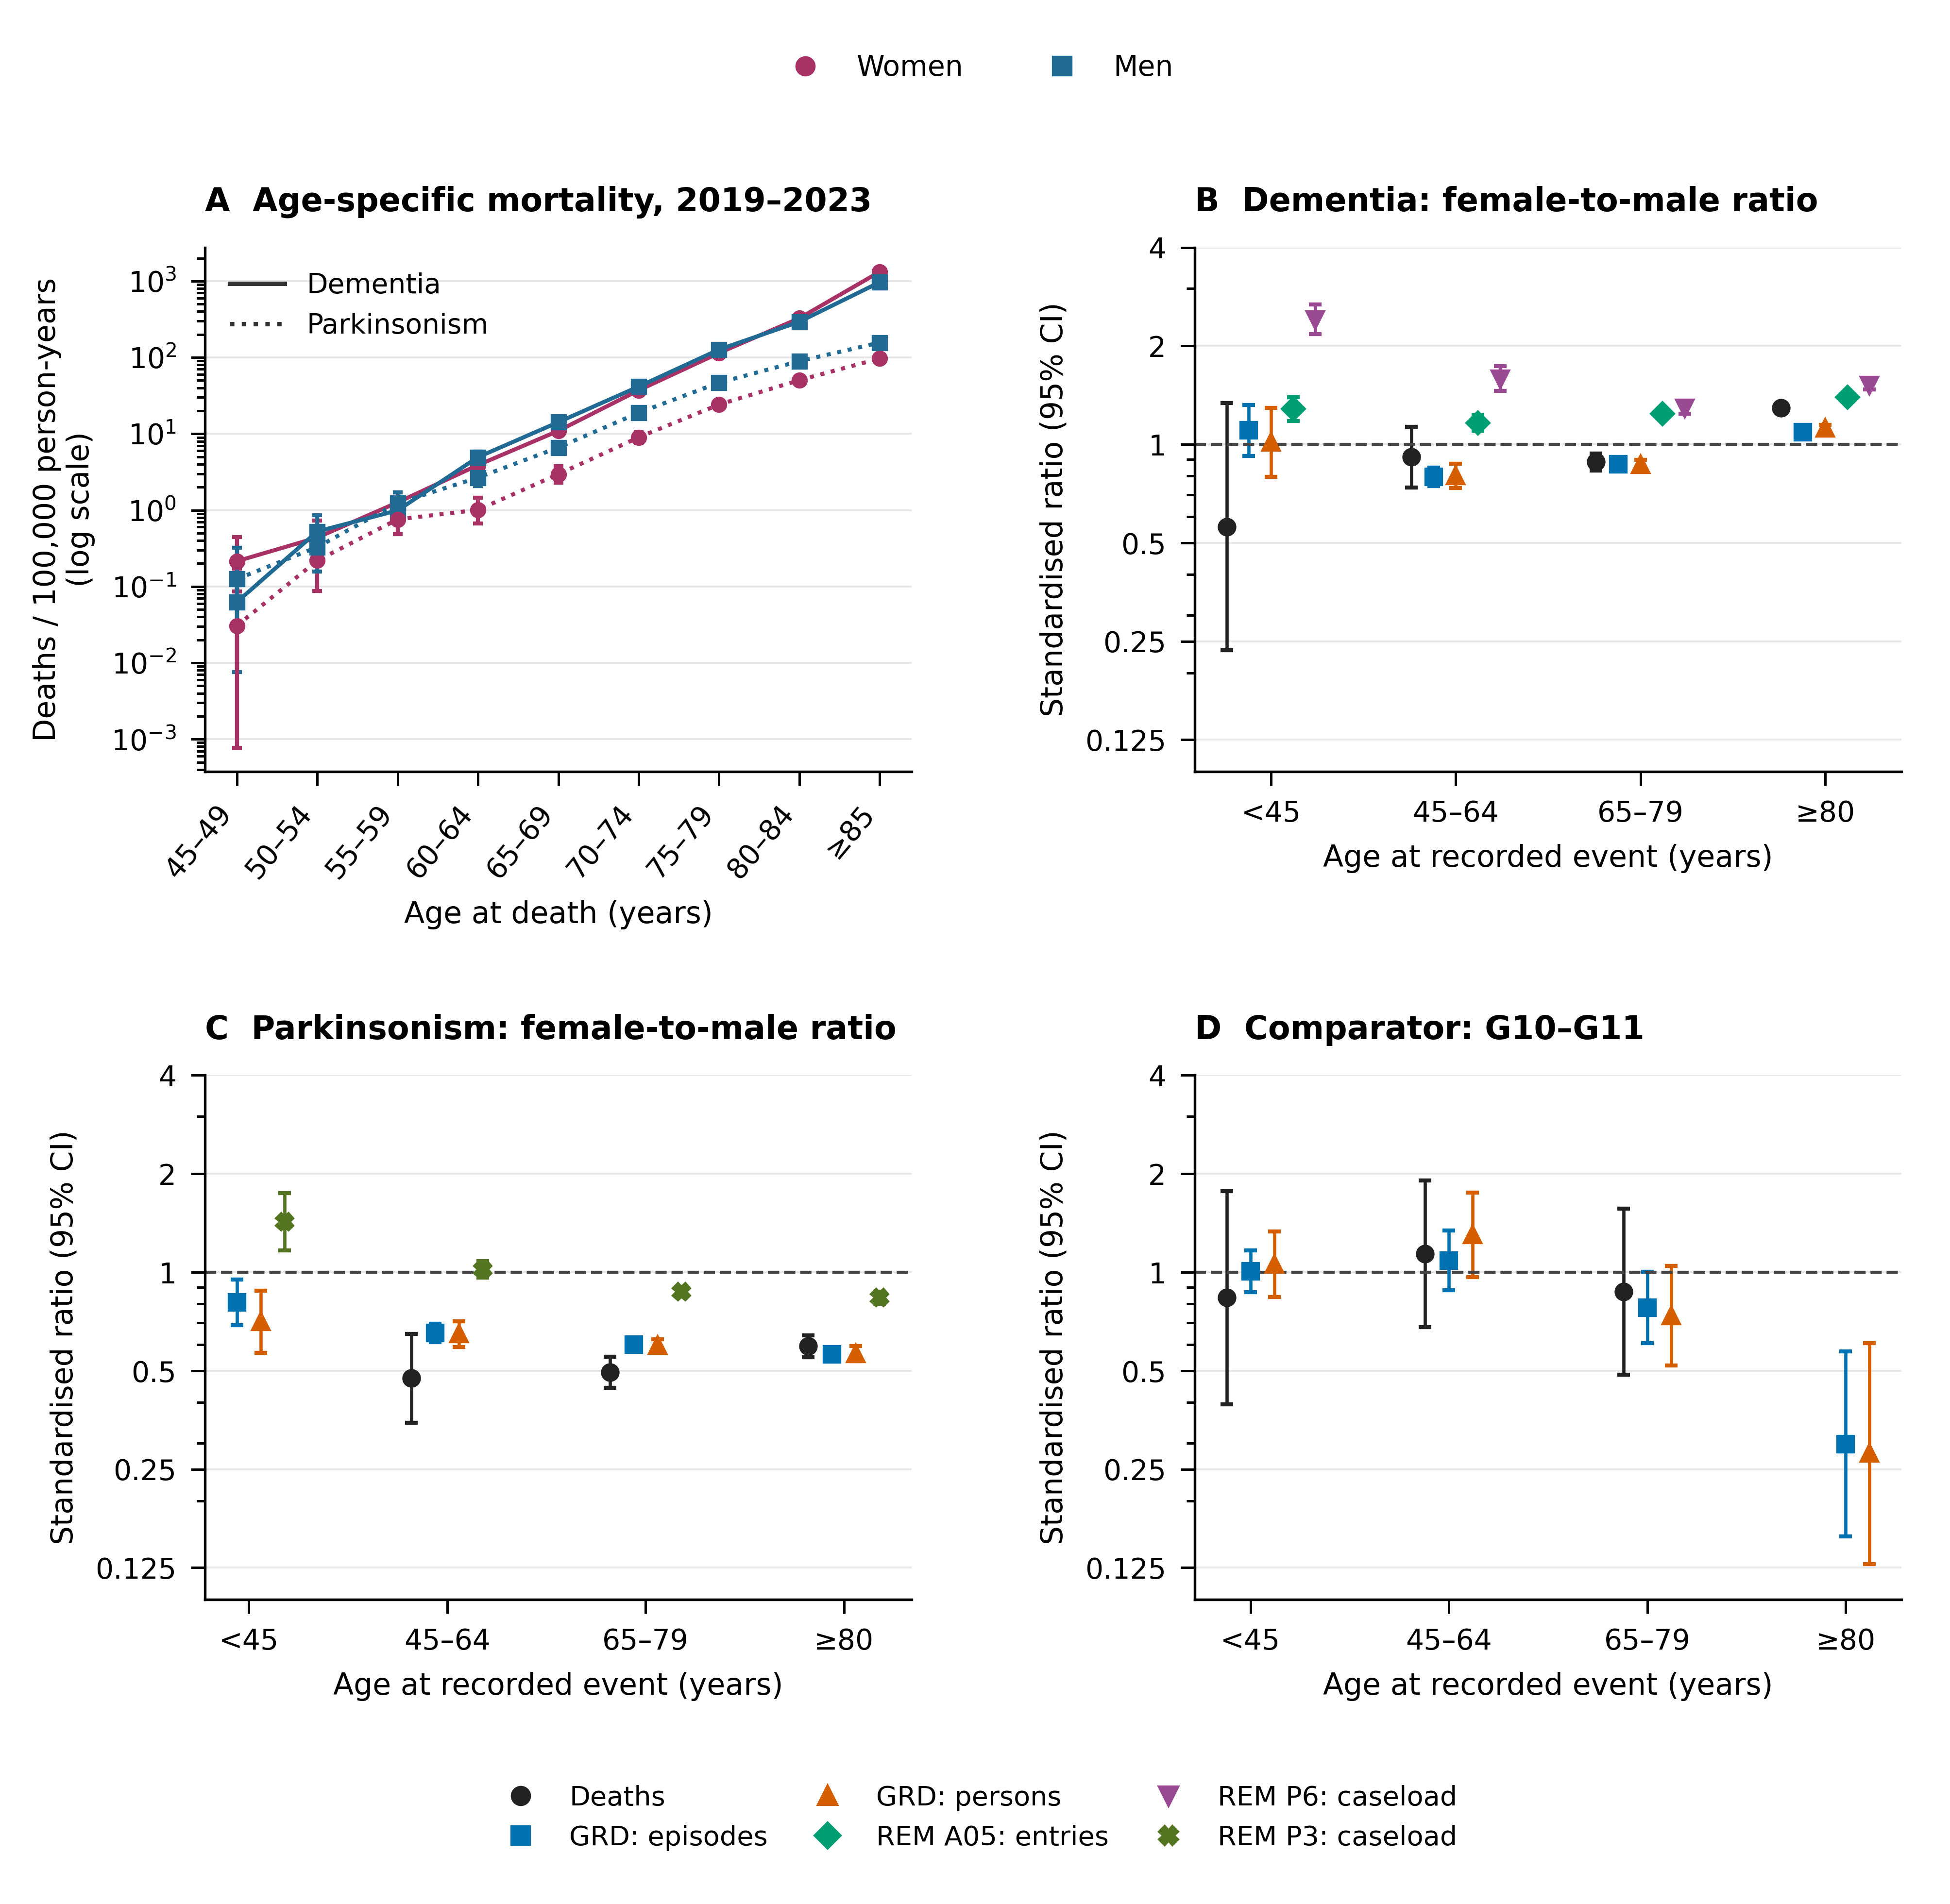
Figure 1. Age and sex patterns across routine sources. A: age-specific mortality with dementia or parkinsonism as underlying cause, 2019–2023, with 95% confidence intervals; all positive counts are shown, including those below five. Zero counts are not plotted on the logarithmic axis. B–D: female-to-male ratios of age-standardised rates with 95% confidence intervals by age class at recorded event. The threshold of at least five records in each sex applies only to ratios in B–D; absent symbols do not indicate zero. Series represent deaths (2019–2023), GRD episodes (2019–2024), first observed GRD records per person (2021–2024), REM A05 entries (2019–2025), and programme caseload/dependency in December 2024. Each source retains its unit and denominator; counts are not pooled or interpreted as incidence. G10–G11 denotes Huntington disease and hereditary ataxias. Ages refer to recorded events or death, not clinical onset. Sources: DEIS, GRD, REM and INE.
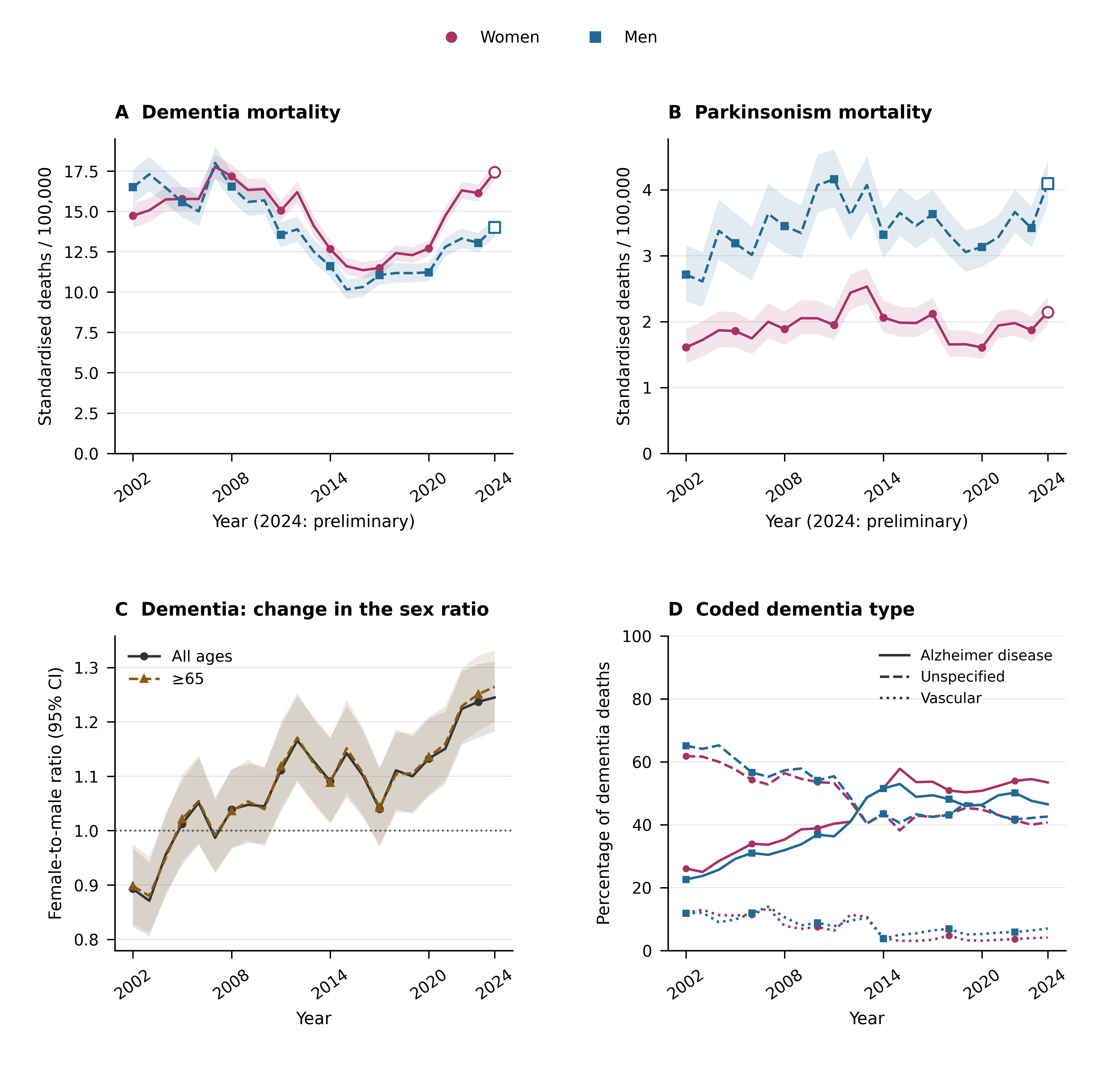
Figure 2. Mortality trends and coding, 2002–2024. A–B: age-standardised mortality rates at all ages in women and men; bands indicate 95% confidence intervals. Open symbols identify preliminary 2024 data, released with a cut-off of 23 June 2026. C: female-to-male dementia mortality ratios for all ages and age ≥65, with 95% confidence intervals; the horizontal line indicates equal rates. D: proportions of dementia deaths coded as Alzheimer disease, unspecified dementia or vascular dementia by sex. These categories do not necessarily exhaust the broad dementia definition; this panel describes underlying-cause coding rather than clinically validated subtypes. Rates and ratios come from the mortality tables and do not represent the Poisson-regression trend in death counts. Sources: DEIS deaths and INE; WHO standard population.
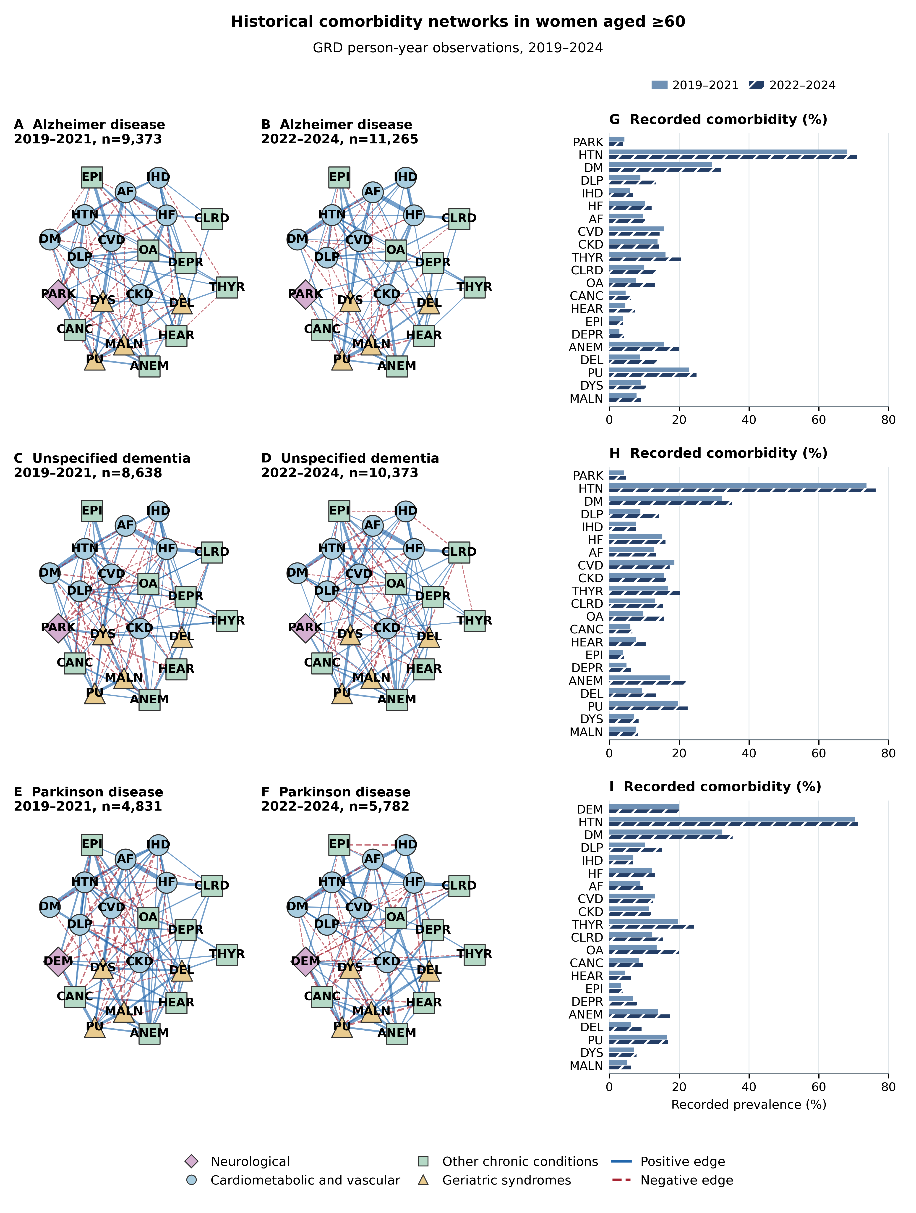
Figure 3. Historical comorbidity networks and recorded prevalence in women aged ≥60 with Alzheimer disease (A–B), unspecified dementia (C–D), or Parkinson disease (E–F) recorded in public-hospital GRD episodes, 2019–2024, including day surgery (CMA) and other coded activities. Each row compares 2019–2021 with 2022–2024. G–I show the recorded percentages of all 21 corresponding conditions beside each pair of networks. Bars equal coded person-years divided by the same disease, sex and period denominator as the network, multiplied by 100; lighter solid bars show 2019–2021 and darker hatched bars show 2022–2024. All bar axes run from 0% to 80%. The unit is the person-year; a woman can contribute multiple years, and 2019–2020 identifiers do not support deduplication between years. Recorded percentages are descriptive summaries of these selected hospital records, rather than population or clinically validated prevalence. These displays have no historical temporal tests or confidence intervals. Edges are regularised partial correlations from graphical lasso of tetrachoric correlations, EBIC γ=0.5, and the original selection threshold. All non-zero edges are retained. The six networks share deterministic node positions, constant node area of 120 pt² and edge-width scale; solid blue edges indicate positive associations and dashed red edges negative associations. Shapes and colours identify communities. Node size does not encode prevalence or centrality. DEM replaces PARK in Parkinson disease networks. Associations between recorded diagnoses do not identify causal mechanisms. PARK, parkinsonism; DEM, dementia; HTN, hypertension; DM, diabetes; DLP, dyslipidaemia; IHD, ischaemic heart disease; HF, heart failure; AF, atrial fibrillation; CVD, cerebrovascular disease; CKD, chronic kidney disease; THYR, hypothyroidism; CLRD, chronic respiratory disease; OA, osteoarthritis; CANC, cancer; HEAR, hearing loss; EPI, epilepsy; DEPR, depression; ANEM, anaemia; DEL, delirium; PU, pressure ulcer; DYS, dysphagia; MALN, malnutrition.
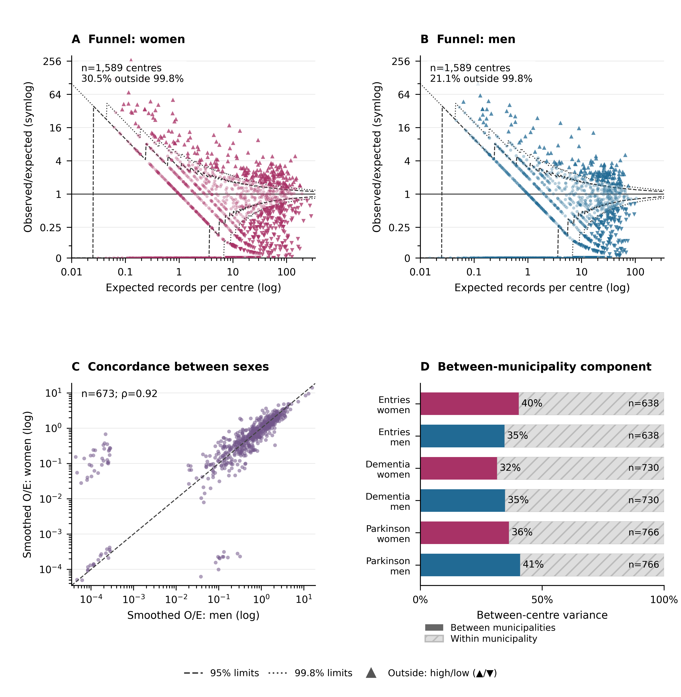
Figure 4. Variation in dementia and Parkinson registration between primary-care centres, 2019–2025. A–B: REM A05 dementia entries at age ≥60, observed/expected (O/E) per centre against expected records based on internal sex- and age-specific rates (60–79 and ≥80) and FONASA enrolment. Poisson control limits are 95% (dashed) and 99.8% (dotted); triangles identify values outside the 99.8% limits. All centres and zeros are retained; x axis is logarithmic and y axis uses symlog with a linear segment from 0 to 0.25. C: Poisson–gamma smoothed O/E in both sexes, restricted to centres with ≥5 expected records in each sex; diagonal: equality; Spearman ρ is calculated in this common sample. D: percentage of between-centre variance attributable to municipality differences from the random-intercept model of log smoothed O/E in the original analysis sample; hatched grey denotes variation within municipalities. These are neither clinical risk intervals nor validated performance indicators. Sources: REM, FONASA and DEIS establishment catalogue. In D, n denotes centres: entries, 638 in 276 municipalities; dementia caseload, 730 in 288 municipalities; Parkinson caseload, 766 in 292 municipalities. Within each outcome, the same samples are used for both sexes.
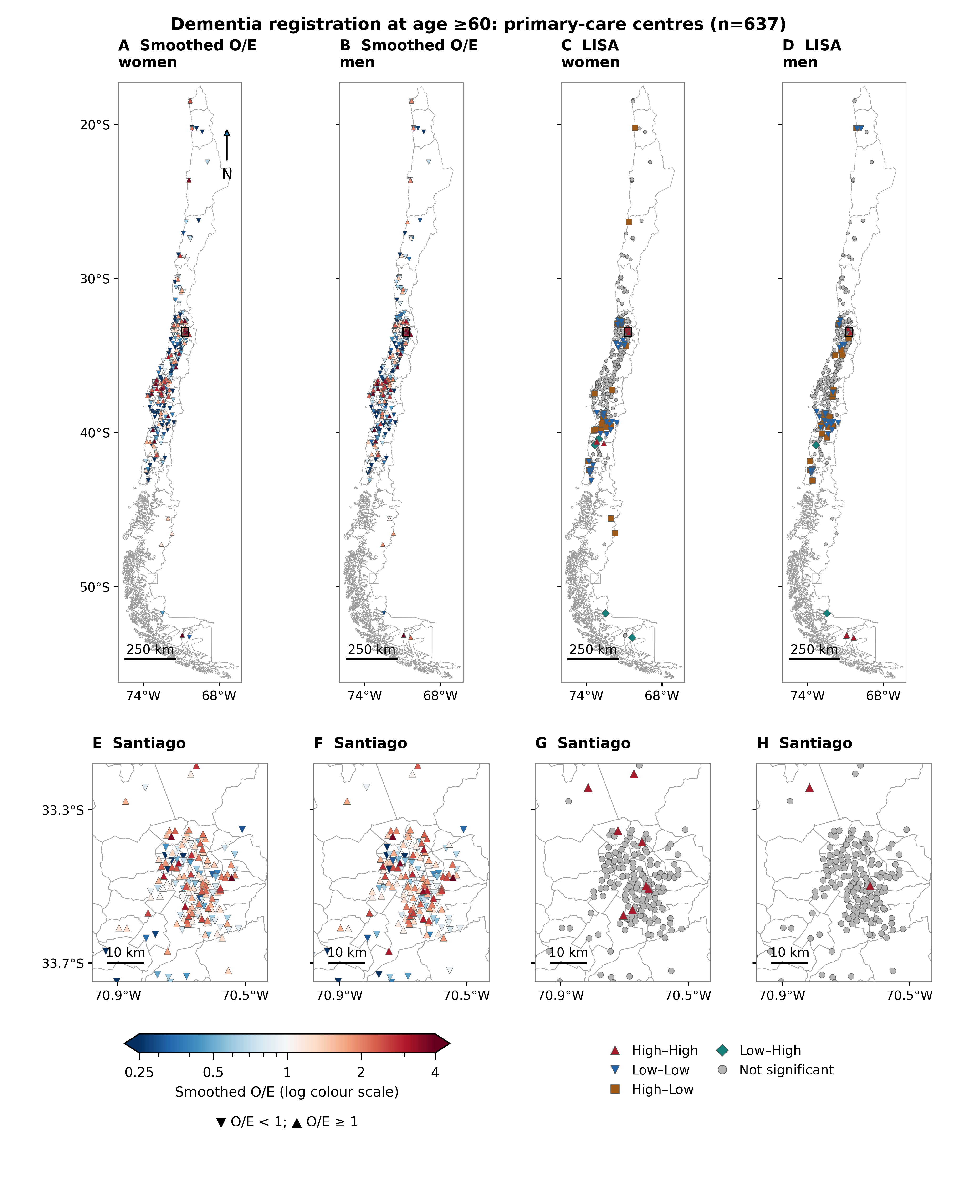
Figure 5. Spatial distribution of dementia registration in primary-care centres, 2019–2025. A–B: Poisson–gamma smoothed O/E of dementia entries at age ≥60 in women and men. C–D: local LISA clusters and spatial outliers by sex. E–H: the same centres in the Santiago enlargement, indicated by rectangles on the national maps. The original spatial sample of 637 centres is retained (precision criteria, rural-post exclusion and available coordinates); this sample does not represent the entire primary-care network. O/E colour limits are shared and logarithmic, from 0.25 to 4; colourbar extensions indicate observations beyond these limits, shown in the extreme colour. Each LISA category uses both shape and colour: High–High and Low–Low indicate local concordance; High–Low and Low–High indicate outliers. LISA uses log O/E, eight nearest neighbours, 999 conditional resamples with replacement and p<0.05 without multiple-comparison correction; clusters are exploratory. Coordinates are WGS84; aspect ratios are adjusted for mean latitude; scale bars are approximate (250 km nationally and 10 km in Santiago). Mainland Chile is shown with regional boundaries and Santiago with municipal boundaries; oceanic and Antarctic territories are omitted. Sources: REM, FONASA, DEIS and project-derived cartography. Downward triangles indicate O/E<1 and upward triangles O/E≥1 in the O/E maps.
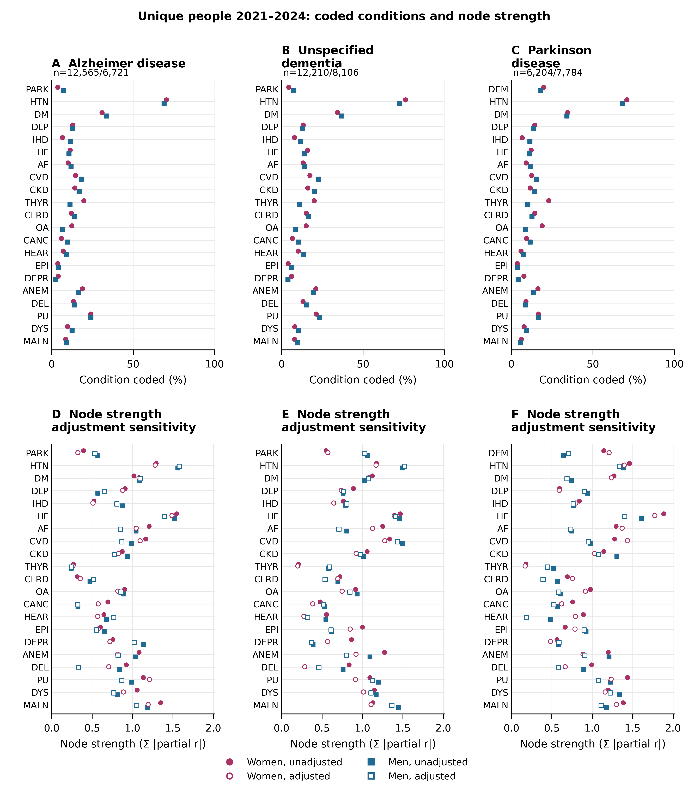
Figure 6. Independent-person sensitivity at age ≥60 with public-hospital GRD episodes, 2021–2024, including day surgery (CMA) and other coded activities. A–C: percentages of people with each condition coded; sample sizes are women/men. D–F: node strength (sum of absolute partial correlations), unadjusted and conditional on age and coding depth. Filled symbols denote unadjusted estimates and open symbols adjusted estimates; shapes identify sex. Each person's first eligible year and all diagnoses recorded in their episodes that year are used; later years are not reused, and identifiers with discordant sex are excluded. Disease membership is fixed in that year; Alzheimer disease and unspecified dementia are disjoint, whereas Parkinson disease may coexist with dementia. Abbreviations follow Figure 3. Percentages describe hospital coding, not population prevalence. These networks use a different unit and window from the historical networks. These are descriptive point estimates without uncertainty bars; adjustment is neither a temporal contrast nor a causal effect. Source: GRD.

Additional methods for REM instruments

Source definitions and complementary observation units
We extended the multisource study with REM functional classifications, mobility assessments, dementia programme reassessments and caregiver measures. Definitions and annual field mappings were obtained from the DEIS annual REM files and coded dictionaries, the REM Series A manual and the REM Series P manual. The seven annual coded templates were checked individually for 2019–2025; a manual description alone was not treated as evidence of a standalone data field.
Series P describes populations recorded under control at the December cut-off; Series A records activities during reporting months. Instrument-specific classifications and activity counts were analysed separately. The data do not establish raw cognitive scores, individual progression, dementia incidence, treatment effectiveness or patient-level linkage between menopause care and neurodegeneration. Functional dependence, fall risk and depression measures were retained as complementary clinical context rather than neurodegenerative diagnoses.

REM P5 functional and mobility classifications
We analysed the original December REM Series P snapshots from 2019 through 2025, validating each code and column against its corresponding annual coded official workbook. The unit of analysis was the reporting establishment, classification category and December snapshot. EFAM categories (autonomous without risk, autonomous with risk and dependency risk) and four Barthel dependency categories formed a seven-category functional distribution for adults aged 65 years or older under control. Timed Up and Go (normal, mild fall risk, high fall risk) and single-leg stance (normal, altered) were analysed as separate instruments with separate classified-population denominators. These administrative category counts do not contain individual test scores or person-linked trajectories.
Exact duplicate rows were removed once. Nonidentical records for the same establishment, category and snapshot were quarantined, as were negative, noninteger or nonnumeric observed counts and complete total/sex triplets that did not satisfy total = men + women. An establishment entered an instrument-specific analysis only when every required category row had numeric total, male and female counts and a consistent source region. Blank cells, explicit zeros and absent rows were retained as distinct source states; no unobserved count was imputed as zero. The denominator for a category share was the sum of all classifications for the same instrument, establishment sample, sex and snapshot. Positive denominators were required.
Age-specific analyses additionally required all source age components to be numeric and nonnegative and to reconcile to the corresponding sex total in every instrument category. We harmonised 65–69, 70–74, 75–79 and 80+ years; the detailed 80–84 through 100+ bands introduced in 2023 were summed to 80+. The latest complete snapshot, December 2025, was examined by sex, age and source region. We report crude regional shares and, within the same stricter age-reconciled provider samples, directly age-standardised shares; neither estimates resident-population prevalence. A balanced-provider sensitivity retained establishments satisfying instrument completeness in every year from 2019 through 2025. Repeated snapshots were not summed as unique people.
For geography, we directly age-standardised regional adverse-classification shares using four common age bands and, separately for each instrument, the pooled national female and male age distribution in the 2025 age-reconciled classified sample as the common standard. Each regional sex-specific proportion was weighted by this same instrument-specific distribution. All four regional age denominators had to be positive. Region was the source administrative region of the reporting provider. Choropleth maps use project Biblioteca del Congreso Nacional de Chile Mapoteca regional boundaries, clipped to mainland Chile and projected to WGS84 / UTM zone 19S (EPSG:32719); a 250-km projected scale bar is shown. Regions with fewer than five age-complete providers are hatched and shown with open comparison markers as a display flag only; no values are suppressed. Oceanic and Antarctic territories are omitted. Standardised shares remain selected under-control recording measures rather than resident-population prevalence, clinical disease risk, travel time, unmet need or access. No sampling confidence intervals were added to these direct administrative counts; reporting, selection and measurement uncertainty remain unquantified.

REM instruments, units of analysis and source quality
We extended the descriptive administrative analysis using annually audited REM Series A coded templates and source CSV files for 2019–2025. GDS-Reisberg global-deterioration reevaluation, dementia caregiver burden reevaluation and caregiver satisfaction were taken from the A06 dementia programme evaluation block using stable codes and annually checked layouts. Zarit abbreviated caregiver burden, programme TUG/functionality change and hospital Barthel change came from A03. Yesavage GDS-15 activity was analysed separately for 2023–2025. These sources contain aggregate recording counts, not individual scores, uniquely identified patients or observed patient trajectories. Caregiver sex is distinct from patient sex.
Exact duplicate source rows were collapsed. After this step, all records at a conflicting year–month–health-service–facility–code key were quarantined. Blank cells and absent category rows were preserved as missing; explicit numeric zero was retained. A January 2021 source cluster repeated exceptionally large identical vectors in all three A06 measures. Because its cause remains unresolved, the entire 2021 year was withheld from their primary series. An all-record versus outside-cluster comparison was retained only as a diagnostic sensitivity analysis.

Complete-case category denominators and interpretation
A06 change-category proportions required nine numeric, non-negative integer fields, reconciliation of total with men plus women, and reconciliation of each sex total with its increased, maintained and decreased categories. For Zarit, both intense and non-intense burden rows had to be present in the same facility-month, with coherent numeric total/sex fields. For TUG, the functionality questionnaire and hospital Barthel, all three change-category rows had to be present and coherent within each instrument's own facility-month set. Proportions were calculated by dividing summed category recordings by summed eligible category recordings. We reported the eligible/observed sets and exclusions rather than substituting zero for missing rows.
TUG and the functionality questionnaire describe the programme discharge setting (age 60+), whereas hospital Barthel refers to admission-to-discharge change (age 65+). Zarit concerns caregivers of people with severe dependency and is not dementia-specific. Increasing deterioration, increasing burden and increasing satisfaction represent different constructs; the categories were not pooled into a common favourable-response estimate. Yesavage context was restricted to A03 application counts. A27 follow-up activity was not harmonised because the official 2023 template repeats COL11 for both an age field and men, with different sex columns in subsequent years. Shared mental-health risk-result rows were not treated as Yesavage-specific. No causal benefit, treatment effect, population prevalence or clinical diagnostic accuracy was estimated.

Additional results from REM instruments
The additional REM analyses extend the descriptive burden account with functional status, fall-risk classifications, dementia programme reassessments and caregiver measures. They describe the people or activities recorded in each programme. Their denominators remain specific to the instrument and are not national disease-prevalence denominators.

Recorded functional classifications and completeness
The seven-category functional sample included 809 of 1,998 establishments with at least one retained functional category in December 2019 and 965 of 2,054 in December 2025. Complete-provider selection therefore changes the population represented by these estimates. Across the twelve P5 category codes, 20 exact extra source rows were removed, 5 sex-total errors were quarantined and 0 nonidentical establishment-category snapshots required quarantine.
Among women in the annual complete-provider functional sample, dependency risk or any Barthel dependency accounted for 30.94% (149,550/483,296) in 2019 and 30.11% (176,197/585,129) in 2025. These percentages describe the classified under-control sample and cannot be interpreted as population dependency prevalence.
Among men in the annual complete-provider functional sample, dependency risk or any Barthel dependency accounted for 26.49% (78,364/295,780) in 2019 and 25.45% (93,773/368,430) in 2025. These percentages describe the classified under-control sample and cannot be interpreted as population dependency prevalence.

Separate mobility classifications and age structure
In December 2025, women had 36.96% mild or high TUG fall-risk classifications (172,916/467,846; 1,684 providers) and 47.60% altered single-leg stance classifications (247,722/520,441; 1,931 providers). The two instrument denominators are distinct.
In December 2025, men had 29.76% mild or high TUG fall-risk classifications (93,668/314,747; 1,685 providers) and 40.63% altered single-leg stance classifications (141,664/348,699; 1,935 providers). The two instrument denominators are distinct.
The December 2025 age-reconciled samples contained 492 providers for functional classification, 824 providers for timed up and go, 899 providers for single-leg stance. Age-specific distributions use these stricter samples, and older source age bands were collapsed to the common 80+ category.

Provider selection sensitivity and regional recording
The balanced-provider samples comprised 280 functional-classification, 699 TUG and 1,170 single-leg stance establishments with complete data in every December from 2019 through 2025. This sensitivity fixes provider membership but does not track the same individuals or remove selection, case-mix or measurement differences.
For women, dependency risk or dependency in the balanced functional sample changed from 30.83% to 31.16% between 2019 and 2025; the corresponding annual complete-provider shares were 30.94% and 30.11%.
For men, dependency risk or dependency in the balanced functional sample changed from 26.00% to 25.91% between 2019 and 2025; the corresponding annual complete-provider shares were 26.49% and 25.45%.
All 16 source regions had positive classified denominators in the four common age bands for both sexes and all three instruments, permitting direct age standardisation in the stricter age-reconciled samples. Regional tables compare crude and standardised shares within those same selected samples, and national choropleth maps display standardised values on common scales. Age standardisation adjusts the observed age distribution but cannot remove provider selection, differences in case mix within age bands or recording differences. These geographic results do not establish resident-population disease prevalence, delayed diagnosis or clinical access.
Sparse provider participation limits some regional comparisons: functional classifications in Aysén came from only one age-complete provider, with 18 female and 14 male classified records; Arica y Parinacota had four age-complete functional providers. We retained all 16 regional values and flagged fewer than five providers with map hatching and open comparison markers. This display flag does not quantify statistical precision or remove selection bias. Regional low/high rankings should not be interpreted as population gradients.

Dementia programme evaluations: recorded activity and selected change categories
In 2025, the GDS-Reisberg source contained 6,414 recorded reevaluations (4,063 in women and 2,351 in men) from 121 facilities. All nine mapped cells were complete and coherent in 351 of 626 observed facility-month rows. In the eligible female subset, increased global deterioration represented 722/2,315 recordings (31.2%). The complete-case denominator is narrower than all reported activity and should not be interpreted as all women with dementia in Chile.
The 2021 raw A06 spike was dominated by 12 original rows from four facilities in January. The cluster contributed 107,160 to each of the three distinct measures, with identical nine-cell vectors and equal thirds in the change categories. Arithmetic equations for all three measures can be satisfied by this pattern; source reconciliation alone therefore did not establish plausibility. The unresolved year appears as a gap in primary trends, while its raw-versus-outside-cluster counts remain explicitly diagnostic.

Caregiver burden and functional change in their own reporting settings
Within 2025 paired-category Zarit records, intense caregiver burden was 23,459/47,244 (49.7%) among female caregiver recordings and 6,399/13,313 (48.1%) among male caregiver recordings. These proportions describe selected evaluations of caregivers of people with severe dependency. They do not identify a dementia-only caregiver cohort, unique caregivers or population prevalence.
The 2025 improved-category results among female recordings in each separate setting were Timed Up and Go: 3,604/14,529 (24.8%), retaining 297/2,995 observed sets (9.9%); Functionality questionnaire: 5,815/20,131 (28.9%), retaining 485/2,991 observed sets (16.2%); Hospital Barthel change: 6,882/29,131 (23.6%), retaining 499/902 observed sets (55.3%). These selected denominators, especially the small complete-set fraction for programme TUG, limit generalisation. The instrument, programme/hospital setting, age scope and changing reporting sample prevent pooling or causal comparison across tools.

Depression-screening activity as contextual evidence
The 2025 Yesavage GDS-15 application row contained 99,464 coherent activity recordings (64,944 in women and 34,520 in men). These are screening-activity counts; shared mental-health risk rows cannot establish Yesavage-specific positivity, and A27 follow-up fields were not harmonised. This depression-screening context remains conceptually separate from GDS-Reisberg dementia deterioration.

Relationship to the reproductive and diagnostic recording analyses
These findings add complementary information to the original recorded neurodegenerative burden, reproductive-history analyses and menopause-care context. The functional and mobility distributions identify the classifications observed among people under control, while dementia reassessment and caregiver measures describe activity among selected reporting programmes. Differences in provider completeness, observation units and patient composition limit direct comparisons between instruments.
The new REM results do not add an individual-level test of hormone exposure and cognitive decline. Shared provider or regional patterns can support a subsequent ecological analysis with explicit denominator and reporting checks, but cannot establish that the same women received menopause treatment and subsequently experienced a neurodegenerative outcome. No new hormonal association model was fitted in this extension.

Table NI-P-T1. Annual reporting and complete classification samples, December 2019–2025
Year | Instrument | Any category present: facilities | All category rows: facilities | Complete numeric totals: facilities | Complete age and sex: facilities
2019 | Functional classification | 1998 | 809 | 809 | 372
2020 | Functional classification | 1890 | 661 | 661 | 305
2021 | Functional classification | 1966 | 654 | 654 | 305
2022 | Functional classification | 1995 | 784 | 784 | 412
2023 | Functional classification | 2012 | 864 | 864 | 423
2024 | Functional classification | 2043 | 941 | 941 | 508
2025 | Functional classification | 2054 | 965 | 965 | 492
2019 | Timed Up and Go | 1681 | 1433 | 1433 | 740
2020 | Timed Up and Go | 1505 | 1183 | 1183 | 596
2021 | Timed Up and Go | 1648 | 1285 | 1285 | 653
2022 | Timed Up and Go | 1768 | 1492 | 1491 | 863
2023 | Timed Up and Go | 1832 | 1593 | 1593 | 733
2024 | Timed Up and Go | 1900 | 1669 | 1669 | 870
2025 | Timed Up and Go | 1935 | 1685 | 1685 | 824
2019 | Single-leg stance | 1742 | 1695 | 1695 | 1126
2020 | Single-leg stance | 1573 | 1507 | 1507 | 927
2021 | Single-leg stance | 1718 | 1645 | 1645 | 1043
2022 | Single-leg stance | 1826 | 1779 | 1779 | 1250
2023 | Single-leg stance | 1873 | 1835 | 1835 | 843
2024 | Single-leg stance | 1932 | 1898 | 1897 | 952
2025 | Single-leg stance | 1972 | 1944 | 1944 | 899
Each instrument has a separate denominator. Completeness requires every category row and nonblank, nonnegative, integer counts, with total equal to men plus women. Blank and absent source fields remain unobserved. Age analysis additionally requires all mapped age components and equality to sex totals. Providers can recur between years.
Table NI-P-T2. Recorded functional classifications by sex, December 2019–2025
Shares use the sum of all categories from the same complete selected providers and sex. Functional classifications concern adults aged 65 years or older under control; mobility instruments concern their separately classified under-control populations. These are recorded category distributions, not population prevalence. Exact duplicate source rows are removed; conflicting or inconsistent rows are quarantined.
Year | Sex | Category | Recorded n | Classified N | Share (%)
2019 | Men | Autonomous with risk | 77,452 | 295,780 | 26.19
2019 | Men | Autonomous without risk | 139,964 | 295,780 | 47.32
2019 | Men | Dependency risk | 35,487 | 295,780 | 12.00
2019 | Men | Mild dependency | 25,578 | 295,780 | 8.65
2019 | Men | Moderate dependency | 5,700 | 295,780 | 1.93
2019 | Men | Severe dependency | 5,371 | 295,780 | 1.82
2019 | Men | Total dependency | 6,228 | 295,780 | 2.11
2019 | Women | Autonomous with risk | 129,134 | 483,296 | 26.72
2019 | Women | Autonomous without risk | 204,612 | 483,296 | 42.34
2019 | Women | Dependency risk | 66,037 | 483,296 | 13.66
2019 | Women | Mild dependency | 49,123 | 483,296 | 10.16
2019 | Women | Moderate dependency | 10,967 | 483,296 | 2.27
2019 | Women | Severe dependency | 10,097 | 483,296 | 2.09
2019 | Women | Total dependency | 13,326 | 483,296 | 2.76
2020 | Men | Autonomous with risk | 48,613 | 190,590 | 25.51
2020 | Men | Autonomous without risk | 90,171 | 190,590 | 47.31
2020 | Men | Dependency risk | 22,658 | 190,590 | 11.89
2020 | Men | Mild dependency | 16,188 | 190,590 | 8.49
2020 | Men | Moderate dependency | 3,951 | 190,590 | 2.07
2020 | Men | Severe dependency | 4,320 | 190,590 | 2.27
2020 | Men | Total dependency | 4,689 | 190,590 | 2.46
2020 | Women | Autonomous with risk | 80,838 | 312,473 | 25.87
2020 | Women | Autonomous without risk | 132,694 | 312,473 | 42.47
2020 | Women | Dependency risk | 42,376 | 312,473 | 13.56
2020 | Women | Mild dependency | 31,092 | 312,473 | 9.95
2020 | Women | Moderate dependency | 7,809 | 312,473 | 2.50
2020 | Women | Severe dependency | 8,109 | 312,473 | 2.60
2020 | Women | Total dependency | 9,555 | 312,473 | 3.06
2021 | Men | Autonomous with risk | 36,059 | 129,594 | 27.82
2021 | Men | Autonomous without risk | 52,819 | 129,594 | 40.76
2021 | Men | Dependency risk | 15,609 | 129,594 | 12.04
2021 | Men | Mild dependency | 12,936 | 129,594 | 9.98
2021 | Men | Moderate dependency | 3,619 | 129,594 | 2.79
2021 | Men | Severe dependency | 4,218 | 129,594 | 3.25
2021 | Men | Total dependency | 4,334 | 129,594 | 3.34
2021 | Women | Autonomous with risk | 59,708 | 215,245 | 27.74
2021 | Women | Autonomous without risk | 77,607 | 215,245 | 36.06
2021 | Women | Dependency risk | 29,127 | 215,245 | 13.53
2021 | Women | Mild dependency | 24,761 | 215,245 | 11.50
2021 | Women | Moderate dependency | 6,590 | 215,245 | 3.06
2021 | Women | Severe dependency | 7,914 | 215,245 | 3.68
2021 | Women | Total dependency | 9,538 | 215,245 | 4.43
2022 | Men | Autonomous with risk | 69,954 | 229,090 | 30.54
2022 | Men | Autonomous without risk | 93,643 | 229,090 | 40.88
2022 | Men | Dependency risk | 27,264 | 229,090 | 11.90
2022 | Men | Mild dependency | 21,935 | 229,090 | 9.57
2022 | Men | Moderate dependency | 5,200 | 229,090 | 2.27
2022 | Men | Severe dependency | 5,419 | 229,090 | 2.37
2022 | Men | Total dependency | 5,675 | 229,090 | 2.48
2022 | Women | Autonomous with risk | 116,834 | 379,751 | 30.77
2022 | Women | Autonomous without risk | 138,302 | 379,751 | 36.42
2022 | Women | Dependency risk | 49,013 | 379,751 | 12.91
2022 | Women | Mild dependency | 42,803 | 379,751 | 11.27
2022 | Women | Moderate dependency | 10,045 | 379,751 | 2.65
2022 | Women | Severe dependency | 10,588 | 379,751 | 2.79
2022 | Women | Total dependency | 12,166 | 379,751 | 3.20
2023 | Men | Autonomous with risk | 86,806 | 282,066 | 30.78
2023 | Men | Autonomous without risk | 120,473 | 282,066 | 42.71
2023 | Men | Dependency risk | 27,964 | 282,066 | 9.91
2023 | Men | Mild dependency | 27,539 | 282,066 | 9.76
2023 | Men | Moderate dependency | 6,421 | 282,066 | 2.28
2023 | Men | Severe dependency | 6,353 | 282,066 | 2.25
2023 | Men | Total dependency | 6,510 | 282,066 | 2.31
2023 | Women | Autonomous with risk | 139,474 | 460,490 | 30.29
2023 | Women | Autonomous without risk | 178,686 | 460,490 | 38.80
2023 | Women | Dependency risk | 50,386 | 460,490 | 10.94
2023 | Women | Mild dependency | 54,038 | 460,490 | 11.73
2023 | Women | Moderate dependency | 12,235 | 460,490 | 2.66
2023 | Women | Severe dependency | 12,413 | 460,490 | 2.70
2023 | Women | Total dependency | 13,258 | 460,490 | 2.88
2024 | Men | Autonomous with risk | 96,319 | 323,573 | 29.77
2024 | Men | Autonomous without risk | 142,918 | 323,573 | 44.17
2024 | Men | Dependency risk | 30,742 | 323,573 | 9.50
2024 | Men | Mild dependency | 32,292 | 323,573 | 9.98
2024 | Men | Moderate dependency | 7,144 | 323,573 | 2.21
2024 | Men | Severe dependency | 7,118 | 323,573 | 2.20
2024 | Men | Total dependency | 7,040 | 323,573 | 2.18
2024 | Women | Autonomous with risk | 152,177 | 517,126 | 29.43
2024 | Women | Autonomous without risk | 208,216 | 517,126 | 40.26
2024 | Women | Dependency risk | 53,739 | 517,126 | 10.39
2024 | Women | Mild dependency | 61,664 | 517,126 | 11.92
2024 | Women | Moderate dependency | 13,341 | 517,126 | 2.58
2024 | Women | Severe dependency | 13,244 | 517,126 | 2.56
2024 | Women | Total dependency | 14,745 | 517,126 | 2.85
2025 | Men | Autonomous with risk | 107,460 | 368,430 | 29.17
2025 | Men | Autonomous without risk | 167,197 | 368,430 | 45.38
2025 | Men | Dependency risk | 34,415 | 368,430 | 9.34
2025 | Men | Mild dependency | 36,248 | 368,430 | 9.84
2025 | Men | Moderate dependency | 7,734 | 368,430 | 2.10
2025 | Men | Severe dependency | 7,714 | 368,430 | 2.09
2025 | Men | Total dependency | 7,662 | 368,430 | 2.08
2025 | Women | Autonomous with risk | 165,117 | 585,129 | 28.22
2025 | Women | Autonomous without risk | 243,815 | 585,129 | 41.67
2025 | Women | Dependency risk | 58,732 | 585,129 | 10.04
2025 | Women | Mild dependency | 71,541 | 585,129 | 12.23
2025 | Women | Moderate dependency | 15,029 | 585,129 | 2.57
2025 | Women | Severe dependency | 14,925 | 585,129 | 2.55
2025 | Women | Total dependency | 15,970 | 585,129 | 2.73
Table NI-P-T3. Recorded fall-risk and balance classifications by sex, December 2019–2025
Year | Instrument | Sex | Category | Recorded n | Classified N | Share (%)
2019 | Single-leg stance | Men | Altered | 110,121 | 268,947 | 40.95
2019 | Single-leg stance | Men | Normal | 158,826 | 268,947 | 59.05
2019 | Single-leg stance | Women | Altered | 199,287 | 412,442 | 48.32
2019 | Single-leg stance | Women | Normal | 213,155 | 412,442 | 51.68
2019 | Timed Up and Go | Men | High fall risk | 22,935 | 224,913 | 10.20
2019 | Timed Up and Go | Men | Mild fall risk | 48,683 | 224,913 | 21.65
2019 | Timed Up and Go | Men | Normal | 153,295 | 224,913 | 68.16
2019 | Timed Up and Go | Women | High fall risk | 41,591 | 344,850 | 12.06
2019 | Timed Up and Go | Women | Mild fall risk | 90,816 | 344,850 | 26.33
2019 | Timed Up and Go | Women | Normal | 212,443 | 344,850 | 61.60
2020 | Single-leg stance | Men | Altered | 66,287 | 161,774 | 40.98
2020 | Single-leg stance | Men | Normal | 95,487 | 161,774 | 59.02
2020 | Single-leg stance | Women | Altered | 118,480 | 249,123 | 47.56
2020 | Single-leg stance | Women | Normal | 130,643 | 249,123 | 52.44
2020 | Timed Up and Go | Men | High fall risk | 13,836 | 136,735 | 10.12
2020 | Timed Up and Go | Men | Mild fall risk | 30,131 | 136,735 | 22.04
2020 | Timed Up and Go | Men | Normal | 92,768 | 136,735 | 67.85
2020 | Timed Up and Go | Women | High fall risk | 25,756 | 208,973 | 12.33
2020 | Timed Up and Go | Women | Mild fall risk | 56,221 | 208,973 | 26.90
2020 | Timed Up and Go | Women | Normal | 126,996 | 208,973 | 60.77
2021 | Single-leg stance | Men | Altered | 58,516 | 133,419 | 43.86
2021 | Single-leg stance | Men | Normal | 74,903 | 133,419 | 56.14
2021 | Single-leg stance | Women | Altered | 104,164 | 205,581 | 50.67
2021 | Single-leg stance | Women | Normal | 101,417 | 205,581 | 49.33
2021 | Timed Up and Go | Men | High fall risk | 10,257 | 100,428 | 10.21
2021 | Timed Up and Go | Men | Mild fall risk | 21,006 | 100,428 | 20.92
2021 | Timed Up and Go | Men | Normal | 69,165 | 100,428 | 68.87
2021 | Timed Up and Go | Women | High fall risk | 18,846 | 154,298 | 12.21
2021 | Timed Up and Go | Women | Mild fall risk | 39,499 | 154,298 | 25.60
2021 | Timed Up and Go | Women | Normal | 95,953 | 154,298 | 62.19
2022 | Single-leg stance | Men | Altered | 90,181 | 220,468 | 40.90
2022 | Single-leg stance | Men | Normal | 130,287 | 220,468 | 59.10
2022 | Single-leg stance | Women | Altered | 163,498 | 342,607 | 47.72
2022 | Single-leg stance | Women | Normal | 179,109 | 342,607 | 52.28
2022 | Timed Up and Go | Men | High fall risk | 19,175 | 190,124 | 10.09
2022 | Timed Up and Go | Men | Mild fall risk | 39,450 | 190,124 | 20.75
2022 | Timed Up and Go | Men | Normal | 131,499 | 190,124 | 69.16
2022 | Timed Up and Go | Women | High fall risk | 36,615 | 294,817 | 12.42
2022 | Timed Up and Go | Women | Mild fall risk | 74,369 | 294,817 | 25.23
2022 | Timed Up and Go | Women | Normal | 183,833 | 294,817 | 62.35
2023 | Single-leg stance | Men | Altered | 110,153 | 284,498 | 38.72
2023 | Single-leg stance | Men | Normal | 174,345 | 284,498 | 61.28
2023 | Single-leg stance | Women | Altered | 198,477 | 420,956 | 47.15
2023 | Single-leg stance | Women | Normal | 222,479 | 420,956 | 52.85
2023 | Timed Up and Go | Men | High fall risk | 25,101 | 245,080 | 10.24
2023 | Timed Up and Go | Men | Mild fall risk | 50,297 | 245,080 | 20.52
2023 | Timed Up and Go | Men | Normal | 169,682 | 245,080 | 69.24
2023 | Timed Up and Go | Women | High fall risk | 48,177 | 374,746 | 12.86
2023 | Timed Up and Go | Women | Mild fall risk | 94,129 | 374,746 | 25.12
2023 | Timed Up and Go | Women | Normal | 232,440 | 374,746 | 62.03
2024 | Single-leg stance | Men | Altered | 126,676 | 311,266 | 40.70
2024 | Single-leg stance | Men | Normal | 184,590 | 311,266 | 59.30
2024 | Single-leg stance | Women | Altered | 222,882 | 467,711 | 47.65
2024 | Single-leg stance | Women | Normal | 244,829 | 467,711 | 52.35
2024 | Timed Up and Go | Men | High fall risk | 27,629 | 278,600 | 9.92
2024 | Timed Up and Go | Men | Mild fall risk | 57,281 | 278,600 | 20.56
2024 | Timed Up and Go | Men | Normal | 193,690 | 278,600 | 69.52
2024 | Timed Up and Go | Women | High fall risk | 53,916 | 419,791 | 12.84
2024 | Timed Up and Go | Women | Mild fall risk | 104,006 | 419,791 | 24.78
2024 | Timed Up and Go | Women | Normal | 261,869 | 419,791 | 62.38
2025 | Single-leg stance | Men | Altered | 141,664 | 348,699 | 40.63
2025 | Single-leg stance | Men | Normal | 207,035 | 348,699 | 59.37
2025 | Single-leg stance | Women | Altered | 247,722 | 520,441 | 47.60
2025 | Single-leg stance | Women | Normal | 272,719 | 520,441 | 52.40
2025 | Timed Up and Go | Men | High fall risk | 31,333 | 314,747 | 9.95
2025 | Timed Up and Go | Men | Mild fall risk | 62,335 | 314,747 | 19.80
2025 | Timed Up and Go | Men | Normal | 221,079 | 314,747 | 70.24
2025 | Timed Up and Go | Women | High fall risk | 59,876 | 467,846 | 12.80
2025 | Timed Up and Go | Women | Mild fall risk | 113,040 | 467,846 | 24.16
2025 | Timed Up and Go | Women | Normal | 294,930 | 467,846 | 63.04
Shares use the sum of all categories from the same complete selected providers and sex. Functional classifications concern adults aged 65 years or older under control; mobility instruments concern their separately classified under-control populations. These are recorded category distributions, not population prevalence. Exact duplicate source rows are removed; conflicting or inconsistent rows are quarantined.
Table NI-P-T4. Annual and balanced-provider sensitivity for adverse functional or mobility classifications
Year | Instrument | Sex | Provider sample | Facilities | Adverse n | Classified N | Share (%)
2019 | Single-leg stance | Men | Annual complete providers | 1692 | 110,121 | 268,947 | 40.95
2019 | Single-leg stance | Women | Annual complete providers | 1690 | 199,287 | 412,442 | 48.32
2019 | Functional classification | Men | Annual complete providers | 809 | 78,364 | 295,780 | 26.49
2019 | Functional classification | Women | Annual complete providers | 809 | 149,550 | 483,296 | 30.94
2019 | Timed Up and Go | Men | Annual complete providers | 1433 | 71,618 | 224,913 | 31.84
2019 | Timed Up and Go | Women | Annual complete providers | 1432 | 132,407 | 344,850 | 38.40
2020 | Single-leg stance | Men | Annual complete providers | 1500 | 66,287 | 161,774 | 40.98
2020 | Single-leg stance | Women | Annual complete providers | 1503 | 118,480 | 249,123 | 47.56
2020 | Functional classification | Men | Annual complete providers | 661 | 51,806 | 190,590 | 27.18
2020 | Functional classification | Women | Annual complete providers | 661 | 98,941 | 312,473 | 31.66
2020 | Timed Up and Go | Men | Annual complete providers | 1182 | 43,967 | 136,735 | 32.15
2020 | Timed Up and Go | Women | Annual complete providers | 1183 | 81,977 | 208,973 | 39.23
2021 | Single-leg stance | Men | Annual complete providers | 1641 | 58,516 | 133,419 | 43.86
2021 | Single-leg stance | Women | Annual complete providers | 1642 | 104,164 | 205,581 | 50.67
2021 | Functional classification | Men | Annual complete providers | 654 | 40,716 | 129,594 | 31.42
2021 | Functional classification | Women | Annual complete providers | 654 | 77,930 | 215,245 | 36.21
2021 | Timed Up and Go | Men | Annual complete providers | 1285 | 31,263 | 100,428 | 31.13
2021 | Timed Up and Go | Women | Annual complete providers | 1285 | 58,345 | 154,298 | 37.81
2022 | Single-leg stance | Men | Annual complete providers | 1779 | 90,181 | 220,468 | 40.90
2022 | Single-leg stance | Women | Annual complete providers | 1779 | 163,498 | 342,607 | 47.72
2022 | Functional classification | Men | Annual complete providers | 784 | 65,493 | 229,090 | 28.59
2022 | Functional classification | Women | Annual complete providers | 784 | 124,615 | 379,751 | 32.81
2022 | Timed Up and Go | Men | Annual complete providers | 1491 | 58,625 | 190,124 | 30.84
2022 | Timed Up and Go | Women | Annual complete providers | 1491 | 110,984 | 294,817 | 37.65
2023 | Single-leg stance | Men | Annual complete providers | 1835 | 110,153 | 284,498 | 38.72
2023 | Single-leg stance | Women | Annual complete providers | 1834 | 198,477 | 420,956 | 47.15
2023 | Functional classification | Men | Annual complete providers | 864 | 74,787 | 282,066 | 26.51
2023 | Functional classification | Women | Annual complete providers | 864 | 142,330 | 460,490 | 30.91
2023 | Timed Up and Go | Men | Annual complete providers | 1593 | 75,398 | 245,080 | 30.76
2023 | Timed Up and Go | Women | Annual complete providers | 1593 | 142,306 | 374,746 | 37.97
2024 | Single-leg stance | Men | Annual complete providers | 1895 | 126,676 | 311,266 | 40.70
2024 | Single-leg stance | Women | Annual complete providers | 1896 | 222,882 | 467,711 | 47.65
2024 | Functional classification | Men | Annual complete providers | 941 | 84,336 | 323,573 | 26.06
2024 | Functional classification | Women | Annual complete providers | 941 | 156,733 | 517,126 | 30.31
2024 | Timed Up and Go | Men | Annual complete providers | 1668 | 84,910 | 278,600 | 30.48
2024 | Timed Up and Go | Women | Annual complete providers | 1669 | 157,922 | 419,791 | 37.62
2025 | Single-leg stance | Men | Annual complete providers | 1935 | 141,664 | 348,699 | 40.63
2025 | Single-leg stance | Women | Annual complete providers | 1931 | 247,722 | 520,441 | 47.60
2025 | Functional classification | Men | Annual complete providers | 965 | 93,773 | 368,430 | 25.45
2025 | Functional classification | Women | Annual complete providers | 965 | 176,197 | 585,129 | 30.11
2025 | Timed Up and Go | Men | Annual complete providers | 1685 | 93,668 | 314,747 | 29.76
2025 | Timed Up and Go | Women | Annual complete providers | 1684 | 172,916 | 467,846 | 36.96
2019 | Single-leg stance | Men | Balanced providers, 2019–2025 | 1170 | 90,006 | 220,019 | 40.91
2019 | Single-leg stance | Women | Balanced providers, 2019–2025 | 1169 | 164,546 | 338,811 | 48.57
2019 | Functional classification | Men | Balanced providers, 2019–2025 | 280 | 45,274 | 174,098 | 26.00
2019 | Functional classification | Women | Balanced providers, 2019–2025 | 280 | 89,960 | 291,808 | 30.83
2019 | Timed Up and Go | Men | Balanced providers, 2019–2025 | 699 | 50,332 | 164,686 | 30.56
2019 | Timed Up and Go | Women | Balanced providers, 2019–2025 | 699 | 96,304 | 257,980 | 37.33
2020 | Single-leg stance | Men | Balanced providers, 2019–2025 | 1166 | 59,496 | 143,570 | 41.44
2020 | Single-leg stance | Women | Balanced providers, 2019–2025 | 1169 | 106,762 | 222,078 | 48.07
2020 | Functional classification | Men | Balanced providers, 2019–2025 | 280 | 32,344 | 123,692 | 26.15
2020 | Functional classification | Women | Balanced providers, 2019–2025 | 280 | 64,091 | 207,401 | 30.90
2020 | Timed Up and Go | Men | Balanced providers, 2019–2025 | 699 | 34,767 | 109,539 | 31.74
2020 | Timed Up and Go | Women | Balanced providers, 2019–2025 | 699 | 67,394 | 173,214 | 38.91
2021 | Single-leg stance | Men | Balanced providers, 2019–2025 | 1167 | 48,026 | 107,902 | 44.51
2021 | Single-leg stance | Women | Balanced providers, 2019–2025 | 1168 | 85,891 | 166,657 | 51.54
2021 | Functional classification | Men | Balanced providers, 2019–2025 | 280 | 26,440 | 83,577 | 31.64
2021 | Functional classification | Women | Balanced providers, 2019–2025 | 280 | 52,662 | 144,108 | 36.54
2021 | Timed Up and Go | Men | Balanced providers, 2019–2025 | 699 | 23,068 | 73,889 | 31.22
2021 | Timed Up and Go | Women | Balanced providers, 2019–2025 | 699 | 44,545 | 116,717 | 38.16
2022 | Single-leg stance | Men | Balanced providers, 2019–2025 | 1170 | 68,713 | 168,892 | 40.68
2022 | Single-leg stance | Women | Balanced providers, 2019–2025 | 1170 | 125,454 | 263,792 | 47.56
2022 | Functional classification | Men | Balanced providers, 2019–2025 | 280 | 37,858 | 129,675 | 29.19
2022 | Functional classification | Women | Balanced providers, 2019–2025 | 280 | 75,662 | 221,619 | 34.14
2022 | Timed Up and Go | Men | Balanced providers, 2019–2025 | 699 | 39,589 | 128,040 | 30.92
2022 | Timed Up and Go | Women | Balanced providers, 2019–2025 | 699 | 77,173 | 202,826 | 38.05
2023 | Single-leg stance | Men | Balanced providers, 2019–2025 | 1170 | 81,002 | 210,866 | 38.41
2023 | Single-leg stance | Women | Balanced providers, 2019–2025 | 1170 | 146,422 | 310,027 | 47.23
2023 | Functional classification | Men | Balanced providers, 2019–2025 | 280 | 41,165 | 151,738 | 27.13
2023 | Functional classification | Women | Balanced providers, 2019–2025 | 280 | 81,324 | 255,746 | 31.80
2023 | Timed Up and Go | Men | Balanced providers, 2019–2025 | 699 | 47,844 | 157,581 | 30.36
2023 | Timed Up and Go | Women | Balanced providers, 2019–2025 | 699 | 93,814 | 247,131 | 37.96
2024 | Single-leg stance | Men | Balanced providers, 2019–2025 | 1169 | 89,603 | 223,713 | 40.05
2024 | Single-leg stance | Women | Balanced providers, 2019–2025 | 1169 | 158,520 | 336,321 | 47.13
2024 | Functional classification | Men | Balanced providers, 2019–2025 | 280 | 43,295 | 164,632 | 26.30
2024 | Functional classification | Women | Balanced providers, 2019–2025 | 280 | 85,277 | 274,181 | 31.10
2024 | Timed Up and Go | Men | Balanced providers, 2019–2025 | 699 | 52,068 | 171,436 | 30.37
2024 | Timed Up and Go | Women | Balanced providers, 2019–2025 | 699 | 99,932 | 264,479 | 37.78
2025 | Single-leg stance | Men | Balanced providers, 2019–2025 | 1170 | 102,225 | 252,901 | 40.42
2025 | Single-leg stance | Women | Balanced providers, 2019–2025 | 1169 | 179,981 | 379,533 | 47.42
2025 | Functional classification | Men | Balanced providers, 2019–2025 | 280 | 46,865 | 180,911 | 25.91
2025 | Functional classification | Women | Balanced providers, 2019–2025 | 280 | 93,094 | 298,763 | 31.16
2025 | Timed Up and Go | Men | Balanced providers, 2019–2025 | 699 | 58,558 | 195,492 | 29.95
2025 | Timed Up and Go | Women | Balanced providers, 2019–2025 | 699 | 111,187 | 297,475 | 37.38
Adverse classification means dependency risk or any Barthel dependency; mild/high TUG fall risk; or altered single-leg stance, respectively. Balanced samples retain providers with complete instrument totals in every December 2019–2025. Balance of providers does not imply that the same people were observed.
Table NI-P-T5. Age-specific functional and mobility classifications in December 2025
Instrument | Sex | Age (years) | Category | Recorded n | Classified N | Share (%)
Single-leg stance | Men | 65–69 | Altered | 18,826 | 68,454 | 27.50
Single-leg stance | Men | 65–69 | Normal | 49,628 | 68,454 | 72.50
Single-leg stance | Men | 70–74 | Altered | 22,601 | 65,843 | 34.33
Single-leg stance | Men | 70–74 | Normal | 43,242 | 65,843 | 65.67
Single-leg stance | Men | 75–79 | Altered | 23,976 | 53,207 | 45.06
Single-leg stance | Men | 75–79 | Normal | 29,231 | 53,207 | 54.94
Single-leg stance | Men | 80+ | Altered | 36,048 | 56,372 | 63.95
Single-leg stance | Men | 80+ | Normal | 20,324 | 56,372 | 36.05
Single-leg stance | Women | 65–69 | Altered | 35,115 | 108,466 | 32.37
Single-leg stance | Women | 65–69 | Normal | 73,351 | 108,466 | 67.63
Single-leg stance | Women | 70–74 | Altered | 40,036 | 97,552 | 41.04
Single-leg stance | Women | 70–74 | Normal | 57,516 | 97,552 | 58.96
Single-leg stance | Women | 75–79 | Altered | 40,582 | 77,235 | 52.54
Single-leg stance | Women | 75–79 | Normal | 36,653 | 77,235 | 47.46
Single-leg stance | Women | 80+ | Altered | 65,367 | 90,571 | 72.17
Single-leg stance | Women | 80+ | Normal | 25,204 | 90,571 | 27.83
Functional classification | Men | 65–69 | Autonomous with risk | 20,883 | 59,978 | 34.82
Functional classification | Men | 65–69 | Autonomous without risk | 31,580 | 59,978 | 52.65
Functional classification | Men | 65–69 | Dependency risk | 3,260 | 59,978 | 5.44
Functional classification | Men | 65–69 | Mild dependency | 2,714 | 59,978 | 4.52
Functional classification | Men | 65–69 | Moderate dependency | 560 | 59,978 | 0.93
Functional classification | Men | 65–69 | Severe dependency | 476 | 59,978 | 0.79
Functional classification | Men | 65–69 | Total dependency | 505 | 59,978 | 0.84
Functional classification | Men | 70–74 | Autonomous with risk | 19,234 | 59,327 | 32.42
Functional classification | Men | 70–74 | Autonomous without risk | 30,689 | 59,327 | 51.73
Functional classification | Men | 70–74 | Dependency risk | 3,642 | 59,327 | 6.14
Functional classification | Men | 70–74 | Mild dependency | 3,769 | 59,327 | 6.35
Functional classification | Men | 70–74 | Moderate dependency | 726 | 59,327 | 1.22
Functional classification | Men | 70–74 | Severe dependency | 626 | 59,327 | 1.06
Functional classification | Men | 70–74 | Total dependency | 641 | 59,327 | 1.08
Functional classification | Men | 75–79 | Autonomous with risk | 15,137 | 50,093 | 30.22
Functional classification | Men | 75–79 | Autonomous without risk | 22,904 | 50,093 | 45.72
Functional classification | Men | 75–79 | Dependency risk | 4,628 | 50,093 | 9.24
Functional classification | Men | 75–79 | Mild dependency | 4,798 | 50,093 | 9.58
Functional classification | Men | 75–79 | Moderate dependency | 848 | 50,093 | 1.69
Functional classification | Men | 75–79 | Severe dependency | 902 | 50,093 | 1.80
Functional classification | Men | 75–79 | Total dependency | 876 | 50,093 | 1.75
Functional classification | Men | 80+ | Autonomous with risk | 13,043 | 62,691 | 20.81
Functional classification | Men | 80+ | Autonomous without risk | 19,893 | 62,691 | 31.73
Functional classification | Men | 80+ | Dependency risk | 9,488 | 62,691 | 15.13
Functional classification | Men | 80+ | Mild dependency | 11,768 | 62,691 | 18.77
Functional classification | Men | 80+ | Moderate dependency | 2,731 | 62,691 | 4.36
Functional classification | Men | 80+ | Severe dependency | 2,853 | 62,691 | 4.55
Functional classification | Men | 80+ | Total dependency | 2,915 | 62,691 | 4.65
Functional classification | Women | 65–69 | Autonomous with risk | 33,274 | 95,781 | 34.74
Functional classification | Women | 65–69 | Autonomous without risk | 51,502 | 95,781 | 53.77
Functional classification | Women | 65–69 | Dependency risk | 5,063 | 95,781 | 5.29
Functional classification | Women | 65–69 | Mild dependency | 4,357 | 95,781 | 4.55
Functional classification | Women | 65–69 | Moderate dependency | 590 | 95,781 | 0.62
Functional classification | Women | 65–69 | Severe dependency | 500 | 95,781 | 0.52
Functional classification | Women | 65–69 | Total dependency | 495 | 95,781 | 0.52
Functional classification | Women | 70–74 | Autonomous with risk | 29,254 | 89,212 | 32.79
Functional classification | Women | 70–74 | Autonomous without risk | 44,864 | 89,212 | 50.29
Functional classification | Women | 70–74 | Dependency risk | 6,067 | 89,212 | 6.80
Functional classification | Women | 70–74 | Mild dependency | 6,653 | 89,212 | 7.46
Functional classification | Women | 70–74 | Moderate dependency | 916 | 89,212 | 1.03
Functional classification | Women | 70–74 | Severe dependency | 688 | 89,212 | 0.77
Functional classification | Women | 70–74 | Total dependency | 770 | 89,212 | 0.86
Functional classification | Women | 75–79 | Autonomous with risk | 23,005 | 76,270 | 30.16
Functional classification | Women | 75–79 | Autonomous without risk | 32,142 | 76,270 | 42.14
Functional classification | Women | 75–79 | Dependency risk | 7,692 | 76,270 | 10.09
Functional classification | Women | 75–79 | Mild dependency | 9,602 | 76,270 | 12.59
Functional classification | Women | 75–79 | Moderate dependency | 1,317 | 76,270 | 1.73
Functional classification | Women | 75–79 | Severe dependency | 1,173 | 76,270 | 1.54
Functional classification | Women | 75–79 | Total dependency | 1,339 | 76,270 | 1.76
Functional classification | Women | 80+ | Autonomous with risk | 20,809 | 113,393 | 18.35
Functional classification | Women | 80+ | Autonomous without risk | 26,331 | 113,393 | 23.22
Functional classification | Women | 80+ | Dependency risk | 18,569 | 113,393 | 16.38
Functional classification | Women | 80+ | Mild dependency | 25,976 | 113,393 | 22.91
Functional classification | Women | 80+ | Moderate dependency | 6,815 | 113,393 | 6.01
Functional classification | Women | 80+ | Severe dependency | 7,039 | 113,393 | 6.21
Functional classification | Women | 80+ | Total dependency | 7,854 | 113,393 | 6.93
Timed Up and Go | Men | 65–69 | High fall risk | 3,180 | 62,960 | 5.05
Timed Up and Go | Men | 65–69 | Mild fall risk | 7,730 | 62,960 | 12.28
Timed Up and Go | Men | 65–69 | Normal | 52,050 | 62,960 | 82.67
Timed Up and Go | Men | 70–74 | High fall risk | 4,062 | 60,630 | 6.70
Timed Up and Go | Men | 70–74 | Mild fall risk | 9,834 | 60,630 | 16.22
Timed Up and Go | Men | 70–74 | Normal | 46,734 | 60,630 | 77.08
Timed Up and Go | Men | 75–79 | High fall risk | 4,914 | 48,557 | 10.12
Timed Up and Go | Men | 75–79 | Mild fall risk | 10,948 | 48,557 | 22.55
Timed Up and Go | Men | 75–79 | Normal | 32,695 | 48,557 | 67.33
Timed Up and Go | Men | 80+ | High fall risk | 10,965 | 50,518 | 21.71
Timed Up and Go | Men | 80+ | Mild fall risk | 15,947 | 50,518 | 31.57
Timed Up and Go | Men | 80+ | Normal | 23,606 | 50,518 | 46.73
Timed Up and Go | Women | 65–69 | High fall risk | 5,329 | 99,393 | 5.36
Timed Up and Go | Women | 65–69 | Mild fall risk | 15,774 | 99,393 | 15.87
Timed Up and Go | Women | 65–69 | Normal | 78,290 | 99,393 | 78.77
Timed Up and Go | Women | 70–74 | High fall risk | 7,215 | 89,762 | 8.04
Timed Up and Go | Women | 70–74 | Mild fall risk | 19,408 | 89,762 | 21.62
Timed Up and Go | Women | 70–74 | Normal | 63,139 | 89,762 | 70.34
Timed Up and Go | Women | 75–79 | High fall risk | 9,271 | 70,633 | 13.13
Timed Up and Go | Women | 75–79 | Mild fall risk | 20,019 | 70,633 | 28.34
Timed Up and Go | Women | 75–79 | Normal | 41,343 | 70,633 | 58.53
Timed Up and Go | Women | 80+ | High fall risk | 23,714 | 79,373 | 29.88
Timed Up and Go | Women | 80+ | Mild fall risk | 27,270 | 79,373 | 34.36
Timed Up and Go | Women | 80+ | Normal | 28,389 | 79,373 | 35.77
Only providers with all numeric age and sex components reconciling to instrument sex totals are included. Detailed 80–84 through 100+ source categories are collapsed to 80+, permitting comparison with the pre-2023 age structure. Each age/sex/instrument denominator contains the same providers across all of its categories; zero-denominator provider strata are omitted.
Table NI-P-T6. Regional crude and directly age-standardised adverse-classification shares, December 2025
Source region | Instrument | Sex | Age-complete providers | Classified N | Crude share (%) | Age-standardised share (%)
Tarapacá | Single-leg stance | Men | 15 | 6,296 | 45.35 | 46.17
Antofagasta | Single-leg stance | Men | 17 | 4,193 | 36.04 | 36.94
Atacama | Single-leg stance | Men | 16 | 3,481 | 39.33 | 39.53
Coquimbo | Single-leg stance | Men | 33 | 8,959 | 38.15 | 37.61
Valparaíso | Single-leg stance | Men | 119 | 35,539 | 41.06 | 40.23
O’Higgins | Single-leg stance | Men | 46 | 12,238 | 41.33 | 41.94
Maule | Single-leg stance | Men | 83 | 18,347 | 36.49 | 38.01
Biobío | Single-leg stance | Men | 67 | 17,488 | 33.30 | 34.05
La Araucanía | Single-leg stance | Men | 105 | 15,072 | 39.28 | 40.25
Los Lagos | Single-leg stance | Men | 121 | 13,537 | 44.05 | 44.56
Aysén | Single-leg stance | Men | 12 | 525 | 39.24 | 42.04
Magallanes | Single-leg stance | Men | 7 | 1,692 | 70.15 | 70.44
Metropolitana | Single-leg stance | Men | 196 | 91,841 | 44.29 | 44.15
Los Ríos | Single-leg stance | Men | 24 | 2,917 | 53.86 | 53.39
Arica y Parinacota | Single-leg stance | Men | 10 | 5,640 | 34.38 | 33.38
Ñuble | Single-leg stance | Men | 28 | 6,111 | 43.68 | 43.37
Tarapacá | Single-leg stance | Women | 15 | 8,879 | 53.77 | 53.76
Antofagasta | Single-leg stance | Women | 17 | 6,639 | 45.04 | 46.06
Atacama | Single-leg stance | Women | 16 | 4,870 | 47.64 | 47.76
Coquimbo | Single-leg stance | Women | 33 | 13,748 | 43.62 | 43.31
Valparaíso | Single-leg stance | Women | 118 | 53,191 | 48.14 | 47.00
O’Higgins | Single-leg stance | Women | 46 | 17,117 | 47.71 | 48.99
Maule | Single-leg stance | Women | 83 | 24,815 | 42.63 | 45.14
Biobío | Single-leg stance | Women | 67 | 26,345 | 40.51 | 41.37
La Araucanía | Single-leg stance | Women | 104 | 20,961 | 47.07 | 47.91
Los Lagos | Single-leg stance | Women | 121 | 20,282 | 51.20 | 51.45
Aysén | Single-leg stance | Women | 12 | 744 | 43.82 | 45.20
Magallanes | Single-leg stance | Women | 7 | 2,609 | 78.15 | 77.63
Metropolitana | Single-leg stance | Women | 196 | 152,594 | 50.54 | 50.01
Los Ríos | Single-leg stance | Women | 24 | 4,534 | 60.41 | 59.66
Arica y Parinacota | Single-leg stance | Women | 10 | 7,458 | 39.13 | 38.76
Ñuble | Single-leg stance | Women | 28 | 9,038 | 50.85 | 50.92
Tarapacá | Functional classification | Men | 11 | 6,976 | 23.28 | 25.12
Antofagasta | Functional classification | Men | 10 | 3,757 | 26.80 | 27.10
Atacama | Functional classification | Men | 9 | 3,292 | 24.18 | 26.78
Coquimbo | Functional classification | Men | 16 | 9,880 | 27.58 | 27.02
Valparaíso | Functional classification | Men | 74 | 35,165 | 23.13 | 23.09
O’Higgins | Functional classification | Men | 23 | 10,366 | 24.63 | 26.22
Maule | Functional classification | Men | 41 | 15,749 | 25.98 | 27.88
Biobío | Functional classification | Men | 54 | 22,211 | 25.74 | 27.13
La Araucanía | Functional classification | Men | 45 | 17,458 | 30.88 | 30.83
Los Lagos | Functional classification | Men | 39 | 11,296 | 28.50 | 29.15
Aysén | Functional classification | Men | 1 | 14 | 42.86 | 36.95
Magallanes | Functional classification | Men | 6 | 2,872 | 26.18 | 27.12
Metropolitana | Functional classification | Men | 131 | 82,476 | 24.17 | 24.64
Los Ríos | Functional classification | Men | 9 | 1,576 | 27.92 | 27.74
Arica y Parinacota | Functional classification | Men | 4 | 4,534 | 21.31 | 20.78
Ñuble | Functional classification | Men | 19 | 4,467 | 30.76 | 31.21
Tarapacá | Functional classification | Women | 11 | 9,974 | 31.14 | 31.62
Antofagasta | Functional classification | Women | 10 | 6,477 | 35.28 | 32.99
Atacama | Functional classification | Women | 9 | 4,757 | 30.61 | 32.81
Coquimbo | Functional classification | Women | 16 | 16,014 | 32.43 | 31.02
Valparaíso | Functional classification | Women | 74 | 56,403 | 28.37 | 27.20
O’Higgins | Functional classification | Women | 23 | 15,725 | 27.18 | 28.62
Maule | Functional classification | Women | 41 | 23,187 | 30.38 | 32.02
Biobío | Functional classification | Women | 54 | 35,228 | 30.56 | 31.20
La Araucanía | Functional classification | Women | 45 | 26,612 | 35.88 | 34.60
Los Lagos | Functional classification | Women | 39 | 17,890 | 32.96 | 32.62
Aysén | Functional classification | Women | 1 | 18 | 38.89 | 22.57
Magallanes | Functional classification | Women | 6 | 4,604 | 35.43 | 32.60
Metropolitana | Functional classification | Women | 131 | 141,732 | 29.05 | 28.38
Los Ríos | Functional classification | Women | 9 | 2,566 | 35.58 | 34.32
Arica y Parinacota | Functional classification | Women | 4 | 6,620 | 28.60 | 27.26
Ñuble | Functional classification | Women | 19 | 6,849 | 33.41 | 33.25
Tarapacá | Timed Up and Go | Men | 15 | 4,975 | 27.44 | 28.76
Antofagasta | Timed Up and Go | Men | 18 | 4,151 | 32.50 | 33.20
Atacama | Timed Up and Go | Men | 15 | 2,934 | 29.04 | 28.99
Coquimbo | Timed Up and Go | Men | 27 | 8,373 | 31.43 | 30.91
Valparaíso | Timed Up and Go | Men | 111 | 32,795 | 30.65 | 29.88
O’Higgins | Timed Up and Go | Men | 45 | 13,182 | 33.40 | 33.85
Maule | Timed Up and Go | Men | 76 | 17,456 | 26.87 | 28.23
Biobío | Timed Up and Go | Men | 67 | 15,481 | 26.45 | 27.25
La Araucanía | Timed Up and Go | Men | 84 | 14,550 | 30.17 | 30.58
Los Lagos | Timed Up and Go | Men | 109 | 13,272 | 32.12 | 32.65
Aysén | Timed Up and Go | Men | 11 | 494 | 29.76 | 31.80
Magallanes | Timed Up and Go | Men | 7 | 862 | 20.07 | 20.96
Metropolitana | Timed Up and Go | Men | 187 | 82,332 | 31.75 | 31.54
Los Ríos | Timed Up and Go | Men | 20 | 2,269 | 30.72 | 30.36
Arica y Parinacota | Timed Up and Go | Men | 8 | 5,631 | 23.16 | 22.42
Ñuble | Timed Up and Go | Men | 24 | 3,908 | 26.23 | 26.52
Tarapacá | Timed Up and Go | Women | 15 | 6,653 | 39.17 | 39.86
Antofagasta | Timed Up and Go | Women | 18 | 6,536 | 43.56 | 44.05
Atacama | Timed Up and Go | Women | 15 | 4,141 | 35.40 | 36.23
Coquimbo | Timed Up and Go | Women | 27 | 12,848 | 39.03 | 38.94
Valparaíso | Timed Up and Go | Women | 110 | 49,005 | 37.70 | 36.50
O’Higgins | Timed Up and Go | Women | 45 | 18,373 | 39.65 | 40.83
Maule | Timed Up and Go | Women | 76 | 23,708 | 31.34 | 33.73
Biobío | Timed Up and Go | Women | 67 | 23,327 | 33.20 | 34.33
La Araucanía | Timed Up and Go | Women | 84 | 20,990 | 38.33 | 38.60
Los Lagos | Timed Up and Go | Women | 109 | 19,942 | 40.55 | 40.91
Aysén | Timed Up and Go | Women | 11 | 684 | 36.70 | 37.58
Magallanes | Timed Up and Go | Women | 7 | 1,358 | 28.94 | 28.04
Metropolitana | Timed Up and Go | Women | 187 | 135,091 | 39.34 | 38.67
Los Ríos | Timed Up and Go | Women | 20 | 3,381 | 34.96 | 35.36
Arica y Parinacota | Timed Up and Go | Women | 8 | 7,448 | 28.36 | 27.96
Ñuble | Timed Up and Go | Women | 24 | 5,676 | 33.74 | 34.95
The same age-reconciled provider sample underlies crude and standardised shares. Direct standardisation uses four common age bands (65–69, 70–74, 75–79, 80+) and instrument-specific weights from the pooled national female and male classified population in those samples. All 16 regions have positive denominators in all four age bands for both sexes. Aysén functional classifications come from one age-complete provider (18 female and 14 male classified records), and Arica y Parinacota from four. The map hatches and uses open markers for fewer than five providers as a display flag only; all values remain in the analysis. These selected under-control classification shares are not population prevalence, access measures or disease risks.
Table NI-P-T7. Latest complete-snapshot summary and public-catalogue coverage, December 2025
Instrument | Sex | Complete providers | Mapped providers | Adverse classification | Adverse n | Classified N | Share (%)
Single-leg stance | Men | 1935 | 1932 | Altered balance | 141,664 | 348,699 | 40.63
Single-leg stance | Women | 1931 | 1928 | Altered balance | 247,722 | 520,441 | 47.60
Functional classification | Men | 965 | 963 | Dependency risk or dependency | 93,773 | 368,430 | 25.45
Functional classification | Women | 965 | 963 | Dependency risk or dependency | 176,197 | 585,129 | 30.11
Timed Up and Go | Men | 1685 | 1682 | Mild or high fall risk | 93,668 | 314,747 | 29.76
Timed Up and Go | Women | 1684 | 1681 | Mild or high fall risk | 172,916 | 467,846 | 36.96
Catalogue coverage requires usable mainland coordinates; regional choropleth maps use source-region age-reconciled aggregates instead. Mapped counts can differ between sexes when an instrument denominator is zero. Classification denominators are source-defined selected under-control populations, not resident or enrolled population denominators.
Table NI-P-T8. Source exclusions and missing numeric sex-total fields for P5 analysis
Year | Source rows | Exact extra rows removed | Conflicting rows excluded | Sex-total errors excluded | Invalid-count rows excluded | Blank total/sex cells
2019 | 19690 | 0 | 0 | 0 | 0 | 0
2020 | 17546 | 0 | 0 | 0 | 0 | 0
2021 | 18601 | 20 | 0 | 0 | 0 | 0
2022 | 20071 | 0 | 0 | 3 | 0 | 1
2023 | 20649 | 0 | 0 | 2 | 0 | 0
2024 | 21327 | 0 | 0 | 0 | 0 | 1
2025 | 21699 | 0 | 0 | 0 | 0 | 0
The row universe contains the twelve functional, TUG and single-leg stance category codes only. Blank total/sex cells are counted among deduplicated, nonconflicting rows before complete-provider selection. Missing category rows and blank cells are different exclusion mechanisms. The new analysis does not alter frozen earlier project estimates.
Table NI-A-T1. Recorded dementia programme evaluations and complete-field availability, 2019–2025
Year | Measure | Recorded events | Women | Men | Facilities | Complete 9-cell rows / observed | Primary status
2019 | Caregiver burden | 639 | 482 | 157 | 13 | 22/71 | Retained
2020 | Caregiver burden | 180 | 113 | 67 | 16 | 5/40 | Retained
2021 | Caregiver burden | Withheld | Withheld | Withheld | Withheld | 24/79 | Source anomaly
2022 | Caregiver burden | 789 | 584 | 205 | 31 | 53/127 | Retained
2023 | Caregiver burden | 1,292 | 928 | 364 | 55 | 103/212 | Retained
2024 | Caregiver burden | 1,547 | 1,116 | 431 | 50 | 128/233 | Retained
2025 | Caregiver burden | 1,709 | 1,196 | 513 | 58 | 130/254 | Retained
2019 | Caregiver satisfaction | 74 | 51 | 23 | 5 | 4/6 | Retained
2020 | Caregiver satisfaction | 17 | 10 | 7 | 2 | 0/3 | Retained
2021 | Caregiver satisfaction | Withheld | Withheld | Withheld | Withheld | 13/17 | Source anomaly
2022 | Caregiver satisfaction | 291 | 215 | 76 | 7 | 39/46 | Retained
2023 | Caregiver satisfaction | 199 | 148 | 51 | 14 | 23/40 | Retained
2024 | Caregiver satisfaction | 435 | 327 | 108 | 8 | 31/51 | Retained
2025 | Caregiver satisfaction | 452 | 338 | 114 | 18 | 38/68 | Retained
2019 | GDS-Reisberg | 538 | 356 | 182 | 13 | 10/62 | Retained
2020 | GDS-Reisberg | 197 | 124 | 73 | 12 | 3/39 | Retained
2021 | GDS-Reisberg | Withheld | Withheld | Withheld | Withheld | 38/113 | Source anomaly
2022 | GDS-Reisberg | 1,591 | 1,088 | 503 | 47 | 74/199 | Retained
2023 | GDS-Reisberg | 2,678 | 1,711 | 967 | 71 | 150/333 | Retained
2024 | GDS-Reisberg | 5,702 | 3,638 | 2,064 | 117 | 324/583 | Retained
2025 | GDS-Reisberg | 6,414 | 4,063 | 2,351 | 121 | 351/626 | Retained
Monthly records may include repeated evaluations of the same person. All 2021 values for these three measures are withheld from primary interpretation because an unresolved January cluster dominates the source. Complete-field availability is an audit of observed rows, not national reporting completeness. Sex refers to the person evaluated: the patient for GDS-Reisberg and the caregiver for caregiver measures.
Table NI-A-T2. Sex-specific change categories in complete dementia evaluation rows, 2025
Measure | Sex of evaluated person | Recorded evaluations N | Increase n (%) | Maintained n (%) | Decrease n (%) | Eligible rows | Observed rows
Caregiver burden | Men | 383 | 69 (18.0%) | 269 (70.2%) | 45 (11.7%) | 130 | 254
Caregiver burden | Women | 742 | 167 (22.5%) | 490 (66.0%) | 85 (11.5%) | 130 | 254
Caregiver satisfaction | Men | 60 | 15 (25.0%) | 41 (68.3%) | 4 (6.7%) | 38 | 68
Caregiver satisfaction | Women | 190 | 53 (27.9%) | 118 (62.1%) | 19 (10.0%) | 38 | 68
GDS-Reisberg | Men | 1,216 | 378 (31.1%) | 786 (64.6%) | 52 (4.3%) | 351 | 626
GDS-Reisberg | Women | 2,315 | 722 (31.2%) | 1,516 (65.5%) | 77 (3.3%) | 351 | 626
Eligibility requires all nine mapped cells numeric, non-negative integers, total=men+women, and sex totals=sum of the three change categories. Missing cells are not replaced by zero. Increase in global deterioration or caregiver burden is adverse; increase in satisfaction has a different interpretation. These are aggregate change categories, not raw scores or longitudinal treatment effects.

Table NI-A-T3. Unresolved 2021 A06 source anomaly: diagnostic sensitivity contrast
Measure | All source records | Flagged January cluster | Cluster share | Records outside cluster
GDS-Reisberg | 108,078 | 107,160 | 99.15% | 918
Caregiver burden | 107,678 | 107,160 | 99.52% | 518
Caregiver satisfaction | 107,216 | 107,160 | 99.95% | 56
The cluster consists of four facilities and 12 original source rows. All three distinct measures repeat identical nine-cell vectors, and each change category equals one third of its sex total. The source rows were confirmed verbatim. Values outside the cluster are a diagnostic sensitivity contrast, not adopted corrections. The entire 2021 year is withheld from primary analyses for these measures.

Table NI-A-T4. Intense caregiver burden in paired Zarit category records, 2019–2025
Year | Caregiver sex | Intense burden n | Paired-category N | Intense burden (%) | Eligible facility-month sets | Observed facility-month sets | Eligible facilities
2019 | Men | 3,743 | 8,673 | 43.2% | 3,619 | 6,386 | 802
2019 | Women | 13,152 | 30,304 | 43.4% | 3,619 | 6,386 | 802
2020 | Men | 2,732 | 6,601 | 41.4% | 2,583 | 4,885 | 701
2020 | Women | 9,325 | 21,692 | 43.0% | 2,583 | 4,885 | 701
2021 | Men | 4,745 | 10,719 | 44.3% | 3,695 | 6,312 | 807
2021 | Women | 15,541 | 34,072 | 45.6% | 3,695 | 6,312 | 807
2022 | Men | 5,293 | 11,567 | 45.8% | 4,908 | 8,078 | 1,009
2022 | Women | 21,415 | 44,057 | 48.6% | 4,908 | 8,078 | 1,009
2023 | Men | 6,015 | 13,209 | 45.5% | 5,661 | 9,102 | 1,064
2023 | Women | 26,219 | 52,579 | 49.9% | 5,661 | 9,102 | 1,064
2024 | Men | 7,852 | 16,431 | 47.8% | 6,173 | 9,718 | 1,123
2024 | Women | 27,681 | 55,568 | 49.8% | 6,173 | 9,718 | 1,123
2025 | Men | 6,399 | 13,313 | 48.1% | 5,034 | 7,774 | 860
2025 | Women | 23,459 | 47,244 | 49.7% | 5,034 | 7,774 | 860
The denominator sums the intense and non-intense burden categories only in facility-months with both rows present, numeric total/sex cells and coherent sex totals. Explicit zero is retained; an absent row or blank is not zero. Caregivers of people with severe dependency are not a dementia-specific cohort, and repeated evaluations may recur. Percentages are not population prevalence.
Table NI-A-T5. Functional change categories in complete programme or hospital records, 2025
Instrument / setting | Sex | Recorded evaluations N | Improved n (%) | Maintained n (%) | Declined n (%) | Eligible / observed facility-month sets
Functionality questionnaire | Men | 4,460 | 1,079 (24.2%) | 3,069 (68.8%) | 312 (7.0%) | 485/2,991
Functionality questionnaire | Women | 20,131 | 5,815 (28.9%) | 12,895 (64.1%) | 1,421 (7.1%) | 485/2,991
Hospital Barthel change | Men | 29,160 | 6,401 (22.0%) | 17,846 (61.2%) | 4,913 (16.8%) | 499/902
Hospital Barthel change | Women | 29,131 | 6,882 (23.6%) | 17,025 (58.4%) | 5,224 (17.9%) | 499/902
Timed Up and Go | Men | 3,269 | 841 (25.7%) | 2,299 (70.3%) | 129 (3.9%) | 297/2,995
Timed Up and Go | Women | 14,529 | 3,604 (24.8%) | 10,317 (71.0%) | 608 (4.2%) | 297/2,995
All three category rows must be present with non-negative integer total/sex counts and total=men+women. TUG and the functionality questionnaire describe discharge from Más Adultos Mayores Autovalentes (age 60+); hospital Barthel describes admission-to-discharge change (age 65+). These are distinct selected settings and are not dementia-specific. No individual pairing or causal intervention benefit is established.
Table NI-A-T6. Annual complete-set functional change results and selection, 2019–2025
Year | Instrument / setting | Recorded evaluations N | Improved | Maintained | Declined | Eligible / observed sets | Eligible sets (%)
2019 | Functionality questionnaire | 25,494 | 32.8% | 59.1% | 8.1% | 495/2,935 | 16.9%
2019 | Hospital Barthel change | 36,583 | 20.0% | 64.2% | 15.8% | 435/925 | 47.0%
2019 | Timed Up and Go | 21,075 | 36.5% | 56.7% | 6.8% | 380/2,938 | 12.9%
2020 | Functionality questionnaire | 10,502 | 29.2% | 60.0% | 10.8% | 190/834 | 22.8%
2020 | Hospital Barthel change | 32,899 | 20.8% | 59.8% | 19.4% | 457/922 | 49.6%
2020 | Timed Up and Go | 2,926 | 25.2% | 65.0% | 9.8% | 59/540 | 10.9%
2021 | Functionality questionnaire | 24,513 | 29.3% | 61.8% | 8.8% | 487/1,943 | 25.1%
2021 | Hospital Barthel change | 34,396 | 21.8% | 59.5% | 18.6% | 488/959 | 50.9%
2021 | Timed Up and Go | 9,904 | 26.7% | 66.2% | 7.2% | 189/1,074 | 17.6%
2022 | Functionality questionnaire | 25,324 | 28.0% | 64.6% | 7.4% | 527/2,824 | 18.7%
2022 | Hospital Barthel change | 41,613 | 20.4% | 61.3% | 18.3% | 508/952 | 53.4%
2022 | Timed Up and Go | 19,695 | 32.3% | 61.1% | 6.5% | 392/2,745 | 14.3%
2023 | Functionality questionnaire | 30,825 | 29.9% | 63.7% | 6.3% | 576/3,271 | 17.6%
2023 | Hospital Barthel change | 47,766 | 22.1% | 62.4% | 15.5% | 596/1,087 | 54.8%
2023 | Timed Up and Go | 25,551 | 33.4% | 61.2% | 5.5% | 452/3,267 | 13.8%
2024 | Functionality questionnaire | 32,341 | 27.6% | 65.6% | 6.9% | 606/3,508 | 17.3%
2024 | Hospital Barthel change | 56,402 | 22.5% | 61.7% | 15.8% | 637/1,139 | 55.9%
2024 | Timed Up and Go | 24,470 | 25.8% | 69.6% | 4.6% | 416/3,521 | 11.8%
2025 | Functionality questionnaire | 24,591 | 28.0% | 64.9% | 7.0% | 485/2,991 | 16.2%
2025 | Hospital Barthel change | 58,291 | 22.8% | 59.8% | 17.4% | 499/902 | 55.3%
2025 | Timed Up and Go | 17,798 | 25.0% | 70.9% | 4.1% | 297/2,995 | 9.9%
Each instrument retains its own eligible facility-month sample. Percentages sum recorded category counts over complete sets; sample composition changes by year. Missing categories are not imputed. Different setting/age scopes prevent direct pooling into a neurodegenerative outcome. Values describe repeated administrative evaluations.
Table NI-A-T7. Recorded Yesavage GDS-15 applications, 2023–2025
Year | Activity | Recorded events | Women | Men | Facilities | Coherent / observed rows
2023 | Yesavage GDS-15 applications | 59,089 | 36,313 | 22,776 | 565 | 2707/2707
2024 | Yesavage GDS-15 applications | 91,037 | 59,729 | 31,308 | 717 | 4562/4563
2025 | Yesavage GDS-15 applications | 99,464 | 64,944 | 34,520 | 707 | 4738/4738
Yesavage GDS-15 concerns depressive symptoms, not GDS-Reisberg global dementia deterioration. Only the unambiguous A03 application row is analysed. A27 follow-up activities were not harmonised: the official 2023 template repeats COL11 for an age field and men, and sex columns change in later years. Shared mental-health risk-result rows are not Yesavage-specific and were not used to estimate a depression-risk proportion.
Table NI-A-T8. Source-record cleaning for the Series A instrument analyses
Year | Selected source rows | Exact duplicate rows removed | Conflicting keys quarantined | Conflicting rows quarantined | Retained rows | A06 primary rows withheld
2019 | 23,477 | 0 | 0 | 0 | 23,477 | 0
2020 | 12,067 | 0 | 0 | 0 | 12,067 | 0
2021 | 17,918 | 0 | 0 | 0 | 17,918 | 209
2022 | 25,959 | 0 | 0 | 0 | 25,959 | 0
2023 | 32,961 | 0 | 0 | 0 | 32,961 | 0
2024 | 37,391 | 12 | 4 | 8 | 37,371 | 0
2025 | 31,882 | 0 | 0 | 0 | 31,882 | 0
Scope is the 15 codes used in this analysis. Exact duplicates were collapsed across all source fields; every remaining conflicting key was quarantined rather than arbitrarily selecting a version. Keys contain year, month, health service, facility and code. Blank and explicit-zero mapped cells remain distinct. Subsequent complete-case restrictions are additional and instrument-specific. No source file was changed.

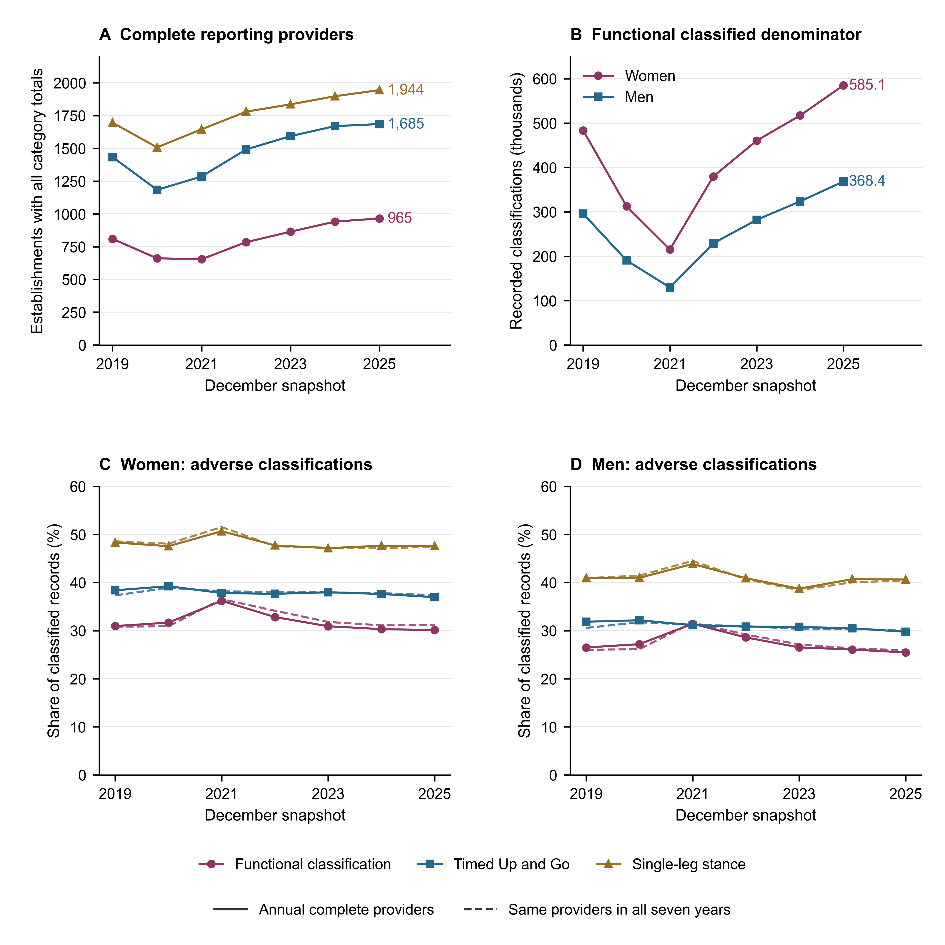
Figure NI-P-F1. December reporting completeness, classified-population denominators and provider-selection sensitivity, 2019–2025. A: establishments with complete numeric total and sex counts in all seven functional, three Timed Up and Go (TUG) or two single-leg stance categories, respectively. A provider with a zero sex-specific instrument denominator contributes no record to that sex-specific share. B: functional classified denominators by sex in annual complete-provider samples. C–D: adverse classifications as percentages of their respective classified denominators: dependency risk or any Barthel dependency; mild/high TUG fall risk; and altered single-leg stance. Solid lines use annual complete providers; dashed lines retain the same 280 functional, 699 TUG and 1,170 balance providers across all seven years. Categories are age 65+ under-control classifications, not population prevalence or neurodegenerative diagnoses. Exact duplicates are removed, inconsistent records are quarantined, and absent or blank fields are not imputed as zero. Balanced membership does not establish person-level follow-up; provider selection and case mix remain. Administrative counts have no added sampling intervals. Source: annual DEIS REM Series P files and coded templates.
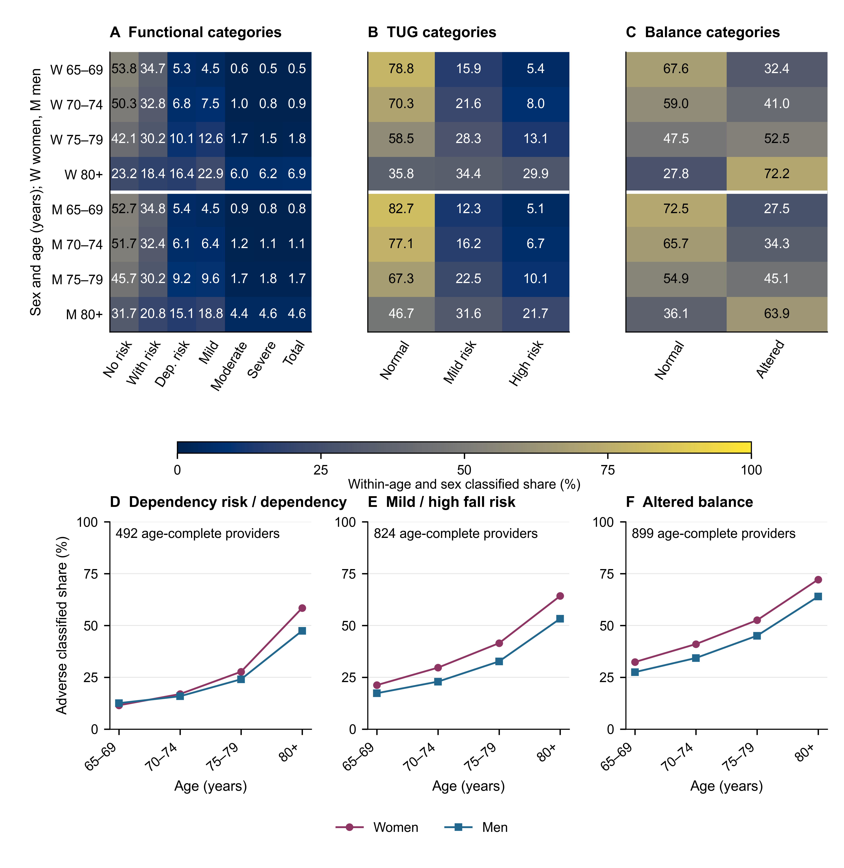
Figure NI-P-F2. Age and sex composition of functional and mobility classifications in December 2025. A–C: numerical heat maps of within-age, sex and instrument category percentages, with women (W) above men (M). Functional categories are autonomous without risk, autonomous with risk, dependency risk and mild, moderate, severe or total Barthel dependency. TUG categories are normal, mild fall risk and high fall risk; single-leg stance is normal or altered. D–F: adverse-classification shares across the same four age bands, with distinct markers for women and men. The age-reconciled provider samples contain 492 functional, 824 TUG and 899 balance providers before removing zero sex/age denominators; all source age cells must be observed and reconcile to sex totals in every required category. The 80+ band sums 80–84 through 100+ categories. Each instrument has a separate classified-population denominator. These selected under-control shares cannot estimate population prevalence or individual disease progression, and are not neurodegenerative-disease-specific. No missing field is recoded to zero. Source: DEIS REM Series P 2025 and its coded workbook; exact numerators, denominators and provider counts accompany the figure.
Figure NI-P-F3. Regional functional and mobility classification shares, December 2025. A–C: female choropleths; D–F: female/male comparisons ordered north–south. All panels share 0–100% scales. Direct age standardisation uses 65–69, 70–74, 75–79 and 80+ years and instrument-specific pooled female-plus-male age weights from the national age-reconciled classified sample (492 functional, 824 TUG and 899 balance providers before zero-denominator exclusions). Both sexes in all 16 regions have positive denominators in all four age bands. Weights, counts and crude comparisons are retained in the source tables and Table NI-P-T6. Hatching/open markers flag fewer than five providers; all values remain. Aysén functional counts come from one provider (18 female, 14 male); Arica y Parinacota uses four. Selected under-control shares do not estimate population prevalence or accessibility. Source: DEIS REM 2025 and BCN Mapoteca. Mainland boundaries use EPSG:32719 and 250-km scale bars; oceanic and Antarctic territories are omitted.
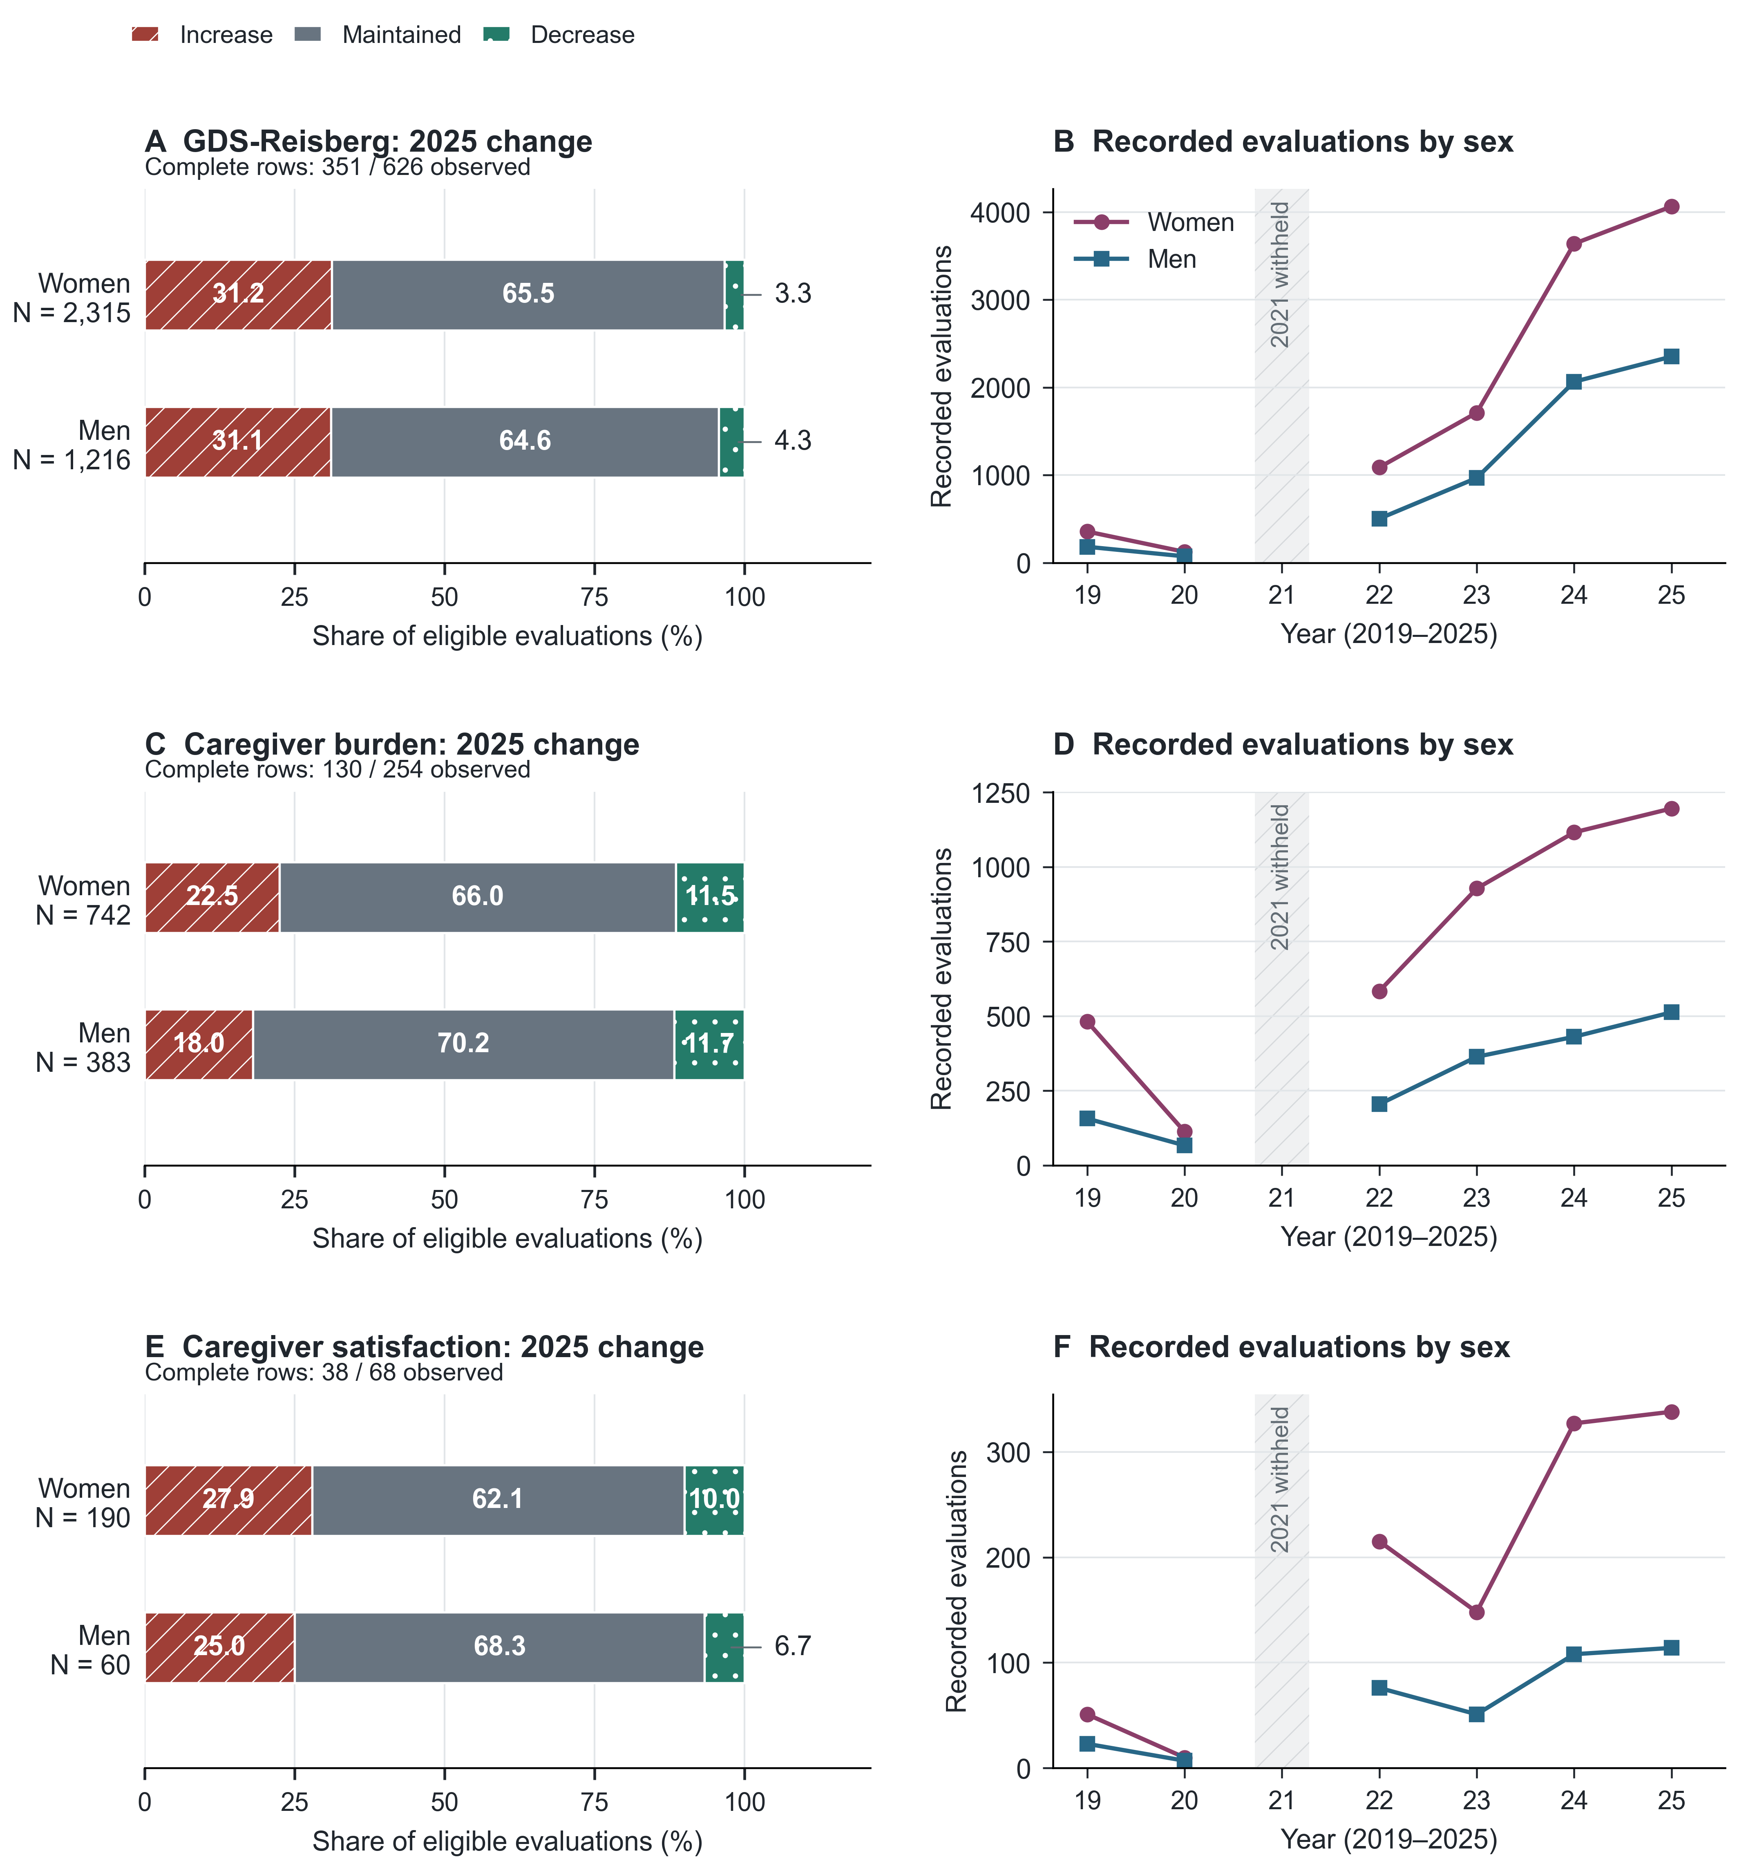
Figure NI-A-F1. Panels A, C and E show sex-specific increased, maintained and decreased categories in 2025 complete, coherent nine-cell A06 rows; denominators and observed/eligible rows are displayed. Panels B, D and F show recorded activity by sex in observed facilities, with the entire unresolved 2021 year withheld as a visible gap. Monthly recordings may repeat people. Sex refers to patients for GDS-Reisberg and caregivers for caregiver measures. Increase in deterioration/burden and increase in satisfaction have different meanings. No raw score, treatment effect or national prevalence is implied. Missing cells were not replaced by zero.
Figure NI-A-F2. Panels A and B describe observed reporting facilities and the fraction of observed rows meeting all nine-cell completeness/coherence criteria. The unresolved 2021 A06 year is withheld from primary comparisons. Panel C gives 2025 eligible/observed row counts; a missing cell is not a recorded zero. Panel D contrasts all 2021 source recordings with those outside a flagged four-facility January cluster; this logarithmic point comparison is diagnostic and is not an adopted correction. The original cluster contributes 107,160 to each measure. Coverage is observed-source coverage, not national completeness, and perfect arithmetic reconciliation did not resolve the suspicious replicated vectors.
Figure NI-A-F3. Panel A shows intense burden among repeated caregiver evaluation recordings in facility-months with both Zarit categories present and coherent total/sex cells. Panel B shows the selected paired-set fraction; absent rows and blanks are not zero. This severe-dependency caregiver scope is not dementia-specific. Panels C–E show 2025 improved, maintained and declined categories within each instrument's separate complete three-category sets, with recorded evaluation denominators. Programme TUG/functionality (age 60+) and hospital Barthel (age 65+) represent different settings and cannot be pooled as a treatment response. Panel F shows Yesavage GDS-15 application activity, a depression-screening construct distinct from GDS-Reisberg. All counts may repeat individuals; no population risk, causal benefit or clinical diagnostic accuracy is inferred.

