INDUSTRY 4.0
SMART GARMENT FACTORY SAFETY & MONITORING SYSTEM
[TexyShield]

Higher National Diploma in Software Engineering
Final Project Documentation
HDSE25.2F



School of Computing and Engineering
National Institute of Business Management
Kandy
Title of the project: Industry 4.0 Smart Garment Factory Safety & Monitoring System [TexyShield]

Authors:
W.A.S. Soysa. KAHNDSE252F-006
T.A. A. Kaumadee. KAHNDSE252F-012
W.A.D.N.S. Weragoda. KAHNDSE252F-018
T.D. Jayasooriya. KAHNDSE252F-020

Name of the program: Higher National Diploma in Software Engineering 25.2F

Name of supervisor: Mrs. N.W.A.M.V.A.D.T.Weerasinghe

Name of Institution: National Institute of Business Management

Date: 13th of August - 2026

“The project is submitted in partial fulfilment of the requirements of the Higher National Diploma of Software Engineering of National Institute of Business Management.”
Declaration
“I declare that this project is original and does not include, without proper acknowledgement, any material previously submitted for a Higher National Diploma or similar qualification at any institution. To the best of my knowledge and belief, it contains no material previously published or written by another individual or myself, except where appropriate references are provided within the text. I also grant permission for this project report, if approved, to be made available for photocopying, for the title and abstract to be shared with external organizations.”
W.A.S. Soysa. | KAHNDSE252F-006
T.A. A. Kaumadee. | KAHNDSE252F-012
W.A.D.N.S. Weragoda. | KAHNDSE252F-018
T.D. Jayasooriya. | KAHNDSE252F-020

Project Supervisor: Mrs. N.W.A.M.V.A.D.T.Weerasinghe.
Signature: ……………………………….…
Date of Submission: ……………………...
Course Director: Mrs. N.W.A.M.V.A.D.T.Weerasinghe.
Signature: …………………………………...
Date: ………………………………………...
Preamble
This project report documents the design, development, and implementation of an Industry 4.0 Smart Garment Factory Safety and Monitoring System. It details the integration of IoT hardware, AI-driven computer vision, and mobile application dashboards to ensure occupational safety and automated environmental control. The report follows a standard academic structure, moving from the organizational context and problem definition through methodology, analysis, design, and conclusion.
This expanded edition builds on the original submission by elaborating the reasoning behind each design decision, adding fuller technical explanations of the hardware-software interaction, and clarifying how each chapter connects to the overall goal of a proactive, largely autonomous industrial safety net. Where the original document used a placeholder or a compact bullet, this version explains the underlying engineering rationale so the report can also serve as a stand-alone technical reference.

Abstract
Industrial environments face significant challenges regarding worker safety, environmental monitoring, and access control. This project presents a Smart Garment Factory Safety & Monitoring System that leverages the Internet of Things (IoT), Artificial Intelligence, and a mobile application to automate safety protocols. The system utilises an ESP32 microcontroller network with a PIR sensor, a Light Dependent Resistor (LDR), a temperature sensor, a gas sensor, and a current sensor to continuously monitor factory floor conditions. Six relay channels convert these readings into automated actions: lighting control, air-conditioning activation, gas-exhaust ventilation, a combined fire response (buzzer, water pump, AC/light shutdown), and an overcurrent power cut-off. A dedicated ESP32-CAM module scans worker QR codes to log precise In and Out timestamps to a secure digital ledger. An Android mobile application, built with Kotlin and Jetpack Compose and backed by Firebase Realtime Database, gives administrators and workers real-time visibility into sensor status, alerts, and attendance. Together, these components form a proactive, largely autonomous safety net for industrial floors.

List of Keywords
- Industry 4.0
- Internet of Things (IoT)
- Smart Garment Factory
- Worker Safety
- ESP32
- ESP32-CAM
- Artificial Intelligence
- Android
- Firebase
- Sensors
- Relay Automation
- QR Attendance

List of Figures
Figure 1.1: Organisation structure of Marsylka Manufacturing Lanka (Pvt) Ltd 17
Figure 3.2: Use case diagram of system actors 36
Figure 3.13: System context diagram 44
Figure 3.4: Fire detection sequence diagram 38
Figure 3.1: Use case diagram of the current (manual) system 35
Figure 3.3: Class diagram of proposed system 37
Figure 3.14: ER diagram of proposed system 45
Figure 3.5: Sequence diagram: Scan QR Attendance 39
Figure 3.6: Sequence diagram: View Safety Status & Alerts 39
Figure 3.7: Sequence diagram: Report Machine Fault 40
Figure 3.8: Sequence diagram: View Attendance & Fault Logs 40
Figure 3.9: Sequence diagram: Monitor Live Sensor Dashboard 41
Figure 3.10: Sequence diagram: Receive Critical Safety Alerts 41
Figure 3.11: Sequence diagram: Manage Maintenance Requests 42
Figure 3.12: Sequence diagram: Trigger Automated Safety Response 42
Figure 4.1: Splash Screen 1 48
Figure 4.2: Splash Screen 2 49
Figure 4.3: Landing Page 50
Figure 4.4: Login Screen 51
Figure 4.5: Register Screen 52
Figure 4.6: Admin Dashboard 53
Figure 4.7: Attendance Blockchain Ledger 54
Figure 4.8: Blockchain Safety Ledger 55
Figure 4.9: Emergency Report Alert (Admin view) 56
Figure 4.10: Worker Dashboard 57
Figure 4.11: Profile Screen 58
Figure 4.12: AR Machine Details screen 59
Figure 4.13: AR Overlay in use 60
Figure 4.14: Emergency Report screen 61
Figure 4.15: PPE Detection screens 62
Figure 4.16: Worker Health Detection screen 63
Figure 4.17: Health trend view 64
Figure 5.1: Approval Letter from Marsylka Manufacturing Lanka (Pvt) Ltd 75
Figure 5.2: Survey QR code 76
Figure 5.3: Survey response screenshots 80

List of Tables
Table 4.1: Firebase Realtime Database root node descriptions 68
Table 5.1: Survey Response Summary 76
Table 5.2: Daily Log Sheet 85

List of Acronyms and Abbreviations
Acronym | Meaning
IoT | Internet of Things
PIR | Passive Infrared (motion sensor)
LDR | Light Dependent Resistor
AC | Air Conditioner
ppm | Parts Per Million
UID | Unique Identifier
UML | Unified Modelling Language
UI | User Interface
QR | Quick Response (code)
API | Application Programming Interface

Acknowledgement
We would like to extend our heartfelt gratitude to everyone who contributed to the successful completion of this Industry 4.0 Smart Garment Factory Safety & Monitoring System. Special thanks go to our project supervisor for their invaluable guidance, constant encouragement, and constructive feedback throughout the design and development process. We are also grateful to our institution for providing the resources and laboratory access necessary to prototype the hardware components, and to our families and peers for their continued support.
We would also like to express our sincere appreciation to Marsylka Manufacturing Lanka (Pvt) Ltd for approving us to conduct this academic project within their organization. In particular, we are grateful to their Human Resources Manager for reviewing and approving our request, and for permitting us to observe relevant workplace activities and collect the information necessary for this project. Their cooperation and trust in providing access to the factory environment were invaluable in grounding this project in a real industrial setting.

Table of Contents
Declaration iii
Preamble iv
Abstract v
List of Keywords vi
List of Figures vii
List of Tables ix
List of Acronyms and Abbreviations x
Acknowledgement xi
Chapter 1: Introduction 16
1.1 Introduction of the Organization 16
1.2 Organization Structure 17
1.3 Current Operations in Organization 18
1.4 Users and Responsibilities of the Organization 19
1.5 Problem Definition 20
1.6 Project Objectives 21
1.7 Proposed Solution 22
1.8 Chapter Summary 23
Chapter 2: Methodology 24
2.1 Introduction 24
2.2 Data Collection Methods 25
2.3 Software Process Model 26
2.4 Software Development Tools 27
2.4.1 Emergent Technologies Used 28
2.4.1.1 Artificial Intelligence & Machine Learning (AI/ML) 28
2.4.1.2 Internet of Things (IoT) 28
2.4.1.3 Augmented Reality (AR) 29
2.4.1.4 Blockchain Technology 29
2.5 Testing Strategies 30
2.5.1 Functionality Testing 30
2.5.2 Usability Testing 30
2.5.3 Interface Testing 30
2.5.4 Compatibility Testing 31
2.6 Implementation Plan 32
2.7 Chapter Summary 33
Chapter 3: Analysis 34
3.1 Introduction 34
3.2 UML Diagrams 35
3.2.1 Use Case Diagram of Current System 35
3.2.2 Use Case Diagram of Proposed System 36
3.2.3 Class Diagram of Proposed System 37
3.2.4 Sequence Diagram of Proposed System [For each Use Case] 38
3.2.5 Context Diagram of Proposed System 44
3.3 ER Diagram of Proposed System 45
3.4 Chapter Summary 46
Chapter 4: Solution Design 47
4.1 Introduction 47
4.2 Interface Design 48
4.2.1 Splash Screen 1 [App Launch] 48
4.2.2 Splash Screen 2 [Branding / Auth Check] 49
4.2.3 Landing Page 50
4.2.4 Login Screen 51
4.2.5 Register Screen [Sign Up] 52
4.2.6 Admin Dashboard 53
4.2.6.1 Attendance Blockchain Ledger Screen 54
4.2.6.2 Blockchain Safety Ledger Screen 55
4.2.6.3 Emergency Report Alert in Admin Dashboard 56
4.2.7 Worker Dashboard 57
4.2.7.1 Profile Screen 58
4.2.7.2 AR Machine Details Screen 59
4.2.7.3 Emergency Report 61
4.2.7.4 PPE Detection [Entrance] 62
4.2.7.5 WorkerHealthDetection Screen 63
4.3 Database Schema & Architecture details 65
4.3.1 Overview 65
4.3.2 Justification for Realtime Database 65
4.3.3 Complete JSON Tree Structure 66
4.3.4 Node Descriptions 68
4.3.5 Key Design Considerations 70
4.3.5.1 Data Grouping and Query Efficiency 70
4.3.5.2 Offline Synchronisation 70
4.3.5.3 Timestamps 70
4.3.5.4 Security Rules 70
4.4 Artificial Intelligence Model Training & Methodology 71
4.4.1 Frameworks and Training Process 71
4.4.2 Safety & PPE Detection Models 71
4.4.3 Worker Health & Ergonomics Models 71
4.4.4 Machine Identification Models 72
Chapter 5: Conclusion 73
References 74
Appendices 75

Chapter 1: Introduction
1.1 Introduction of the Organization
Marsylka Manufacturing Lanka (Pvt) Ltd is a garment manufacturing company located in the Export Processing Zone, Polgahawela, Sri Lanka, specialising in the production of ladies' wear. The factory operates with a workforce of approximately 750 employees across 14 active production lines, making it a mid-to-large-scale apparel manufacturing operation with significant exposure to the everyday safety and machine-reliability challenges typical of the garment industry. As a supplier operating under international buyer compliance requirements, the factory maintains formal safety policies and procedures, but as detailed in the sections below, several of its safety and monitoring processes remain manual, reactive, or fragmented across standalone devices rather than unified into a single digital system. This project uses Marsylka Manufacturing Lanka as its industry case study, with the factory's Quality Assurance representative providing the operational data that grounds the requirements and design decisions throughout this report.

1.2 Organization Structure
The following diagram shows the organization's structure.

Factory Manager
Production Manager
Quality Control Manager
nager

ontro
Maintenance Manager
Safety Officer
HR & Administration
Production Supervisors
Quality Inspectors
Technicians
Team Leader
Machine Operators & General Workers

Figure 1.1: Organisation structure of Marsylka Manufacturing Lanka (Pvt) Ltd

1.3 Current Operations in Organization
Machine maintenance at the factory is currently reactive, with servicing performed "only when a fault occurs" rather than on a fixed weekly, monthly, or scheduled basis. Common problems reported include thread breakage, needle breakage, fabric jamming, and motor failure. Significantly, the factory's QA representative confirmed that these machine breakdowns directly affect daily production output. Fault reporting itself is entirely manual; a worker who notices a problem informs their supervisor verbally, with no maintenance team routing, log book, or digital system currently in place to track recurring issues or response times.
On the safety side, the factory already has a workplace safety policy, conducts regular safety training, and requires workers to wear PPE including face masks and gloves. Emergencies such as fire, smoke, or gas leaks are handled by following established fire procedures aligned with buyer compliance requirements, maintaining designated smoke areas, and providing fire-safety training to employees. For monitoring, the factory currently uses CCTV cameras, smoke sensors, temperature sensors, and a fire alarm system, but these operate as separate, disconnected devices rather than as part of an integrated digital safety monitoring system, and the factory does not currently use gas sensors or motion sensors at all. This combination of reactive machine maintenance and fragmented, non-integrated safety devices is the core operational gap this project addresses.

1.4 Users and Responsibilities of the Organization
- Quality Assurance / Admin: Oversees compliance with safety and quality standards across all 14 production lines, and under the proposed system would monitor real-time dashboards, machine-health data, and receive critical alerts for fire, gas, or equipment hazards.
- Floor Supervisor: Currently the first point of contact when a worker reports a machine fault or safety concern; would use the proposed mobile application to receive and act on real-time alerts for their assigned line.
- Machine Operator / General Worker: Operates sewing machines (lockstitch, overlock, flatlock, buttonhole, button-sewing, bartack, and zigzag machines) and is currently responsible for verbally reporting faults or hazards to a supervisor; relies on PPE, safety training, and the factory's fire procedures for protection while on the floor.
The QA representative specifically noted the difficulty of "handling 100% compliance procedures while achieving maximum efficiency in production" without it affecting safety, directly highlighting that current responsibilities are stretched thin across manual processes, which the proposed system aims to relieve through automation.

1.5 Problem Definition
Based on the factory's current operations, this project addresses the following problems:
- Reactive, Undocumented Machine Maintenance: With approximately 550 of the factory's sewing machines in active operation and servicing performed only when a fault occurs, recurring issues like thread breakage, needle breakage, and motor failure are not tracked systematically, and breakdowns are confirmed to directly disrupt daily production.
- Fragmented Safety Technology: The factory already operates CCTV cameras, smoke sensors, temperature sensors, and a fire alarm system, but these exist as standalone tools rather than a unified digital safety monitoring system. There is no gas sensing, no motion sensing, and no central dashboard tying these signals together.
- Manual, Verbal Fault and Hazard Reporting: Faults and safety concerns are reported by informing a supervisor directly, with no maintenance team routing, log book, or digital system, creating delays and no historical record for analysis.
- Compliance vs Efficiency Pressure: The QA representative identified fire risk and health risk as the most common safety concerns, and explicitly noted that balancing full safety compliance against production efficiency is an ongoing operational challenge.

1.6 Project Objectives
- To develop a digital safety monitoring system capable of consolidating the factory's existing sensor inputs (CCTV, smoke, temperature, fire alarm) with new gas and motion sensing into a single, real-time platform.
- To introduce automated, threshold-based alerts for fire, smoke, gas, and temperature hazards that reduce reliance on manual observation and verbal fault reporting.
- To provide a structured digital channel for logging and tracking machine faults (thread breakage, needle breakage, fabric jamming, motor failure), replacing the current supervisor-only verbal reporting process.
- To develop a mobile application for supervisors and management, a feature the factory's QA representative directly confirmed would be useful, giving real-time visibility into safety status and machine health across all 14 production lines.
- To support the factory's existing PPE, safety-training, and fire-compliance procedures with real-time monitoring, rather than replacing them, so the system strengthens rather than disrupts current buyer-compliance practices.

1.7 Proposed Solution
The proposed solution is an AI-based Smart Garment Factory Safety Monitoring and Employee Assistance System, directly informed by the factory's confirmed interest in such a system, real-time safety alerts, and a supervisor/manager mobile application. Building on the sensors already present on the floor (CCTV, smoke, temperature, fire alarm), the system introduces gas and motion sensing to close the current monitoring gaps, and ties all sensor inputs into a unified dashboard rather than the disconnected devices currently in use. Threshold-based logic mirroring the escalation pattern the factory already follows for fire procedures triggers automated alerts and, where applicable, safety responses, while a digital fault-logging channel replaces the current verbal, supervisor-only reporting process for machine issues such as thread breakage, needle breakage, and motor failure. A companion mobile application delivers this information to supervisors and management in real time, directly addressing the compliance-versus-efficiency tension the QA representative raised, by giving staff visibility into safety conditions without requiring constant manual floor inspection.

1.8 Chapter Summary
This chapter introduced Marsylka Manufacturing Lanka (Pvt) as the industry case study for this project, and outlined its current operations: reactive machine maintenance, manual verbal fault reporting, and safety technology (CCTV, smoke, temperature, and fire alarm systems) that operates without central integration or gas/motion sensing. These gaps, confirmed directly by the factory's Quality Assurance representative, define the problems this project sets out to solve, and directly shape the objectives and proposed AI-based safety monitoring and employee assistance system detailed in this report.

Chapter 2: Methodology
2.1 Introduction
This chapter outlines the methodology adopted to design and develop the Smart Garment Factory Safety Monitoring and Employee Assistance System. It explains how requirements were gathered directly from Marsylka Manufacturing Lanka (Pvt) Ltd, the tools selected to build the hardware and software components, and the testing strategies used to validate the system before deployment. Given that the project addresses real safety and machine maintenance gaps identified at an operating garment factory, the methodology places particular emphasis on grounding every design decision in verified, factory-reported data rather than on assumptions.

2.2 Data Collection Methods
- Structured Questionnaire (Primary Data Collection): A structured Google Form questionnaire was distributed to Marsylka Manufacturing Lanka's Quality Assurance representative, covering respondent and factory information, machine information, worker safety practices, existing technology usage, and project feedback. This single, targeted response from a Dedicated Quality Assurance officer with direct floor-level visibility provided authoritative, first-hand data on the factory's 750 employees, 14 production lines, and approximately 550 active sewing machines, and formed the primary evidence base for the problem definition and objectives in Chapter 1.
- Categorical and Open-Ended Questions: The questionnaire combined closed multiple-choice questions (e.g., machine types in use, PPE requirements, existing safety technologies) with open-ended questions (e.g., "What are the most common safety risks in your factory?", "What challenges do you face in monitoring worker safety?"). This mixed format allowed quantifiable comparison of current practices against Industry 4.0 best practices, while still capturing qualitative insight into operational pain points such as the tension between compliance and production efficiency.
- Permission and Ethics: The questionnaire explicitly requested and received formal permission to use Marsylka Manufacturing Lanka as the case study for this HND final year project, and separately requested and received permission to photograph the factory environment and equipment for academic purposes only, ensuring the data collection process was conducted ethically and with documented organizational consent.
- Software Process Model: The Waterfall model was adopted for development. Hardware safety logic sensor thresholds, relay behaviour, and alert conditions were defined, built, and tested first, based directly on the risks the factory identified (fire risk and health risk) and the technologies it confirmed were already in place (CCTV, smoke sensors, temperature sensors, fire alarm system). The mobile application and reporting layer were developed only once this safety-critical foundation was stable, since the factory's own QA representative confirmed that machine breakdowns already disrupt daily production, meaning any new system had to be verified thoroughly before being trusted on a live floor.
2.3 Software Process Model
The Waterfall model was adopted for the development of the TexyShield system. This model was chosen because the hardware safety logic, sensor thresholds, and alert conditions needed to be strictly defined, built, and tested first. These foundational elements were based directly on the risks identified by the factory (fire risk and health risk) and existing technologies. Since the factory's QA representative confirmed that machine breakdowns disrupt daily production, the mobile application and reporting layer were developed sequentially only after the safety-critical hardware foundation was verified and stable.

2.4 Software Development Tools
The following software development tools and frameworks were used to implement the system:
- Integrated Development Environments (IDEs)
- Android Studio: Used for developing the Android mobile application.
- Arduino IDE / PlatformIO: Used for writing and uploading the C++ firmware to the ESP32 and ESP32-CAM microcontrollers.
- Mobile Application Framework
- Kotlin & Jetpack Compose: The modern programming language and UI toolkit used to build the native Android application interfaces.
- Database & Backend
- Firebase Realtime Database: A cloud-hosted NoSQL JSON database used to sync live IoT sensor data and alerts in real-time.
- Firebase Authentication: Used to securely manage worker and admin logins.
- Artificial Intelligence & Machine Learning Tools
- TensorFlow Lite / ML Kit: Used to run the pre-trained object detection models directly on the mobile device for PPE (mask) detection and AR features.
- Google Colab: A cloud-based Jupyter notebook environment used for data pre-processing, image dataset handling, and training the Artificial Intelligence models (such as PPE mask detection) utilising Python and cloud GPUs.
- Python / OpenCV: Used during the data pre-processing and AI training phase for health and risk detection.
- UI/UX Prototyping
- Figma: Used to design the wireframes and user interfaces for the Admin and Worker dashboards.

2.4.1 Emergent Technologies Used
To resolve the factory’s challenges with reactive machine maintenance and fragmented safety protocols, this project integrates four pillars of Industry 4.0 technology into a unified platform designed to create a zero-accident, high-efficiency manufacturing environment:

2.4.1.1 Artificial Intelligence & Machine Learning (AI/ML)
The system relies on a Python FastAPI backend running advanced deep learning models to automate safety monitoring and replace manual floor checks. Utilising the YOLOv8 and YOLO11 architectures for real-time computer vision, the system actively detects whether workers are wearing mandatory PPE (face masks and gloves) at factory entrances, tracks skeletal keypoints for instant fall detection, and analyses facial micro-expressions to monitor worker fatigue. Furthermore, to address the factory's reliance on reactive maintenance, an Ensemble Learning approach using a Random Forest Classifier (Scikit-Learn) analyses machine telemetry. This allows the system to predict the failure probability of sewing machines, warning mechanics of overheating or motor issues before a critical breakdown halts production.

2.4.1.2 Internet of Things (IoT)
To digitise the physical factory floor, the system deploys a network of ESP32 microcontrollers equipped with environmental sensors (DHT22 for temperature, MQ2 for gas, PIR for motion) and hardware sensors (ACS712 for current). These nodes stream live telemetry to a Firebase Realtime Database, unifying previously disconnected CCTV and fire alarm systems into a single digital dashboard. Beyond passive monitoring, the IoT network is designed for automated response; the microcontrollers can physically trigger 6-channel relays to automatically activate exhaust fans, sound buzzers, or cut main power. This ensures that life-safety actions such as shutting off a sewing machine during an electrical overcurrent event happen instantaneously without waiting for human intervention.

2.4.1.3 Augmented Reality (AR)
The Kotlin-based Android mobile application features an Augmented Reality (AR) Assistant module designed to drastically reduce machine downtime and simplify troubleshooting. When a mechanic points their smartphone camera at any of the 550 sewing machines on the factory floor, a CNN image classifier identifies the specific machine type. The application then bridges the gap between digital telemetry and the physical world by rendering holographic overlays directly onto the machine. Mechanics can view real-time sensor data, maintenance status, and digital repair instructions contextually and hands-free, eliminating the need to consult paper manuals or navigate complex menus while holding tools.

2.4.1.4 Blockchain Technology
As a garment manufacturer subject to strict international buyer compliance requirements, maintaining a transparent and mathematically secure audit trail is critical. To achieve this, high-security events are processed by the backend and mined into a custom blockchain ledger. This includes Worker Attendance logs, captured via ESP32-CAM QR scanners, and the Safety Ledger, which records both worker-submitted Emergency SOS reports and automated AI hazard detections. By utilising blockchain technology, the system ensures that safety incidents, emergency response times, and attendance records remain immutable; they cannot be altered, deleted, or tampered with retroactively by either management or workers.

2.5 Testing Strategies
Testing is an essential part of the development process to ensure the reliability, quality, and performance of the system. Several testing strategies were applied to verify that all system components function correctly and meet user expectations.
2.5.1 Functionality Testing
Each sensor and its corresponding automated response were tested individually to confirm correct triggering behaviour; for example, verifying that a simulated temperature rise or gas presence correctly activates the intended alert, mirroring the fire-risk and health-risk concerns Marsylka's QA representative flagged as the factory's most common safety issues. Testing also covered the digital fault-logging function intended to replace the current practice of workers verbally informing a supervisor when a machine issue (thread breakage, needle breakage, fabric jamming, or motor failure) occurs.
2.5.2 Usability Testing
The mobile application's interface was evaluated for clarity, particularly from the perspective of supervisors and management, the two user groups the factory specifically confirmed would benefit from such an application. Feedback focused on ensuring safety alerts are immediately visible and unambiguous, and that the interface does not add friction to floor operations, addressing the QA representative's concern that maintaining full compliance can come at the cost of production efficiency.
2.5.3 Interface Testing
Communication between the sensor hardware, backend service, and mobile application was tested end-to-end to confirm that a triggered alert reaches the supervisor/manager application without noticeable delay, directly targeting the factory's existing gap of having safety devices (CCTV, smoke sensors, temperature sensors, fire alarm) that operate independently rather than as an integrated monitoring system.

2.5.4 Compatibility Testing
The mobile application was tested across multiple Android OS versions and screen sizes to ensure supervisors and managers can reliably access safety information and alerts regardless of their device, supporting practical day-to-day use across a 750-employee, 14-line production facility.

2.6 Implementation Plan
- Phase 1: Requirements confirmation and threshold calibration, based directly on the factory's questionnaire responses (fire risk, health risk, and the machine faults most commonly reported: thread breakage, needle breakage, fabric jamming, motor failure).
- Phase 2: Sensor and hardware assembly, extending the factory's existing CCTV, smoke, temperature, and fire-alarm infrastructure with new gas and motion sensing.
- Phase 3: Firmware development for automated, threshold-based alert and relay logic.
- Phase 4: Development of the digital fault-logging and alert pipeline, replacing the current supervisor-only verbal reporting process.
- Phase 5: Mobile application development (Kotlin, Jetpack Compose) for supervisors and managers, integrated with the real-time database.
- Phase 6: End-to-end integration testing and validation against the specific risks and gaps identified by Marsylka Manufacturing Lanka, followed by deployment planning.
2.7 Chapter Summary
This chapter described a Waterfall-based methodology in which every stage was informed directly by data collected from Marsylka Manufacturing Lanka (Pvt) Ltd, a 750-employee, 14-production-line ladies' wear manufacturer. Requirements were gathered through a structured questionnaire completed by the factory's Quality Assurance representative, with formal permission obtained to use the factory as the project's case study. Appropriate hardware and software tools were selected to extend the factory's existing but disconnected safety technologies into a unified, real-time monitoring system, and a staged testing strategy was defined for functionality, usability, interface, and compatibility to ensure the resulting system reliably addresses the fire risk, health risk, and machine-fault reporting gaps the factory itself identified.

Chapter 3: Analysis
3.1 Introduction
This chapter analyses the requirements of the Smart Garment Factory Safety Monitoring and Employee Assistance System and visualises the interaction between the system's actors, Worker, Supervisor/QA Admin, Maintenance Technician, and the IoT Sensor System itself using UML diagrams. The analysis is grounded directly in the operational data gathered from Marsylka Manufacturing Lanka (Pvt) Ltd, ensuring the modelled use cases, data flows, and system behaviour reflect the factory's actual reporting practices, existing technology, and identified risks (fire risk and health risk).

3.2 UML Diagrams
3.2.1 Use Case Diagram of Current System
Before TexyShield, safety monitoring at the factory was entirely manual. Workers marked attendance on a paper sheet, supervisors relied on visual patrols to check safety conditions, and faults were reported verbally or by radio and logged by hand. The use case diagram below captures this as-is process, which the proposed system in the following sections is designed to replace.
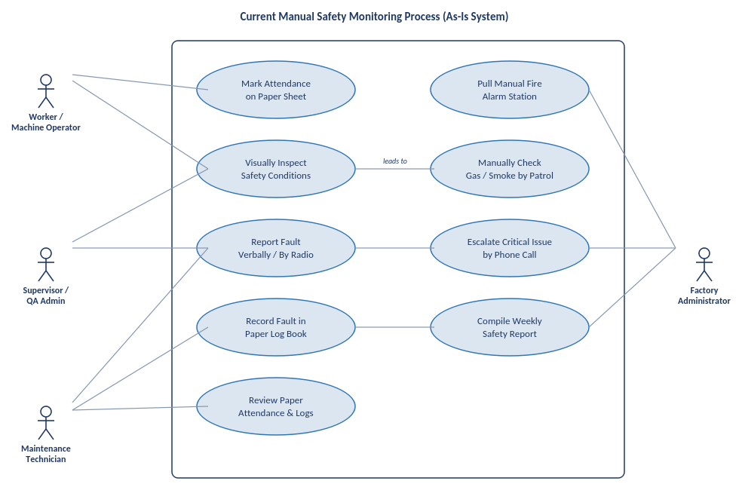
Figure 3.1: Use case diagram of the current (manual) system

3.2.2 Use Case Diagram of Proposed System
Shows four actors: Worker, Supervisor/QA Admin, Maintenance Technician, and the IoT Sensor System interacting with core functions such as QR attendance, fault reporting, live dashboard monitoring, and automated safety response. The IoT Sensor System acts autonomously, triggering alerts without waiting for human input.
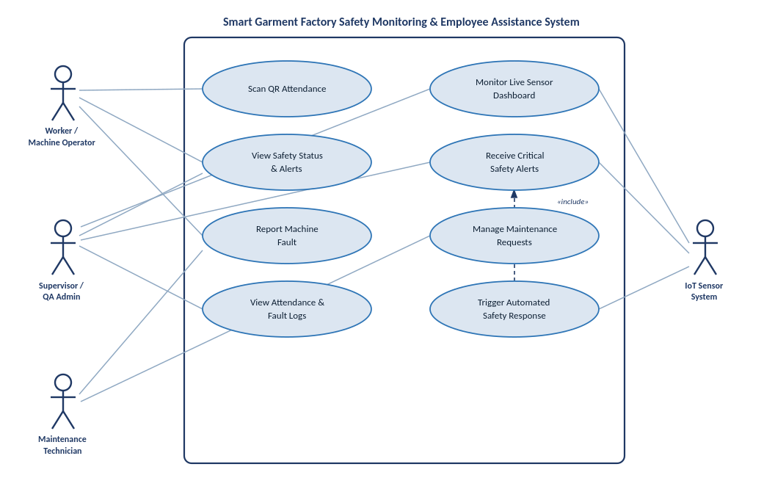
Figure 3.2: Use case diagram of system actors

3.2.3 Class Diagram of Proposed System
The class diagram below models the core data and behaviour of TexyShield. A base User class is specialised into Worker, Supervisor and MaintenanceTechnician, each interacting with domain classes such as AttendanceRecord, MachineFault, SensorReading, SafetyAlert, MaintenanceRequest, BlockchainLedgerEntry, Actuator and EmergencyReport.
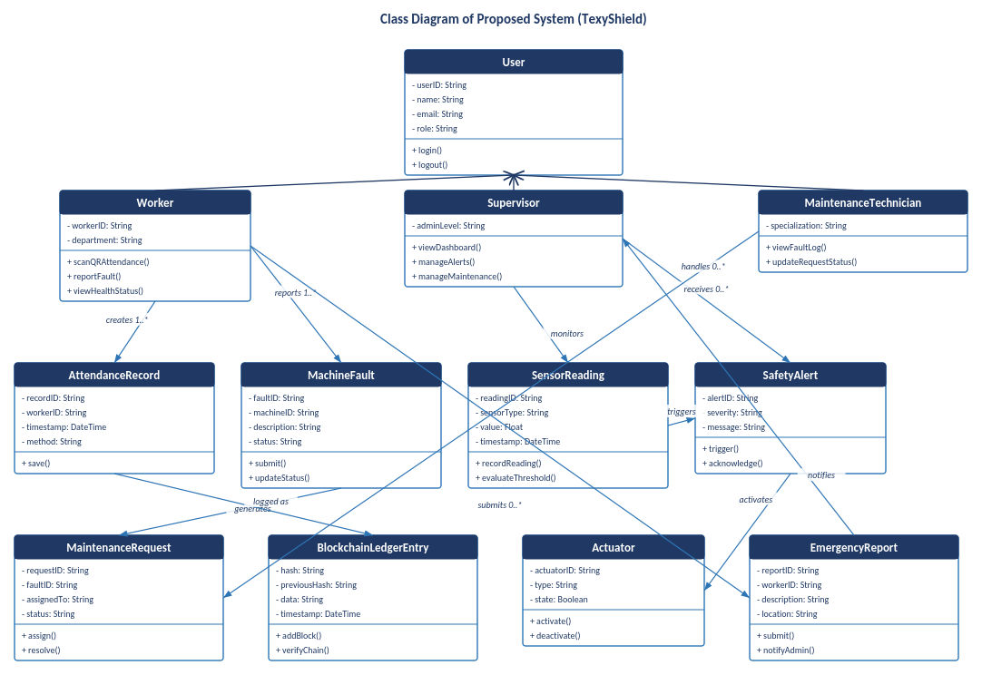
Figure 3.3: Class diagram of proposed system

3.2.4 Sequence Diagram of Proposed System [For each Use Case]
Traces a fire event from sensor trigger to resolution: temperature and gas readings are evaluated together, actuators respond instantly on-device, and the alert is only pushed to the Supervisor App afterwards so the physical safety response never depends on network availability.

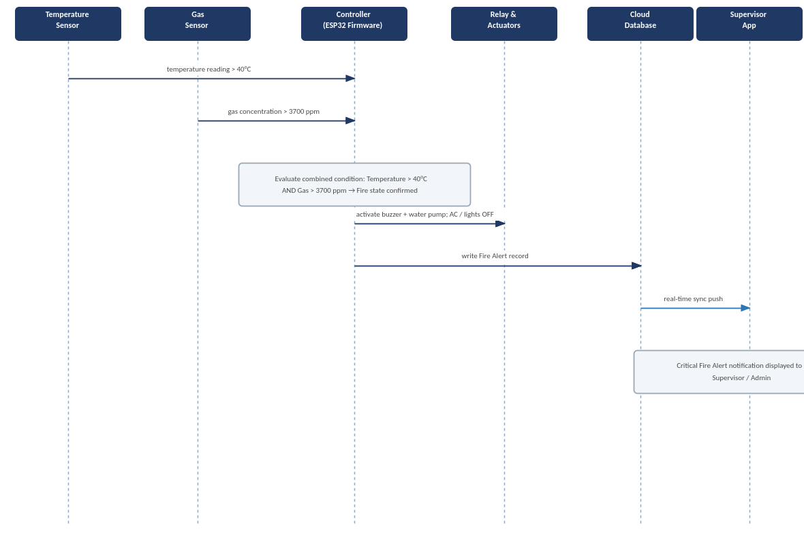
Figure 3.4: Fire detection sequence diagram

The sequence diagrams below trace the message flow for each use case identified in the proposed system's use case diagram (Figure 3.2), complementing the fire detection scenario already covered in section 3.2.3.
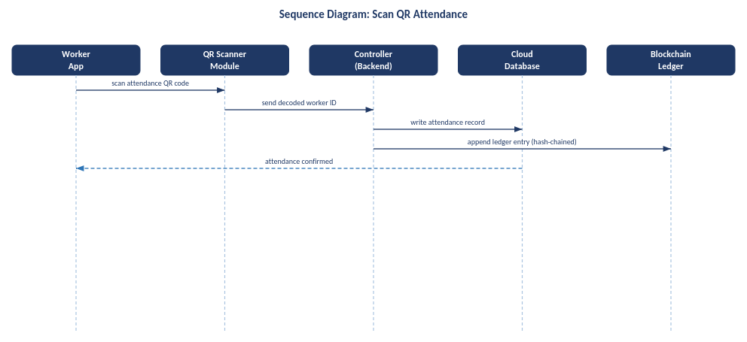
Figure 3.5: Sequence diagram: Scan QR Attendance
A worker scans the attendance QR code; the controller resolves the worker ID, writes the attendance record to the cloud database, and appends a hash-chained entry to the blockchain ledger.
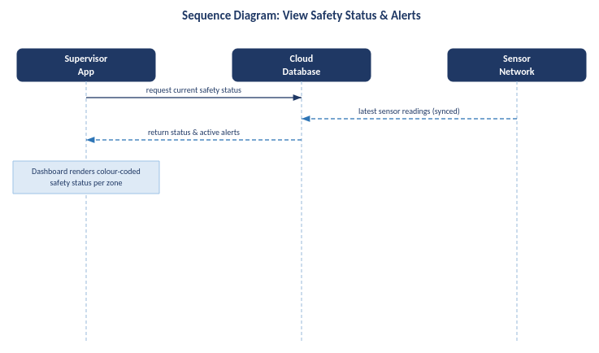
Figure 3.6: Sequence diagram: View Safety Status & Alerts
The Supervisor App requests the current safety status; the cloud database returns the latest synced sensor readings together with any active alerts for display on the dashboard.
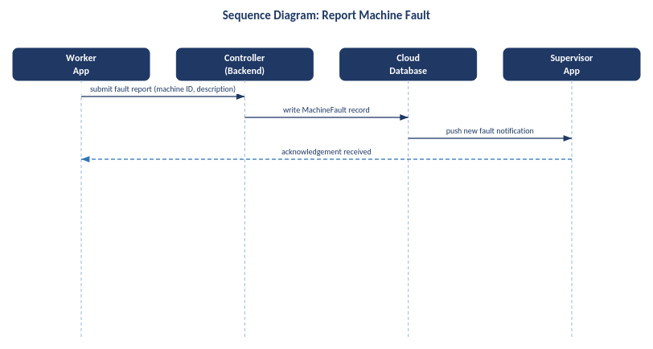
Figure 3.7: Sequence diagram: Report Machine Fault
A worker submits a fault report from the Worker App; the controller writes the fault record and the cloud database pushes a notification to the Supervisor App.
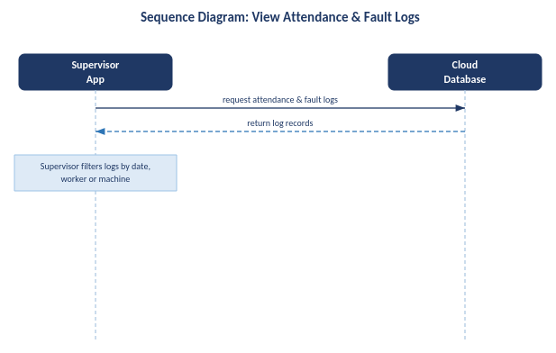
Figure 3.8: Sequence diagram: View Attendance & Fault Logs
The Supervisor App requests attendance and fault log records from the cloud database for filtering and review by date, worker or machine.
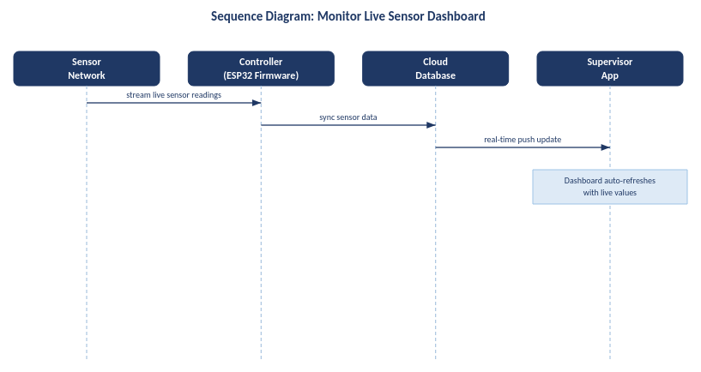
Figure 3.9: Sequence diagram: Monitor Live Sensor Dashboard
Live sensor readings stream from the sensor network through the controller to the cloud database, which pushes real-time updates to the Supervisor App dashboard.
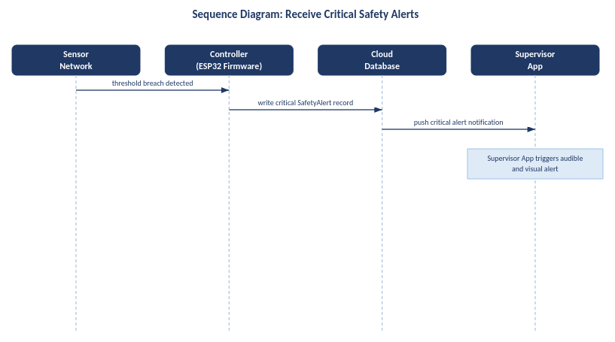
Figure 3.10: Sequence diagram: Receive Critical Safety Alerts
When a sensor threshold breach is detected, the controller writes a critical safety alert which the cloud database pushes to the Supervisor App, triggering an audible and visual alert.
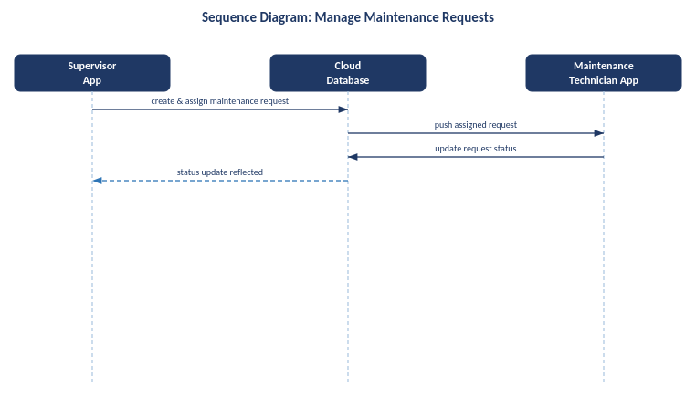
Figure 3.11: Sequence diagram: Manage Maintenance Requests
The Supervisor App creates and assigns a maintenance request; the assigned technician receives it and updates its status, which is reflected back to the Supervisor App.
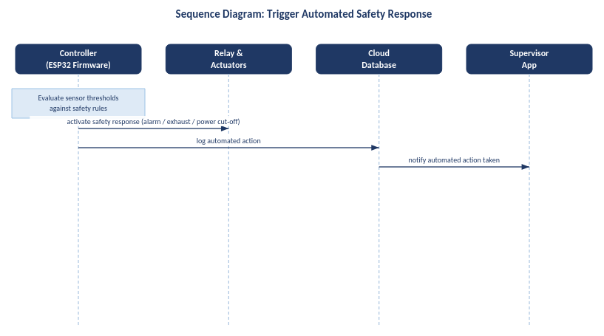
Figure 3.12: Sequence diagram: Trigger Automated Safety Response
The controller evaluates sensor thresholds on-device and, where safety rules are breached, activates the relay-controlled actuators directly while logging the automated action to the cloud database.

3.2.5 Context Diagram of Proposed System
Places the system at the centre of all data flow: sensor and QR inputs flow in, while relay-controlled actuators, the worker app, and the supervisor/admin app receive outputs, with a cloud database syncing all activity in real time.
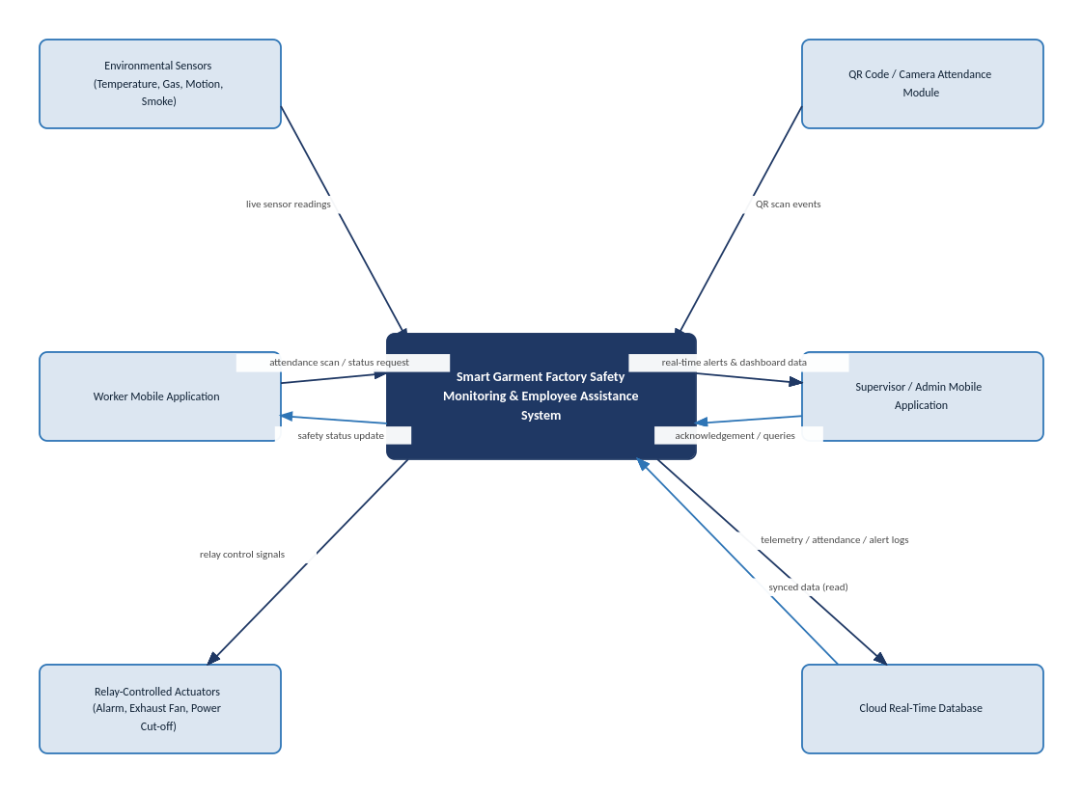
Figure 3.13: System context diagram

3.3 ER Diagram of Proposed System
The entity-relationship diagram below shows how attendance, fault, sensor, alert, maintenance and emergency-report data are structured and related within the underlying database, including the blockchain ledger used to keep attendance records tamper-evident.
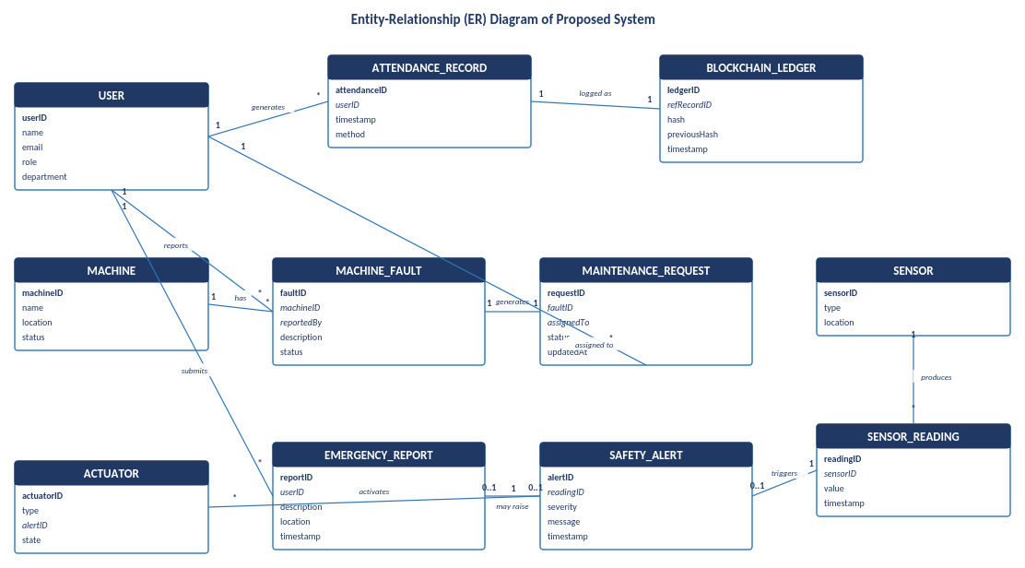
Figure 3.14: ER diagram of proposed system

3.4 Chapter Summary
Through UML modelling grounded in Marsylka Manufacturing Lanka's actual reporting structure and safety technology, this chapter mapped the data flow between physical hazard triggers, automated hardware response, and software-based supervisor notification. The use case diagram clarified how each factory role interacts with the system, the context diagram showed how the system unifies previously disconnected safety devices, and the sequence diagram confirmed that life-safety actions are never gated on network or database availability, ensuring the fire, gas, and machine-fault protocols integrate reliably with the attendance and dashboard features described in later chapters.

Chapter 4: Solution Design
4.1 Introduction
This chapter presents the design of the proposed solution, the TexyShield mobile application (branded under the Smart Garment Factory Safety Monitoring & Employee Assistance System), covering its interface design, underlying database structure, and report layouts. Each interface below reflects an implemented screen of the application, described with its purpose and represented through pseudo code that models its core logic. The database design translates the data these interfaces capture and display into a structured schema, and the report layout section documents the printable/exportable outputs the system generates.

4.2 Interface Design

4.2.1 Splash Screen 1 [App Launch]
Initial launch screen featuring a clean white background with a neon green factory logo ("SMART GARMENT FACTORY APP"). It serves as the primary visual introduction to the application.



BEGIN
Display White Background
Render "Smart Garment Factory" Neon Logo at Center
Start Initialization
Wait for minimum duration
Transition to SplashScreen 2
END

Figure 4.1: Splash Screen 1

4.2.2 Splash Screen 2 [Branding / Auth Check]
Secondary branding splash screen showcasing the "TexyShield" identity with a dark mode aesthetic. Features a red and white shield emblem, subtitle "Industry 4.0 Safety & Monitoring", and tagline "POWERED BY AI & BLOCKCHAIN".

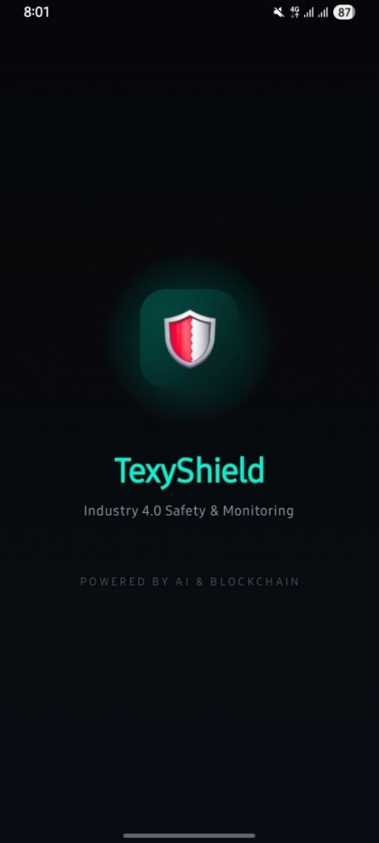

BEGIN
Display Dark Background
Render Shield Logo at Center
Render "TexyShield" Text
Initialize AI & Blockchain Models in Background
Wait for minimum duration
IF User is Logged In:
Fetch User Role
IF Role == "Admin":
Navigate to Admin Dashboard
ELSE:
Navigate to Worker Dashboard
ELSE:
Navigate to LandingPage
END

Figure 4.2: Splash Screen 2

4.2.3 Landing Page
Gateway for unauthenticated users, providing navigation paths to log in or register. Clean, welcoming interface with primary call-to-action buttons.

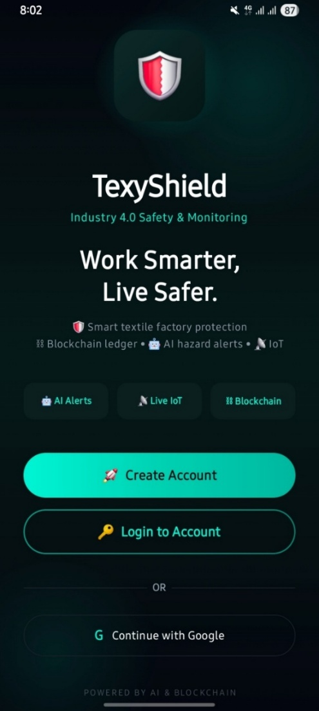

BEGIN
Render App Logo
Render "Login" Button
Render "Register" Button
ON "Login" Button Click:
Navigate to LoginScreen
ON "Register" Button Click:
Navigate to RegisterPage
END

Figure 4.3: Landing Page

4.2.4 Login Screen
Secure authentication interface requiring the user's registered email and password. Includes form validation and visual feedback.

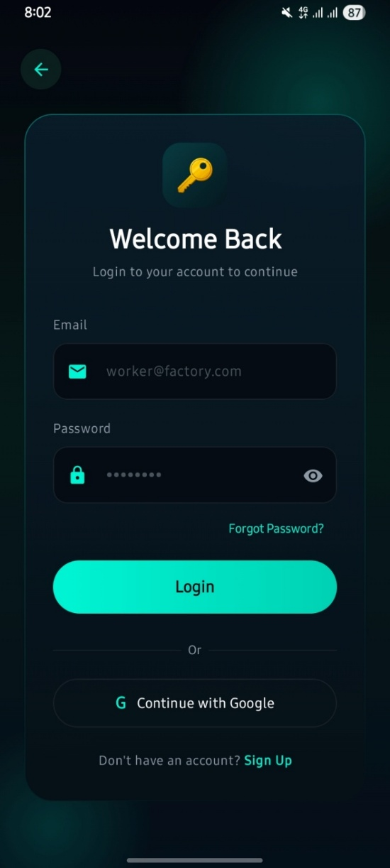

BEGIN
Render Email & Password Inputs
Render Login Button
ON Login Button Click:
Display Loading Spinner
Call Authentication API
Hide Loading Spinner
IF Auth Success:
Navigate to Dashboard based on Role
ELSE:
Display Error Alert ("Invalid Credentials")
END

Figure 4.4: Login Screen

4.2.5 Register Screen [Sign Up]
Registration form designed to capture necessary user details to provision a new account, including role selection.

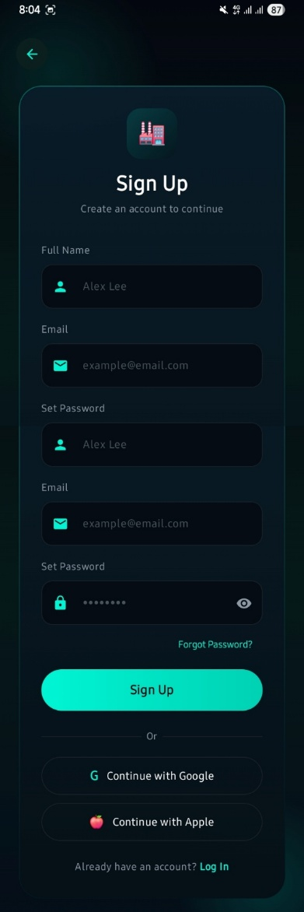

BEGIN
Render Name, Email, Password Inputs
Render Role Selection Dropdown (Admin/Worker)
Render Register Button
ON Register Button Click:
Validate Form Inputs
Display Loading Spinner
Call Registration API
Hide Loading Spinner
IF Success:
Display Success Alert
Navigate to LoginScreen
ELSE:
Display Error Alert ("Registration Failed")
END

Figure 4.5: Register Screen

4.2.6 Admin Dashboard
Command centre tailored for administrators. Features metric cards for Live IoT Sensors (Temperature, Fabric Dust Gas, Current, Motion, Light) and AI Predictions (Fabric Storage Fire Risk, Sewing Machine Overcurrent), plus quick links like Safety Ledger, Attendance, and PPE Detection.

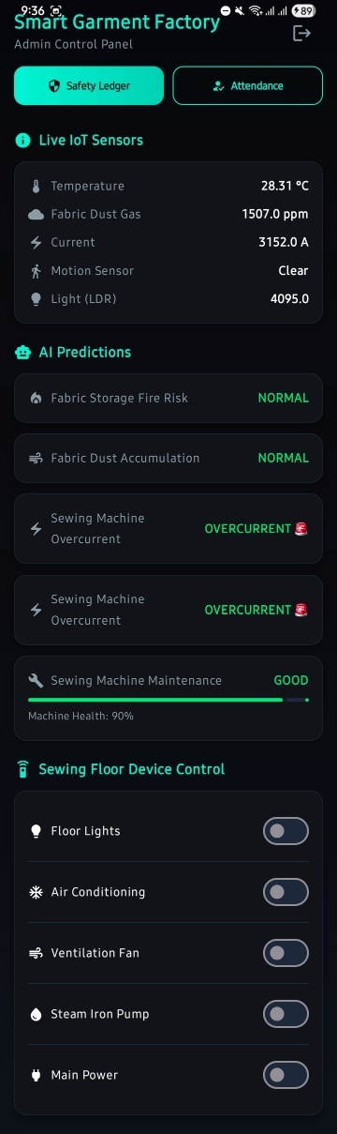

BEGIN
Fetch Live IoT Sensors Data
Fetch AI Predictions Status
Render Navigation Buttons (Safety Ledger, Attendance, PPE Check)
Render Live Data Cards
Render Device Control Toggles
END

Figure 4.6: Admin Dashboard

4.2.6.1 Attendance Blockchain Ledger Screen
Administrative view displaying a blockchain-backed ledger for worker attendance. Features a Live Entrance Camera Feed, Chain Integrity Status (VALID - NO TAMPERING DETECTED), and chronological blocks (Genesis Block).

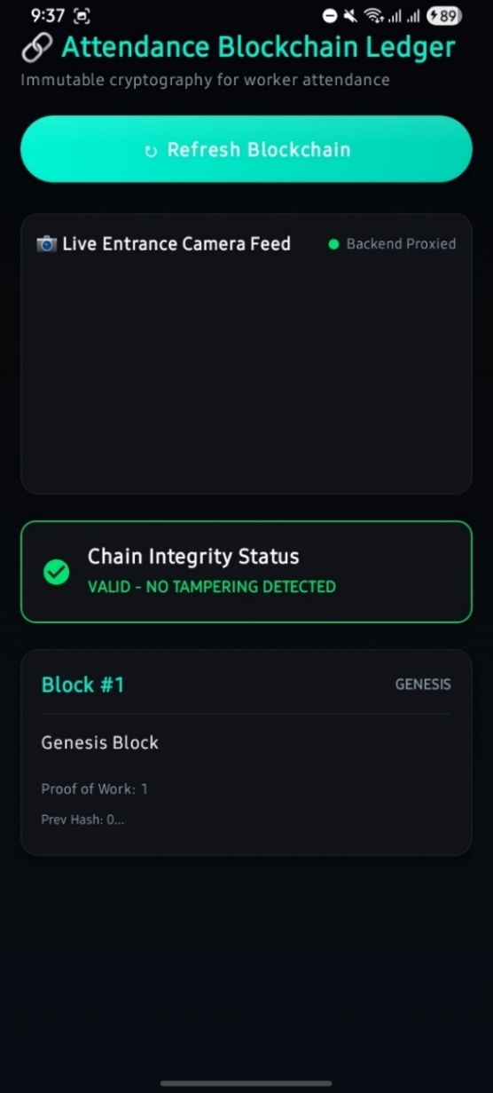

BEGIN
Render "Refresh Blockchain" Button
Render "Live Entrance Camera Feed"
Render "Chain Integrity Status"
Display Loading Spinner
Call Blockchain API to fetch attendance blocks
Hide Loading Spinner
Render ListView of Blocks
ON Refresh Click:
Reload Blocks & Verify Integrity
END

Figure 4.7: Attendance Blockchain Ledger

4.2.6.2 Blockchain Safety Ledger Screen
High-security auditing interface accessed via the "Safety Ledger". Presents immutable event logs anchored to a blockchain for critical safety reports.

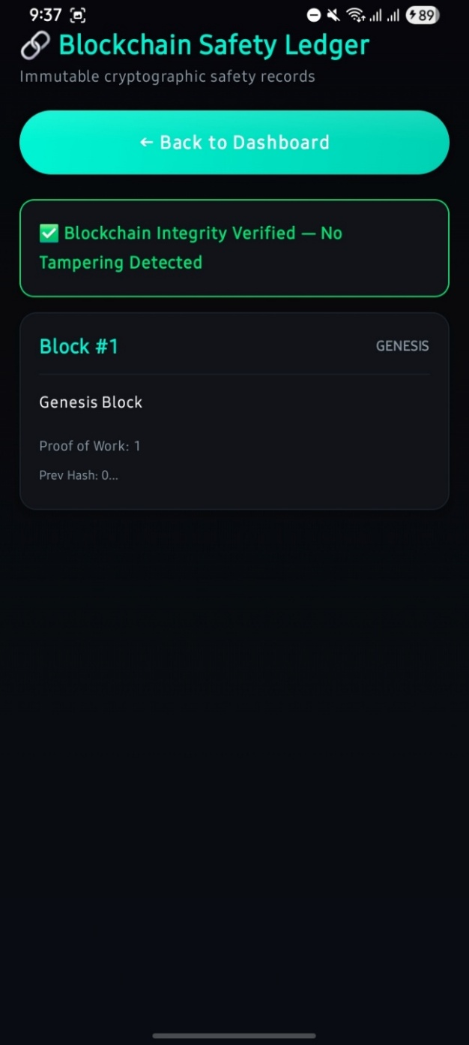

BEGIN
Render Screen Title ("Safety Ledger")
Display Loading Spinner
Call Blockchain API to fetch safety blocks
Hide Loading Spinner
Render ListView of Safety Event Blocks
END

Figure 4.8: Blockchain Safety Ledger

4.2.6.3 Emergency Report Alert in Admin Dashboard
Admin interface for viewing and managing emergency reports submitted by workers. Displays incident details, severity, and location.

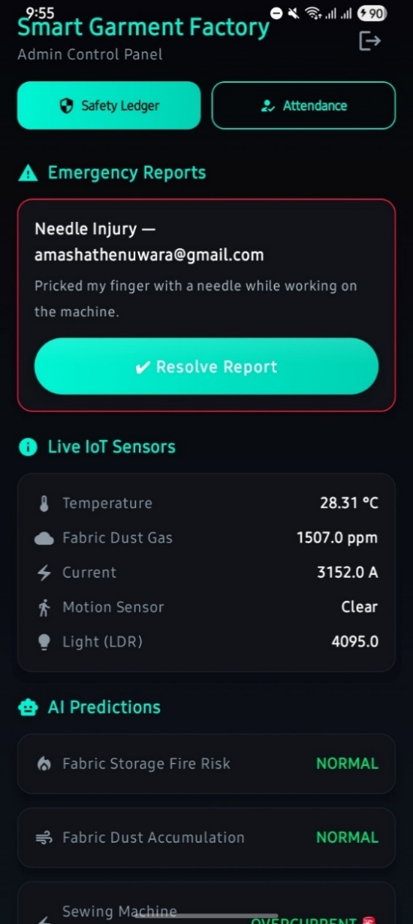

BEGIN
Fetch Active Emergency Reports
Render List of Reports with Severity Tags
ON Report Click:
Open Details and Action Modal
ON Modal Action "Resolve" Click:
Update Report Status to "Resolved"
Close Modal
Refresh Reports List
END

Figure 4.9: Emergency Report Alert (Admin view)

4.2.7 Worker Dashboard
Streamlined interface for factory workers prioritising actionable information such as daily tasks, real-time personal health metrics, machinery scanning, and emergency reporting.

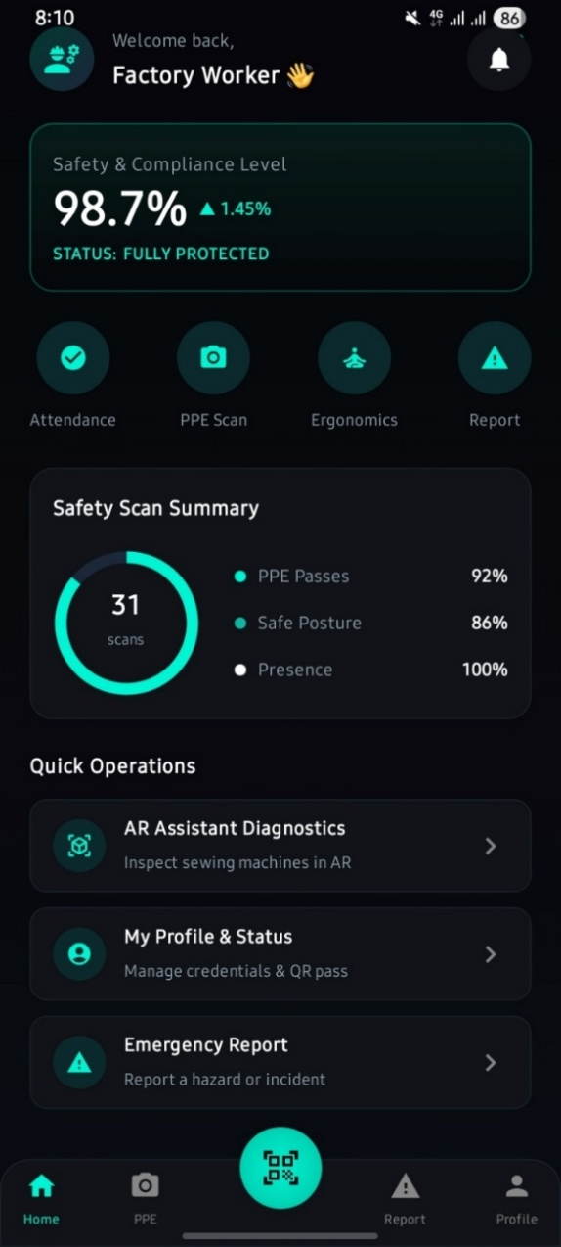

BEGIN
Fetch Worker Tasks
Render Health Widget Summary
Render "Scan Machinery (AR)" Button
Render Floating Action Button (FAB) for Emergency (SOS)
END

Figure 4.10: Worker Dashboard

4.2.7.1 Profile Screen
User management interface viewing account details, settings, and sign-out options.

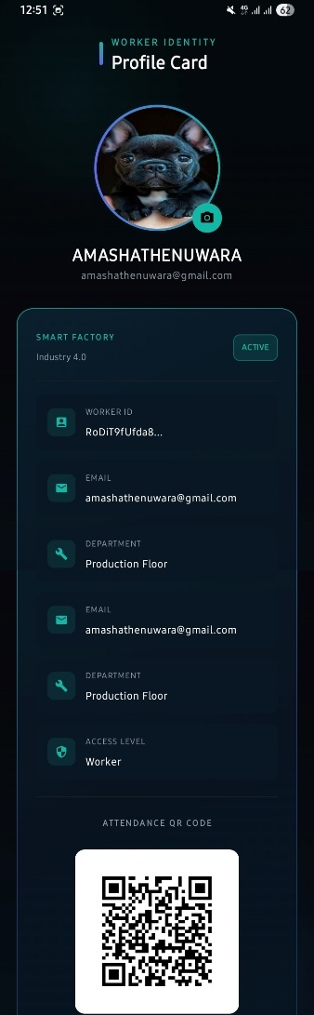

BEGIN
Fetch User Profile Data
Render Profile Details (Name, Email, Role)
Render "Logout" Button
ON Logout Click:
Clear Local Auth Tokens
Navigate to LandingPage
END

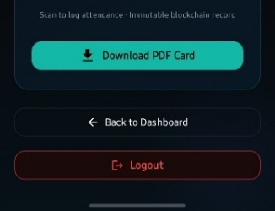

Figure 4.11: Profile Screen

4.2.7.2 AR Machine Details Screen
Augmented reality module overlaying digital instructions, maintenance markers, and safety warnings directly onto physical factory machinery.

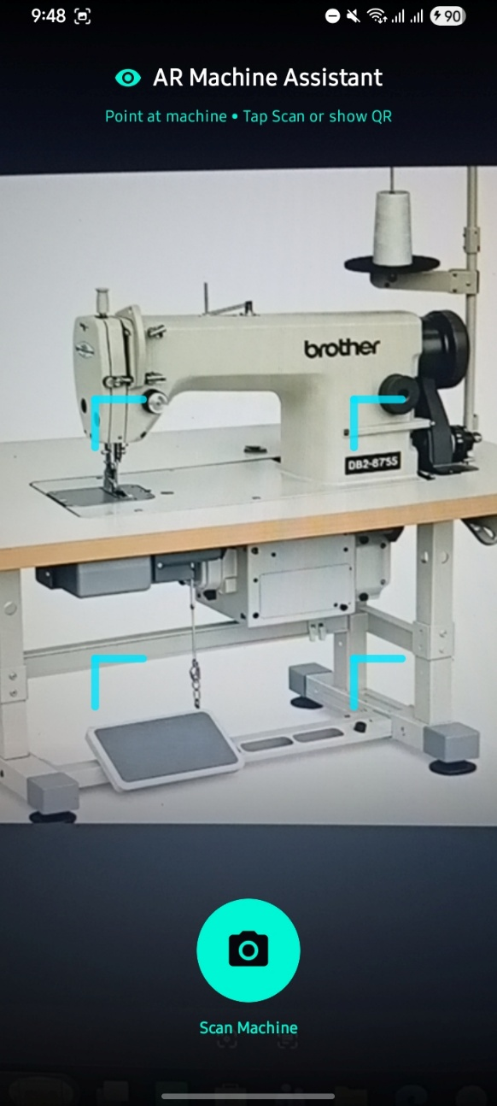

BEGIN
Request Camera Permissions
Start Camera Preview
Run Machine Recognition Model
IF Machine Recognized:
Fetch Machine Maintenance Data
Render AR Overlays at Anchor Points
ELSE:
Display "Searching for Machinery..." Overlay
END

Figure 4.12: AR Machine Details screen

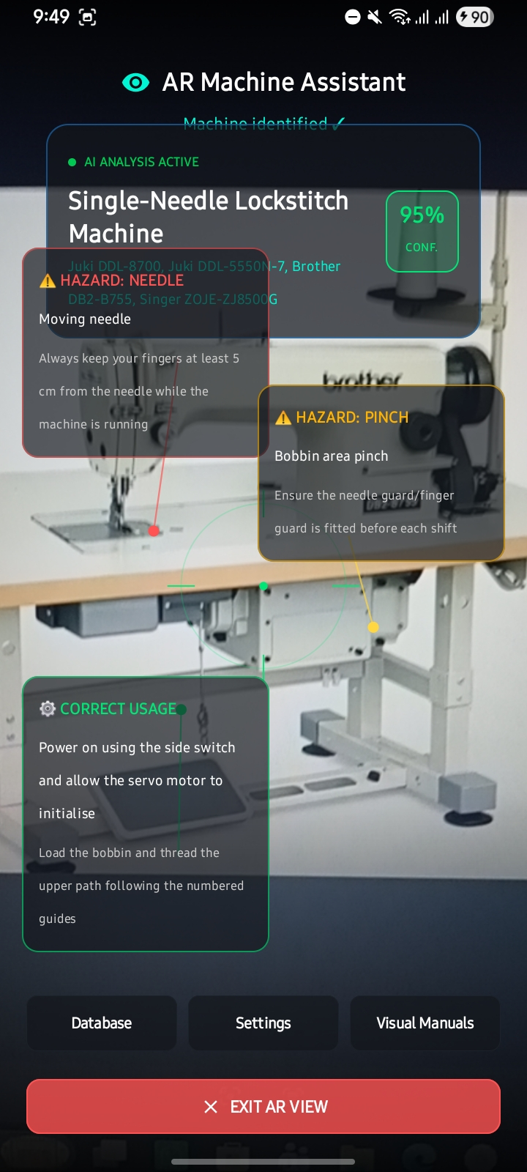
Figure 4.13: AR Overlay in use

4.2.7.3 Emergency Report
Highly accessible for rapid incident reporting by workers. Includes quick-select categories, description, and submit button.

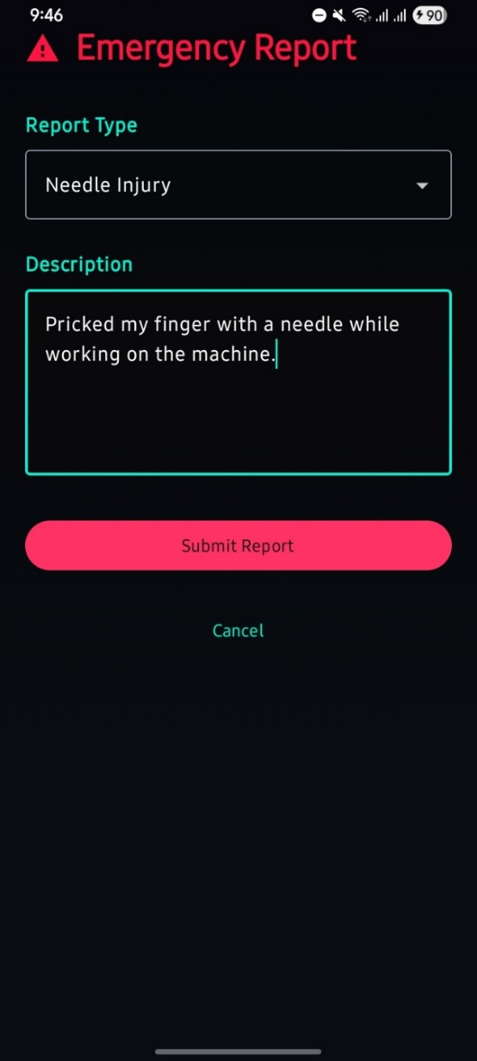
Figure 4.14: Emergency Report screen

BEGIN
Render Emergency Category Grid (Fire, Medical, Machine Failure, etc.)
Render Text Area for Optional Details
Render "SUBMIT ALERT" Button
ON Submit:
Display Loading Spinner
Call Emergency Report API (Include Worker ID & Location)
Hide Loading Spinner
IF Success:
Display Success Alert ("Alert Broadcasted")
Navigate to Worker Dashboard
ELSE:
Display Error Alert
END

4.2.7.4 PPE Detection [Entrance]
AI-powered computer vision screen analysing camera feed to detect mandatory PPE (face mask, gloves). Flashes green if detected, highlights in red if missing.

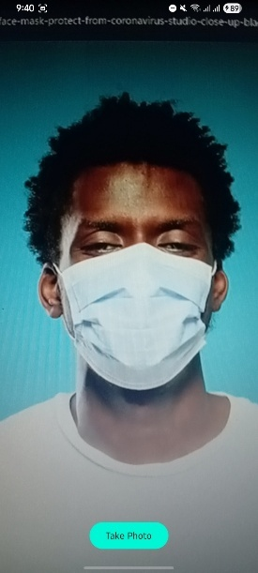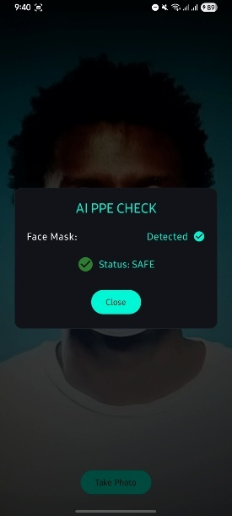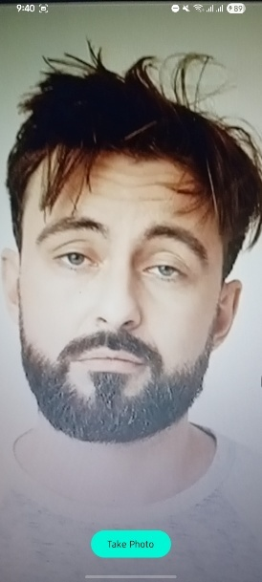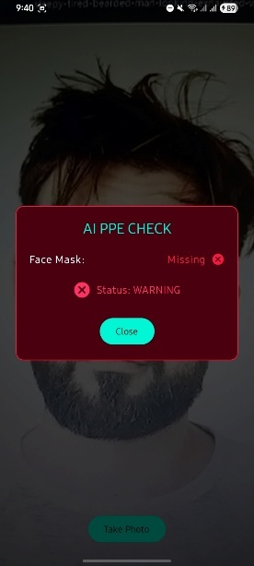
Figure 4.15: PPE Detection screens
BEGIN
Request Camera Permissions
Start Camera Preview
Run PPE Object Detection Model on Frame Stream
IF PPE Detected (Confidence > Threshold):
Display "Compliance Confirmed" Overlay (Green)
Log Event to Database
ELSE:
Display "Missing Equipment: [Item Name]" Overlay (Red)
Log Warning Event
END

4.2.7.5 WorkerHealthDetection Screen
Health monitoring dashboard visualising telemetry data from wearable devices (Heart Rate, Body Temperature) to monitor worker fatigue.

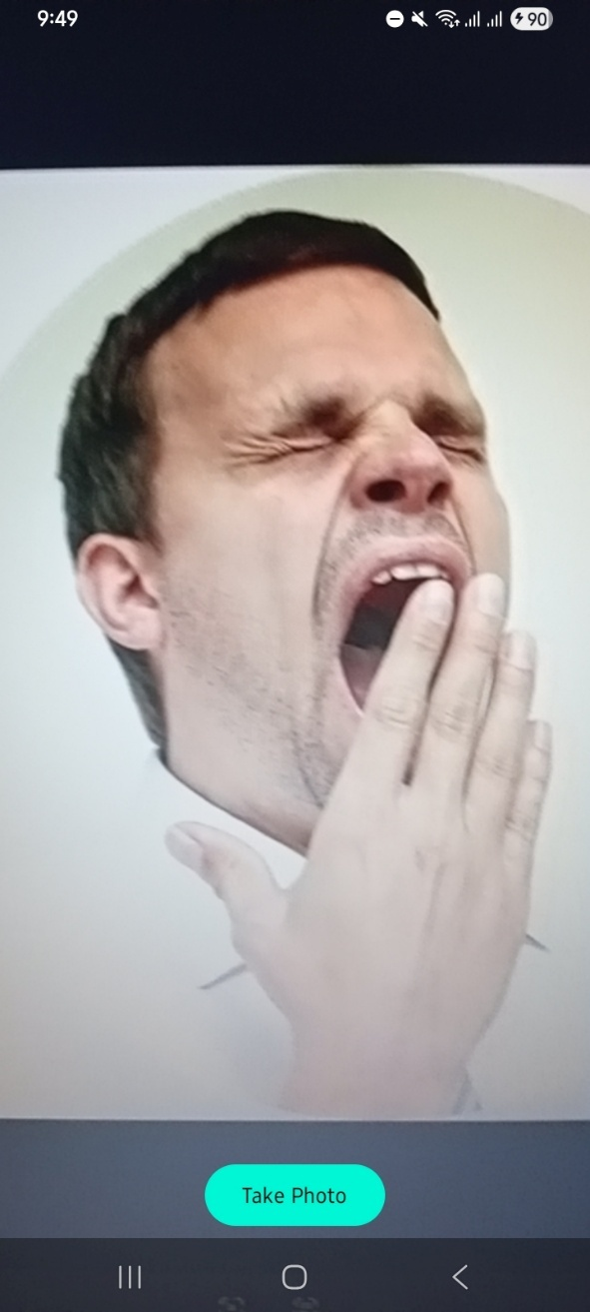

BEGIN
Subscribe to Health Data WebSocket/Stream
Render Real-time Line Charts (HR & Temp)
ON Data Update:
Update Charts
IF Data > Safety Threshold:
Render Warning Overlay ("High Heart Rate Detected. Please take a break.")
Trigger Local Notification
END

Figure 4.16: Worker Health Detection screen

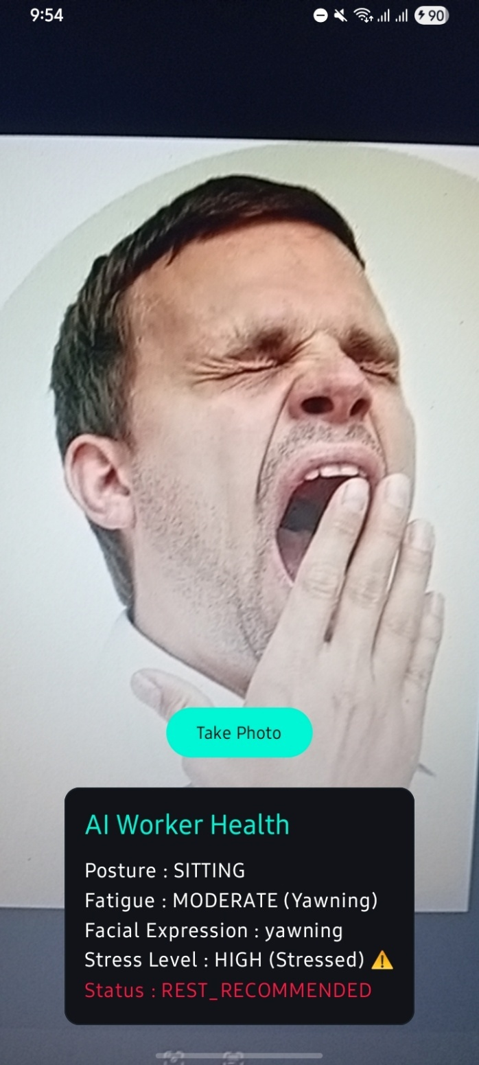
Figure 4.17: Health trend view

4.3 Database Schema & Architecture details
4.3.1 Overview
The TexyShield Smart Garment Factory system uses Firebase Realtime Database (RTDB) as its primary data store. Unlike a relational database, which organises records into fixed rows, columns and tables, or Firestore, which organises data into discrete collections and documents, the Realtime Database stores all application data as a single, large JSON tree. Every entity in the system attendance records, user profiles, sensor readings, emergency reports, health metrics, and PPE compliance logs exists as a nested node within this one tree, and the entire structure is synchronised across connected clients in real time.
This architecture was selected because the core requirement of the system is low-latency, bidirectional data streaming between factory-floor devices (IoT sensors, wearables, entrance cameras) and the mobile/web dashboards used by workers and administrators, rather than complex relational querying.

4.3.2 Justification for Realtime Database
Live synchronisation: Every client subscribed to a node receives updates within milliseconds of a change, which is essential for live machine telemetry, health monitoring and emergency alerts.
Offline-first behaviour: The Firebase SDK maintains a local, in-memory/disk cache on the device. If the factory floor loses connectivity, the app continues to read and write locally (for example, queuing an Attendance check-in or an Emergency Report) and automatically synchronises those queued writes with the cloud JSON tree once the connection is restored.
Simple, predictable structure: A single JSON tree keeps the data model easy to reason about for a system with a moderate number of well-defined entities, and avoids the overhead of managing multiple collections and composite indexes.
Low operational overhead: RTDB requires minimal server-side configuration, which suited the project timeline and team size.

4.3.3 Complete JSON Tree Structure
Below is the full hierarchical structure of the database. Each top-level key represents a root node; nested keys prefixed with "$" (such as $userId, $machineId, or $cameraId) represent dynamic identifiers rather than literal keys, and $pushId denotes a Firebase-generated unique record identifier.
{
"Attendance": {
"$userId": {
"$pushId": {
"date": "2026-07-14",
"status": "Present",
"time": "1784380977737",
"userId": "RoDiT9fUfda85jR6riPXaGS11M23"
}
}
},

"Users": {
"$userId": {
"fullName": "John Doe",
"email": "worker@factory.com",
"role": "Worker",
"isActive": true,
"createdAt": "1784380900000"
}
},

"SensorTelemetry": {
"$machineId": {
"$pushId": {
"sensorType": "Temperature",
"value": 45.5,
"aiRiskFlag": false,
"time": "1784380977737"
}
}
},

"EmergencyReports": {
"$pushId": {
"workerId": "RoDiT9fUfda85jR6riPXaGS11M23",
"category": "Machine Failure",
"description": "Sewing machine motor overheating",
"severity": "High",
"status": "Pending",
"time": "1784380977737"
}
},

"WorkerHealth": {
"$userId": {
"$pushId": {
"heartRate": 85,
"bodyTemp": 36.6,
"fatigueWarning": false,
"time": "1784380977737"
}
}
},

"PPELogs": {
"$cameraId": {
"$pushId": {
"workerId": "RoDiT9fUfda85jR6riPXaGS11M23",
"status": "Missing PPE",
"missingItems": "Hard Hat",
"time": "1784380977737"
}
}
}
}

4.3.4 Node Descriptions
The table below summarises the purpose and nesting strategy of each root node in the database. Nodes that are frequently queried per-entity (Attendance, SensorTelemetry, WorkerHealth, PPELogs) are grouped under the relevant identifier so the client can attach a listener to a single branch rather than the whole tree, which reduces bandwidth and improves read performance. EmergencyReports is deliberately kept flat so administrators can retrieve a single, factory-wide list of active cases.
Table 4.1: Firebase Realtime Database root node descriptions
Root Node | Nesting Structure | Description
Attendance | /Attendance/$userId/$pushId | Records daily worker attendance. Entries are grouped under each worker's unique userId, allowing the app to efficiently query a single employee's attendance history without scanning the entire node. A Firebase push ID is generated for every new check-in/check-out record.
Users | /Users/$userId | Stores employee profile information and links each Firebase Authentication UID (userId) to the corresponding factory role (Admin or Worker), full name, email, and account status.
SensorTelemetry | /SensorTelemetry/$machineId/$pushId | Captures real-time IoT sensor readings (e.g. temperature) from factory machinery. Data is grouped by machineId so dashboards can subscribe to live updates for a specific machine, and includes an AI-generated risk flag for anomaly detection.
EmergencyReports | /EmergencyReports/$pushId | Maintains a flat, ungrouped list of all emergency reports raised by workers. Because it is not nested by user, administrators can retrieve a single consolidated list of pending or active emergencies across the entire factory floor.
WorkerHealth | /WorkerHealth/$userId/$pushId | Logs live biometric data streamed from wearable devices, including heart rate, body temperature, and a fatigue-warning flag. Grouping by userId enables continuous, per-worker health monitoring.
PPELogs | /PPELogs/$cameraId/$pushId | Stores Personal Protective Equipment (PPE) compliance results generated by AI-powered entrance cameras. Records are grouped by cameraId to trace detections back to a specific monitoring location.

4.3.5 Key Design Considerations
4.3.5.1 Data Grouping and Query Efficiency
Nodes that require per-entity history (Attendance, SensorTelemetry, WorkerHealth, PPELogs) are indexed first by the relevant identifier (userId, machineId, or cameraId) and then by a push ID for each event. This two-level nesting allows the application to attach a Firebase listener directly to a specific worker's or machine's branch, avoiding the cost of filtering the entire dataset on the client.
4.3.5.2 Offline Synchronisation
Firebase Realtime Database's built-in disk persistence allows the mobile application to remain functional without network access. Writes made offline, such as an attendance check-in or a newly filed emergency report, are held in a local write-ahead queue and automatically replayed against the cloud database as soon as connectivity resumes, ensuring no data loss on the factory floor.
4.3.5.3 Timestamps
All time-based fields (time, createdAt) are stored as Unix epoch millisecond strings rather than formatted date strings. This keeps values sortable and timezone-independent, and allows the client to format them for display according to the user's locale.
4.3.5.4 Security Rules
Access to each root node is restricted through Firebase Security Rules based on the authenticated user's UID and role (Admin or Worker), so that a worker can only read/write their own Attendance, WorkerHealth and EmergencyReports entries, while Admin accounts are granted read access across all nodes for monitoring and reporting.

4.4 Artificial Intelligence Model Training & Methodology
The TexyShield system utilises a dedicated Python FastAPI backend (ai-service/) to process sensor data and run advanced machine learning models. The system relies on two primary classes of machine learning: Deep Learning (Computer Vision) and Ensemble Learning (Sensor Telemetry).
4.4.1 Frameworks and Training Process
The computer vision models were trained using the Ultralytics YOLO framework, specifically leveraging YOLOv8 and YOLO11 architectures for object detection and image classification. Custom datasets were curated and annotated, including images of workers with and without masks, various sewing machines, and faces exhibiting signs of fatigue. The models were trained using PyTorch on GPUs. The resulting PyTorch weight files (.pt) are dynamically loaded by the FastAPI server to run real-time inferences on incoming video streams from the factory floor.
4.4.2 Safety & PPE Detection Models
Purpose: To detect if workers are wearing required face masks or gloves.
Methodology: The system uses YOLOv8, a state-of-the-art Convolutional Neural Network (CNN). Unlike older two-stage models, YOLO passes the entire image through a single neural network, predicting bounding boxes and class probabilities simultaneously. This single-pass architecture allows it to run at extremely high frame rates, which is critical for processing live CCTV streams where instantaneous alerts are required to prevent accidents.
4.4.3 Worker Health & Ergonomics Models
Purpose: To analyse facial expressions for fatigue and stress, and to detect if a worker has collapsed (fall detection).
Methodology: This module utilises YOLO Image Classification and YOLO-Pose (Pose Estimation). A specialised YOLO-Classification head was trained on facial micro-expressions to categorise the worker’s state (e.g., Alert, Fatigued, Stressed). For fall detection, YOLO-Pose extracts human skeletal keypoints (joints, spine) and tracks their coordinates in real-time. Sudden, drastic changes in the vertical alignment of the spine trigger an immediate fall alert. This approach provides sub-millisecond inference times, allowing the system to track multiple workers on the floor simultaneously.
4.4.4 Machine Identification Models
Purpose: To identify the specific type of sewing machine from a camera feed and load the correct Augmented Reality (AR) overlays for mechanics.
Methodology: A YOLOv8 Classification Model was trained using transfer learning on thousands of augmented images of different sewing machines. Those images were obtained from Marsylka Manufacturing Lanka (Pvt) Ltd garment factory[client]. This deep CNN abstracts robust structural features, allowing the AR camera to instantly recognise the machine type regardless of the highly variable lighting and occlusions typical in a factory environment.

Chapter 5: Conclusion
Built using Marsylka Manufacturing Lanka (Pvt) Ltd, a 750-employee, 14-line ladies' wear manufacturer as the case study, the TexyShield system replaced the factory's reactive maintenance and fragmented manual safety practices with unified real-time IoT sensing, AI risk prediction, QR attendance, blockchain records, and a mobile app for workers and admins.
All core objectives were met: real-time monitoring, automated hazard response, contactless attendance, centralised visibility, digital fault reporting, and worker wellbeing support.
As an academic project based on a single case study, the AI models need more data to generalise, and the blockchain/AR modules remain in their early stages. Future work includes expanding training data, integrating existing CCTV, and piloting on a few lines before a full rollout.
Overall, the system strengthens rather than replaces Marsylka's existing safety policies, offering a scalable path to safer ladies' wear manufacturing.

References

Espressif Systems, 2026. ESP32 Series Datasheet. [online] Available at: https://www.espressif.com/en/products/socs/esp32 [Accessed 10 August 2026].
Figma, 2026. Figma: The Collaborative Interface Design Tool. [online] Available at: https://www.figma.com [Accessed 10 August 2026].
Google, 2026. Android Developers: Jetpack Compose. [online] Available at: https://developer.android.com/jetpack/compose [Accessed 10 August 2026].
Google, 2026. Firebase Realtime Database Documentation. [online] Available at: https://firebase.google.com/docs/database [Accessed 10 August 2026].
Jocher, G., Chaurasia, A. and Qiu, J., 2023. YOLO by Ultralytics. [online] Available at: https://github.com/ultralytics/ultralytics [Accessed 10 August 2026].
Kaggle, 2026. Kaggle Datasets for Machine Learning and Data Science. [online] Available at: https://www.kaggle.com/datasets [Accessed 10 August 2026].
Kotlin Foundation, 2026. Kotlin Programming Language. [online] Available at: https://kotlinlang.org/docs/home.html [Accessed 10 August 2026].
Pedregosa, F. et al., 2011. Scikit-learn: Machine Learning in Python. Journal of Machine Learning Research, 12, pp.2825-2830.
Ramírez, S., 2026. FastAPI Documentation. [online] Available at: https://fastapi.tiangolo.com [Accessed 10 August 2026].

Appendices
Approval Letter from Organization
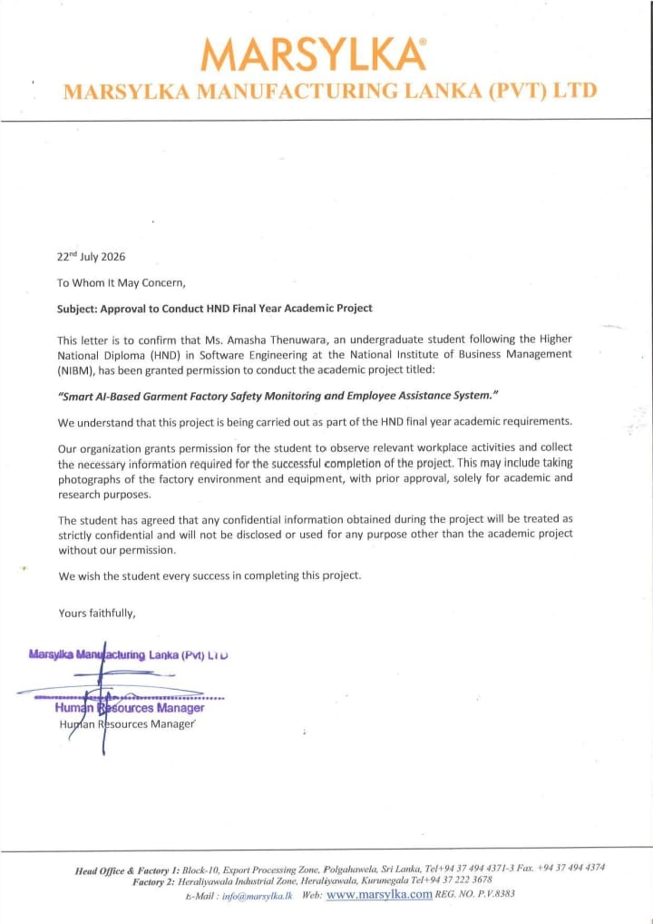
Figure 5.1: Approval Letter from Marsylka Manufacturing Lanka (Pvt) Ltd
Questioners and Interview Questions
As part of the data-gathering process for the HND Final Year Project titled “Smart AI-Based Garment Factory Safety Monitoring and Employee Assistance System,” a structured questionnaire was distributed to an industry representative to collect first-hand information on factory operations, machine management, workplace safety practices, and the perceived value of an AI-driven monitoring solution. The survey was completed by Mrs R.P.A.P. Jayarathne, Dedicated Quality Assurance Officer at Marsylka Manufacturing Lanka (Pvt) Ltd, a garment manufacturing facility located in the Export Processing Zone, Polgahawela. The responses summarised below provide the real-world context and requirements that informed the design of the system, including its safety monitoring, PPE detection, and emergency reporting features.
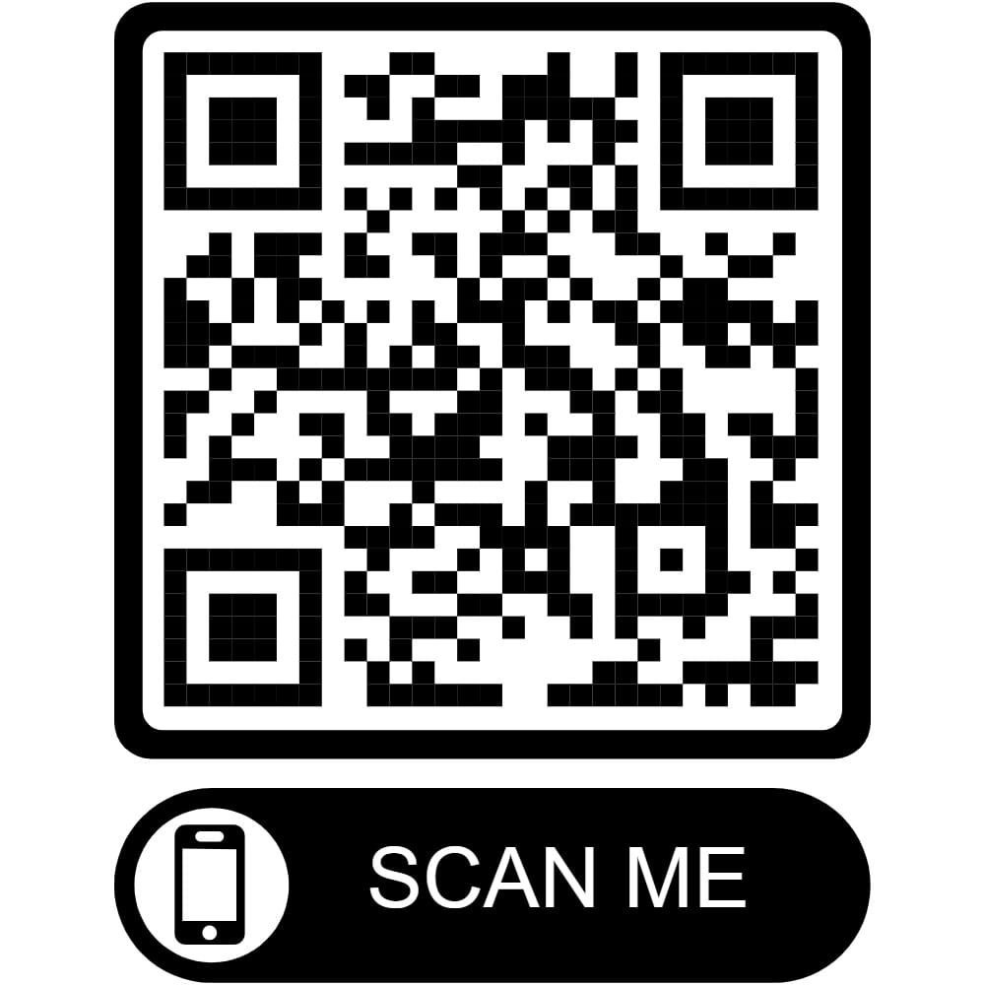
Figure 5.2: Survey QR code
Scan to view the original Google Form
Survey Response Summary
Table 5.1: Survey Response Summary
Respondent's Name | R.P.A.P. Jayarathne
Position | Dedicated Quality Assurance
Factory Name | Marsylka Manufacturing Lanka (Pvt) Ltd
Factory Location | Export Processing Zone, Polgahawela
Types of Garments Manufactured | Ladies Wears
Approximate Number of Employees | 750
Number of Production Lines | 14
Types of Sewing Machines Used | Lockstitch, Overlock, Flatlock, Buttonhole, Button Sewing, Bartack, Zigzag
Approx. Number of Sewing Machines in Operation | 550
Machine Maintenance Frequency | Weekly
Common Sewing Machine Problems | Thread Breakage, Needle Breakage, Fabric Jamming, Motor Failure, Machine Overheating, Noise/Vibration, Electrical Problems
How Faults Are Reported | Inform Supervisor, Maintenance Team
Do Breakdowns Affect Daily Production? | Yes
Workplace Safety Policy in Place? | Yes
Required PPE for Workers | Face Mask, Gloves
Regular Safety Training Conducted? | Yes
Common Safety Risks | Fire risk, health risk
Emergency Management Approach | Following fire procedures and compliance requirements of buyers, maintaining smoke areas, and providing fire training to employees.
Digital Safety Monitoring System in Use? | No
Technologies Currently Used | CCTV Cameras, Smoke Sensors, Fire Alarm System
Challenges in Monitoring Worker Safety | Difficult to maintain 100% compliance procedures while achieving maximum production efficiency, which directly affects safety.
AI-Based Safety Monitoring System Beneficial? | Yes
Would Real-Time Safety Alerts Be Useful? | Yes
Would a Mobile App for Supervisors/Managers Be Useful? | Yes
Suggestions for Improving Workplace Safety | Need to improve machine and floor safety, fire and chemical safety, ergonomics, and health.
Permission to Use Factory as Case Study? | Yes
Permission to Take Photographs for Academic Use? | Yes
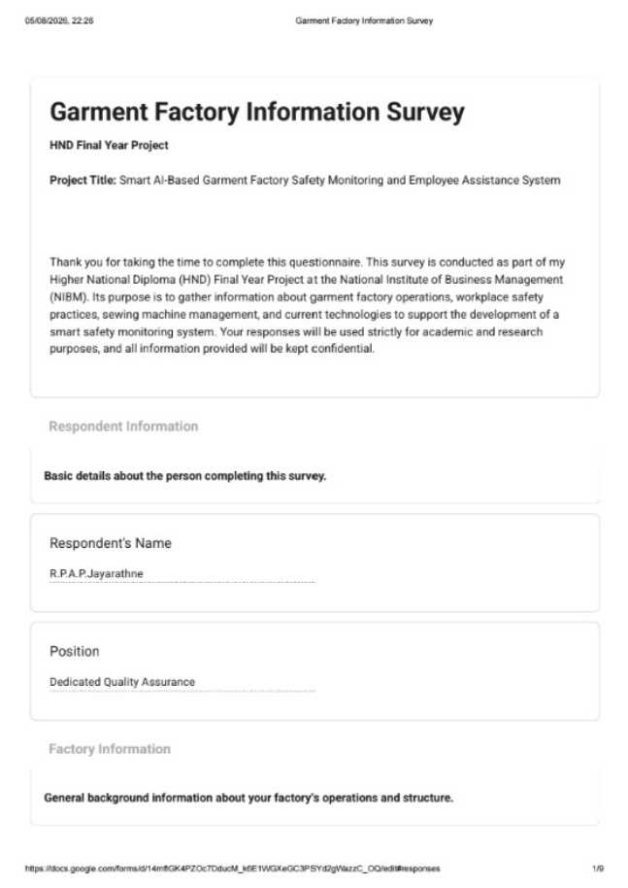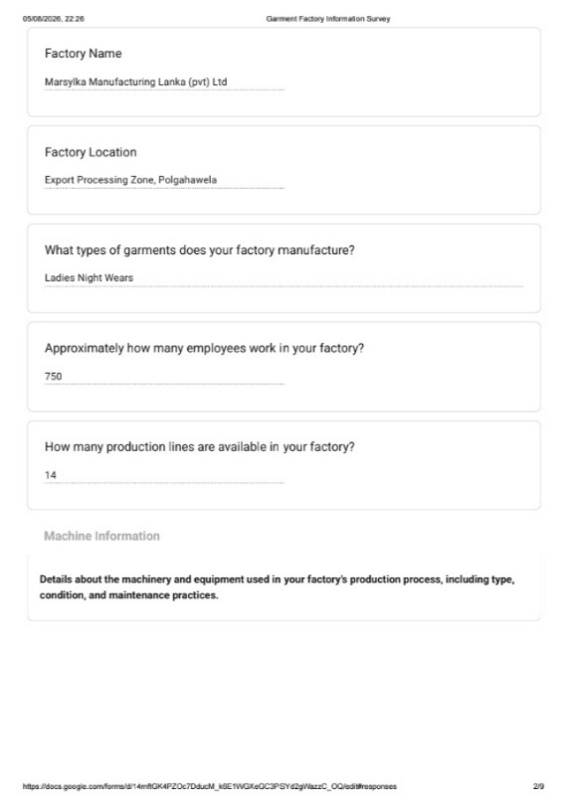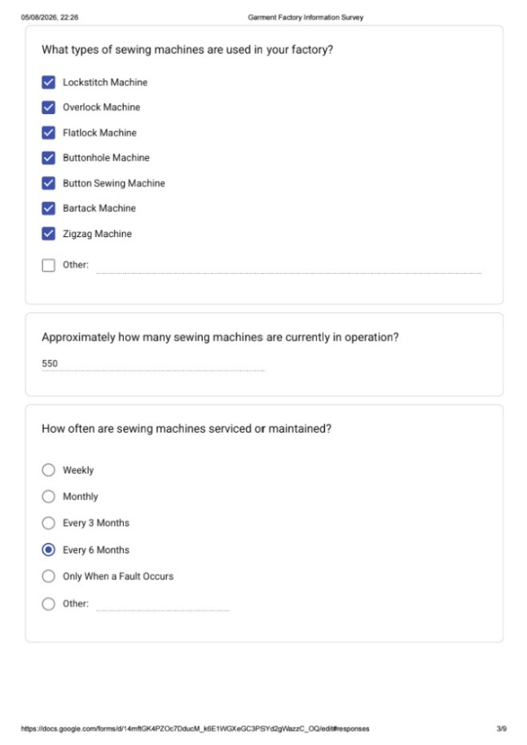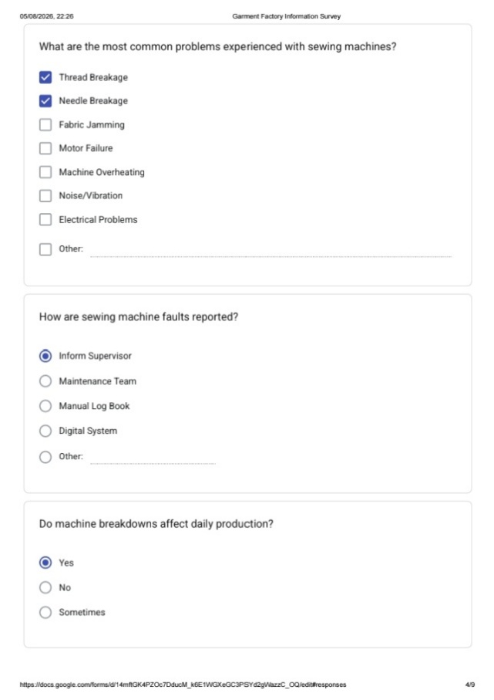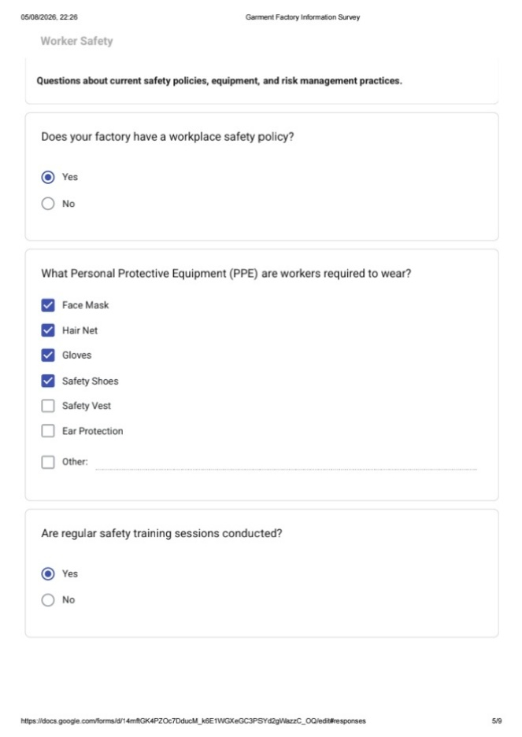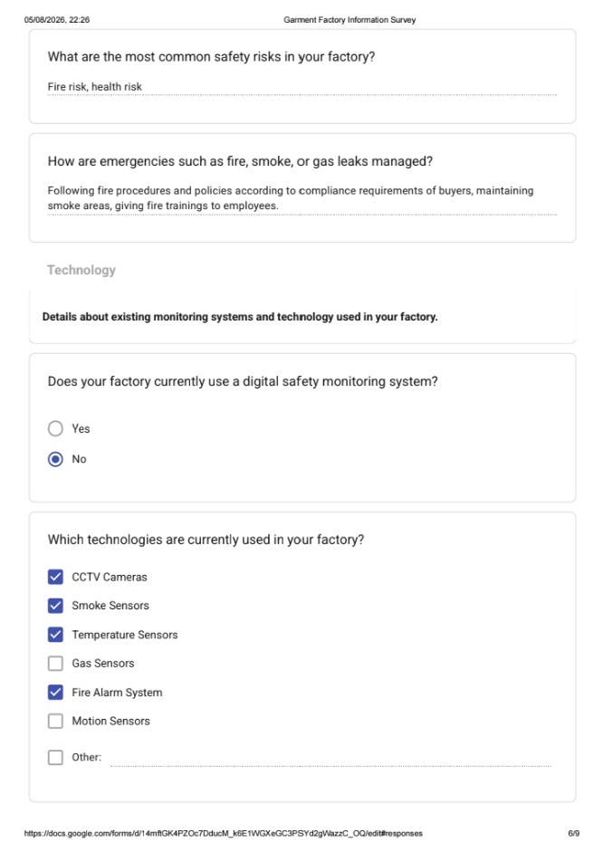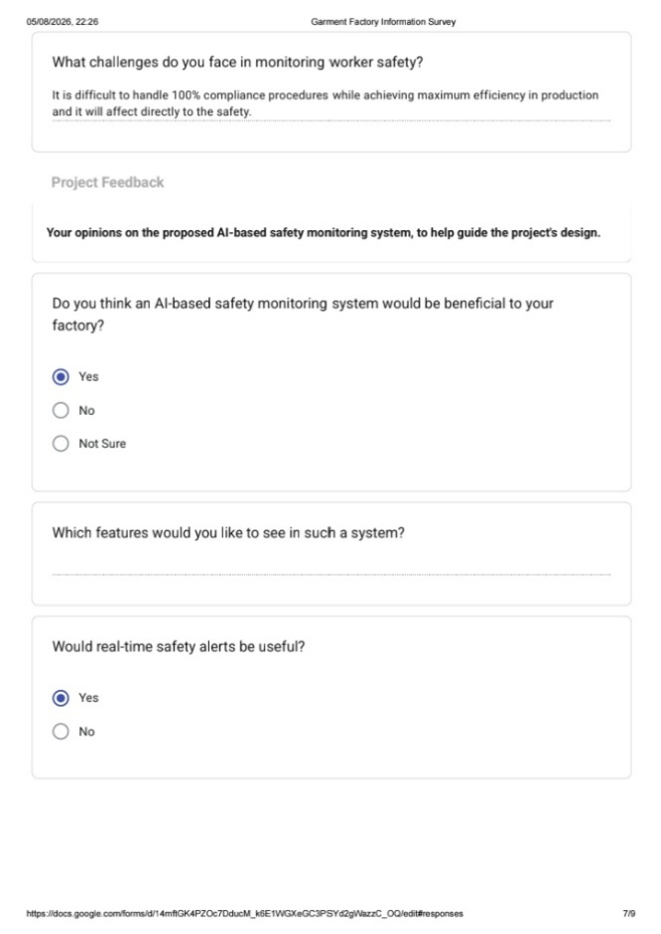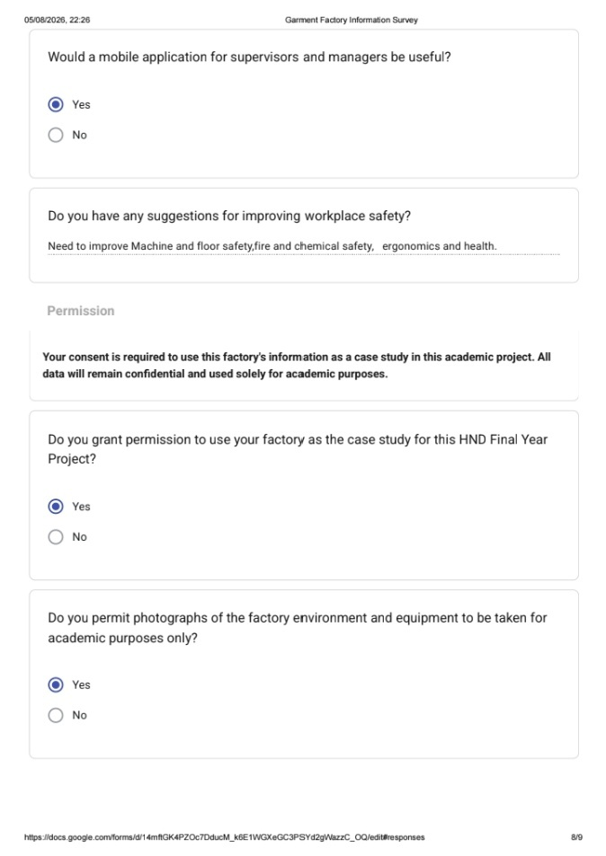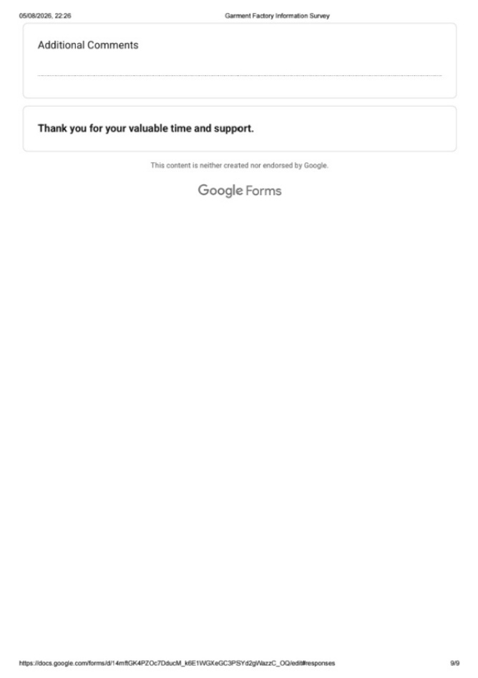
Figure 5.3: Survey response screenshots

Git Hub Link
https://github.com/AmashaThenuwara/Industry_4.0_SmartFactorySafety-MonitoringSystem.git

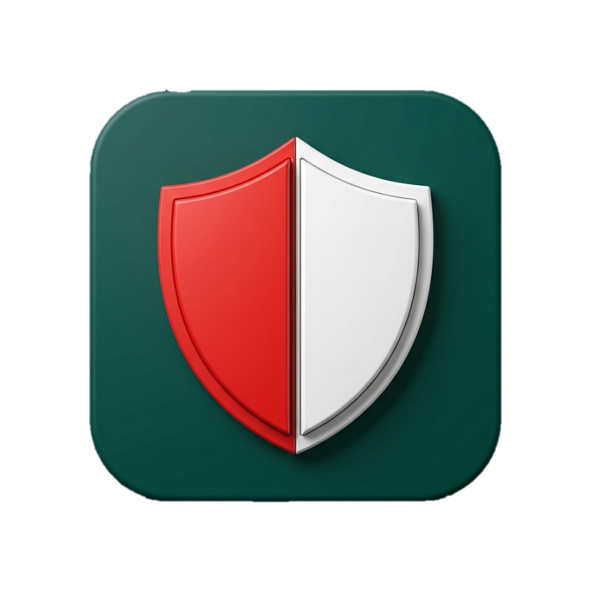
TexyShield
Industry 4.0 Smart Garment Factory Safety & Monitoring System

USER MANUAL
Welcome to TexyShield
Welcome to TexyShield, your intelligent assistant for maintaining a safe and efficient factory environment. This guide will help you navigate the system’s features, whether you are managing the factory floor or operating machinery.
Getting Started
When you open the application, you will be greeted by a welcome screen.
- Existing Users: Tap Login and enter your registered email and password to access your dashboard.
- New Users: Tap Register to create your account. You will need to provide your full name, email, a secure password, and select your designated role (Worker or Administrator).
Administrator Guide
If you are logged in as an Administrator, your dashboard serves as a central command hub for monitoring factory health and safety.
- Factory Overview & Controls: Your dashboard displays summary cards giving you an instant glance at the factory's operational health. You can also monitor and toggle sewing floor device controls directly from this screen.
- Attendance & Security: Tap Attendance to monitor the live camera feed at the factory entrance and view secure, blockchain-verified attendance records. Tap "Refresh" to fetch the latest data.
- Safety Ledger: Access the Safety Ledger to review a highly secure, immutable list of past safety events and their verification statuses.
- Emergency Response: If an incident occurs, you will receive emergency alerts in your notifications. Open the alert to review the details, dispatch necessary assistance, and mark the situation as "Resolved" once it has been handled.
- PPE Verification: Open the PPE Check module to monitor the automated safety equipment checks happening at the factory entrances.

Factory Worker Guide
If you are logged in as a Worker, your dashboard is streamlined to focus on your daily tasks, equipment maintenance, and personal safety.
- Daily Tasks & Profile: Check your dashboard for today's assignments. You can tap the Profile icon in the top navigation bar at any time to review your personal details or securely log out.
- Health Monitoring: Tap the Health Widget to view interactive graphs of your heart rate and body temperature over time. Pay close attention to this screen - if any limits are exceeded, the system will display colour-coded warnings advising you to take action.
- Augmented Reality (AR) Maintenance: To perform a maintenance check on your equipment, tap Scan Machinery (AR). Point your device’s camera at the machinery and follow the holographic text and arrows that appear on your screen for guided assistance.
- Emergency Reporting (SOS): In the event of an accident or hazard, tap the red SOS button on your dashboard. Select the type of emergency, type in any optional details, and tap Submit Alert to instantly notify the administration team.
Automated PPE Clearance
When entering the factory floor, an automated kiosk handles your safety clearance.
- Stand clearly in front of the entrance camera.
- The system will automatically scan you for required Personal Protective Equipment (PPE), such as masks and gloves.
- If your equipment is worn correctly, you will be granted clearance. If anything is missing, the system will display a warning telling you exactly which equipment you need to put on.

Daily Log Sheet

Table 5.2: Daily Log Sheet
Week/Date | Activities Completed | Lecturer’s Comments | Lecturer’s Signature
Proposal Presentation  (27th of May - 2026) | Finalized the project idea, identified its key features, and selected four emerging technologies for implementation | Add more features: stress, burnout detector,  predictive maintenance - machine failure alerts
1st progress  (23rd/24th of June - 2026) | We completed the hardware component by integrating IoT sensors (gas, light, current, motion, and temperature) connected to an ESP32 microcontroller to monitor real-time factory conditions and detect fire risk and machine overcurrent.  We configured the system to automatically control devices such as lights, air conditioning, exhaust fans, water pumps, and the main power supply in response to hazardous situations like fire, gas leaks, and electrical overloads.  We also integrated Artificial Intelligence to predict fire risks, detect gas anomalies, and identify overcurrent conditions. | Hardware 50% complete; the next step is to integrate and verify the  machine and human change prediction features using the mobile app. Do more research related to factory environments"
2nd Progress  (16th of July - 2026) | Started development of the Kotlin mobile application and successfully implemented user authentication.  Built separate Admin and Worker side interfaces.  Integrated Firebase for real-time data storage; hardware sensor readings and risk predictions are displayed on the admin page via Firebase.  Structured the Worker-side layout and profile page.  Designed a consistent UI/UX theme across the application. | Hardware is 50% complete, and the AR feature for machine details has  been implemented. Camera-based human detection has not yet started.
Final Progress  [Viva / Presentation]  (30th of July - 2026) | Completed the hardware integration by adding the ESP32-CAM module to capture worker QR code details, with entries verified and recorded on the admin side through a blockchain-based process, including a live camera feed for real-time monitoring.  Completed AI training with image pre-processing for PPE (mask) detection and worker health detection.  Implemented machine maintenance detection using AR technology to display machine details and user manuals through the app.  Integrated an interactive, responsive, and polished UI/UX, including a landing page.  Finalized the application name.  Completed the mobile application and hardware components.  Secured a client to partner with us on the project. | Overall, the project is good -  the hardware, AR machine details,  and stress detection all work well

