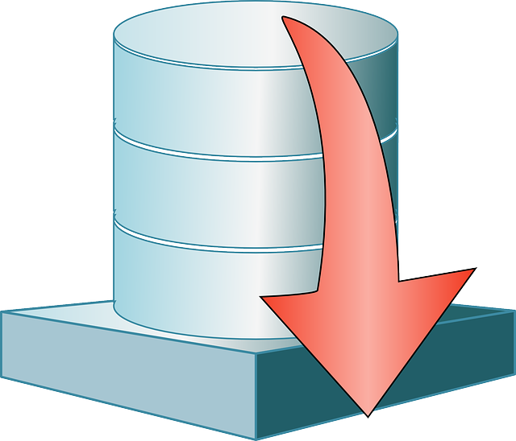

Jason Jensen and Ibra Cisse  CS 4318  January 30, 2016

Database project for CS 4318

# Team Members:

Ibra Cisse

Jason Jensen

Project Name: recommendation of Medication

Table of Content

1. Abstract………………………………………………………………………….3
2. Description………………………………………………………………………4
3. Database design…………………………………………………………………5
4. Database modeling……………………………………………………………..6

Abstract

Going to the drug store could be a hassle depending on the sickness or illness one possesses. Even knowing the illness that you are carry, choosing a medicine for your body could be a very difficult due to abnormal recommendation and many different drugs to choose from. This project will help many people by providing the best medicine known to work for a specific illness. These term are based on recommendation from surveys that people write. From the review, we ranked items based on most approval and deemed to be the best medicine to take for illness. The following illnesses which are common to our daily lives would be included in the database system: Headache, toothache, stomached, allergies, relaxation, detoxing, juicing for health benefits.