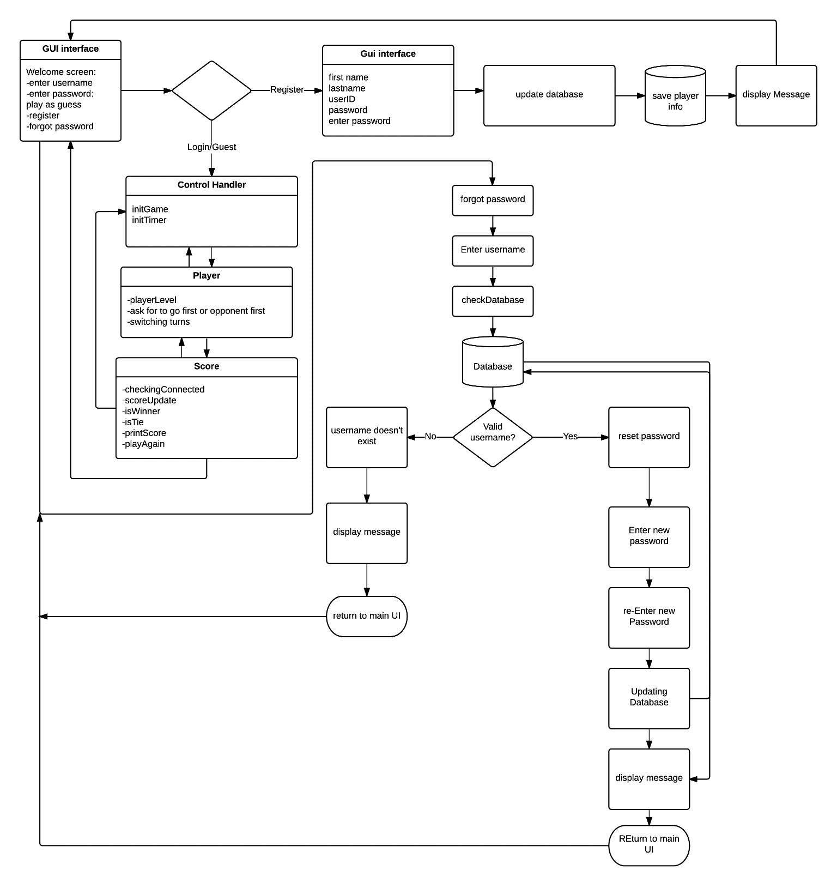

Product Specifications

Table of Contents:
Modification History 3
Major Milestones 4
Abstract 5
Document References 6
Glossary 7
Class Diagram 8
Use Case Sequence Diagram 9
Use case 1 9
General Description 9
Sequence Diagram 9
Use case 2 9
General Description 9
Sequence Diagram 9
Use case 3 9
General Description 9
Sequence Diagram 9
Use case 4 9
General Description 9
Sequence Diagram 9
Use case 5 10
General Description 10
Sequence Diagram 10
Use case 6 10
General Description 10
Sequence Diagram 10
Use case 7 10
General Description 10
Sequence Diagram 10
Use case 8 10
General Description 10
Sequence Diagram 11
Use case 9 11
General Description 11
Sequence Diagram 11
Use case 10 11
General Description 11
Sequence Diagram 11
Use case 11 11
General Description 11
Sequence Diagram 11
Use case 12 11
General Description 11
Sequence Diagram 12
Use case 13 12
General Description 12
Sequence Diagram 12
Use case 14 12
General Description 12
Sequence Diagram 12
User Interface 13
Others 14

Modification History

2/26/2016 - Use Case Diagram modified to accommodate guest user specifications and history record.

2/26/2016 – Edited for consistency and clarity

Major Milestones

Date | Milestone

Abstract
Tic-Tac-Toe is a two-player game, played on a 3x3 grid, where the winner is the first player to connect three in a row. Despite its simplicity, it is a good exercise for improve reasoning skills. Due to this, it is considered a good game for children to help them improve their acumen. The game was originally played on paper, and was one of the first games played on a computer. The purpose of this project is to develop a new version of the game utilizing a 6x6 grid and in which the winner is the player with the most 4 in a row squares once the entire board is filled.

Document References
Document | Location
Requirements | GitHub
Software Management Plan | GitHub
Specifications | GitHub
Minutes and Time Log | GitHub

Glossary

Term | Definition
Graphical User Interface | A graphical user interface is a human-computer interface (i.e., a way for humans to interact with computers) that uses windows, icons and menus and which can be manipulated by a mouse (and often to a limited extent by a keyboard as well).
6x6x4 grid | A grid with 6 boxes on each side (6x6), consisting of 36 total units. The winner is the player with the most 4 stones(x4) in a horizontal, vertical, or diagonal row.
Tic tac toe | A game for two players who take turns marking the spaces in a grid. The player who succeeds in placing three respective marks in a horizontal, vertical, or diagonal row wins the game.
Single Player | A single-player video game is a video game where input from only one player is expected throughout the course of the gaming session. "Single-player game" usually refers to a game that can only be played by one person, while "single-player mode" usually refers to a particular game mode that is designed to be played by a single player, though the game also contains modes that can be played by several players simultaneously.
Multi-player | A multi-player video game is a video game in which more than one person can play in the same game environment at the same time. Computer and video games are often single-player activities that put the player against pre-programmed challenges and/or AI-controlled opponents, which often lack the flexibility and ingenuity of regular human thinking.
User | A user is an agent, either a human agent (end-user) or software agent, who uses a computer or network service. A user often has a user account and is identified by a username (also user name). Other terms for username include login name, screen name (also screenname), nickname, or handle
Password | A password is a secret word or string of characters that is used for user authentication to prove identity, or for access approval to gain access to a resource.

Acronym | Meaning
GUI | Graphical User Interface
AI | Artificial Intelligence

Class Diagram

Use Case Sequence Diagram

Use case 1

General Description
Register – Register a new user

Sequence Diagram

Use case 2

General Description
Login – Log in as existing user

Sequence Diagram

Use case 3

General Description
Play as guest – Play a game without logging in. Does not track statistics.

Sequence Diagram

Use case 4

General Description
Forgot password – Option to reset password.

Sequence Diagram

Use case 5

General Description
View Statistics – View Wins/Loss record.

Sequence Diagram

Use case 6

General Description
Clear history – Clear wins/Loss. Displays mocking notification of your abject failure.

Sequence Diagram

Use case 7

General Description
Select game mode – Choose between PvP or PvA.

Sequence Diagram

Use case 8

General Description
Select difficulty – Choose difficulty of AI: Easy, Medium, Hard.

Sequence Diagram

Use case 9

General Description
Select color – Choose colors for stones used.

Sequence Diagram

Use case 10

General Description
Select first player – Decide who will go first.

Sequence Diagram

Use case 11

General Description
Move – Make a move.

Sequence Diagram

Use case 12

General Description
Replay – Start a new game once a game ends.

Sequence Diagram

Use case 13

General Description
Logout – Log user out so another user can log in or to play as guest.

Sequence Diagram

Use case 14

General Description
Quit – Exit out of application.

Sequence Diagram

User Interface

Others

