# Product Specifications

* Product is to be designed in a 6x6x4 grid
* Implementation of the product is to be done with an appropriate GUI
* Product must support two players; user against computer or user against another user
* The game will end when either user or computer have 4 stones in a row
* User can play as a guest or with a registered username
* Product must keep track of each players history and display upon users request
* Product must support game difficulty

**Table of Contents:**

# Modification History.................................................................................................................... 3

# Major Milestones.......................................................................................................................... 4

# Abstract........................................................................................................................................... 5

# Document References.................................................................................................................. 6

# Glossary...........................................................................................................................................7

# Class Diagram................................................................................................................................ 8

# Use Case Sequence Diagram....................................................................................................... 9

# Use case 1....................................................................................................................................... 9

# General Description..........................................................................................................…........9

# Sequence Diagram....................................................................................................................... 9

# Use case 2...................................................................................................................................... 9

# General Description..................................................................................................................... 9

# Sequence Diagram....................................................................................................................... 9

# User Interface.............................................................................................................................. 10

# Others........................................................................................................................................... 11

# 

# Modification History

2/26/2016 -Use Case Diagram modified to accommodate guest user specifications and history record

# Major Milestones

|  |  |
| --- | --- |
| Date | Milestone |
| 2/28/2016 | Completion of Product Design and Specifications. |
| 3/18/2016 | Start of implementation for the GUI |
| 3/05/2016 | First version of the User Interface completed |
| 3/24/2016 | First version of the gameplay completed |
|  |  |
|  |  |
|  |  |
|  |  |

# Abstract

# Document References

|  |  |
| --- | --- |
| Document | Location |
| Requirements | GitHub |
| Software Management Plan | GitHub |
| Specifications | GitHub |
| Minutes and Time Log | GitHub |

# 

# 

# Glossary

|  |  |
| --- | --- |
| Term | Definition |
| Graphical User Interface | A graphical user interface is a human-computer interface (i.e., a way for humans to interact with computers) that uses [windows](http://www.linfo.org/window.html), [icons](http://www.linfo.org/icon.html) and menus and which can be manipulated by a mouse (and often to a limited extent by a keyboard as well). |
| 6x6x4 grid | A grid consisting of 36 total units. The winner is the player who is first to have 4 stones in a row; either horizontally, or vertically, or diagonally. |
| Tic tac toe | A game for two players, *X* and *O*, who take turns marking the spaces in a grid. The player who succeeds in placing three respective marks in a horizontal, vertical, or diagonal row wins the game. |
| Single Player | A single-player video game is a video game where input from only one player is expected throughout the course of the gaming session. "Single-player game" usually refers to a game that can only be played by one person, while "single-player mode" usually refers to a particular [game mode](http://en.wikipedia.org/wiki/Game_mode) that is designed to be played by a single player, though the game also contains modes that can be played by several players simultaneously. |
| Multi-player | A multi-player video game is a video game in which more than one person can play in the same game environment at the same time. Computer and video games are often [single-player](http://en.wikipedia.org/wiki/Single-player_video_game) activities that put the player against pre-programmed challenges and/or [AI-controlled opponents](http://en.wikipedia.org/wiki/Non-player_character), which often lack the flexibility and ingenuity of regular human thinking. |
| User | A user is an [agent](http://en.wikipedia.org/wiki/Intelligent_agent), either a human agent (end-user) or [software agent](http://en.wikipedia.org/wiki/Software_agent), who uses a [computer](http://en.wikipedia.org/wiki/Computer) or [network](http://en.wikipedia.org/wiki/Computer_network) [service](http://en.wikipedia.org/wiki/Service_(systems_architecture)). A user often has a user account and is identified by a username (also user name). Other terms for username include login name, screen name (also screenname), [nickname](http://en.wikipedia.org/wiki/Nickname#Computing), or handle |
| Password | A password is a secret [word](http://en.wikipedia.org/wiki/Word) or [string](http://en.wikipedia.org/wiki/String_(computer_science)) of [characters](http://en.wikipedia.org/wiki/Character_(computing)) that is used for user [authentication](http://en.wikipedia.org/wiki/Authentication) to prove identity, or for [access approval](http://en.wikipedia.org/wiki/Authorization) to gain access to a resource. |

|  |  |
| --- | --- |
| Acronym | Meaning |
| GUI | Graphical User Interface |
| AI | Artificial Intelligence |
|  |  |

## Class Diagram

## 

# Use Case Sequence Diagram

Main Class

Database Record Module

Winning Combination MoLogic/Game

Modul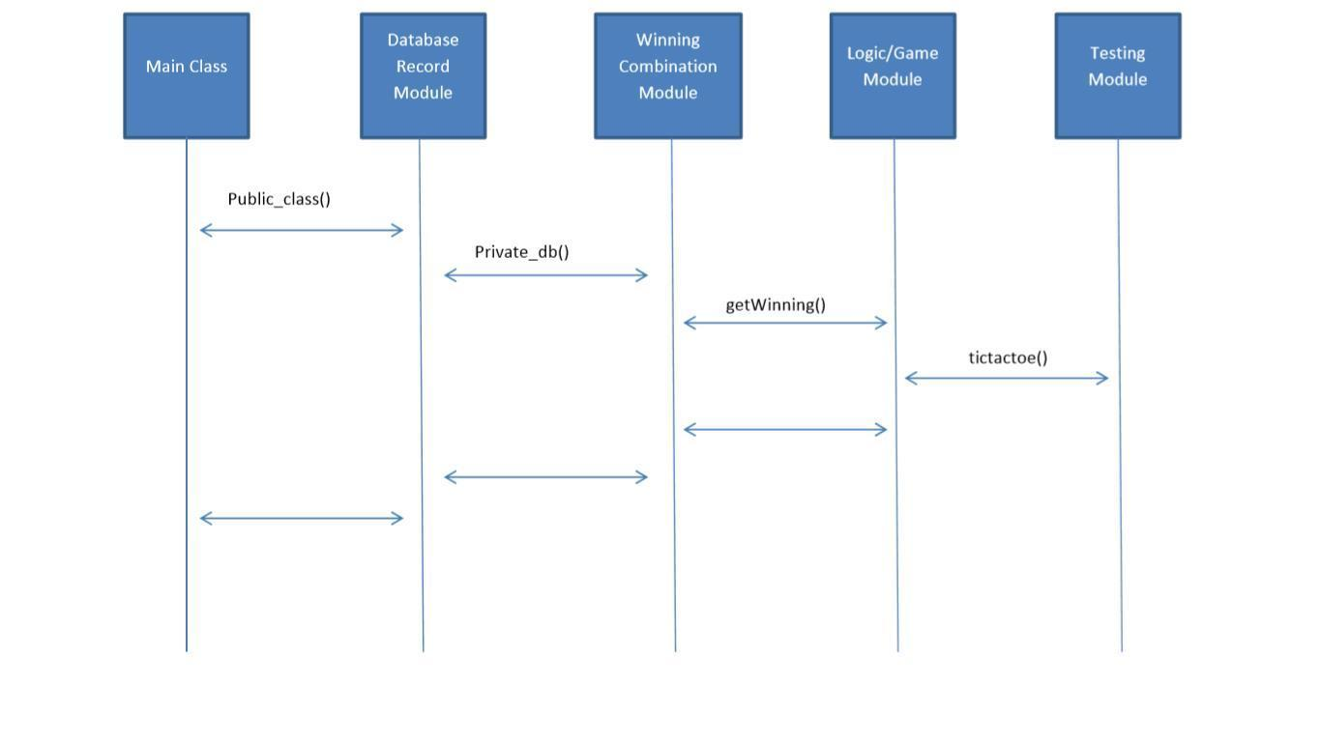

M

|  |  |
| --- | --- |
| Case 1 |  |
| private startMenu: | At the start menu, user will be able to determine the game that he/she is going to play, the difficulty level, and if any help needed, user will be able to get it from the menu |

|  |  |
| --- | --- |
| Case 2 |  |
| private helpbutton; | User will be able to click menu for help. This will help the user understand the format of the game and answer any questions the user may have. |

|  |  |
| --- | --- |
| Case 3 |  |
| private newgame; | User will get new menu after game play to restart new game or start different mode for game play. |

|  |  |
| --- | --- |
| Case 4 |  |
| private exitbutton; | User will set exit menu to continue game play of choice. |

|  |  |
| --- | --- |
| Case 5 |  |
| private difficultyButton: | User will be able to choose difficulty depending on game play. Select Hard, Medium, Easy. |

|  |  |
| --- | --- |
| Case 6 |  |
| private difficultyEasy; | User will have limited time of game play under easy mode. |

|  |  |
| --- | --- |
| Case 7 |  |
| private difficultyHard; | User will have limited time of game play under hard. |

|  |  |
| --- | --- |
| Case 8 |  |
| private difficultyMedium; | User will have limited time of game play under normal. |

### 

### Sequence Diagram

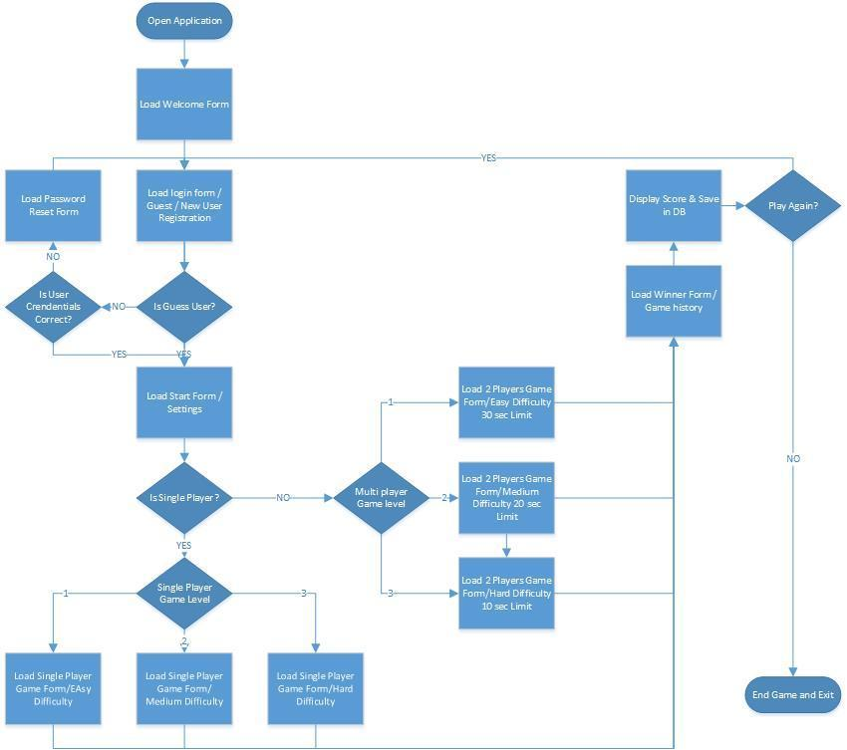

### User Interface

# 

# 

# 