**CS209-210 Mini Project Report**

By Archit Sharma (2101AI05)

# Overview

For the mini-project of CS209-210 course, I and Aadit built a paper piano with capacitive touch. The project uses graphite on paper to act as a capacitive touch sensor. Graphite being a conductor of electricity could be used to measure the change in capacitance when touched by our hand, this is the same concept used in most modern touchscreens. An Arduino UNO board is programmed to process the input and play relevant sound through the piezo-buzzer. An android app was also built to act as a user interface between the Arduino and the user. The app allows user to operate the piano in three modes- Free Play, Learn to Play and Auto Play. The Arduino reads the input through HC-05 Bluetooth module. Different songs and octaves are also allowed to be chosen.

Each of the aspect of the circuit is explained in detail in their relevant sections which can be in either of the reports.

# My Contribution

In this team project, my contributions are listed below-

1. Copilot_Piano App- I designed an Android App for this project to act as a user interface.
2. Arduino Code- Though the code for Arduino was written in collaboration, I completed the main body of the program, including initialization of different variables and implementing the logic for the default Free Play mode.

Rest of this report covers the above section in details and explains the technical innerworkings.

# Android App

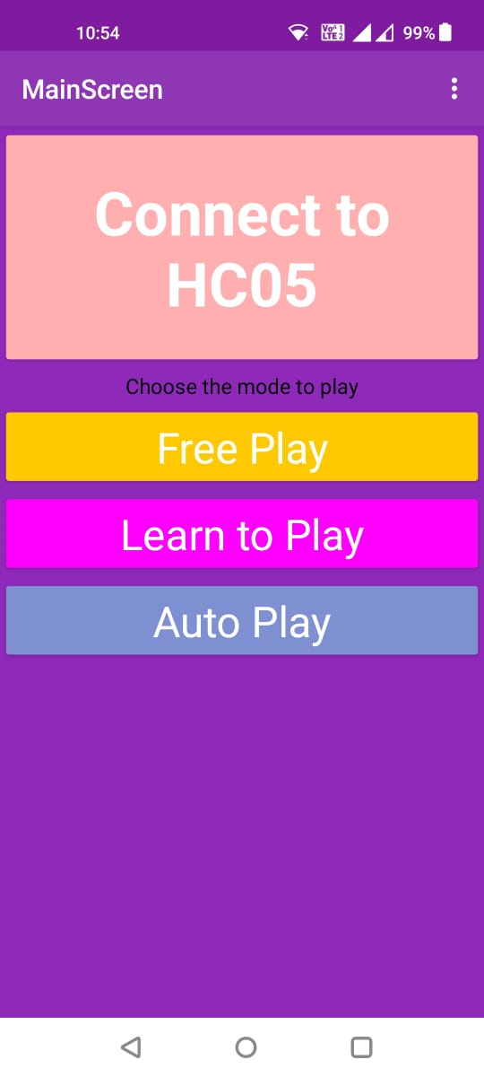 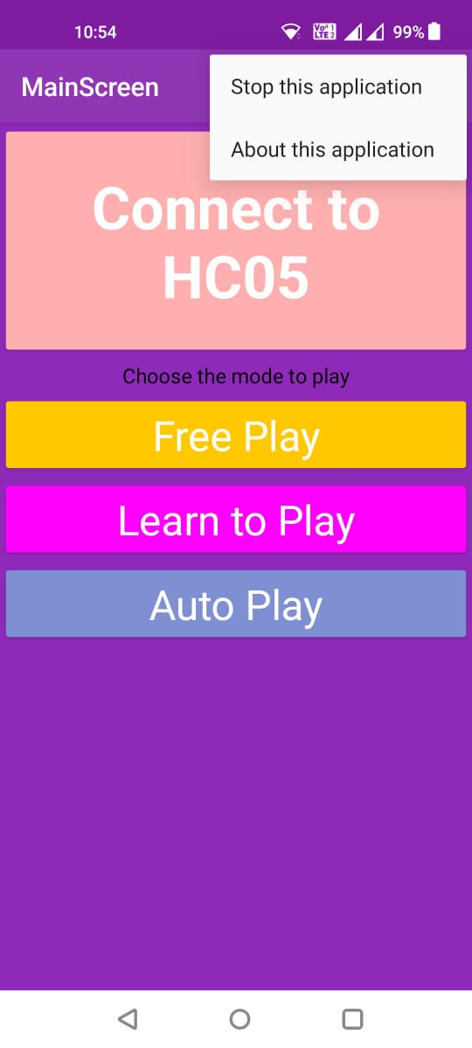 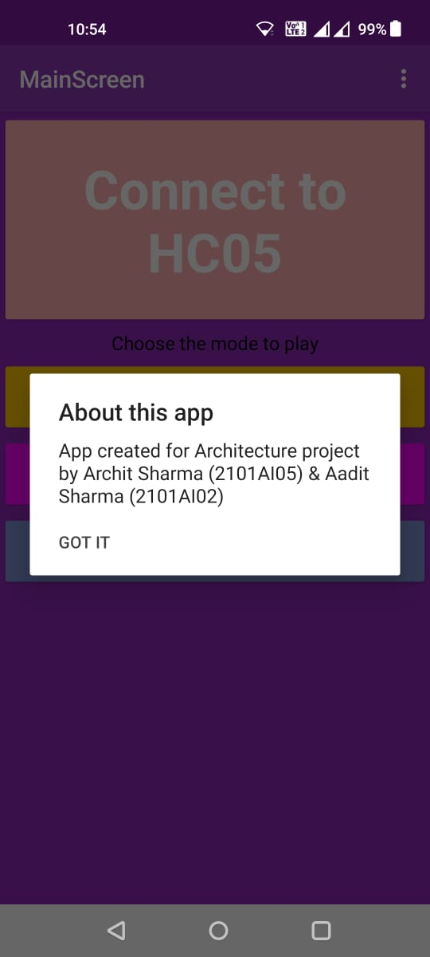

I designed an app with the name of ‘Piano_Copilot’ to act as a user-interface between the users and the Arduino board. The piano can be played in three modes, the app allows the user to operate the Arduino in any of the three modes, each of these modes are explained below-

1. 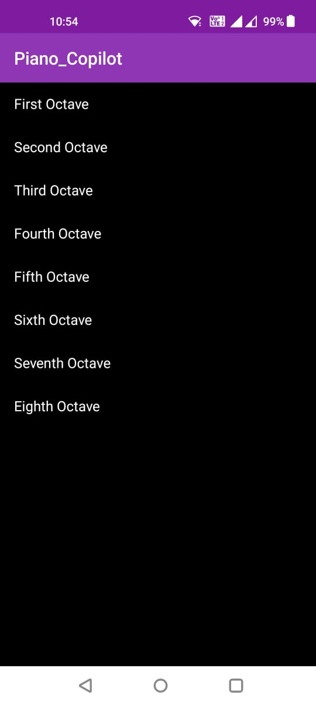**Free Play-** This is the default state of the piano. When the user selects this mode, the app asks the user for an octave and when an octave is selected, the app directs the Arduino to play the note in the selected octave corresponding to the key pressed by the user. In this mode the paper piano acts as a ‘vanilla’ piano. The first octave is the lowest pitched octave and the pitch of the notes increases from first to sixth hence in this octave, the frequencies of the notes are very close to each other and since the piezo-buzzer does not allow us to control any other parameter other than frequency, the notes sound similar. All the notes in the other seven octaves sound distinct. The app sends a character from ‘1’ to ‘8’ as Bluetooth output to the HC-05 module which tells the Arduino the correct octave to play (The inner workings will be explained in the Arduino code section).
2. 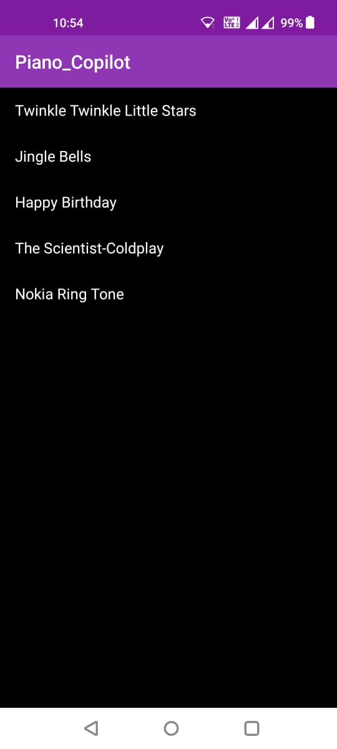**Learn to Play-** This is an interactive tutorial mode, which allows the user to learn to play some tunes and song on paper piano. Currently, 5 songs have been implemented, when a song is selected, the piano sends a character from ‘A’ to ‘E’ corresponding to each song to the HC-05 module, the Arduino reads this signal and then programmatically selects the correct octave and lights a LED corresponding to the next key to be played. When the user selects the correct key, the next key is lit up and so on until all the correct notes have been played and then the piano goes to its default free play state in first octave, if somehow an incorrect mode is selected, the piano does not proceed further.
3. 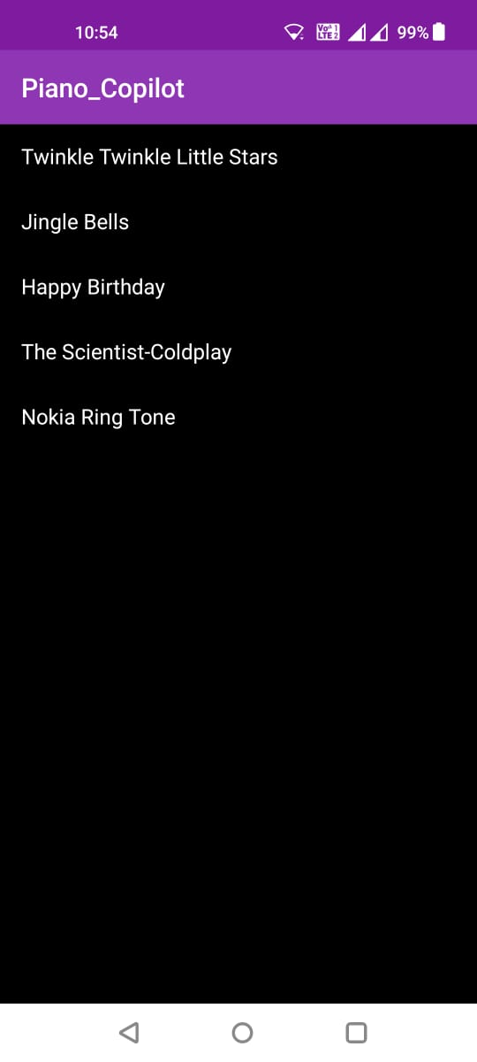**Auto Play-** This mode sets the ‘Arduino’ to play the songs on its own. Here the app sends a character, ‘a’ to ‘e’ via Bluetooth to the HC-05 module. All the 5 tutorial songs have been implemented for this mode, and here the arduino plays the notes with some time delay between it notes, since this note is programatically implemented, the tempo of the song is not as good as a human player.

## Development

The part for communicating with HC-05 was designed using MIT App inventor 2 while the interface was created on my own, the corresponding source files have been attached along this report. XML files were edited using VS Code for improving the user interface/

# Arduino Code

The complete code for Arduino was written by both Aadit and me. My contribution included writing the setup, loop and octave selection Code. The complete code is also uploaded.

### Initialization Code

The following was initialized-

* Speaker pin was initialized as pin 13.
* 7 capacitive sensor objects were initialized measuring capacitance between pin 2 and pin connected to key.
* 7 led pins were initialized- 3 digital pins 10 to 12 and also 4 analog pins acting as digital pins from A0 to A3 as we had exhausted all the digital pins.
* A 2d 8 by 7 integer array was initialized with the name frequency which contained frequency corresponding to each of the 7 notes and each of the 8 octaves.

### Setup Function

The default octave was initialized as 0 and each of the LEDs and speaker were initialized in output mode. The Serial bit rate was initialized at 9600 bits/second.

### Loop Function

The loop is the function which keeps on repeating throughout the time the Arduino is switched on. The Bluetooth Module writes its input on the Serial of the Arduino. The loop reads this in ‘data’ variable and subtracts character ‘1’ to obtain the corresponding octave index for the frequency array. If data was equal to ‘A’ to ‘E’, the code calls corresponding functions to play song in tutorial mode or if the data was a character from ‘a’ to ‘e’, the code calls function to play the song on its own. Otherwise, the Arduino stays in default Free play mode and obtains the capacitance value from the capacitive sensors and prints the read values on the Serial for the purpose of debugging. If the capacitive values for any of the sensor is more than 600 than the Arduino plays the frequency for 300ms.

# Sources

The following sources were used for various purposes-

1. Capacitive Sensor Library Documentation- <https://playground.arduino.cc/Main/CapacitiveSensor/>
2. A basic HC-05 tutorial- <https://create.arduino.cc/projecthub/mayooghgirish/arduino-bluetooth-basic-tutorial-d8b737>
3. Piano Terminology and Basic Knowledge- <https://www.europianosnaples.com/piano-keys-101/#:~:text=The%2012%20notes%20are%20C,and%20flats%20are%20black%20keys>.
4. Frequencies corresponding to different notes- <https://pages.mtu.edu/~suits/notefreqs.html>