Practical - 1
Practical Title: Project Initiation, Requirement Analysis, Sitemap, Wireframe, and GitHub Setup

Problem Definition: Initiate the semester-long StudentHub portal by identifying the problem scope, user roles, key modules, navigation flow, and minimum 10 pages. Create a sitemap, low-fidelity wireframe, project folder structure, README file, and GitHub repository.

Theory

What is URL and parts of URL?
Answer: A URL is a web address used to find resources on the internet. It mainly contains a protocol (http/https), domain name (website host), port number, file path, and optional query parameters.
Source: https://web.dev/articles/url-parts

How does HTML file process in web browser?
Answer: The browser fetches the HTML file from the server, parses tags to build the DOM, loads CSS to make the CSSOM, runs JavaScript, and then combines them into a render tree to paint the page on the screen.
Source: https://developer.mozilla.org/en-US/docs/Learn_web_development/Getting_started/Web_standards/How_browsers_load_websites

3. How will page navigation flow managed among all HTML pages?
Answer: Page navigation is managed using standard <a> hyperlink tags placed inside the navigation bar across all HTML pages, using relative paths to link pages together.
Source: https://developer.mozilla.org/en-US/docs/Learn_web_development/Core/Structuring_content/Creating_links

4. How will GitHub commits be maintained after each practical?
Answer: After finishing each practical, changes are saved in that practical's folder and committed with a short descriptive message using git add and git commit, then pushed to GitHub.
Source: https://git-scm.com/doc

Implementation

I planned the StudentHub portal for students and admin, created the sitemap for all 11 pages, drew the home page wireframe using Draw.io, and initialized the GitHub repository.

Evidence of Work (Screenshots)
Figure 1.1: Home Page Wireframe
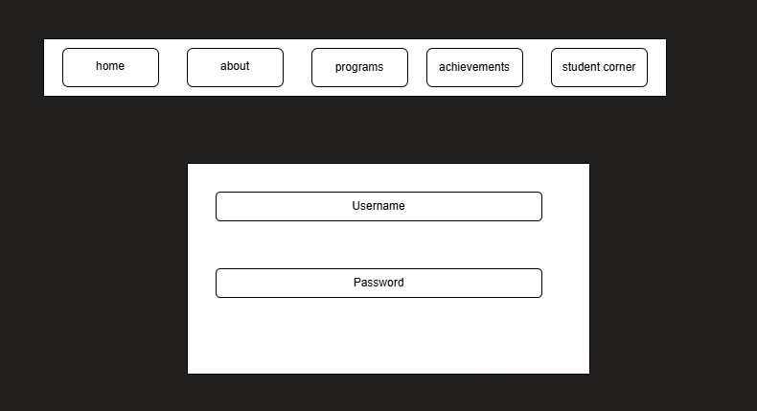
Description: This is the basic wireframe structure of the home page.
Figure 1.2: StudentHub Sitemap
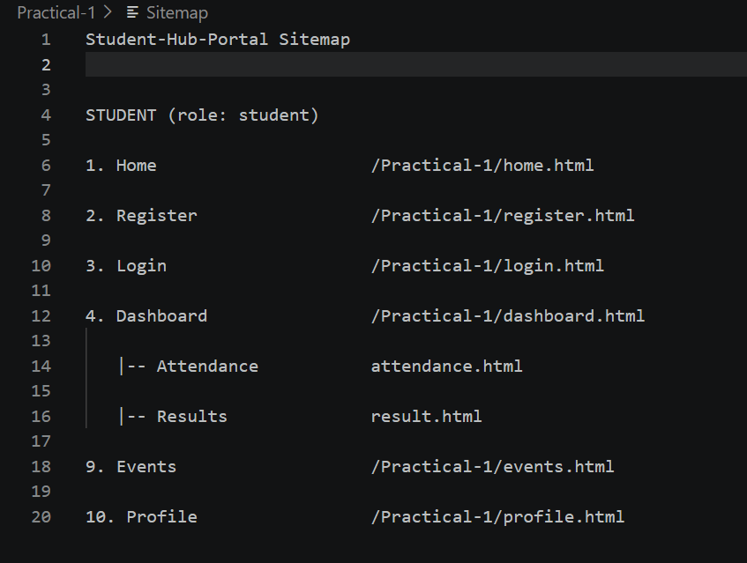

Description: This is the sitemap showing the navigation flow among all 11 pages.

GitHub Repository Link: https://github.com/AmateurCoder9/Student-Hub-Portal/tree/main/Practical-1

Challenges Faced:

Planning the navigation flow for 11 pages without confusing links was confusing at first. I drew a rough tree diagram before finalizing the sitemap.

Learning Outcomes:

I learned the parts of a URL, how browsers load HTML, how to plan sitemaps and wireframes, and how to manage code using Git.

Faculty Remarks: (Keep this blank for faculty)

