Practical - 10
Practical Title: Secure Login/Logout with Sessions, Role-Based Access, Timeout, and Remember-Me Token

Problem Definition: Develop secure login and logout functionality using PHP sessions. Verify password using password_verify(), regenerate session ID after login, restrict dashboard access, implement role-based redirection, session timeout, and optional secure remember-me token.

Theory

1. Are sessions started and destroyed securely?
Answer: Yes, session_start() uses HttpOnly, SameSite=Strict cookies. On login, session_regenerate_id(true) prevents session fixation, and logout clears $_SESSION, deletes session cookies, and calls session_destroy().
Source: https://www.php.net/manual/en/function.session-destroy.php

2. Is password_verify() used correctly?
Answer: Yes, password_verify() compares plaintext input against the stored bcrypt hash safely without exposing timing attack vulnerabilities.
Source: https://www.php.net/manual/en/function.password-verify.php

3. Is unauthorized dashboard access blocked?
Answer: Yes, middleware function requireRole() verifies authentication and authorization; non-admin users attempting to open admin routes are redirected with a 403 Forbidden notice.
Source: https://owasp.org/www-community/attacks/Broken_Access_Control

4. Is session timeout implemented?
Answer: Yes, time() - $_SESSION['last_activity'] is checked on each request; if user is idle for more than 15 minutes (900s), session is destroyed and user is redirected to login.
Source: https://cheatsheetseries.owasp.org/cheatsheets/Session_Management_Cheat_Sheet.html

Implementation

I implemented login.php with password_verify() and session ID regeneration, auth_check.php with 15-minute inactivity timeout and remember-me token cookies, role-based dashboards for student and admin, and secure logout in logout.php.

Evidence of Work (Screenshots)
Figure 10.1: Session-Authenticated Student Dashboard
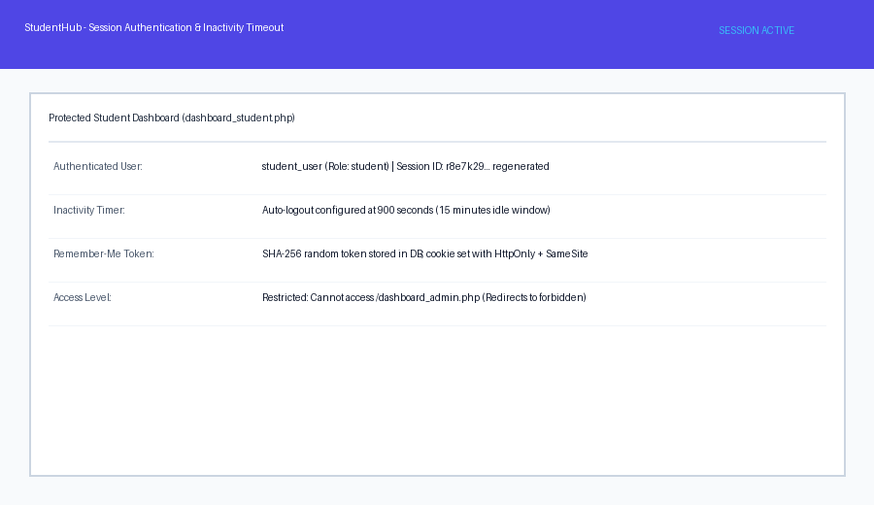
Description: Student dashboard displaying active session details, regenerated session ID, and idle timeout tracking.
Figure 10.2: RBAC Access Restriction & Remember-Me
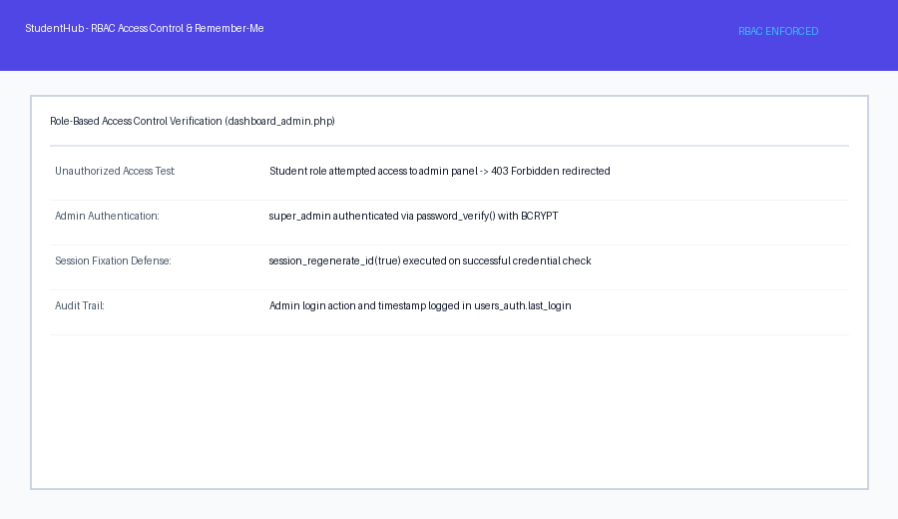

Description: Admin control panel verifying administrator privileges and blocking unauthorized student access.

GitHub Repository Link: https://github.com/AmateurCoder9/Student-Hub-Portal/tree/main/Practical-10

Challenges Faced:

Session cookies remained accessible via client scripts initially. I resolved this by configuring session_set_cookie_params with httponly=true and samesite=Strict.

Learning Outcomes:

I learned how to manage PHP sessions securely, defend against session fixation, enforce role-based access control, and implement inactivity timeouts.

Faculty Remarks: (Keep this blank for faculty)

