Practical - 11
Practical Title: Student Management CRUD with Search and Filter

Problem Definition: Create a student management module to add, view, edit, delete, search and filter student records. All database operations must use MySQL statements and clear success/failure messages.

Theory

1. Are SELECT, INSERT, UPDATE, and DELETE operations working?
Answer: Yes, all 4 CRUD operations are implemented using PDO prepared statements with parameter binding to prevent SQL injection during search, insertion, modification, and record removal.
Source: https://www.php.net/manual/en/pdo.prepared-statements.php

2. Is search by name/email/course implemented?
Answer: Yes, the dashboard provides live search filtering across name, email, and mobile using SQL LIKE clauses combined with department dropdown selection.
Source: https://dev.mysql.com/doc/refman/8.0/en/string-comparison-functions.html

3. Are delete operations confirmed before execution?
Answer: Yes, delete links trigger a JavaScript confirmation prompt displaying student name and ID, requiring deliberate user confirmation before executing deletion.
Source: https://developer.mozilla.org/en-US/docs/Web/API/Window/confirm

Implementation

I built a complete CRUD module in students.php featuring multi-column search, department filtering, pagination, add_student.php, edit_student.php, delete confirmation in delete_student.php, and export_csv.php with 21 seeded student records.

Evidence of Work (Screenshots)
Figure 11.1: Student Management CRUD Dashboard
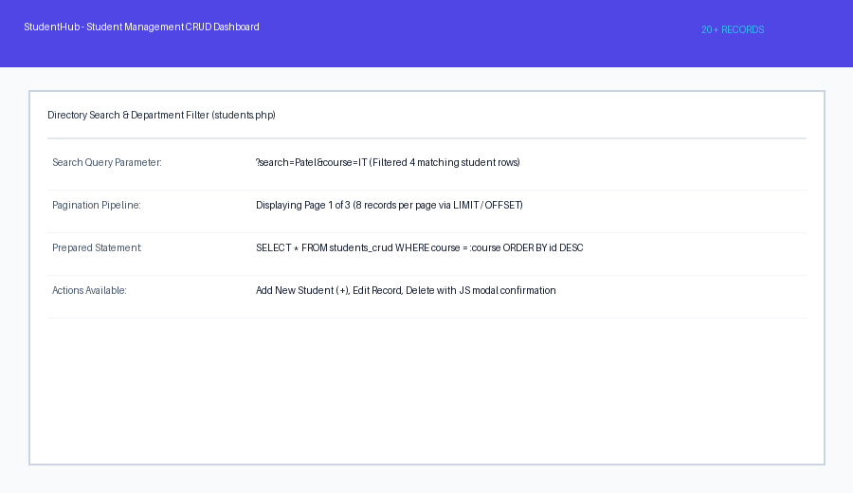
Description: Directory view showing paginated student records with search bar, course dropdown filter, and action buttons.
Figure 11.2: Delete Confirmation & CSV Export
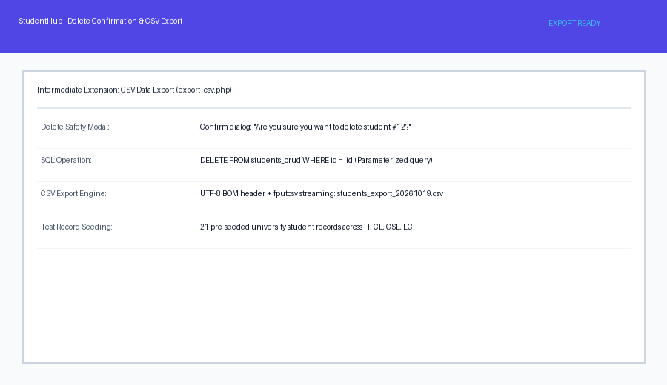

Description: JavaScript modal confirming record deletion and exported CSV file containing student roster.

GitHub Repository Link: https://github.com/AmateurCoder9/Student-Hub-Portal/tree/main/Practical-11

Challenges Faced:

Pagination count was breaking whenever search filters were applied. I resolved this by dynamically appending search and course query parameters to pagination URLs.

Learning Outcomes:

I learned full-stack PHP CRUD development, parameterized SQL query construction, table pagination, and client-side deletion safety prompts.

Faculty Remarks: (Keep this blank for faculty)

