Practical - 12
Practical Title: Event Management CRUD with Poster Upload and File Validation

Problem Definition: Develop event management functionality for admin users. Admin can add, view, update, delete, and upload event posters with file type and file size validation.

Theory

1. Are add, update, and delete functionalities implemented correctly?
Answer: Yes, administrators can create events with poster images, update textual details or swap posters with automatic deletion of obsolete image files, and delete events cleanly.
Source: https://www.php.net/manual/en/function.unlink.php

2. Is the UI linked with the database correctly?
Answer: Yes, event records are dynamically read from events_crud and rendered as responsive visual cards displaying poster thumbnails, category tags, and registration status badges.
Source: https://www.php.net/manual/en/pdostatement.fetchall.php

3. Are poster uploads validated for type and size?
Answer: Yes, server-side validation inspects genuine MIME types using finfo_file() (allowing only JPG, PNG, WEBP), restricts uploads to 2 MB, and assigns randomized unique filenames.
Source: https://www.php.net/manual/en/features.file-upload.php

4. Are success and failure messages displayed?
Answer: Yes, session flash messages provide feedback for upload confirmation, validation failures, and database changes.
Source: https://www.php.net/manual/en/reserved.variables.session.php

Implementation

I created events.php displaying dynamic event cards with category filtering, add_event.php with server-side MIME type and 2MB size checks, secure image renaming, edit_event.php with old poster cleanup, and delete_event.php.

Evidence of Work (Screenshots)
Figure 12.1: Event Management Catalog with Posters
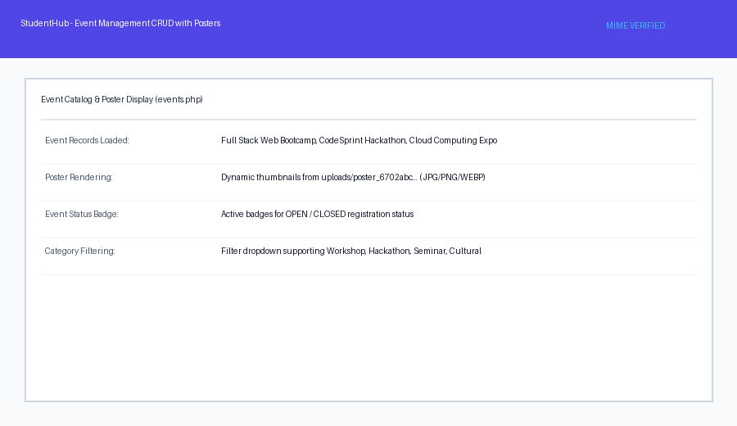
Description: Catalog of university events showing uploaded poster thumbnails, categories, dates, and status tags.
Figure 12.2: Server-Side File Upload Validation
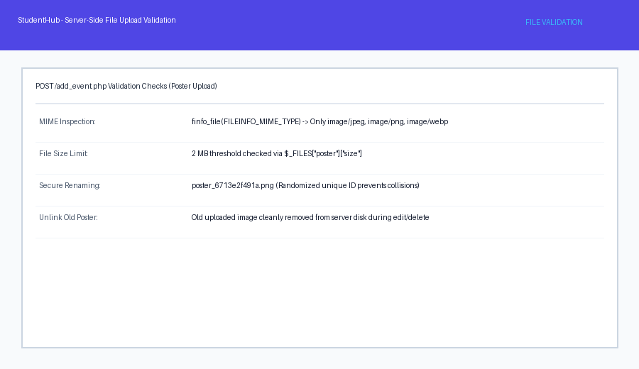

Description: Validation error feedback blocking invalid file formats and oversized images during upload.

GitHub Repository Link: https://github.com/AmateurCoder9/Student-Hub-Portal/tree/main/Practical-12

Challenges Faced:

Uploading a new poster during edit left the previous orphaned image on the server. I solved this by calling unlink() on the old poster path before updating database records.

Learning Outcomes:

I mastered server-side multipart file uploads, MIME-type inspection with Fileinfo, directory security, and media asset lifecycle management in PHP.

Faculty Remarks: (Keep this blank for faculty)

