Practical - 13
Practical Title: PHP JSON API and AJAX/Fetch-Based CRUD without Page Reload

Problem Definition: Create simple PHP JSON API endpoints for events or students and consume them using Fetch API. Perform list, add, update, and delete operations asynchronously without full page reload.

Theory

1. Do PHP endpoints return valid JSON responses?
Answer: Yes, the endpoint sets header('Content-Type: application/json; charset=UTF-8') and outputs standardized envelopes with success flags, HTTP status codes, and data payloads.
Source: https://www.php.net/manual/en/function.json-encode.php

2. Are GET and POST requests handled properly?
Answer: Yes, the RESTful API inspects $_SERVER['REQUEST_METHOD'] to route GET (fetch/search), POST (create), PUT (update), and DELETE (remove) actions with appropriate status codes.
Source: https://developer.mozilla.org/en-US/docs/Web/HTTP/Methods

3. Are loading, success, and error states shown on the frontend?
Answer: Yes, the Single Page Application shows an animated CSS spinner while fetch() is pending, non-blocking toast notifications on success, and inline error messages on failure.
Source: https://developer.mozilla.org/en-US/docs/Web/API/Fetch_API/Using_Fetch

4. Is input validation performed before database operations?
Answer: Yes, the API validates payload fields before SQL execution, returning HTTP 400 Bad Request with an associative error dictionary if validation fails.
Source: https://developer.mozilla.org/en-US/docs/Web/HTTP/Status/400

Implementation

I developed RESTful JSON API api/events_api.php supporting GET, POST, PUT, DELETE with HTTP status codes, coupled with a responsive SPA frontend in index.html and app.js featuring debounced live search and zero page reloads.

Evidence of Work (Screenshots)
Figure 13.1: Fetch API Asynchronous SPA Dashboard
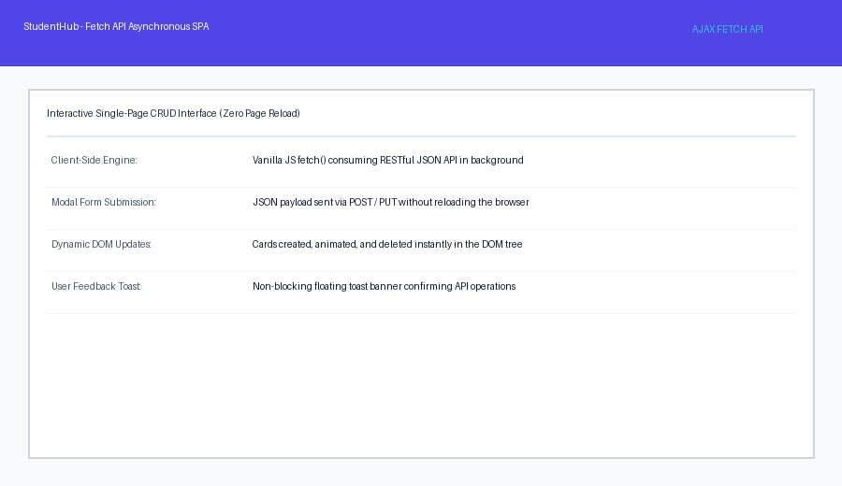
Description: Single page application rendering dynamic event cards via Fetch API without refreshing the browser.
Figure 13.2: Debounced Live Search & JSON API
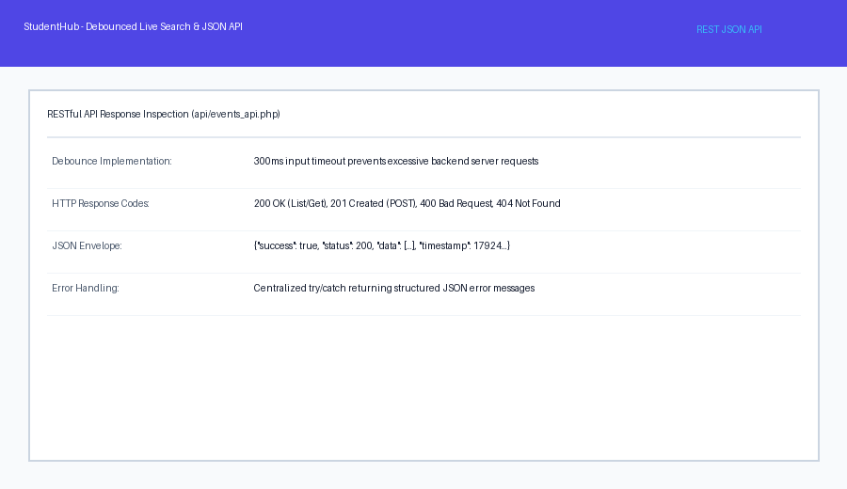

Description: Network tab inspection showing background asynchronous requests and debounced live search execution.

GitHub Repository Link: https://github.com/AmateurCoder9/Student-Hub-Portal/tree/main/Practical-13

Challenges Faced:

Live search on every keyup triggered excessive API requests. I implemented a 300ms debounce timer in JavaScript to optimize performance and prevent server flooding.

Learning Outcomes:

I learned how to build RESTful PHP JSON APIs, consume backend endpoints with modern JavaScript Fetch API (async/await), and create interactive zero-reload web interfaces.

Faculty Remarks: (Keep this blank for faculty)

