Practical - 14
Practical Title: Admin Dashboard with Role-Based Access Control, Dynamic Menu, and Audit Log

Problem Definition: Develop an admin dashboard that displays user statistics, student count, event count and latest registrations. Restrict access to admin users only and show dynamic menu options based on role.

Theory

1. Are dashboard values loaded dynamically from the database?
Answer: Yes, metric cards compute real-time statistics directly from MySQL using SQL COUNT() queries over users, students, events, and registrations tables.
Source: https://dev.mysql.com/doc/refman/8.0/en/counting-rows.html

2. Is access restricted to admin users?
Answer: Yes, access is protected by requireAdmin() middleware which verifies session existence and confirms the role is strictly 'admin', redirecting non-admins to login.
Source: https://owasp.org/www-community/Role_Based_Access_Control

3. Are role-based menus working?
Answer: Yes, renderDynamicMenu() generates administrative tools (Audit Logs, CRUD modules) for admins while displaying a student portal menu for regular student users.
Source: https://www.php.net/manual/en/language.control-structures.switch.php

4. Are important admin actions recorded in audit_logs?
Answer: Yes, administrative actions including logins, account status toggles, and record changes trigger logAuditAction() which logs user ID, action, entity, IP, and timestamp.
Source: https://cheatsheetseries.owasp.org/cheatsheets/Logging_Cheat_Sheet.html

Implementation

I built dashboard.php featuring live KPI metric cards, dynamic role-based navigation sidebar in auth.php, recent registration feed, user status toggle, and audit_logs.php tracking administrative security events.

Evidence of Work (Screenshots)
Figure 14.1: Administrative KPI Dashboard
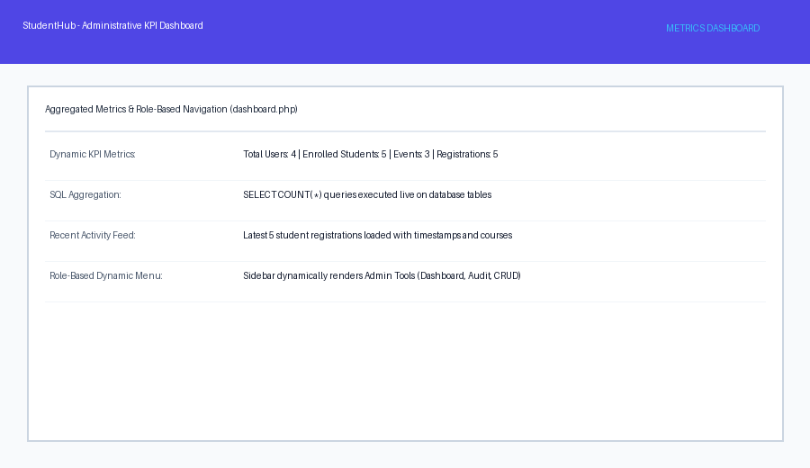
Description: Admin dashboard displaying aggregated metric cards, role-based sidebar, and latest event registrations.
Figure 14.2: Audit Trail Logs & User Status Control
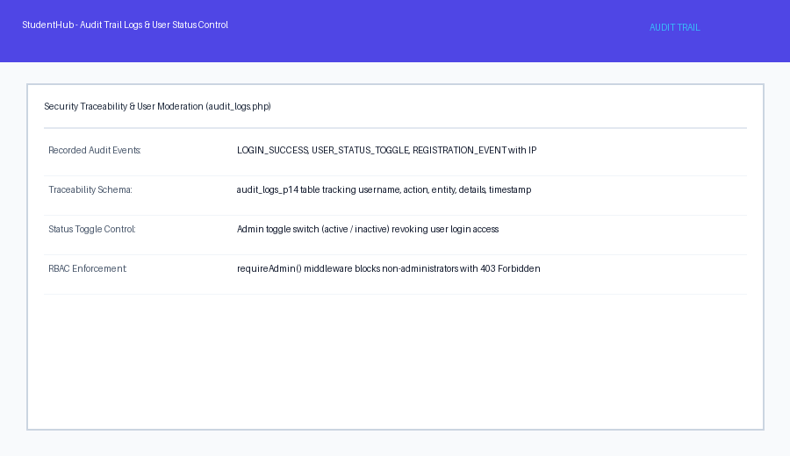

Description: Audit trail interface showing chronological security logs with IP addresses and user moderation controls.

GitHub Repository Link: https://github.com/AmateurCoder9/Student-Hub-Portal/tree/main/Practical-14

Challenges Faced:

Audit log tables could grow unbounded without indexed queries. I added indexes on user_id and logged_at to ensure fast dashboard log retrieval.

Learning Outcomes:

I learned how to build role-based administrative control panels, perform SQL statistical aggregations, implement dynamic navigation menus, and maintain audit trails.

Faculty Remarks: (Keep this blank for faculty)

