Practical - 2
Practical Title: Semantic HTML5 Pages with Accessibility-Ready Structure

Problem Definition: Develop static HTML5 skeletons for at least 10 StudentHub pages such as Home, About, Register, Login, Dashboard, Events, Profile, Contact, Admin, FAQ, and Feedback. Use semantic tags and accessibility-friendly structure.

Theory

1. Are semantic tags such as header, nav, main, section, article, aside, and footer used properly?
Answer: Yes, semantic tags are used to organize each page: <header> for site banner, <nav> for menu links, <main> for core content, <section> and <article> for grouped info/posts, and <footer> for copyright info.
Source: https://developer.mozilla.org/en-US/docs/Glossary/Semantics#semantics_in_html

2. Are form labels, headings, image alt text, and navigation links accessible?
Answer: Yes, every form input has a <label> linked with for and id, headings follow h1 to h3 order, images have alt text, and links have clear names instead of 'click here'.
Source: https://developer.mozilla.org/en-US/docs/Learn_web_development/Core/Accessibility/HTML

3. Is the page structure consistent across all pages?
Answer: Yes, all 11 pages share the same uniform layout with a top header and navigation bar, center content area, and bottom footer.
Source: https://developer.mozilla.org/en-US/docs/Learn_web_development/Core/Structuring_content/Basic_HTML_syntax

Implementation

I created 11 static HTML5 pages for StudentHub using semantic tags (<header>, <nav>, <main>, <section>, <footer>) and added accessible forms with labels and input types.

Evidence of Work (Screenshots)
Figure 2.1: Semantic Home Page Layout
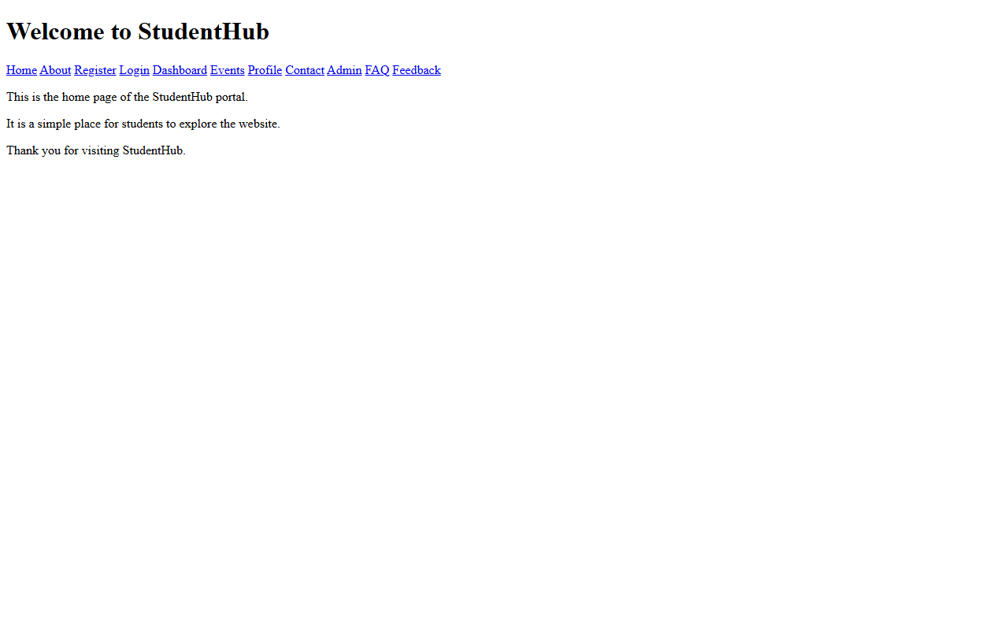
Description: Home page showing semantic header, nav, main, and footer sections.
Figure 2.2: Student Registration Form
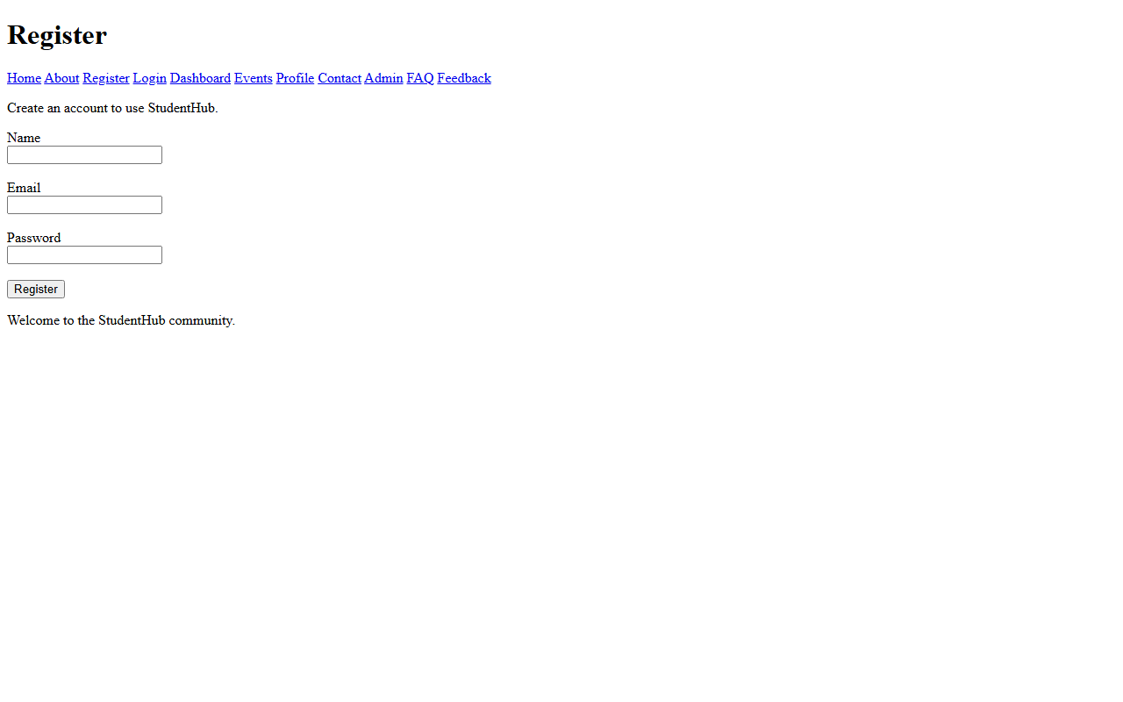

Description: Registration form with input boxes, radio buttons, and accessible labels.

GitHub Repository Link: https://github.com/AmateurCoder9/Student-Hub-Portal/tree/main/Practical-2

Challenges Faced:

Deciding between <section> and <article> tags was tricky. I used <article> for standalone cards like events and <section> for broader page blocks.

Learning Outcomes:

I learned how to use semantic HTML5 elements properly, how to link multiple HTML pages, and how to make basic accessible forms.

Faculty Remarks: (Keep this blank for faculty)

