Practical - 3
Practical Title: Responsive UI Design using CSS2.0/CSS3.0, CSS Grid, and Flexbox

Problem Definition: Design responsive layouts for Home, About, Registration, Dashboard, and Events pages using CSS Grid and Flexbox. Optional to use CSS framework such as Bootstrap or Tailwind. Ensure mobile-first responsiveness.

Theory

1. How does the layout adapt for mobile, tablet, and desktop screens?
Answer: Media queries (@media) adjust the layout based on width: single-column vertical stack on mobile (<768px), two columns on tablet, and multi-column grid on desktop screens.
Source: https://developer.mozilla.org/en-US/docs/Learn_web_development/Core/CSS_layout/Responsive_Design

2. Which layout technique is used and why?
Answer: Both are used: Flexbox is used for 1D alignments like navigation menu buttons and form rows, while CSS Grid is used for 2D card layouts like dashboard and events.
Source: https://developer.mozilla.org/en-US/docs/Learn_web_development/Core/CSS_layout/Grids

3. Are typography, spacing, colors, and contrast readable?
Answer: Yes, text sizes use rem units, proper margins/padding prevent crowding, and dark text on light backgrounds provides high contrast for readability.
Source: https://developer.mozilla.org/en-US/docs/Web/Accessibility/Understanding_WCAG/Perceivable/Color_contrast

4. Is the framework used consistently without unnecessary inline CSS?
Answer: Yes, all styles are placed in an external style.css file with no inline style attributes, keeping the code clean and easy to maintain.
Source: https://developer.mozilla.org/en-US/docs/Learn_web_development/Core/Styling_basics/CSS_asset_management

Implementation

I created style.css using CSS Grid for cards and Flexbox for menus, and added media queries to make the portal responsive on mobile, tablet, and desktop.

Evidence of Work (Screenshots)
Figure 3.1: Dashboard Responsive Grid

Description: Dashboard cards displayed in a multi-column CSS Grid on desktop view.
Figure 3.2: Mobile Responsive View
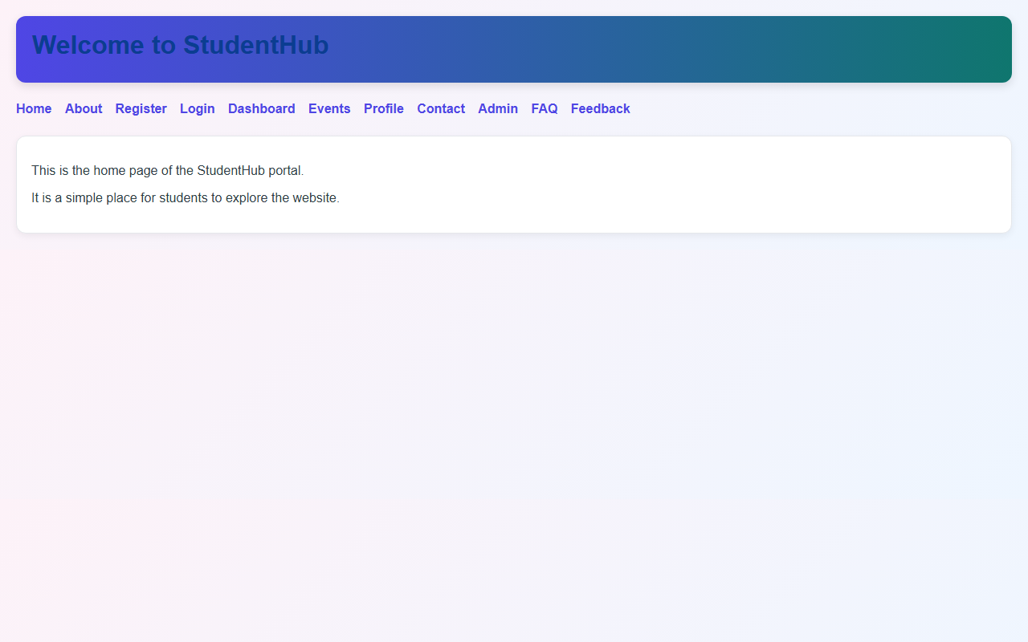

Description: Layout stacking vertically in a single-column layout on mobile view.

GitHub Repository Link: https://github.com/AmateurCoder9/Student-Hub-Portal/tree/main/Practical-3

Challenges Faced:

Grid cards were overflowing on mobile screens. I fixed this by using grid-template-columns: repeat(auto-fit, minmax(260px, 1fr)) and max-width: 100%.

Learning Outcomes:

I learned how to use Flexbox and CSS Grid, write media queries for responsive layouts, and organize styles in an external CSS file.

Faculty Remarks: (Keep this blank for faculty)

