Practical - 4
Practical Title: JavaScript DOM Manipulation, Event Handling, and UI Interactivity

Problem Definition: Add dynamic UI components such as collapsible FAQ, modal popup, image/content slider, notification banner, hamburger menu, and light/dark theme switcher using JavaScript.

Theory

1. How are DOM elements selected and modified?
Answer: Elements are selected using document.getElementById() and querySelector(), and modified by changing textContent or toggling CSS classes with classList.toggle().
Source: https://developer.mozilla.org/en-US/docs/Learn_web_development/Extensions/Client-side_APIs/Manipulating_documents

2. Are event listeners attached correctly?
Answer: Yes, listeners are attached using addEventListener('click', handler) in JavaScript rather than inline HTML onclick, with preventDefault() used on form submits.
Source: https://developer.mozilla.org/en-US/docs/Learn_web_development/Core/Scripting/Events

3. Is localStorage used for remembering theme choice?
Answer: Yes, theme selection is saved using localStorage.setItem('theme', value) and read on page load with localStorage.getItem('theme') to maintain user preference.
Source: https://developer.mozilla.org/en-US/docs/Web/API/Window/localStorage

4. Does interactivity improve usability without breaking accessibility?
Answer: Yes, interactive components toggle aria-expanded attributes and remain accessible via keyboard keys like Tab and Enter.
Source: https://developer.mozilla.org/en-US/docs/Web/Accessibility/ARIA

Implementation

I wrote JavaScript for FAQ accordion expansion, modal popups, hamburger menu toggle, and a dark/light mode toggle with theme persistence in localStorage.

Evidence of Work (Screenshots)
Figure 4.1: FAQ Accordion and Modal Interaction
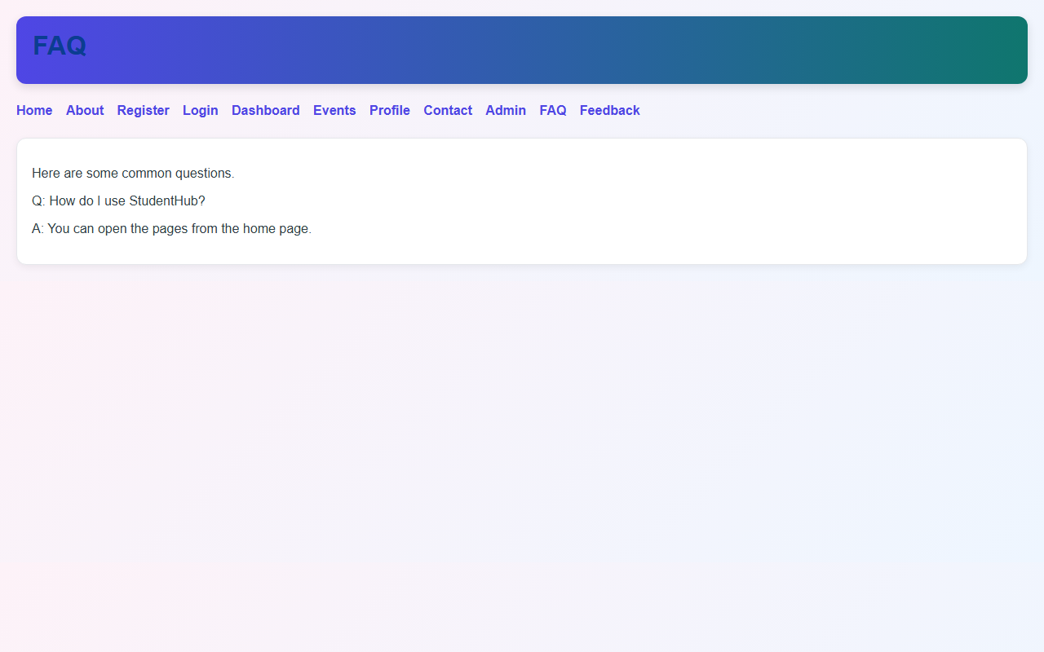
Description: Collapsible FAQ answer open and interactive modal dialog on screen.
Figure 4.2: Password Validation & Interactivity
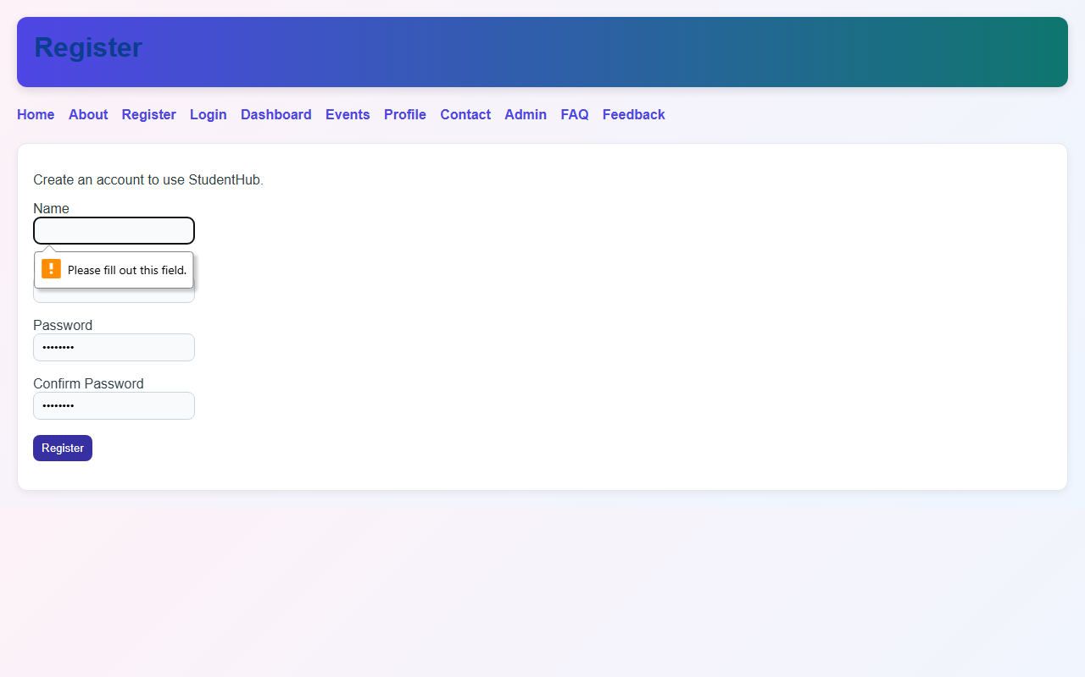

Description: Interactive registration form testing password mismatch validation.

GitHub Repository Link: https://github.com/AmateurCoder9/Student-Hub-Portal/tree/main/Practical-4

Challenges Faced:

The page briefly flashed white before switching to dark mode on refresh. I fixed it by running the localStorage theme check script in the <head> tag.

Learning Outcomes:

I learned DOM element selection and modification, event handling with JavaScript, and storing user preferences in localStorage.

Faculty Remarks: (Keep this blank for faculty)

