Practical - 5
Practical Title: Registration Form with Frontend Validation and User-Friendly Error Handling

Problem Definition: Create a student registration form with HTML5 input types and JavaScript validation for name, email, mobile number, password, confirm password, course, year, gender, and terms acceptance. Use Regular Expression for validations.

Theory

1. Are correct input types and attributes used?
Answer: Yes, input types like text, email, tel, password, radio, and checkbox are used along with required, minlength, and pattern attributes.
Source: https://developer.mozilla.org/en-US/docs/Learn_web_development/Core/Forms/Form_validation

2. Are validation errors displayed near the relevant fields?
Answer: Yes, small <span> error labels sit directly beneath each input field and display clear red error messages whenever input is invalid or missing.
Source: https://developer.mozilla.org/en-US/docs/Learn_web_development/Core/Forms/User_actions

3. Is password strength checked?
Answer: Yes, a function tests password length, letters, numbers, and symbols, updating an HTML5 <meter> bar and strength label in real time as user types.
Source: https://developer.mozilla.org/en-US/docs/Web/HTML/Element/meter

4. Is the form accessible using keyboard and screen-reader-friendly labels?
Answer: Yes, all inputs support keyboard Tab navigation and set aria-invalid='true' with aria-describedby pointing to the error message during errors.
Source: https://developer.mozilla.org/en-US/docs/Web/Accessibility/ARIA/Attributes/aria-invalid

Implementation

I created client-side form validation in register.js using Regular Expressions for email and 10-digit phone, password matching, and a live password strength meter.

Evidence of Work (Screenshots)
Figure 5.1: Validation Error Messages
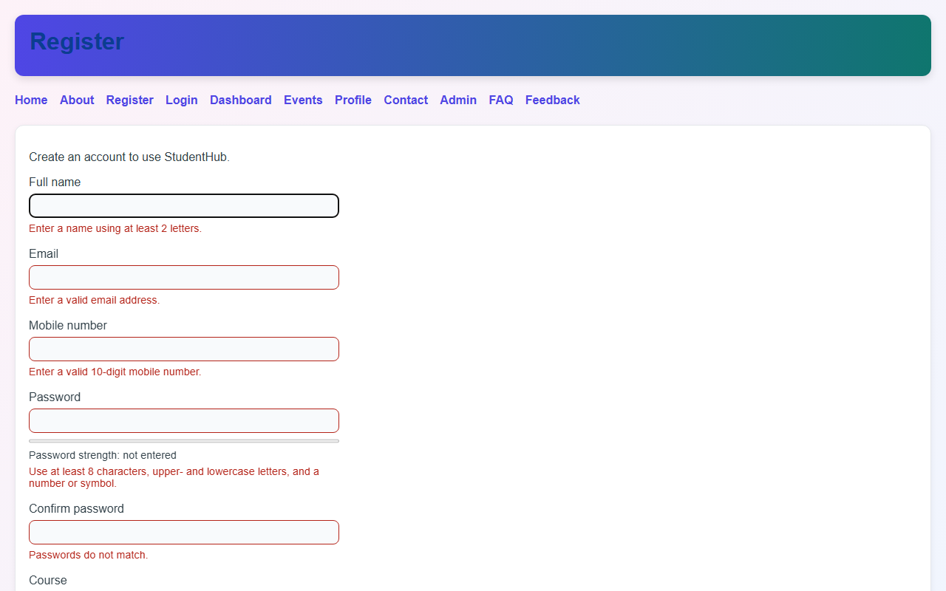
Description: Form showing red error messages below empty and invalid fields.
Figure 5.2: Password Strength Meter & Success State
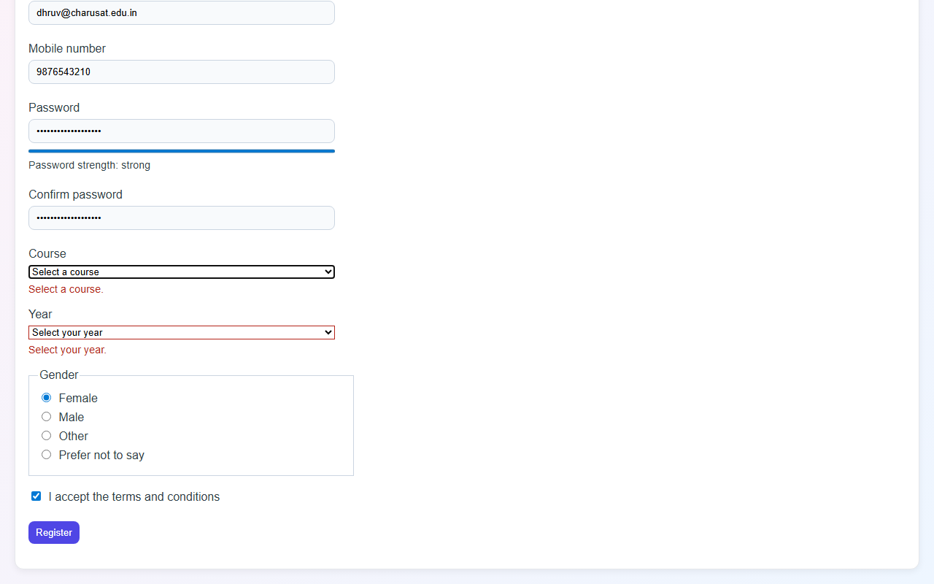

Description: Real-time password strength meter and successful form submission state.

GitHub Repository Link: https://github.com/AmateurCoder9/Student-Hub-Portal/tree/main/Practical-5

Challenges Faced:

Getting regex to validate 10-digit phone numbers and clearing error messages immediately as the user typed required adding input event listeners.

Learning Outcomes:

I learned how to write Regular Expressions, perform client-side form validation, and display helpful inline error messages.

Faculty Remarks: (Keep this blank for faculty)

