Practical - 6
Practical Title: Rendering External JSON Data using Fetch API, Search and Filter

Problem Definition: Display event lists, student profiles, notices, or FAQs from external JSON files using Fetch API. Implement dynamic rendering, search, filter, sorting, and pagination.

Theory

1. How is JSON fetched, parsed, and rendered?
Answer: fetch('events.json') requests the file asynchronously, response.json() parses it into a JavaScript array, and DOM methods create and render cards on the page.
Source: https://developer.mozilla.org/en-US/docs/Web/API/Fetch_API/Using_Fetch

2. Which array methods are used for search, filter, sort, and pagination?
Answer: filter() finds matching titles and categories, sort() orders records, slice() extracts items for the current page, and forEach() loops to render each card.
Source: https://developer.mozilla.org/en-US/docs/Web/JavaScript/Reference/Global_Objects/Array

3. How are loading and error states handled?
Answer: A 'Loading...' message displays while fetch is pending. On success, records render, and on failure, the .catch() block displays a red error notice.
Source: https://developer.mozilla.org/en-US/docs/Web/JavaScript/Guide/Using_promises

4. How is modularity maintained in JavaScript files?
Answer: Code is divided into clear helper functions for fetching data, filtering/sorting records, creating card elements, and handling pagination buttons.
Source: https://developer.mozilla.org/en-US/docs/Web/JavaScript/Guide/Modules

Implementation

I created events.json, students.json, and faqs.json, and used fetch() in data.js to dynamically render cards with live search, category filtering, and pagination.

Evidence of Work (Screenshots)
Figure 6.1: Dynamic Cards from JSON
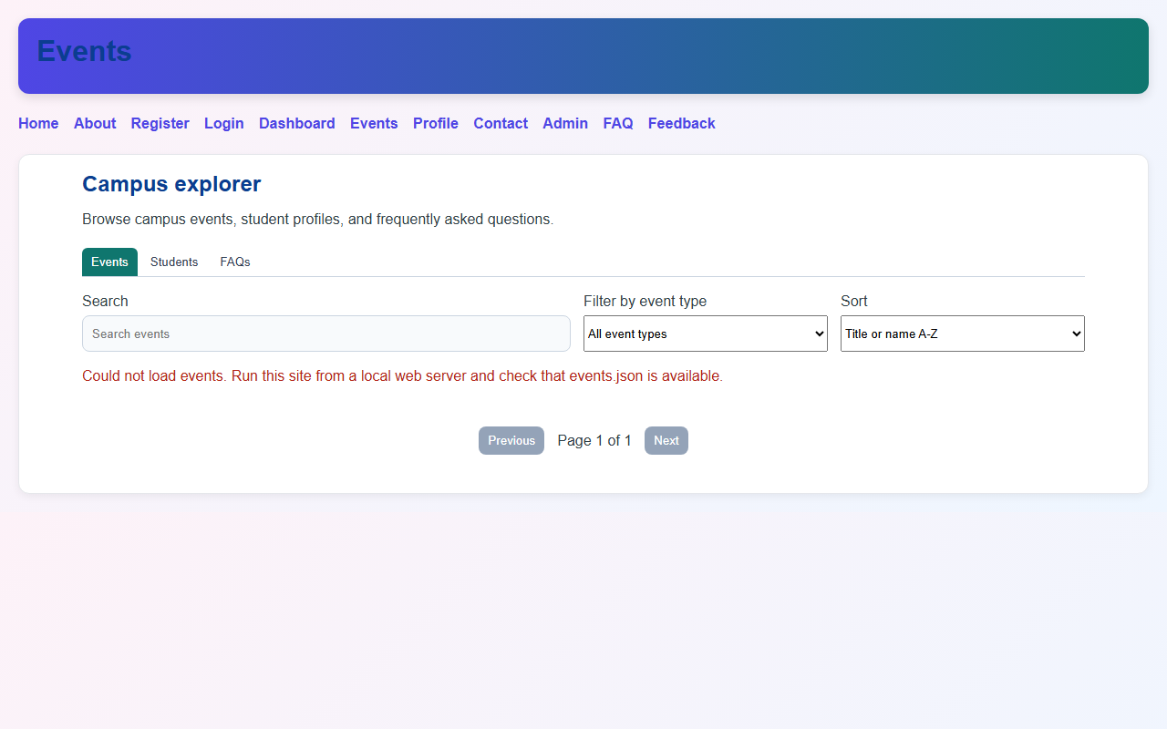
Description: Cards loaded from events.json and rendered dynamically on the page.
Figure 6.2: Search and Category Filtering
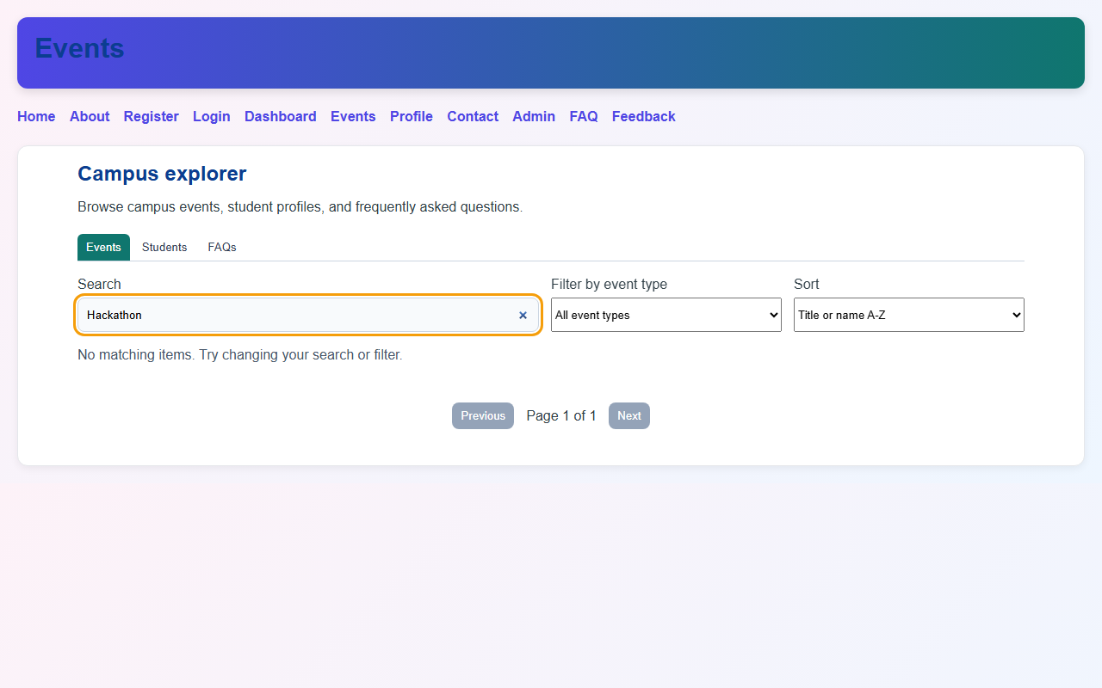

Description: Live search keyword filtering with responsive card display.

GitHub Repository Link: https://github.com/AmateurCoder9/Student-Hub-Portal/tree/main/Practical-6

Challenges Faced:

Opening the HTML file directly via file:// blocked fetch due to CORS policy. I resolved this by opening the project through a local web server.

Learning Outcomes:

I learned how to use the Fetch API with Promises, structure JSON data, and implement client-side search, filtering, and pagination.

Faculty Remarks: (Keep this blank for faculty)

