Practical - 7
Practical Title: PHP Form Processing with Server-Side Validation and CSV/JSON File Storage

Problem Definition: Process submitted registration/contact form data using PHP. Validate and sanitize inputs on the server side and store records in CSV or JSON file format. Display success/error messages.

Theory

1. Is the form submitted using POST?
Answer: Yes, the form uses method='POST' so user data is sent inside the HTTP request body instead of being visible in the browser URL like GET.
Source: https://www.php.net/manual/en/tutorial.forms.php

2. Are inputs validated and sanitized server side?
Answer: Yes, inputs are sanitized with filter_input() and htmlspecialchars(), and validated to ensure non-empty fields, valid emails, and 10-digit mobile numbers.
Source: https://www.php.net/manual/en/book.filter.php

3. Is file writing handled safely?
Answer: Yes, CSV writing uses fopen() in append mode ('a') with fputcsv() for safe escaping, while JSON uses file_get_contents(), json_decode(), and file_put_contents().
Source: https://www.php.net/manual/en/function.fputcsv.php

4. Are success and error responses displayed clearly?
Answer: Yes, an $errors array shows field-level error messages in red, and a green banner confirms successful storage in both CSV and JSON files.
Source: https://www.php.net/manual/en/language.variables.superglobals.php

Implementation

I built register.php to process registration data via POST, validate inputs server-side, append submissions to submissions.csv, and save them in submissions.json.

Evidence of Work (Screenshots)
Figure 7.1: Server-Side Form Validation
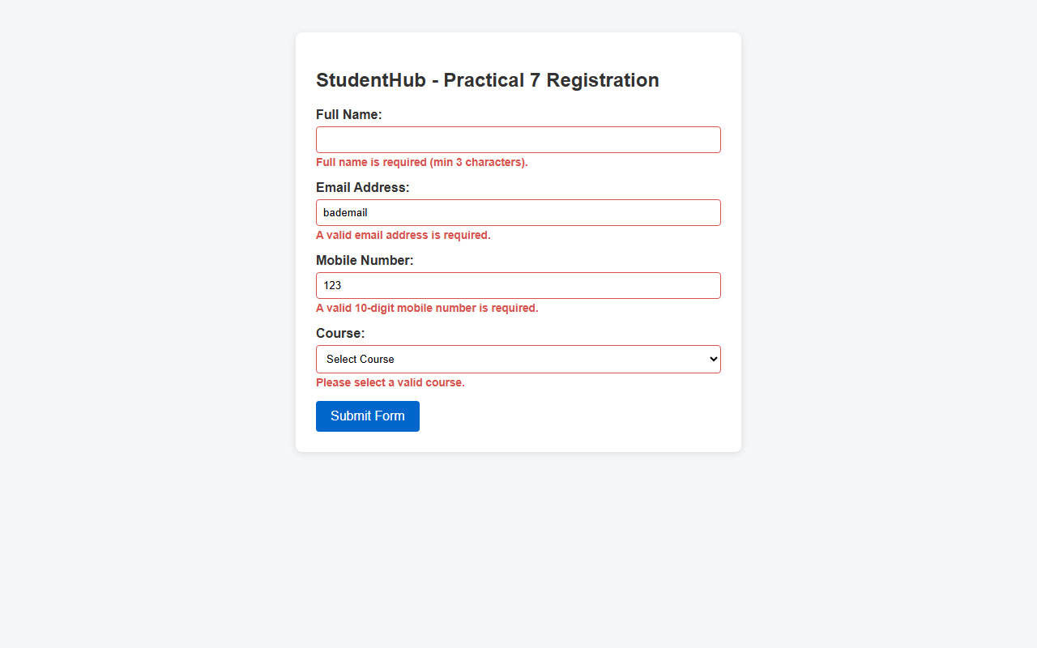
Description: PHP displaying red error messages for missing or invalid inputs.
Figure 7.2: Successful Submission in CSV and JSON
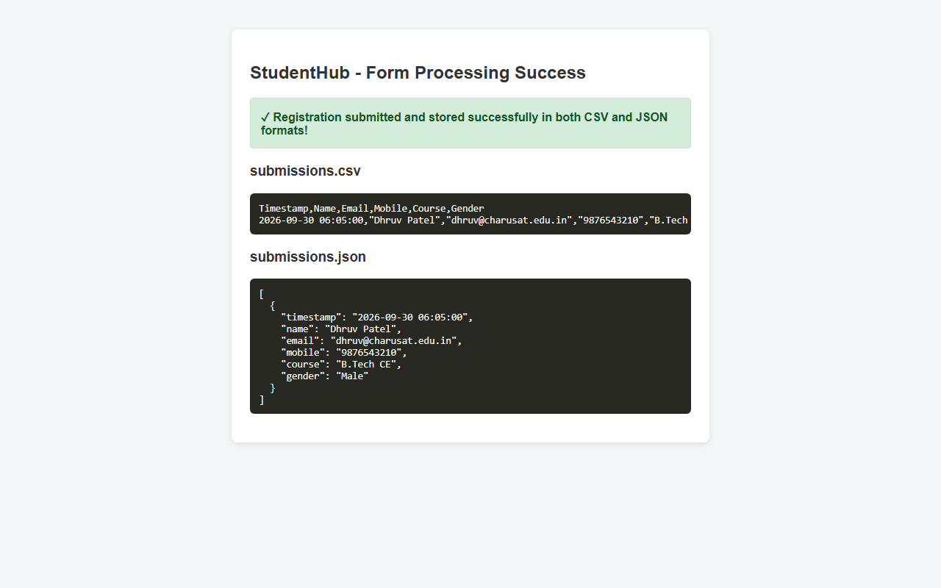

Description: Success message and verified records stored inside submissions.csv and submissions.json.

GitHub Repository Link: https://github.com/AmateurCoder9/Student-Hub-Portal/tree/main/Practical-7

Challenges Faced:

The CSV header row kept getting written on every form submission. I fixed this by checking !file_exists($csvFile) before writing the column header.

Learning Outcomes:

I learned how to process POST forms in PHP, validate and sanitize input on the server, and store records in CSV and JSON files.

Faculty Remarks: (Keep this blank for faculty)

